**Space Panda**

*Game Design Document (GDD) Version 2.0*

*Shakuras, home world of the Protoss Dark Templars; Artist: David Luong*

## Game Identity / Mantra:

The player character is a panda (named Bam) who returns to his home planet only to discover that his wife (named Boo) has been kidnapped and must defeat several evil minions and bosses in order to rescue her.

## Design Pillars:

1. Futuristic (>200 years) fantasy world among the stars
2. Dark spacey level, action-packed, and dangerous environment
3. UFO scans and large boss slightly decrease the player’s health

## Genre/Story/Mechanics:

Side-view gameplay with horizontal and vertical gameplay spaces. Bam the panda arrives home after he was called to defend another planet to find that his wife, Boo, is gone and his place has been ransacked. Turns out, the enemies he fought earlier from the other planet have decided to attack his home personally. After observing their tracks, Bam finds out Boo is being held in a prison at the home planet of the enemies. He must travel across space defeating UFO scans and a final boss who guards the path to Boo. Luckily with his ability to shoot lasers out of his eyes, he makes it to the Boo, defeats the final boss, and rescues the love of his life.

CAMERA:

Third Person, Side-view, FOV extends across the screen and is only revealed as the player progresses to the right.

## Features:

PRIORITY ONE:

Player has limited laser-shooting ability which replenishes quickly.

PRIORITY TWO:

Enemy UFO scans and Enemy Boss deliver minor damage to player.

WISHLIST:

Health can be replenished with the floating blue orbs the player collects along the way.

## Interface:

WD or arrow keys allow the player to move left or move right.

Holding Down Space Bar activates long jump.

Player’s health is three segmented bar and has the ability to gain health by collecting blue orbs.

Enemies do damage via contact.

UI/UX:

Health and score feedback

Transition between start and end scenes UI mechanic

## Art Style:

CONSTRUCTION:

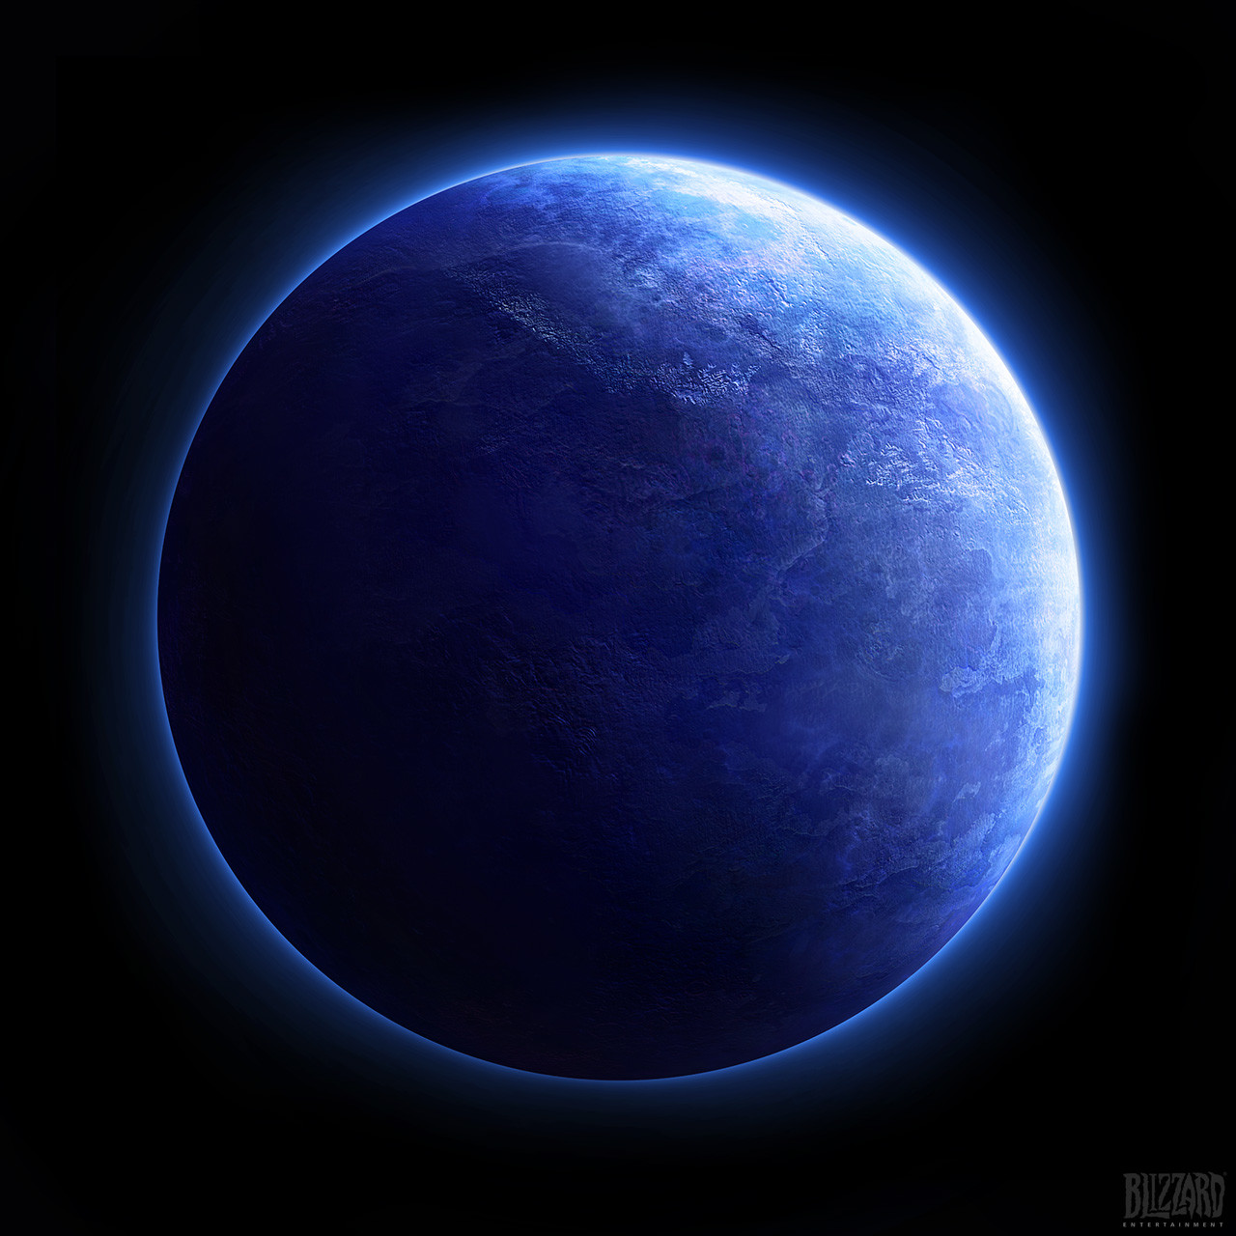

*Shakuras, home Planet of the Protoss Dark Templars; Artist: David Luong (home planet of protagonist)*

*Pandas; Artist: Adela Homutova (character inspiration)*

One level with one final boss encounter (giant red panda).

Beneficial orbs glow blue or purple.

Environment is dark.

Enemies cause damage via contact.

If health is lost, player respawns.

## Audio:

THEME:

Subtle ambient space theme for each level:

<https://freesound.org/people/X3nus/sounds/449945/>

SFX:

Growling of final boss:

<https://freesound.org/people/orginaljun/sounds/379067/>

SPECIAL:

Winning Page music:

<https://freesound.org/people/Setuniman/sounds/207637/>

## Development Roadmap:

**Platform:** Windows PC 64-bit executable.

**Audience:** Teen and above.

**Milestone 1:** PRE-PRODUCTION 07/15/2019

**Milestone 2:** VERTICAL SLICE (MIDTERM) 07/29/2019

**Milestone 3:** BETA 08/05/2019

**Milestone 4:** FINAL (RELEASE) 08/07/2019

**Milestone 5:** PUBLIC PRESENTATION 08/09/2019