Name : Maria Zafar
Course: Artifical Intelligence(Machine Learning)
Institute: Tech-Hub Faisalabad

1.Command : chmod
Explanation: chmod stand for Change Mode.It is used to change the permision of a file that is granted to either a user or a owner in order to make a file executable.
Structure:
chmod [options] permission filename

Output:
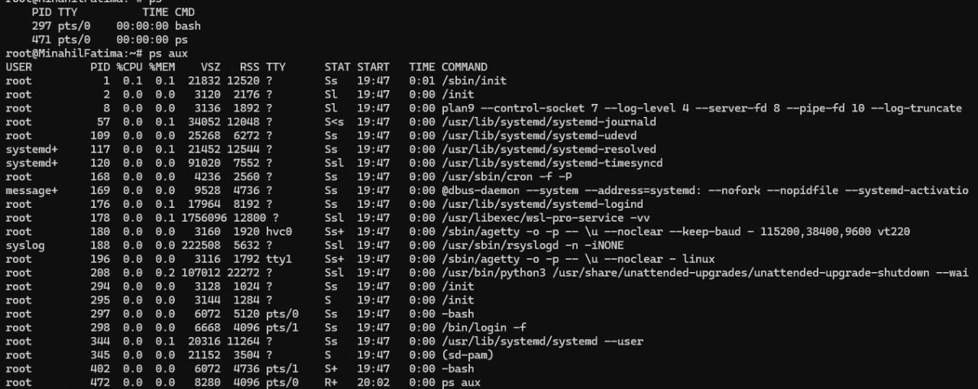
2.Command: ps
Explanation : ps stand for process status. It tells what is processing speed,memory usage of every program running in computer device.
Structure:
ps [options]
Output:
3.Command : kill ID
Explanation: Every process running in computer has a specific ID .This command is used to terminate a specific program by its ID.

Structure:
kill [option]PID
Output:

4.Command : sudo apt update
Explanation: sudo stand for Super user do ( user permision access) and apt stand for Advanced Package Tool.It tells the system about that what the latest updates or download are available for different software in a system,so user might access them and download the latest packages.
Structure:
Output:
