USER STORIES

1. As a manager I want to register socks to the system so they can be seen in the online shop.
2. As a manager, I want to be able to remove a pair of socks from the shop, so that it cannot be purchased anymore.
3. As a manager, I want to be able to update a pair of socks (see not funcional requirement ), so the Information displayed to the customer is up to date.

As a customer I want to be able to add a t-shirt to a shopping cart so that I can purchase multiple products at the same time.

As a customer I want to be able to add a trouser to a shopping cart so that I can purchase multiple products at the same time.

As a customer I want to be able to add a pair socks to a shopping cart so that I can purchase multiple products at the same time.

As a registered customer I want to create a wish list with a title, so that i can add products to t and save them to buy them later.

As a registered customer I want to delete one of my wishlists, so that i can keep only the ones that I want.

As a registered customer I want to be able to change the title of a wishlist so that I can edit my lists and have them organized.

As a registered customer I want to be able to add a t-shirt to a wish list so that I can save the t-shirt there and buy it later.

As a registered customer I want to be able to add a pair of socks to a wish list so that I can save them there and buy it later.

As a registered customer I want to be able to add a trouser to a wish list so that I can save the trousers there and buy them later.

As a registered customer I want to be able to remove trousers from a wish list so if I change my mind they are not saved among my desired products any more.

As a registered customer I want to be able to remove a t-shirt from a wish list so if I change my mind they are not saved among my desired products any more.

As a registered customer I want to be able to remove a pair of socks from a wish list so if I change my mind they are not saved among my desired products any more.

As a manager I want to make the costumers pay for the products they want to by so that my shop is profitable.

As a customer I want to be able to remove a pair of socks from my shopping cart so if I change my mind I do not have to buy them.

As a customer I want to be able to remove trousers from my shopping cart so if I change my mind I do not have to buy them.

As a customer I want to be able to remove a t-shirt from my shopping cart so if I change my mind I do not have to buy them.

As a customer I want to purchase the products in my shopping cart, so that i can buy multiple products at the same time.

As a customer I want to be able to increase the quantity of a t-shirt I have in my shopping cart, so that I can buy mo re of the same model without having to add it one by one.

As a customer I want to be able to increase the quantity of a pair of socks I have in my shopping cart, so that I can buy more of the same model without having to add it one by one.

As a customer I want to be able to increase the quantity of a trouser I have in my shopping cart, so that I can buy more of the same model without having to add it one by one.

As a registered customer I want to be able to edit the information that the store has stored about me (see non-functional requiremnt ) so that I can change it if anything updates.

As a customer I want to be able to decrease the quantity of the t-shirts I have in my shopping cart, so that I can buy less of the same model without having to remove them one by one.

As a customer I want to be able to decrease the quantity of a trouser I have in my shopping cart, so that I can buy less of the same model without having to remove them one by one.

As a customer I want to be able to decrease the quantity of a pair of socks I have in my shopping cart, so that I can buy less of the same model without having to remove them one by one.

As a manager, I want to request specific information (see non-functional requirement) about the unregistered customer when they make a purchase so I can use it during the shipping process.

As a registered customer I want to be able to specify if I want to get notifications from the shop with information about offers and news, so I don’t get unrequested notifications.

As a registered customer I want to choose to recieve notification so I can be informed about the offers

As a registerd customer I want to filter(see non functional) the notification I recieve so I don’t recieve to many of them

As a register customer I want to be able to disable notifications (if i have them enabled), so I don’t get notified anymore

As a manager, I want to notify the users that decided to get notifications with information about special offers and news from the shop, so that they can be updated regarding any information about the shop.

As a customer, I want be able to became registered custmer so I can get its advantages.

As a register customer, I want to authenticate myself so that i can see my account details and past orders.

As a manager, I want to be able to change a t-shirt price for the register-customers, so i can set discounts.

As a manager, I want to be able to change a trousers price for the register-customers, so i can set discounts.

As a manager, I want to be able to change a socks price for the register-customers, so i can set discounts.

As a manager, I want to give a registered customer certain amount of points (see non functional requirement ??) after they complete an order so that I can encourage them to buy more in the future.

As a registered customer, I want to ex-change my points for discounts(see not funcional requirement ) when i am completing a purchase, so that I can save money.

As a manager, I want to be able to modify a t-shirt's price, so I can increase and decrease the price.

As a manager, I want to be able to modify the t-shirt's price, so I can increase and decrease the price.

As a manager, I want to be able to modify the t-shirt's price, so I can increase and decrease the price.

As a manager, I want to be able to update a t-shirt's (see not funcional requirement ), so the Information displayed to the customer is up to date

As a manager, I want to be able to update a trousers (see not funcional requirement ), so the Information displayed to the customer is up to date

As a manager, I want to be able to remove a t-shirt from the shop, so that it cannot be purchased anymore.

As a manager, I want to be able to remove a trousers from the shop, so that it cannot be purchased anymore.

As a manager I want to register a t-shirt to the system so they can be seen in the online shop

As a manager I want to register trousers to the system so they can be seen in the online shop

Non Fuctional

The price of the products will be in €.

Regarding the required information, the shop will store the following details about:

-T-shirts: size, material, color, price, title, description, image, brand, type

-Trousers: size, material, color, price, title, description, image, brand, type

-Socks: size, material, color, price, title, description, image, brand, title,type.

-Registered customer: name, email, phone number ,shipping address (optional).

-Orders: name, email and phone number for contact person. Shipping address , identificaion and quantity of the products, total price, date of purchase, status (processing order/shipping in progress/delivered)

Shipping adress: Country, city, postcode, street, number, apartment/floor/extra info (optional)

The total prize of all of the products in the shopping cart will be displayed so the customer knows how much their purchase will be before purchasing it.

There will be a system of points for registered customers. This points can be optained after sucessfully completing a purchase (1 points for each 1€) and can be exchange while completing a posterior purchase (100 point =-10€). The points can only be used once and have an expiration date of 2 months.

The notification will be of different types(they will be filtered this way):new products added, individual product price change, dicount(temporary)

The possible colors for the products are: black, white, red, green, blue, yellow, grey, purple, brown, orange and multicolor.

The possible sizes for the products are:

-socks: XXS(28-30),XS (31-32), S (33-36), M (37-40), L (40-43), XL (44++)

-T-shirts: XXS, XS, S, M, L, XL, XXL

-Trousers: 32, 34, 36, 38, 40, 42, 44, 46, 48, 50, 52 (guys if you think it would be easier that all the sixzes are the same type we can also use s m l for trousers)

Ask about how we sould manage register costumers and non registers costumers, maybe as a inheritance or separate them.

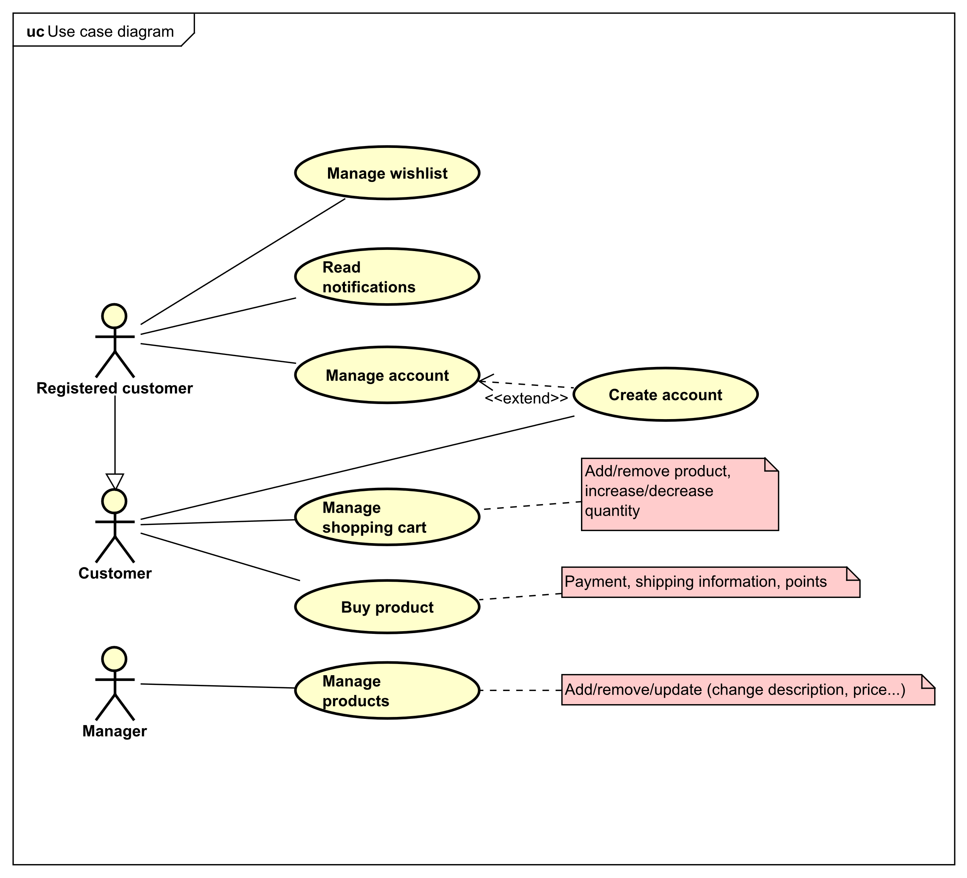

Use Cases

|  |  |
| --- | --- |
| Use Case | Manage whishlist |
| Summary | The customer sees a product (T-shirt, trouser, socks) that would like to add to the whishlilst and they chose to add. The system will display different options for the customer to select depending on the different products characteristics (color, size...).The system will store the product in the whishlist. If the customer do not want anymore the product he selects to remove it and the system will delete from the whishlilst. |
| Actor |  |
| Precondition |  |
| Postcondition |  |
| Base Sequence |  |
| Notes |  |

|  |  |
| --- | --- |
| Use Case | Manage shopping cart |
| Summary | The customer sees a product (T-shirt, trouser, socks) that would like to add to the shopping cart and they choose to add it to the shopping cart. The system will display different options for the customer to select depending on the different products characteristics (color, size...).The system will store the product in the shopping cart. The customer will keep looking for different products to add to their shopping cart and at anytime they can increase a decrase the amount any of the same product that has been added before to their shopping cart. If the customer do not want anymore the product he selects to remove it and the system will delete from the shopping cart. |
| Actor |  |
| Precondition |  |
| Postcondition |  |
| Base Sequence |  |
| Notes |  |

|  |  |
| --- | --- |
| Use Case | Buy product |
| Summary | A customer wants to buy a list of products which has been already added to the shopping cart. The system will request personal and shipping information to the customer. If they are already registered in the system, the informaton will be filled for them, but they will have the possibility to change it before confirming that the information is correct. The system validates the data and shows an overview of the order, including the products and the total price. If the customer is registered, they can now choose if they want to use their points (they can use only part of them, all of them or not use them, as desired), the system updates the total price. The customer selects to proceed to the payment and the system will inform them that they will have to pay by cash when they receive their products. The customer confirms that they understand this and the system shows an overview of the order, inculding the products, the information and the total price. The customer confirms that they want to place the order and the system validates all the data once more and shows a confirmation message to the customer. |
| Actor |  |
| Precondition |  |
| Postcondition |  |
| Base Sequence |  |
| Notes |  |

|  |  |
| --- | --- |
| Use Case | Manage products |
| Summary | A manager wants to add, remove or update a product from the system.  The manager selects which category they want to manage (t-shirts, trousers or socks) The system displays a list of products from that category that are already stored in the system. The manager choose the desired action (add/remove/update).  In case they wants to add a product the system requests the required information. The manager fill all of it and confirm. The system validates and record the information about the product.  In case they wants to remove a product he will select the desired product and choose to delete it from the system.  In case they wants to update a product the manager selects the product, edits the information and confirms. The system validates and saves the product with the new information. |
| Actor | Manager |
| Precondition | Manager already logged in the system. In case of edit and remove, the product should already be stored in the system. |
| Postcondition | The desired product (t-shirt, trouser or socks) will be added, updated or removed from the system. |
| Base Sequence | 1. The system asks to choose between add, remove or edit products 2. The manager chooses between the different operations 3. The system displays a list of the product types: trousers, t-shirts and socks. 4. The manager chooses the type. 5. The system displays a list of the products of that type that are already stored in the system.   CASE ADD:   1. The system request the information for the specific product (see notes) 2. The manager fills the information and confirm. (ES 1) 3. The system displays a list of possible colors. 4. The manager chooses at least one of the available colors (see non-fuctional requirement ??) and confirm. (ES 2) 5. For each color, the system shows a list of sizes (see non-fuctional requirement ??) and request the number of stock for each of them. 6. The manager fills the information and confirm. (ES 3) 7. The system displays an overview of the new product and ask for final confirmation. 8. The manager confirms. 9. The product is added to the system and the list is updated with it.   CASE REMOVE:   1. The manager selects from the list the product they want to remove. 2. The system higlights the product and shows an overview of its information. (see non-functional requirement ??) 3. The manager confirms. 4. The product is deleted from the system and the list is updated. CASE EDIT: |
| Exception sequences | ES 1: Step 7 in case ADD is an exception sequence if the information is incomplete or incorrect:  8b. System displays an error (see notes) and asks for the information to be introduced again.  Go back to main flow, case ADD step 7.  ES 2: Step 9 in case ADD is an exception sequence if the manager confirms without choosing any color.  10b. System displays an error indicating that the manager must select at least 1 color.  Go back to main flow, case ADD step 9.  ES 3: Step 11 in case ADD is an exception sequence if the manager introduces the stock in an incorrect format.  12b. System displays an error indicating that the stock must be natural whole numbers and asks for the information to be introduced again.  Go back to main flow, casse ADD step 11. |
| Notes | The requested information is the following (see non-fuctional requirement ??)  -T-shirts: material, price, title, description, image, brand, type  -Trousers: material, price, title, description, image, brand, type  -Socks: material, price, title, description, image, brand, title, type.  ES 1 can show the following errors: ?????????????????   * Invalid price, try again. * The title must be less than 35 characters. * Title can’t be empty, try again. * Description can’t be empty, try again. * Material can’t be empty, try again. * Price can’t be empty, try again. * Brand can’t be empty, try again. * First upload a picture. |

|  |  |
| --- | --- |
| Use Case | Read notifications |
| Summary | A registered customer wants to read notifications sent by the system in case of: new products added, individual product price change, diccount(temporary)... The notification will contain a body and a title.  The sytem displays a list of the user notifications with just the title. If the customer wants to read the body of the notification they select the desired one and the system displays the body.  A registered customer can decide witch type of notifcations they wants to receive. (see Manage account use case) |
| Actor | Registerd Customer |
| Precondition |  |
| Postcondition |  |
| Base Sequence |  |
| Notes |  |

|  |  |
| --- | --- |
| Use Case | Create account (extend manage account) |
| Summary | A customer wants to create an account in the shop. The system request personal and shipping information. The customer fill this information and confirm. The system validate it and send the customer and confirmation message. |
| Actor |  |
| Precondition |  |
| Postcondition |  |
| Base Sequence |  |
| Notes |  |

|  |  |
| --- | --- |
| Use Case | Manage account |
| Summary | The system displays the account details for the registered customer.  If they want to change the information in their account, they select the desired information and update it with the right one, the system will validate and save the changes.  In case the customer wants to delete their account they will chose to delete it. The system will remove it and show a confirmation message to the customer. |
| Actor |  |
| Precondition |  |
| Postcondition |  |
| Base Sequence |  |
| Notes |  |