NUME: Lenghel Maria

Laborator 7

1. - elemente html si CSS

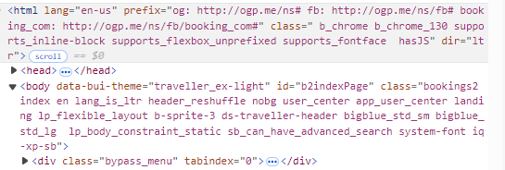

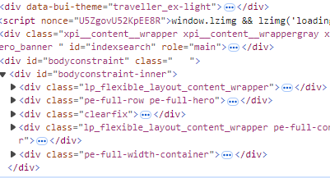

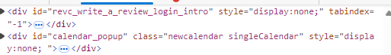

- elemente care se modifica cu ajutorul JavaScript

Link pt exercitiile: 1,2,3-

[Marialenghel27/Laborator-7](https://github.com/Marialenghel27/Laborator-7)