# Project Number {**3**}

# Project Title {**Traveling and Shipment Routing Using Genetic Algorithm**}

# Teams Members:

|  |  |  |  |  |  |
| --- | --- | --- | --- | --- | --- |
| Team Member Full Name | University | Department | Task Distribution | | Note |
| Mariam Ashraf Amin | Cairo | Computer Science | GUI + Genetic Algorithm implementation + Generate graph figure and best fitness plot | - | |

# Project Description

The project is a genetic algorithm for solving the Traveling Salesman Problem (TSP). It evaluates population fitness based on the total distance traveled. Selection (using ranking or tournament), crossover, and mutation operations are applied to evolve the population towards better solutions. The algorithm terminates either after a specified number of generations or when finds the best solution (saturation).

This project has GUI, the user can create a graph, set various parameters for the genetic algorithm, and visualize the evolution of the algorithm's fitness over generations. The algorithm finds the best fitness value, and displays them along with a plot of fitness evolution.

# Depended libraries Project Description

|  |  |  |  |  |
| --- | --- | --- | --- | --- |
| Library Name | Command in terminal | .py | Why? | Note |
| matplotlib | pip install matplotlib | main.py | to create visualizations, such as the fitness evolution plot | - |
| networkx | pip install networkx | main.py | to visualize and manipulate the graph | - |
| Pillow | pip install Pillow | main.py | to open and resize images | - |
| tkinter | pip install tk | main.py | to create GUI for the project | - |
| ast | pip install ast | main.py | to convert the entered graph from string to dictionary | - |

# GUI (Your GUI)

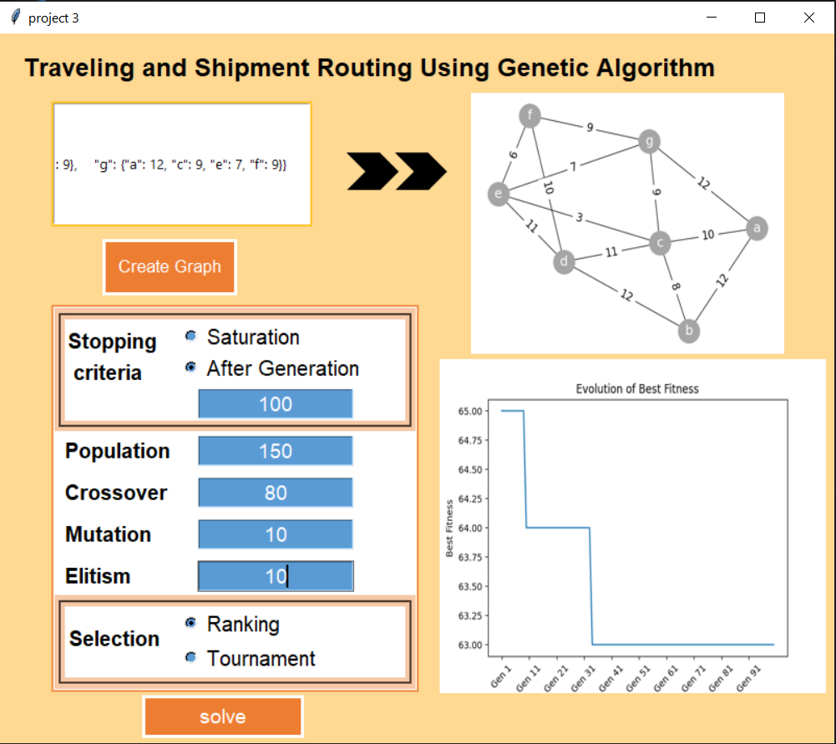

**Dataset description: (If exist)**

**Link of Dataset**

No Dataset for this Problem