**שימו לב!**

**קובץ ה–PDF מכיל את השאלות לבחינה ולאחריו הטקסט**

**(כדי להגיע לטקסט יש לגלול לעמוד המתאים)**

**קובץ ה–Word מכיל רק את השאלות לבחינה והוא מיועד לכתיבת תשובותיכם.**

שימו לב: על השאלות הפתוחות אפשר לענות באנגלית ,בעברית או בערבית - אלא אם כתוב אחרת  או אם נתבקשתם לצטט מהטקסט.

בשאלות עליהן אתם מתבקשים לענות או להסביר במילים שלכם או לפעמים להסיק מסקנה , **אין להעתיק או לתרגם מהטקסט**

**Music Lessons Are Good For the Brain**

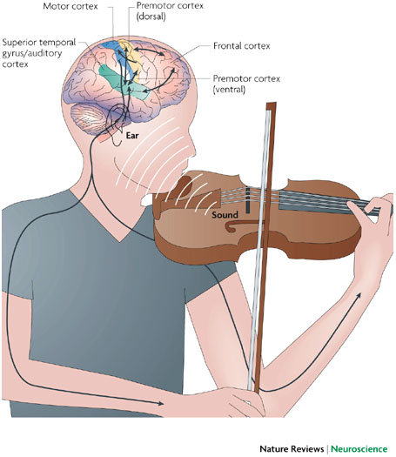

**Question based on the title of the text and the sentence under the title.**

1. The text will discuss learning music in a positive way. Quote **two phrases,** which support this idea.

1.______________________________________________________

2. ______________________________________________________

(8 points)

**Questions based on paragraphs 1-4.**

1. According to paragraph 1, why do many people believe that music improves the brain?

_________________________________________________________

__________________________________________________________

(6 points)

1. List three benefits of music lessons in childhood.
2. _____________________________________________
3. ______________________________________________
4. ______________________________________________

(6 points)

1. What do "these unwanted phenomena" (paragraph 2) refer to?

__________________________________________________________ (6 points)

1. **Mark each sentence True or False according to the text.**

a) If you learned a musical instrument many years ago, you will not benefit when you are older. **__________True __________False**

b) It’s too hard for older people to start learning an instrument.

**__________True __________False**

c) The cognitive benefits of music lessons last a lifetime.

**__________True __________False**

d) The research about older people starting music lessons is reliable.

**__________True ___________False**

(8 points)

**Questions based on paragraphs 5-7**

1. What do you think is the most positive about the results of this Hanna-Pladdy’s first study?

**Explain in your own words.**

___________________________________________________________

___________________________________________________________

(8 points)

**המשך המבחן בעמוד הבא**

1. a. Based on the results of Hanna-Pladdy's second study, which of the following children would benefit most from music lessons?

**Choose the correct answer.**

1. A child who had music lessons from ages 7-17.

2. A child who had music lessons from ages 11-18.

b. Are the results of Hann-Paddy’s second study similar or different to her first study or both?

**Mark Similar, Different or Both**

__________Similar __________Different __________Both

Explain your answer.

__________________________________________________________

__________________________________________________________

c. Based on the results of the second study, which of the following adults would benefit most from music lessons?

**Choose the correct answer.**

1. A retired university professor.

2. A retired factory worker

(10 points)

**המשך המבחן בעמוד הבא**

**Question based on paragraphs 8-10**

1. What happens to people when their hearing declines?

**Complete the chart to show the results. Write in the empty boxes.**

|  |  |  |  |  |
| --- | --- | --- | --- | --- |
| **Our hearing declines** |  |  |  |  |

(8 points)

**Questions based on paragraphs 11 -14**

9 a. List two non-musical benefits for elderly people who learn piano.

1. ___________________________________________________
2. ____________________________________________________

b. The text mentions many benefits of music lessons. Which one **do you think** is the most important? **Explain why in your own words.**

**Answer in English.**

__________________________________________________________

__________________________________________________________

(8 points)

**המשך המבחן בעמוד הבא**

1. a. Are the findings of Jennifer Burgos and Julene Johnson similar or different?

**Mark similar or different.**

__________similar __________different

b. **Explain your answer in your own words.**

________________________________________________________

________________________________________________________

(8 points)

1. You have a 75-year-old relative who is looking for a new hobby. Based on what you have read in the text, encourage him/her to join a choir **in your own words. Write 2-3 sentences in English.**

_________________________________________________________

_________________________________________________________

_________________________________________________________

(8 points)

**המשך המבחן בעמוד הבא**

1. According to paragraph 13, which of the following statements would Jennifer Burgos agree or disagree with?

**Mark the correct answers.**

a) People cannot benefit from music lessons if they begin at 80 years old. **Agree / Disagree**

b) Many people are hesitant about starting music lessons at a later age. **Agree / Disagree**

c) The main benefits of learning music are physical. **Agree / Disagree**

d) If you don't learn to a high level, you won't benefit from music lessons. **Agree / Disagree**

(8 points)

**This question is based on the whole text.**

1. An 8 year old that you know is trying to decide between taking music lessons or karate lessons. Based on what you have learned from the text, how would you convince him/her to take music lessons? Write **3-4 sentences**.

**Answer in your own words.**

___________________________________________________________

___________________________________________________________

__________________________________________________________

(8 points)

**The End**