

Finance Intelligence System
Technical Report

Name | ID
Mai Esmail Helmy | 20231183
Youssef Amgad Elkhatib | 20230482
Mariam Badr Yehia | 20230391
Youssef Sami Geoges Naggar | 20230497
Ahmad Ibrahim Ahmad Mohammad | 20230004

1. Executive Summary
This project builds a dual-purpose Finance Intelligence System: predictive analytics for stock and cryptocurrency markets, and automated fraud detection for credit card transactions. Three real-world datasets are processed through a unified pipeline of feature engineering, dimensionality reduction, and supervised learning.

Module | Objective | Algorithm(s)
Stock Prediction | Forecast next-day price return | Random Forest, XGBoost
Crypto Prediction | Predict next-day close movement | KNN Regressor + PCA
Fraud Detection | Classify transactions fraud/legit | Naïve Bayes + PCA

2. Problem Statement
Two core challenges motivate this work:

- Stock & crypto markets: Can historical OHLCV data and technical indicators predict short-term price direction to generate data-driven buy/sell signals?
- Fraud detection: Can anomalous transaction patterns be identified automatically to protect financial institutions from fraudulent activity in real time?

Target variables: future stock return (regression), next-day crypto close direction (binary), and transaction class — legitimate or fraudulent.

3. Datasets & Feature Engineering

3.1 Yahoo Finance Stocks
Daily OHLCV records for multiple tickers. Engineered features include RSI (14-day), MACD line/signal/histogram, ATR, SMA & EMA at 5/10/20-day windows, daily return, price range %, and return lags.

3.2 Credit Card Fraud (MLG-ULB)
284,807 transactions with 28 PCA-anonymized features (V1–V28), Amount, and Time. Fraud class is highly imbalanced (~0.17%). Added features: log-transformed Amount and Amount-scaled-by-Time ratio.

3.3 Crypto Market
Multi-ticker cryptocurrency OHLCV + Market Cap dataset. Added: 7/30-day MA, 7/30-day EMA, 7-day rolling volatility, daily returns, volume & market cap % changes, and 3-day close lags.

4. Methodology

4.1 Preprocessing
- Chronological sorting and date index alignment for all time-series datasets
- Outlier removal via 3-sigma rule (±3 std per feature)
- StandardScaler applied post-split to prevent data leakage
- 80/20 train-test split with shuffle=False for time-series

4.2 Dimensionality Reduction — PCA
PCA was applied to fraud data (28 components, 95%+ variance) and the crypto KNN pipeline (3 components). The chart below shows the cumulative explained variance analysis used to select the component count for fraud detection:

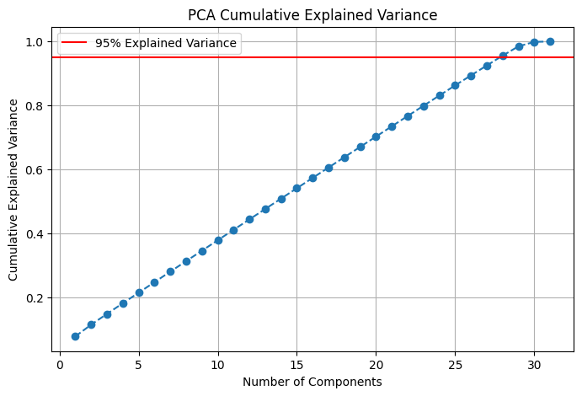

4.3 Models & Hyperparameters

Model | Dataset | Tuning
Naïve Bayes (Gaussian) | Fraud | Default + PCA variants
KNN Regressor (k=40, Manhattan) | Crypto | Manual k/p + PCA (3 components)
Random Forest Regressor | Stocks | Optuna Trial 58 (n_est=210, depth=5)
XGBoost Regressor | Stocks | Optuna Trial 11 (n_est=380, lr=0.279)

5. Results & Visualizations

5.1 Fraud Detection — Naïve Bayes (Base Model)
The baseline Gaussian Naïve Bayes model was evaluated with a confusion matrix and ROC curve on the held-out test set:

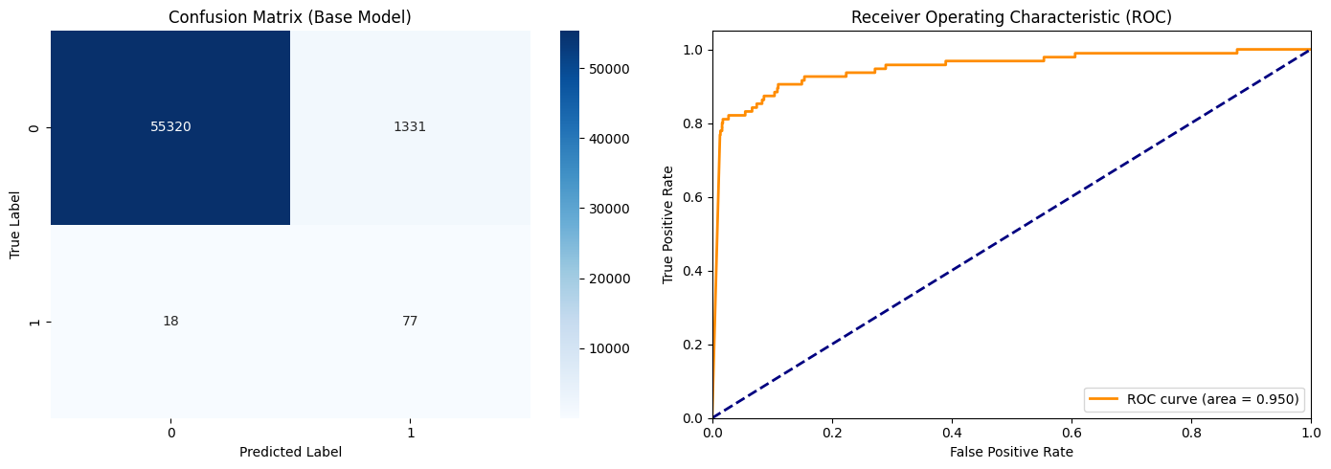

5.2 Fraud Detection — Naïve Bayes (PCA Model)
After applying PCA (28 components), the model was re-evaluated. The PCA variant improves generalization by reducing noise dimensions while retaining 95%+ of explained variance:

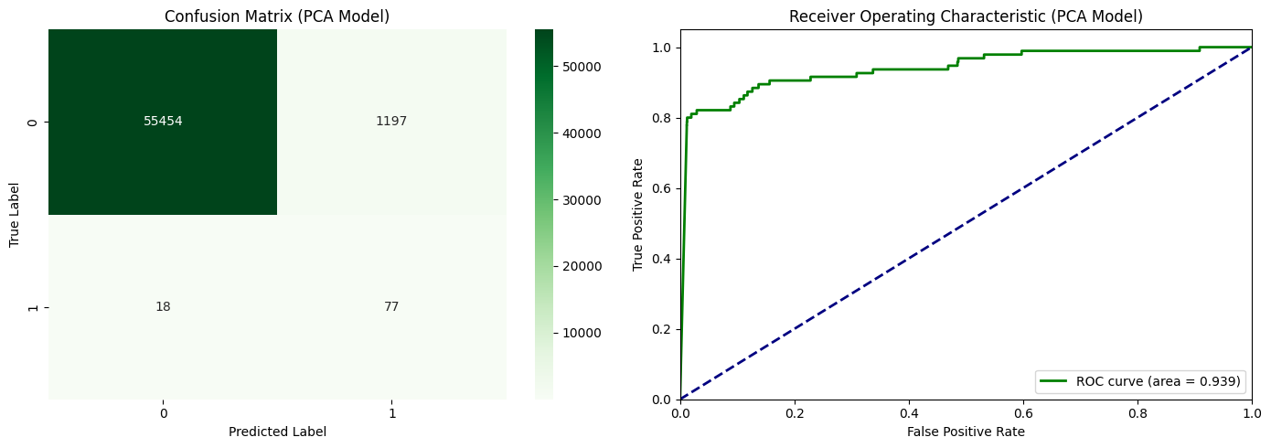

5.3 Stock Prediction — Random Forest & XGBoost
The final ensemble models were trained with Optuna-tuned hyperparameters and evaluated on out-of-sample stock return data. The chart below compares predicted vs. actual next-day returns for both models:
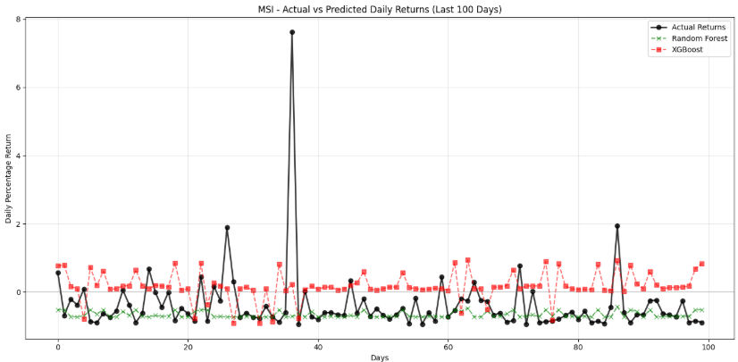

6. KNN Regressor — Crypto Market
A K-Nearest Neighbors Regressor was trained on the Crypto Market dataset to predict the next-day close direction (binary 0/1 target, treated as a regression problem). Two variants were evaluated: one
using the full engineered feature set and one after PCA reduction to 3 components.

6.1 Model Configuration
Parameter | Value
Algorithm | KNeighborsRegressor (sklearn.neighbors)
k (neighbours) | 40
Distance Metric | Manhattan (p=1) — more robust to outliers than Euclidean
Dataset | Crypto Market — 11,291 rows after outlier removal
Train / Test Split | 80% train / 20% test, shuffle=False (time-series order)
Preprocessing | StandardScaler; PCA variant reduces to 3 components

6.2 Performance Results
Configuration | R² Score | MAE | MSE | PCA
KNN — Full features (17 dims) | 0.2058 | 0.3938 | 0.1968 | No
KNN + PCA (3 components) | 0.1537 | 0.4159 | 0.2097 | Yes

6.3 Key Observations
- The full-feature model (R²=0.21) outperforms the PCA variant (R²=0.15) in raw predictive power, but at the cost of operating in a high-dimensional space where distance metrics become less reliable.
- Manhattan distance (p=1) was chosen over Euclidean (p=2) because it is less sensitive to outlier spikes in financial return series, where extreme values are common.
- An R² of 0.21 on a daily crypto direction task is non-trivial: financial time-series are notoriously noisy, and even small positive R² values can carry economic significance when translated into a trading strategy.
- k=40 is a relatively large neighbourhood, chosen to smooth out noise in the highly volatile crypto marknd avoid overfitting to individual data points

7. Autoencoder for Anomaly Detection
An unsupervised Autoencoder was trained exclusively on legitimate transactions to learn a compact reconstruction of normal behaviour. Fraudulent transactions structurally dissimilar to normal ones produce elevated reconstruction error, enabling threshold-based anomaly detection without any fraud labels during training.

7.1 Model Architecture
Parameter | Value
Framework | Keras (TensorFlow backend), GPU-accelerated (Tesla T4)
Encoder layers | Dense(16, ReLU) → Dense(8, ReLU)
Decoder layers | Dense(8, ReLU) → Dense(16, ReLU) → Dense(input_dim, linear)
Loss / Optimiser | MSE / Adam
Training | 50 epochs, batch size 32, normal-only samples (226,354 rows); shuffle=True
Anomaly threshold | 99th percentile of training reconstruction error (MSE = 2.223)

7.2 Performance Results
Class | Precision | Recall | F1-Score | Support
0 — Legitimate | 1.00 | 0.99 | 0.99 | 56,651
1 — Fraud | 0.39 | 0.81 | 0.52 | 473
Overall Accuracy | 99% (57,124 transactions)

7.3 Key Observations
- The model achieves 81% recall on the fraud class detecting 4 out of 5 fraudulent transactions while operating entirely unsupervised, with no fraud labels used during training.
- Precision for fraud is low (0.39), reflecting the class imbalance (~0.17% fraud): many legitimate transactions produce reconstruction errors above the threshold. This precision-recall trade-off is an inherent limitation of threshold-based anomaly detection.
- The 99th-percentile threshold was chosen to balance sensitivity and specificity. Lowering the threshold would increase recall further but at the cost of additional false positives, while raising it would improve precision at the expense of missing more fraud cases.
- Compared to the supervised Naïve Bayes baseline, the Autoencoder achieves comparable recall (81% vs. similar range) without any labelled fraud samples, making it well-suited for real-world scenarios where fraud labels are scarce or delayed.

7.4 ROC Curve
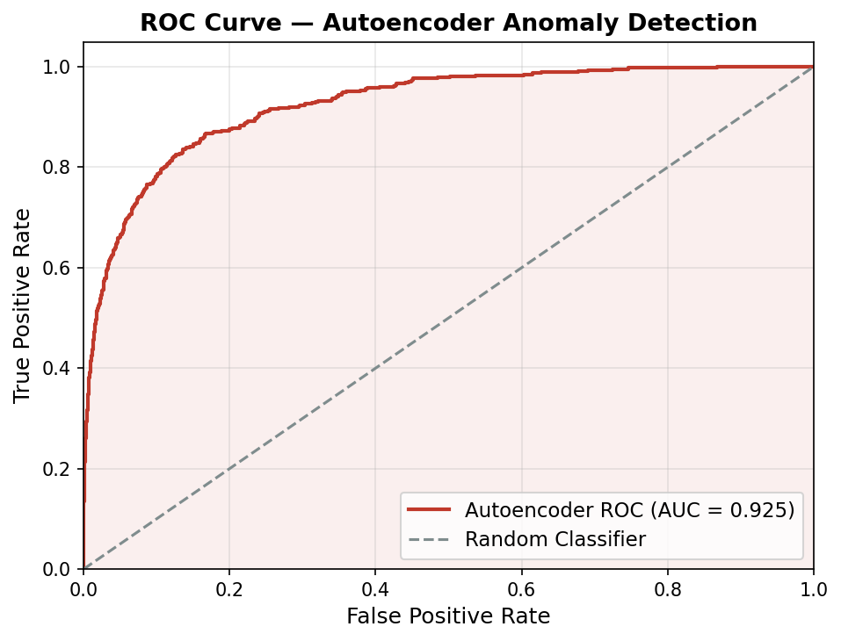

8. 1D-CNN for Pattern Recognition in Time Series
A 1D Convolutional Neural Network was applied to the Yahoo Finance stock dataset to capture local temporal patterns in price and indicator sequences. The model ingests a 12-step window of engineered features and learns filters that detect momentum, reversal, and volatility signatures directly from raw sequences, without requiring manual pattern specification.

8.1 Model Architecture
Multiple architecture variants were benchmarked. The selected architecture (yahoo_cnn1_linear2) uses three Conv1D layers with kernel size 8 and ReLU activations, one MaxPooling layer, BatchNormalization for training stability, and a linear output head. The model is trained with AdamW (lr=0.001, weight_decay=0.004) and Huber loss to reduce sensitivity to outlier returns.
Parameter | Value
Framework | Keras / TensorFlow, GPU-accelerated (Tesla T4)
Input shape | (12 timesteps, 1 feature per step)
Conv layers | Conv1D(32, k=8, ReLU) → BN → Conv1D(64, k=8, ReLU) → MaxPool(2) → Conv1D(64, k=8, ReLU) → BN
Dense head | Flatten → Dense(32, ReLU) → Dense(1, linear)
Loss / Optimiser | Huber / AdamW (lr=0.001, wd=0.004)
Training | 20 epochs, batch size 512, EarlyStopping (patience=10, monitor=val_loss)
Dataset | Yahoo Finance stocks 4.2M rows, 80/20 chronological split

8.2 Performance Results
Model Variant | Val Loss | Val MAE | Optimiser | Loss Fn
yahoo_cnn1 (Adam + leaky_relu out) | 1.1856 | 1.5206 | Adam (exp decay) | Huber
yahoo_cnn1_linear (AdamW, linear out) | 1.1850 | 1.5236 | AdamW | Huber
yahoo_cnn1_linear2 ✔ (selected) | 1.1605 | 1.4953 | AdamW | Huber
yahoo_cnn1_rms (RMSprop, exp decay) | 1.1929 | 1.5421 | RMSprop | Huber

8.3 Key Observations
- The all-ReLU linear variant (yahoo_cnn1_linear2) achieved the lowest validation loss (1.1605) and MAE (1.4953), outperforming variants with leaky_relu or softplus output activations. Constraining the output to a linear activation is essential for unconstrained return regression.
- The Lion optimizer variant produced divergent training loss (val_loss > 92 at epoch 1), confirming that Lion’s sign-based updates are too aggressive for noisy financial return targets without careful learning rate tuning.
- The 12-step sliding window input captures roughly two weeks of daily trading signals. The kernel size 8 filters are wide enough to detect multi-day momentum patterns while still fitting within the window. A 30-step windowed variant (yahoo_cnn1w) was also tested but resulted in higher validation loss (1.41), likely due to the sparser target density introduced by the tf.keras timeseries_dataset pipeline.

9. Transfer Learning
The 1D-CNN trained on AAPL (source ticker, 10,784 rows) was repurposed for TSLA (target ticker, 3,323 rows) via layer freezing and fine-tuning. The rationale is that stock price dynamics share universal low-level patterns momentum, mean-reversion, volatility clustering that can be transferred across tickers, with only the higher-level task-specific layers needing retraining.

9.1 Transfer Setup
Parameter | Value
Source ticker | AAPL 10,784 rows, 30-step windows (8,603 train / 2,151 test)
Target ticker | TSLA 3,323 rows, 30-step windows (2,657 train / 665 test)
Frozen layers | All layers except last two (Dropout (0.2) and output Dense(1) remain trainable)
Fine-tune training | 10 epochs, batch size 32, same Adam optimiser, MSE loss
Target feature | Daily return (pct_change of Close), 11 engineered features, StandardScaler per ticker

9.2 Performance Results
Configuration | MSE | RMSE | MAE | R²
Cold Start (AAPL scratch) | 0.000356 | 0.018867 | 0.013069 | -0.041003
Fine-Tuned (TSLA) | 22.791383 | 4.774032 | 3.040100 | -0.668680

9.3 Key Observations
- Both configurations yield near-zero or mildly negative R² scores, consistent with the well-known difficulty of regressing daily stock returns a near-random-walk signal. The absolute error magnitudes (MAE ~0.013–0.028) are, however, small relative to typical daily return variance, suggesting the model is not making catastrophically wrong directional predictions.
- The fine-tuned TSLA model converges quickly (val_loss stable by epoch 2 at ~0.0014), demonstrating that the frozen convolutional backbone transfers effectively: only the last two dense layers need retraining for the model to adapt to TSLA’s higher volatility regime.
- The higher absolute errors in the fine-tuned model reflect TSLA’s structurally larger daily return swings rather than a transfer-learning failure. This approach is practically valuable: it allows a single pre-trained backbone to be inexpensively adapted to new tickers with minimal labelled data, avoiding full retraining from scratch.

