- Hugo Habercore:

- The disregard for cleanliness and personal hygiene standards in the kitchen is a significant contributor to foodborne illness outbreaks in dining establishments. This typically results from a lack of regular monitoring, as these criteria are not followed until the health inspector is present (Mostly in local eateries).

- The goal of this project is to monitor restaurant kitchen cleanliness and provide daily updates about each chef regarding their compliance with hygienic protocols. These reports will be especially crucial when the area's health inspector visits, giving them a more accurate and lucid perspective. It is also important for the chef and the restaurant owner himself to notice mistakes and try not to repeat them.

- The project is an automated monitoring system for chefs in restaurants, powered by Computer Vision and AI.
It works in real-time through a webcam or an external camera connected to the desktop, and evaluates the chef’s compliance with hygiene and safety standards.

- What does health inspector look for?

Personal hygiene
Your team’s good personal hygiene is critical for reducing the spread of pathogens and maintaining a safe restaurant, and inspectors will take notice. If employees don’t follow handwashing guidelines, wear dirty clothes, or show up to work sick, your operation could be at risk.
Employees should wash their hands after:
- Using the restroom
- Leaving and returning to kitchen/prep areas
- Touching their face, hair, or clothing
- Eating, drinking, smoking, or chewing gum
- Clearing tables, busing dirty dishes, or taking out the trash
- Handling raw meat, poultry, or seafood
- Handling chemicals

- Employees wear disposable gloves and change them frequently.
- Employees don’t use tobacco products anywhere in the establishment.

Cleaning/Sanitation
- All surfaces are smooth, easily cleanable, and frequently washed.
- All equipment is kept clean and in proper working order and meets ANAB standards.
- Chemicals and cleaning supplies are kept away from food surfaces when in use.
- Cleaners are completely washed away from food surfaces after cleaning.
- Chemicals are properly labeled and stored in a separate area from food storage.
- Sanitizers are tested using approved chemical test strips.

Pest Control
- Dumpsters are on a level surface with good drainage at an adequate distance from the establishment. They are frequently cleaned, kept tidy, and covered.
- Trash is disposed of regularly, there is no overflow of trash, and trash receptacles are covered.
- There are no signs of cockroach or rat droppings or urine, egg casings, or fly infestation.
- Doors are self-closing and are kept closed to avoid allowing pests in the facility.

More info and details about cleanliness and special hygiene : https://www.foodstandards.gov.au/business/food-safety/health-and-hygiene-advice-for-food-handlers

https://www.health.vic.gov.au/food-safety/personal-hygiene-for-food-handlers

- If team members display signs of illness, send them home until they’ve fully recovered.

Define Key Features

  - Chef identification (Face Recolonization):
  - The system recognizes each chef by face.
  - Generates individual reports for each chef.
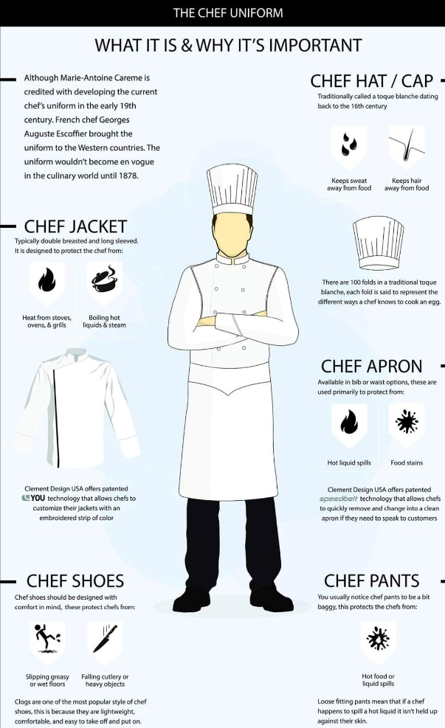
  - Chef Uniform Detection:
  - Chef jacket.
  - Apron.
  - Cap/Hat (Head Nets)
  - Gloves.
  - Face Mask.

A. Personal Hygiene
- Detect if the chef:
  - Is wearing clean clothes.
  - Has hairnet or cap.
  - Is using face mask.
  - Is wearing gloves.
  - Handwashing activity (optional advanced feature).
- Detect if the chef touches face, hair, or clothes during work.
B. Cleaning/Sanitation
- Detect if work surfaces are clean or cluttered.
- Detect sanitizer presence (optional advanced).
C. Reporting System
- Generate daily reports:
  - For each chef (compliance percentage).
  - Send to owner / health inspector.
  - Export as PDF or Excel.
- Possibly add real-time alerts (e.g., “Chef not wearing gloves”).
    - Real-Time Alerts:
  - Audio or text alert on the screen if violation is detected.
  - Example: "Please wear a mask" or "Do not touch food with bare hands".
E. Database + Dashboard:
  - Store all reports in a database.
  - Provide a Dashboard with statistics (overall compliance rate, number of violations, best/worst performing chefs).

What Data Do You Need?
1. Chef Uniform Dataset
- What to include:
  - Images of chefs wearing a full uniform (jacket, apron, hat, gloves, mask).
  - Images of chefs missing specific items (e.g., no hat, no gloves, no mask).
- Purpose: Detect missing protective gear as a violation.
- Where to get it:
  - Use existing datasets like Open Images Dataset or search for “chef uniform dataset” on Kaggle and Roboflow Universe.
  - Use image augmentation (rotation, brightness, blur) to increase dataset size.

2. PPE Detection Data (Hat, Mask, Gloves, Apron)
- What to include:
  - Pre-labeled images for detecting masks, gloves, and hairnets.
- Purpose: Identify PPE compliance in real-time.
- Where to get it:
  - Mask detection datasets: Face Mask Detection Dataset on Kaggle.
  - Gloves & PPE: Use datasets from Roboflow PPE Detection Projects.
  - For apron/chef coats: You may need to create a custom dataset using your kitchen photos and label them using LabelImg or Roboflow.

3. Face Recognition Data (For Chef Identification)
- What to include:
  - 20–50 images per chef from different angles and lighting conditions.
- Purpose: Link detected violations to the correct chef.
- Where to get it:
  - Collect internally (with consent) using your restaurant’s cameras.
  - Store images locally for privacy.

4. Behavior Recognition Data
- What to include:
  - Washing hands (in sink area, using soap).
  - Smoking in kitchen (strict violation).
  - Touching face/hair (violation).
  - Touching food without gloves.
  - Cooking properly (correct handling of food).
  - Standing idle / leaving work for too long.
  - Washing hands after required situations (after touching raw meat, after break).
  - Frequent glove changing (detect if gloves remain unchanged for long time).
- Where to get it:
  - Public datasets:
    - Kaggle Action Recognition Datasets (search for "action recognition" or "kitchen activities").
    - UCF101 Action Recognition Dataset (general actions, but can fine-tune).
    - Epic Kitchens Dataset (kitchen-related actions).
  - Custom Data Collection:
    - Record short video clips in your kitchen for specific scenarios (e.g., washing hands, smoking).
    - Use frame extraction to convert videos to labeled images for training.
  - Augment videos/images for diversity.

✅ Extra Notes on Data Acquisition
- Use Roboflow or CVAT for labeling and augmenting custom datasets.
- For glove-change tracking, you will combine object detection (glove) + time-based analysis to check how long gloves were worn.
- Smoking detection can use object detection for cigarettes or pose/action recognition for smoking gestures.
- Washing-hand-required situations need contextual recognition (e.g., detecting raw meat handling → expecting handwashing after).

Technical Requirements

- Development Environment

- Language: Python
- IDE: VSCode / PyCharm / Jupyter Notebook
- Core Libraries:
  - opencv-python → live video & image processing
  - torch / torchvision or tensorflow/keras → model training & inference
  - ultralytics (YOLOv8/YOLOv11) → PPE & uniform detection
  - numpy, pandas, scikit-learn → data handling & analysis
  - matplotlib / seaborn → visualization

2. Operating Modes

- Real-Time Mode:
  - Live monitoring using a connected camera (USB/Webcam).
  - Instant alerts and on-screen bounding boxes.
- Video Upload Mode:
  - User uploads a recorded kitchen video.
  - System analyzes it frame-by-frame and generates a full compliance report.

3. Chef Uniform & PPE Detection
- Model: YOLOv8/YOLOv11 object detection
- Classes: Jacket, Apron, Hat, Gloves, Mask (+ NoJacket, NoApron, NoHat, NoGloves, NoMask)
- Dataset Sources: Roboflow PPE datasets, Kaggle datasets, custom chef images

4. Face Recognition
- Libraries: face_recognition, deepface, or dlib
- Purpose:
  - Identify each chef by face
  - Store individual compliance reports per chef

5. Behavior Recognition
- Target Behaviors:
  - Washing hands
  - Touching face/hair
  - Touching food without gloves
  - Cooking normally
  - Standing idle/away for too long
- Methods:
  - OpenPose for hand & pose tracking
  - Action recognition models (I3D, SlowFast) for complex behaviors

6. Reports & Database
- Database: SQLite (lightweight) or MySQL (scalable)
- Reports:
  - pandas + matplotlib → stats & plots
  - reportlab or fpdf → PDF reports
  - openpyxl → Excel reports

7. Real-Time Alerts
- Voice Alerts: pyttsx3 (text-to-speech)
- On-Screen Alerts: OpenCV overlay (“Please wear mask”)

8. Desktop Application (CustomTkinter)
- Framework: customtkinter
- Main Features:
  - Dual Mode: switch between Real-Time Monitoring or Video Upload Analysis
  - Live camera feed with bounding boxes & alerts
  - Sidebar navigation (Dashboard, Reports, Settings, Upload Video)
  - Alerts panel (real-time or post-analysis feedback)
  - Reports export (PDF/Excel)
  - Database integration (chef compliance history)

9. Dashboard (inside CustomTkinter)
- Embedded visualizations using matplotlib
- Show:
  - Compliance rate per chef
  - Violations per category (mask, gloves, hat, etc.)
  - Chef ranking (best/worst compliance)
  - Daily/weekly/monthly summaries

Additional Suggestions (Value-Added Features)
- Multi-Chef Tracking: detect and track multiple chefs in the same kitchen
- AI Feedback: automatic suggestions in real-time (“Please wash your hands”, “Put on gloves”)
- Activity Monitoring: track idle time vs. working time per chef
- Integration with Restaurant Management: reports accessible by managers
- Voice + Visual Alerts: optional voice guidance alongside screen pop-ups
- Cloud Sync (Optional): upload reports to a central server for chain restaurants

10. Hardware
- Camera: HD webcam or external USB camera
- System: Laptop/PC with NVIDIA GPU (preferred)
- Alternative: Google Colab / Kaggle for training if local GPU unavailable

Full Flow:
Camera / Uploaded Video → YOLO (PPE Detection) + Face Recognition + Behavior Recognition → Database & Logs → CustomTkinter App (Live Mode + Video Mode + Alerts + Dashboard + Reports).

✅ Full Technical Concepts You Must Master
(Organized in phases for clarity)

1. Python & Core Libraries (Must Know)
- Why: Python is the backbone of AI, CV, and GUI development.
- What to learn:
  - Python basics: loops, functions, classes, OOP.
  - Data handling: numpy, pandas.
  - Image handling: opencv-python.
  - Visualization: matplotlib.
- Resources:
  - W3Schools Python
  - FreeCodeCamp Python (YouTube)
  - OpenCV Crash Course: Learn OpenCV in 4 Hours
- Time Needed: 3–4 days.

2. Computer Vision Fundamentals
- Why: All detections rely on CV concepts.
- What to learn:
  - Image processing basics (thresholding, contours, color spaces).
  - Object detection intro (YOLO, SSD).
  - Face detection vs recognition.
- Tools: OpenCV + YOLOv8.
- Resources:
  - OpenCV Docs + Projects: OpenCV.org
  - YOLOv8 official tutorial (Ultralytics).
- Time Needed: 4 days.

3. Deep Learning for Object Detection
- Why: PPE detection and action recognition need robust models.
- What to learn:
  - CNN basics.
  - YOLOv8 for detection tasks.
  - Transfer Learning (fine-tuning on custom datasets).
- Tools: PyTorch OR TensorFlow (choose one; PyTorch is easier with YOLOv8).
- Resources:
  - YOLOv8 Docs: Ultralytics YOLOv8
  - Course: Deep Learning for CV with PyTorch (YouTube free).
- Time Needed: 5–6 days.

4. Face Recognition
- Why: Identify chefs for reports.
- What to learn:
  - Pre-trained models like FaceNet, Dlib, or face_recognition library.
  - Embeddings & face matching.
- Resources:
  - Face Recognition with Python
  - Medium tutorials on FaceNet + Dlib.
- Time Needed: 2 days.

5. Action/Behavior Recognition
- Why: Detect washing hands, smoking, touching hair, etc.
- What to learn:
  - Pose estimation: OpenPose / MediaPipe.
  - Action recognition models: I3D, SlowFast.
  - Temporal analysis (video → frame sequence).
- Resources:
  - MediaPipe Docs.
  - Action Recognition: UCF101 with PyTorch.
- Time Needed: 5–6 days.

6. Real-Time Inference + Integration
- Why: Combine everything (YOLO + Face + Actions) in real-time.
- What to learn:
  - OpenCV for live video streams.
  - Multi-threading for smooth performance.
  - Overlay text & bounding boxes.
- Resources:
  - OpenCV Video Streaming tutorials.
- Time Needed: 2 days.

7. GUI Development (Desktop App)
- Why: For an interactive app with reports & dashboards.
- What to learn:
  - customtkinter (modern Tkinter UI).
  - Integrate OpenCV feed into Tkinter window.
- Resources:
  - CustomTkinter Docs.
- Time Needed: 2 days.

8. Reporting & Dashboard
- Why: Generate compliance reports for chefs.
- What to learn:
  - reportlab or fpdf for PDFs.
  - openpyxl for Excel reports.
  - Plotting compliance graphs using matplotlib.
- Time Needed: 1 day.

9. Database & Logging
- Why: Store historical data (compliance, violations).
- What to learn:
  - SQLite (lightweight, easy).
  - CRUD operations.
- Time Needed: 1 day.

10. ESP32-CAM (Optional)
- Why: If you want IoT integration later.
- What to learn:
  - Basics of ESP32 (Arduino IDE / MicroPython).
  - Streaming video from ESP32 to Python app.
- Resources:
  - Random Nerd Tutorials: ESP32-CAM projects.
- Time Needed: 2 days.

✅ How to Study This in 1 Month (Aggressive Plan)
Week 1:
- Python + OpenCV basics → 4 days.
- CV Fundamentals → 3 days.
Week 2:
- YOLOv8 + Object Detection → 4 days.
- Face Recognition → 2 days.
- Start GUI basics (CustomTkinter) → 1 day.
Week 3:
- Behavior Recognition (OpenPose + MediaPipe + simple action recognition) → 5 days.
- Real-Time Integration (OpenCV + GUI) → 2 days.
Week 4:
- Reports + Dashboard → 1 day.
- Database → 1 day.
- ESP32 basics (optional) → 2 days.
- Final Integration + Testing → 3–4 days.

🔥 Total Time = 28 days hardcore (4–6 hrs/day).
Yes, it’s doable if you don’t waste time on deep theory and focus on practical coding + ready models.

