Tempo Background

Tempo Tea is a CBD bubbly tea with organic ingredients, including natural caffeine. It was introduced in 2000 but went off the market the following year due to COVID-19. Now, this product is coming back. Your challenge: what would be the marketing communication strategy?

Tempo Tea - https://www.tempobev.com/

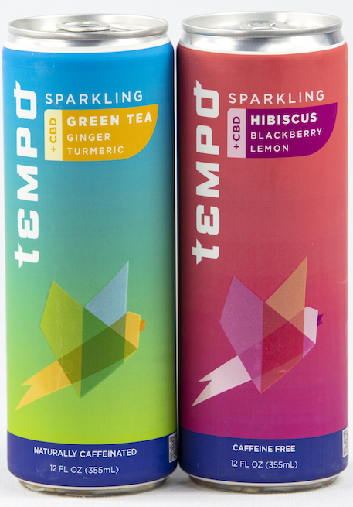
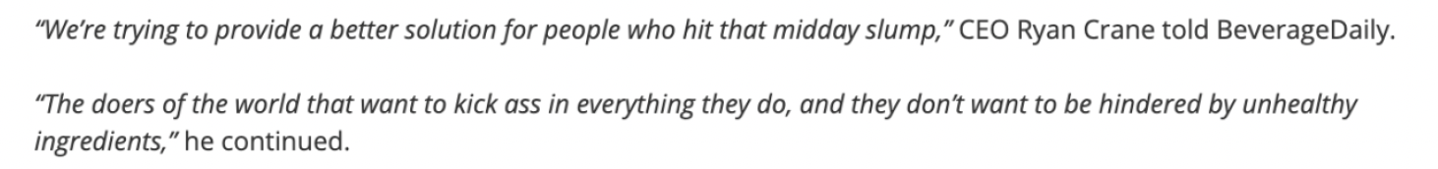

CBD-infused sparkling teas were created to help people rebalance and ‘Set Their Own Tempo’ during the day,” says Ryan Crane, CEO of Tempo. “Whether it’s when you wake up, before you go to bed, while you’re working during the day, or as a substitute for an afternoon coffee or alcoholic nightcap, Tempo is designed to give you an uplifting boost that doesn’t fall short on flavor.”
Tempo’s sparkling green tea is a naturally caffeinated beverage infused with 25mg of hemp-derived CBD, real ginger, and turmeric. The company says it’s meant to kickstart creative energy.
Tempo’s sparkling hibiscus tea is built for those who want to unwind, reset, and relax, the company says. This blend, also infused with 25mg of hemp-derived CBD, pairs non-caffeinated hibiscus tea with blackberry and citrus.
Consumers Research:
21-34 • What are they drinking? Water, Juices, Energy drinks? NA Beverages?

- Gen Z and Millennials enjoy a wide range of beverages when dining out.

- Their preferences tend to lead in multiple categories, including soft drinks, lemonade, milkshakes, smoothies, and alcoholic beverages. Gen Z and Millennials tend to consume energy drinks regularly.

- However, they are now looking for healthier options such as enhanced waters and RTD teas.

- Healthy hydration products for Gen Z and millennials’ demand for sparkling iced tea has driven the growth of bottled tea consumption.

- Popular options include Kombucha Wonder Drink Sparkling Fermented Tea, Lipton Sparkling Tea, and Sound Sparkling Organic Tea. Young consumers are attracted to beverages that deliver health benefits and boost energy.

Category:
Who’s buying RTD Tea (regular & functional)

- Gen Z and Millennials are already the most engaged in functional product usage and are significantly more focused on diets that support mental and physical well-being.

- Young consumers are shifting towards RTD tea, driven by increased awareness regarding
the health concerns caused by consuming carbonated drinks. Gen Z and millennials are opting for herbal, sweet, and fruity teas.

Category: Who’s using CBD products?
- According to Forbes Health, 61% of men use CBD products; strong use among women as well at 60%.

- According to Headset Data, the market share of cannabis beverages has increased by over 40% in the U.S.
- Consumers who want to treat medical conditions such as pain and alleviate anxiety and depression.

- Young U.S. consumers who want to improve sleep quality, reduce stress, or relax. Gen Z is reported to be the most stressed generation, which could make CBD-infused products more attractive to lower high-stress levels.

- Consumers believe CBD is safer than alcohol. They also associate tea and CBD with relaxation. Newer types of CBD drinks gaining traction are flavored waters (like Cloud Water), non-alcoholic cocktails, and drink powders.
  - Key Brand problems
Crowded market space. (With so many options in the market, it’s hard for brands like Tempo to thrive and get visibility)

Most teas are not perceived as energy drinks. Thirty-four percent of Tempo’s target audience (18-24) drinks energy drinks daily.

Cost vs. other RTD teas ($29.99 vs. $8.00)
Tea in a can doesn’t look as natural as a bottled one.

