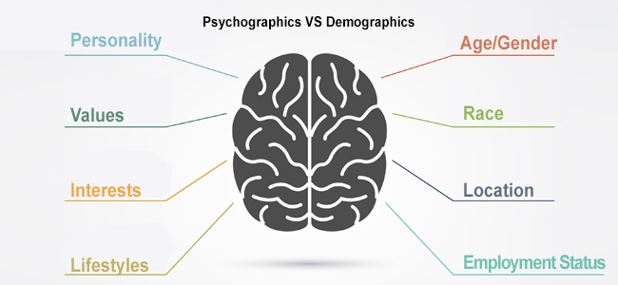

The Differences Between Psychographics and Demographics
Audience segmentation is one of the most fundamental practices in the marketing world, primarily because it enables businesses to target potential customers in the most accurate and cost-effective manner possible. As any seasoned marketer will tell you, one of the quickest ways to blow an advertising budget is to fail to identify your target audience, which is why segmentation is such an essential component of any effective marketing strategy.
Demographic segmentation — i.e., defining audiences by factors such as age, gender, marital status, income, etc. — has been used by marketers for decades to help define their target audience profiles. But as countless real-world marketing campaigns have shown, it is not uncommon for people who fall within the same demographic profile to act in radically different ways.
While this doesn't invalidate the use of demographics — after all, they can be excellent starting points — it does underscore the need for brands to seek more nuanced information about their target audience.
Enter psychographics. This field of study focuses on collecting and analyzing the characteristics of an audience that are slightly more intangible, such as interests, habits, attitudes, emotions, and preferences.
Armed with this information, marketers can infer not only what product or service a customer might buy, but also why they would buy it. In healthcare, providers can use psychographic data to enhance patient education and activation efforts. In other words, psychographics provides marketers and providers with a window into the motivations, values and desires of a target audience, offering a substantial amount of insight into the drivers of consumer behavior from several different angles.
Psychographic segmentation is the act of identifying and classifying groups of people based on these shared data points, so that you can customize your brand’s tone and message to better connect with the people you’re trying to reach.

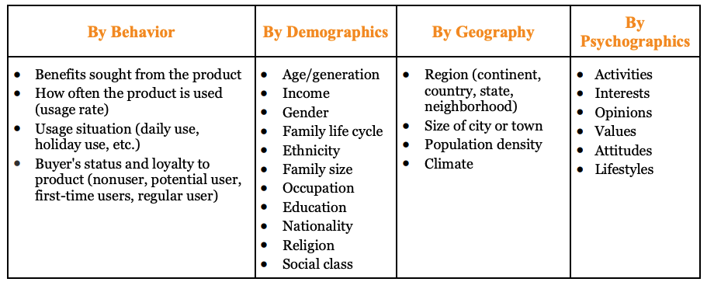
w

