

Data Storytelling

Team:
Mariam Moustafa Khairy Ahmed Sayed Kamel
Ashraqat Muhammed Khaifa Jana Khaled Abou Elmagd
Sara Sayed Hafez

Project Overview:
Customer churn is one of the biggest challenges faced by telecommunication companies. Losing customers leads to decreased revenue and increased customer acquisition costs. This project analyzes customer demographics, services, billing information, and contract details to identify the main reasons behind customer churn.

Objectives
The main objectives of this project are to:
- Design an Entity Relationship Diagram (ERD) for the telecom database.
- Create a schema mapping between the dataset and the relational database.
- Build and implement the database using MySQL.
- Clean and preprocess the data using SQL, Excel (Power Query), and Python.
- Import the fully cleaned dataset back into MySQL.
- Perform SQL queries to analyze customer behavior and churn.
- Build a Power Pivot Data Model.
- Create DAX measures and calculated fields for business analysis.
- Develop Pivot Tables to summarize key performance indicators (KPIs).
- Present data-driven insights and business recommendations through Data Storytelling.

Dataset Description
The IBM Telco Customer Churn dataset contains customer information collected by a telecommunications company. The data includes customer demographics, subscribed services, contract details, payment information, and customer status.
The dataset is divided into multiple files to simulate a real-world relational database environment. Each file represents a different business entity, making it suitable for database design, SQL analysis, and data storytelling.

Business Scenario
A telecommunications company has experienced an increase in customer churn over the past year. The management team wants to identify the key factors that influence customer churn and improve customer retention.
To achieve this goal, the available customer data will be organized into a relational database, cleaned using multiple tools, analyzed using SQL, and summarized using analytical models to support business decision-making.

Entity Relationship Diagram (ERD)
The first phase of the project involved designing an Entity Relationship Diagram (ERD) to create a well-structured relational database. The ERD defines the entities, their attributes, primary keys (PK), foreign keys (FK), and the relationships between them, ensuring data integrity and minimizing redundancy.
The database is centered around the Customer Entity, which connects the remaining entities and represents the core of the database structure.

The main entities in the database are:
- Customer: Stores the unique customer identifier and serves as the central table linking all related entities.
- Demographics: Contains customer demographic information, including gender, age, marital status, dependents, and senior citizen status.
- Location: Stores geographical information such as city, zip code, latitude, and longitude.
- Population: Contains population statistics associated with each location.
- Services: Includes customer subscription details, internet and phone services, contract type, payment method, tenure, monthly charges, and total charges.
- Status: Stores customer status information, including churn label, churn category, churn reason, and Customer Lifetime Value (CLTV).
The relationships between these entities were established using primary and foreign keys, resulting in a normalized relational database that supports efficient storage, querying, and analysis.
Entity Relationship Diagram (ERD)
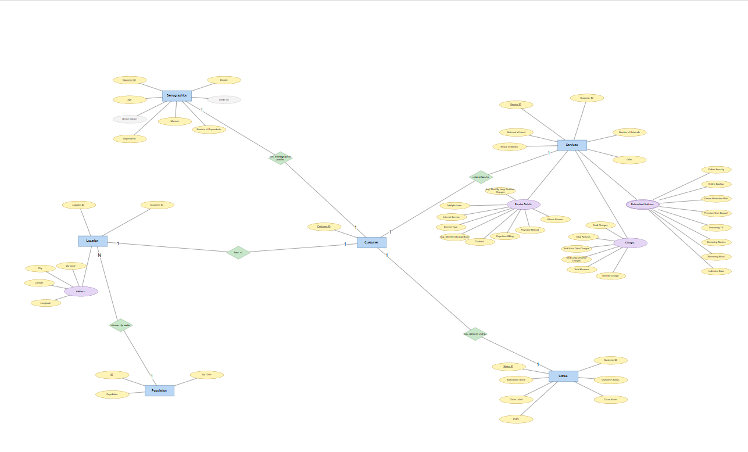

Database Implementation (MySQL)
After designing the ERD, the database was implemented in MySQL. The database structure was created based on the ERD by defining tables, primary keys, foreign keys, and relationships between entities.

The implementation included:
- Creating the database
- Creating all tables
- Defining Primary Keys (PK)
- Defining Foreign Keys (FK)
- Establishing relationships
- Importing the dataset

Schema Mapping
After implementing the database, schema mapping was performed to match the dataset columns with their corresponding database tables and fields. This process ensured consistency between the dataset and the relational database structure.

The mapping includes:
- Customer
- Demographics
- Location
- Population
- Services
- Status

Entity | Mapped Attributes
Customer: | Customer ID
Demographics: | Gender, Age, under 30, Senior Citizen, Married, Dependents, Number of Dependents
Location: | Location ID, Customer ID, City, Zip Code, Latitude, Longitude
Population: | ID, Zip Code, Population
Services: | Service ID, Customer ID, Referred a Friend, Number of Referrals, Tenure in Months, Offer, Phone Service, Avg Monthly Long Distance Charges, Multiple Lines, Internet Service, Internet Type, Avg Monthly GB Download, Online Security, Online Backup, Device Protection Plan, Premium Tech Support, Streaming TV, Streaming Movies, Streaming Music, Unlimited Data, Contract, Paperless Billing, Payment Method, Monthly Charge, Total Charges, Total Refunds, Total Extra Data Charges, Total Long Distance Charges, Total Revenue
Status: | Status ID, Customer ID, Satisfaction Score, Customer Status, Churn Label, Churn Score, CLTV

Data Cleaning
After importing the dataset into MySQL, a data cleaning process was performed to improve data quality and ensure accurate analysis. The cleaning was completed using SQL, Excel (Power Query), and Python.

The cleaning process included:
SQL
- Removed duplicate records.
- Checked for missing values.
- Standardized text values.
- Verified data integrity.

Excel & Power Query
- Removed unnecessary columns.
- Corrected data types.
- Trimmed extra spaces.
- Handled missing values.

Python
- Validated the cleaned dataset.
- Converted data types.
- Performed final data quality checks.
- Exported the cleaned dataset for analysis.

SQL Analysis
SQL queries were used to analyze the cleaned dataset and answer key business questions related to customer churn. The analysis helped identify customer behavior, service usage, and revenue patterns.

The analysis includes:
- Total number of customers
- Churned vs. retained customers
- Churn rate
- Customer distribution by contract type
- Customer distribution by internet service
- Payment method analysis
- Average monthly charges
- Revenue analysis
- Customer tenure analysis

Excel
Excel was used for the initial inspection and validation of the dataset. The following issues were identified:
- Duplicate records (~352 rows).
- Missing values distributed across 7 columns.
- Empty string values.
- Inconsistent text casing.
- Leading and trailing spaces.
- Inconsistent Boolean values.
- Outliers and invalid numeric values.
- Mixed data formats.
- Special characters in Customer ID.
- An unnecessary empty column (Unnamed: 30).

Power Query
Power Query was used to transform and standardize the data by:
- Removing the Unnamed: 30 columns.
- Replacing or handling missing values.
- Changing data types.
- Trimming and cleaning text values.
- Standardizing categorical values.
- Removing duplicate records.
- Preparing the dataset for further processing.
Python

Python was used to perform advanced data cleaning and validation by:

- Renamed column names for consistency.
- Checked for missing values.
- Removed rows with missing customer IDs.
- Filled missing ZIP codes with the most common value.
- Filled missing latitude and longitude values with the median.
- Removed duplicate records.
- Removed extra spaces from text columns.
- Cleaned and standardized the City column.
- Removed non-numeric characters from the Zip_code column.
- Validated latitude and longitude values.
Dashboard
After completing the data cleaning, SQL analysis, and Power Pivot modeling, an interactive dashboard was created to visualize the key performance indicators (KPIs) and customer churn metrics. The dashboard provides a clear overview of customer demographics, revenue, churn rate, internet services, payment methods, and customer distribution, enabling quick and effective business insights.
The dashboard includes:
- KPI Cards (Total Customers, Total Revenue, Churn Rate, Average CLTV)
- Customer distribution by Gender
- Customer distribution by City
- Customer Status (Stayed, Churned, Joined)
- Average Population
- Customer distribution by Age
- Customer distribution by Internet Type
- Customer distribution by Payment Method
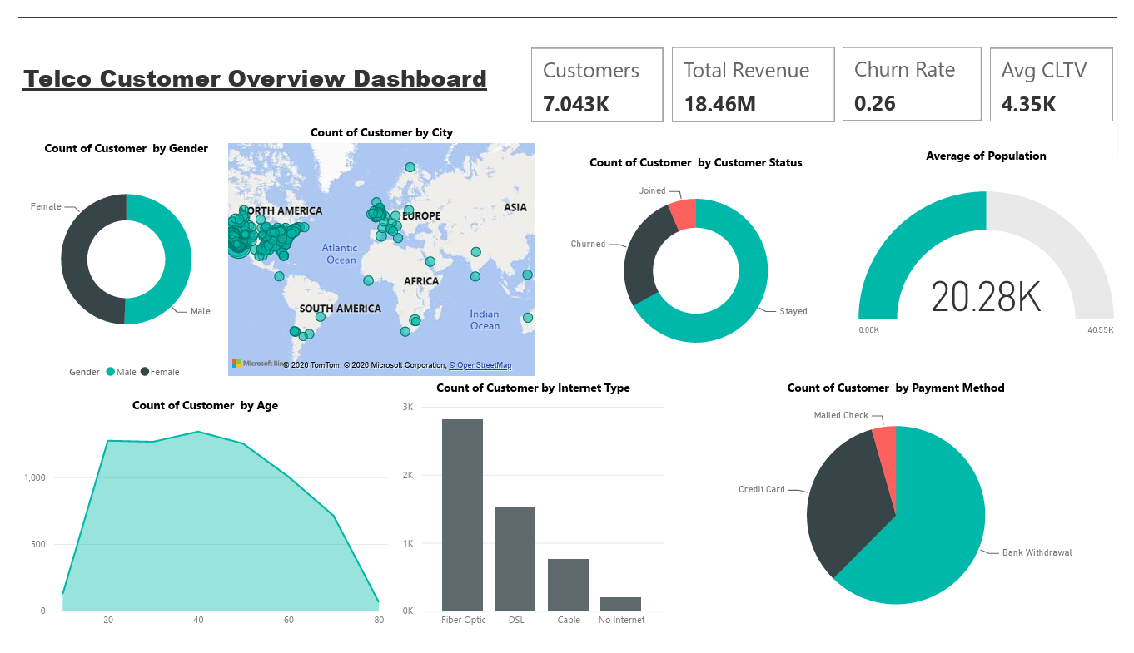

Recommendations
Based on the findings, the following recommendations are proposed:
- Promote long-term contracts to improve customer retention.
- Improve the quality of internet services for high-risk customers.
- Offer personalized discounts and loyalty programs.
- Encourage customers to use automatic payment methods.

Conclusion
This project successfully transformed raw telecom customer data into meaningful business insights through database design, data cleaning, SQL analysis, and Power Pivot. The dataset was organized using a relational database, cleaned with SQL, Excel, Power Query, and Python, and analyzed to identify the key factors influencing customer churn.
The findings highlighted important patterns in customer behavior, such as the impact of contract type, internet service, payment method, monthly charges, and customer tenure on churn. These insights provide valuable support for data-driven decision-making and help the company develop effective customer retention strategies.
Overall, the project demonstrates how combining database management, data preprocessing, and analytical techniques can transform raw data into actionable business insights.

