**Multimedia**

This project prepared by:

Mariam Emad Anwar

Mayar Hany Abdelmoez

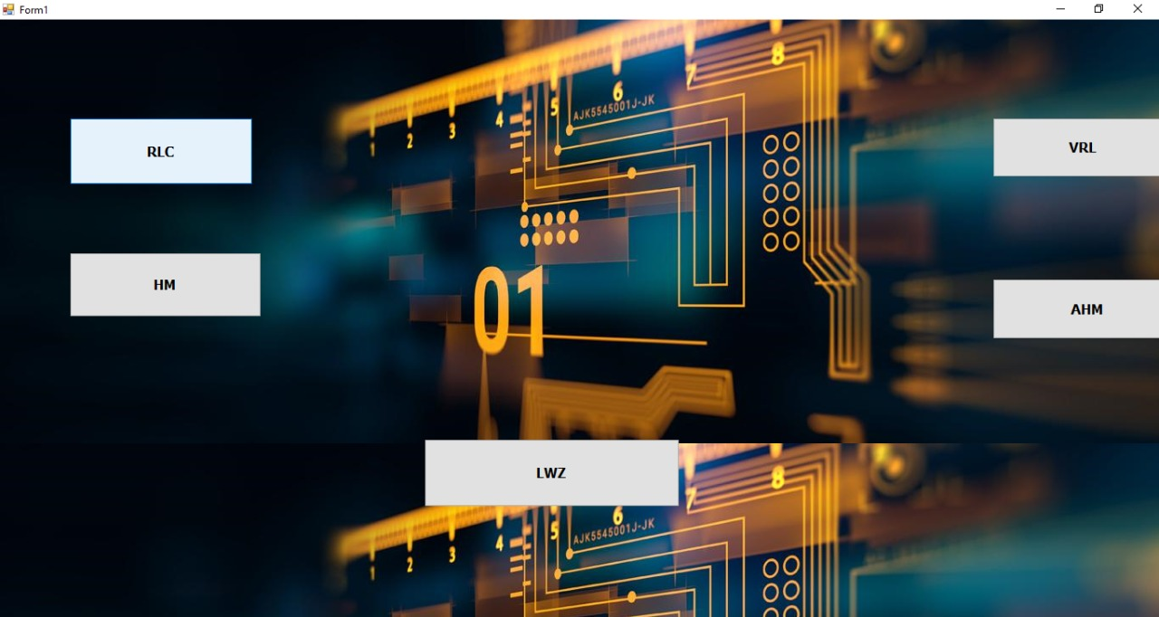**Home page:**

1. 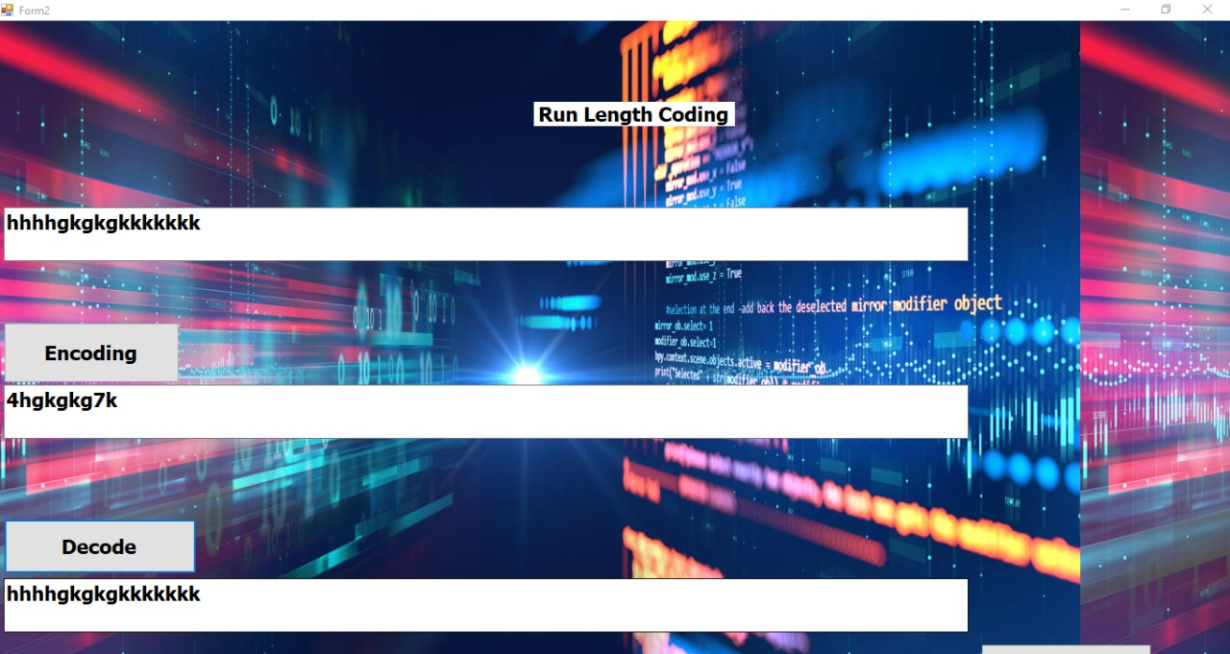**Run Length Coding:**
2. 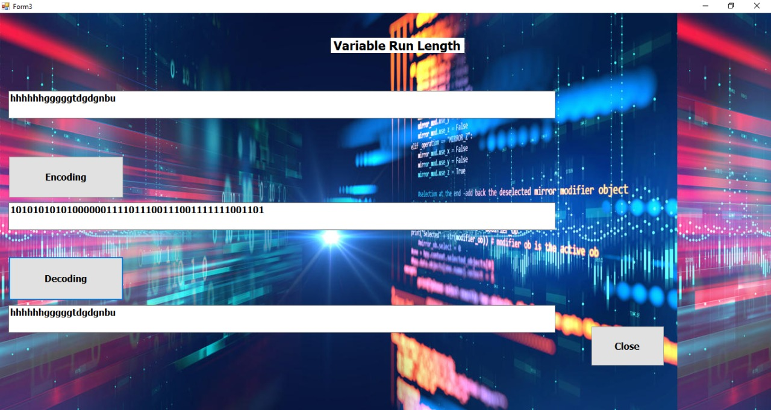**Variable Length:**
3. **Huffman:**

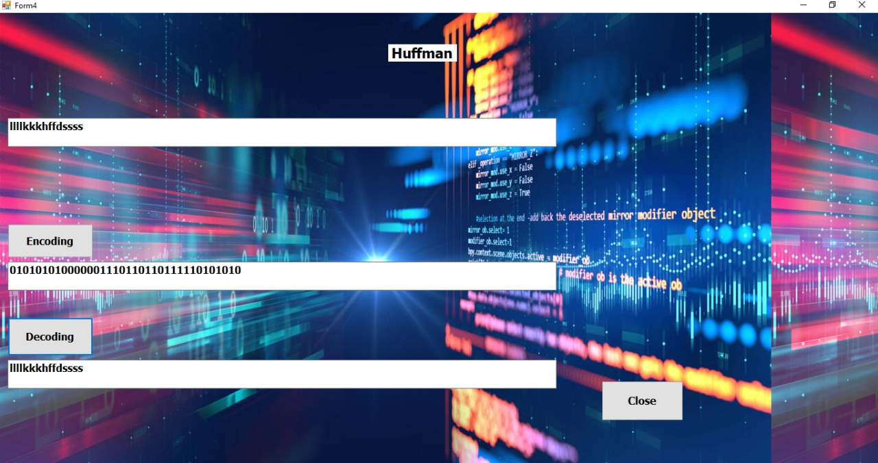

1. **Adaptive Huffman:**

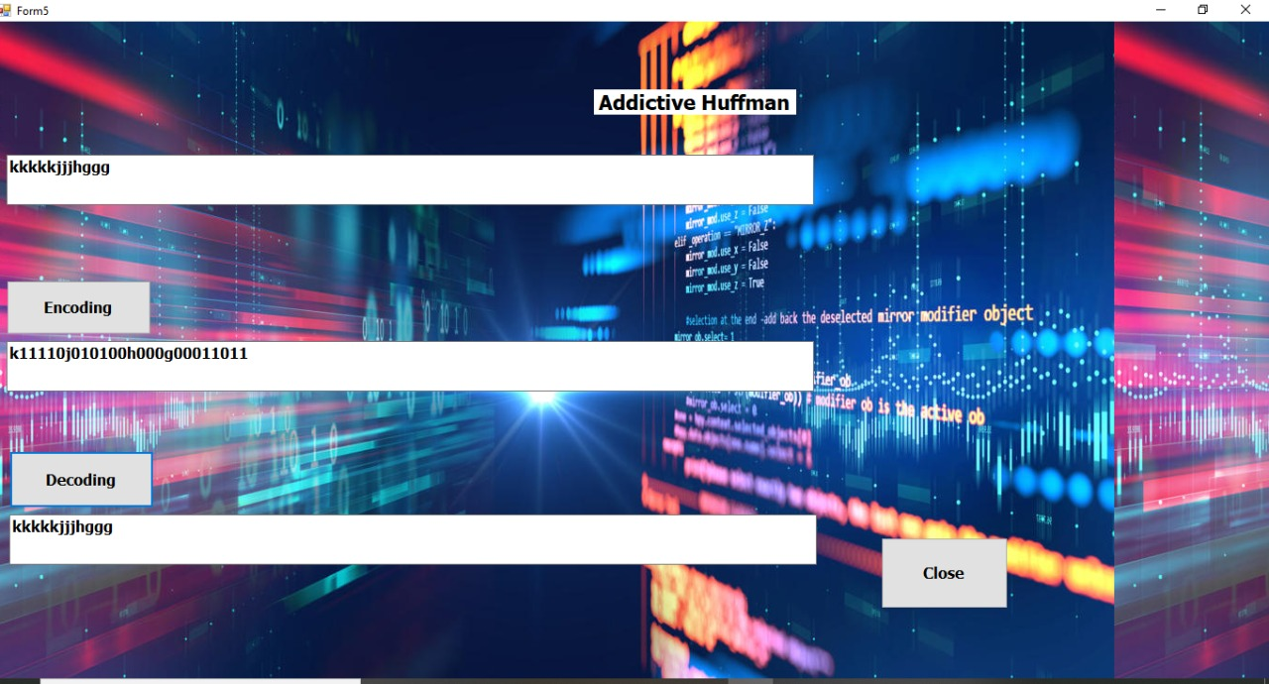

1. **LZW**

