


Lebanese University - Faculty of Sciences
Section - I

Department of Computer Science
2025-2026



Project submitted in the context of the course
I3306 Database II

Prepared by:
Mariam Atwi
Hoda Shour
Fatima Assaad

Student ID:

Mariam Atwi: 111802
Hoda Shour:108884
Fatima Assaad:120597

Acknowledgements

I would like to sincerely express my gratitude to my instructor, Dr. Mohammed Dbouk, for the I3306 Database II course, for his expert guidance and continuous support throughout the development of this project. The Crime Reporting System project significantly enhanced my understanding of database design principles, normalization techniques, SQL implementation, and database security considerations. I would also like to acknowledge all individuals who contributed to this project in various capacities, as their support played an important role in the successful completion of this work.
Table of Contents
Introduction 4
CHAPTER 1: 5
Database Application Architecture 5
1. Introduction 5
2. Role of each component 5
User Client 5
Database Server 5
CHAPTER 2 : 6
Database Modeling 6
1. Introduction 6
2. Adopted topic – business requirements 6
3. Entity Relationship Diagram 6
4. Mapping ERD to database schema 6
CHAPTER 3: 7
Services and Interface modeling 7
CHAPTER 4: 8
Application Implementation and testing 8
1. DDL scripts 8
2. DML scripts 8
Data insertions 8
Data modification and deletion 8
Set of relevant extractions - queries 8
3. Conclusion 8
Conclusion: 9

Introduction:

The Crime Reporting System is a comprehensive database application designed to facilitate crime reporting and management between residents and law enforcement agencies. In today's society, efficient crime reporting and response mechanisms are crucial for maintaining public safety and trust in law enforcement.
This project aims to provide a robust database solution that allows residents to report crimes and enables police departments to efficiently receive, categorize, and respond to these reports. The system maintains detailed records of residents, policemen, crime categories, crime reports, and response actions, ensuring data integrity and facilitating effective crime management.
The database is designed following industry best practices, including normalization to third normal form, comprehensive referential integrity constraints, and role-based security measures. This report documents the complete development lifecycle from conceptual design through implementation and testing.

……

CHAPTER 1:

Database Application Architecture

Introduction:

The Crime Reporting System follows a client-server architecture with a three-tier design pattern. This architecture separates the application into three logical layers: presentation (user interface), application logic (business rules), and data storage (database server).

The architecture consists of:
- User Client Layer: Web or desktop interface for residents and police officers
- Application Server Layer: Business logic processing and validation
- Database Server Layer: Data storage, retrieval, and management

This separation ensures:
- Scalability: Multiple clients can access the system simultaneously
- Maintainability: Changes to one layer don't require modifications to others
- Security: Centralized data management with controlled access
- Performance: Optimized data processing at the server level

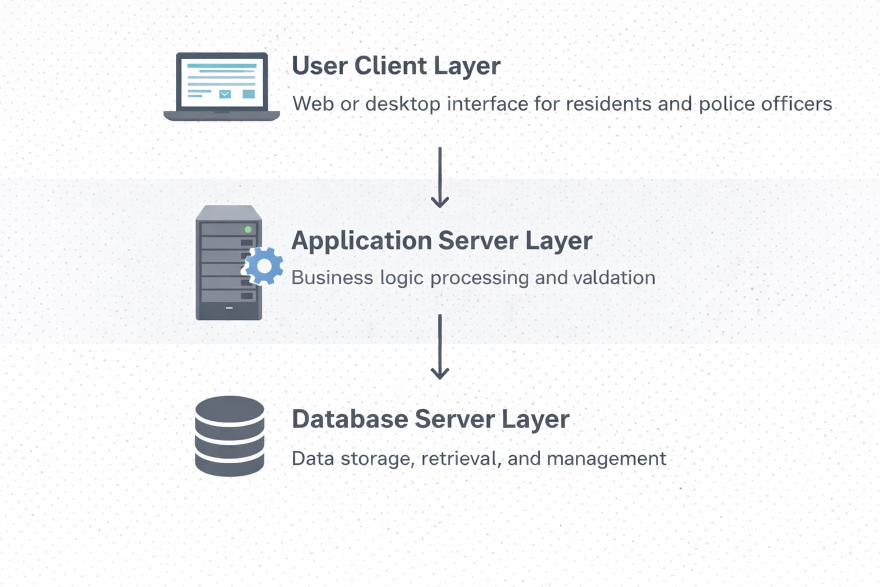

Role of each component

User Client:

The user client layer delivers the graphical user interface (GUI) using PHP combined with HTML and CSS, ensuring clear presentation and responsive design. It is responsible for handling user interactions, sending requests to the application server, and displaying processed results. A secure authentication system verifies user credentials against database records, manages sessions, redirects users to role-specific dashboards, and ensures proper login and logout handling.

The system uses role-based dashboards to provide tailored access for four user types: administrators, residents, policemen, and supervisors. Administrators have full control over the system, including report management, user administration, system configuration, and crime categories. Residents can submit crime reports with detailed information and images, track report status, and view their own report history securely. Policemen manage and update only their assigned cases, including viewing details, changing statuses, and recording response actions. Supervisors oversee the entire system by monitoring reports, assigning cases to officers, balancing workloads, and tracking performance with read-only access to investigation details.

Database Server:
- Data Storage: Persistently storing all crime reports, user information, and system data
- Data Manipulation: Processing INSERT, UPDATE, DELETE operations
- Data Retrieval: Executing SELECT queries and returning results
- Transaction Management: Ensuring ACID properties for all database operations
- Integrity Enforcement: Applying constraints (primary keys, foreign keys, check constraints)
- Security Management: Controlling user access through authentication and authorization
- Trigger Execution: Automatically enforcing business rules through database triggers
- Backup and Recovery: Maintaining data availability and disaster recovery

DBMS Used: Microsoft SQL Server

CHAPTER 2 :

Database Modeling

Introduction

Database modeling is a critical phase in database development that involves translating business requirements into a structured data model.

Adopted topic – business requirements

System Overview:
The Crime Reporting System addresses the need for efficient communication between residents and law enforcement. The system must handle crime reports from citizens and enable police departments to organize and respond to these reports effectively.

Key Business Requirements:

Resident Management:
- Residents are identified by their Social Security Number (SSN)
- Each resident has a full name (first, middle, last), contact number, gender, and date of birth
- Residents can have one or more addresses (city, street, apartment)
- Residents can submit multiple crime reports
Crime Reporting:
- Each crime report has a unique ID and is submitted by a single resident
- Reports include date/time of witness, location details, description, and captured images
- Each report is received by a specific policeman
- Reports must be categorized and have a status (Open, Closed, Pending, Under Investigation)
Crime Categories:
- Crimes are classified into categories (Theft, Assault, Murder, etc.)
- Each category has a unique code, name, and degree of affection
- Categories help in prioritizing and allocating resources
Police Personnel:
- Policemen are identified by SSN
- Each policeman has personal information, joining date, and salary
- Policemen receive crime reports and perform response actions
- Track workload through report assignments
Response Actions:
- After receiving a report, police must perform one or more response actions
- Each action has a name, target, description, date/time, status, and assigned policeman
- Actions track the progress of crime investigation and resolution

Additional Assumptions:
To complete the data model, the following assumptions were made:
- Address Management: Separated addresses into a distinct table to support multiple addresses per resident
- Status Values: Defined standard status values (Open, Closed, Pending, Under Investigation, Critical)
- Action Types: Common action types include Investigation, Arrest, Scene Secured, Patrol Check, etc.
- Date/Time Precision: Using DATETIME for accurate timestamp recording
- Image Storage: Storing image file paths rather than binary data for performance
- Salary Range: Policeman salaries have a minimum threshold of 1000

Entity Relationship Diagram:
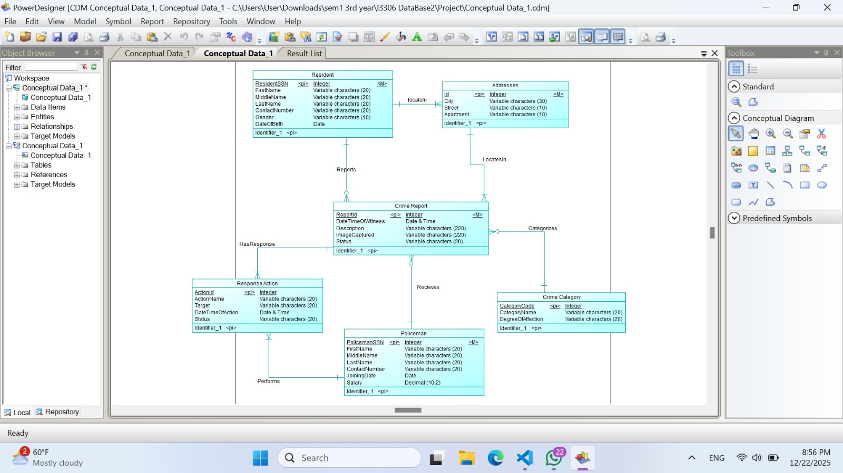

3.Mapping ERD to database schema

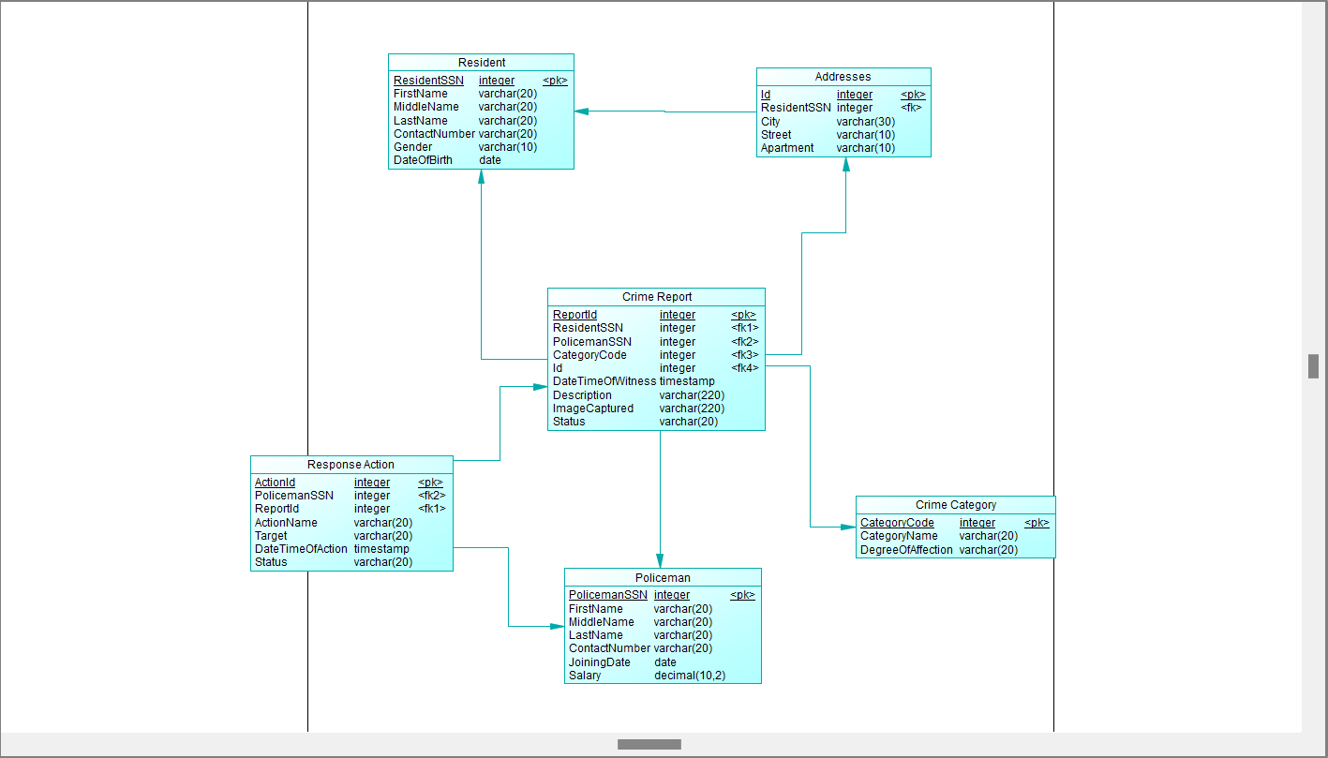

CHAPTER 3:

Services and Interface modeling

Login Page
The Login Page serves as the primary entry point to the Crime Reporting System, providing a secure authentication interface where users enter their username and password credentials to access the system. Upon successful authentication, the system validates the user's credentials against the database and redirects them to their role-specific dashboard (Admin Dashboard, Resident Portal, Policeman Dashboard, or Supervisor Dashboard) based on their assigned permissions and authority level.
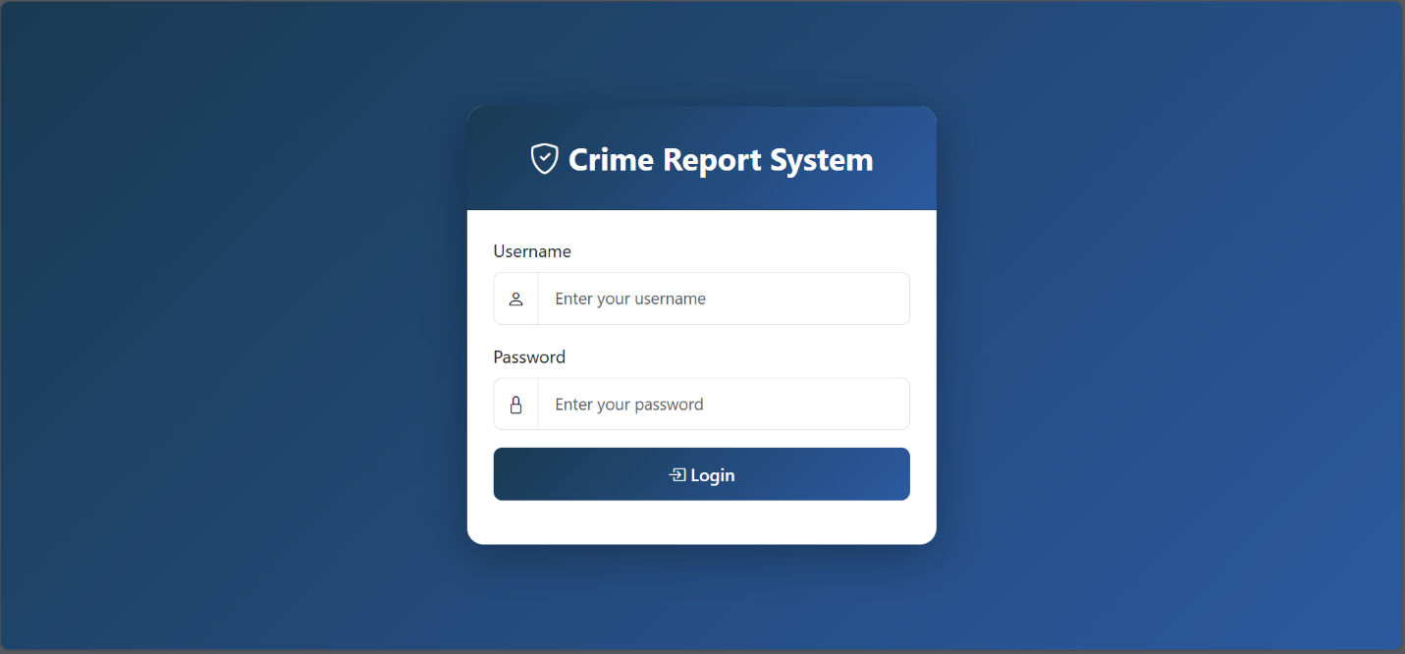

Admin Dashboard
The Admin Dashboard displays the logged-in administrator’s username with a logout option and includes statistical cards showing system activity. It also provides a Reports Management section that allows administrators to view all crime reports in the system and fully manage them by editing, updating, or deleting records with complete administrative privileges.
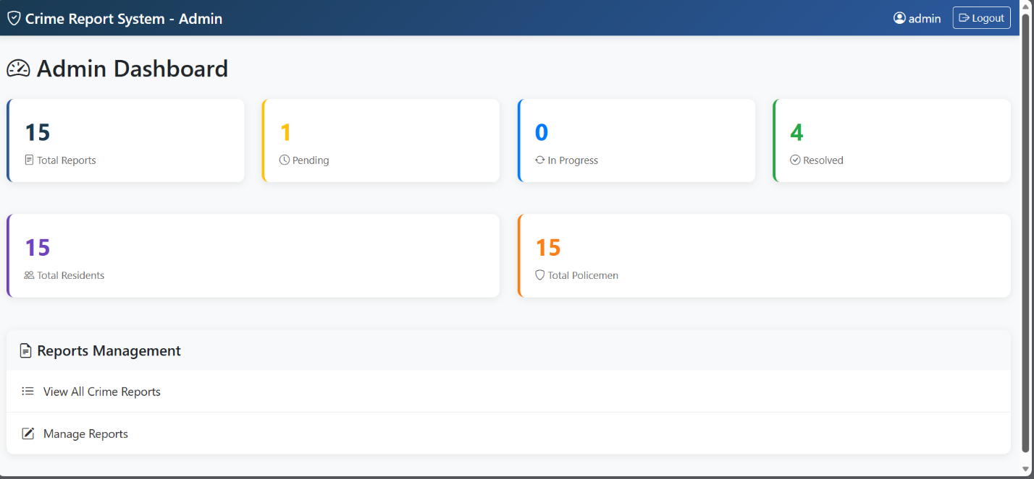
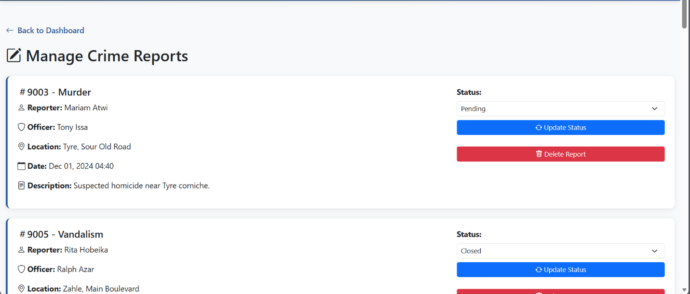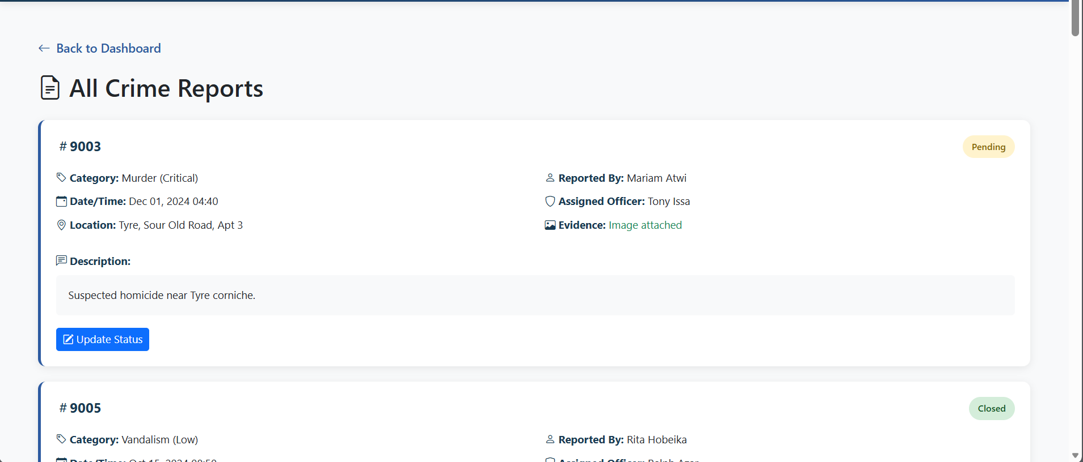

Resident Dashboard:
The Resident Portal displays with the logged-in resident’s username and a logout option. It and statistical cards showing the system activity.The portal provides core functionality through options to submit new crime reports with full details and evidence, as well as to view the complete history and current status of all reports submitted by the resident.
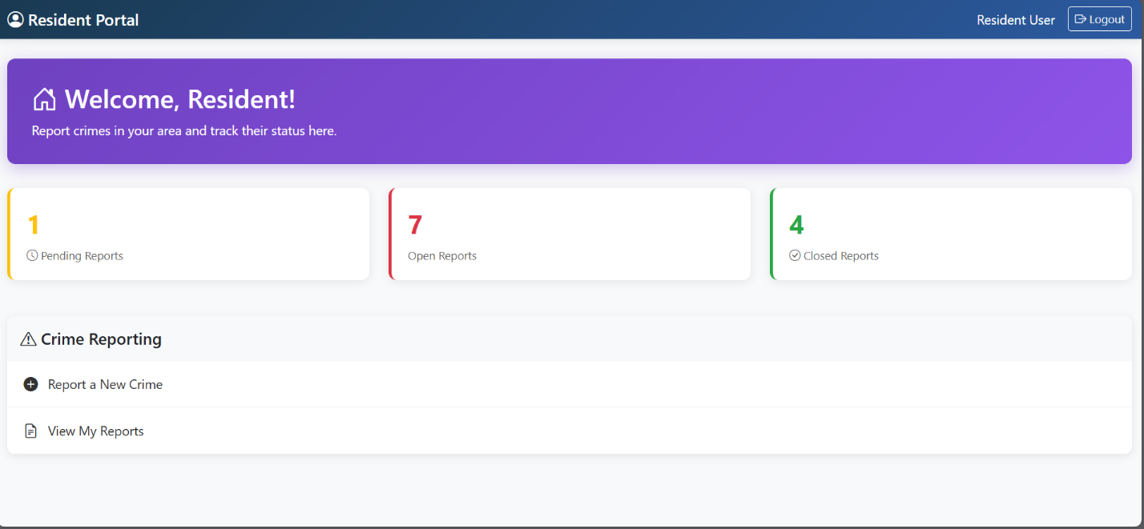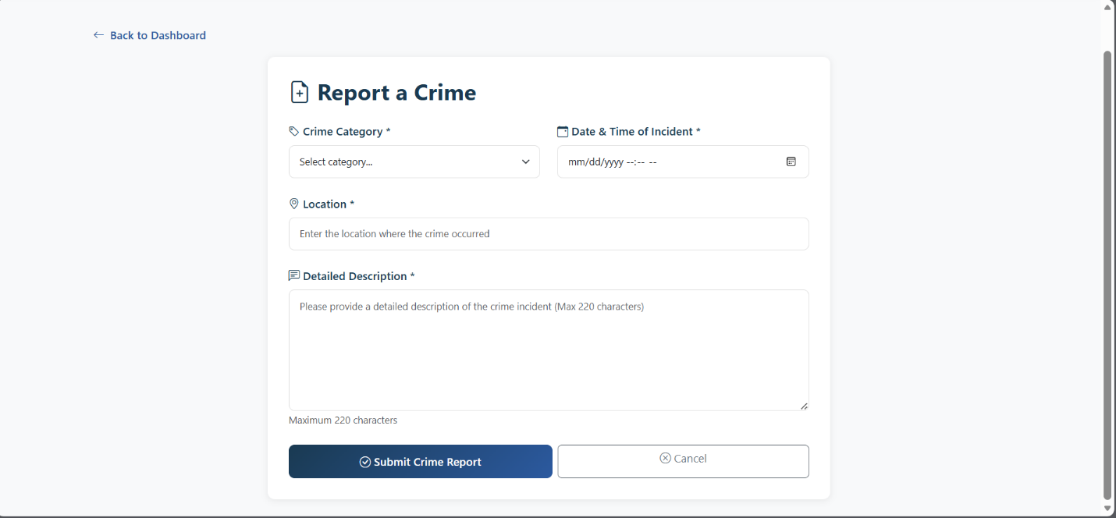
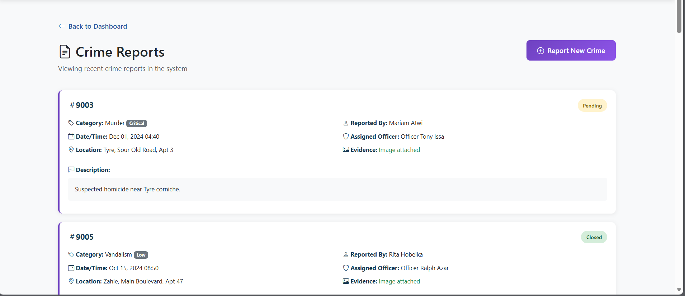

Policeman Dashboard:
The Policeman Dashboard displays logged-in officer’s name and a logout option. It includes statistical cards showing the system activity.The dashboard is organized into two main sections: Case Management, which allows officers to view assigned cases, access case details, and update case statuses, and Response Actions, which enables managing investigation actions, adding new actions, and reviewing action history.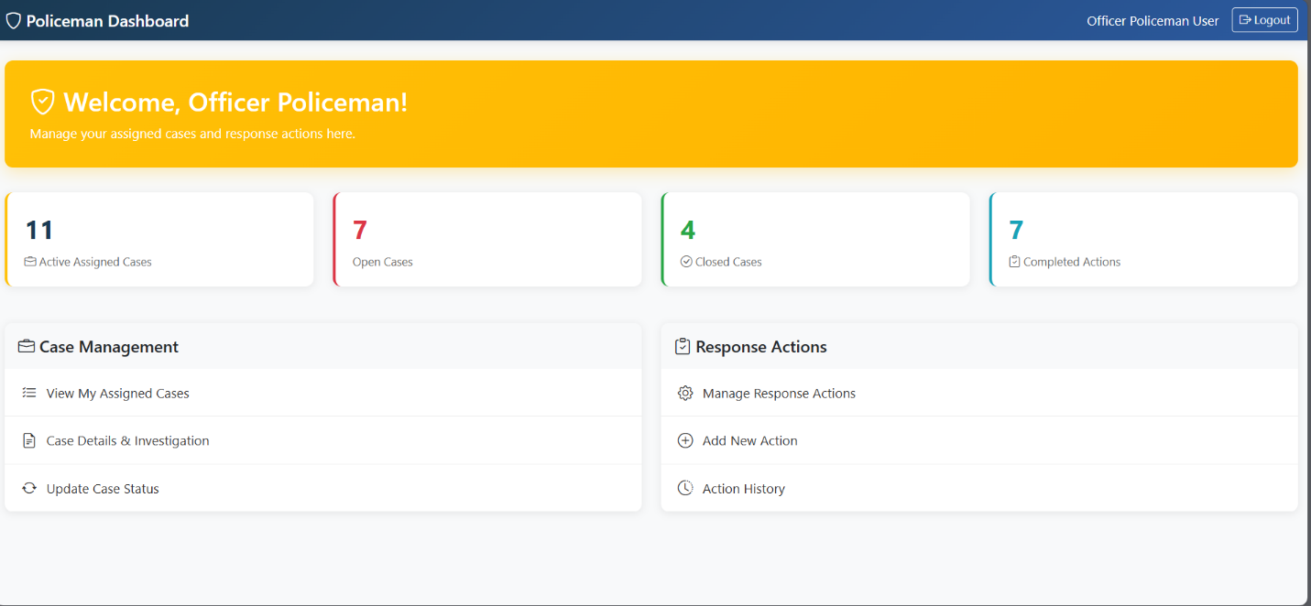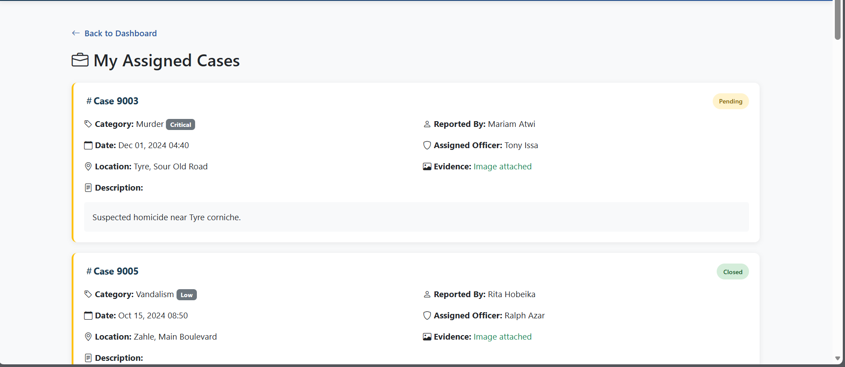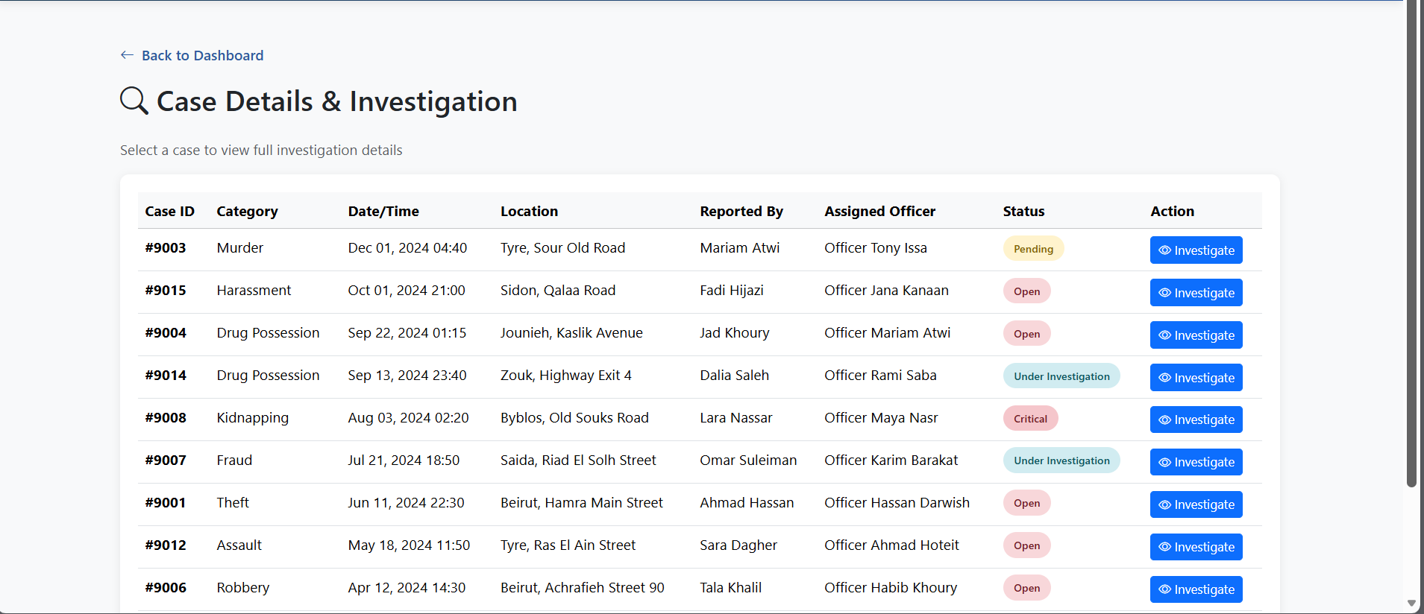
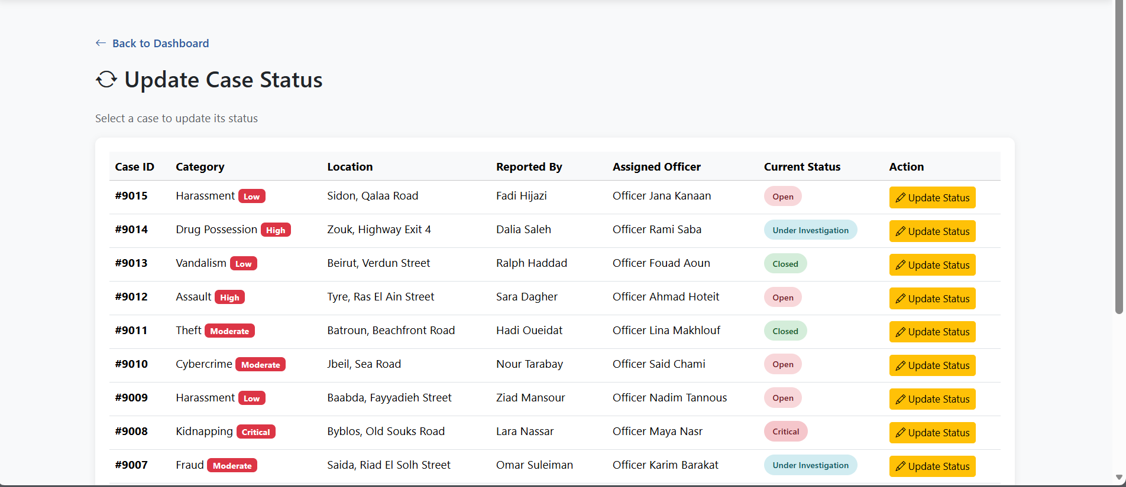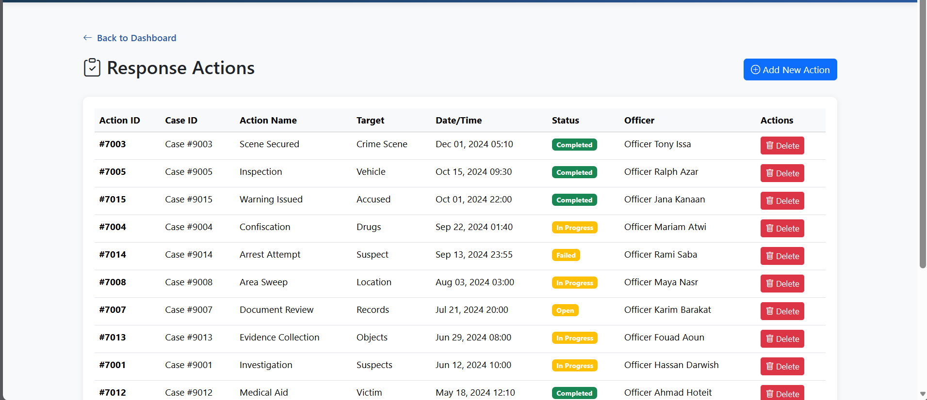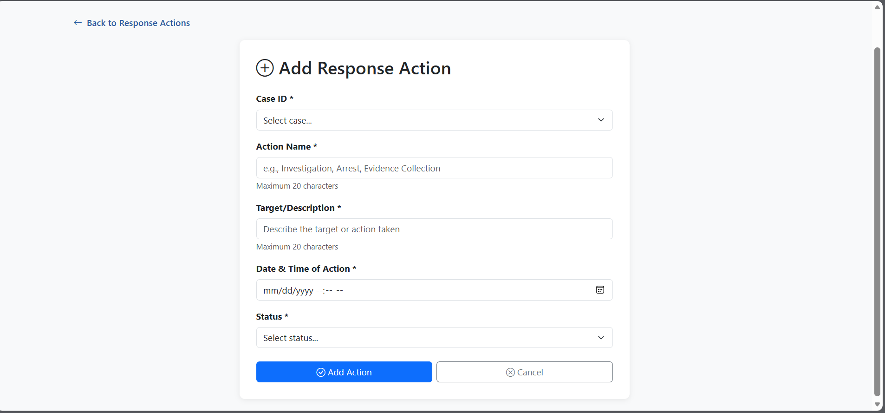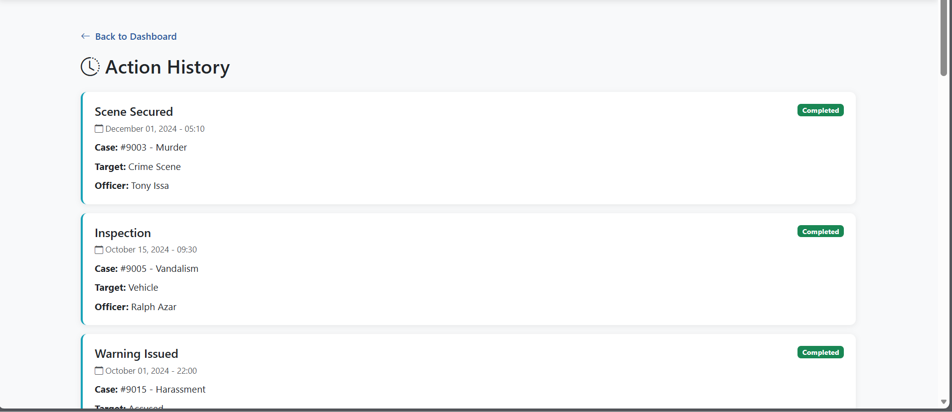

Supervisor Dashboard:
The Supervisor Dashboard displays the logged-in supervisor’s username and a logout option. It shows statistical cards providing system activity. The dashboard includes a Report Management section that allows supervisors to review all crime reports across the system and assign cases to police officers based on availability and workload.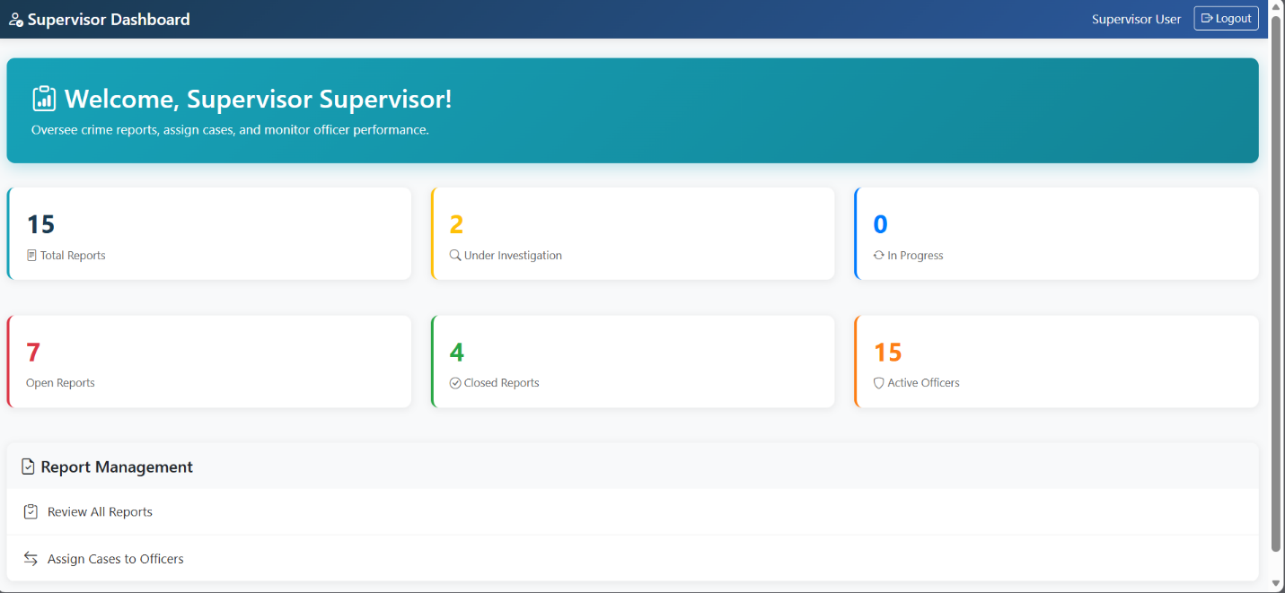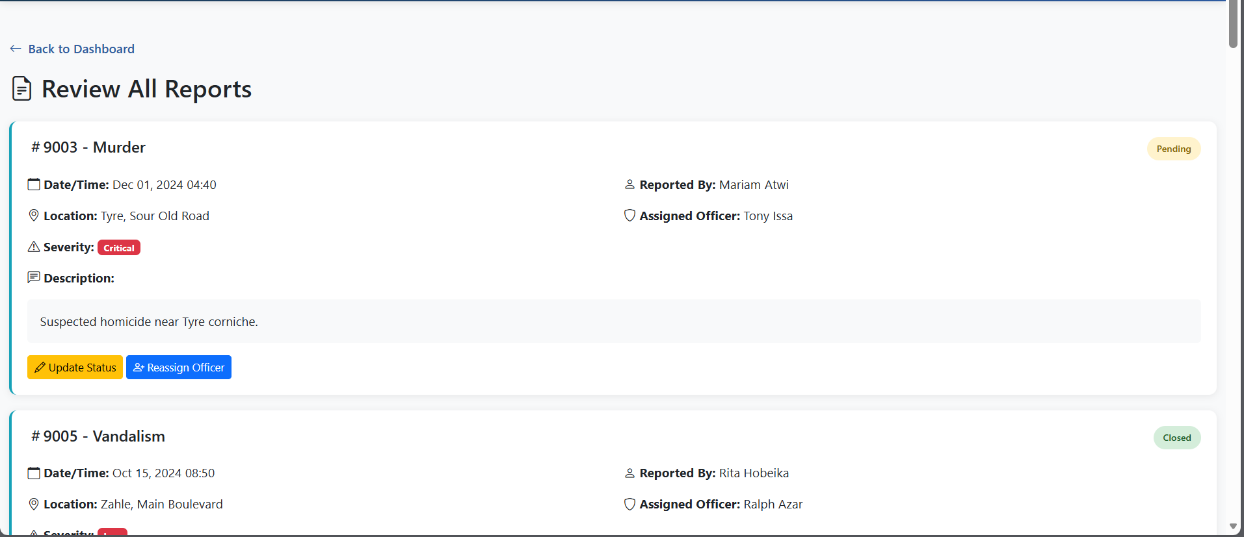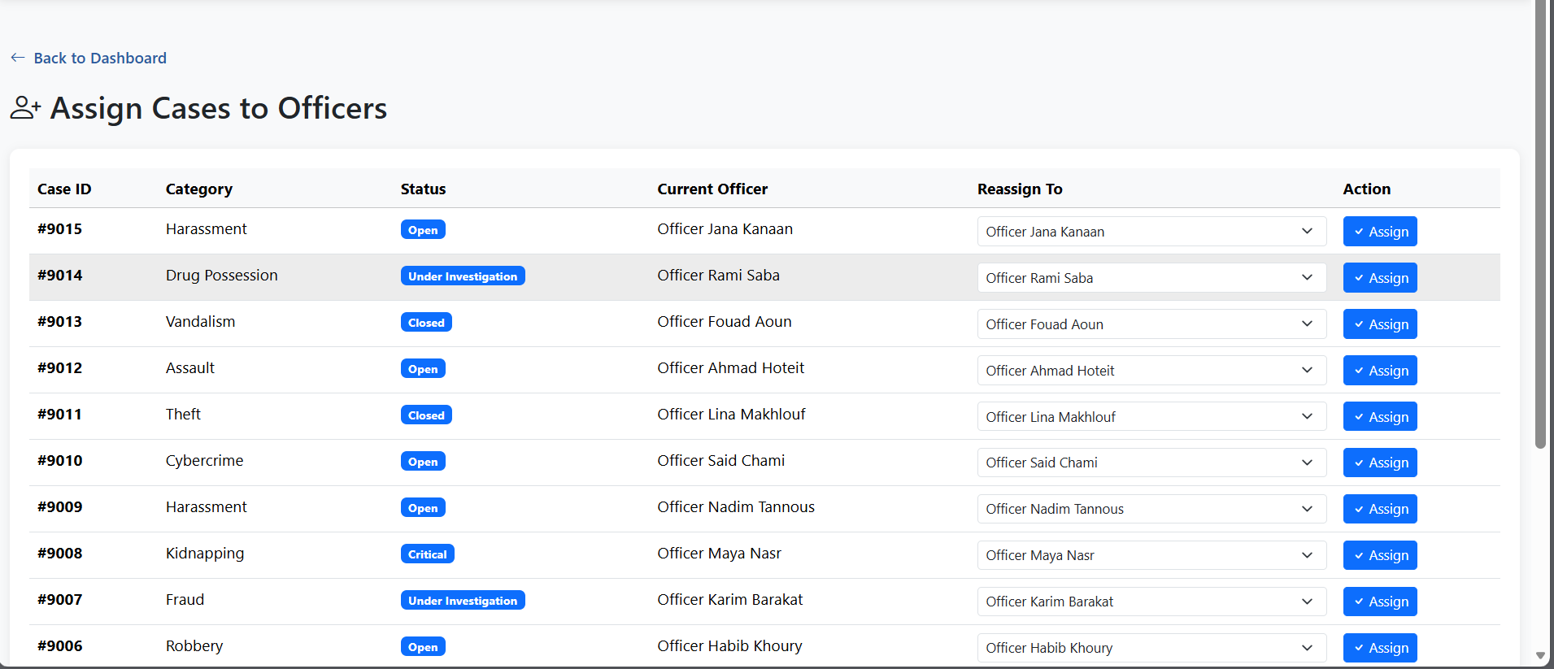

CHAPTER 4:

Application Implementation and testing

Connect To Database:

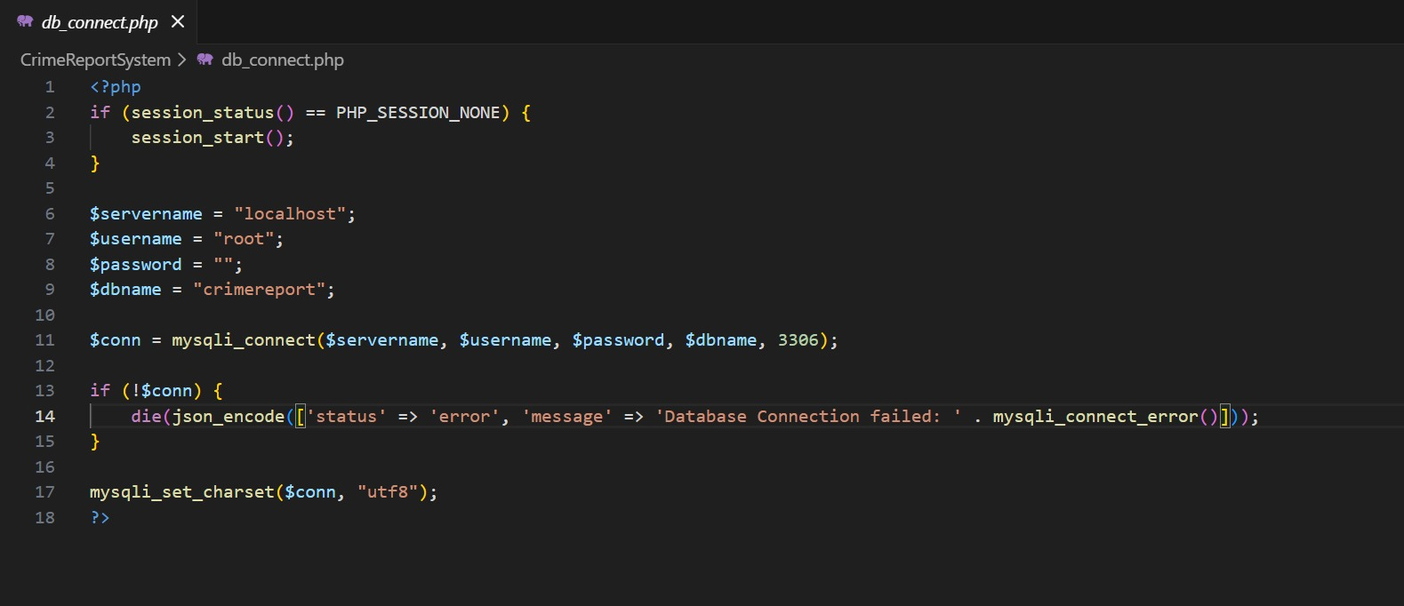

Create Database:

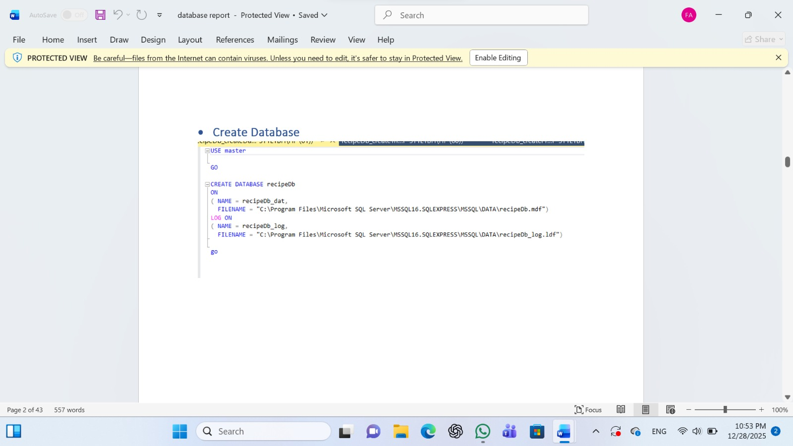

DDL scripts

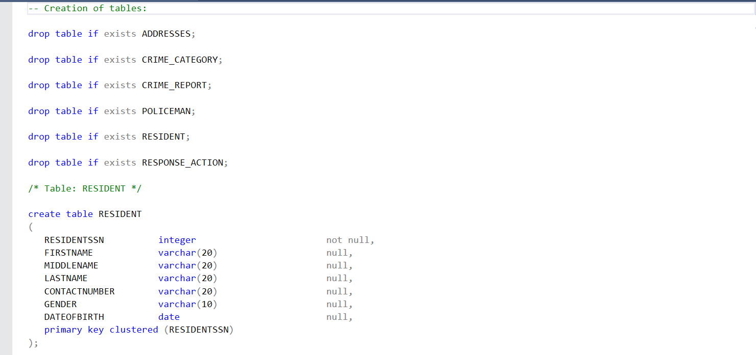
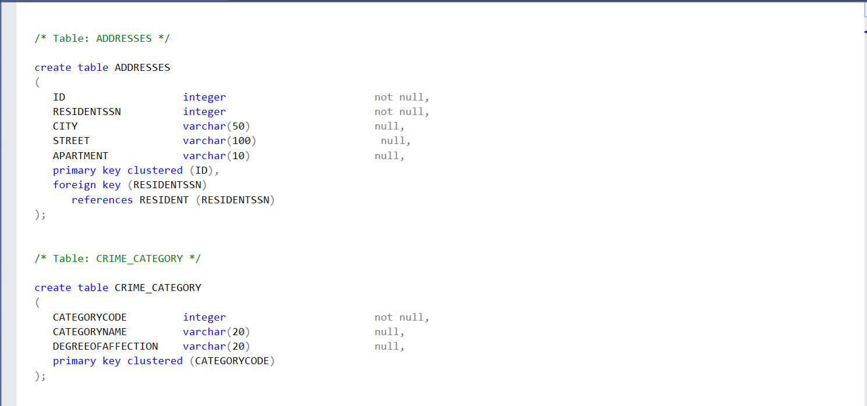

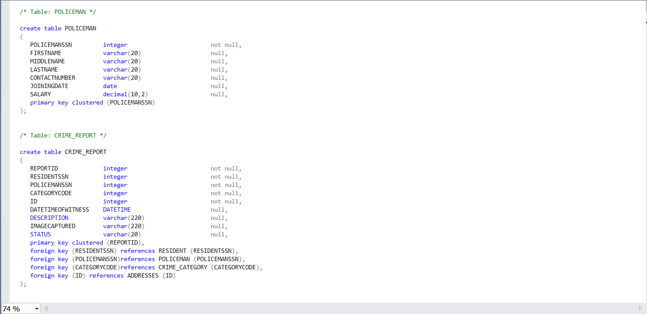

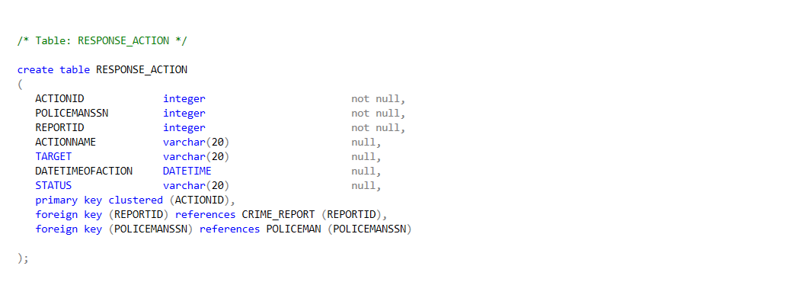
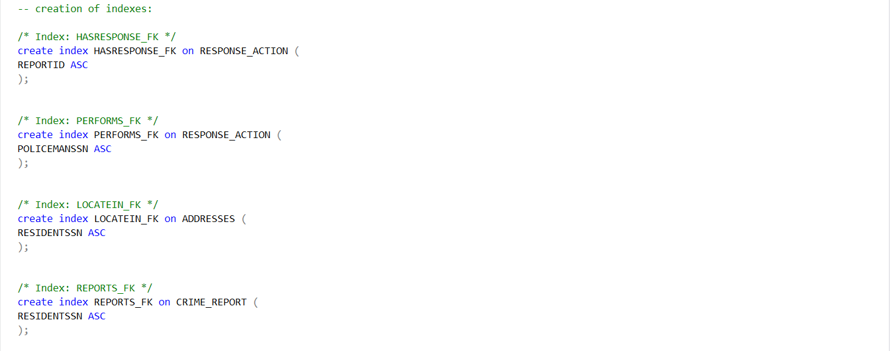

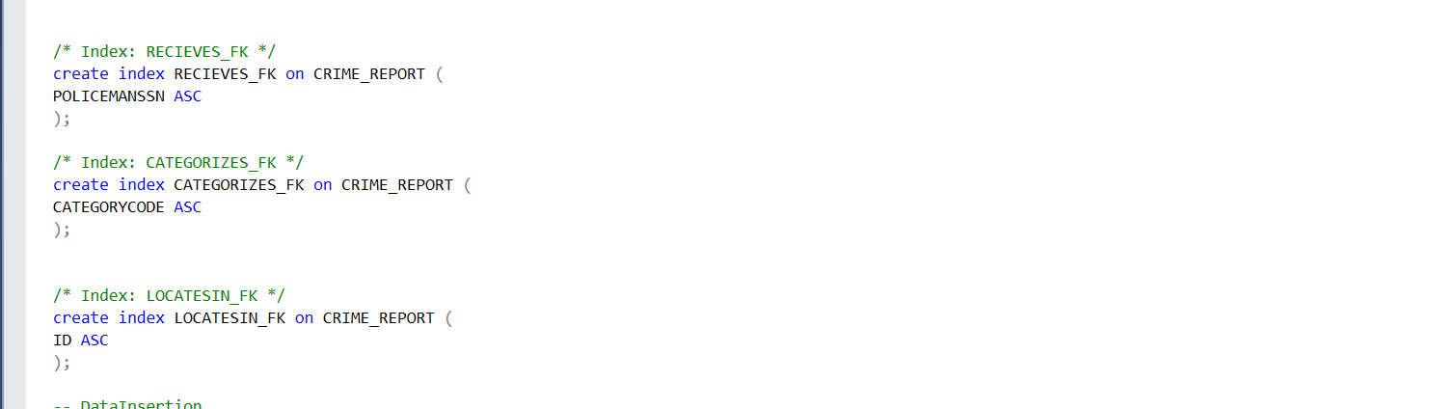

2.DML scripts

Data insertions:

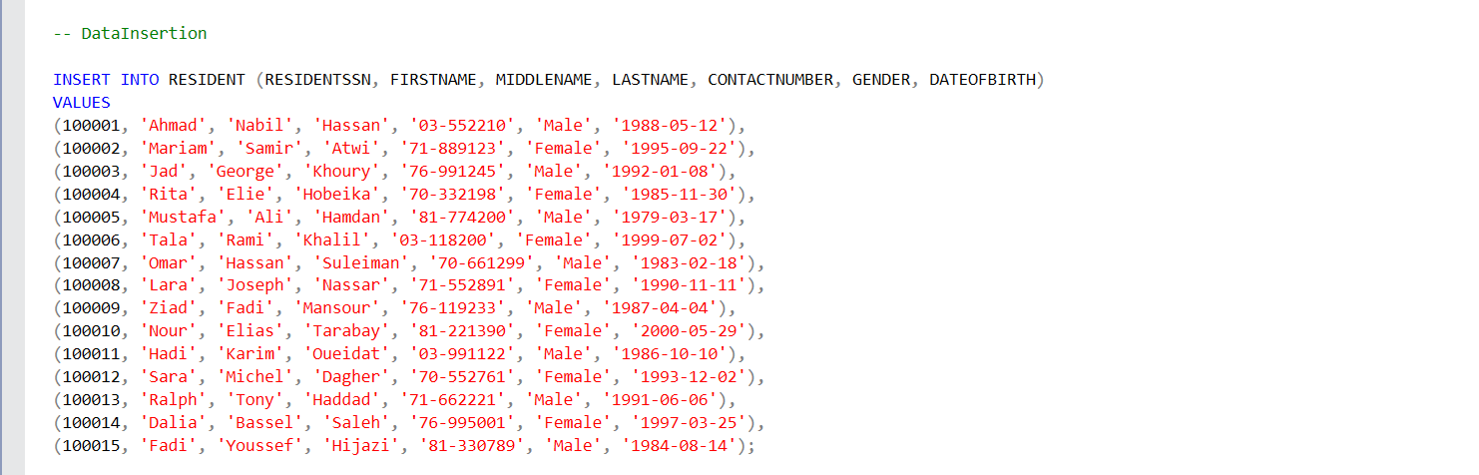
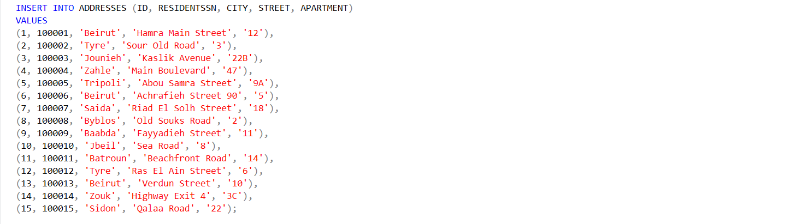
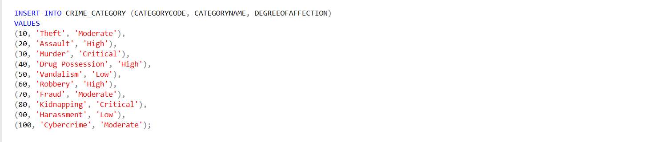

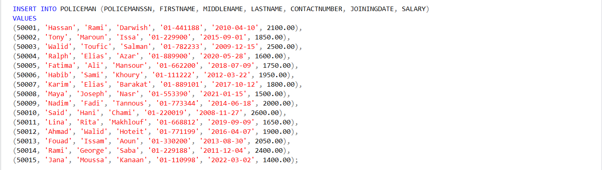
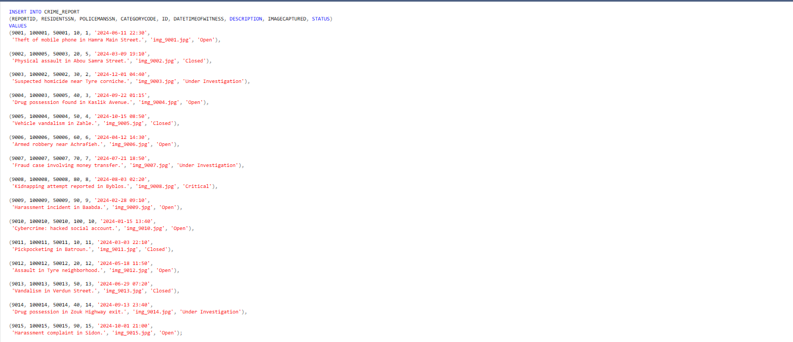

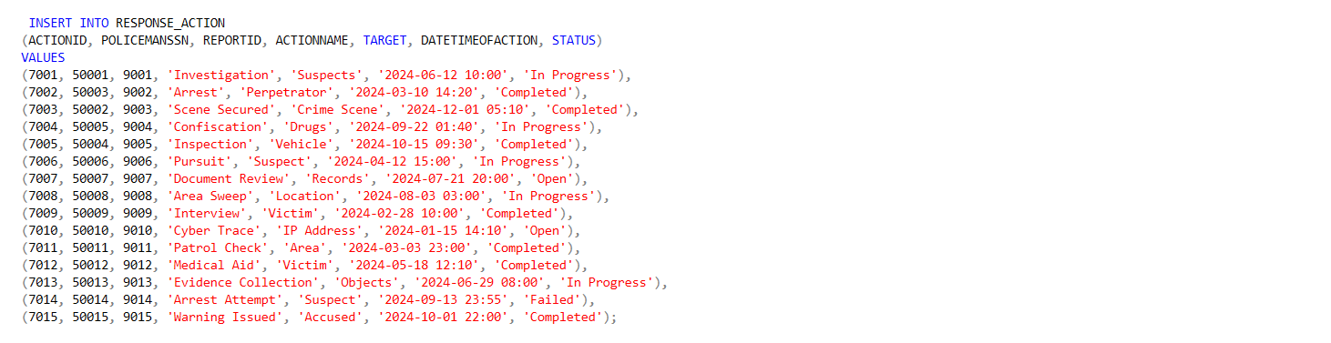

1.Set of relevant extractions – queries:

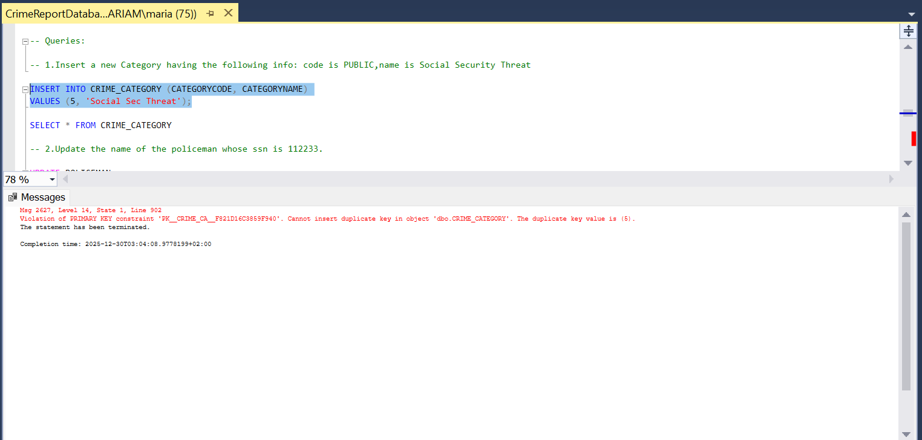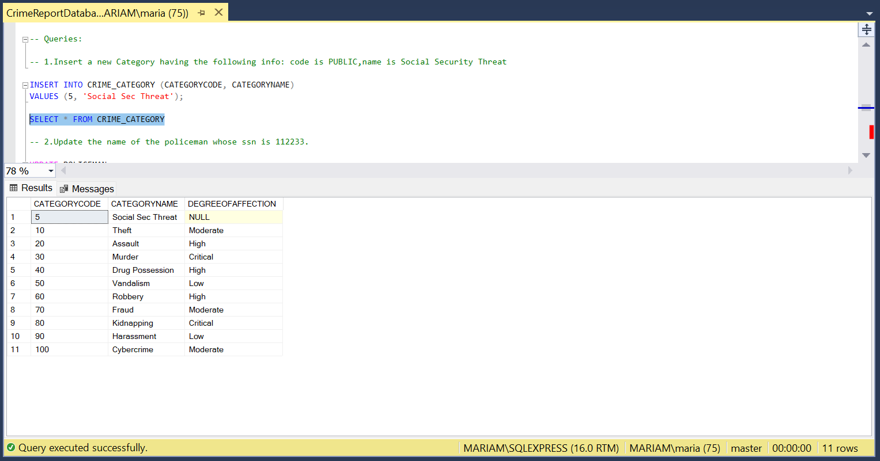
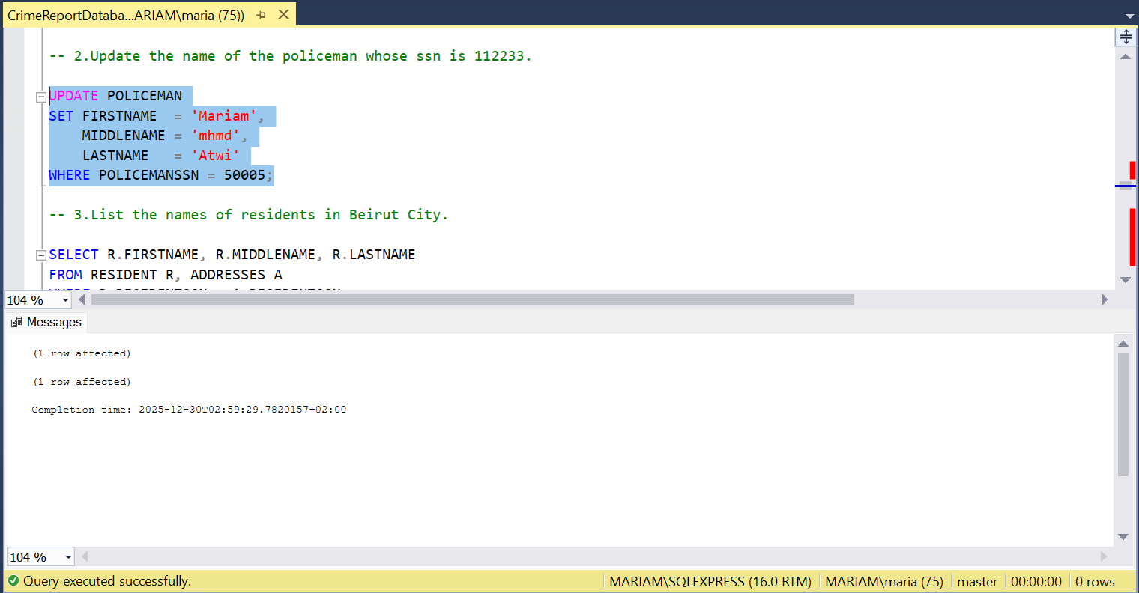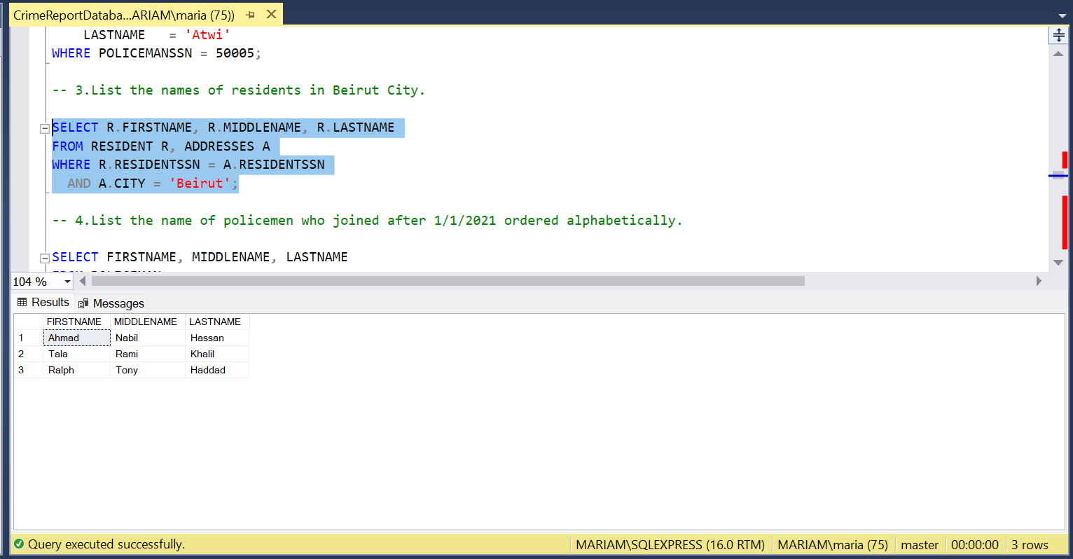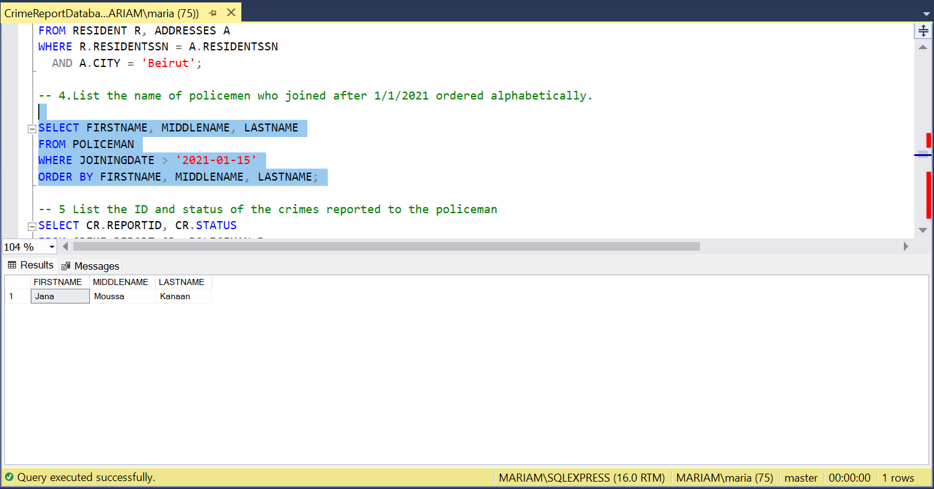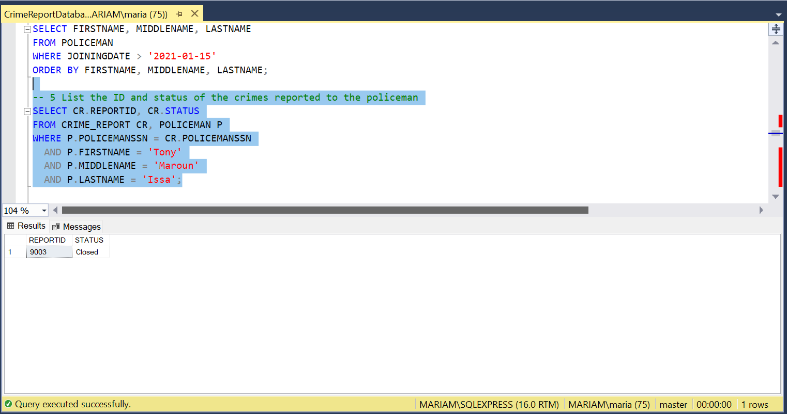
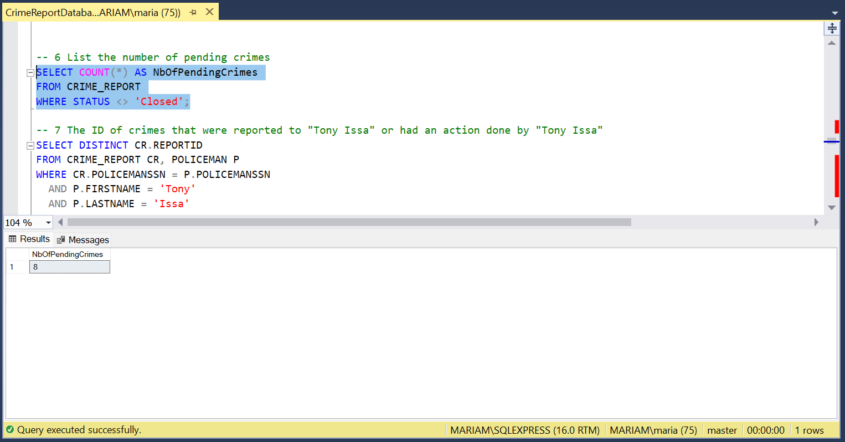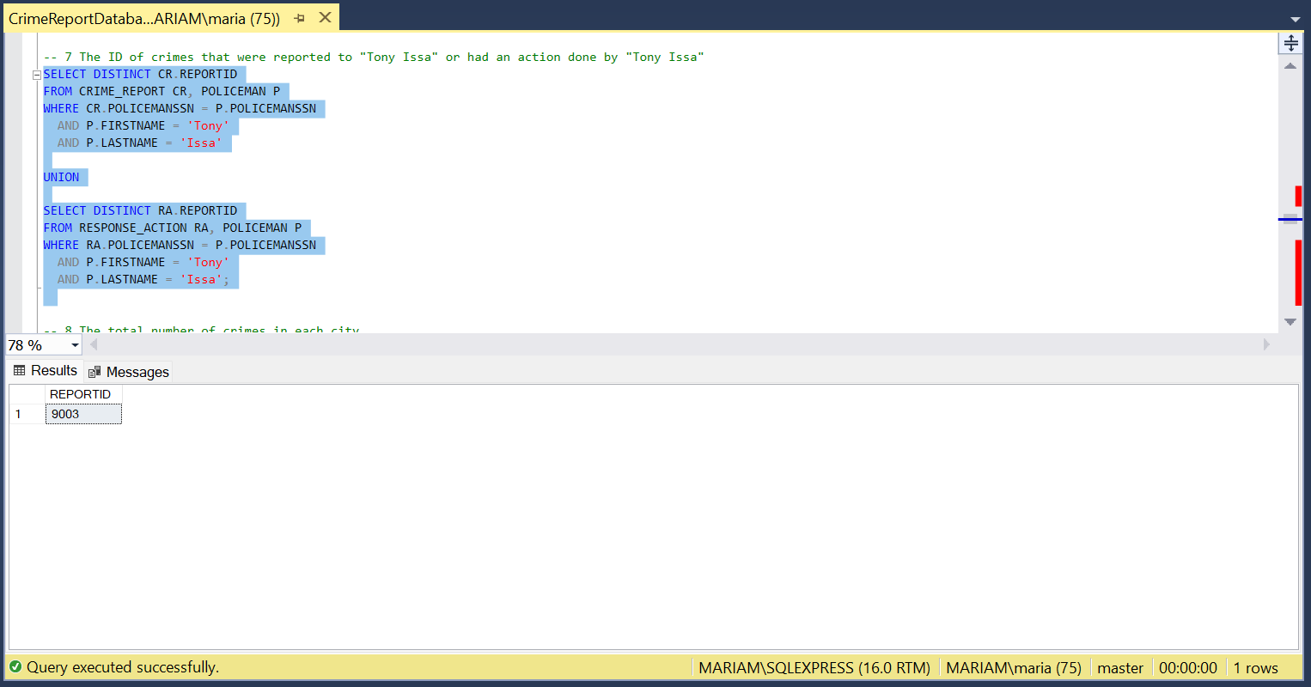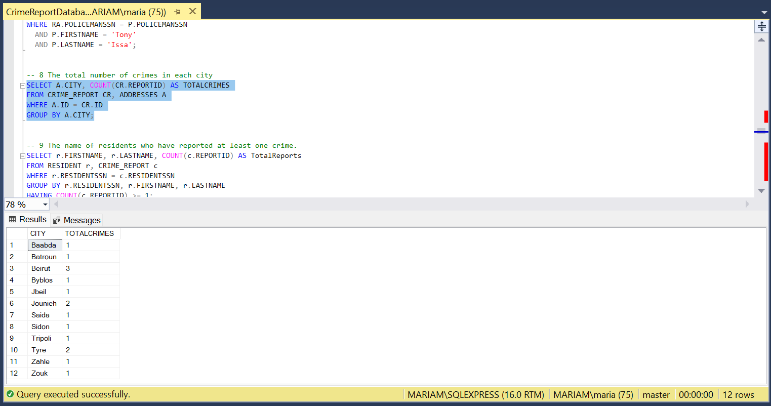
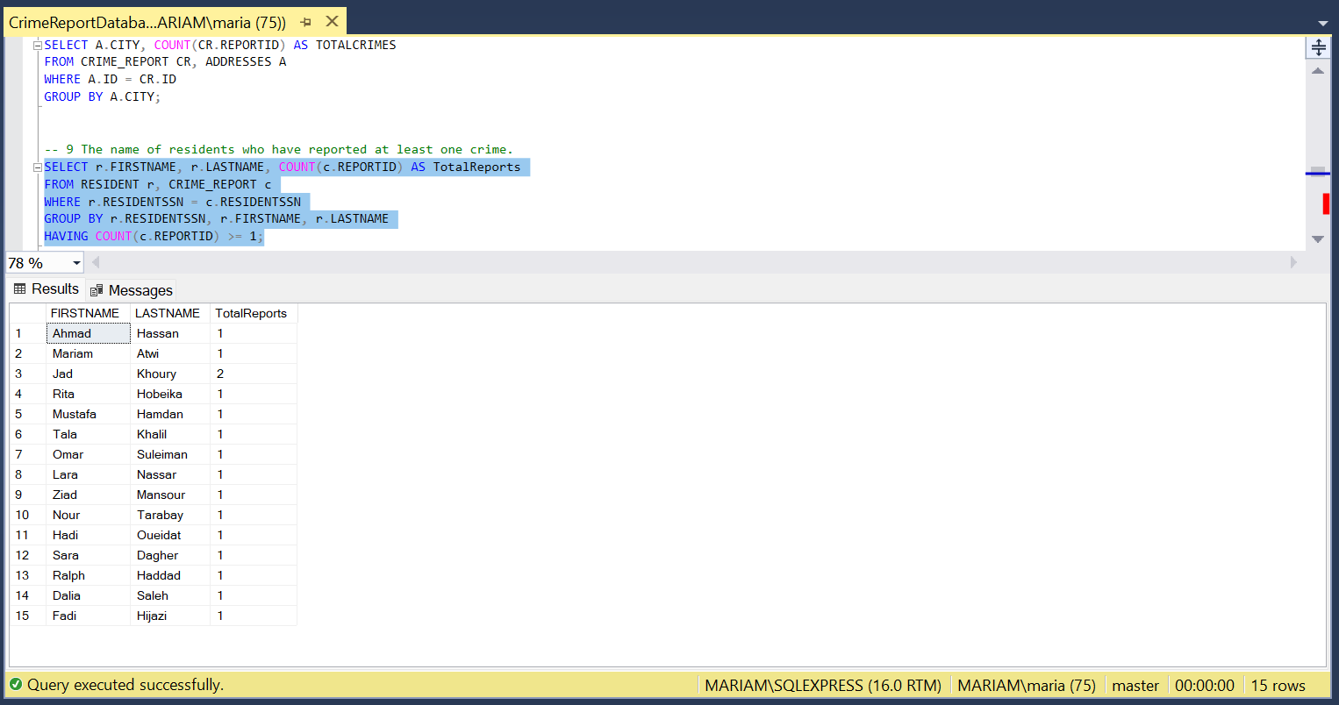
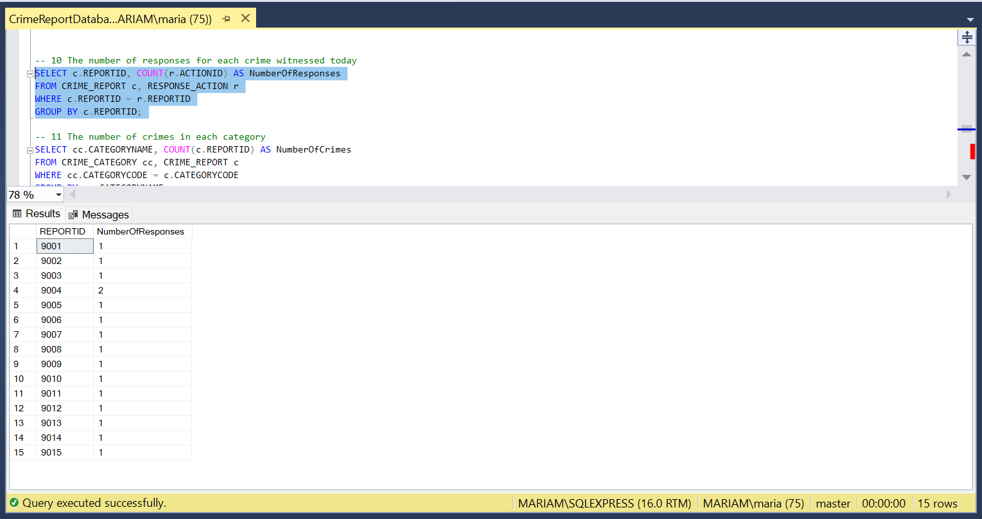
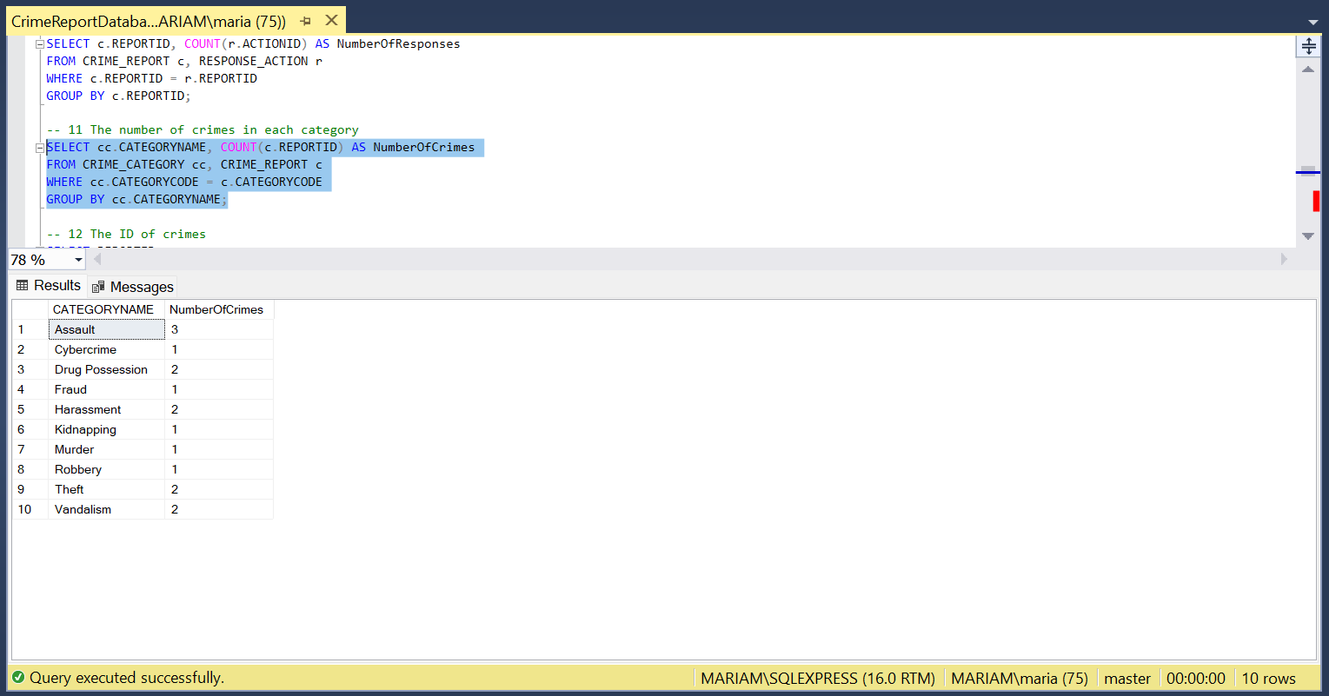
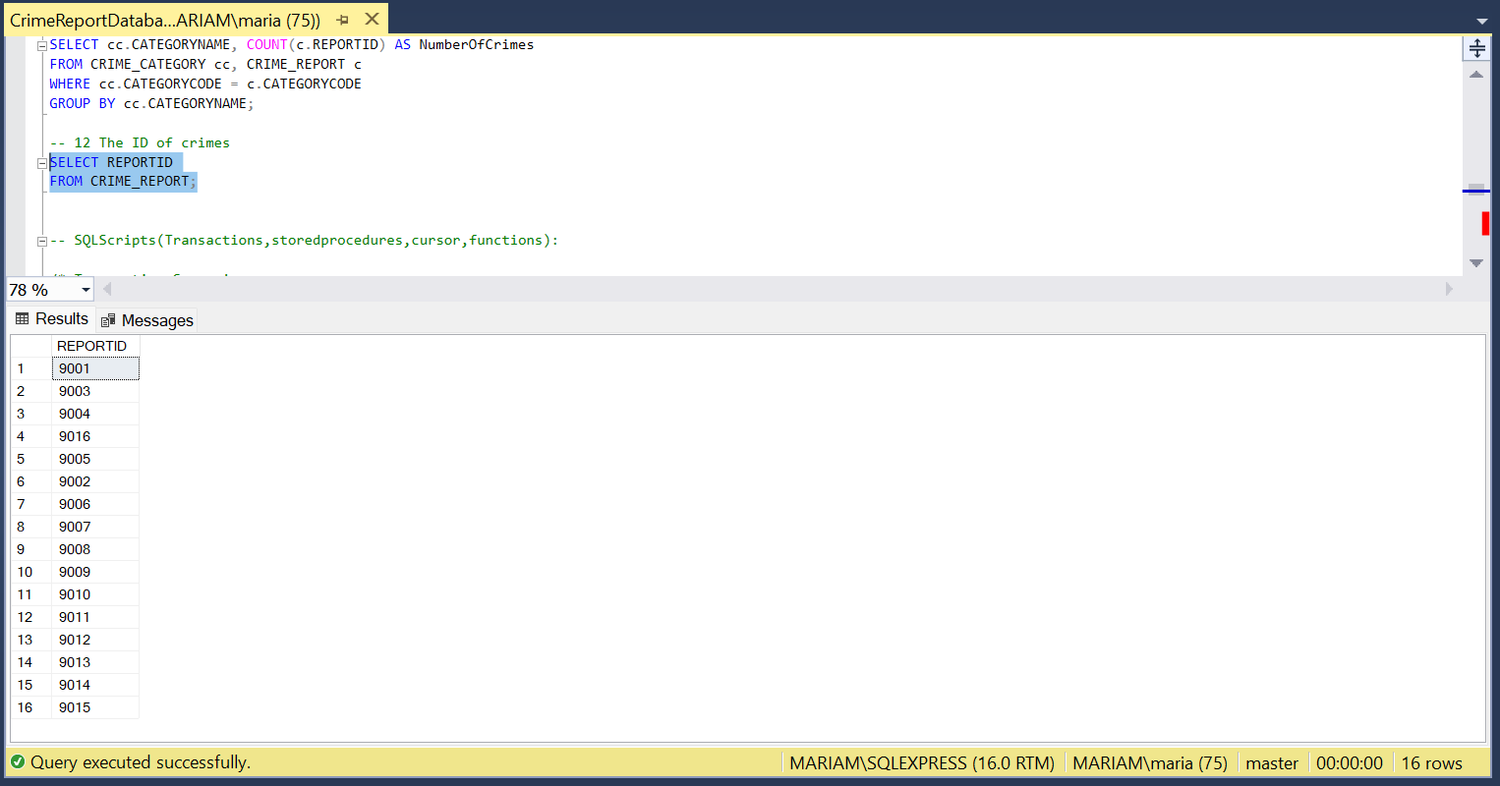

Create Procedure, Functions,Transactions and Declare Cursors

Create stored procedures:

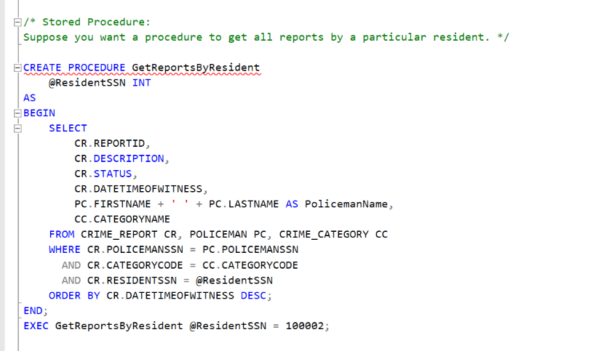

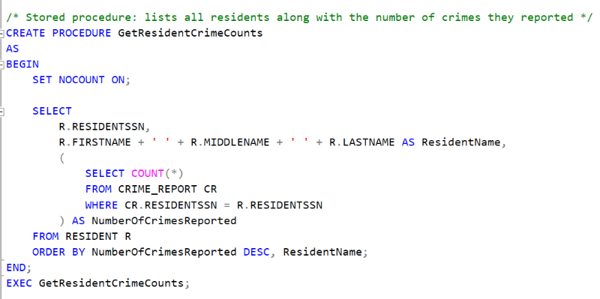

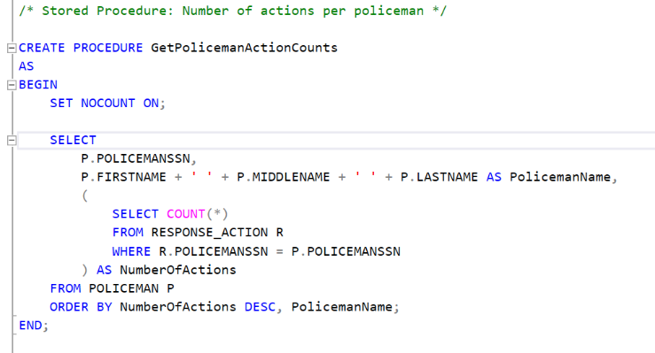

Functions:
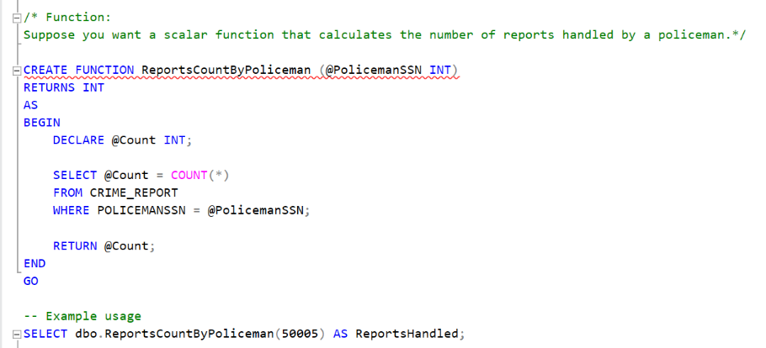
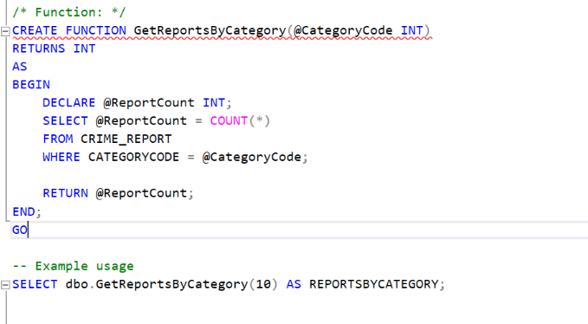

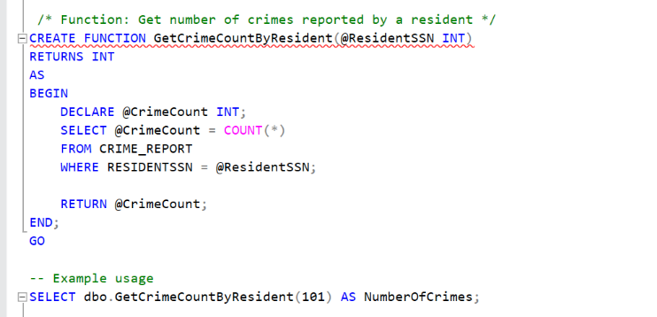

Transactions:
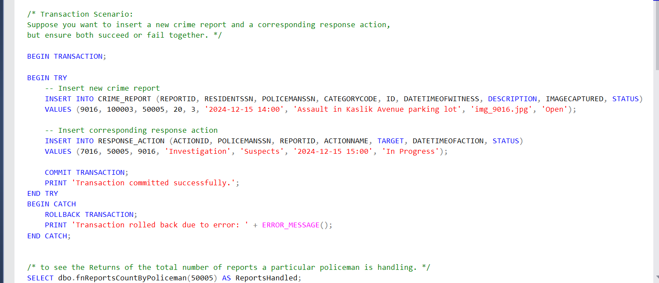
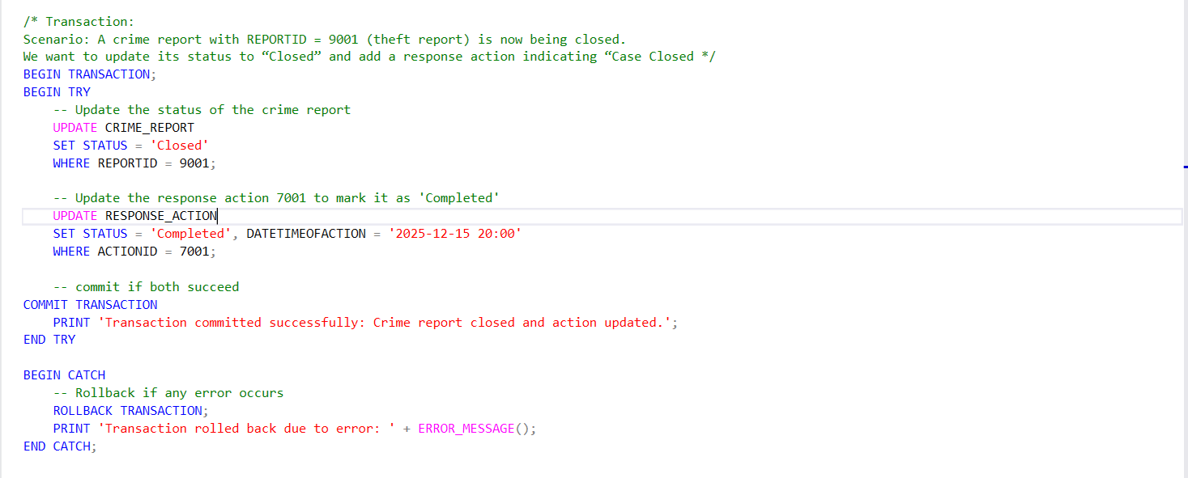

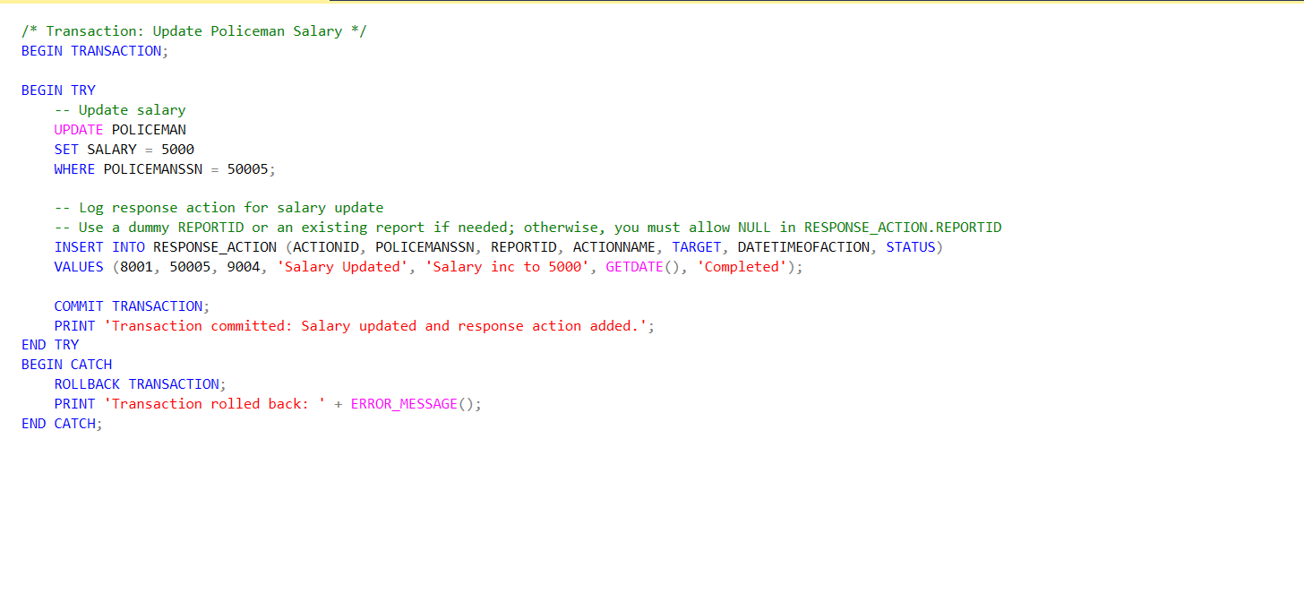

Cursors: 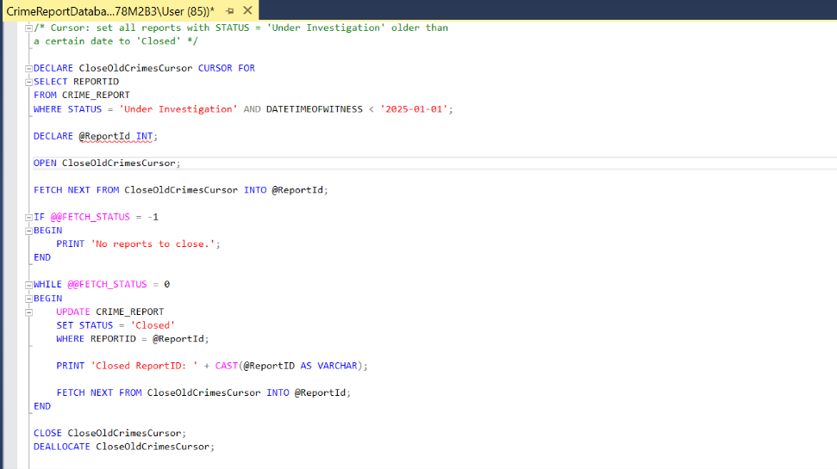
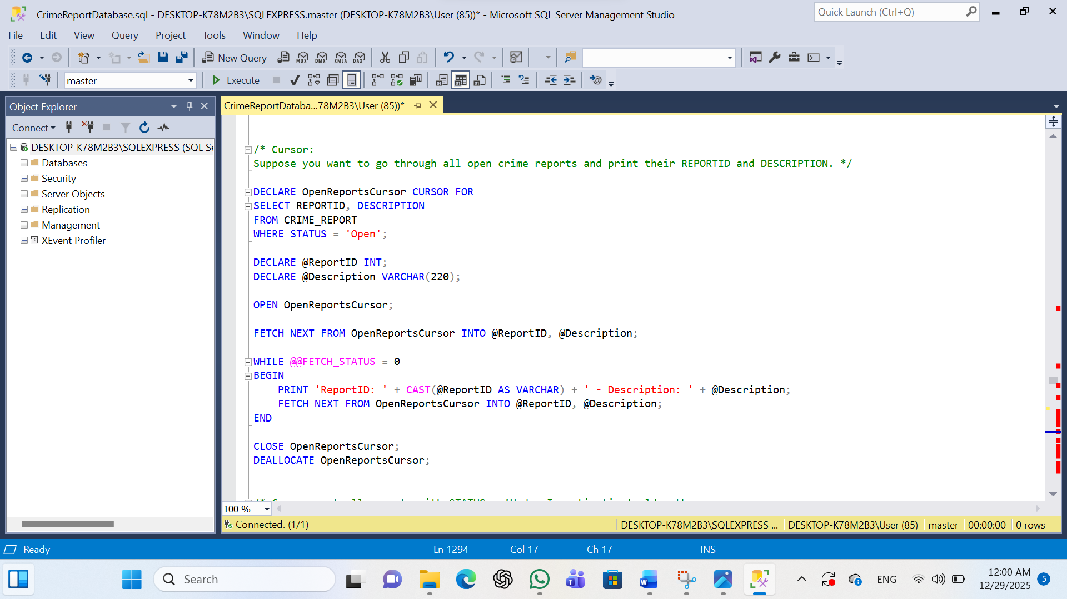
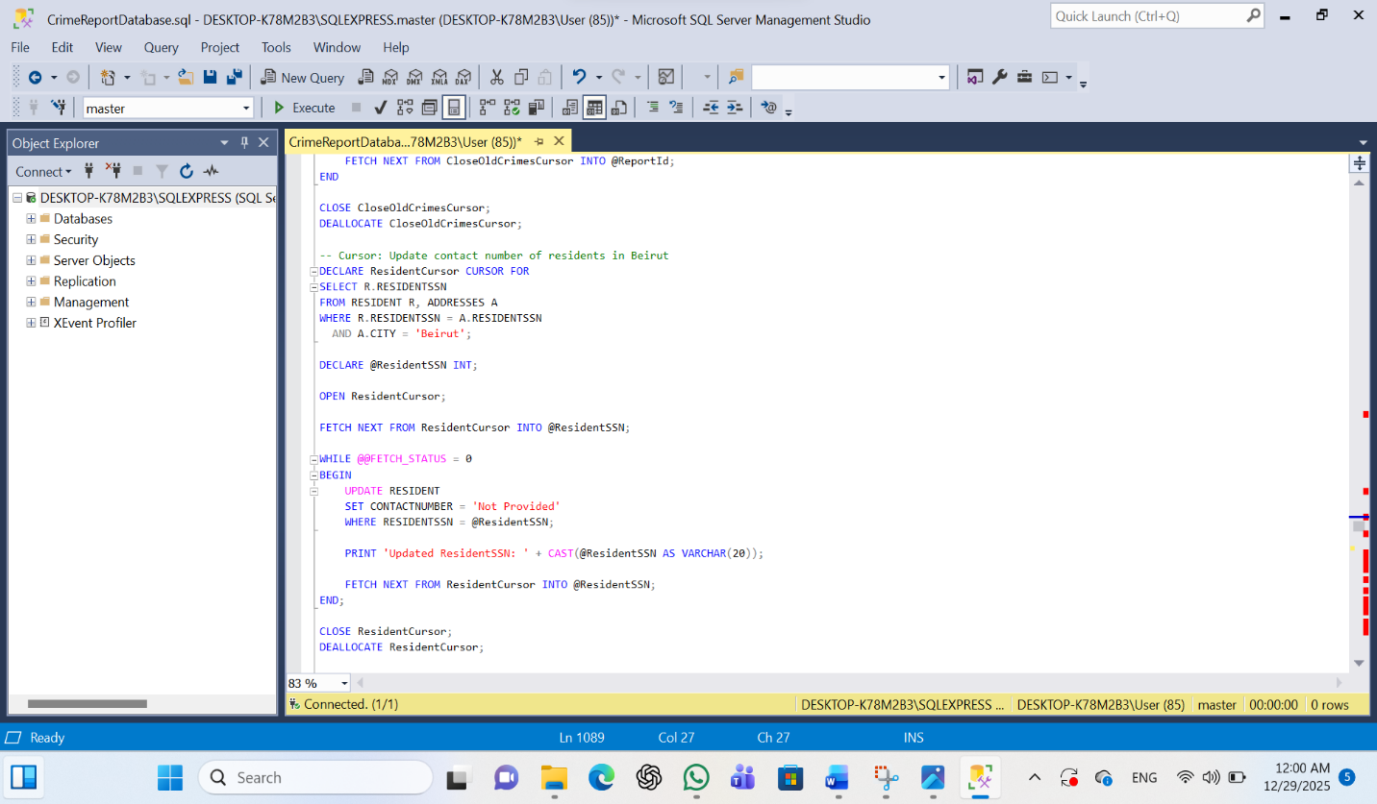

Create Views:

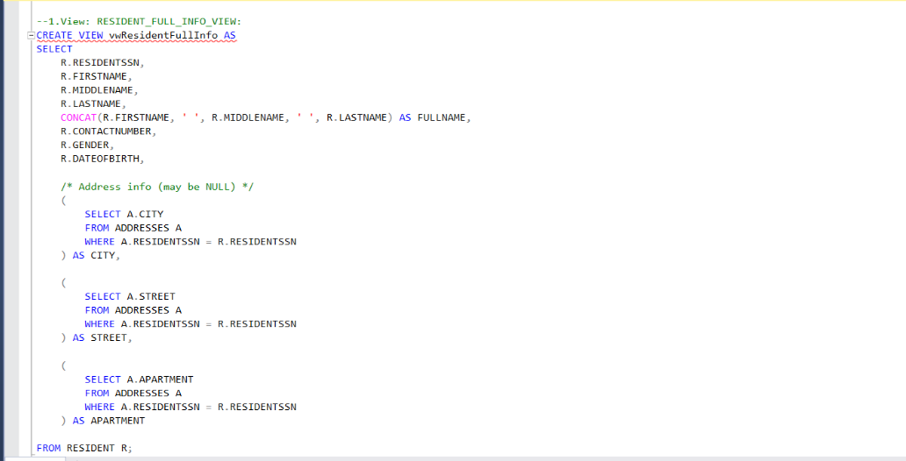
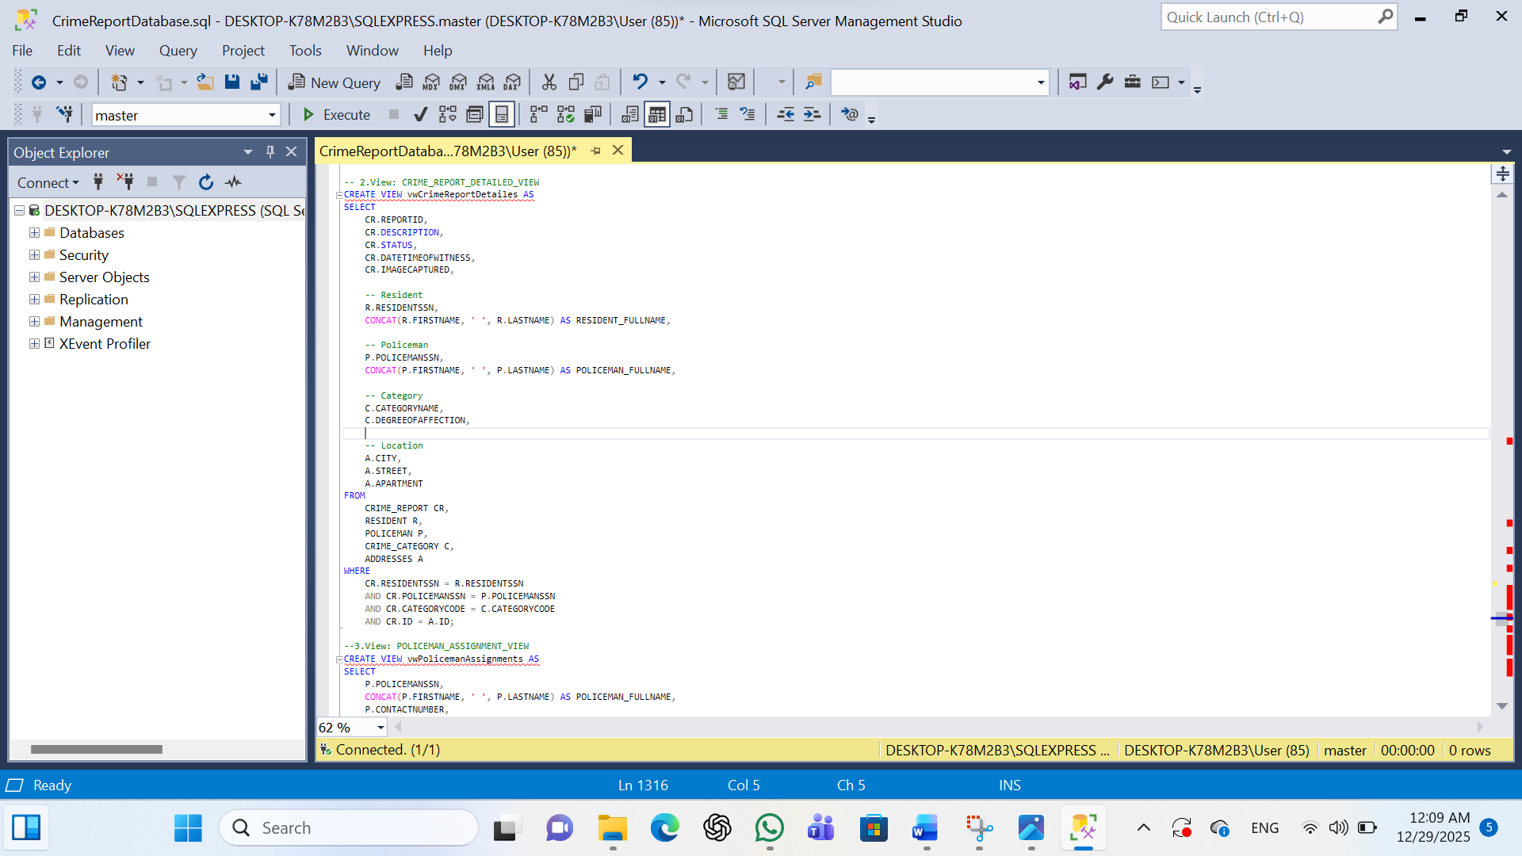
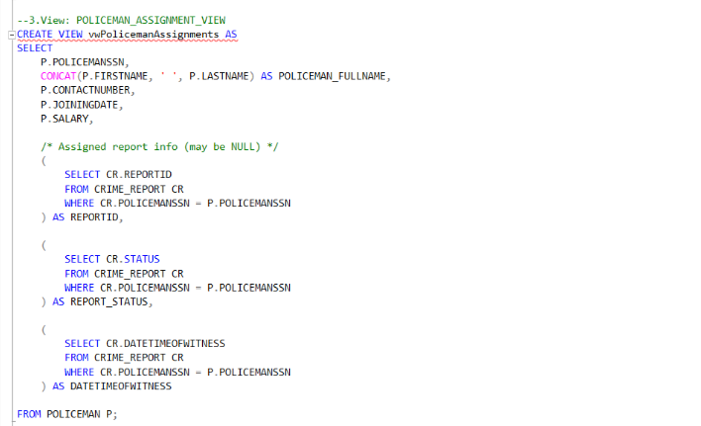

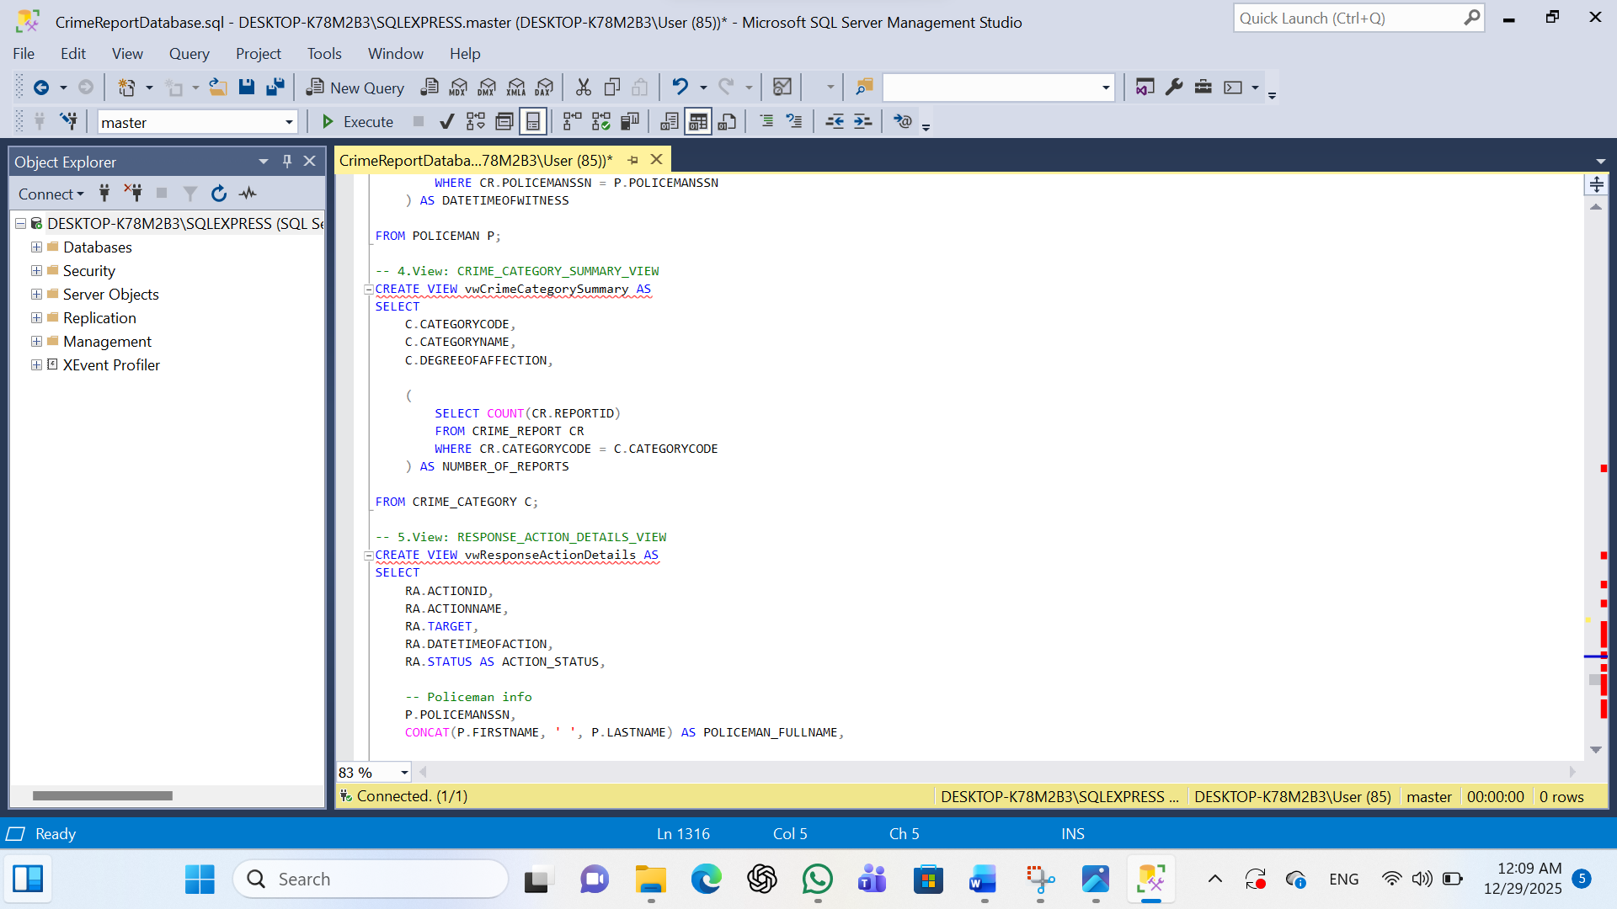

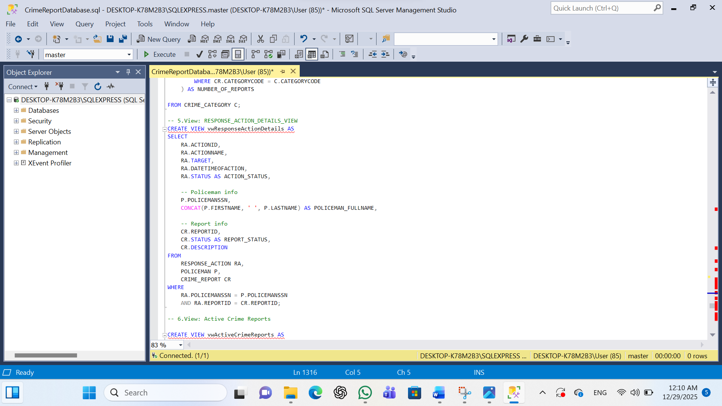
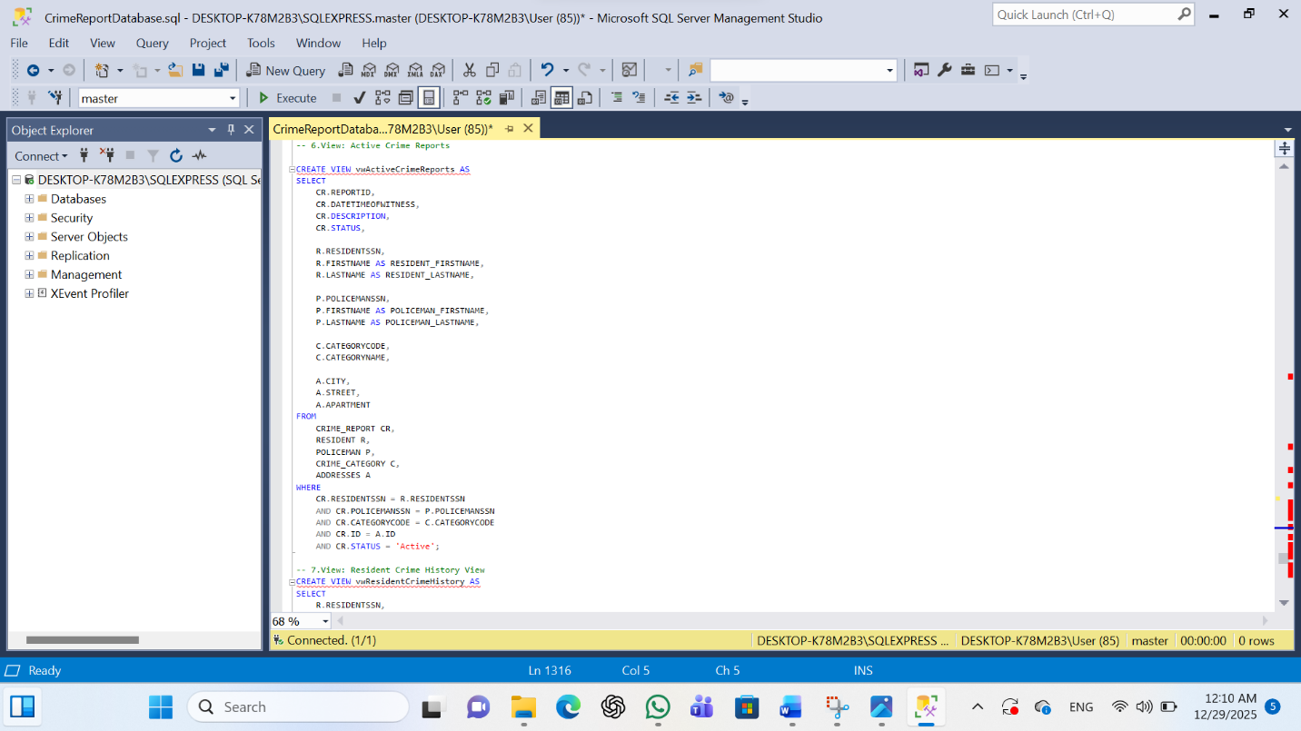

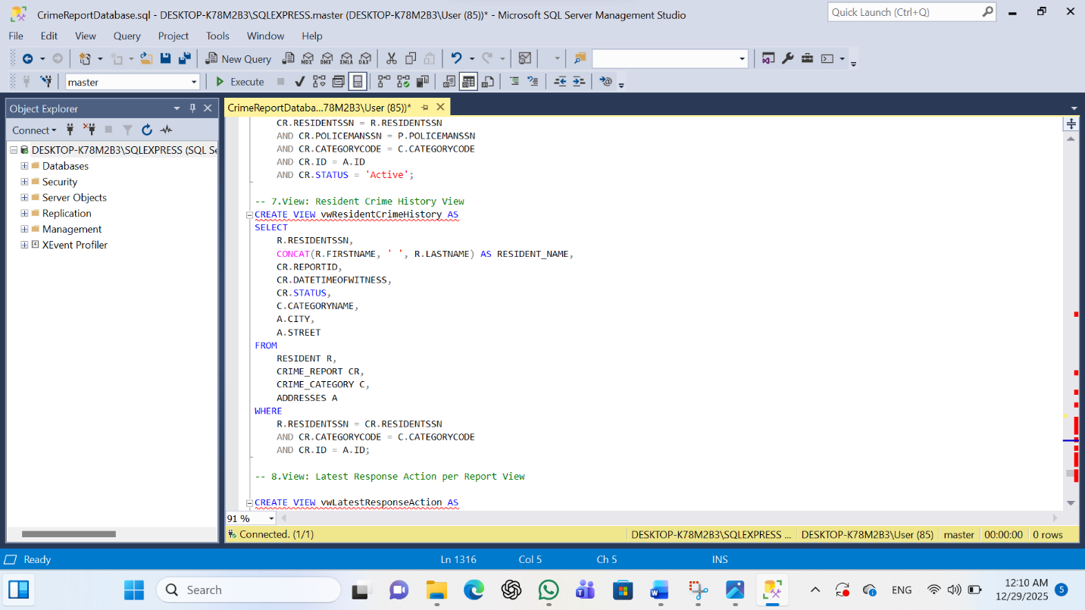

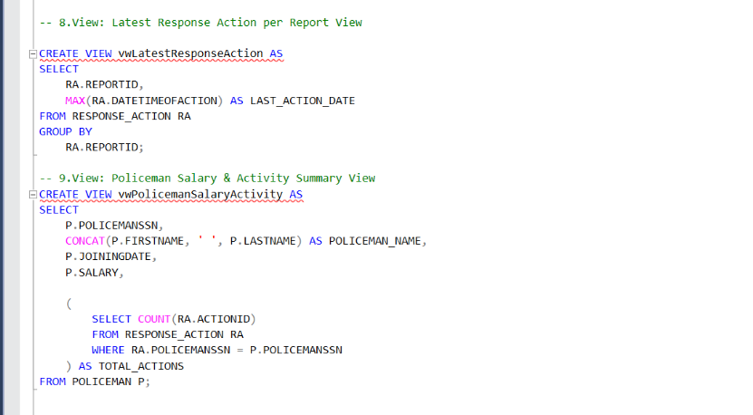

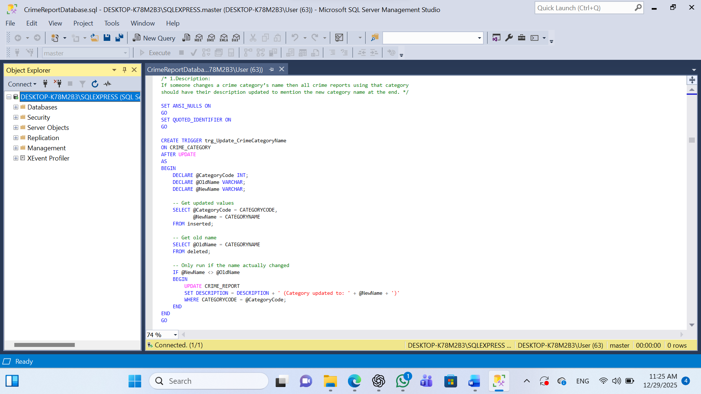
Create Triggers:

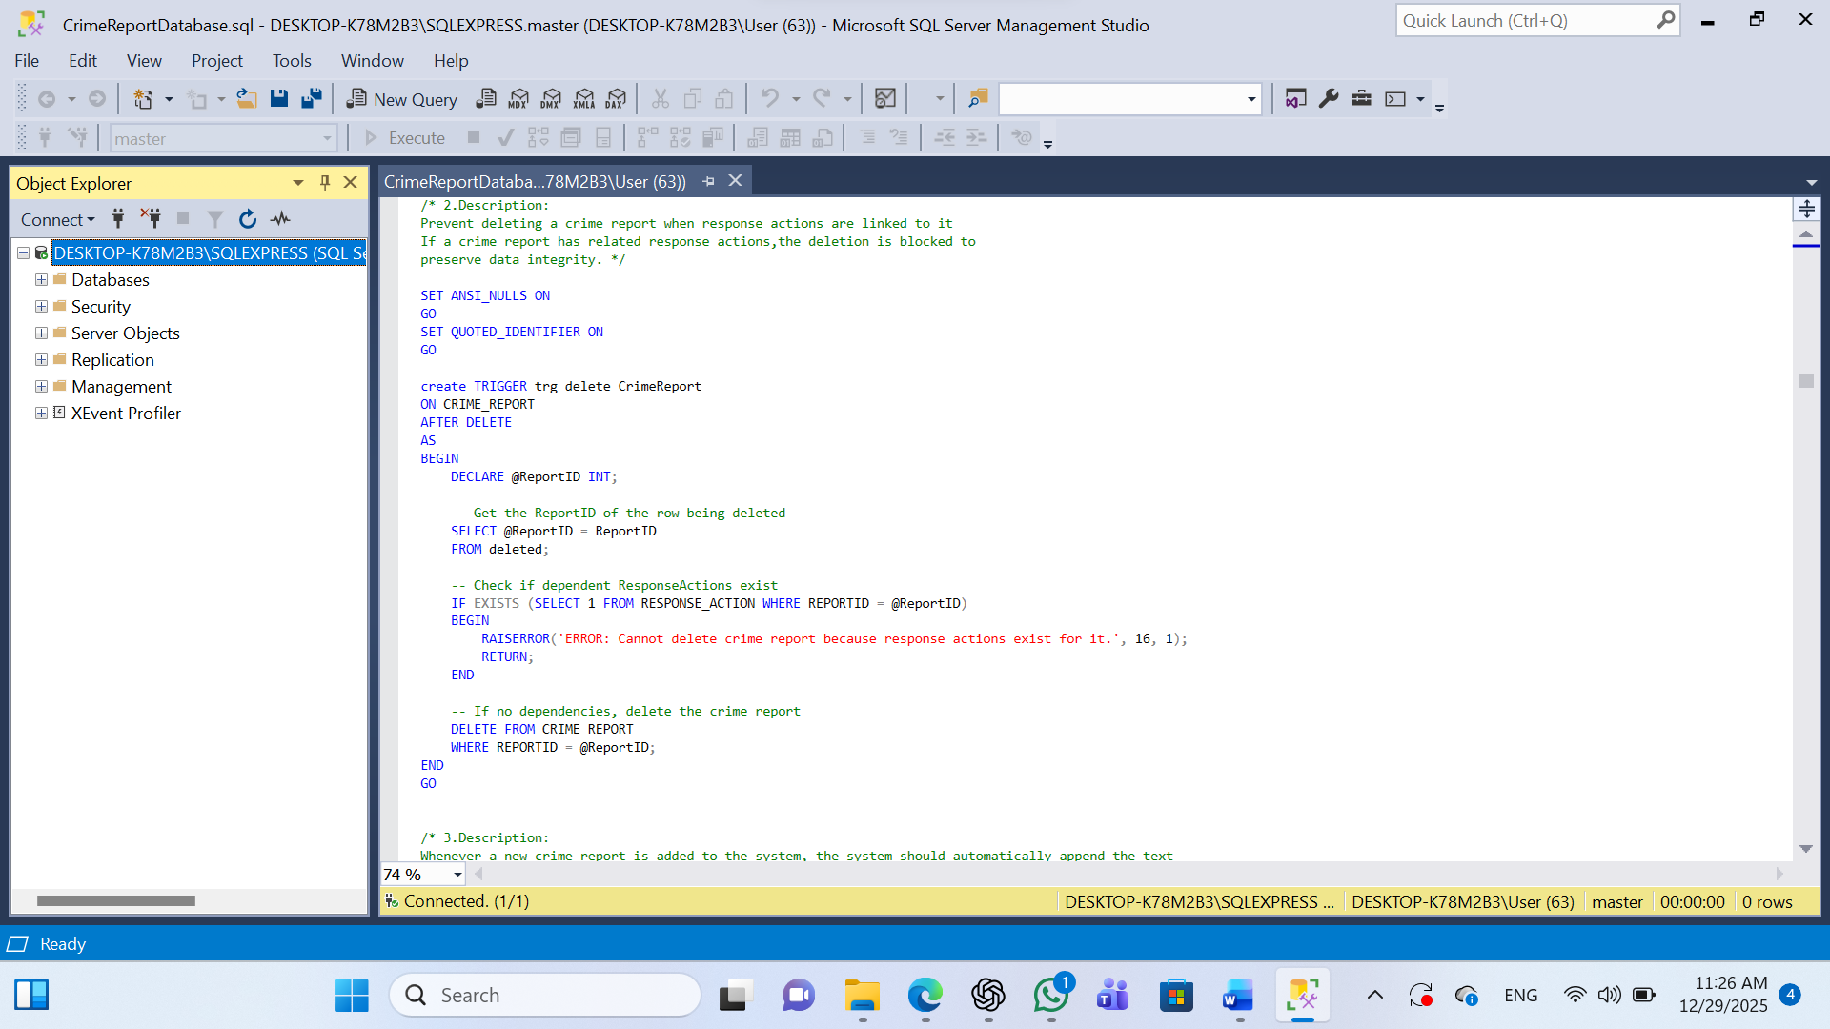

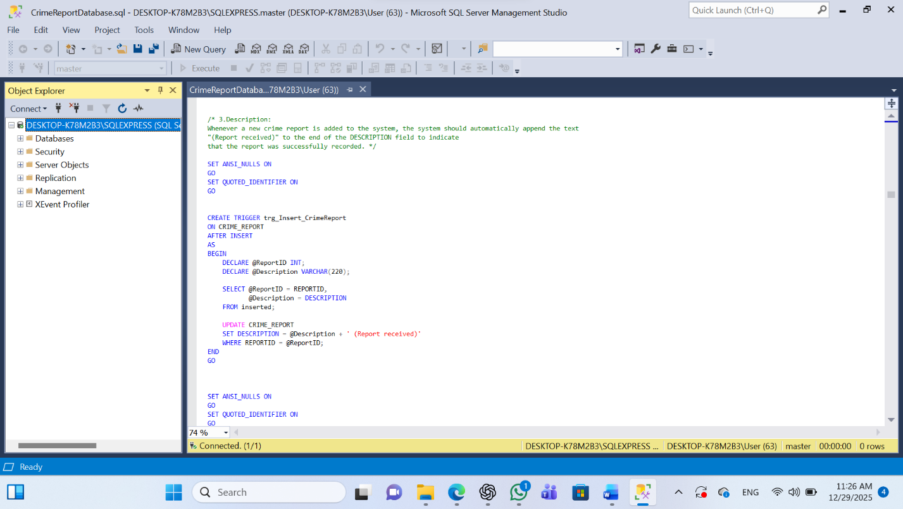
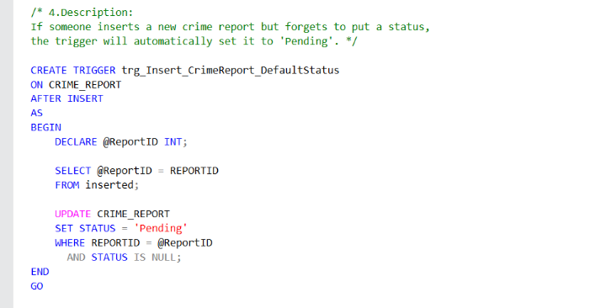

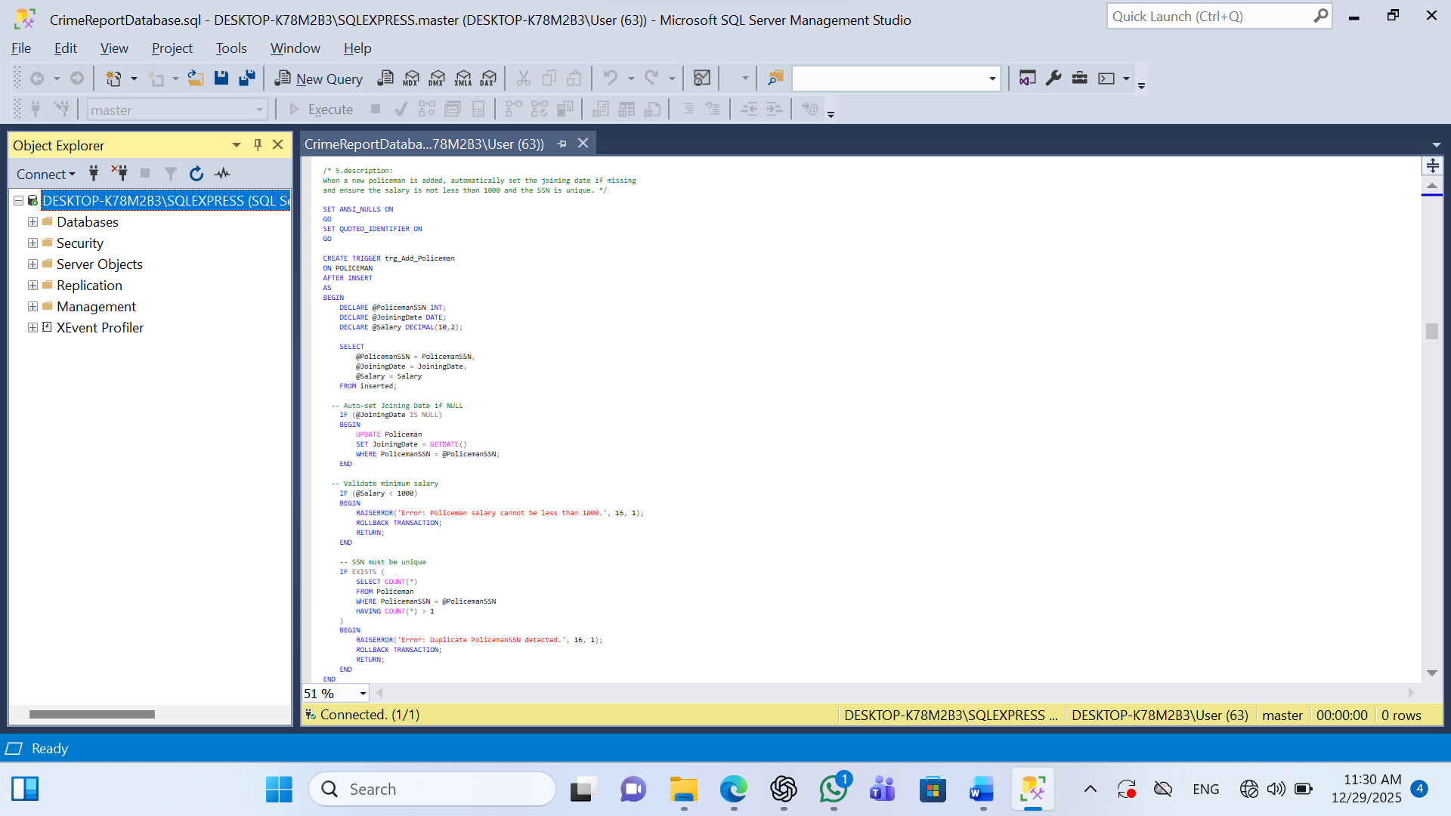

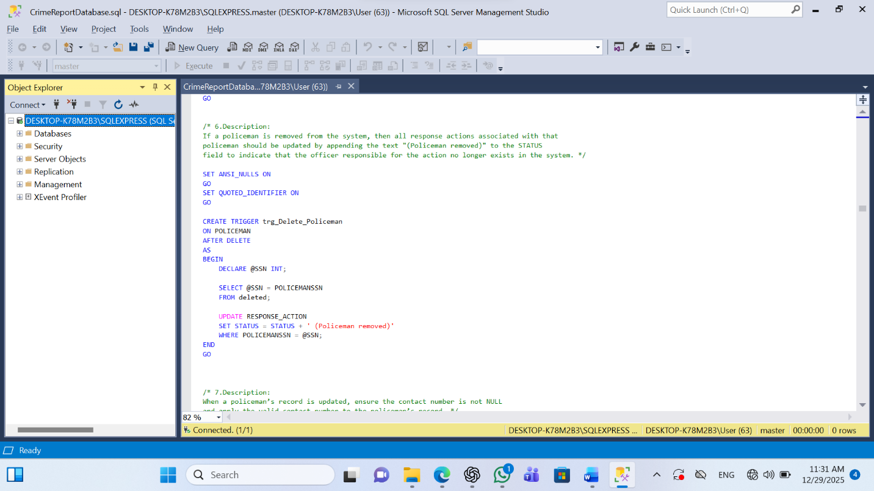
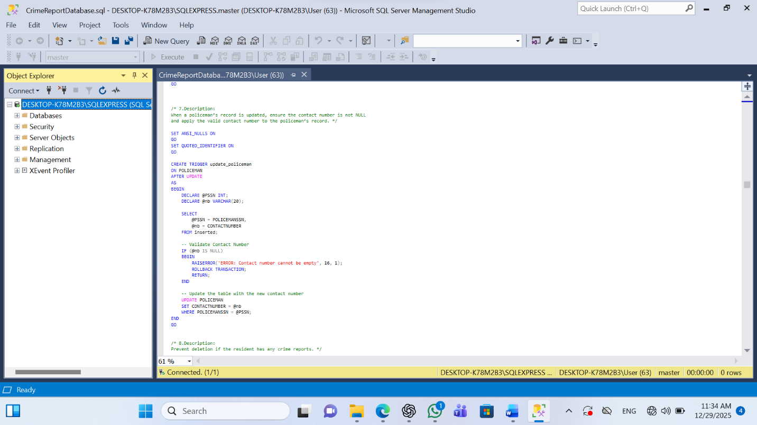
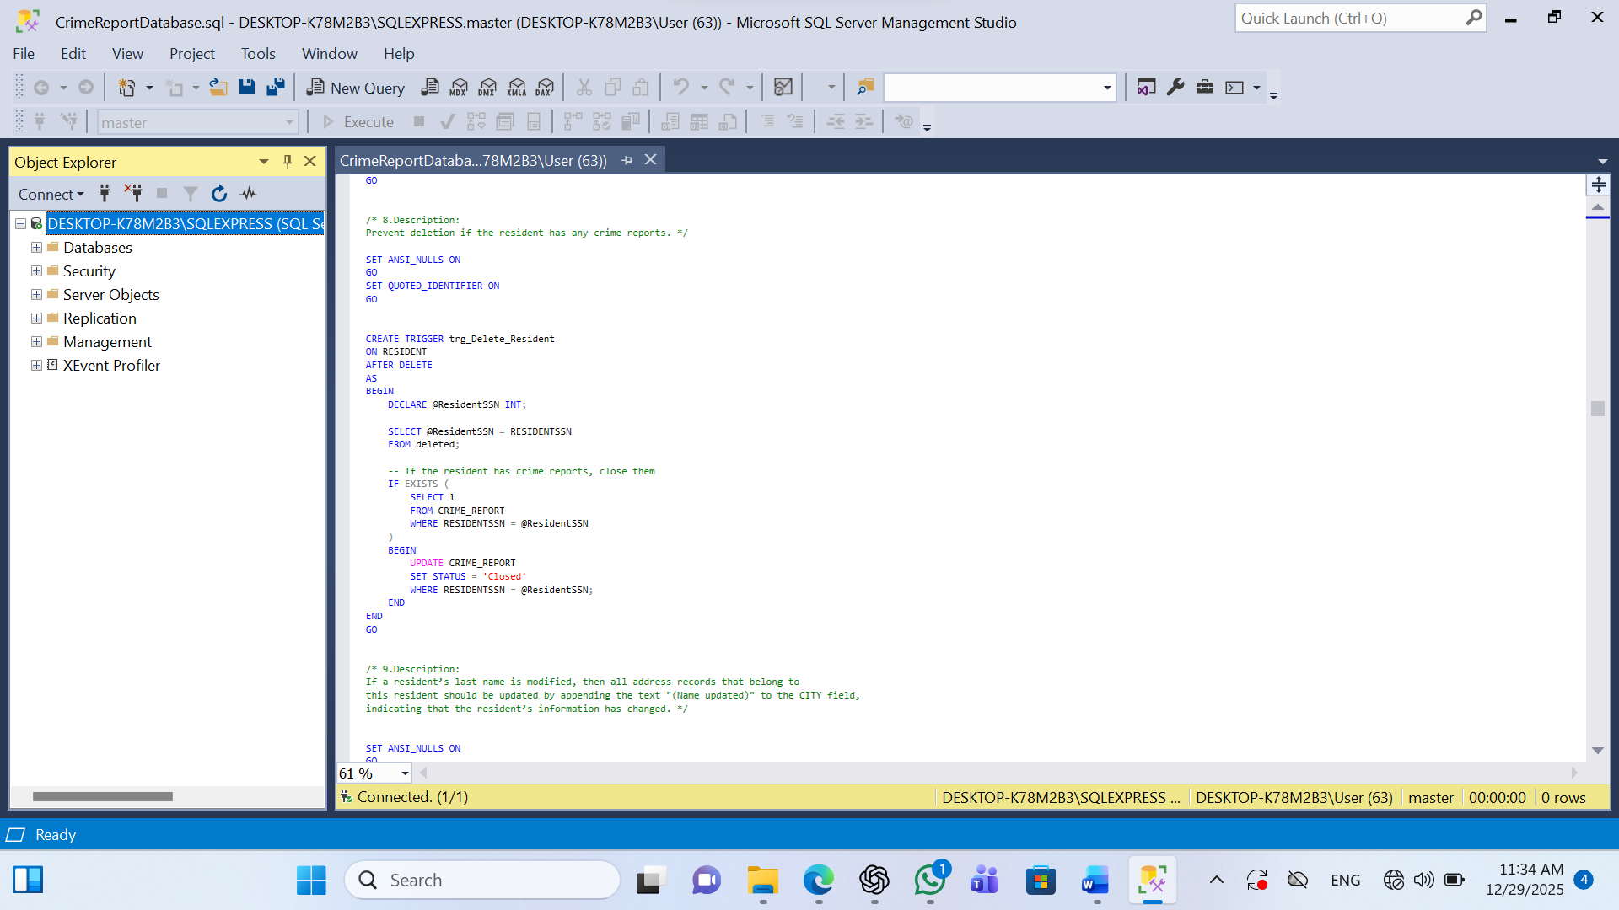
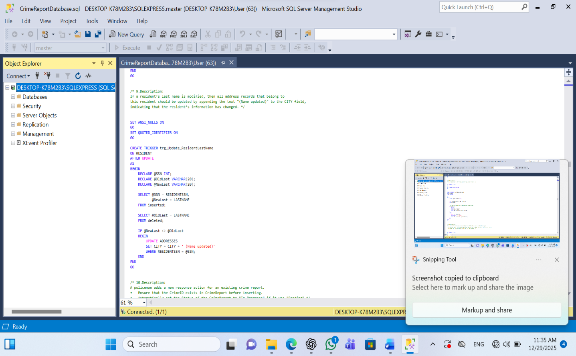
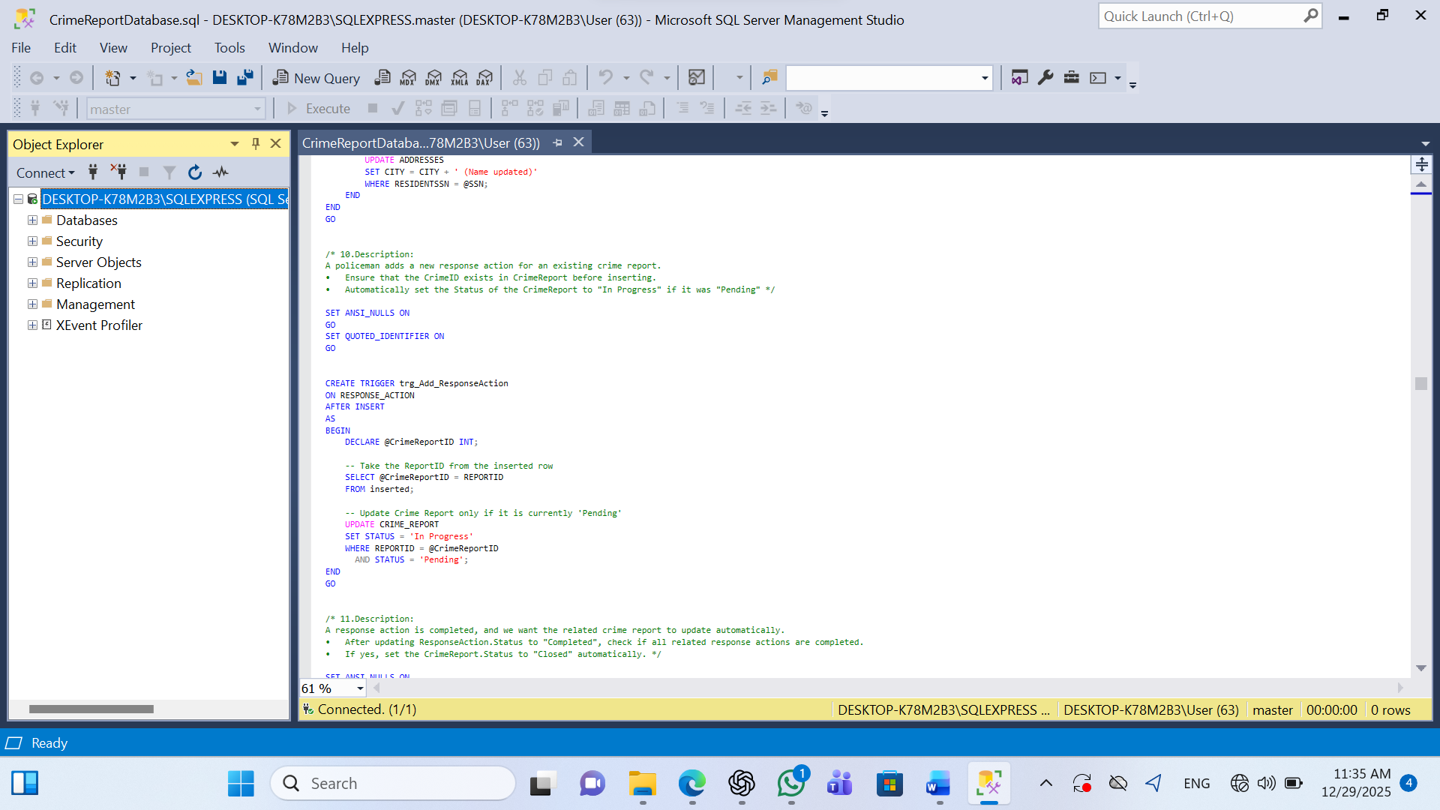
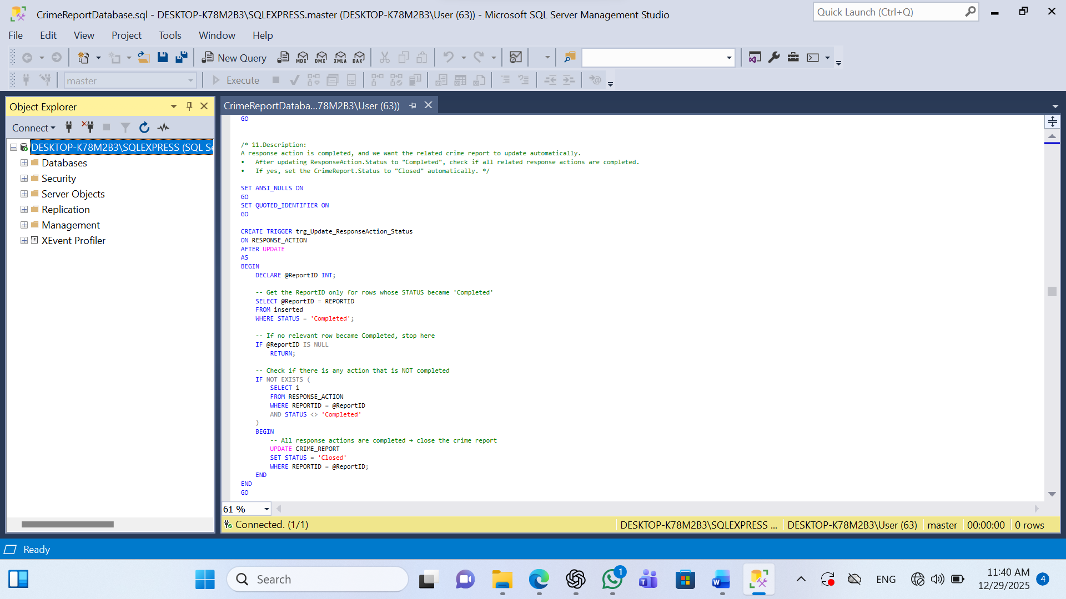

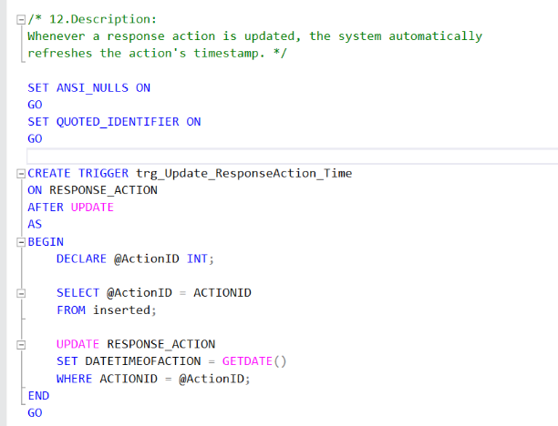
Security:
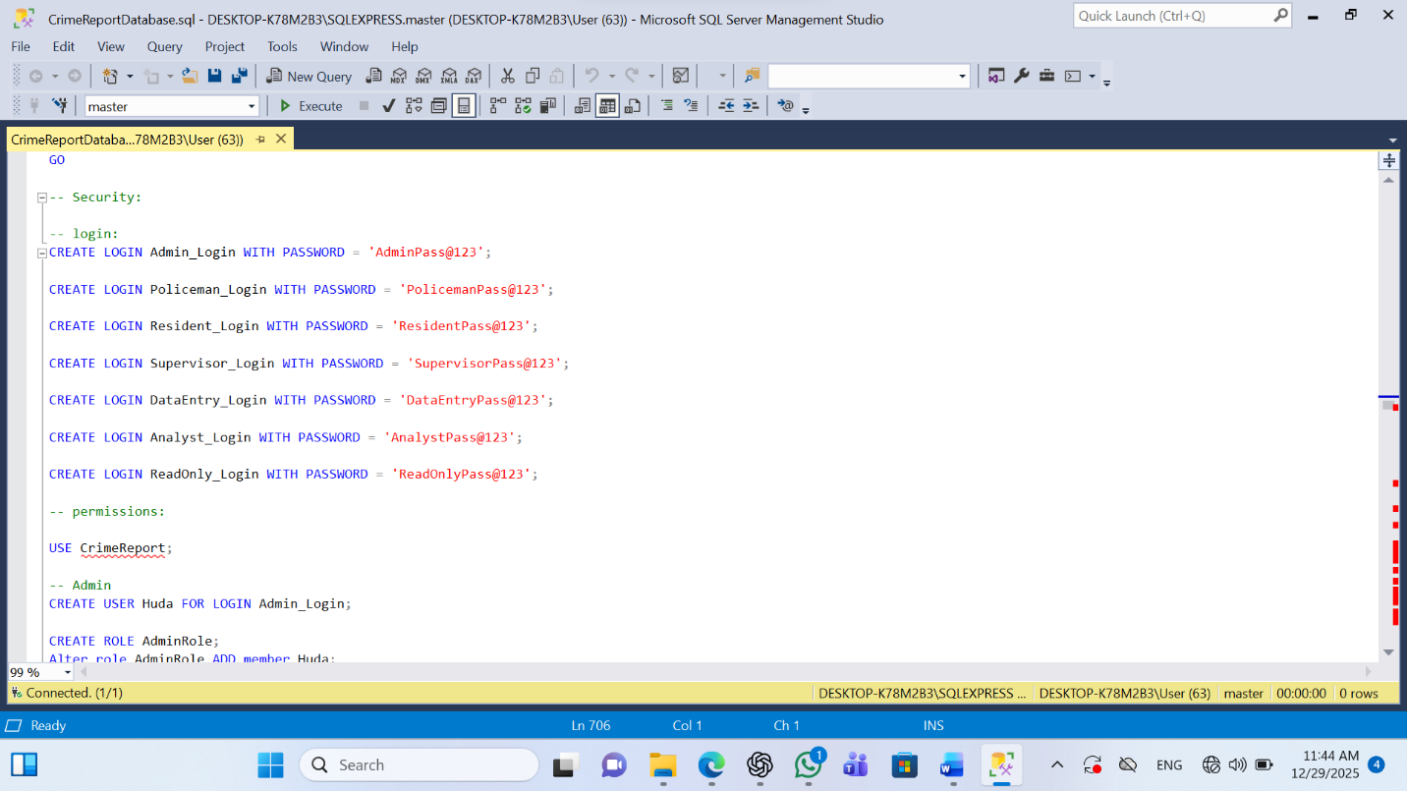

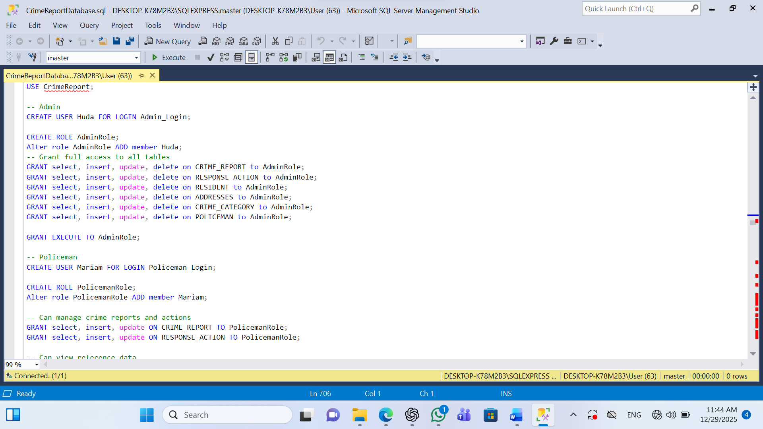

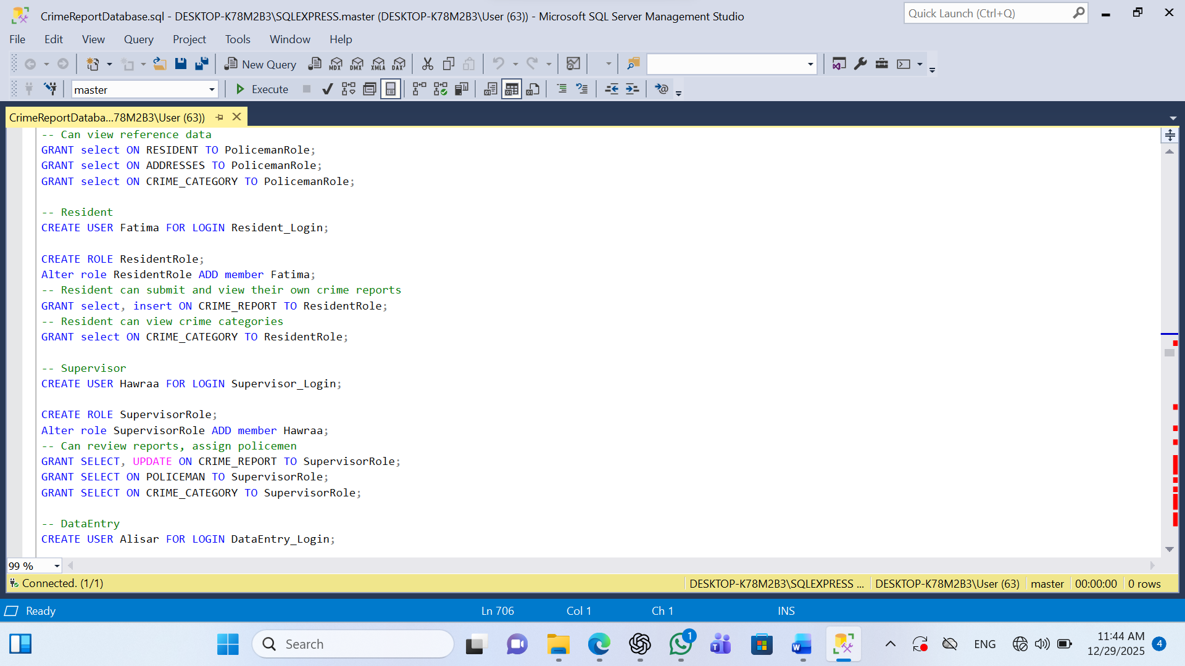

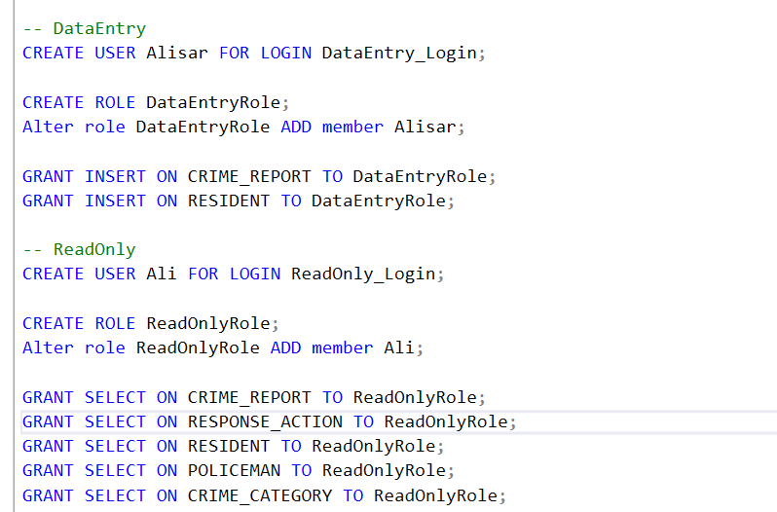

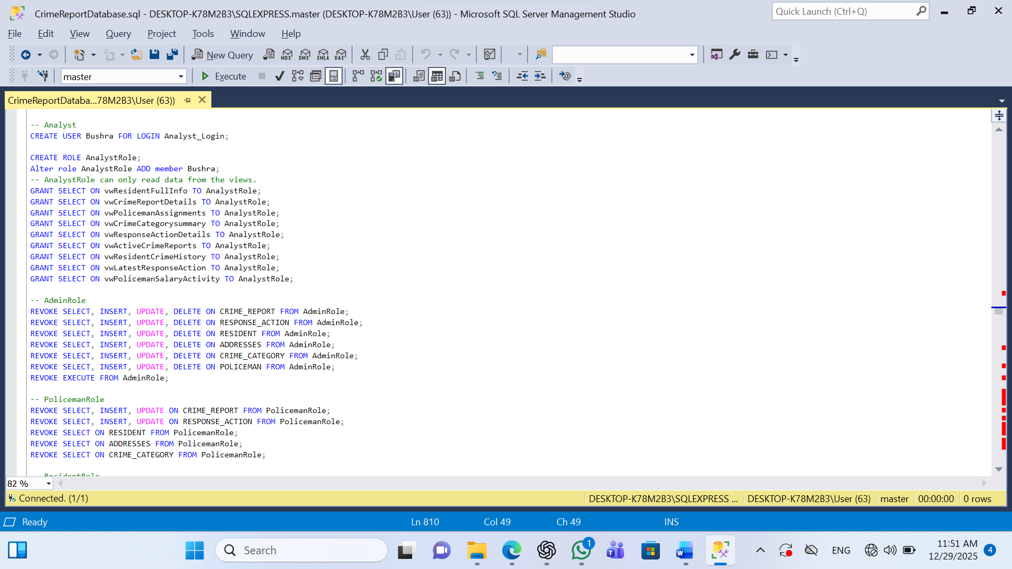

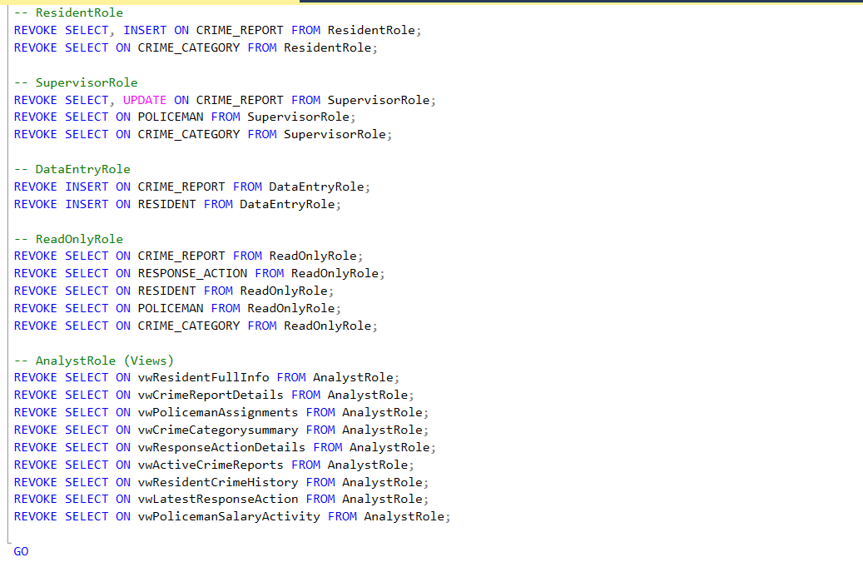

Testing:
Login:
When the user tries to log in with username or password combinations are invalid it will give error guiding users to correct credentials. Additionally, client-side validation checks for empty mandatory fields, showing immediate tooltip warnings to prompt users to complete all required inputs.
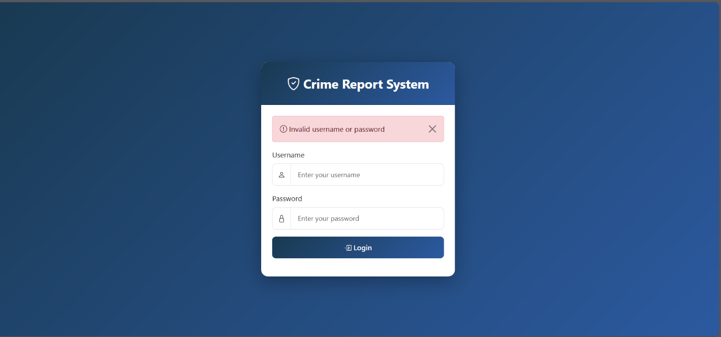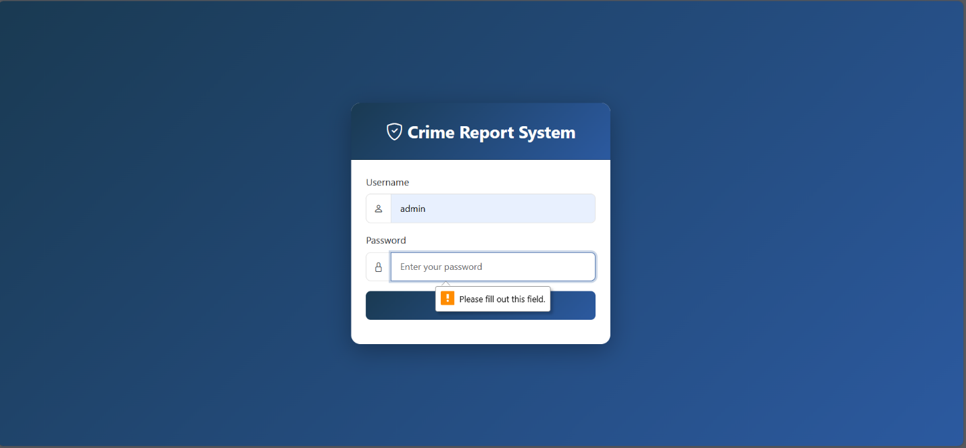

Report a crime:
When a resident attempts to submit a crime report without selecting a required crime category from the dropdown menu it will trigger an error . The Submit Crime Report and Cancel buttons at the bottom, demonstrating comprehensive client-side validation that prevents incomplete form submissions and ensures residents provide all essential information before creating a crime report record in the database.
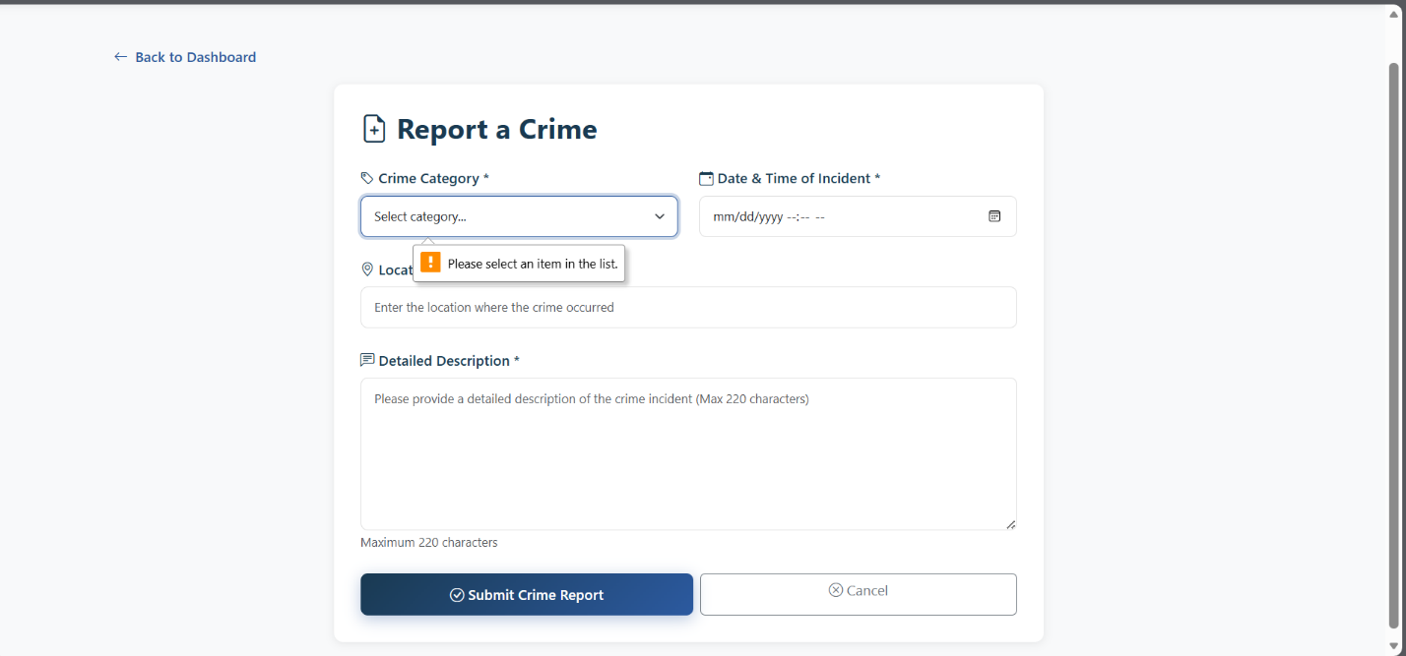

if the resident provides all the info and press on submit crime report it will show that the crimereport is successfully submitted:
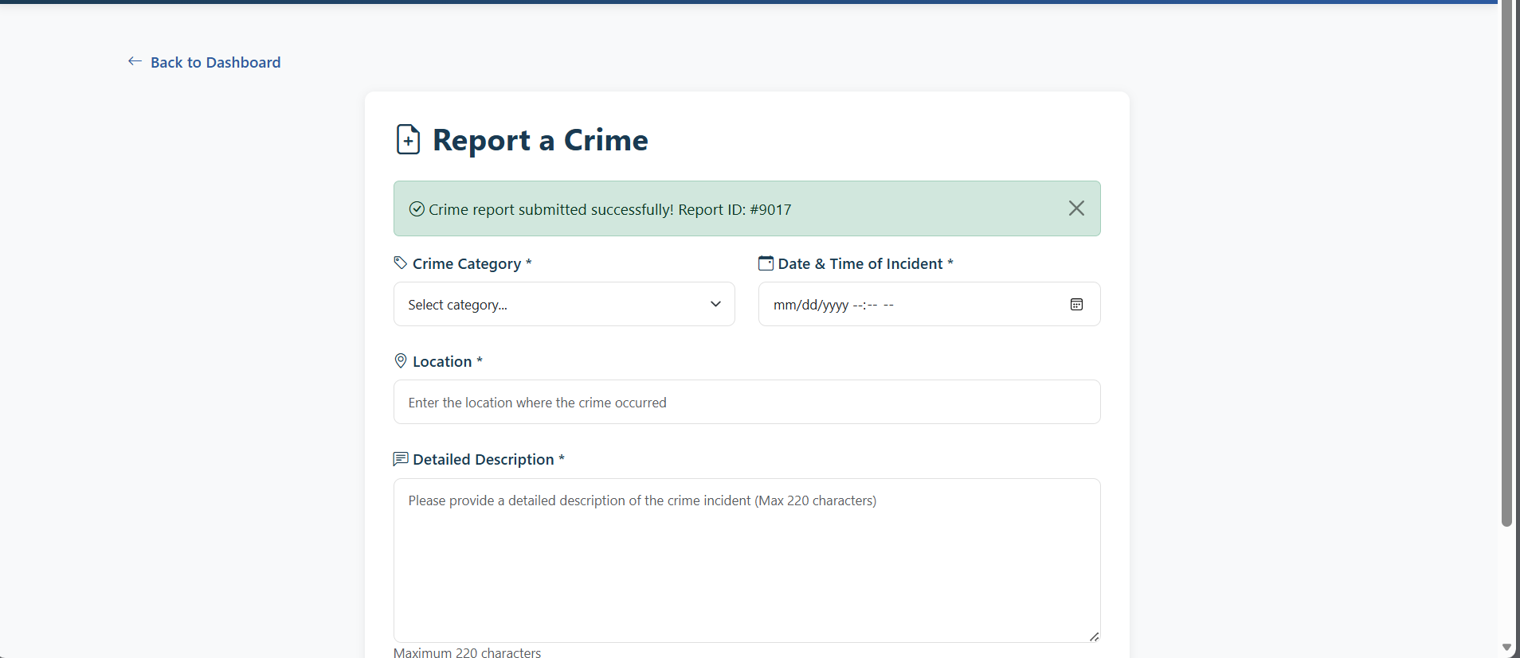
In policeman dashboard after a resident report a crime it will show in the assigned case of the policeman showing (report received):

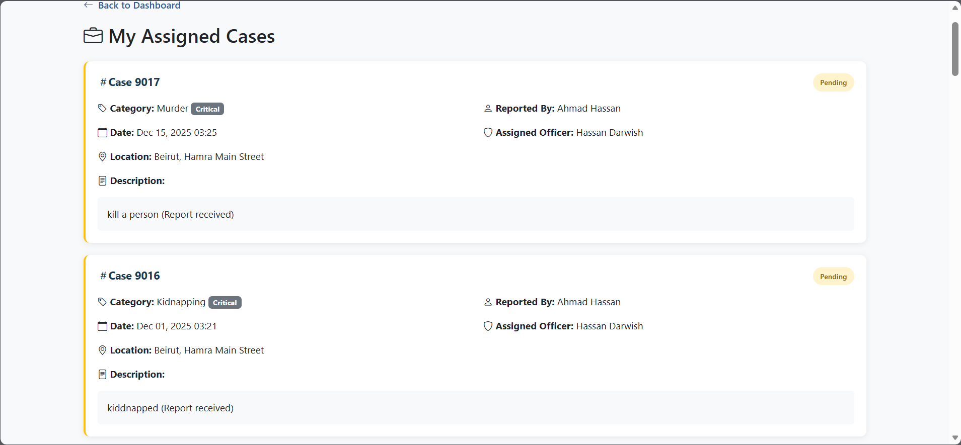

The policemen after successfully updating a crime report's status showing a prominent green success "Case status updated successfully!" to provide immediate positive feedback to the officer. The form displays case, Current Status, dropdown menu that allows officers to change the investigation status, and action buttons "Update Status" and "Cancel" at the bottom, demonstrating the system's confirmation messaging that reassures officers their database update operation completed successfully.
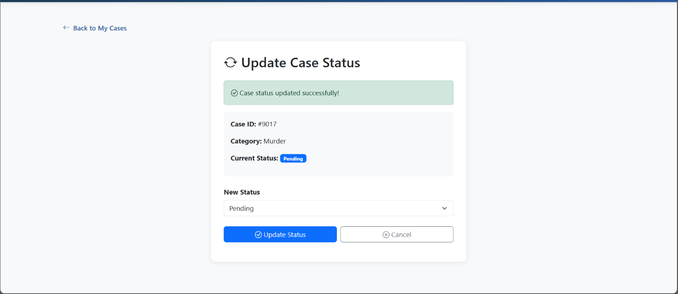

The supervisors when assign a case it will show a green success banner confirming the completed assignment operation. The interface presents a comprehensive data table with columns and buttons and demonstrating the supervisor's ability to view all cases with their categories and redistribute workload by selecting available officers from dropdown menus.
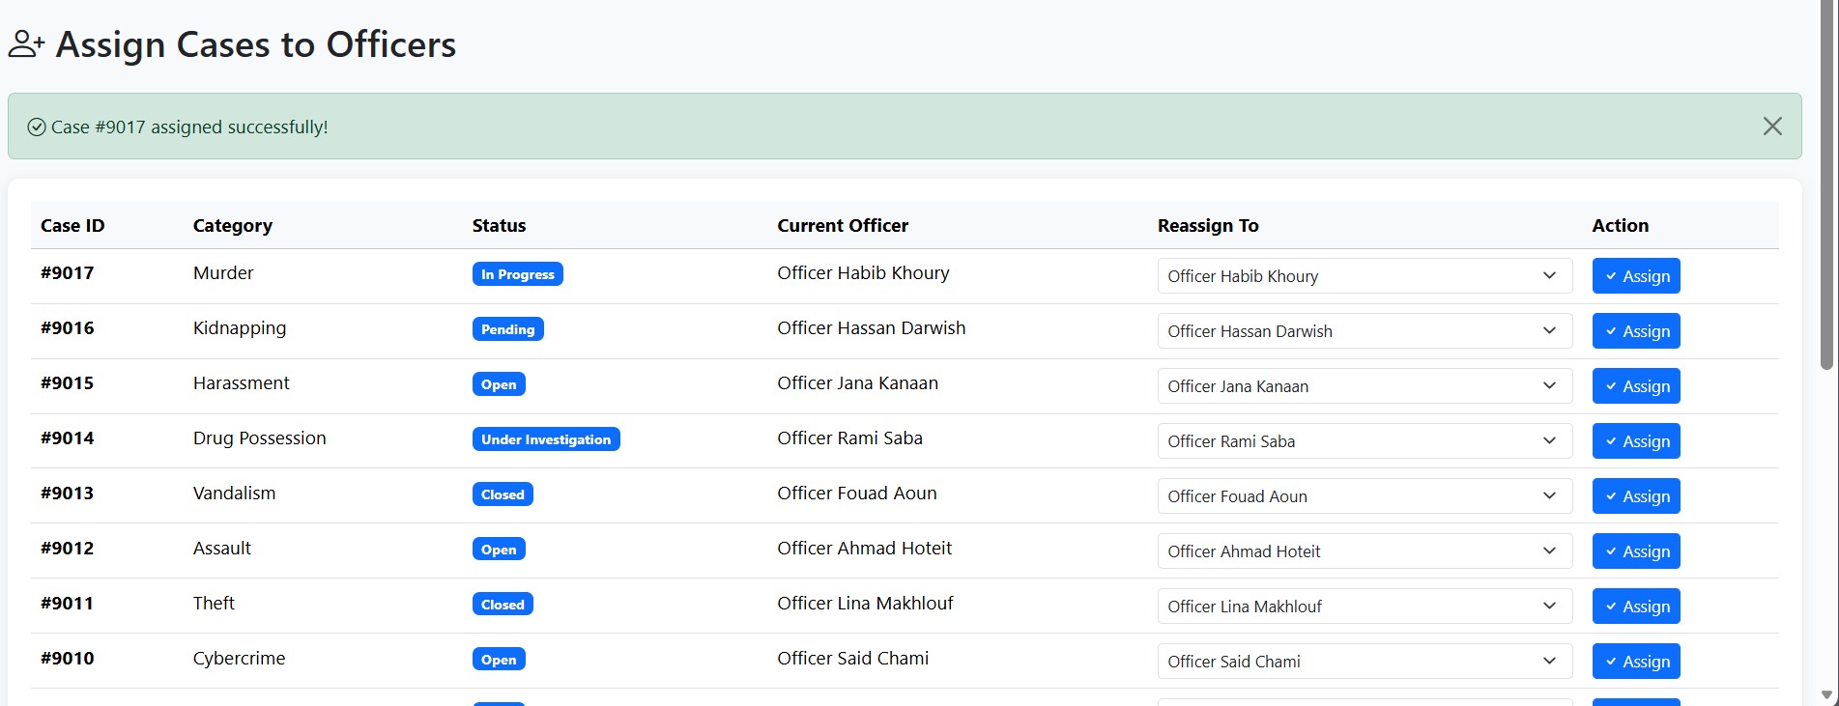
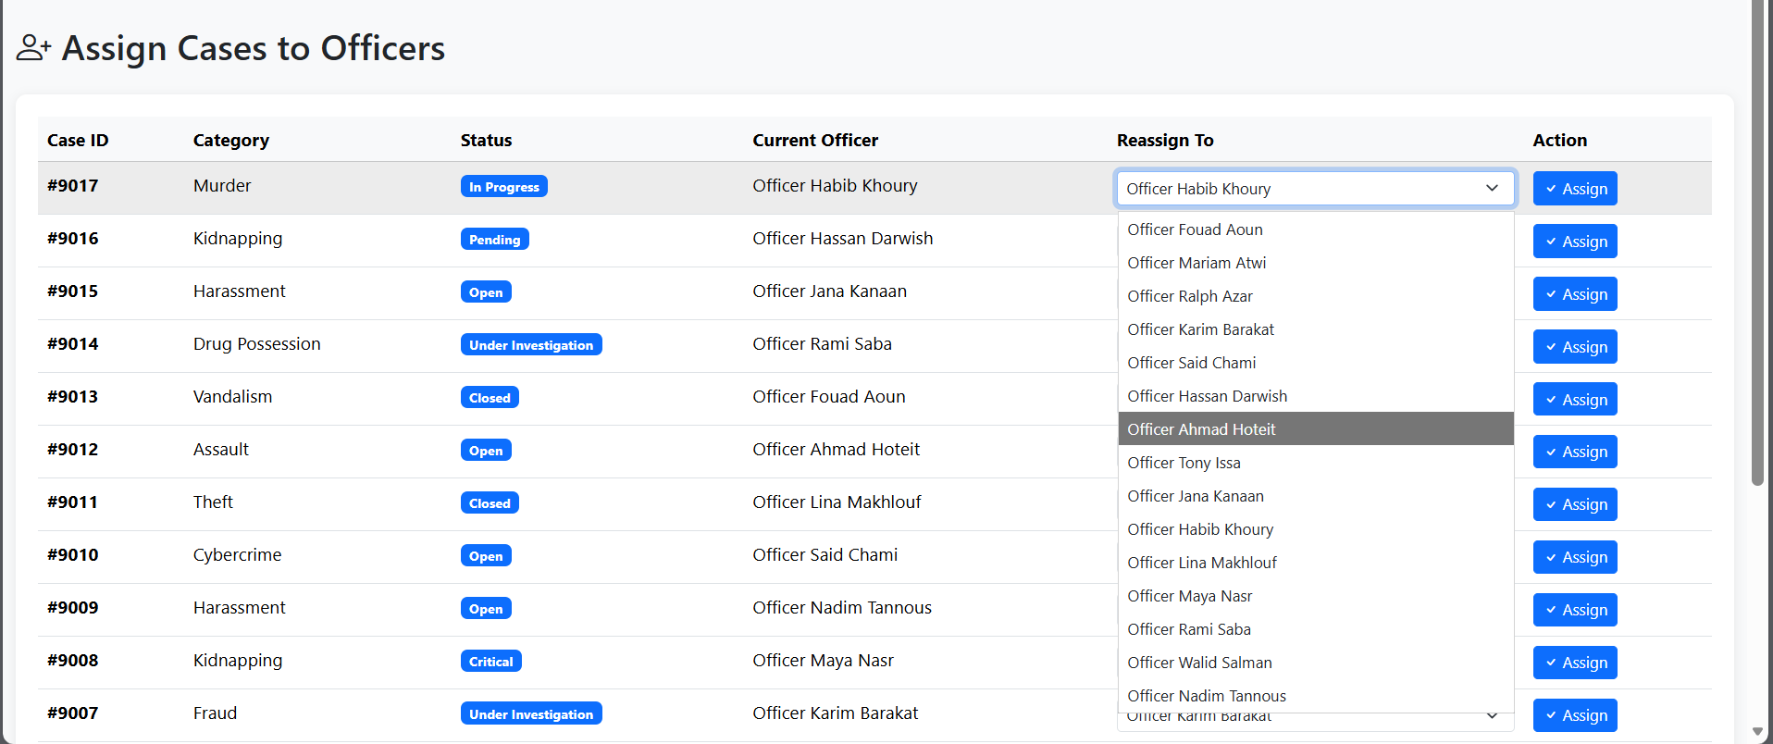

Conclusion:
In this system, residents can submit crime reports that include detailed information such as the type of crime, description, date and time, location, and any captured images. Policemen can review these reports, take response actions, and update their status accordingly. Supervisors oversee the entire operation, monitoring all reports, assigning cases to officers and reviewing performance metrics.The system manages all related data, including resident information, addresses, crime categories, assigned policemen, supervisor assignments, and actions taken, allowing efficient tracking, monitoring, and analysis of crime incidents and law enforcement responses at all levels of the organization.

