

Egypt University of Informatics

Computer and Information Systems

Data Analysis Course

EUI Computer Science Student productivity through university days

Submitted by: Maryam Ahmed Abo Ghazala 22-101113

3/9/2024

# Introduction

This report presents the findings of a survey conducted to determine which part of the day people are most productive. Understanding the patterns of productivity throughout the day can provide valuable insights for individuals and organizations seeking to optimize their work schedules. By identifying the peak productivity periods, individuals can arrange their tasks accordingly and maximize their efficiency. This report aims to uncover these patterns and shed light on the best times for productivity.

# Research Question

# Which part of the university day is computer science students more productive: from 9:00 to 11:00, from 11:00 to 1:00, or from 2:00 to 4:00?

# Hypothesis

It is hypothesized that computer science students will exhibit higher productivity levels during the time interval from 9:00 to 11:00.

# Population of Interest:

The population of interest for this survey includes computer science students enrolled at eui university.

# Sampling Method:

# Convenience sampling was used to collect the data for this survey. Convenience sampling was chosen due to its practicality and ease of access to participants within the limited resources and time constraints. While this sampling method allows for convenient data collection, it may introduce selection bias, as individuals who are more motivated or organized may be more likely to respond to the survey. Therefore, the results should be interpreted with caution and may not be fully representative of the entire population of computer science students.

# Bias Identification:

# In designing this survey, we took steps to identify and minimize potential sources of bias. One potential bias could be self-reporting bias, where participants may overestimate or underestimate their productivity during certain time intervals. To mitigate this bias, we encouraged participants to rate their productivity on a scale of 1 to 5 for each time interval, allowing for more nuanced responses. Additionally, we emphasized the importance of honest and accurate responses to the participants to reduce bias.

# Survey Questions:

1. On a scale of 1 to 5, rate your productivity from 9:00 to 11:00 during the university day.

2. On a scale of 1 to 5, rate your productivity from 11:00 to 1:00 during the university day.

3. On a scale of 1 to 5, rate your productivity from 2:00 to 4:00 during the university day.

Online survey link: <https://forms.gle/fkrSx6pedas6yc7JA>

(The survey went online to making the process more efficient and cost-effective. The data can be automatically collected and stored in a digital format, reducing the need for manual data entry and potential errors.)

Number of samples collected: 30

# Analysis:

# To analyse the data collected from this survey, we will calculate basic descriptive statistics such as the mean, median, and mode for each time interval. These statistics will provide insights into the average productivity levels and the central tendency of the responses.

|  |
| --- |
|  |
| The bar chart provides information about student productivity levels during different time slots. It shows how the productivity of students varies throughout the day. The x-axis represents the different time slots, while the y-axis represents the productivity levels of the students.  Based on the chart, it can be observed that student productivity is highest during the first time slot and gradually decreases as the day progresses |

We will also create visual representations of the data using charts and graphs to identify any trends or patterns. One such visualization is a bar chart that displays the average productivity ratings for each time interval. This visualization will allow us to compare the productivity levels across the different time intervals and draw conclusions based on the observed patterns.

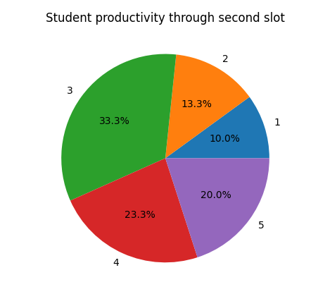

# Conclusion

# Based on the analysis of the survey data and from the mean we got, it can be concluded that, according to the responses of the computer science students, the most productive time interval during the university day is from 9:00 to 11:00. However, it is important to note that individual preferences and factors such as circadian rhythms, personal motivation, task requirements, and external distractions can significantly influence productivity.

# Any potential issues

During the data collection process, a potential issue that may arise is response bias, where participants may provide biased or inaccurate ratings of their productivity. To address this, we emphasized the importance of honest and accurate responses to the participants, ensuring that their ratings reflect their true experiences. Additionally, the survey design aimed to collect ratings for specific time intervals rather than relying solely on subjective self-assessments, reducing potential bias.