**Documentation**

**Brief**

Web Application used to show and download songs

To accomplish project used

1- **ASP.Net**: for development website

2- **Entity Framework**: used for ORM

3**- GitHub**: used for upload website source code

**1-Functional Requirements**

User can perform

1-Register

2- login

3-add new song

4- show and download any song

5- delete song he/she added it

**System Models**

**1-UseCase Model**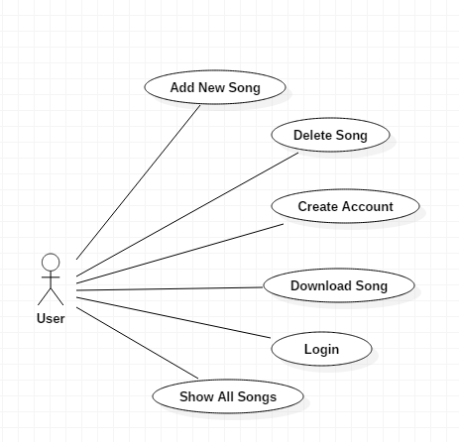

**2- Use Case Table**

|  |  |  |
| --- | --- | --- |
| **Use Case ID:** | 1 | |
| **Use Case Name:** | Create Account | |
| **Actors:** | User | |
| **Pre-conditions:** | The User is opening website Register page | |
| **Post-conditions:** | The User is logged in to his/her new account | |
| **Flow of events:** | **User Action** | **System Action** |
| 1- User chooses to ‘Sign Up’ |  |
|  | 2- System displays sign up form with editable fields for each data item |
| 3- User fills sign up form |  |
|  | 4- System validates data  5- System logs the user into his/her new account |
| **Exceptions:** | **User Action** | **System Action** |
| 1 - User Enters invalid input or the e- mail is Exists |  |
|  | 2- System notifies user and waits for new valid input |

|  |  |  |
| --- | --- | --- |
| **Use Case ID:** | 2 | |
| **Use Case Name:** | Login | |
| **Actors:** | User | |
| **Pre-conditions:** | The User is opening website Login page | |
| **Post-conditions:** | The User is logged in to his/her new account | |
| **Flow of events:** | **User Action** | **System Action** |
| 1- User chooses to ‘Login’ |  |
|  | 2- System displays login up form with editable fields for each data item |
| 3- User fills sign up form |  |
|  | 4- System validates data  5- System logs the user into his/her new account |
| **Exceptions:** | **User Action** | **System Action** |
| 1 - User Enters invalid the e- mail |  |
|  | 2- System notifies user and waits for new valid e-mail |

|  |  |  |
| --- | --- | --- |
| **Use Case ID:** | 3 | |
| **Use Case Name:** | Add Song | |
| **Actors:** | User | |
| **Pre-conditions:** | The User is opening website Home page | |
| **Post-conditions:** | The new Songs is added | |
| **Flow of events:** | **User Action** | **System Action** |
| 1- User chooses to ‘add Song` |  |
|  | 2- System displays form with editable fields for each data item |
| 3- User fills form data |  |
|  | 4- System validates data  5- System added new song and refresh user page |
| **Exceptions:** | **User Action** | **System Action** |
| 1 - User Enters invalid input |  |
|  | 2- System notifies user and waits for new valid input |

**3-Classes**

