Star Schema - 4-Step Dimensional Modeling Process
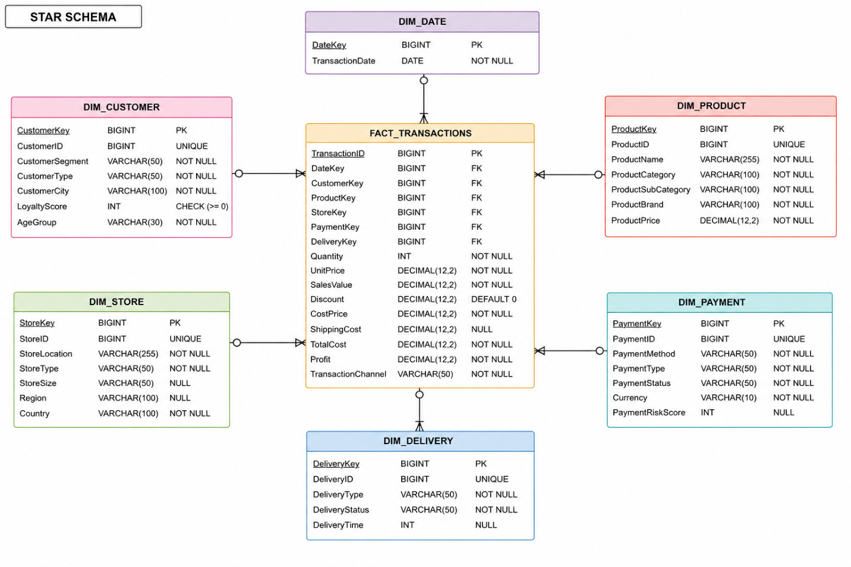

Step 1: Choose the Business Process
The business process represented by this model is:
Sales Transactions
Each transaction records information about:
- Customer
- Product
- Store
- Payment
- Delivery
- Date

Step 2: Declare the Grain
The grain specifies exactly what one row in the fact table represents.

Grain Definition
One record in FACT_TRANSACTIONS represents:
A single product purchased by a customer from a store on a specific date using a specific payment method and delivery method.
This is the lowest level of detail stored in the warehouse.

Step 3: Identify the Dimensions
Dimensions provide descriptive information about transactions.

DIM_DATE
- DateKey
- TransactionDate

DIM_CUSTOMER
- CustomerKey
- CustomerID
- CustomerSegment
- CustomerType
- CustomerCity
- LoyaltyScore
- AgeGroup

DIM_PRODUCT
- ProductKey
- ProductID
- ProductName
- ProductCategory
- ProductSubCategory
- ProductBrand
- ProductPrice

DIM_STORE
- StoreKey
- StoreID
- StoreLocation
- StoreType
- StoreSize
- Region
- Country

DIM_PAYMENT
- PaymentKey
- PaymentID
- PaymentMethod
- PaymentType
- PaymentStatus
- Currency
- PaymentRiskScore

DIM_DELIVERY
- DeliveryKey
- DeliveryID
- DeliveryType
- DeliveryStatus
- DeliveryTime

Step 4: Identify the Facts
Facts are the measurable business values stored in the fact table.

FACT_TRANSACTIONS
Foreign Keys:
- DateKey
- CustomerKey
- ProductKey
- StoreKey
- PaymentKey
- DeliveryKey
Measures:
- Quantity
- UnitPrice
- SalesValue
- Discount
- CostPrice
- ShippingCost
- TotalCost
- Profit
Additional Transaction Information:
- TransactionID
- TransactionChannel

SNOWFLAKE – NORMALIZATION STEPS

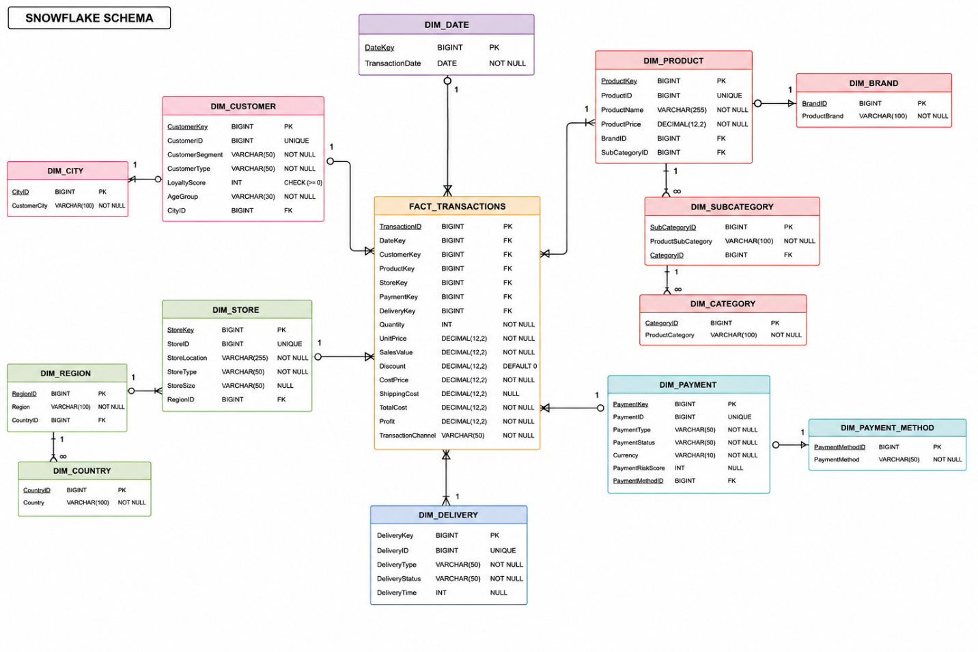

Step 1: Identify repeating attributes
In the star schema, several attributes are repeated and can be normalized:
- ProductBrand, ProductCategory, ProductSubCategory
- Region, Country
- PaymentMethod

Step 2: Apply normalization (3NF decomposition)
These repeating attributes are separated into individual tables:
- DIM_BRAND
- DIM_CATEGORY
- DIM_SUBCATEGORY
- DIM_REGION
- DIM_COUNTRY
- DIM_PAYMENT_METHOD

Step 3: Define relationships between tables
- Product → Brand, Category, SubCategory
- Store → Region → Country
- Payment → PaymentMethod
This creates hierarchical relationships between dimensions.

Step 4: Validate snowflake structure
The schema is now fully normalized:
- Redundancy is reduced
- Data integrity is improved
- Storage is optimized
- More joins are required compared to star schema

