PostgreSQL Data Access and Query Optimizer — Task 4: Answer
Mariam Avaliani

1. Theory recap

1.1 The path of a query
A query goes through four steps before I get a result:
- Parser — checks that the SQL text is written correctly, and builds a query tree from it.
- Rewriter — applies stored rules to the query tree. The most important case: a query on a VIEW gets rewritten to use the view's real base tables instead.
- Planner/Optimizer — this is the part that decides how to run the query. For each table, it looks at every possible way to read it (a sequential scan is always possible; an index scan is added if a useful index exists), estimates how expensive each way is, and picks the cheapest one. For queries with more than one table, it also tries different join orders and join methods (nested loop, merge join, hash join) and picks the cheapest combination.
- Executor — runs the finished plan from the bottom up and returns the actual rows.

1.2 Statistics
The planner's cost estimates come from statistics: row and page counts per table and index (stored in pg_class.reltuples and relpages), plus per-column statistics (most common values, histograms, how many NULLs) collected by ANALYZE and shown in the pg_stats view. autovacuum usually keeps these numbers up to date on its own. After a big data load or a big change to a table, running ANALYZE by hand is a good idea — it is cheap, since it only reads a sample of rows, not the whole table — and it makes sure the next query plan uses fresh numbers instead of old ones. An important idea here is selectivity: how large a share of a table's rows a WHERE condition is expected to match. The more selective a filter is, the more useful an index scan becomes compared to a sequential scan.

1.3 Caching
PostgreSQL keeps table and index data in memory (shared_buffers, plus whatever the operating system caches on its own), and it also caches query plans for prepared statements. Running the same query twice, with no changes to the data, is usually faster the second time just because of this "warm cache" — the needed pages are already in memory instead of being read from disk. This means one EXPLAIN ANALYZE run right after starting the database can be misleading. Running it at least twice and comparing the two is the only way to tell a real improvement in the plan from a simple cache warm-up — which is exactly what Task 1 and Task 2 below do.

1.4 EXPLAIN, EXPLAIN ANALYZE, EXPLAIN (ANALYZE, BUFFERS)
- EXPLAIN alone only plans the statement. It shows the plan PostgreSQL picked and its cost estimates, without running anything, so it is always safe to use, even for INSERT/UPDATE/DELETE.
- EXPLAIN ANALYZE actually runs the statement, then adds real numbers next to the estimates: actual time and actual rows for each part of the plan. This is what shows whether the planner's estimates were close to what really happened. Because it really runs the query, wrapping a write statement in BEGIN; EXPLAIN ANALYZE ...; ROLLBACK; is a safe way to test it without changing any data.
- EXPLAIN (ANALYZE, BUFFERS) also reports how many pages were read from cache (shared hit) versus from disk (shared read) for each part of the plan — the clearest way to see caching in action instead of just guessing from timing.

1.5 Access paths
- Sequential Scan (Seq Scan) — reads the whole table, page by page, in the order it is stored. PostgreSQL picks this when there is no useful index, when most of the table will be returned anyway, or when the table is small enough that using an index costs more than it saves. It still has to read past dead rows even though they are not returned.
- Index Scan — looks up matching entries in the index to find each row's location (TID), then goes to that page in the table to get the actual row and check if it is visible. This extra visit to the table is needed because the index usually does not store every column the query needs, and because the index itself does not track row visibility.
- Index Only Scan — skips the visit to the table completely and answers the query using only the index. This needs two things: the query must only ask for columns that are part of the index, and the table pages involved must be marked as "all visible" in the Visibility Map, so PostgreSQL can trust the index without double-checking the table. A table that was just bulk-loaded usually does not have these marks set until VACUUM runs, which is why an Index Only Scan often needs a VACUUM first.
- Bitmap Scan (Bitmap Index Scan + Bitmap Heap Scan) — a middle option. First it builds a list in memory of which table pages contain matching rows (one pass through the index), then it reads just those pages in one pass. This avoids the random back-and-forth an Index Scan would do when many scattered rows match, while still avoiding a full Seq Scan when only part of the table matches.

1.6 INSERT vs. COPY, and UPSERT
Every INSERT statement pays some fixed cost — checking permissions, taking locks, checking types — on top of the actual write. Because of this, many small single-row INSERT statements are slower overall than one INSERT with many rows in its VALUES list, or an INSERT ... SELECT that pulls rows from another table. COPY goes further: it loads data in one transaction with very little per-row cost, which makes it the fastest way to bulk-load data in theory — but it needs a strict input format, so one broken line makes the whole COPY fail.
UPSERT is PostgreSQL's INSERT ... ON CONFLICT (...) DO UPDATE / DO NOTHING syntax. For each row being inserted, if it breaks a unique or primary-key constraint named in the conflict target, PostgreSQL runs the alternative action instead of raising an error: DO NOTHING just skips that row, DO UPDATE updates the existing row instead (usually using the new values through the special EXCLUDED table). This gives one atomic insert-or-update result even with several users writing at the same time, without the application needing a separate SELECT-then-decide step.

2. Task 1 — Table without Index
I created a new table for this module's exercises and filled it with the same kind of data as the previous module: about 5 years of rows, one every 10 seconds.
CREATE TABLE labs.test_index_plan (
num float NOT NULL,
load_date timestamptz NOT NULL
);

INSERT INTO labs.test_index_plan(num, load_date)
SELECT random(), x
FROM generate_series('2017-01-01 0:00'::timestamptz,
'2021-12-31 23:59:59'::timestamptz, '10 seconds'::interval) x;
The task sheet says to insert into labs.test_index (the table name from the previous module), but that table is not the one this task uses later — every later step here (the index, the COPY export) points at labs.test_index_plan. I think this is a copy-paste mistake in the task sheet, so I inserted into labs.test_index_plan instead, since that is the table the rest of the task actually needs.
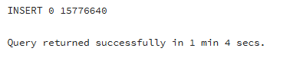
15,776,640 rows loaded in 1 minute 4 seconds — about the same size and time as the load in the previous module.
Then I checked the plan with plain EXPLAIN first, so I could see the estimates before running anything. I turned off parallel workers to keep the plan simple to read:
SET max_parallel_workers_per_gather = 0;

EXPLAIN
SELECT *
FROM labs.test_index_plan
WHERE load_date BETWEEN '2021-09-01 0:00' AND '2021-10-31 11:59:59'
ORDER BY 1;
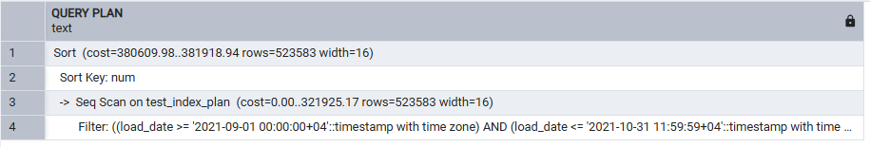
With no index yet, the plan is a Seq Scan feeding a Sort. Since plain EXPLAIN never runs the query, there are only cost estimates here — no actual time or actual rows.
Next, I ran EXPLAIN ANALYZE twice in a row, to see the real numbers and check how much caching changes them:
EXPLAIN ANALYZE
SELECT *
FROM labs.test_index_plan
WHERE load_date BETWEEN '2021-09-01 0:00' AND '2021-10-31 11:59:59'
ORDER BY 1;
-- ran the same statement again right after
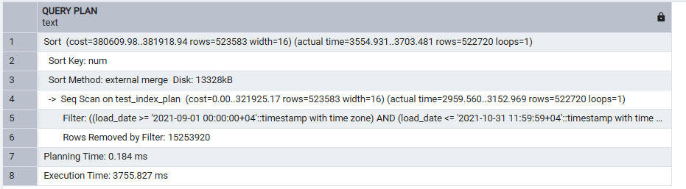
First run: Execution Time 3755.827 ms. The Sort has to spill to disk (Sort Method: external merge, Disk: 13328kB), since sorting over 500,000 rows by num does not fit in memory.
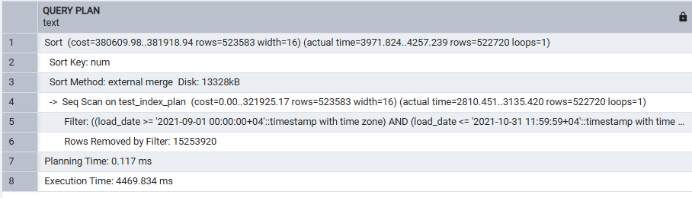
Second run: Execution Time 4469.834 ms — a little slower than the first run, not faster. I expected the warm cache to make this run quicker, but here the large disk sort seems to cost more than caching saves, so the two runs came out close, with the second one even a bit behind.
Finally, I added BUFFERS to see the cache effect directly in page counts instead of guessing from timing:
EXPLAIN (ANALYZE, BUFFERS)
SELECT *
FROM labs.test_index_plan
WHERE load_date BETWEEN '2021-09-01 0:00' AND '2021-10-31 11:59:59'
ORDER BY 1;
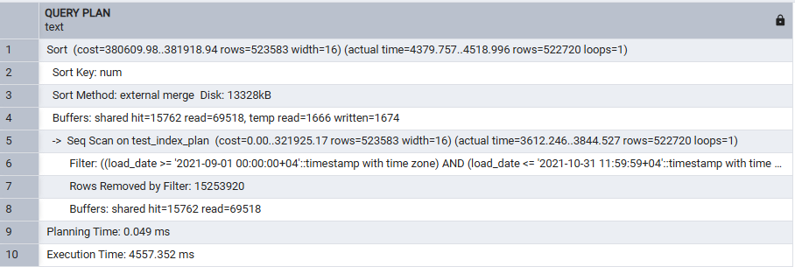
shared hit=15762, read=69518. Most of the pages this query needs (69,518) still had to be read from disk, not found in PostgreSQL's own cache (15,762 hits). The table has over 15 million rows, so it does not fully fit in shared_buffers — this is likely why the two EXPLAIN ANALYZE runs above did not show a clear speed-up.
My takeaway from Task 1: with no index, every version of EXPLAIN shows the same Seq Scan + Sort shape — only the amount of detail changes (estimates only, then real timings, then real page counts). Here, the real numbers also showed something the theory alone would not have: the cache warm-up effect I expected between the two runs did not really show up, because the sort itself is expensive enough, spilling to disk, that it dominates the timing either way.

3. Task 2 — Adding Index
I created a B-Tree index on load_date:
CREATE INDEX idx_test_index_plan_btree ON labs.test_index_plan(load_date);
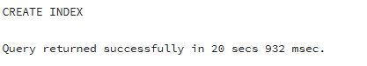
Index built in 20 seconds 932 ms — a similar time to building the same kind of index in the previous module, since it is the same number of rows.
I ran the same query as Task 1 twice, now with the index in place:
SET max_parallel_workers_per_gather = 0;

EXPLAIN ANALYZE
SELECT *
FROM labs.test_index_plan
WHERE load_date BETWEEN '2021-09-01 0:00' AND '2021-10-31 11:59:59'
ORDER BY 1;
-- ran twice
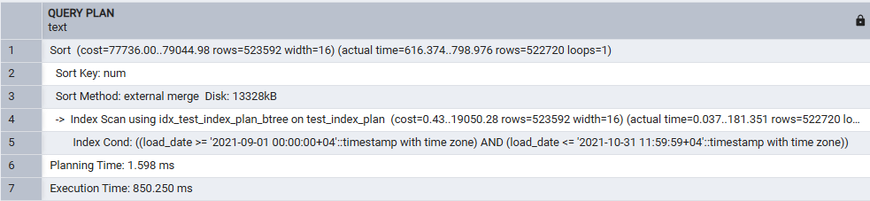
First run: 850.250 ms. The plan now uses Index Scan using idx_test_index_plan_btree instead of a Seq Scan, so the WHERE condition is checked using the index, not by reading every row.
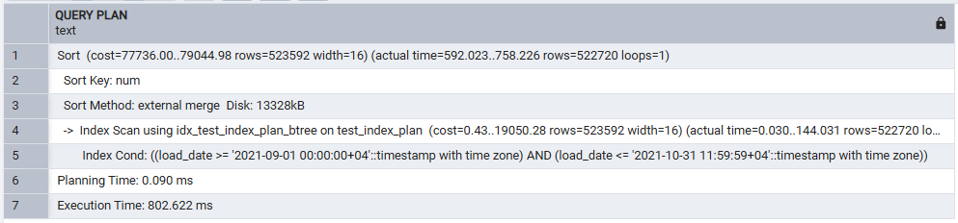
Second run: 802.622 ms, close to the first. Both runs are far faster than Task 1's roughly 4000 ms, because the index lets PostgreSQL go straight to the matching rows instead of reading and filtering the whole table.
One thing I noticed here: the query orders by 1, and the table is defined as num first, then load_date — so ORDER BY 1 actually sorts by num, not by load_date. That means the index on load_date cannot help with the ordering at all, and the plan still needs a full Sort (both screenshots above still show "Sort Key: num" and "Sort Method: external merge", the same as Task 1). The real speed-up here comes only from the Index Cond narrowing down the rows before that sort runs, not from the index removing the sort step.

Getting an Index Only Scan
Since the query still selects *, it needs num, which is not part of the load_date index, so PostgreSQL still has to visit the table for every matching row (a regular Index Scan). For an Index Only Scan, the query has to ask for only columns that are actually in the index — here that means selecting just load_date. I also ran VACUUM first, so the Visibility Map is up to date and PostgreSQL can trust it without rechecking the table:
VACUUM labs.test_index_plan;

EXPLAIN ANALYZE
SELECT load_date
FROM labs.test_index_plan
WHERE load_date BETWEEN '2021-09-01 0:00' AND '2021-10-31 11:59:59'
ORDER BY 1;
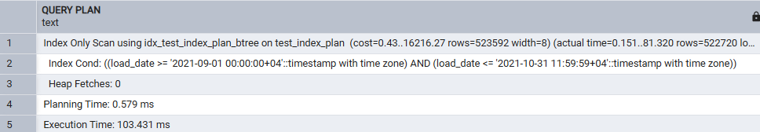
103.431 ms, with Index Only Scan using idx_test_index_plan_btree and Heap Fetches: 0 — the query is answered from the index alone, with no table visit needed. There is also no Sort node this time, because with only load_date selected, ORDER BY 1 now means load_date, which the index already returns in sorted order.

BRIN instead of B-Tree
DROP INDEX idx_test_index_plan_btree;

CREATE INDEX idx_test_index_plan_brin ON labs.test_index_plan USING brin(load_date);

SET max_parallel_workers_per_gather = 0;

EXPLAIN ANALYZE
SELECT *
FROM labs.test_index_plan
WHERE load_date BETWEEN '2021-09-01 0:00' AND '2021-10-31 11:59:59'
ORDER BY 1;
-- ran twice
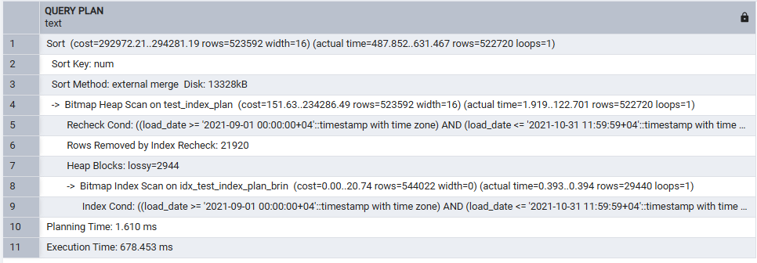
First run: 678.453 ms, using Bitmap Heap Scan driven by Bitmap Index Scan on idx_test_index_plan_brin. BRIN only narrows the search down to page ranges, so PostgreSQL still needs the bitmap step to find and check the actual matching rows, and it still needs the Sort node (same num-ordering reason as above).
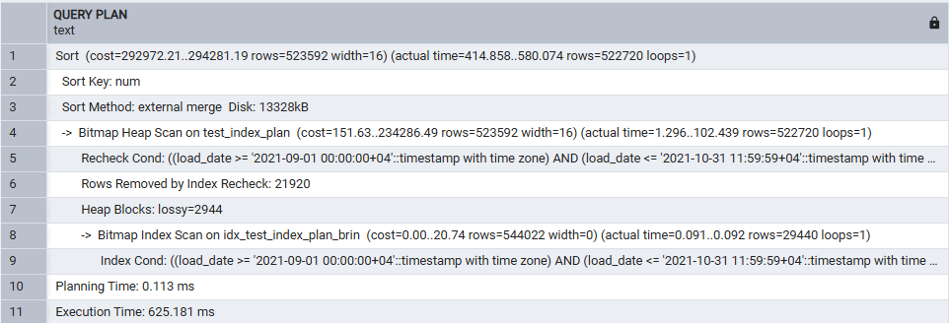
Second run: 625.181 ms. In this run, BRIN came out a little faster than the B-Tree index scan above (roughly 650 ms average against roughly 825 ms average) — even though BRIN is a much smaller, cheaper index that gives the planner less exact information to work with. For this data and this date range, the extra bitmap step clearly was not a problem.

4. Task 3 — Bulk Insert
I created the destination table with its index already in place, before loading any data:
CREATE TABLE labs.test_inserts (
num float NOT NULL,
load_date timestamptz NOT NULL
);

CREATE INDEX idx_test_inserts_btree ON labs.test_inserts(load_date);
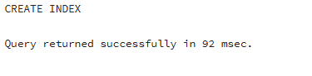
Both statements succeeded; the index is empty at this point, since test_inserts has no rows yet.
Then I filled it from the existing test_index_plan table with INSERT ... SELECT, and timed it:
INSERT INTO labs.test_inserts (num, load_date)
SELECT num, load_date
FROM labs.test_index_plan;
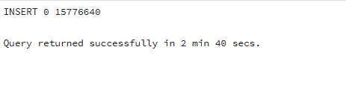
All 15,776,640 rows copied in 2 minutes 40 seconds. This is slower than the plain INSERT in Task 1 (1 minute 4 seconds) for the same number of rows, even though it is a single statement — here PostgreSQL also has to update the load_date index for every row as it goes in, since the index already existed before the load. This is likely why bulk-loading tools often build indexes after loading data, not before.

emp table and a more efficient multi-row INSERT
CREATE TABLE emp (
empno NUMERIC(4) NOT NULL CONSTRAINT emp_pk PRIMARY KEY,
ename VARCHAR(10) UNIQUE,
job VARCHAR(9),
mgr NUMERIC(4),
hiredate DATE
);
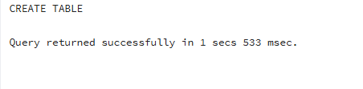
Table created, with a primary key on empno and a unique constraint on ename — both matter later, for the UPSERT in Task 5.
The task sheet has 14 separate INSERT INTO emp VALUES (...); statements, one row each. Each one pays its own fixed cost (checking permissions, taking a lock, checking types) for just one row. Instead, I wrote one INSERT with all 14 rows in a single VALUES list, which is the more efficient way the task is asking for:
INSERT INTO emp (empno, ename, job, mgr, hiredate) VALUES
(1, 'SMITH', 'CLERK', 13, '17-DEC-80'),
(2, 'ALLEN', 'SALESMAN', 6, '20-FEB-81'),
(3, 'WARD', 'SALESMAN', 6, '22-FEB-81'),
(4, 'JONES', 'MANAGER', 9, '02-APR-81'),
(5, 'MARTIN', 'SALESMAN', 6, '28-SEP-81'),
(6, 'BLAKE', 'MANAGER', 9, '01-MAY-81'),
(7, 'CLARK', 'MANAGER', 9, '09-JUN-81'),
(8, 'SCOTT', 'ANALYST', 4, '19-APR-87'),
(9, 'KING', 'PRESIDENT', NULL, '17-NOV-81'),
(10, 'TURNER', 'SALESMAN', 6, '08-SEP-81'),
(11, 'ADAMS', 'CLERK', 8, '23-MAY-87'),
(12, 'JAMES', 'CLERK', 6, '03-DEC-81'),
(13, 'FORD', 'ANALYST', 4, '03-DEC-81'),
(14, 'MILLER', 'CLERK', 7, '23-JAN-82');
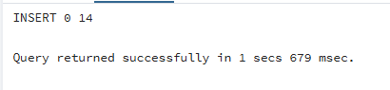
One INSERT 0 14 instead of fourteen separate INSERT 0 1 results — same final data, but the cost of a single statement instead of fourteen.
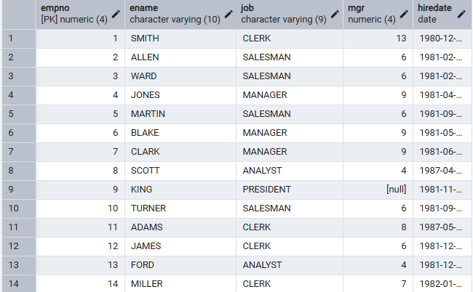
All 14 rows in the table, checked with SELECT * FROM emp.

5. Task 4 — COPY Command
I exported test_index_plan to a CSV file, with load_date forced into quotes and num left as a plain number (CSV already leaves a plain numeric column unquoted, so only load_date needed FORCE QUOTE):
COPY labs.test_index_plan
TO 'C:/temp/test_index_plan.csv'
WITH (FORMAT csv, HEADER, DELIMITER ',', FORCE_QUOTE (load_date));
I used C:/temp/ again for the same reason as before: this file is written by the PostgreSQL server process itself, so the path has to be one that process can actually write to.
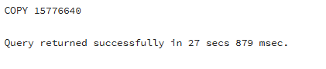
15,776,640 rows exported in 27 seconds 879 ms. Opening the file shows load_date values in quotes (for example "2017-01-01 00:00:00+04") and num values as plain numbers on the same line.
I also exported a smaller, date-filtered slice. COPY TO cannot take a WHERE clause directly, so I wrapped the source in a query instead:
COPY (
SELECT * FROM labs.test_index_plan
WHERE load_date BETWEEN '2021-09-01 0:00' AND '2021-09-01 11:59:59'
)
TO 'C:/temp/test_index_plan_short.csv' DELIMITER ',' CSV HEADER;
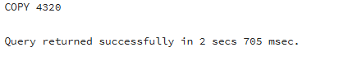
4,320 rows exported in 2 seconds 705 ms — just under half a day of 10-second-interval rows.
Then I created the destination table for the import, with its index already in place, the same as Task 3:
CREATE TABLE labs.test_copy (
num float NOT NULL,
load_date timestamptz NOT NULL
);

CREATE INDEX idx_test_copy_btree ON labs.test_copy(load_date);
The task sheet says to add the B-Tree index "on the table test_inserts" again here — but test_inserts already got its index back in Task 3. It is test_copy, the table this step just created, that needs one before the COPY import below. I think this is another copy-paste mistake in the task sheet, so I indexed test_copy instead.
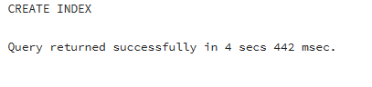
Both statements succeeded, in 4 seconds 442 ms.
I loaded test_copy from the CSV file I exported earlier, and timed it to compare against Task 3's INSERT ... SELECT:
COPY labs.test_copy(num, load_date)
FROM 'C:/temp/test_index_plan.csv'
WITH (FORMAT csv, HEADER, DELIMITER ',');
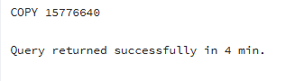
15,776,640 rows loaded in 4 minutes. I expected COPY to beat Task 3's INSERT ... SELECT (2 minutes 40 seconds), since the theory says COPY has much less per-row overhead — but here it was slower, not faster. Both tables already had an index before loading, so that part is the same for both. My best guess is that reading and converting a CSV text file added more cost here than the per-row overhead INSERT ... SELECT would have paid working directly with PostgreSQL's own internal row format, but I have not measured that part separately, so I cannot say for sure.

6. Task 5 — UPSERT
Before running the UPSERT, the current emp rows for these empno values were: 1 = SMITH/CLERK, 4 = JONES/MANAGER, 11 = ADAMS/CLERK, 14 = MILLER/CLERK — and 15 did not exist yet. So this one statement needs to update four existing rows and insert one brand-new row (15), all at once, using empno (the primary key) as the conflict target:
INSERT INTO emp (empno, ename, job, mgr, hiredate) VALUES
(1, 'SMITH', 'MANAGER', 13, '01-DEC-21'),
(14, 'KELLY', 'CLERK', 1, '01-DEC-21'),
(15, 'HANNAH', 'CLERK', 1, '01-DEC-21'),
(11, 'ADAMS', 'SALESMAN', 8, '01-DEC-21'),
(4, 'JONES', 'ANALIST', 9, '01-DEC-21')
ON CONFLICT (empno) DO UPDATE SET
ename = EXCLUDED.ename,
job = EXCLUDED.job,
mgr = EXCLUDED.mgr,
hiredate = EXCLUDED.hiredate;
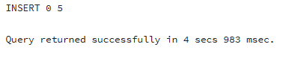
One statement, no error: INSERT 0 5 — meaning 5 rows were affected in total.
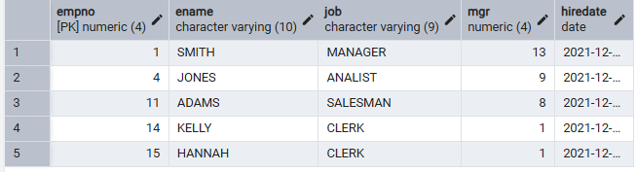
SELECT * FROM emp WHERE empno IN (1,4,11,14,15) ORDER BY empno afterward: empno 1 is now MANAGER (name unchanged, SMITH), empno 4 is now ANALIST, empno 11 is now SALESMAN, empno 14 was renamed from MILLER to KELLY, and empno 15 (HANNAH) is brand new — all five with hiredate 2021-12-01.
None of the ename changes conflict with the UNIQUE(ename) constraint (each new name is either unchanged or genuinely new), which is why ON CONFLICT (empno) alone is enough here, without also handling an ename conflict.
My takeaway: without ON CONFLICT, this exact statement would have failed on the very first row that already exists (empno = 1), and the whole multi-row INSERT would have rolled back. Without UPSERT, the only other option would be a slower way — check if each row exists with a SELECT, then decide whether to INSERT or UPDATE it — and that is not atomic, so two users doing this at the same time could still collide between the check and the write.

7. Summary
A query goes through parsing, rewriting, cost-based planning, and execution. The planner's choice between a sequential, index, index-only, or bitmap scan comes entirely from table and column statistics and the estimated cost of each option — this is why EXPLAIN (showing that reasoning) and EXPLAIN ANALYZE (showing whether the reasoning matched what really happened) are the main tools for understanding performance.
Caching means one timing run is never enough evidence by itself. My own results above showed this clearly: the two EXPLAIN ANALYZE runs in Task 1 did not get faster the second time, because a large disk-based sort cost more than caching saved, and the BUFFERS output (mostly disk reads, not cache hits) explained why.
For loading data, per-statement overhead makes many small INSERTs the slowest option, and one multi-row INSERT is clearly better. COPY being the fastest option overall is not something I could confirm here: in my own test, COPY FROM a CSV file was actually slower than INSERT ... SELECT into an already-indexed table, most likely because of the extra cost of parsing text.
Finally, ON CONFLICT (UPSERT) turns what would otherwise be a fragile check-then-write sequence into one atomic, safe statement, as Task 5 showed directly.

