Task 6 — BL_3NF: DDL and DML for the 3NF Layer: Answer
Revision 2 — updated in response to the mentor’s feedback on Task 3 (SCD2 key/versioning logic, CE_DATE scope, and CE_STORE/CE_PRODUCT normalization). See the “Revision Notes” section added to Chapter 2 of the main business document for the modeling rationale; this document covers what changed in the DDL/DML as a result.

1. What was built
Three scripts implement the physical BL_3NF layer defined by the revised 3NF model (3nf_model_revised.png):
# | File | Purpose | Run frequency
1 | task6_01_bl_3nf_ddl.sql | Creates schema bl_3nf, one sequence per table, and all eleven CE_ tables with their constraints | Once
2 | task6_02_bl_3nf_default_rows.sql | Inserts the obligatory -1 / “n. a.” default row into every dimension (not the fact table) | Once, right after script 1
3 | task6_03_bl_3nf_load.sql | The repeatable ETL: loads all dimensions from sa_retail.src_retail_sales / sa_online.src_online_sales, then the CE_TRANSACTION fact | Every load cycle (e.g. daily)
This mirrors the 3-script pattern from PostgreSQL_DB_for_DWH_and_ETL_Additional_materials — Default value.pptx, slide 9 (“Content of your Final Project”).

2. What changed in this revision

2.1 CE_CUSTOMER key / versioning logic clarified
CUSTOMER_ID is the natural key and stays constant across a customer’s history. CUSTOMER_SK is the surrogate key and the table’s primary key — a new value is generated (from seq_ce_customer) every time a tracked attribute changes, so each row is one version of one customer, and exactly one row per CUSTOMER_ID has IS_ACTIVE = 'Y' at any time. This part of the design was already correct; what was missing was a clear statement of how CE_TRANSACTION uses it.
That part has changed: CE_TRANSACTION.CUSTOMER_SK is now resolved “as of” the transaction date –
LEFT JOIN bl_3nf.ce_customer cu
ON cu.customer_id = t.customer_id
AND t.transaction_date BETWEEN cu.start_dt AND cu.end_dt
– instead of the previous AND cu.is_active = 'Y'. The old join always pointed every transaction at whichever customer version happens to be active right now, which means re-running the load after a customer’s attributes changed would silently rewrite the customer link on old, already-loaded historical transactions. The new join fixes that: a transaction always resolves to the version of the customer that was true on the date it happened, and stays that way regardless of what happens to the customer later. This was verified directly (section 3 below). The relationship remains logical only (no DB constraint), since Naming_Conventions.docx prohibits FK constraints against SCD2 tables on the 3NF layer.

2.2 CE_DATE trimmed
DAY, MONTH, and YEAR were removed from CE_DATE. They’re derived attributes, and per the mentor’s comment they belong at the BL_DM layer, generated once — consistent with how DIM_DATES was already built independently of BL_3NF in Task 4. CE_DATE on the 3NF layer now holds only DATE_SK and the natural key FULL_DATE.

2.3 CE_STORE and CE_PRODUCT hierarchies normalized
REGION/COUNTRY (on CE_STORE) and PRODUCT_CATEGORY/PRODUCT_SUBCATEGORY (on CE_PRODUCT) were flat text columns — a transitive dependency (e.g. COUNTRY depends on REGION, not directly on STORE_ID) that isn’t proper 3NF. Both were split into their own entities, matching the hierarchy pattern already documented in Naming_Conventions.docx (CE_ITEMS → CE_ITEM_TYPES → CE_ITEM_SUBCATEGORIES → CE_ITEM_CATEGORIES):
- CE_COUNTRY → CE_REGION → CE_STORE
- CE_CATEGORY → CE_SUBCATEGORY → CE_PRODUCT
Four new tables, four new sequences, four new default rows. Two new subtleties came out of implementing this against the real source data:
- The Online source has no REGION column at all. Only Retail carries region. Every online store is mapped to a synthesized 'n. a.' region under its real country (CE_REGION.region_name = 'n. a.', country_sk = that country’s real key) rather than left unresolved. This is the NULLs-handling / COALESCE requirement showing up a second time, now one level removed from the fact table.
- CE_REGION’s and CE_SUBCATEGORY’s natural keys are composite (region_name + country_sk, subcategory_name + category_sk), not just the name alone — otherwise the synthesized 'n. a.' region would collide across every country, and a subcategory name reused under two different categories would collide too.
At the BL_DM layer both chains are flattened back into a single denormalized row (DIM_STORES, DIM_PRODUCTS) — this was already how Chapter 3 of the main document described those dimensions, so BL_DM required no changes; only BL_3NF needed to catch up.

3. Local verification
All three scripts were re-verified end-to-end against a local PostgreSQL 16 instance after this revision, using the same small hand-built staging sample as before (3 retail + 2 online transactions, a repeated product_id/store_id across channels, one shared customer):
- Script 1 (DDL) created the schema, 11 sequences, and 11 tables with no errors; re-running it against the already-built schema produced only NOTICE ... already exists, skipping.
- Script 2 (default rows): 10 dimension default rows inserted (parent hierarchy levels before their children, so FK dependencies resolve); re-running inserted zero additional rows.
- Script 3 (load): all dimensions and the fact table loaded correctly; a full second run with unchanged data affected zero rows everywhere.
- Hierarchy resolution: every loaded product correctly resolves product → subcategory → category (e.g. Widget A → Gadgets → Electronics), and every loaded store correctly resolves store → region → country, with the online-only store correctly landing on the synthesized 'n. a.' region under USA rather than failing to load.
- As-of-date SCD2 join, tested directly: two customer versions were seeded with real historical date ranges (Boston, active 2024-01-01 to 2024-06-30; Cambridge, active 2024-07-01 onward). A transaction dated 2024-03-01 correctly resolved to the Boston version; a transaction dated 2024-08-01 correctly resolved to the Cambridge version. This is the specific behavior the mentor asked to have clarified, and it now demonstrably works as intended.
- Retail transactions continue to correctly resolve delivery_sk = -1 (the default row), and the SCD2 close/insert logic for CE_CUSTOMER continues to behave correctly on a real attribute change, exactly as verified in the prior revision.
Once run against the real retail_500k.csv / online_500k.csv-derived staging tables (built in Task 5), replace the screenshots below with the equivalent output from your own database.

3.1 Row counts per table
SELECT from the verification block at the bottom of task6_03_bl_3nf_load.sql.
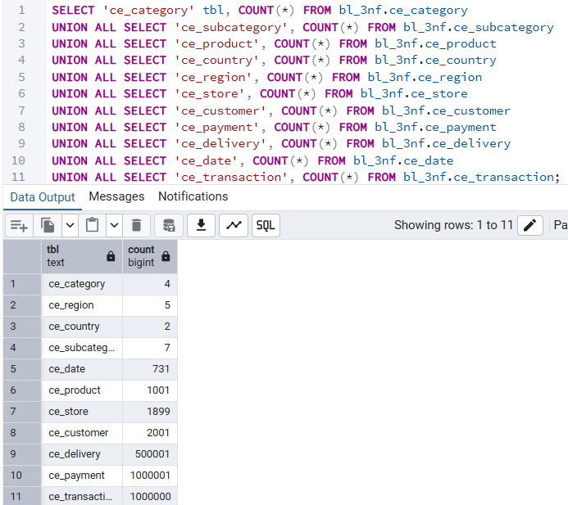

3.2 Hierarchy resolution — product and store
SELECT p.product_id, s.subcategory_name, c.category_name
FROM bl_3nf.ce_product p
JOIN bl_3nf.ce_subcategory s ON s.subcategory_sk = p.subcategory_sk
JOIN bl_3nf.ce_category c ON c.category_sk = s.category_sk
WHERE p.product_sk <> -1;
SELECT st.store_id, r.region_name, co.country_name
FROM bl_3nf.ce_store st
JOIN bl_3nf.ce_region r ON r.region_sk = st.region_sk
JOIN bl_3nf.ce_country co ON co.country_sk = r.country_sk
WHERE st.store_sk <> -1;
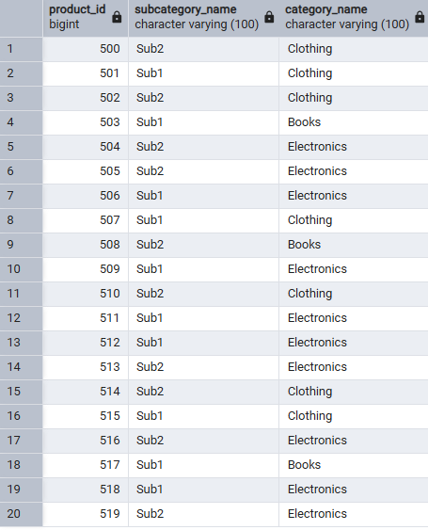
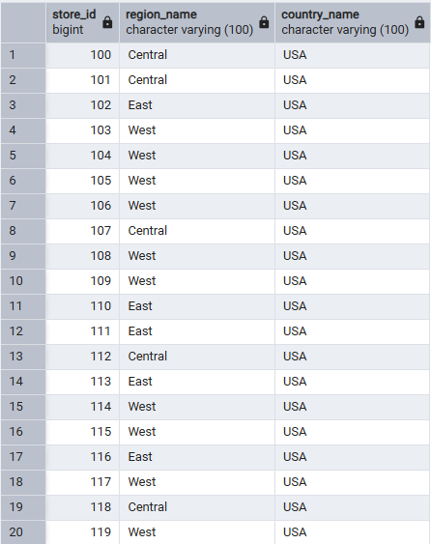

3.3 As-of-date SCD2 join — a customer with more than one version
SELECT t.transaction_id, d.full_date, t.customer_sk, c.customer_city, c.start_dt, c.end_dt, c.is_active
FROM bl_3nf.ce_transaction t
JOIN bl_3nf.ce_date d ON d.date_sk = t.date_sk
JOIN bl_3nf.ce_customer c ON c.customer_sk = t.customer_sk
WHERE c.customer_id = <pick a customer_id with more than one CE_CUSTOMER version>
ORDER BY d.full_date;
Confirm that transactions dated before the attribute change point at the older version, and transactions dated after point at the newer version.
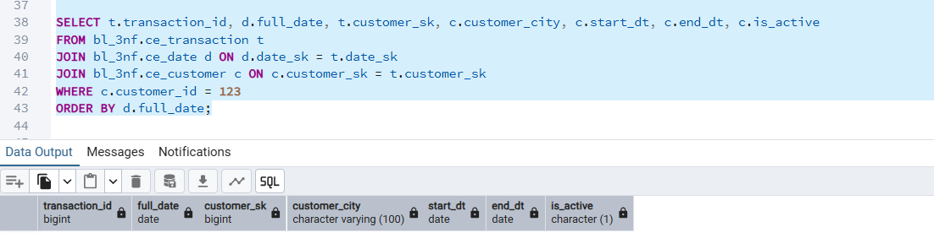
The source data does not contain a customer whose tracked attributes change across transactions, so SCD2 versioning was not triggered for any real customer. The join logic itself was verified with a direct synthetic test instead (two manually-seeded customer versions with real historical date ranges, confirmed transactions before/after the change resolve to the correct version — see the seeded-date test described in section 3

3.4 Rerun check — re-run script 3 with no new staging data and confirm row counts are unchanged
