DWH & Power BI Reporting – Test Strategy
Author: Mariam Avaliani | Data Quality Engineer (Trainee)

1. High-Level Project Diagram
Data flows from the source systems into the Enterprise Data Warehouse (EDW), and from there into three Power BI dashboards. Each dashboard reads its data from the EDW, so any data problem in the EDW can appear in one or more dashboards.
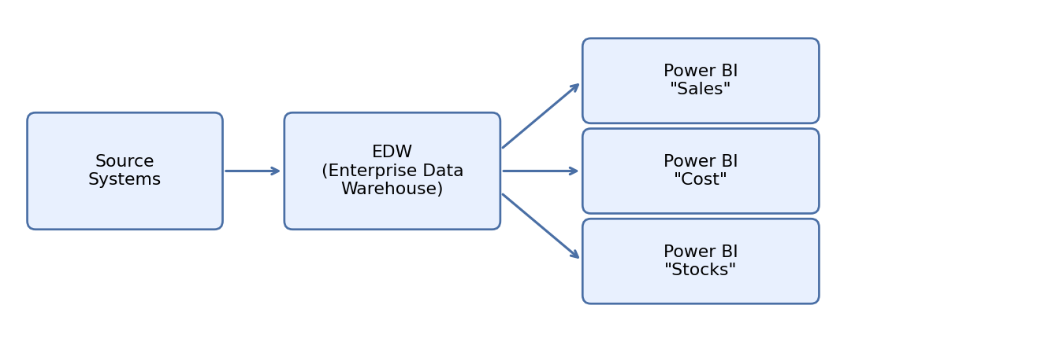
High-level data flow: Source Systems → EDW → Power BI dashboards.

2. Scope of Work
This test strategy covers the verification of data quality and functionality for three Power BI dashboards, tested in the following order of priority:
- Power BI dashboard “Sales”
- Power BI dashboard “Cost”
- Power BI dashboard “Stocks”
For each dashboard, testing focuses on comparing the data shown on the dashboard against the EDW source data, checking the correctness of calculated measures, and verifying that filters and visual elements behave as expected.

3. Entry Criteria
Before testing activities start, the following conditions must be met:
- The EDW is loaded with test data and is available for querying.
- All three Power BI dashboards are deployed to a test workspace and are accessible to the test team.
- The data mapping between the EDW fields and each dashboard's measures and visuals is documented.
- Business rules and expected calculations for each dashboard (for example, how “total cost” or “stock level” should be calculated) are defined and approved.
- Test environment access (EDW credentials, Power BI workspace access) is set up for the test team.

Risks
# | Risk | Severity | Risk Description | Resolution
1 | Dashboard requirements change frequently during development | High | Test cases can become outdated quickly, which causes delays and rework in the test cycle. | Freeze the dashboard requirements before the test cycle starts, or clearly update and re-baseline the affected test cases whenever a change is approved.
2 | EDW data refresh schedule does not match the testing window | Medium | Testers may compare a dashboard against stale or incomplete EDW data, leading to false defects. | Coordinate the EDW refresh schedule with the test team in advance, or trigger a manual refresh right before each test run.
3 | Source systems change without prior notice | Medium | New or changed source data can introduce discrepancies that are not caught until late in testing. | Set up a short weekly sync with the data engineering team to be informed about upcoming source system changes.

4. Test Approach
The following high-level test activities are performed in this order:
1. Review requirements and mapping.
Review the dashboard requirements and the field-level mapping between the EDW and each Power BI dashboard.
2. Verify EDW source data.
Check that the EDW data itself is complete and correct (row counts as expected, no unexpected NULL values, correct data types) before testing anything at the dashboard level.
3. Validate data between EDW and dashboards.
For each dashboard, compare key metrics shown on the dashboard (totals, counts) against the same values calculated directly from the EDW using SQL queries.
4. Verify calculated measures.
Check calculated or derived measures in each dashboard (for example, total sales, cost per unit, stock levels) against the expected business logic.
5. Verify filters and interactivity.
Verify that filters, slicers and drill-down actions on each dashboard return correct and consistent data.
6. Verify visual layout.
Check each dashboard visually: correct titles, labels, chart types, and that no value is cut off or mislabeled.
7. Log defects.
Record every discrepancy found as a defect in the bug tracking tool, with a clear severity and priority.
8. Retest.
Re-test each fixed defect to confirm it is resolved and did not introduce a new problem.
9. Report results.
Summarize the testing outcome, defect statistics and recommendations in the Test Result Report.

