My Jira Onboarding Process
Mariam Avaliani – Task 1
In this document I want to describe the steps I did to finish the Jira onboarding part of Task 1. I will explain it in the order I really did it, and I added screenshots from my own Jira account, so it is easy to follow.

1. Logging in and profile setup
First, I logged in to Jira with my work email, mariami_avaliani@epam.com. When I opened Jira, it showed a welcome page with a few sites, but I did not have access to any of them yet, so I had to click "Request access" on the right site (the one used for our Data Quality group, dq26 project).
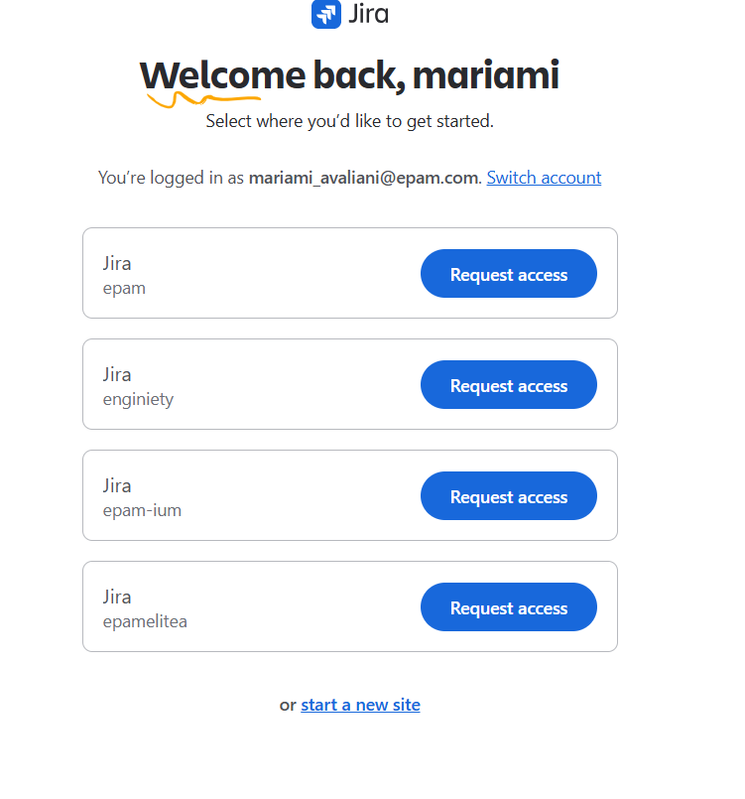
The welcome page where I requested access to the dq26 site.
After I got access, Jira asked me a short question about what kind of work I do, to personalize the experience. I chose "Software development", because it is the closest to QA and testing work, and it gave me the board type I actually needed (Scrum/Kanban style).
I also made sure my Jira profile has my real name and surname, and I uploaded my real photo as the profile picture. I did the same thing on telescope.epam.com, because it also needs a real profile photo.
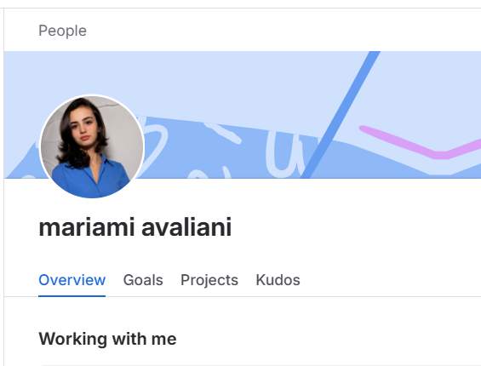
My Jira profile after I added my real name and photo.

2. Creating the self-education task
In the dq26 project, I opened the Backlog and saw that other people from my group already created similar tickets, so I used the same naming style.
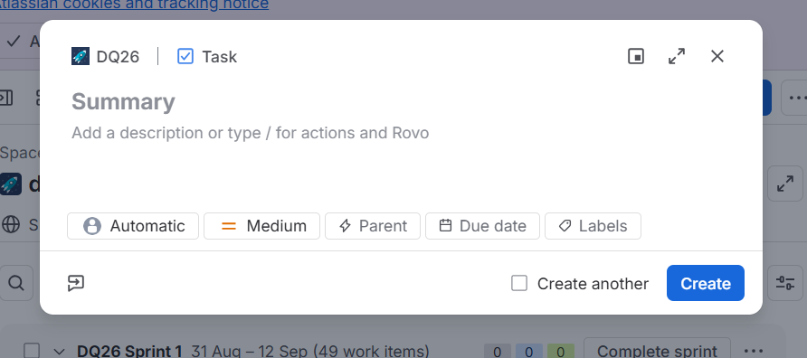
The dq26 backlog, with the other "Study self-education materials" tickets from my group.
I clicked "Create", chose the project dq26 and issue type Task, and filled the fields:
- Summary: "Study self-education materials Mariam Avaliani"
- Assignee: myself (Mariam Avaliani)
- Sprint: DQ26 Sprint 1, same sprint as the rest of the group
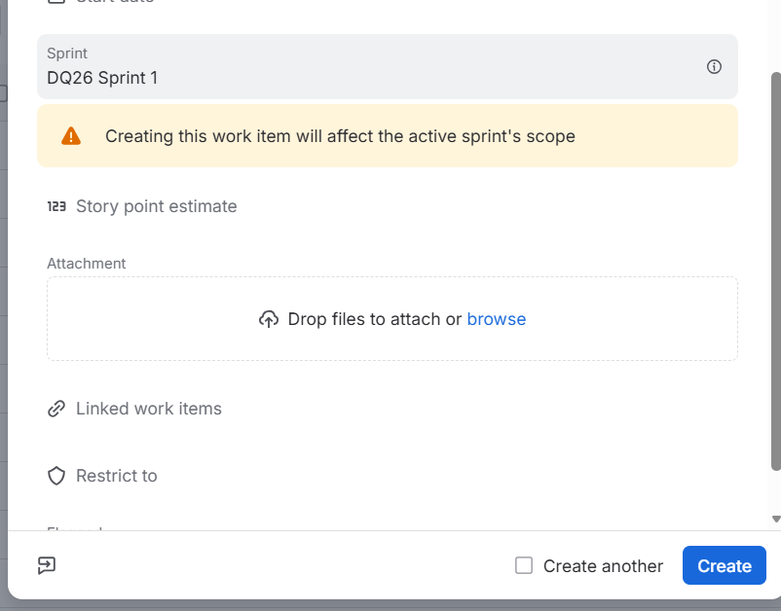
Selecting DQ26 Sprint 1 before creating the ticket.
Before creating it, I opened the full form (all fields) to check that everything needed was visible, and then I pressed "Create". The ticket got the key DQ26-93 and started with the status "To Do".
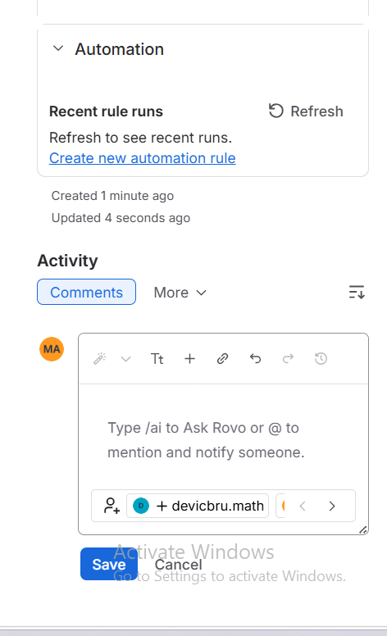
The created ticket DQ26-93 with the Summary, Status and Assignee filled in.

3. Studying the material
The self-education part asked me to read an article about how Jira works for beginners. I read "Get Started with Jira: A Comprehensive Beginner's Guide" by Atlassian. From this article I learned the basic things about Jira, for example what issues and projects are, the difference between Scrum and Kanban boards, how the backlog and sprints work, what statuses like To Do / In Progress / Done mean, and how to assign issues and write comments.

4. Adding a comment and closing the ticket
When I finished reading, I went back to my ticket DQ26-93 and added a comment where I wrote what article I reviewed and put the link to it, so my mentor can check it too.
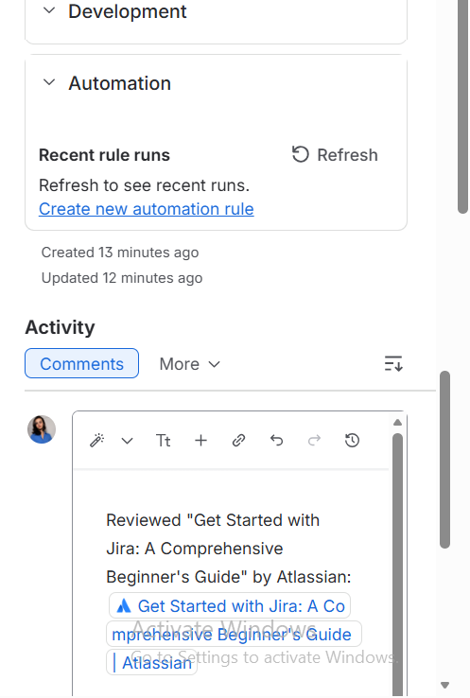
Writing the comment with the link to the article I reviewed.
After that, I changed the status of the ticket from "To Do" to "Done".
Ticket DQ26-93 after I moved it to the Done status.

5. Checklist and GitHub
For the checklist part of Task 1, I chose a computer mouse as my object, because my name starts with "M". I described the object and wrote testing ideas for Smoke, Critical and Extended paths, with positive/negative approach, automation and test type for each item. I saved this as a Word document (Task01_Mariam) and uploaded it to GitHub.

