Task 5 — External Tables on the Staging Layer: Answer

1. What is the purpose of the staging area?
The staging area (the SA_ schemas in this project — SA_RETAIL and SA_ONLINE) is a landing zone that sits between the raw source files and the integrated BL_3NF layer. It exists to:
- Decouple the warehouse from the source. Extraction happens once into staging; every downstream layer (3NF, DM) works off a stable local copy, so a slow, unavailable, or access-restricted source system never blocks the rest of the ETL pipeline.
- Preserve the raw data for traceability. Because EXT_ tables read the file as-is and SRC_ tables keep the source's native structure and values, the original data can always be re-inspected or reprocessed without going back to the source system.
- Give the ETL a safe place to standardize format and type. CSV text is not typed — dates, numbers, and codes need to be parsed and cast into real PostgreSQL types before any business logic can run reliably.
- Absorb structural differences between heterogeneous sources. Retail and Online have different column sets (Region/StoreSize vs. ShippingCost/DeliveryType/DeliveryStatus/DeliveryTime). Staging keeps each source's native shape; only 3NF forces them into one shared, integrated entity.
- Provide the first opportunity to clean and deduplicate, before bad or repeated rows can reach — and corrupt — the integrated model.

2. Why can't data be loaded directly into the 3NF layer?
BL_3NF is an integrated, conformed model: one CE_CUSTOMER table (for example) serves both the Retail and Online source systems, with a single surrogate-key scheme, source-triplet lineage, SCD2 history for Customer, and NOT NULL / typed columns. Raw CSV rows cannot satisfy any of that directly, because they are:
- Untyped and unvalidated — e.g., TransactionDate arrives as free text ("8/4/2024"), not a DATE, and nothing has checked for blank or malformed fields yet.
- Not deduplicated — the same file can contain repeated TRANSACTION_ID rows (this project's source data was intentionally duplicated/expanded, so this is a real, not hypothetical, risk).
- Not conformed across sources — the same concept can be labeled differently per system (e.g. TransactionChannel = 'InStore' in the raw Retail file vs. the 'Retail' label used downstream), and each source carries only its own subset of columns.
- Missing warehouse-only technical columns — surrogate keys, the source triplet (SOURCE_SYSTEM / SOURCE_ENTITY / SOURCE_ID), and audit dates only exist once the ETL process generates them; they are not present in the source file.
If raw or duplicate rows were loaded straight into BL_3NF, the error would propagate into every dependent object — every DIM_/FCT_ table in the star schema is built from BL_3NF, so a bad row here becomes wrong numbers everywhere downstream. It is far cheaper to catch and fix the problem once, upstream, in staging, than to trace it back through the whole warehouse after the fact.
This is why the pipeline is deliberately staged in single-purpose hops:
raw CSV file → EXT_ (foreign table, zero-copy read) → SRC_ (typed, deduplicated, audited staging table) → CE_ (BL_3NF: integrated, conformed, surrogate-keyed) → DIM_ / FCT_ (BL_DM: star schema)

3. What was built for this task
Two schemas were created, one per source data set, per the naming convention (SA_<SOURCE_SYSTEM_NAME>):
Source system | Schema | External (foreign) table | Source (staging) table
Retail (in-store) | sa_retail | ext_retail_sales | src_retail_sales
Online (e-commerce) | sa_online | ext_online_sales | src_online_sales
Each EXT_ table is a PostgreSQL foreign table built with the file_fdw extension, reading the CSV directly with no data copied yet. Each SRC_ table is a real, physical table loaded from its EXT_ counterpart with: correct data types (including an explicit TO_DATE cast for the transaction date instead of relying on file_fdw's implicit casting), exact-duplicate TRANSACTION_ID rows removed using DISTINCT ON (transaction_id), and the required INSERT_DT / SOURCE_SYSTEM / SOURCE_ENTITY audit columns. See 01_staging_retail_sales.sql and 02_staging_online_sales.sql for the full DDL/DML.
Both scripts were test-run end-to-end against sample data (including an intentionally duplicated row) to confirm the file_fdw setup, date parsing, and deduplication logic all work correctly before being pointed at the real project data.

4. Verification Screenshots
The screenshots below confirm that the external (foreign) and source (staging) tables were created successfully in PostgreSQL and contain the loaded data for both source systems.

4.1 sa_retail.ext_retail_sales
SELECT * FROM sa_retail.ext_retail_sales LIMIT 5;
Shows the foreign table reading directly from retail_500k.csv through file_fdw -- no data has been copied into PostgreSQL yet, this is a live read of the file.
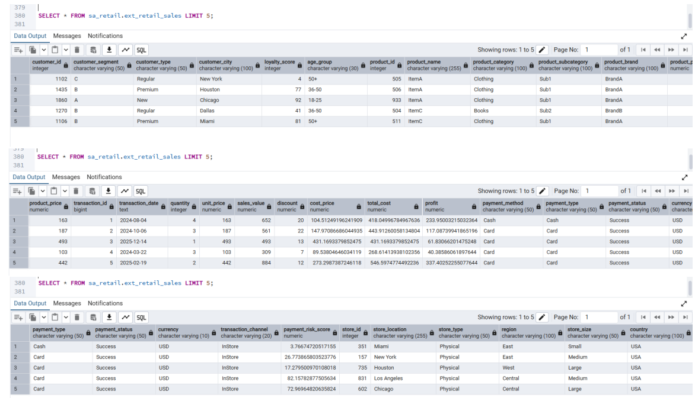

4.2 sa_retail.src_retail_sales
SELECT * FROM sa_retail.src_retail_sales LIMIT 5;
Shows the staging table after loading: correct data types (e.g. TRANSACTION_DATE as a real DATE), plus the INSERT_DT / SOURCE_SYSTEM / SOURCE_ENTITY audit columns added during the load.
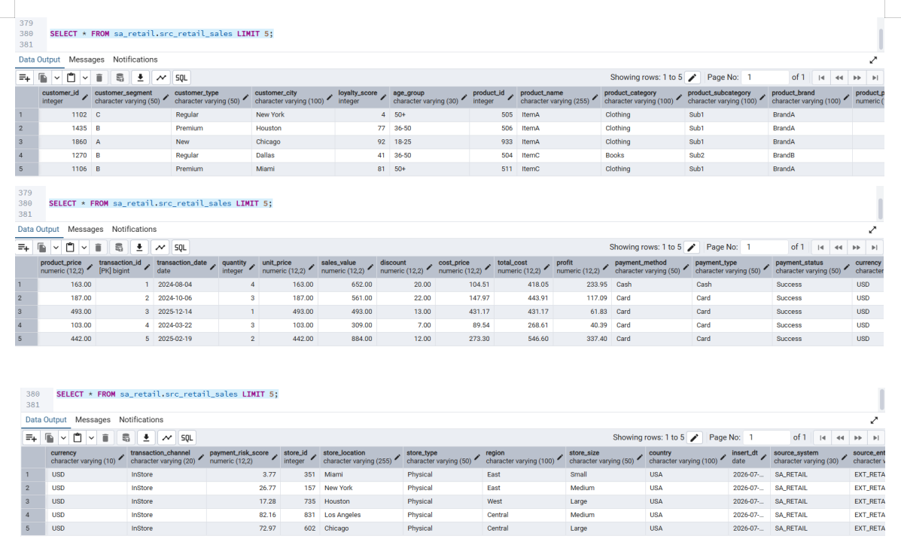

4.3 sa_online.ext_online_sales
SELECT * FROM sa_online.ext_online_sales LIMIT 5;
Shows the foreign table reading directly from online_500k.csv through file_fdw.
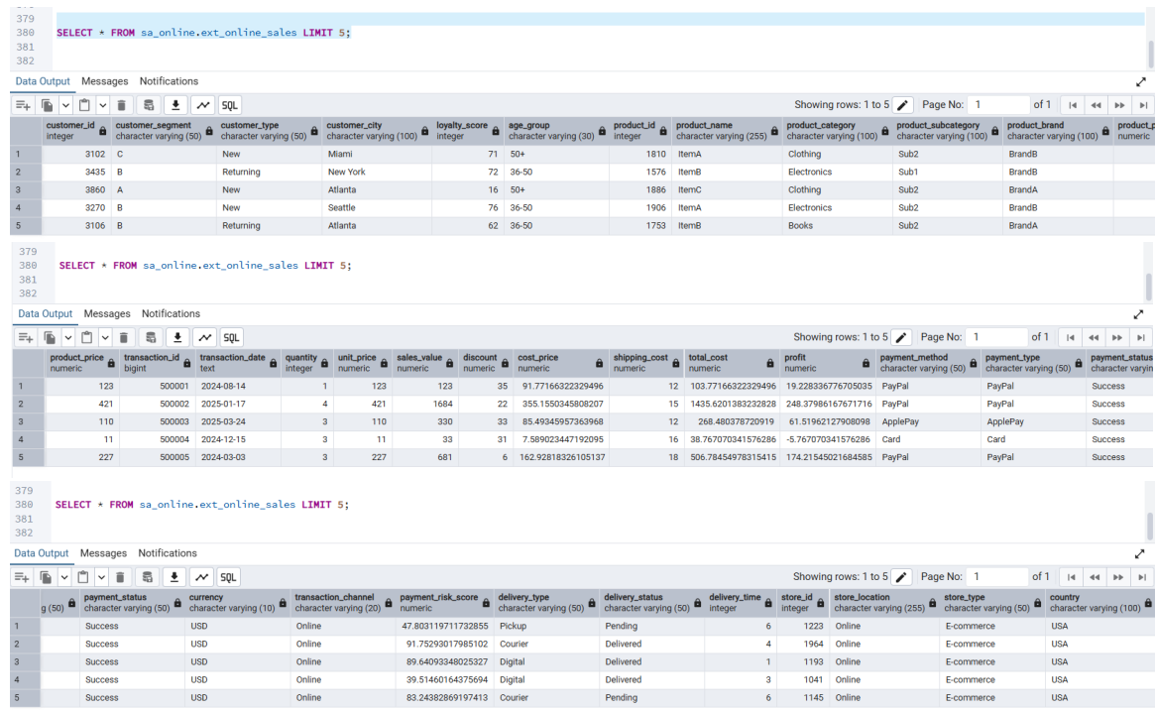

4.4 sa_online.src_online_sales
SELECT * FROM sa_online.src_online_sales LIMIT 5;
Shows the staging table after loading, with the same type corrections and audit columns as the retail table, plus the Online-only columns (SHIPPING_COST, DELIVERY_TYPE, DELIVERY_STATUS, DELIVERY_TIME).
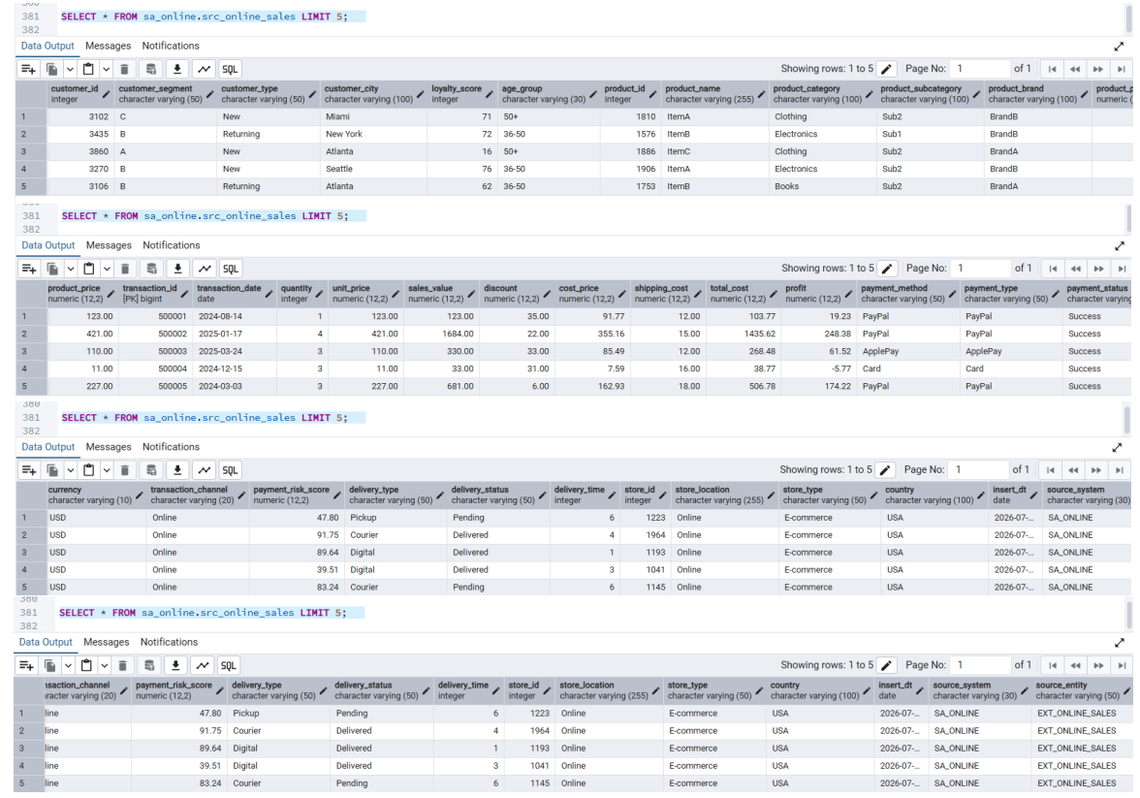

4.5 Deduplication check -- Retail
SELECT (SELECT COUNT(*) FROM sa_retail.ext_retail_sales) AS ext_rows,
(SELECT COUNT(*) FROM sa_retail.src_retail_sales) AS src_rows;
Result: ext_rows = 500,000, src_rows = 500,000. All TRANSACTION_ID values in the retail file were already unique, so the DISTINCT ON (transaction_id) deduplication logic found nothing to remove. This confirms the load is complete and no rows were lost during staging.
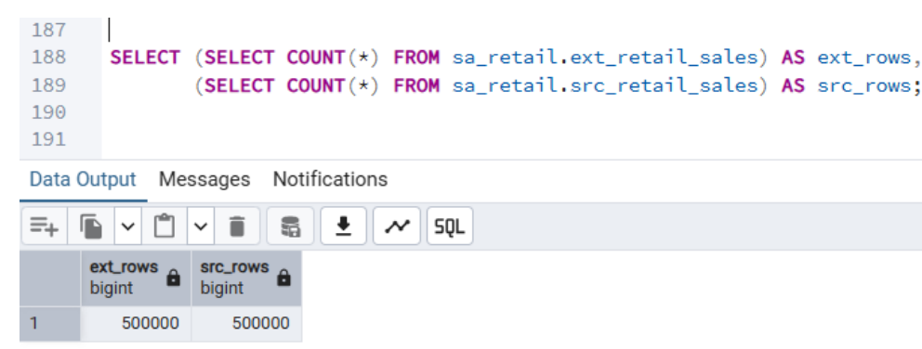

4.6 Deduplication check -- Online
SELECT (SELECT COUNT(*) FROM sa_online.ext_online_sales) AS ext_rows,
(SELECT COUNT(*) FROM sa_online.src_online_sales) AS src_rows;
Result: ext_rows = 500,000, src_rows = 500,000. Same outcome as the retail file -- all TRANSACTION_ID values were already unique.
