Task 12 – Integration Testing and Selenium Basics
Homework write-up
Mariam Avaliani | Data Quality / Data Engineering course

Setup
Before I could run any of the code, I had to install the packages I needed for this homework: pytest, requests, boto3, moto, allure-pytest, and selenium. My terminal (PowerShell) did not recognize the pip and python commands, so instead I installed the packages directly through PyCharm, in Settings → Project → Python Interpreter. I searched for each package name one by one and clicked "Install Package".
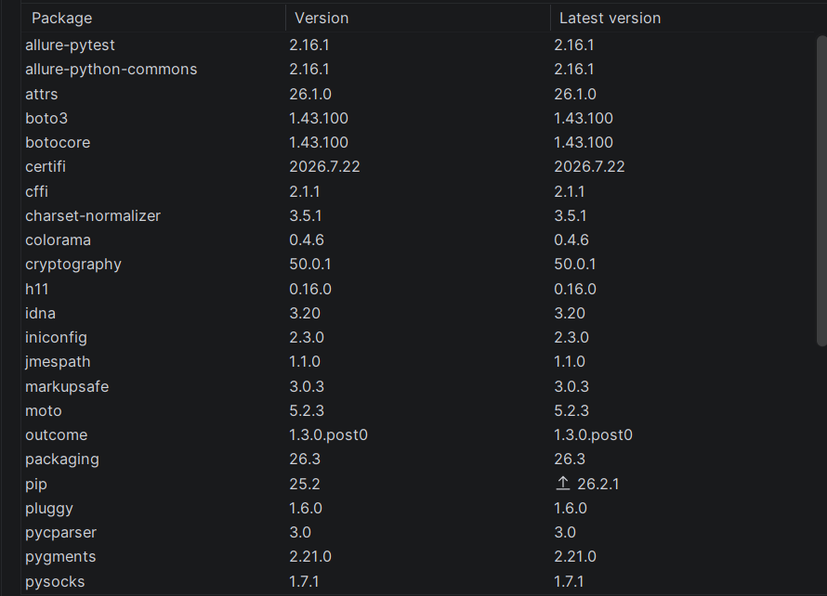
The installed packages, part 1
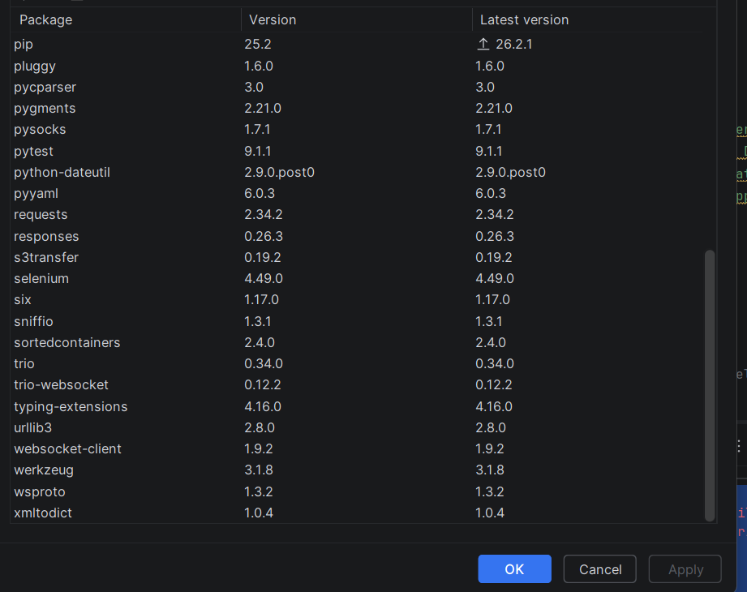
The installed packages, part 2 – pytest, requests and selenium are all there with their versions

Task 1 – API testing with requests + pytest
For this task I tested two different things in one file, using two test classes.
The first class, TestUserPosts, tests a simple REST API (JSONPlaceholder, a fake API made for practice). I send 10 POST requests to create posts for one user and check that each one comes back with status code 201. Then I send a GET request and check that the API returns exactly 10 posts for that user.
The second class, TestBucketDataPresence, is closer to what we do in the Data Warehousing course. It checks that, for a given date, both a GCP bucket (the source) and an AWS bucket (the target) actually contain data. This is the kind of check you would run after a pipeline moves data from one cloud to another – if a bucket is empty, something went wrong. I don't have real AWS or GCP accounts, so in conftest.py I used the moto library to create a fake AWS S3 bucket in memory, and a simple mock object to stand in for the GCP client. This way the test logic runs for real, without touching any real cloud account.
I ran the test file in PyCharm (Run → pytest in task1_api_test.py) and all 4 tests passed.
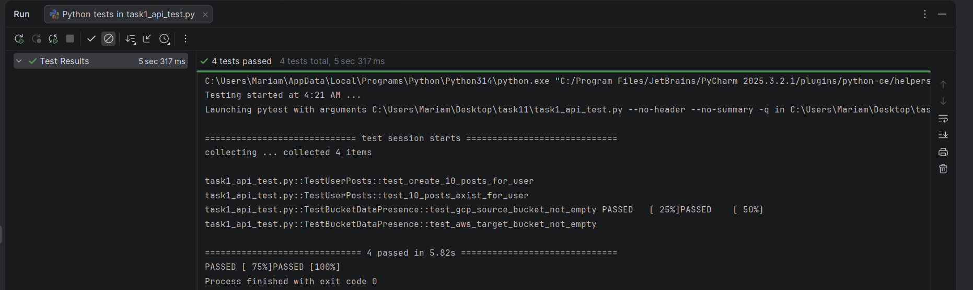
task1_api_test.py – all 4 tests passed

Task 2 – Opening Chrome and Firefox with WebDriver
This task asks to open google.com in both Chrome and Firefox and print the page title, using two different ways of managing the browser driver.
For Chrome, I used the automatic approach: webdriver.Chrome() alone is enough, because Selenium Manager (built into Selenium 4.6+) finds and downloads the correct ChromeDriver by itself. I don't have to configure anything.
For Firefox, I used the manual approach: I would need to download geckodriver myself from the official GitHub releases page, and either put it on my system PATH or give its exact file location in the code with FirefoxService(executable_path=...). I wrote both parts of the code to show I understand the difference, even though this task did not need a screenshot.

Task 3 – Locators
For this task I had to find page elements using six different locator strategies: class name, id, name, CSS selector, XPath, and a relative locator. I used two real pages from phptravels – phptravels.com/demo and phptravels.org/register.php – and looked for fields like first name, last name and email with each method.
When I ran the script, Chrome opened by itself and went to these pages automatically. This is normal – Selenium is controlling the browser directly, so I don't click anything myself, I just watch it work.
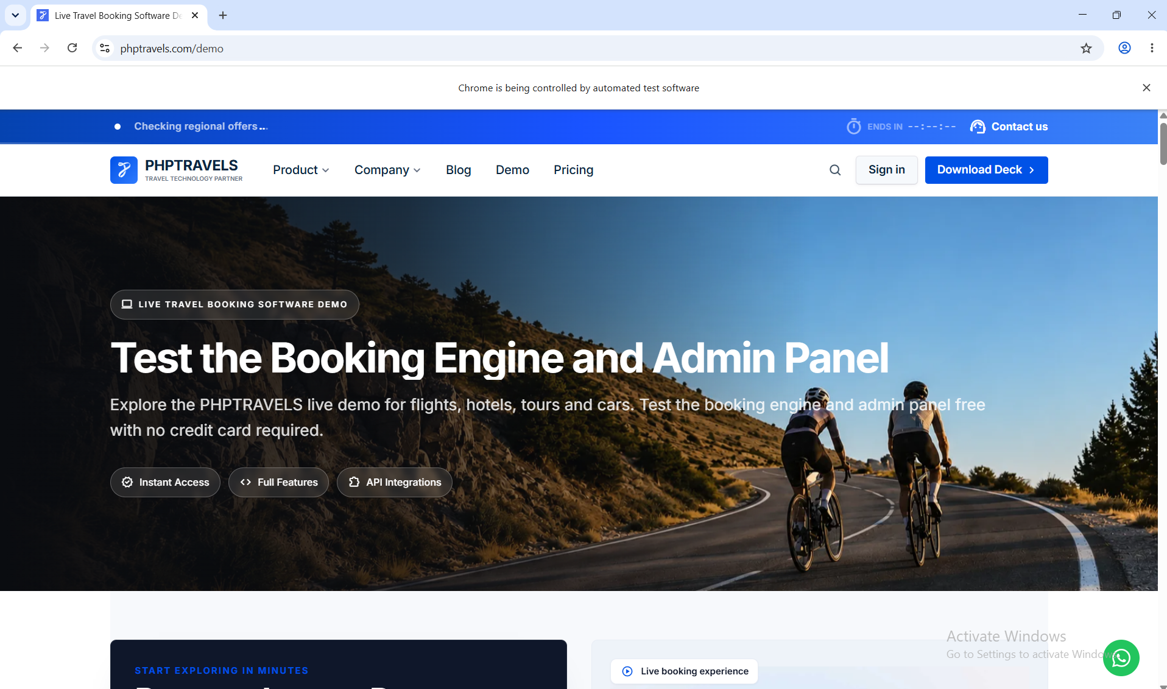
Selenium controlling Chrome automatically on phptravels.com/demo (banner at the top confirms it)
I ran into one error on the XPath part. My first attempt, //input[@class='email'], could not find the field. I looked into why: By.CLASS_NAME matches an element if the given class is one of several classes on that element, but a plain XPath [@class='email'] only matches if the whole class attribute is exactly that one word. Since the real field had more than one class on it, the exact-match XPath failed. I fixed it by using //input[contains(@class, 'first_name')] instead, which works the same way By.CLASS_NAME does. After that fix, all 10 locators (2 for each of the 5 strategies, plus the relative locator) found their elements correctly, and the script finished with exit code 0.

Task 4 – Implicit and explicit waits
This task asks to open a search engine, search for "Selenium", wait for the results, and open the first one – using both an implicit wait and an explicit wait.
Implicit wait is set once on the driver (driver.implicitly_wait(5)) and applies to every element search after that: WebDriver keeps polling the page for up to 5 seconds before giving up. Explicit wait is more targeted – I used WebDriverWait(driver, 10).until(...) to wait specifically for the search results to actually appear before trying to click the first one, since that is the one step where timing is unpredictable.
I tried this on google.com first, but Google blocked the automated browser with a reCAPTCHA check instead of showing search results. This is a well-known problem with Selenium and Google – it is not a mistake in the code, Google's bot detection just does not like automated traffic.
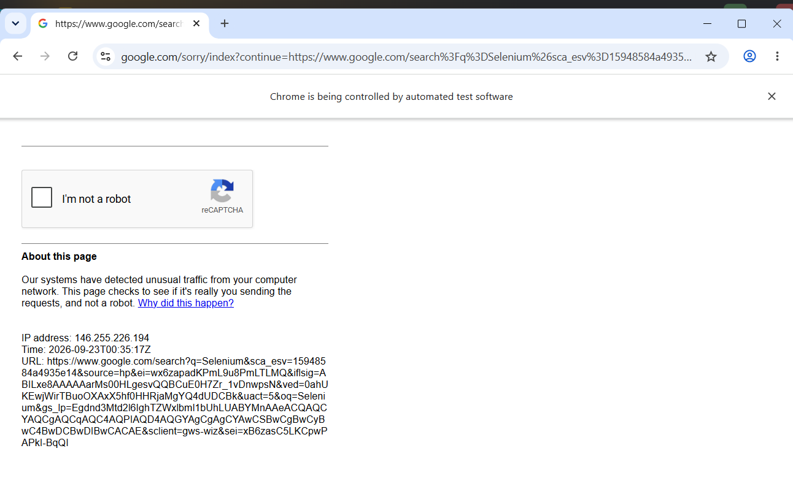
Google blocking the automated browser with a reCAPTCHA check
I switched to DuckDuckGo instead, which does not block Selenium the same way. I kept the same wait logic, just changed the search results locator to match DuckDuckGo's page. After that, the script opened DuckDuckGo, typed "Selenium", waited for the results, and clicked the first one – it landed on selenium.dev.
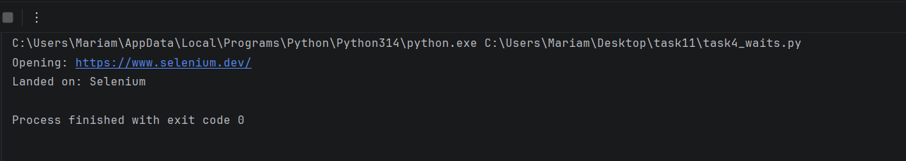
task4_waits.py – opened selenium.dev successfully after switching to DuckDuckGo

