AWS Cloud for Data Engineering
Task 2 – EC2

Prepared by: Mariam Avaliani
Date: 25 August 2026
AWS Account: 260586643565 Region: eu-central-1 (Frankfurt)

Introduction
In this task, I worked with Amazon EC2. I launched an EC2 instance, installed PostgreSQL on it, connected to it with DBeaver, and created a table, a view and a procedure. I copied a file from my S3 bucket to the instance, made a snapshot of the data volume, built an AMI from that snapshot and launched a new instance from it. I also installed Apache on the instance, set up a CloudWatch alarm with an SNS topic, and recreated the instance with a CloudFormation template.

1. Launching the EC2 instance
I launched a t2.micro instance called mariam-avaliani-db-ec2, using Amazon Linux 2023. For the security group, I used the shared SSH-Access-SG group (tagged dilab-training-new), which already allows the traffic this task needs. I attached the AWS_EC2_full_access_S3 IAM role, so the instance can reach S3 without extra credentials. I also required IMDSv2 for the instance metadata service, as the task asks.
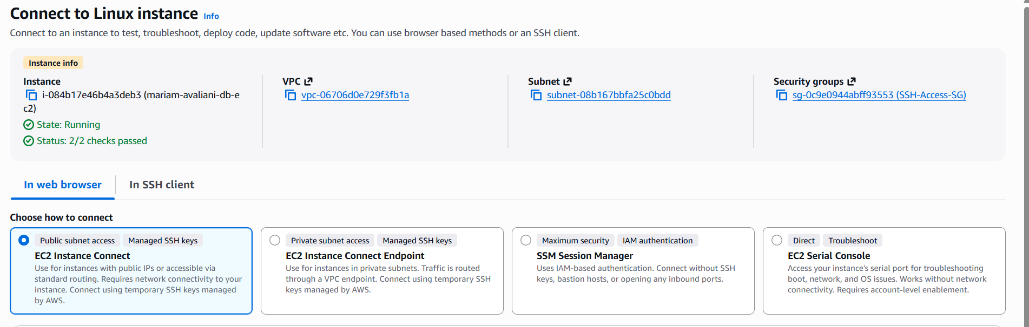
Screenshot 1. The instance mariam-avaliani-db-ec2, State: Running, Status: 2/2 checks passed.
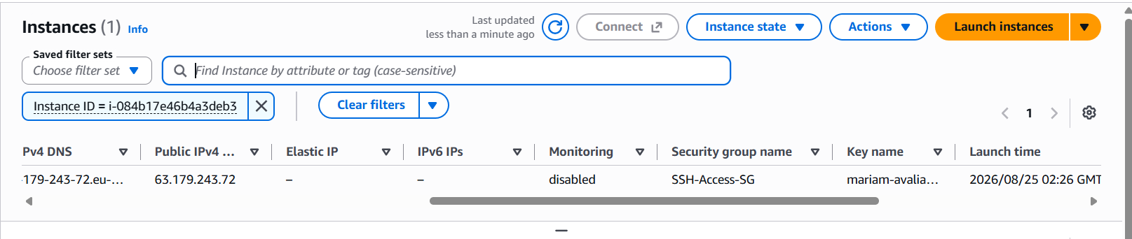
Screenshot 2. Instance details, showing the SSH-Access-SG security group and the mariam-avaliani-key key pair.
I checked the instance metadata options and confirmed that IMDSv2 is set to Required:
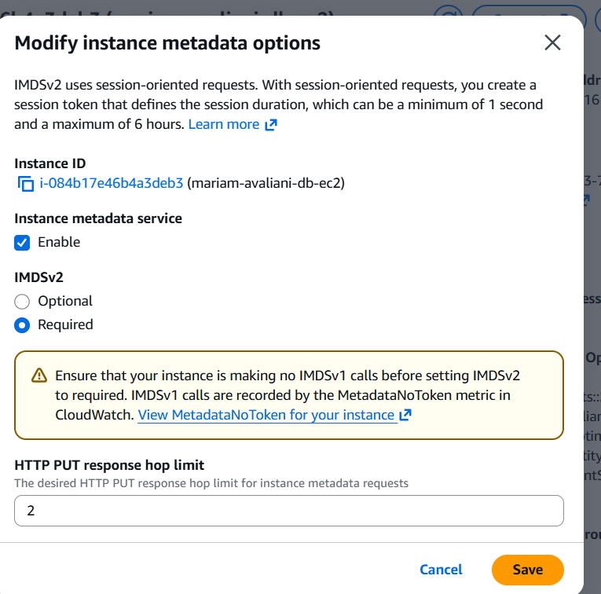
Screenshot 3. Instance metadata options: Instance metadata service Enabled, IMDSv2 Required.
For storage, the instance has an 8 GB root volume and a separate 10 GB data volume, as the task asks. I connected to the instance from PowerShell with my key pair:
PS> ssh -i mariam-avaliani-key.pem ec2-user@63.179.243.72
Last login: ... from ...
[ec2-user@ip-172-31-32-16 ~]$

2. Installing PostgreSQL
I installed PostgreSQL 15 from the command line with dnf, then initialised and started the database:
sudo dnf install postgresql15 postgresql15-server -y
sudo postgresql-setup --initdb
sudo systemctl enable postgresql
sudo systemctl start postgresql
sudo systemctl status postgresql
Active: active (running)
Then I set a password for the postgres database user:
sudo -u postgres psql -c "ALTER USER postgres PASSWORD '********';"
ALTER ROLE

3. Connecting with DBeaver
To connect from DBeaver, I first tried to open port 5432 on the SSH-Access-SG security group, but this failed, because the students-role does not have permission to change this shared security group:
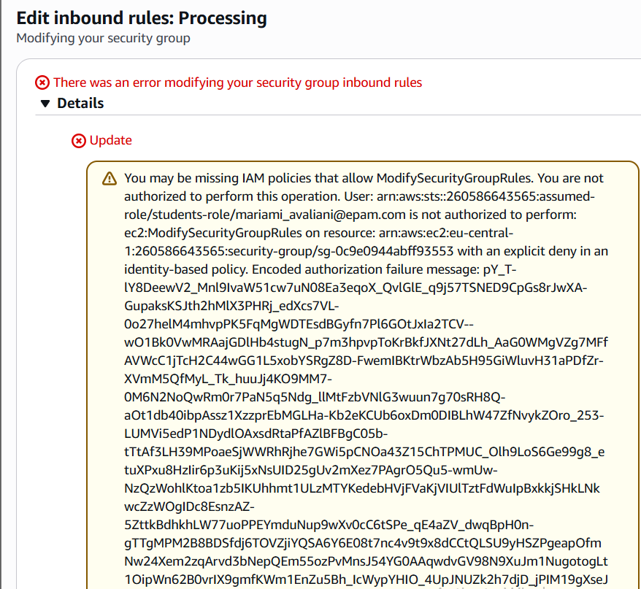
Screenshot 4. Error when trying to add an inbound rule to SSH-Access-SG: not authorized to perform ec2:ModifySecurityGroupRules.
Because of this, I used an SSH tunnel instead of opening the port directly. This way, DBeaver connects to localhost on port 5432, and the traffic goes through the same SSH connection (port 22) that I already use to reach the instance, so I did not need to change the security group at all. I set the SSH Tunnel host to 63.179.243.72, port 22, user ec2-user, and used my .pem key as the private key.
I also had to update the PostgreSQL authentication file (pg_hba.conf), because by default it uses the ident method for local connections, and the tunnel arrives as a local (127.0.0.1) connection. I changed this to scram-sha-256 and restarted PostgreSQL:
sudo sed -i -E '/127\.0\.0\.1\/32/s/ident/scram-sha-256/' /var/lib/pgsql/data/pg_hba.conf
sudo sed -i -E '/::1\/128/s/ident/scram-sha-256/' /var/lib/pgsql/data/pg_hba.conf
sudo systemctl restart postgresql
After that, the connection worked:
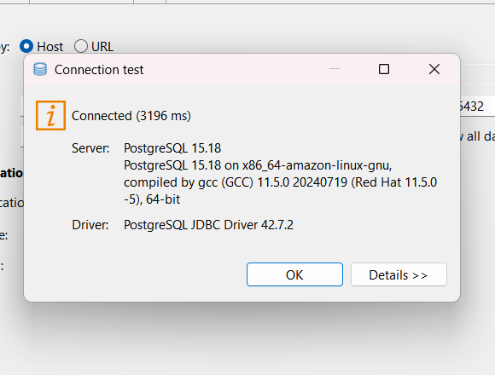
Screenshot 5. DBeaver connection test: Connected (3196 ms), PostgreSQL 15.18.

4. Creating a table, a view and a procedure
In the DBeaver SQL editor, I created a table called students, a view called active_students, and a procedure called add_student. I called the procedure once to add a new row, and then checked the table:
CREATE TABLE students (
id SERIAL PRIMARY KEY,
full_name VARCHAR(100) NOT NULL,
course VARCHAR(50),
enrolled_at DATE DEFAULT CURRENT_DATE
);

CREATE VIEW active_students AS
SELECT id, full_name, course FROM students
WHERE enrolled_at >= CURRENT_DATE - INTERVAL '1 year';

CREATE OR REPLACE PROCEDURE add_student(p_name VARCHAR, p_course VARCHAR)
LANGUAGE plpgsql AS $$
BEGIN
INSERT INTO students (full_name, course) VALUES (p_name, p_course);
END;
$$;

CALL add_student('New Student', 'Cloud AWS');
SELECT * FROM students;
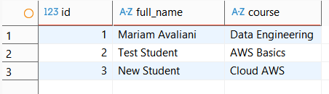
Screenshot 6. Result of SELECT * FROM students, including the row added by the procedure.

5. Copying a file from S3
My S3 bucket contains the data warehouse files from Task 1, under dwh_project/bl_dm/. I copied one of the smaller files, dim_dates.csv, to the instance using the AWS CLI. Because the instance already has the AWS_EC2_full_access_S3 role attached, I did not need to configure any separate credentials:
aws s3 cp s3://mariam-avaliani-de-training-260586643565/dwh_project/bl_dm/dim_dates/dim_dates.csv /home/ec2-user/
download: s3://.../dim_dates.csv to ./dim_dates.csv

ls -la /home/ec2-user/dim_dates.csv
-rw-r--r--. 1 ec2-user ec2-user 204 Aug 24 19:16 /home/ec2-user/dim_dates.csv

cat /home/ec2-user/dim_dates.csv
date_surr_id,full_date,day_of_month_num,day_of_week_num,day_of_week_desc,weekend_flag,
month_num,month_desc,quarter_num,quarter_desc,year_num,insert_dt
-1,1900-01-01,1,1,n.a.,N,1,n.a.,1,NA,1900,1900-01-01

6. Snapshot of the data volume and a new AMI
Before making the snapshot, I formatted and mounted the separate 10 GB data volume, and copied the file I downloaded from S3 onto it, so the snapshot would have something to prove that data persists:
sudo mkfs -t xfs /dev/xvdb
sudo mkdir /data
sudo mount /dev/xvdb /data
sudo cp /home/ec2-user/dim_dates.csv /data/
echo "/dev/xvdb /data xfs defaults,nofail 0 2" | sudo tee -a /etc/fstab
In the EC2 console, under Volumes, I selected the 10 GB data volume attached to my instance and created a snapshot:
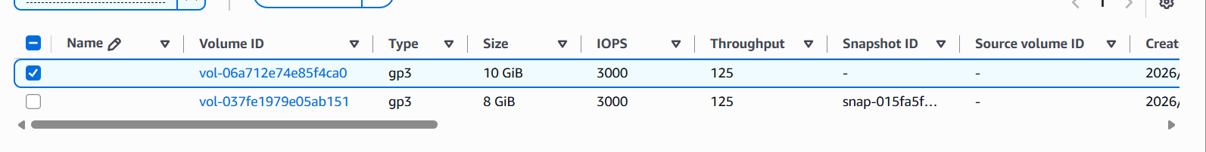
Screenshot 7. The 10 GiB data volume selected before creating a snapshot.
Then, from Snapshots, I created an AMI (mariam-avaliani-data-ami) from that snapshot:
Screenshot 8. New AMI created: ami-00b8d8ae20c705d71.

7. Launching a new EC2 from the AMI and checking that the file persisted
I launched a new instance from this AMI, with the same IMDSv2, IAM role and security group settings as before:
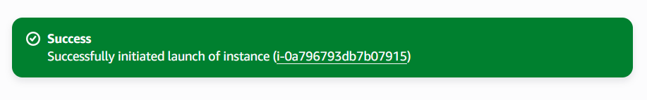
Screenshot 9. New instance launched from the AMI: i-0a796793db7b07915.
This new instance stayed in the Stopped state and had no public IP. This makes sense: the AMI was built from the data volume, not from the system (root) volume, so its root disk has no operating system on it and it cannot start. To check that the file survived the whole snapshot-to-AMI process, I detached the new instance's disk and attached it to my working instance instead, as a second data disk:
Screenshot 10. The volume from the new instance successfully attached to the working instance.
On the working instance, I mounted this disk with the nouuid option, because it is a copy of a disk that was already mounted (same filesystem UUID), and then checked the file:
sudo mkdir -p /verify_ami_data
sudo mount -o nouuid /dev/xvdf /verify_ami_data
cat /verify_ami_data/dim_dates.csv
date_surr_id,full_date,day_of_month_num,day_of_week_num,day_of_week_desc,weekend_flag,
month_num,month_desc,quarter_num,quarter_desc,year_num,insert_dt
-1,1900-01-01,1,1,n.a.,N,1,n.a.,1,NA,1900,1900-01-01
The file content is exactly the same as the original, so the data persisted through the whole volume-snapshot-AMI process.

8. Installing Apache
Before installing Apache, I checked the inbound rules of the SSH-Access-SG security group. All three existing rules already allow all traffic, so port 80 was already open and I did not need to change anything:
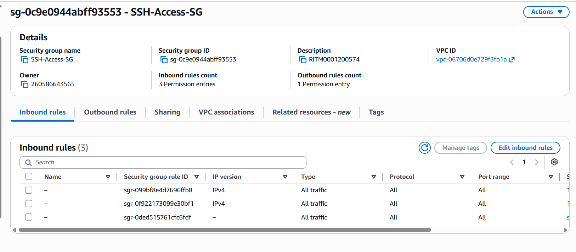
Screenshot 11. SSH-Access-SG inbound rules: all three rules allow all traffic on all ports.
I installed and started Apache, then created a simple index.html page in /var/www/html:
sudo dnf install httpd -y
sudo systemctl enable httpd
sudo systemctl start httpd
Active: active (running), listening on: port 80
I opened the instance's public IP address in a browser, and the page loaded correctly:
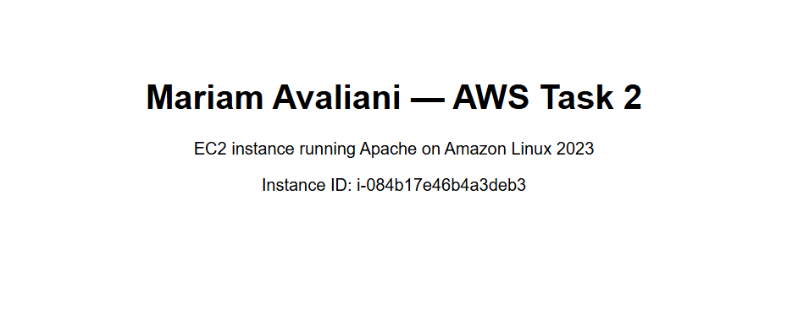
Screenshot 12. The Apache page at http://63.179.243.72, served from /var/www/html.

9. CloudWatch alarm and SNS topic
I created an SNS topic called mariam-avaliani-ec2-alerts, and added an email subscription with my own email address:
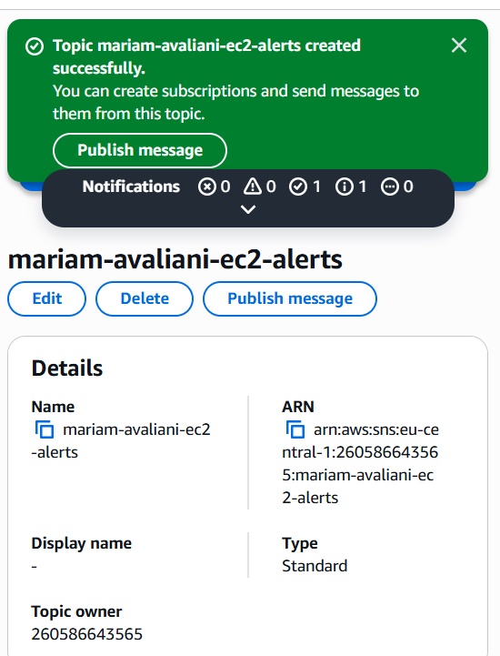
Screenshot 13. SNS topic mariam-avaliani-ec2-alerts created.
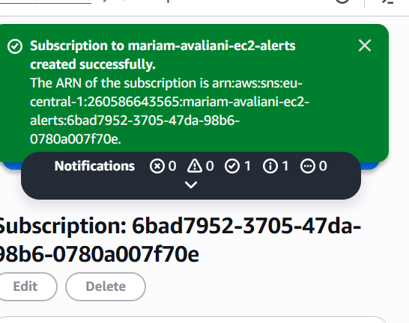
Screenshot 14. Email subscription added to the topic.
Then, in CloudWatch, I created an alarm on the CPUUtilization metric of my instance, set to trigger when CPU usage is greater than 70%, and connected it to the SNS topic:
Screenshot 15. CloudWatch alarm mariam-avaliani-cpu-alarm created and linked to the SNS topic.

10. Recreating the EC2 with CloudFormation
I wrote a CloudFormation template that recreates the same EC2 setup: a t2.micro instance with the current Amazon Linux 2023 AMI, the SSH-Access-SG security group, the AWS_EC2_full_access_S3 IAM instance profile, IMDSv2 required, an 8 GB root volume, and a separate 10 GB data volume attached to it.
Resources:
EC2Instance:
Type: AWS::EC2::Instance
Properties:
ImageId: '{{resolve:ssm:/aws/service/ami-amazon-linux-latest/al2023-ami-kernel-default-x86_64}}'
InstanceType: t2.micro
KeyName: mariam-avaliani-key
SecurityGroupIds: [sg-0c9e0944abff93553]
IamInstanceProfile: AWS_EC2_full_access_S3
MetadataOptions:
HttpEndpoint: enabled
HttpTokens: required
BlockDeviceMappings:
- DeviceName: /dev/xvda
Ebs: { VolumeSize: 8, VolumeType: gp3 }
Tags: [{Key: Name, Value: mariam-avaliani-cfn-ec2}, {Key: owner, Value: student}]

DataVolume:
Type: AWS::EC2::Volume
Properties:
Size: 10
VolumeType: gp3
AvailabilityZone: !GetAtt EC2Instance.AvailabilityZone

DataVolumeAttachment:
Type: AWS::EC2::VolumeAttachment
Properties:
InstanceId: !Ref EC2Instance
VolumeId: !Ref DataVolume
Device: /dev/sdb
I created a stack called mariam-avaliani-task2-stack from this template in the CloudFormation console. All three resources (the instance, the data volume and the attachment) finished with CREATE_COMPLETE:
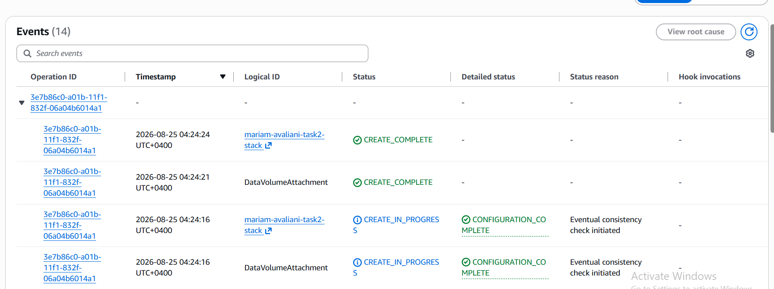
Screenshot 16. CloudFormation stack events: EC2Instance, DataVolumeAttachment and the stack itself all show CREATE_COMPLETE.
Finally, I uploaded the same template file to my S3 bucket, under a cloudformation/ folder:
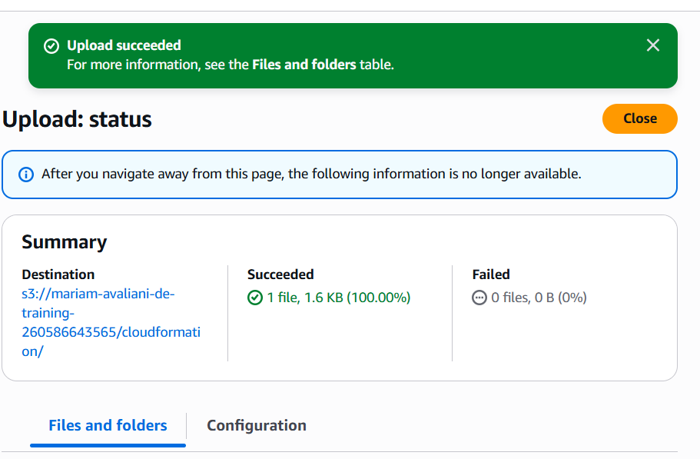
Screenshot 17. Template uploaded to s3://mariam-avaliani-de-training-260586643565/cloudformation/.

Conclusion
In this task, I launched an EC2 instance with the required security group, IAM role and IMDSv2 setting, installed PostgreSQL and connected to it with DBeaver over an SSH tunnel, and created a table, a view and a procedure. I copied a file from S3 to the instance using the attached IAM role, made a snapshot of the data volume, built an AMI from it, and launched a new instance from that AMI. I confirmed that the file survived the whole process by checking its content after attaching the recovered volume to my working instance. I installed Apache and confirmed the page is reachable from a browser, created a CloudWatch alarm connected to an SNS topic, and recreated the same EC2 setup with a CloudFormation template, which I also uploaded to S3. I stopped the EC2 instances once I finished testing them, to avoid unnecessary cost.

References
- Amazon EC2 – user guide
- Amazon EBS snapshots
- Creating an AMI from a snapshot
- Instance metadata and IMDSv2
- Amazon CloudWatch alarms
- Amazon SNS
- AWS CloudFormation

