
POWER BI FINAL PROJECT
ORBIX Retail Group — Sales & Profitability Report
Business Background

Company
ORBIX Retail Group is an omnichannel, multi-category retailer selling Books, Clothing, and Electronics through a network of physical stores (flagship, standard, and warehouse formats) and a direct-to-consumer e-commerce platform.

Logo Concept
A minimalist orbit symbol formed by three connected nodes, representing the company’s three product categories and its two sales channels operating as one connected ecosystem. Navy (trust, stability) is paired with a teal accent (modern, digital) to reflect a technology-driven retail brand.

Field of Activity
ORBIX operates in Georgia (headquarters and flagship store in Tbilisi) and the United States (regional physical stores across the Central, East, and West regions), giving it a cross-border, dual-market retail footprint across in-store and online channels.

Business Process
The report exposes and analyzes the end-to-end sales transaction process — from customer purchase (in-store or online), through product pricing and discounting, payment processing, to order fulfillment and delivery (courier, digital, or pickup) — covering the 2024–2025 period, with roughly one million transactions split evenly between in-store and online channels.

Purpose of the Report
To give business stakeholders a single, interactive view of sales performance, profitability, and operational efficiency across product categories, sales channels, customer segments, and geographies — enabling faster, evidence-based decisions instead of manual spreadsheet reporting.

End User
Regional and category sales managers, the executive/management team, and the marketing team — anyone who needs a quick, self-service view of business performance without querying the database directly.

Business Questions & Problems Addressed
- Which product category or brand generates the most revenue and profit?
- How does performance compare between the InStore and Online channels — which is more profitable?
- Which customer segment (A/B/C, Premium/Regular/New/Returning) delivers the most value?
- Is there a significant share of failed payments, and in which payment method?
- Are there delivery delays (Pending share), and in which delivery type (Courier/Digital/Pickup)?
- What is the sales trend by month/quarter — is there seasonality?
- Which store, region, or country (USA vs. Georgia) is leading, and which needs attention?

Project Process

Connecting to the Data
For this project, I used the data warehouse (DWH_PROJECT) that I built in the previous module. It is a PostgreSQL database with several schemas: staging layers, a 3NF layer, a control layer, and a data mart (bl_dm) with a star schema. I connected Power BI Desktop to this database using the PostgreSQL connector, with the server address and database name from pgAdmin.
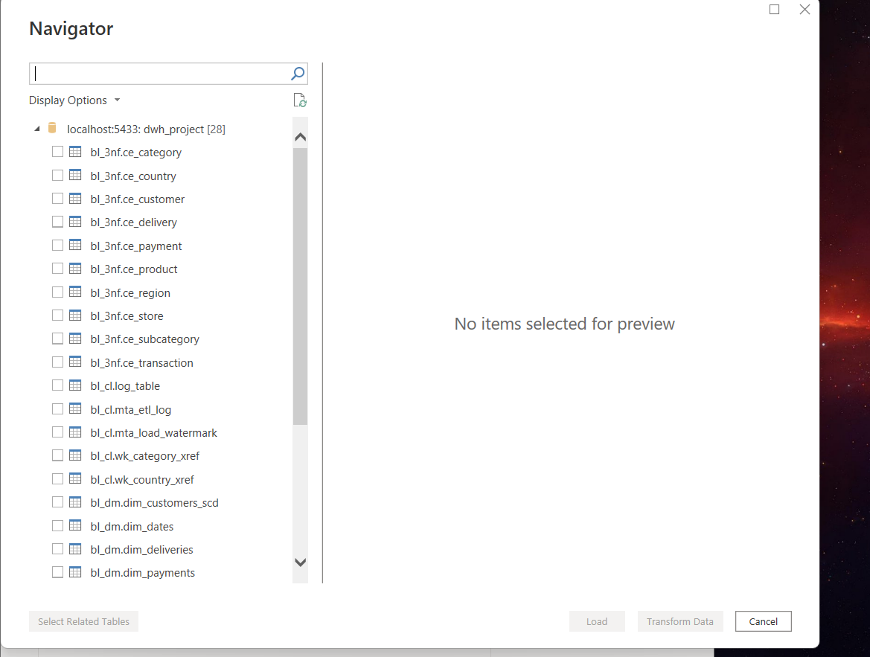

Loading and Cleaning the Data
In the Navigator window, I selected only the tables from the bl_dm schema, because this is the layer that is ready for reporting. I did not select the partition tables of the fact table, because the main table already includes all the data from its partitions. In Power Query, I cleaned the dimension tables by keeping only the valid values in each column and removing placeholder values like "Type1" or unclear test data. To decide which values were valid, I first checked the real data in the database with a few SQL queries.
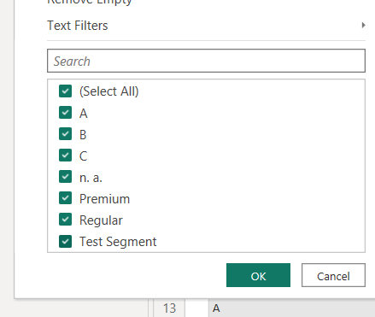

Building the Data Model
After loading the tables, I built the star schema model. Most of the relationships were created automatically, but I added one manually between the customer table and the fact table. While building the model, I found a few data quality issues in the source data warehouse itself, which I explain in detail in the Data Quality Notes section at the end of this document.
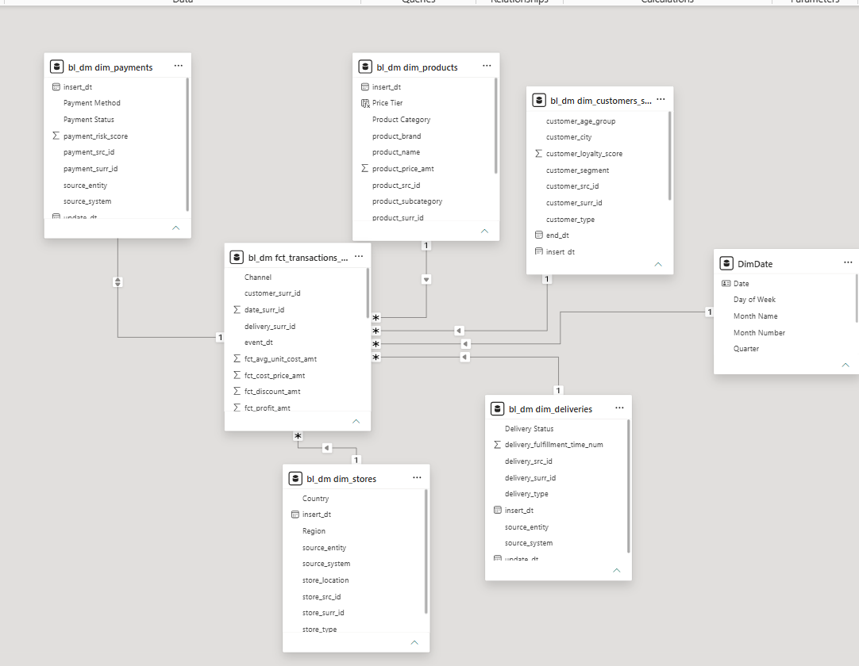
Figure. Final data model — DimDate replaces the unused placeholder date table.

DAX Calculations
I created two calculated columns, Order Value Tier and Price Tier, to group transactions and products by value. I also wrote several measures, for example Total Sales, Total Profit, Profit Margin %, Total Transactions, Average Order Value, and Failed Payment Rate. One of the measures builds the title of a chart automatically, depending on which product category is selected.
For the calendar table, I did not want to hardcode a fixed date range, because the report should keep working correctly if new transactions are loaded later without me having to edit the formula. So I built DimDate using the minimum and maximum transaction dates from the fact table, and generated the calendar between those two values, adding Year, Month Number, Month Name, Quarter, Day of Week, Weekend Flag and Season as extra columns. I marked this table as the official date table in Model view.
DimDate =
VAR MinDate = CALCULATE(MIN('bl_dm fct_transactions_dd'[event_dt]))
VAR MaxDate = CALCULATE(MAX('bl_dm fct_transactions_dd'[event_dt]))
RETURN
ADDCOLUMNS(
CALENDAR(MinDate, MaxDate),
"Year", YEAR([Date]),
"Month Number", MONTH([Date]),
"Month Name", FORMAT([Date], "MMMM"),
"Quarter", "Q" & QUARTER([Date]),
"Day of Week", FORMAT([Date], "dddd"),
"Weekend Flag", IF(WEEKDAY([Date],2) > 5, "Y", "N"),
"Season",
SWITCH(
TRUE(),
MONTH([Date]) IN {12,1,2}, "Winter",
MONTH([Date]) IN {3,4,5}, "Spring",
MONTH([Date]) IN {6,7,8}, "Summer",
"Autumn"
)
)

Designing the Report
I designed the report for a company idea called ORBIX Retail Group, with a custom logo, colors and theme. The report has three pages: Overview, Products & Categories, and Channels & Operations. Every page has KPI cards, charts, and a table with conditional formatting on the profit margin column. The chart title on this page changes automatically depending on the selected category. I also added a hidden drillthrough page that shows transaction-level details for a selected category, and a hidden tooltip page that appears when hovering over the sales chart.
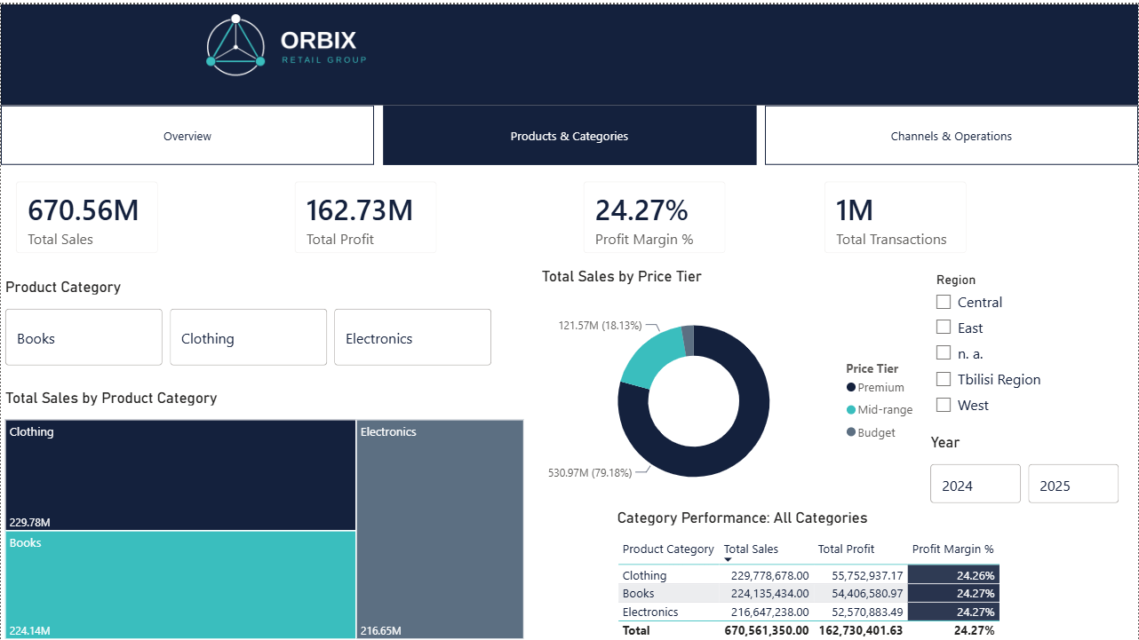
Figure. Products & Categories page — conditional formatting on Profit Margin %, dynamic table title, and data labels on every visual.

Navigation
To make the report easier to use, I added a page navigator with buttons at the top of every page, so the user can move between the three main pages without using the page tabs at the bottom.
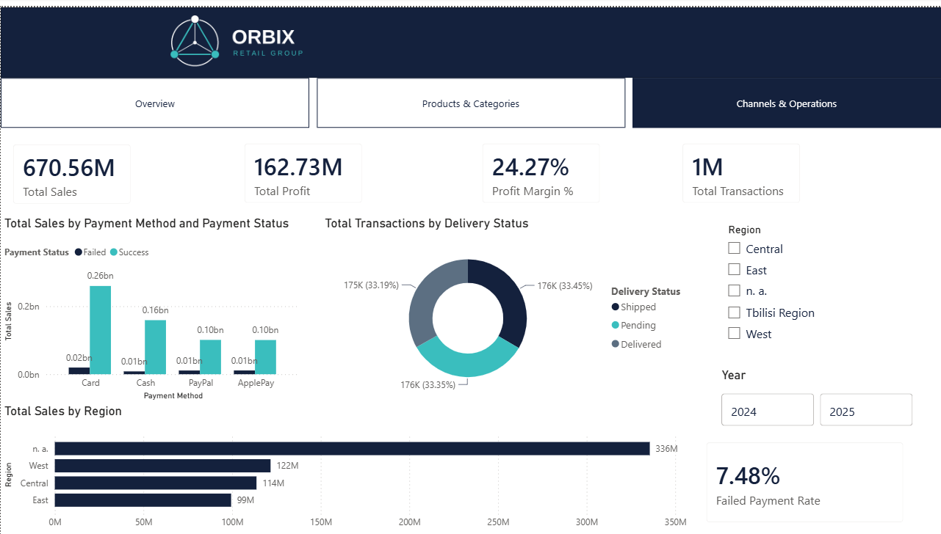
Figure. Channels & Operations page, with the page navigator at the top and the Year / Region slicers on the right.

Revisions After Mentor Feedback
After I finished the first version of the report, I sent it to my mentor for review. The feedback covered naming, layout, filters, and a couple of best-practice points about the data model, so I went back into the report and worked through each comment one by one.
Naming and Report Title
A few chart and axis titles were still showing raw column names, like product_category or store_region, so I renamed them into readable labels such as "Total Sales by Product Category" and "Total Sales by Region". I also added the report title, ORBIX Retail Group — Sales & Profitability Report, to the first page, and renamed the .pbix file to match it, since a report and its file are usually expected to share the same name.
Filters and Interactivity
The original report did not give the user any way to filter the data beyond clicking directly on a chart. I added a Year slicer and a Region slicer on the Overview page, and synced them across all three pages using Power BI's Sync Slicers feature, so a selection made on one page applies everywhere automatically. I also turned on data labels on every visual that was still missing them, including the treemap on the Products & Categories page, so the numbers are visible without hovering.
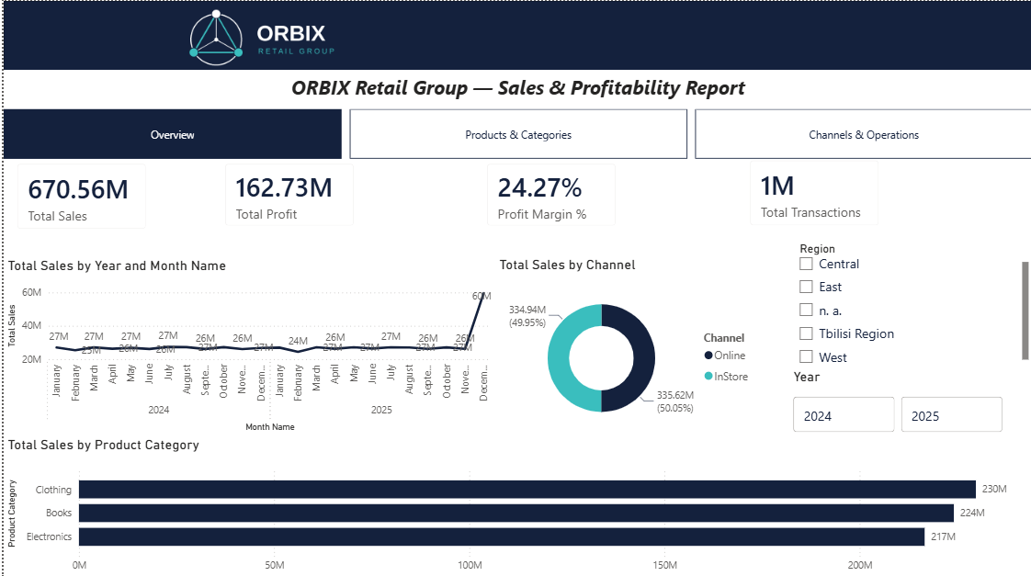
Figure. Overview page, final version — report title, synced Year / Region slicers, and the rebuilt monthly sales trend.
Fixing the Sales Trend Chart
The line chart on the Overview page was originally built directly on the daily transaction date, which meant it was plotting close to a thousand individual points. Since sales average close to one million GEL per day, almost every point showed roughly "1M" and the whole chart looked flat, with one distorted spike at the very end where the axis collapsed. I rebuilt it using Year and Month Name from the DimDate table instead of the raw date, so it now shows a proper monthly trend, with each point around 24–27M, and a clear seasonal increase in December — which is much easier to read and closer to how the business actually performs.
Dynamic Calendar Table
The DimDate table originally used a fixed date range through the CALENDAR function, which is not ideal, because it would not extend automatically if new transactions are added later. I rebuilt it so the start and end dates come directly from the minimum and maximum transaction dates in the fact table (shown in the DAX Calculations section above), and I removed the bl_dm_dim_dates table from the model completely, since it was the original single-row placeholder table from the data warehouse and was not used in any visual.
Improving the Tooltip
The custom tooltip page on the sales chart originally just repeated the Total Sales figure, which is already visible as a data label on the chart itself. My mentor pointed out that a custom tooltip should show something the chart does not already say, so I replaced it with a Sales MoM % measure that compares the current month's sales to the previous month:
Sales MoM % =
VAR CurrentSales = [Total Sales]
VAR PreviousMonthSales = CALCULATE([Total Sales], DATEADD(DimDate[Date], -1, MONTH))
RETURN
DIVIDE(CurrentSales - PreviousMonthSales, PreviousMonthSales)
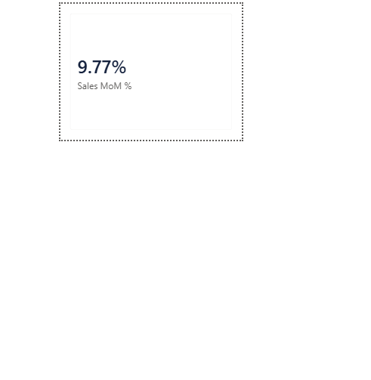
Figure. Sales MoM % on the custom tooltip page.
Alignment and Layout
On the Products & Categories page there was a large gap between the donut chart and the table below it, which made the page feel unbalanced next to the treemap on the left. I moved the donut chart up and resized both columns so they line up more evenly (see the Designing the Report section above). I also fixed an overlap on the Channels & Operations page, where the chart titles were partly hidden behind the KPI cards after I added the slicers.

Publishing to Power BI Service
When the report was ready, I published it to Power BI Service from Power BI Desktop. I checked that the pages, navigation and visuals worked correctly online, and after renaming the file to match the report title, I re-published it and took a screenshot of the publish confirmation below. I also shared the report with my mentor so it can be reviewed online.
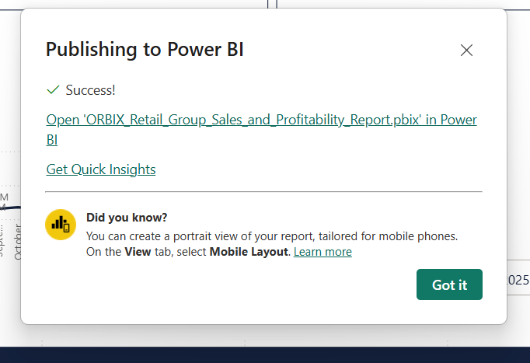
Figure 1. Publish confirmation, showing the report saved as ORBIX_Retail_Group_Sales_and_Profitability_Report.pbix.

Data Quality Notes
While building the model, I found several real problems in the data warehouse itself, and I want to explain them clearly instead of hiding them.
First, the date dimension table (dim_dates) in the database had only one row, a default placeholder row. Because of this, I could not use it for a real date hierarchy, so I built a new date table directly in Power BI with DAX (CALENDAR and ADDCOLUMNS functions) and connected it to the fact table on the transaction date instead.
Second, the customer_surr_id column in the fact table was equal to -1, the default "unknown" value, for 100% of the transactions, close to one million rows. This means the data warehouse never linked transactions to a real customer record. Because of this, I could not build a customer segmentation analysis, so I removed this idea from the report instead of showing a chart full of blank or incorrect values.
Third, the store_region column was empty for the E-commerce and Warehouse store types, because these store types do not have a physical region by design. At first, my Power Query filter removed these rows completely, which made all Online and Warehouse transactions disappear from the store-based charts. I fixed this by keeping these rows in Power Query and labeling them clearly instead of hiding them.
Fourth, the delivery_surr_id column was empty for InStore transactions. This is not a data problem, it is expected, because in-store purchases do not need a delivery record.
I decided to explain all of these findings in the report and in this document, instead of hiding them or showing wrong numbers.

