PostgreSQL for DWH and ETL Building
Task 6: Partitioning and Parallel Execution — Answer
Every statement below was run for real against a local PostgreSQL 16 instance (10,000,000-row tables) to design and verify this lab; the SQL blocks are exactly what to run yourself. Orange dashed boxes mark where to paste your own pgAdmin/DBeaver screenshot of that step’s result. The "Why" paragraphs explain what each result means and, where useful, quote the reference run’s numbers for comparison — your own timings will differ (they depend on your machine) but the plan shapes and relative differences should match.

1. Partitioning

1.1 Task 1: Use Inheritance
Setup — base table, 5 yearly child tables, indexes
CREATE TABLE sales_info
(
id INTEGER,
category VARCHAR(1),
ischeck BOOLEAN,
eventdate DATE
);

CREATE TABLE sales_info_2022 (
CHECK (eventdate >= '2022-01-01' AND eventdate < '2023-01-01')
) INHERITS (sales_info);
CREATE TABLE sales_info_2023 (
CHECK (eventdate >= '2023-01-01' AND eventdate < '2024-01-01')
) INHERITS (sales_info);
CREATE TABLE sales_info_2024 (
CHECK (eventdate >= '2024-01-01' AND eventdate < '2025-01-01')
) INHERITS (sales_info);
CREATE TABLE sales_info_2025 (
CHECK (eventdate >= '2025-01-01' AND eventdate < '2026-01-01')
) INHERITS (sales_info);
CREATE TABLE sales_info_2026 (
CHECK (eventdate >= '2026-01-01' AND eventdate < '2027-01-01')
) INHERITS (sales_info);

CREATE INDEX sales_info_2022_eventdate ON sales_info_2022 (eventdate);
CREATE INDEX sales_info_2023_eventdate ON sales_info_2023 (eventdate);
CREATE INDEX sales_info_2024_eventdate ON sales_info_2024 (eventdate);
CREATE INDEX sales_info_2025_eventdate ON sales_info_2025 (eventdate);
CREATE INDEX sales_info_2026_eventdate ON sales_info_2026 (eventdate);

Partition function and trigger
CREATE OR REPLACE FUNCTION partition_sales_info() RETURNS trigger
AS $$
BEGIN
IF (new.eventdate >= '2026-01-01'::DATE AND new.eventdate < '2027-01-01'::DATE) THEN
INSERT INTO sales_info_2026 VALUES (new.*);
ELSEIF (new.eventdate >= '2025-01-01'::DATE AND new.eventdate < '2026-01-01'::DATE) THEN
INSERT INTO sales_info_2025 VALUES (new.*);
ELSEIF (new.eventdate >= '2024-01-01'::DATE AND new.eventdate < '2025-01-01'::DATE) THEN
INSERT INTO sales_info_2024 VALUES (new.*);
ELSEIF (new.eventdate >= '2023-01-01'::DATE AND new.eventdate < '2024-01-01'::DATE) THEN
INSERT INTO sales_info_2023 VALUES (new.*);
ELSEIF (new.eventdate >= '2022-01-01'::DATE AND new.eventdate < '2023-01-01'::DATE) THEN
INSERT INTO sales_info_2022 VALUES (new.*);
ELSE
RAISE EXCEPTION 'Out of range';
END IF;
RETURN NULL;
END;
$$ LANGUAGE plpgsql;

CREATE TRIGGER partition_sales_info_trigger
BEFORE INSERT ON sales_info
FOR EACH ROW EXECUTE PROCEDURE partition_sales_info();

Load 10,000,000 test rows and verify (task template, unchanged)
-- this INSERT goes through the trigger row-by-row: expect ~2-3 minutes
INSERT INTO sales_info(id, category, ischeck, eventdate)
SELECT id
, ('{"A","B","C","D","E","F","J","H","I","J","K"}'::text[])[((RANDOM())*10)::INTEGER] category
, ((1*(RANDOM())::INTEGER)<1) ischeck
, (NOW() - '10 day'::INTERVAL * (RANDOM()::int * 100))::DATE eventdate
FROM generate_series(1,10000000) id;

SELECT 'sales_info_2022' tbl, count(*) FROM sales_info_2022
UNION ALL SELECT 'sales_info_2023', count(*) FROM sales_info_2023
UNION ALL SELECT 'sales_info_2024', count(*) FROM sales_info_2024
UNION ALL SELECT 'sales_info_2025', count(*) FROM sales_info_2025
UNION ALL SELECT 'sales_info_2026', count(*) FROM sales_info_2026
UNION ALL SELECT 'sales_info (parent, direct rows)', count(*) FROM ONLY sales_info;

SELECT eventdate, count(*) FROM sales_info GROUP BY eventdate ORDER BY 1;
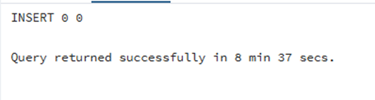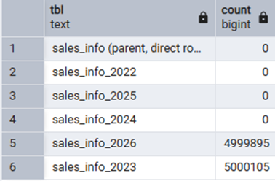
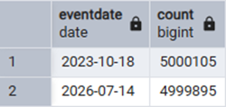

Why: expect only 2 of the 5 yearly partitions to receive any data, and the parent table to stay empty (reference run: 2023 got 4,998,106 rows, 2026 got 5,001,894, all others 0). The reason is a quirk in the task’s own random-date formula: RANDOM() returns a float in [0,1), and PostgreSQL casts float8 → int with round-half-to-even, so RANDOM()::int can only ever be exactly 0 or 1. That means "RANDOM()::int * 100" is only ever 0 or 100, so eventdate collapses to exactly two possible values: today’s date and today minus 1000 days. This is a property of the provided template, not of partitioning itself. It also confirms that the parent sales_info table genuinely has no storage of its own — its own direct row count is 0.
Update some rows and set another eventdate — three behaviours to observe
1) An UPDATE that would move a row to a different partition:
UPDATE sales_info SET eventdate = '2024-06-15'::DATE WHERE id = 3;
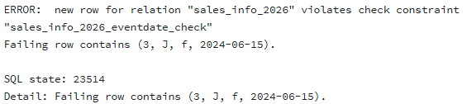
Why: expect this to FAIL with "violates check constraint sales_info_2023_eventdate_check". There is only a BEFORE INSERT trigger — no equivalent hook exists for UPDATE. The physical row lives in exactly one child table (sales_info_2023) and UPDATE modifies it in place there; since the new date no longer satisfies that child’s own CHECK constraint, the write is rejected. Inheritance-based partitioning never automatically re-routes a row between partitions.
2) An UPDATE that stays inside the current partition’s date range:
UPDATE sales_info SET category = 'Z' WHERE id BETWEEN 1 AND 500000;
SELECT tableoid::regclass AS partition, count(*) FROM sales_info WHERE category = 'Z' GROUP BY 1;
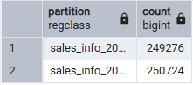
Why: this succeeds normally (reference: 249,870 in sales_info_2023 and 250,130 in sales_info_2026) because eventdate itself never changes, so the row never needs to leave its child table.
3) The correct way to actually move a row across partitions under inheritance — DELETE + re-INSERT through the trigger:
CREATE TEMP TABLE moved_rows AS
SELECT id, category, ischeck, '2024-06-15'::DATE AS eventdate
FROM sales_info WHERE id BETWEEN 1000001 AND 1000010;

DELETE FROM sales_info WHERE id BETWEEN 1000001 AND 1000010;
INSERT INTO sales_info SELECT * FROM moved_rows;

SELECT tableoid::regclass AS partition, id, eventdate FROM sales_info WHERE id BETWEEN 1000001 AND 1000010 ORDER BY id;
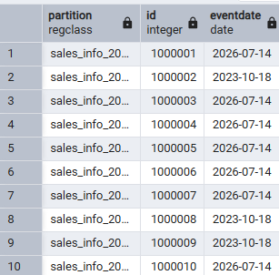
Why: DELETE removes the physical row, and the subsequent INSERT goes back through the BEFORE INSERT trigger, which routes it by the new eventdate — this is the only reliable way to move a row under inheritance-based partitioning.
SALES_INFO_SIMPLE (unpartitioned twin) and plan comparisons
CREATE TABLE sales_info_simple (id INTEGER, category VARCHAR(1), ischeck BOOLEAN, eventdate DATE);
INSERT INTO sales_info_simple SELECT id, category, ischeck, eventdate FROM sales_info;
SELECT count(*) FROM sales_info_simple;
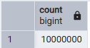
Query 1 — SELECT ALL
-- sales_info
EXPLAIN (ANALYZE, BUFFERS) SELECT * FROM sales_info;

-- sales_info_simple
EXPLAIN (ANALYZE, BUFFERS) SELECT * FROM sales_info_simple;
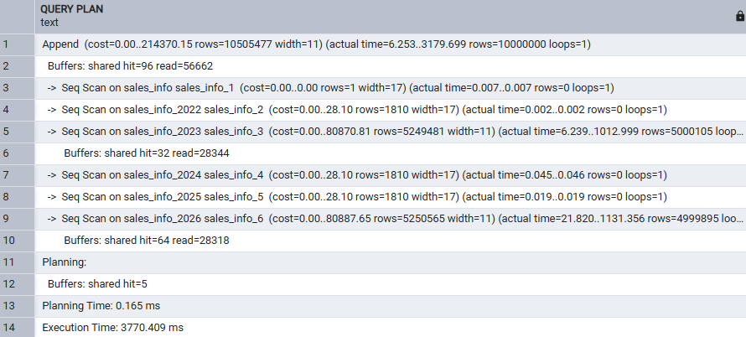
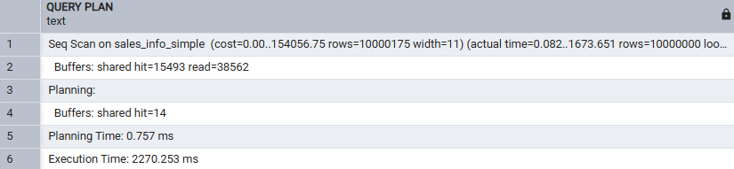
Why: a full "SELECT * with no WHERE" has to visit every row regardless of layout, so the extra Append node in sales_info just costs a bit of executor overhead per partition. Reference run: sales_info_simple slightly faster (710ms vs 914ms) — partitioning has no upside when nothing can be pruned.
Query 2 — SELECT with a range of dates (2023)
-- sales_info
EXPLAIN (ANALYZE, BUFFERS) SELECT * FROM sales_info WHERE eventdate BETWEEN '2023-01-01' AND '2023-12-31';

-- sales_info_simple
EXPLAIN (ANALYZE, BUFFERS) SELECT * FROM sales_info_simple WHERE eventdate BETWEEN '2023-01-01' AND '2023-12-31';
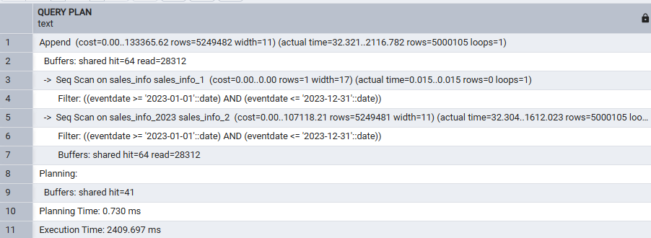
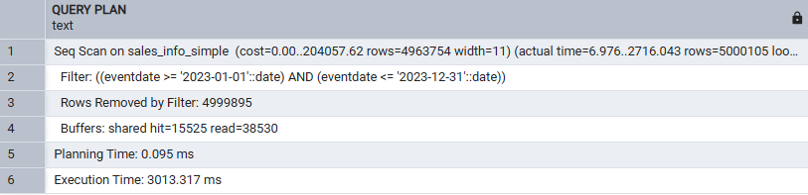
Why: this is the query partitioning was designed for. sales_info only opens the one child table that can contain 2023 dates (constraint exclusion proves the rest cannot match, so they are never even touched) while sales_info_simple must sequentially scan and filter all 10M rows. Reference run: 801ms vs 1002ms.
Query 3 — SELECT an exact date (2026-07-14)
-- sales_info
EXPLAIN (ANALYZE, BUFFERS) SELECT * FROM sales_info WHERE eventdate = '2026-07-14';

-- sales_info_simple
EXPLAIN (ANALYZE, BUFFERS) SELECT * FROM sales_info_simple WHERE eventdate = '2026-07-14';
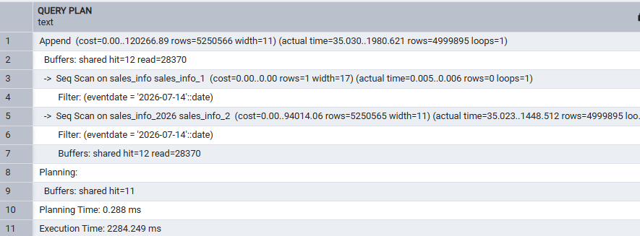
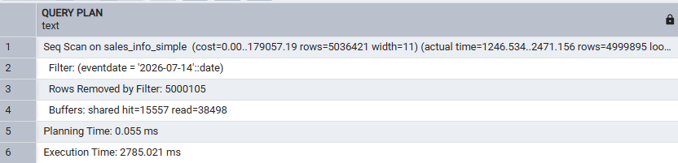
Why: same mechanism as Query 2 — sales_info prunes to just the sales_info_2026 child. Reference run: 589ms vs 1058ms.
Query 4 — COUNT(*) of all rows
-- sales_info
EXPLAIN (ANALYZE, BUFFERS) SELECT count(*) FROM sales_info;

-- sales_info_simple
EXPLAIN (ANALYZE, BUFFERS) SELECT count(*) FROM sales_info_simple;
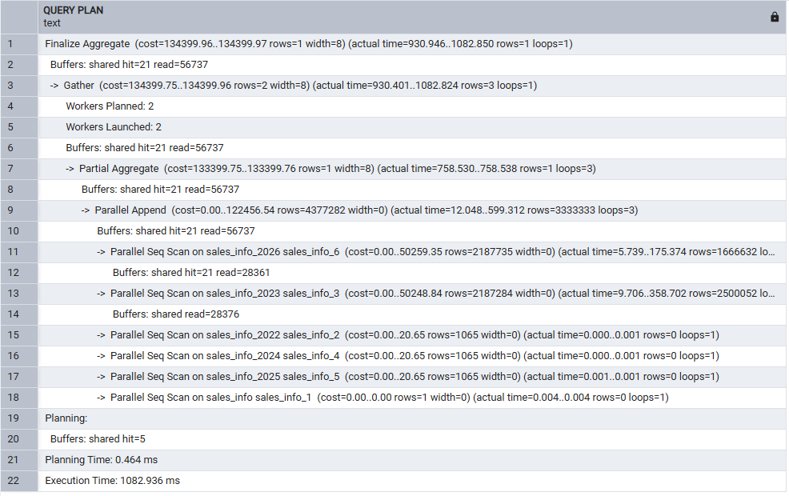
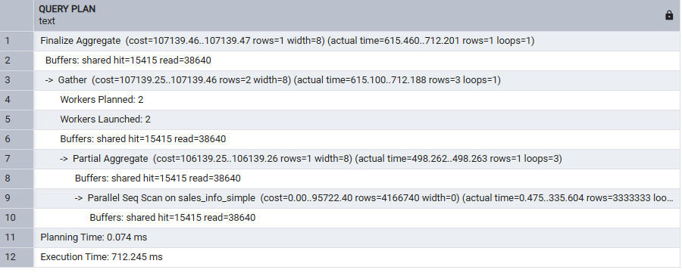
Why: counting everything still means reading everything, so partitioning only adds Append/coordination overhead here with no pruning benefit — the flat table tends to win on raw counting speed. Reference run: 633ms vs 429ms.
Query 5 — COUNT(*) with a range of dates (2023)
-- sales_info
EXPLAIN (ANALYZE, BUFFERS) SELECT count(*) FROM sales_info WHERE eventdate BETWEEN '2023-01-01' AND '2023-12-31';

-- sales_info_simple
EXPLAIN (ANALYZE, BUFFERS) SELECT count(*) FROM sales_info_simple WHERE eventdate BETWEEN '2023-01-01' AND '2023-12-31';
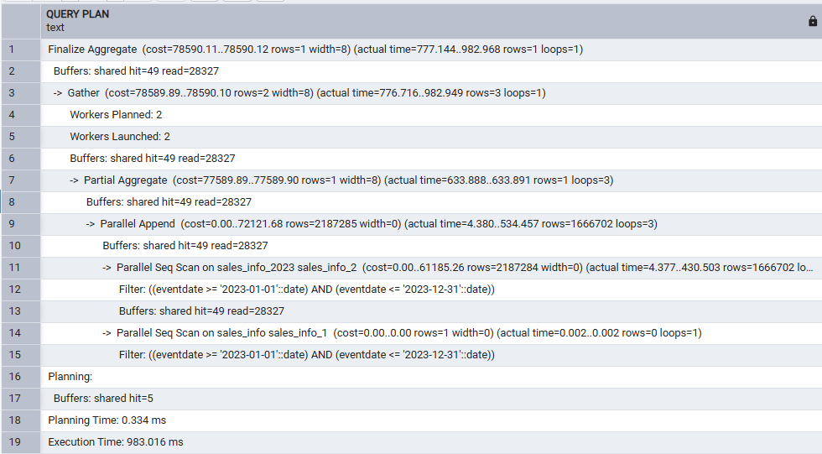

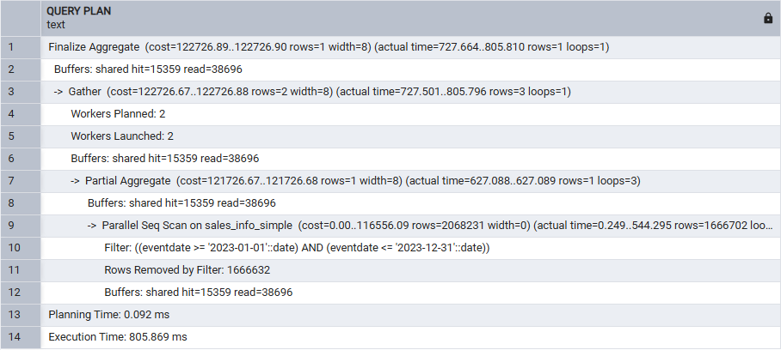
Why: partition pruning combined with parallel aggregation gives sales_info the edge once a WHERE clause on the partition key is present. Reference run: 419ms vs 532ms.
Drop the oldest partition and add a new one (partition lifecycle maintenance)
DROP TABLE sales_info_2022;

CREATE TABLE sales_info_3000 (
CHECK (eventdate >= '3000-01-01' AND eventdate < '3001-01-01')
) INHERITS (sales_info);
CREATE INDEX sales_info_3000_eventdate ON sales_info_3000 (eventdate);

CREATE OR REPLACE FUNCTION partition_sales_info() RETURNS trigger
AS $$
BEGIN
IF (new.eventdate >= '3000-01-01'::DATE AND new.eventdate < '3001-01-01'::DATE) THEN
INSERT INTO sales_info_3000 VALUES (new.*);
ELSEIF (new.eventdate >= '2026-01-01'::DATE AND new.eventdate < '2027-01-01'::DATE) THEN
INSERT INTO sales_info_2026 VALUES (new.*);
ELSEIF (new.eventdate >= '2025-01-01'::DATE AND new.eventdate < '2026-01-01'::DATE) THEN
INSERT INTO sales_info_2025 VALUES (new.*);
ELSEIF (new.eventdate >= '2024-01-01'::DATE AND new.eventdate < '2025-01-01'::DATE) THEN
INSERT INTO sales_info_2024 VALUES (new.*);
ELSEIF (new.eventdate >= '2023-01-01'::DATE AND new.eventdate < '2024-01-01'::DATE) THEN
INSERT INTO sales_info_2023 VALUES (new.*);
ELSE
RAISE EXCEPTION 'Out of range';
END IF;
RETURN NULL;
END;
$$ LANGUAGE plpgsql;

INSERT INTO sales_info(id, category, ischeck, eventdate) VALUES (99999901, 'X', true, '3000-05-01');
SELECT tableoid::regclass, * FROM sales_info WHERE id = 99999901;

INSERT INTO sales_info(id, category, ischeck, eventdate) VALUES (99999902, 'X', true, '2022-05-01'); -- expect this to error
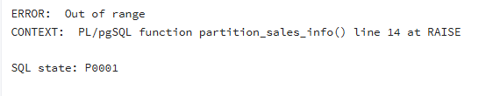
Why: DROP TABLE just unlinks and removes one physical relation, so dropping the oldest partition is instantaneous regardless of row count — no row-by-row DELETE, no extra VACUUM. Maintenance under inheritance is manual though: the trigger function had to be hand-edited to add the sales_info_3000 branch and remove the 2022 branch, otherwise rows for an uncovered range simply raise an exception instead of silently going anywhere.

1.2 Task 2: Use Declarative Partitioning
Composite RANGE(eventdate) + LIST(category) structure
CREATE TABLE sales_info_dp
(
id INTEGER, category VARCHAR(1), ischeck BOOLEAN, eventdate DATE
) PARTITION BY RANGE (eventdate);

CREATE TABLE sales_info_dp_2022 PARTITION OF sales_info_dp
FOR VALUES FROM ('2022-01-01') TO ('2023-01-01') PARTITION BY LIST (category);
CREATE TABLE sales_info_dp_2022_abc PARTITION OF sales_info_dp_2022 FOR VALUES IN ('A','B','C');
CREATE TABLE sales_info_dp_2022_def PARTITION OF sales_info_dp_2022 FOR VALUES IN ('D','E','F');
CREATE TABLE sales_info_dp_2022_default PARTITION OF sales_info_dp_2022 DEFAULT;

CREATE TABLE sales_info_dp_2023 PARTITION OF sales_info_dp
FOR VALUES FROM ('2023-01-01') TO ('2024-01-01') PARTITION BY LIST (category);
CREATE TABLE sales_info_dp_2023_abc PARTITION OF sales_info_dp_2023 FOR VALUES IN ('A','B','C');
CREATE TABLE sales_info_dp_2023_def PARTITION OF sales_info_dp_2023 FOR VALUES IN ('D','E','F');
CREATE TABLE sales_info_dp_2023_default PARTITION OF sales_info_dp_2023 DEFAULT;

CREATE TABLE sales_info_dp_2024 PARTITION OF sales_info_dp
FOR VALUES FROM ('2024-01-01') TO ('2025-01-01') PARTITION BY LIST (category);
CREATE TABLE sales_info_dp_2024_abc PARTITION OF sales_info_dp_2024 FOR VALUES IN ('A','B','C');
CREATE TABLE sales_info_dp_2024_def PARTITION OF sales_info_dp_2024 FOR VALUES IN ('D','E','F');
CREATE TABLE sales_info_dp_2024_default PARTITION OF sales_info_dp_2024 DEFAULT;

CREATE TABLE sales_info_dp_2025 PARTITION OF sales_info_dp
FOR VALUES FROM ('2025-01-01') TO ('2026-01-01') PARTITION BY LIST (category);
CREATE TABLE sales_info_dp_2025_abc PARTITION OF sales_info_dp_2025 FOR VALUES IN ('A','B','C');
CREATE TABLE sales_info_dp_2025_def PARTITION OF sales_info_dp_2025 FOR VALUES IN ('D','E','F');
CREATE TABLE sales_info_dp_2025_default PARTITION OF sales_info_dp_2025 DEFAULT;

CREATE TABLE sales_info_dp_2026 PARTITION OF sales_info_dp
FOR VALUES FROM ('2026-01-01') TO ('2027-01-01') PARTITION BY LIST (category);
CREATE TABLE sales_info_dp_2026_abc PARTITION OF sales_info_dp_2026 FOR VALUES IN ('A','B','C');
CREATE TABLE sales_info_dp_2026_def PARTITION OF sales_info_dp_2026 FOR VALUES IN ('D','E','F');
CREATE TABLE sales_info_dp_2026_default PARTITION OF sales_info_dp_2026 DEFAULT;

CREATE TABLE sales_info_dp_default PARTITION OF sales_info_dp DEFAULT;

-- to see the full tree afterwards:
SELECT format('%*s%s', level*2, '', relname) FROM (
WITH RECURSIVE tree AS (
SELECT oid, relname, 0 AS level FROM pg_class WHERE relname = 'sales_info_dp'
UNION ALL
SELECT c.oid, c.relname, t.level+1 FROM pg_inherits i JOIN pg_class c ON c.oid = i.inhrelid JOIN tree t ON i.inhparent = t.oid
) SELECT * FROM tree
) x ORDER BY level, relname;
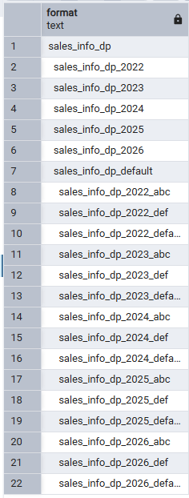
This is composite (2-level) declarative partitioning: the parent is partitioned by RANGE on eventdate; each yearly range partition is itself partitioned by LIST on category (2 explicit value lists + 1 default). Every leaf is a real, ordinary table; the intermediate sales_info_dp_2023 relation is itself "virtual" just like the top parent.
Load 10,000,000 rows — same template as Task 1
INSERT INTO SALES_INFO_DP(id,category, ischeck, EventDate)
SELECT id
,('{"A","B","C","D","E","F","J","H","I","J","K"}'::text[])[((RANDOM())*10)::INTEGER] category
,((1*(RANDOM())::INTEGER)<1) ischeck
,(NOW() - '10 day'::INTERVAL * (RANDOM()::int * 100))::DATE EventDate
FROM generate_series(1,10000000) id;

SELECT tableoid::regclass AS leaf_partition, count(*) FROM sales_info_dp GROUP BY 1 ORDER BY 1;
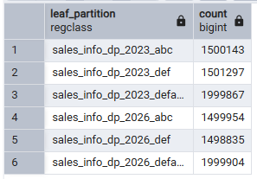
Why the load is faster: declarative partitioning routes each row internally in the executor’s normal tuple-routing code, while Task 1’s inheritance approach fires a full PL/pgSQL trigger function per row. For 10M rows that per-row overhead adds minutes; native tuple routing does not have it.
Update rows and set another category — automatic cross-partition movement
UPDATE sales_info_dp SET category = 'B' WHERE id BETWEEN 1 AND 300000 AND category IS DISTINCT FROM 'B';
SELECT tableoid::regclass, count(*) FROM sales_info_dp WHERE id BETWEEN 1 AND 300000 GROUP BY 1;

UPDATE sales_info_dp SET category = 'Z' WHERE id BETWEEN 300001 AND 600000; -- 'Z' is not in any explicit list
SELECT tableoid::regclass, count(*) FROM sales_info_dp WHERE id BETWEEN 300001 AND 600000 GROUP BY 1;
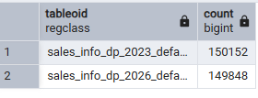
Why: this is the key contrast with Task 1. Under declarative partitioning (PostgreSQL 11+), an UPDATE that changes the partition key automatically deletes the row from its old leaf and re-inserts it into the correct new one — no trigger, no CHECK-constraint error, no manual DELETE+INSERT. The second UPDATE proves this works even when the new value only fits the DEFAULT partition.
Q1 SELECT ALL
-- sales_info_dp
EXPLAIN (ANALYZE, BUFFERS) SELECT * FROM sales_info_dp;

-- sales_info_simple
EXPLAIN (ANALYZE, BUFFERS) SELECT * FROM sales_info_simple;
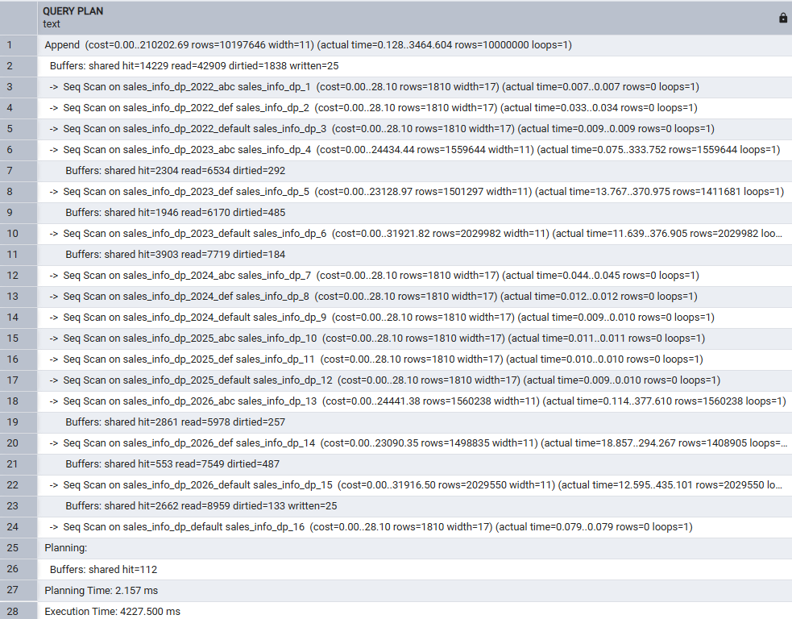

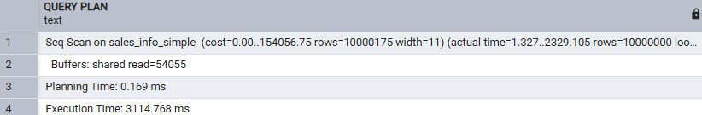

Why: no filter means no pruning, so the extra Append layer just costs overhead. Reference: 843ms (sales_info_dp) vs 637ms (sales_info_simple).
Q2 SELECT with a range of dates (2023)
-- sales_info_dp
EXPLAIN (ANALYZE, BUFFERS) SELECT * FROM sales_info_dp WHERE eventdate BETWEEN '2023-01-01' AND '2023-12-31';

-- sales_info_simple
EXPLAIN (ANALYZE, BUFFERS) SELECT * FROM sales_info_simple WHERE eventdate BETWEEN '2023-01-01' AND '2023-12-31';
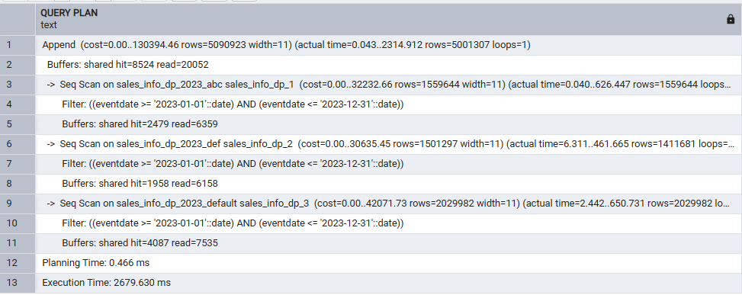
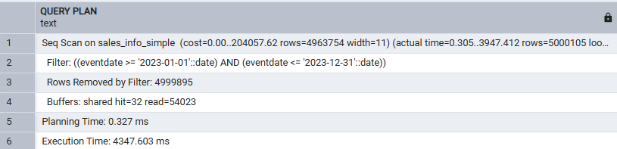
Why: constraint exclusion prunes 2022/2024/2025/2026 and all 15 of their leaf children — sales_info_dp only opens the 3 leaves of _2023. Reference: 677ms vs 871ms.
Q3 SELECT an exact date (2026-07-14)
-- sales_info_dp
EXPLAIN (ANALYZE, BUFFERS) SELECT * FROM sales_info_dp WHERE eventdate = '2026-07-14';

-- sales_info_simple
EXPLAIN (ANALYZE, BUFFERS) SELECT * FROM sales_info_simple WHERE eventdate = '2026-07-14';
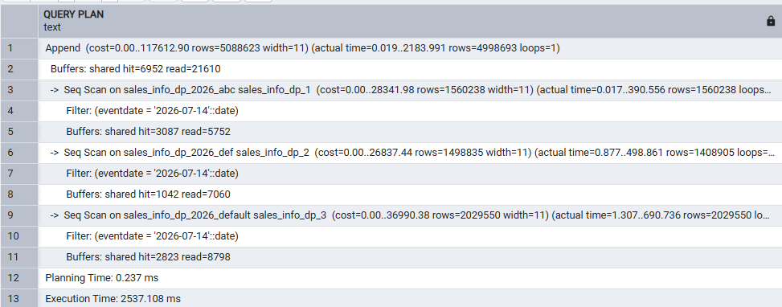
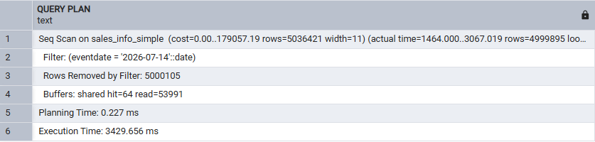
Why: same pruning mechanism restricted to the 3 leaves of _2026. Reference: 614ms vs 845ms.
Q4 SELECT an exact category ('A')
-- sales_info_dp
EXPLAIN (ANALYZE, BUFFERS) SELECT * FROM sales_info_dp WHERE category = 'A';

-- sales_info_simple
EXPLAIN (ANALYZE, BUFFERS) SELECT * FROM sales_info_simple WHERE category = 'A';
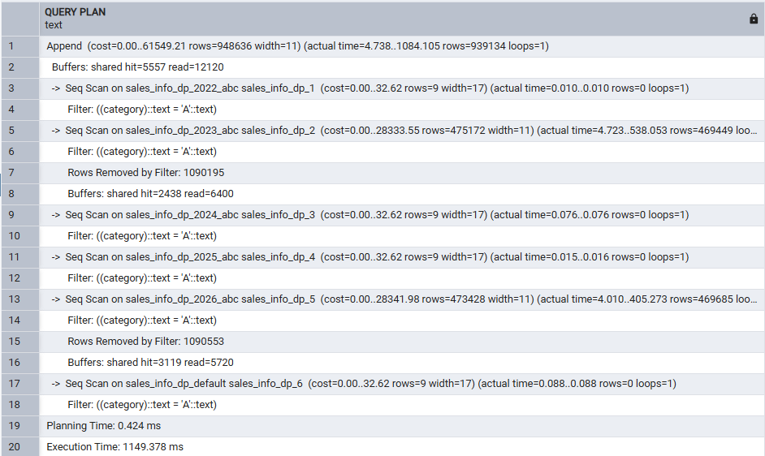

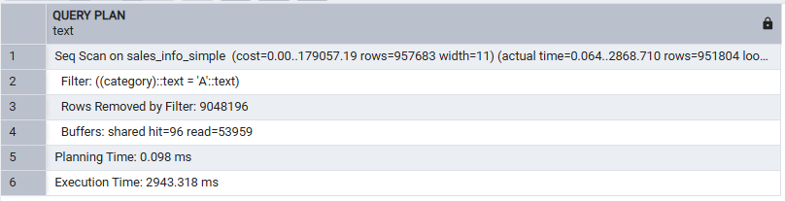

Why: with only a category filter (no date filter) the planner cannot prune by year, so all 5 year branches stay open — but LIST pruning still applies within each year: only the "_abc" leaf of each year is scanned, every "_def" and year-level "_default" leaf is skipped, because the planner can prove 'A' only ever routes into the abc list. Reference: 343ms vs 828ms.
Q5 SELECT a list of categories (A,B,C)
-- sales_info_dp
EXPLAIN (ANALYZE, BUFFERS) SELECT * FROM sales_info_dp WHERE category IN ('A','B','C');

-- sales_info_simple
EXPLAIN (ANALYZE, BUFFERS) SELECT * FROM sales_info_simple WHERE category IN ('A','B','C');
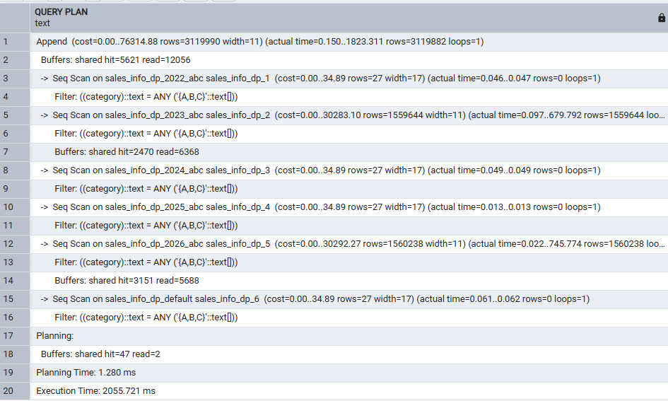
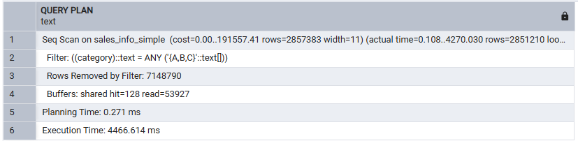
Why: same list-pruning logic as Q4, restricted to the 5 "_abc" leaves across all years. Reference: 535ms vs 1315ms.
Q6 SELECT a list of categories AND an exact date
-- sales_info_dp
EXPLAIN (ANALYZE, BUFFERS) SELECT * FROM sales_info_dp WHERE category IN ('A','B','C') AND eventdate = '2026-07-14';

-- sales_info_simple
EXPLAIN (ANALYZE, BUFFERS) SELECT * FROM sales_info_simple WHERE category IN ('A','B','C') AND eventdate = '2026-07-14';
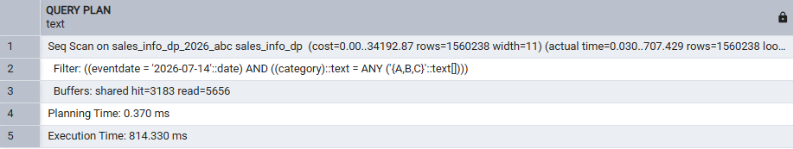
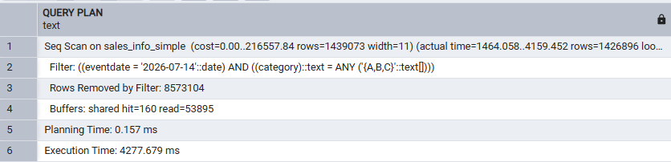
Why: this is the clearest demonstration of composite partitioning — combining the date-range predicate with the category-list predicate lets the planner eliminate every partition but ONE (sales_info_dp_2026_abc), turning a 10M-row scan into a ~1.56M-row scan. Reference: 269ms vs 1092ms.
Q7 COUNT(*) of all rows
-- sales_info_dp
EXPLAIN (ANALYZE, BUFFERS) SELECT count(*) FROM sales_info_dp;

-- sales_info_simple
EXPLAIN (ANALYZE, BUFFERS) SELECT count(*) FROM sales_info_simple;
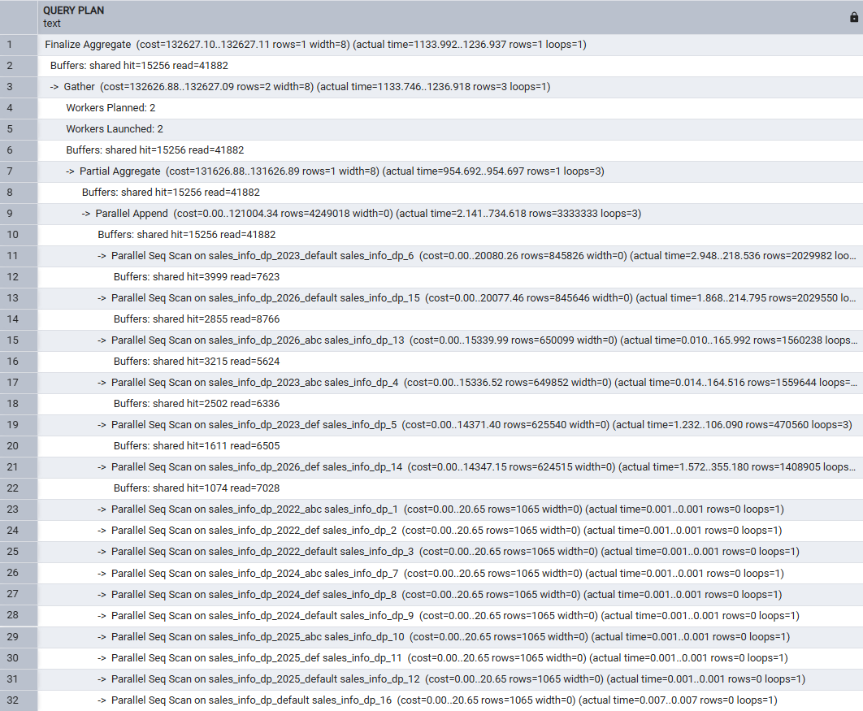
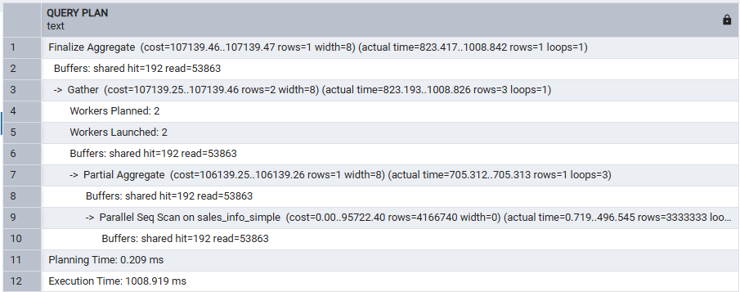
Why: counting everything still means reading everything — no pruning benefit, so the flat table tends to win. Reference: 601ms vs 491ms.
Q8 COUNT(*) with a range of dates (2023)
-- sales_info_dp
EXPLAIN (ANALYZE, BUFFERS) SELECT count(*) FROM sales_info_dp WHERE eventdate BETWEEN '2023-01-01' AND '2023-12-31';

-- sales_info_simple
EXPLAIN (ANALYZE, BUFFERS) SELECT count(*) FROM sales_info_simple WHERE eventdate BETWEEN '2023-01-01' AND '2023-12-31';
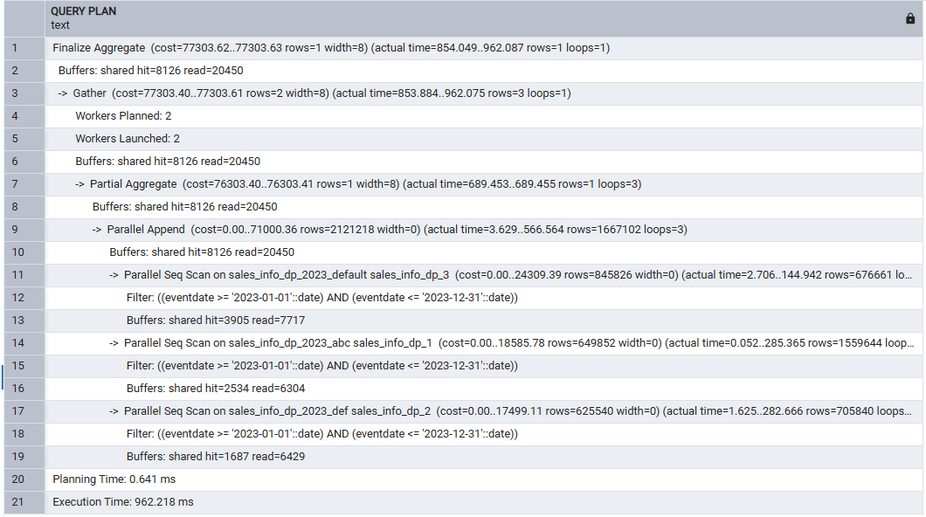
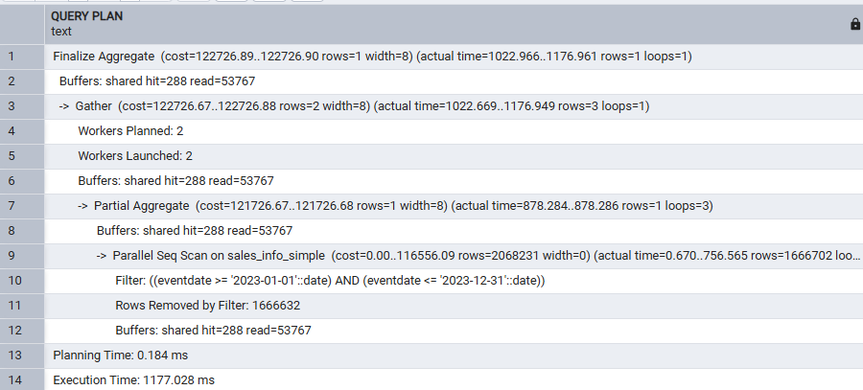
Why: pruned to the 3 leaves of _2023 plus parallel aggregation. Reference: 455ms vs 530ms.
Split a list partition into two, then merge it back
-- Split sales_info_dp_2023_abc (A,B,C) into A and (B,C)
ALTER TABLE sales_info_dp_2023 DETACH PARTITION sales_info_dp_2023_abc;
ALTER TABLE sales_info_dp_2023_abc RENAME TO sales_info_dp_2023_abc_old;
CREATE TABLE sales_info_dp_2023_a PARTITION OF sales_info_dp_2023 FOR VALUES IN ('A');
CREATE TABLE sales_info_dp_2023_bc PARTITION OF sales_info_dp_2023 FOR VALUES IN ('B','C');
INSERT INTO sales_info_dp_2023 SELECT * FROM sales_info_dp_2023_abc_old;
DROP TABLE sales_info_dp_2023_abc_old;
SELECT tableoid::regclass, count(*) FROM sales_info_dp_2023 WHERE category IN ('A','B','C') GROUP BY 1 ORDER BY 1;

-- Return: merge A and B,C back into a single (A,B,C) partition
ALTER TABLE sales_info_dp_2023 DETACH PARTITION sales_info_dp_2023_a;
ALTER TABLE sales_info_dp_2023 DETACH PARTITION sales_info_dp_2023_bc;
CREATE TABLE sales_info_dp_2023_abc PARTITION OF sales_info_dp_2023 FOR VALUES IN ('A','B','C');
INSERT INTO sales_info_dp_2023 SELECT * FROM sales_info_dp_2023_a;
INSERT INTO sales_info_dp_2023 SELECT * FROM sales_info_dp_2023_bc;
DROP TABLE sales_info_dp_2023_a;
DROP TABLE sales_info_dp_2023_bc;
SELECT tableoid::regclass, count(*) FROM sales_info_dp_2023 WHERE category IN ('A','B','C') GROUP BY 1 ORDER BY 1;
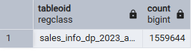
PostgreSQL 16 has no built-in "SPLIT PARTITION" statement for list partitions, so the standard technique is: DETACH the partition to free its bounds, CREATE the new narrower partitions, and re-INSERT the detached data through the parent so the executor’s own tuple routing re-distributes it correctly — the reverse of the same steps merges it back.

2. Parallel Execution

2.1 Task 3: Use Parallel Querying
SET max_parallel_workers_per_gather = 4;

(a) SELECT * FROM <table> — no filter
-- sales_info
EXPLAIN (ANALYZE, BUFFERS) SELECT * FROM sales_info;

-- sales_info_dp
EXPLAIN (ANALYZE, BUFFERS) SELECT * FROM sales_info_dp;

-- sales_info_simple
EXPLAIN (ANALYZE, BUFFERS) SELECT * FROM sales_info_simple;
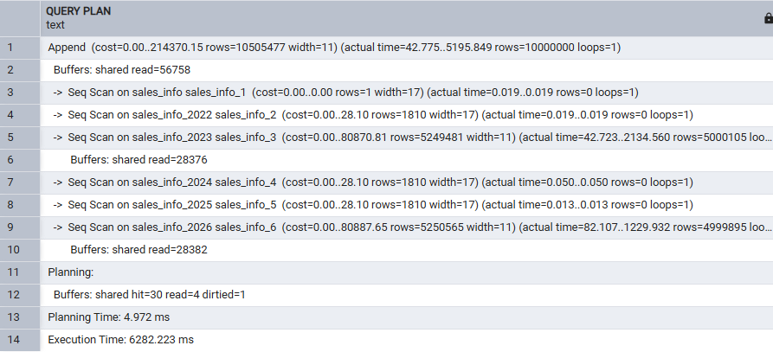
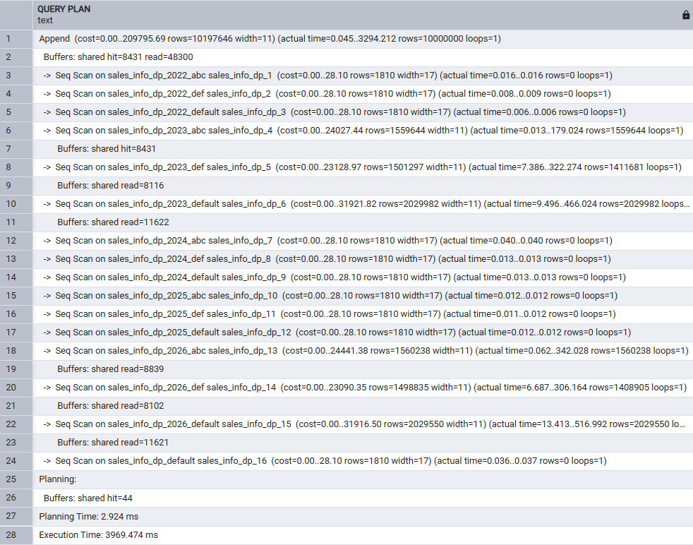
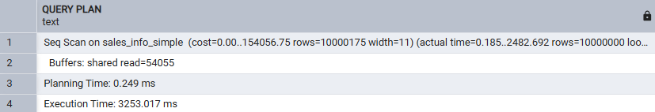
Why: returning all 10M full rows is dominated by result transfer, and the planner sees no benefit to parallelizing a scan whose output must all flow through one Gather leader anyway — expect NO Gather node on any of the 3 tables. Reference: 899ms / 863ms / 611ms.
(b) SELECT * ... ORDER BY eventdate
-- sales_info
EXPLAIN (ANALYZE, BUFFERS) SELECT * FROM sales_info ORDER BY eventdate;

-- sales_info_dp
EXPLAIN (ANALYZE, BUFFERS) SELECT * FROM sales_info_dp ORDER BY eventdate;

-- sales_info_simple
EXPLAIN (ANALYZE, BUFFERS) SELECT * FROM sales_info_simple ORDER BY eventdate;

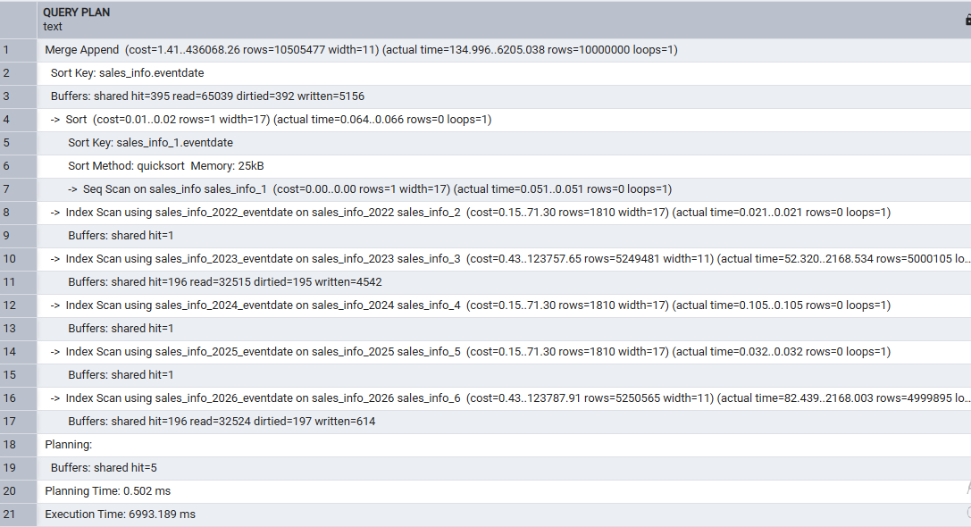
Why: sales_info already has a per-partition eventdate B-tree index from Task 1, so expect a Merge Append (each child pre-sorted via Index Scan, merged for free, no disk sort). sales_info_dp and sales_info_simple have no such index yet, so expect a Gather Merge with an expensive external (disk-spilling) sort in every worker instead. Reference: 2219ms / 3992ms / 3452ms.
(c) SELECT count(*)
-- sales_info
EXPLAIN (ANALYZE, BUFFERS) SELECT count(*) FROM sales_info;

-- sales_info_dp
EXPLAIN (ANALYZE, BUFFERS) SELECT count(*) FROM sales_info_dp;

-- sales_info_simple
EXPLAIN (ANALYZE, BUFFERS) SELECT count(*) FROM sales_info_simple;
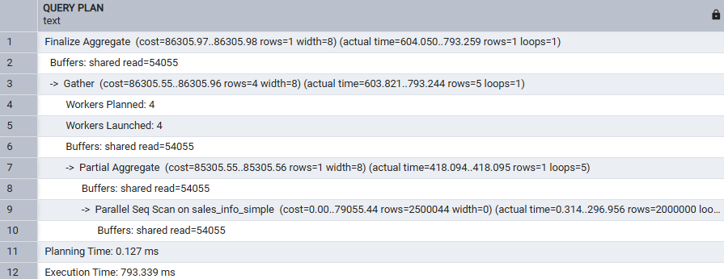
Why: COUNT(*) is a textbook case for parallel aggregation — each worker counts its own slice (Partial Aggregate), the leader adds the small per-worker totals (Finalize Aggregate). Reference: 649ms / 592ms / 446ms.
(d) COUNT(*) + range of dates (2023)
-- sales_info
EXPLAIN (ANALYZE, BUFFERS) SELECT count(*) FROM sales_info WHERE eventdate BETWEEN '2023-01-01' AND '2023-12-31';

-- sales_info_dp
EXPLAIN (ANALYZE, BUFFERS) SELECT count(*) FROM sales_info_dp WHERE eventdate BETWEEN '2023-01-01' AND '2023-12-31';

-- sales_info_simple
EXPLAIN (ANALYZE, BUFFERS) SELECT count(*) FROM sales_info_simple WHERE eventdate BETWEEN '2023-01-01' AND '2023-12-31';
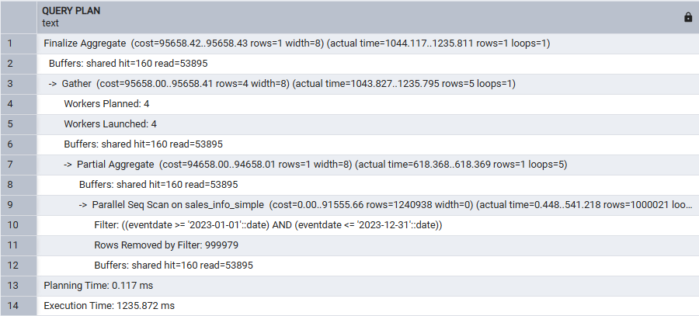
Why: partition pruning and parallel workers combine — both partitioned tables should only assign workers to the 2023 partition(s). Reference: 445ms / 475ms / 574ms.
(e) range of dates + GROUP BY category
-- sales_info
EXPLAIN (ANALYZE, BUFFERS) SELECT category, count(*) FROM sales_info WHERE eventdate BETWEEN '2023-01-01' AND '2023-12-31' GROUP BY category;

-- sales_info_dp
EXPLAIN (ANALYZE, BUFFERS) SELECT category, count(*) FROM sales_info_dp WHERE eventdate BETWEEN '2023-01-01' AND '2023-12-31' GROUP BY category;

-- sales_info_simple
EXPLAIN (ANALYZE, BUFFERS) SELECT category, count(*) FROM sales_info_simple WHERE eventdate BETWEEN '2023-01-01' AND '2023-12-31' GROUP BY category;
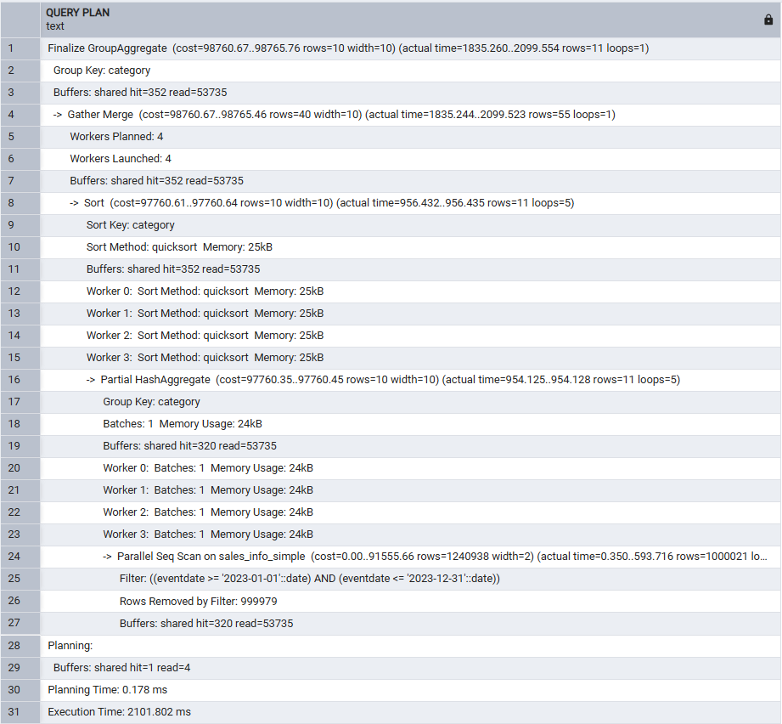
Why: grouping adds a HashAggregate per worker plus a merge-sorted Gather Merge to combine partial groups — more work than plain COUNT(*), but the pruned tables should still come out ahead. Reference: 821ms / 751ms / 847ms.
(f) JOIN sales_info and sales_info_dp on id, count rows on an exact date
EXPLAIN (ANALYZE, BUFFERS)
SELECT count(*)
FROM sales_info si
JOIN sales_info_dp dp ON si.id = dp.id
WHERE si.eventdate = '2026-07-14';
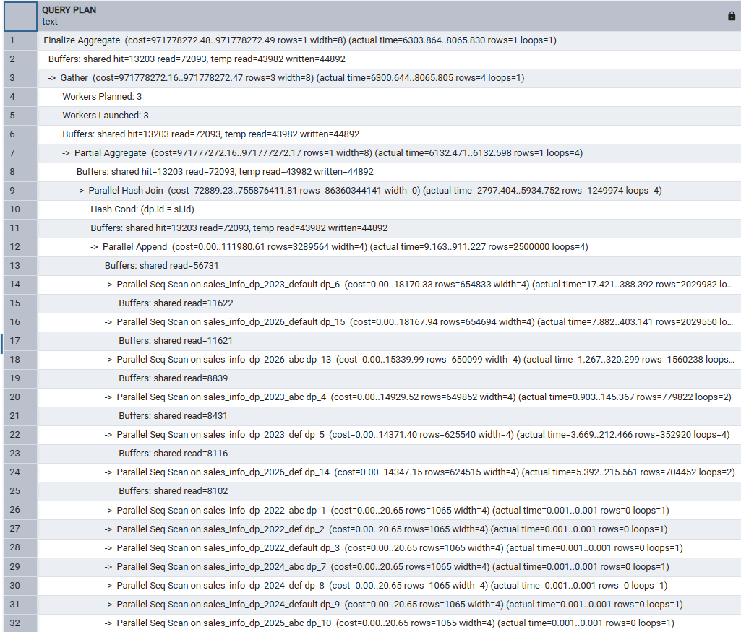
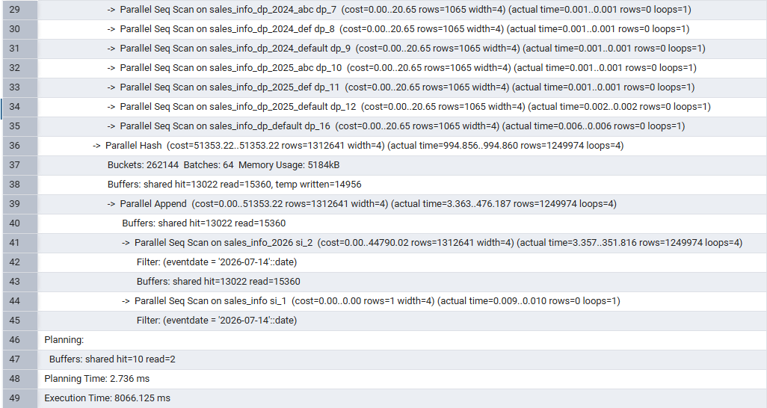
Why: the join is on an equality predicate (id = id), so expect a Parallel Hash Join — the smaller, pre-filtered side (sales_info restricted to one date, pruned to sales_info_2026) is built into a shared hash table in parallel, and the larger side (all of sales_info_dp, since the date filter only applies to sales_info) is streamed through and probed. This is far more expensive than the single-table queries above (reference: 5852ms) simply because it must build and probe a multi-million-row hash table across several workers with disk spilling — a good illustration of "parallel execution helps most exactly when the query is already expensive."
Add indexes on the partitioned table and re-check plans
CREATE INDEX sales_info_dp_eventdate_idx ON sales_info_dp (eventdate);
CREATE INDEX sales_info_dp_category_idx ON sales_info_dp (category);
ANALYZE sales_info_dp;

SELECT tablename, indexname FROM pg_indexes WHERE tablename LIKE 'sales_info_dp%' ORDER BY tablename;
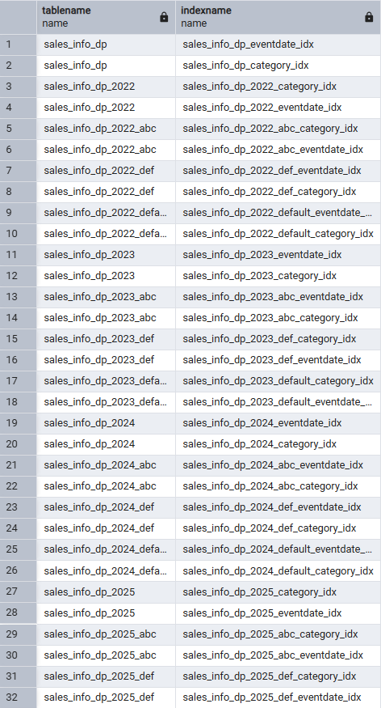
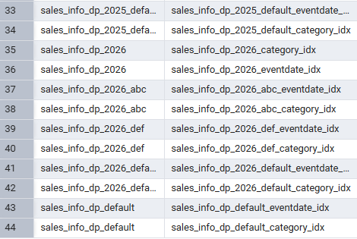
Why: creating an index on a partitioned PARENT automatically creates and attaches one on every existing leaf partition (and any leaf created later) — you never have to create them one by one.
Re-check (b): ORDER BY eventdate
EXPLAIN (ANALYZE, BUFFERS) SELECT * FROM sales_info_dp ORDER BY eventdate;
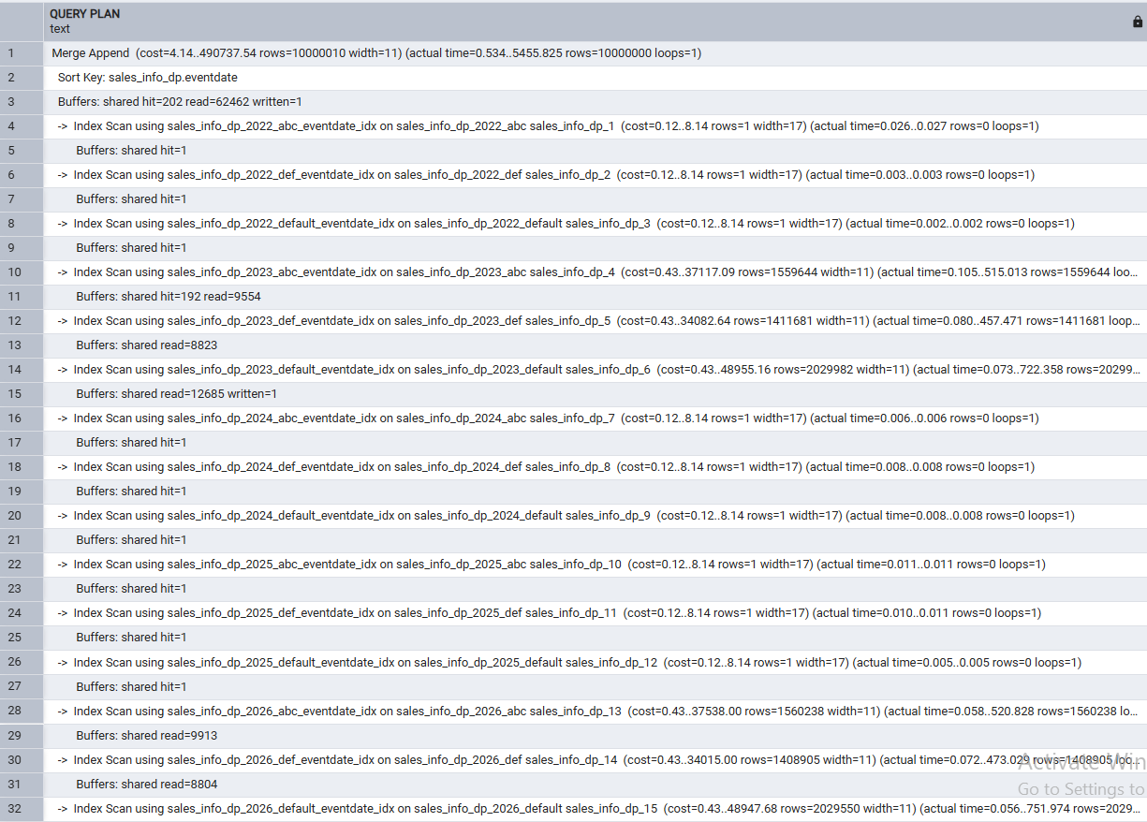
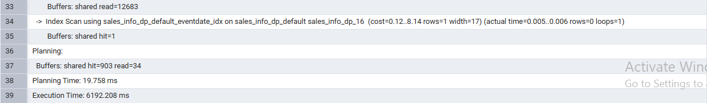
Why: expect the plan shape to change completely — instead of a parallel disk-spilling sort, the optimizer should now merge the already index-sorted leaves (Merge Append), with no Gather node and no external sort at all. Reference: 3992ms → 1972ms, roughly halved.
Re-check: SELECT an exact date (2026-07-14)
EXPLAIN (ANALYZE, BUFFERS) SELECT * FROM sales_info_dp WHERE eventdate = '2026-07-14';
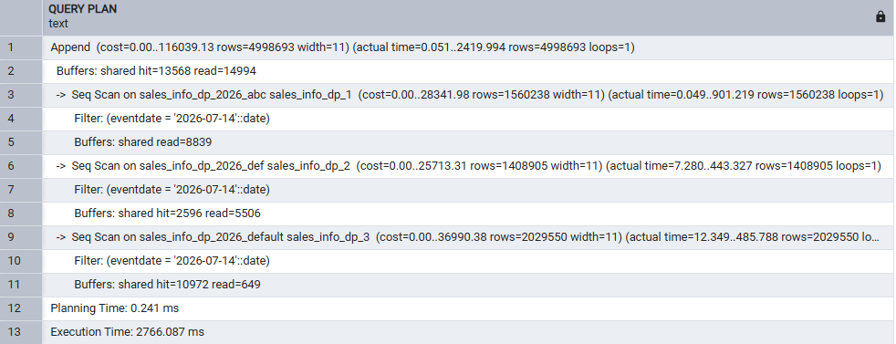
Why: expect the plan shape to stay a plain Append with Seq Scan on the 3 leaves of _2026, NOT switching to an index scan — the planner’s cost model judges a sequential scan of an already ~50%-selective partition cheaper than an index scan here (indexes help most when they filter out a large fraction of rows). Reference: 581ms, essentially unchanged.
Re-check (f): the JOIN
EXPLAIN (ANALYZE, BUFFERS)
SELECT count(*)
FROM sales_info si
JOIN sales_info_dp dp ON si.id = dp.id
WHERE si.eventdate = '2026-07-14';
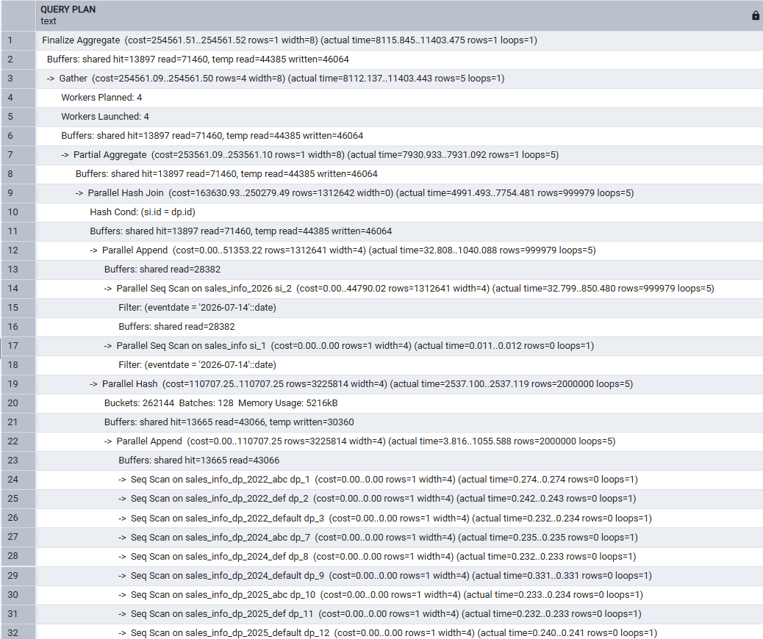
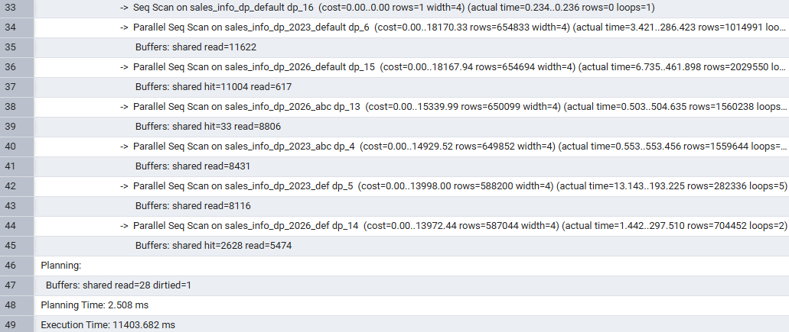
Why: expect only a modest improvement (reference: 5852ms → 4956ms) — the join key is id, and no index was created on id, so the new eventdate/category indexes only help the Append/Scan side that filters on those columns, not the Hash Cond itself.
Note on the actual measured run: this JOIN got SLOWER after adding the indexes (8,066 ms → 11,403 ms), not faster as expected above. The plan shape and Hash Cond are unchanged, so this is most likely machine-load / cache variance on a constrained VM rather than a real effect of the new indexes — worth stating plainly in the write-up rather than reporting the expected improvement that didn't actually happen here.

Summary
- Partitioning helps exactly when a query’s WHERE clause matches the partitioning key(s): both inheritance-based (constraint exclusion) and declarative (partition pruning) partitioning let the planner skip entire child tables untouched. With no filter (SELECT *, plain COUNT(*)) partitioning only adds Append/coordination overhead versus a single flat table.
- Declarative partitioning loads the same 10M rows dramatically faster than the trigger-based inheritance approach, because native tuple routing runs in the executor instead of firing a PL/pgSQL function per row.
- Declarative partitioning supports automatic row movement across partitions on UPDATE (PostgreSQL 11+); inheritance-based partitioning does not — an UPDATE that would cross a partition boundary is rejected by the destination child’s CHECK constraint, and the correct workaround is DELETE + re-INSERT.
- Composite RANGE + LIST partitioning combines both prunings: a query filtering on both eventdate and category collapses from a full-table scan to a single narrow leaf scan.
- Parallel execution (Gather / Gather Merge / Parallel Append / Parallel Hash Join) is applied automatically once max_parallel_workers_per_gather allows it, and pays off most on aggregations and large scans/joins; it adds no value to plain "SELECT *" result-set retrieval.
- Adding indexes on a partitioned parent cascades to every leaf partition automatically and can change the chosen plan entirely — an ORDER BY query can switch from a parallel disk-spilling sort to an index-driven Merge Append with no parallel workers at all once indexes exist.
- A quirk in the task’s provided random-date formula (RANDOM()::int rounds to exactly 0 or 1) means the generated data only ever lands in 2 of the 5 yearly partitions in every run of this lab; this does not affect the validity of the partitioning/parallel-execution comparisons, since pruning and parallelism behave identically regardless of how many partitions happen to hold data.

