Power BI Lab Report
Task 3 – DAX Basics
Mariami Avaliani
In this task I continued working in the same file I used for Lab 1 and Task 2 (PowerBILab1_Avaliani.pbix), since Task 3 uses the same AdventureWorksDW2017 data model. The goal of this task was to learn how to write basic DAX expressions – calculated columns and measures – and use them to build a small report page with time intelligence, ranking and percentage calculations.

1. Creating Simple DAX Expressions

1.1 Calculated Column – Year Month Label
I opened Data View and selected the DimDate table. Then I clicked New Column on the ribbon and wrote this formula:
Year Month Label = FORMAT(DimDate[FullDateAlternateKey], "YYYY - MMM")
This creates a text column that shows the date as a short label, like "2010 - Jul". It uses the FORMAT function to turn a real date into readable text.
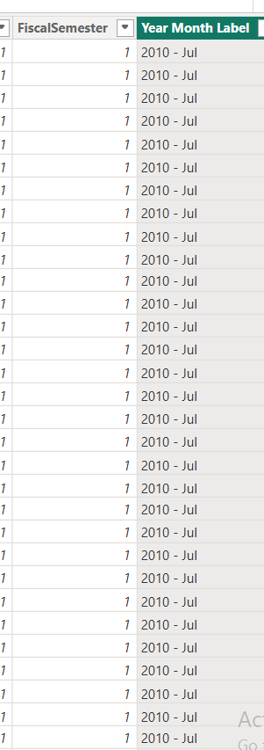
The new Year Month Label column in Data View.

1.2 Line Chart and the Date Hierarchy
Next I went back to Report View, added a new page, and put a Line chart on it. First I dragged OrderDate from FactInternetSales directly onto the X-axis, just to see what happens with a real date field.
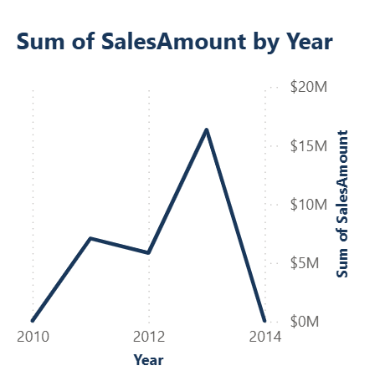
Power BI automatically collapsed the chart to the Year level and added a date hierarchy (Year, Quarter, Month, Day) to the X-axis field well.
Power BI automatically built a hierarchy out of it – Year, Quarter, Month, Day – with drill-down arrows on the chart. This happens because OrderDate is a real Date column, not because I asked for it. It is useful if you actually want the user to be able to drill from year down to day, but I did not need that here, I only wanted one clean row of months. So I removed OrderDate and replaced it with my new Year Month Label column instead, which is text, so no hierarchy gets added.

1.3 Filtering by Year
The chart still had too many months on it (the data goes back to 2005), so I needed to filter it down. The Filters pane is the third icon at the top of the Visualizations panel, next to Build visual and Format visual. I dragged Calendar Year from DimDate into "Filters on this visual", set the filter type to Advanced filtering, and set the condition to "is greater than or equal to" 2013:
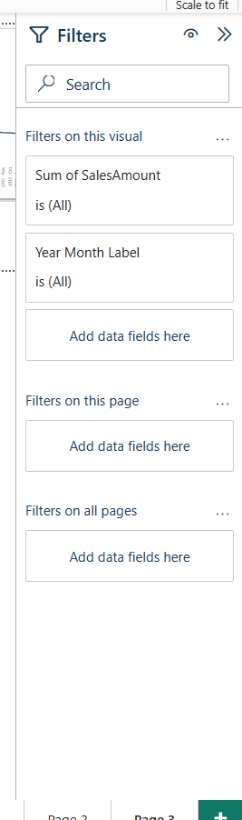
The Filters pane, with Calendar Year added and ready to configure.
This left only 2013 and 2014 on the chart.

1.4 Sorting the X-axis Correctly
After filtering, the months on the X-axis were not in chronological order. Power BI was sorting them by the SalesAmount value instead of by date, so the line looked like it was steadily falling, which was not the real pattern at all:
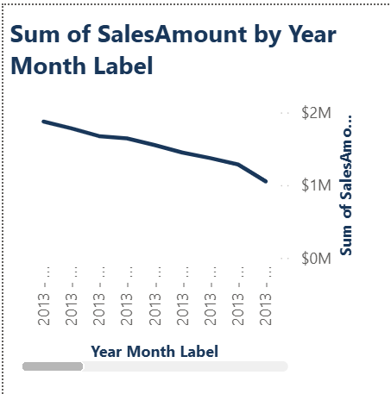
Year Month Label sorted by value instead of by date – a wrong, misleading shape.
To fix this I created a helper column in DimDate:
YearMonthSort = YEAR(DimDate[FullDateAlternateKey]) * 100 + MONTH(DimDate[FullDateAlternateKey])
This produces a number like 201301 for January 2013, which sorts correctly. Then I selected the Year Month Label column, opened the Column tools tab, clicked Sort by Column, and chose YearMonthSort. After that I also had to fix the chart itself with its own "..." menu → Sort by → Year Month Label (Ascending), because the visual had its own separate sort setting on top of the column-level one. Only after doing both did the chart finally show the real, seasonal pattern:
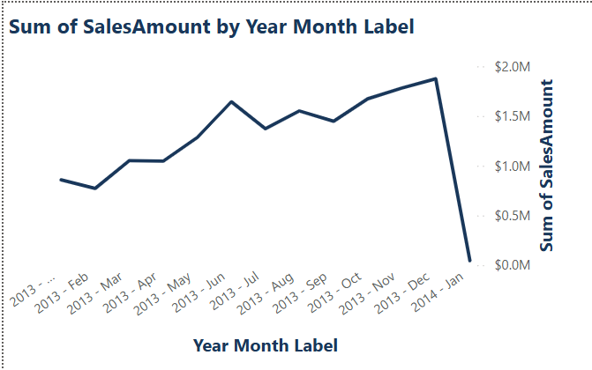
The chart after both the Year filter and the correct chronological sort were applied.

2. Measures

2.1 A Simple Measure – Today Date
My first measure was very simple, using the New Measure button on DimDate:
Today Date = TODAY()
I put it in a Card visual, shortened the format from the default (which also showed the time) to a plain date, and then moved the card down into the bottom right corner of the page so it works like a small footer:
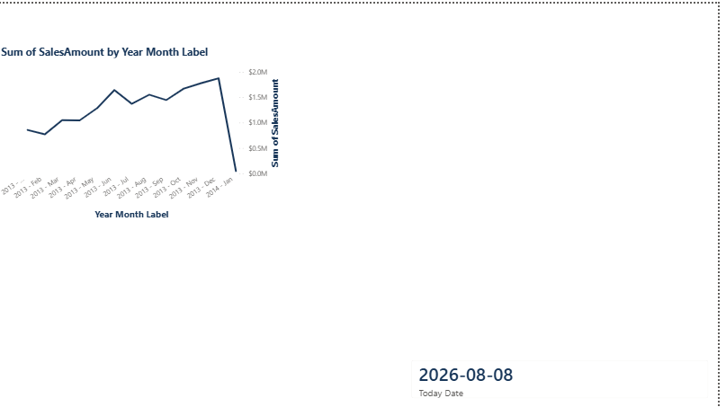
Today Date placed as a footer under the finished Sales by Date chart.

2.2 Order Quantity and Cumulative YTD
I created a measure for total order quantity:
Order Quantity = SUM(FactInternetSales[OrderQuantity])
Then a Year-To-Date version, using CALCULATE together with DATESYTD:
Order Quantity YTD = CALCULATE([Order Quantity], DATESYTD(DimDate[FullDateAlternateKey]))
I put FullDateAlternateKey, Order Quantity and Order Quantity YTD together in a Table to check the numbers. When I first dragged FullDateAlternateKey in, it also expanded into a Year/Quarter/Month/Day hierarchy inside the table, the same as before – I fixed it by clicking the small dropdown arrow on the field and choosing FullDateAlternateKey itself instead of "Date Hierarchy".
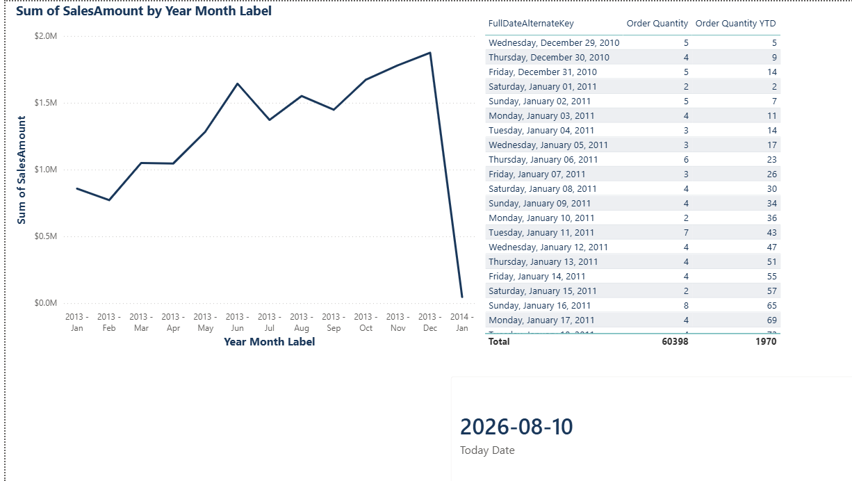
Sales by Date chart, the Order Quantity / YTD table, and the Today Date footer card together on the page.
The YTD column correctly adds up day by day and resets at the start of each new year. One important step I needed here is marking DimDate as a proper Date Table: Table tools → Mark as Date Table → choose FullDateAlternateKey as the date column. Without this, DATESYTD and SAMEPERIODLASTYEAR do not calculate correctly.

3. Create Lab Report
On a new report page I built the final report using more advanced DAX measures.

3.1 Year-To-Date vs Previous Year
I created four more measures:
Sales Amount = SUM(FactInternetSales[SalesAmount])
Sales Amount YTD = CALCULATE([Sales Amount], DATESYTD(DimDate[FullDateAlternateKey]))
Order Quantity PY = CALCULATE([Order Quantity YTD], SAMEPERIODLASTYEAR(DimDate[FullDateAlternateKey]))
Sales Amount PY = CALCULATE([Sales Amount YTD], SAMEPERIODLASTYEAR(DimDate[FullDateAlternateKey]))
PY means Previous Year – SAMEPERIODLASTYEAR shifts the YTD calculation back exactly one year, so I can compare how this year is progressing against the same point last year. I added two Line charts, one with Order Quantity YTD and Order Quantity PY, and one with Sales Amount YTD and Sales Amount PY, both fields on the Y-axis. The shape of the Order Quantity chart looked strange at first – one smooth rise and one sharp drop, instead of the repeating "sawtooth" pattern I expected from a YTD measure:
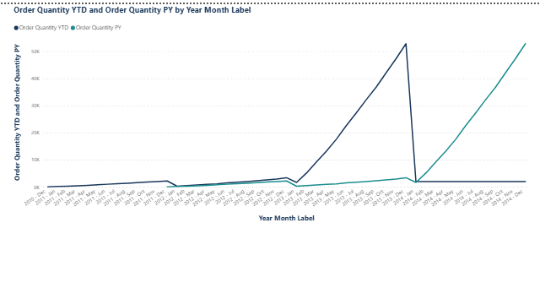
Order Quantity YTD and Order Quantity PY – the shape looked suspicious at first.
To check whether this was a bug, I built a temporary diagnostic table with Year Month Label, Order Quantity YTD and Order Quantity PY, and looked at both the earliest and the latest rows.
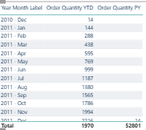
PY is blank for 2010-2011, which makes sense – there is no prior year of data yet at that point.
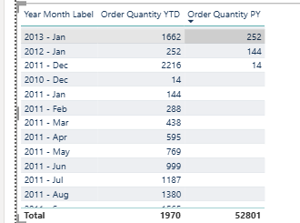
Diagnostic rows around 2011-2013.
It turned out both parts of the chart were correct, not a bug. PY is blank in 2010-2011 because there is no earlier year of real data to compare against (sales only start at the very end of 2010). And the sharp drop to almost zero after January 2014 is because the FactInternetSales data itself ends on 28 January 2014 – so YTD correctly "freezes" at its last value (1970) for the rest of that year, since nothing more gets added, while PY keeps rising because it is copying 2013's real progression. On the chart the frozen value of 1970 just looks tiny next to the 2013 peak of over 52,000, so it looks like it drops to zero, but it does not really – it is just very small in comparison.
The second chart, Sales Amount YTD and Sales Amount PY, follows the same logic, just measured in sales value instead of quantity:
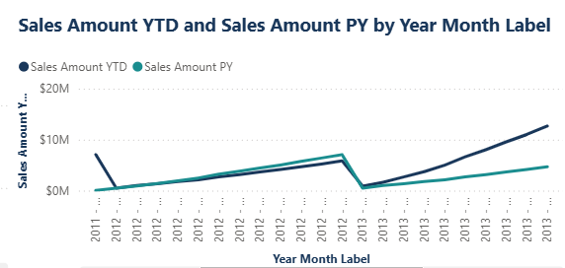
Sales Amount YTD and Sales Amount PY by Year Month Label.

3.2 Welcome Text
I created two small text measures for the top of the page. Current User originally used USERNAME(), and Current Date Text originally called TODAY() directly instead of reusing the Today Date measure from section 2.1. After review, I updated both: Current User now uses USERPRINCIPALNAME(), which reliably returns a UPN (email-format) identity once the report is published to the Service, and Current Date Text now reuses the Today Date measure instead of calling TODAY() a second time. See sections 4.1 and 4.2 for the full before/after reasoning and verification.
Current User = "Welcome, " & USERPRINCIPALNAME()
Current Date Text = "Current Date is: " & FORMAT([Today Date], "m/d/yyyy")
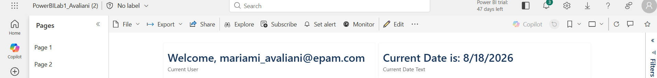
The Welcome and Current Date cards at the top of the report page.

3.3 Order Quantity by Product, Color and Month, with % of Total
I added a Table with Year Month Label, EnglishProductName, Color and Order Quantity, and then created a measure for the percentage of the total:
% of Total OQ = DIVIDE([Order Quantity], CALCULATE([Order Quantity], ALL(DimDate[Year Month Label])))
The idea is that the numerator is the quantity for the current row (one month, one product, one color), and the denominator removes the month filter with ALL() so it calculates the total for that same product and color across every month. But when I added this to the table, every single row showed exactly 100%, which is obviously wrong – the same product and color appearing in different months cannot all be 100% of their own total at once.
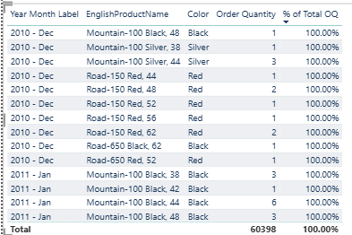
A real bug – every row shows 100%, which is mathematically impossible.
I checked the formula bar first, in case I had a typo:
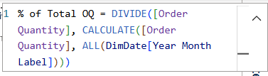
The formula itself was written correctly.
Since the formula looked fine, I built a simpler test measure that should have shown the same grand total number on every row:
Total OQ AllMonths = CALCULATE([Order Quantity], ALL(DimDate[Year Month Label]))
It still matched Order Quantity exactly on every row, which meant ALL() was not actually clearing the filter. I checked the relationship between DimDate and FactInternetSales in Model View to make sure it was not a broken relationship:
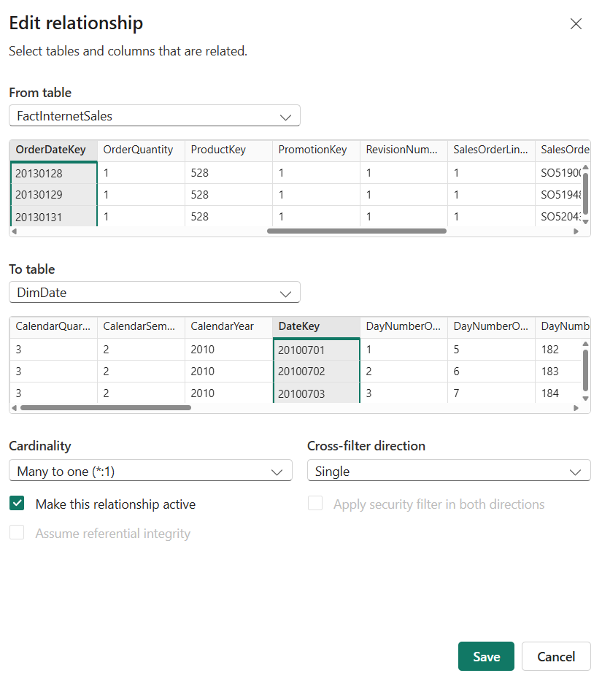
The relationship was healthy: Many-to-one, active, OrderDateKey to DateKey.
The relationship was fine, so the problem had to be somewhere else. I finally found the real cause myself, after remembering the Sort by Column step from Section 1.4: because I had sorted Year Month Label by YearMonthSort, Power BI treats the two columns as linked together for filtering. My ALL() was only clearing Year Month Label, while YearMonthSort was still silently filtering the same month underneath it. I fixed the measure by clearing both columns at once:
% of Total OQ = DIVIDE(
[Order Quantity],
CALCULATE([Order Quantity], ALL(DimDate[Year Month Label]), ALL(DimDate[YearMonthSort]))
)
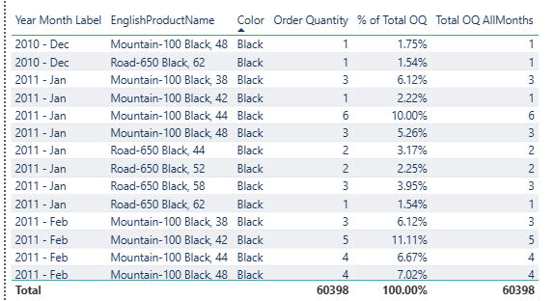
Fixed – Total OQ AllMonths now shows the same 60,398 total on every row, and the percentages are realistic.
After the fix I removed the temporary Total OQ AllMonths diagnostic column, leaving only the columns the task actually asked for:
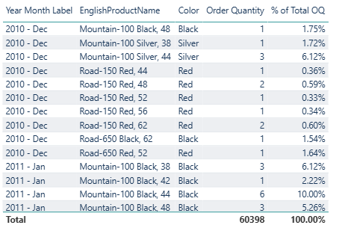
The final, clean % of Total table.

3.4 Sales Amount at Maximum Order Date
This measure shows the sales amount for the latest order date available within whatever filter context is currently active on the page – for example, if a Product Category is selected, it shows the sales on that category's own latest order date, not just the latest date in the entire table:
Sales Amount at Max Date =
VAR MaxOrderDate = MAX ( FactInternetSales[OrderDate] )
RETURN
CALCULATE ( [Sales Amount], FactInternetSales[OrderDate] = MaxOrderDate )
I used a Card for this, because a card is the simplest way to display one fixed KPI number. MAX(FactInternetSales[OrderDate]) is evaluated inside whatever filter context is active, so it always resolves to that context's own latest order date. See section 4.3 for the debugging story: my first version wrapped this in CALCULATE(..., ALL(FactInternetSales)), which actually broke it by erasing the Category filter entirely, so the measure always looked at the table's global latest date (28 January 2014) no matter what was selected.

3.5 Country with Highest Sales
This measure finds the country with the highest total sales across the whole table, and is designed to stay fixed regardless of any other filter or cross-filter selection elsewhere on the page:
Top Country by Sales =
VAR CountryTable =
ADDCOLUMNS(
ALL(DimSalesTerritory[SalesTerritoryCountry]),
"CountrySales", CALCULATE([Sales Amount], REMOVEFILTERS())
)
VAR TopCountry =
TOPN(1, CountryTable, [CountrySales], DESC)
RETURN
MAXX(TopCountry, DimSalesTerritory[SalesTerritoryCountry])
I put the result in a Card again, next to the Sales Amount at Max Date card. I chose a Card here as well because the task only asks for the name of a single best-performing country, not a full comparison, so a card gives a clear one-glance answer. REMOVEFILTERS() inside CALCULATE([Sales Amount], REMOVEFILTERS()) clears every filter before ranking countries – that is what keeps this card fixed even when other visuals cross-filter the page (see section 4.4). The result was "United States", which also matches the country split I saw earlier in the Pie chart from Task 2 (where the US had the largest slice).
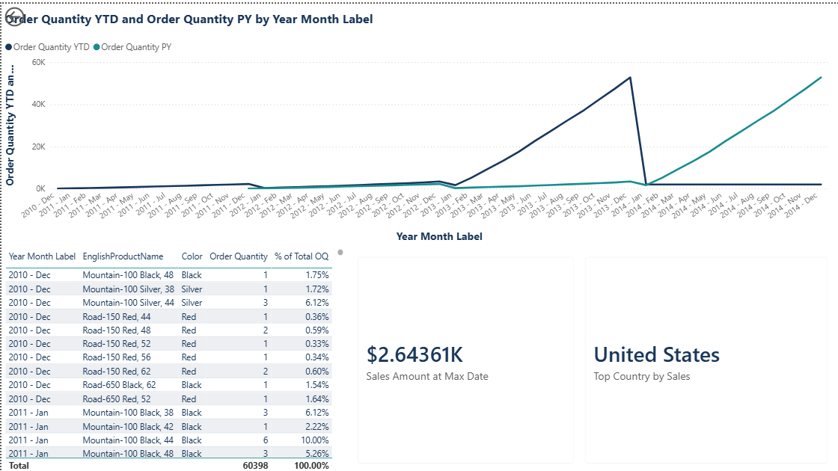
The % of Total table together with the Sales Amount at Max Date and Top Country by Sales cards.

3.6 Ranking Product Categories by Sales
Finally, I used RANKX to rank the product categories by total sales:
ProductCategory Rank =
RANKX(
ALL(DimProductCategory[EnglishProductCategoryName]),
CALCULATE([Sales Amount]),
,
DESC
)
I added a Table with EnglishProductName, Sales Amount, ProductCategory Rank and EnglishProductCategoryName, but the result was a mess – it showed every product crossed with every category, and the ranks did not make sense:
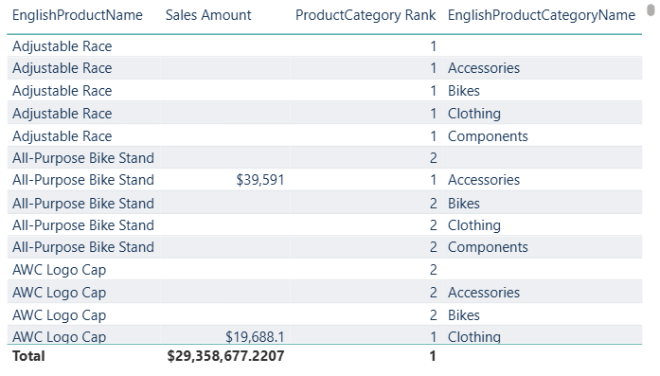
A mistake – EnglishProductName was still in the table, creating a confusing cross-join.
I had left the old EnglishProductName field in the table by accident. Once I removed it and kept only EnglishProductCategoryName, Sales Amount and ProductCategory Rank, the table shrank down to just the four real categories with correct ranks:
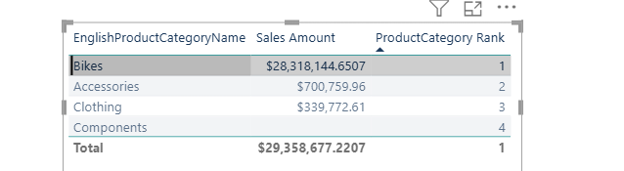
Fixed – Bikes, Accessories, Clothing and Components, each with its rank. (This screenshot also reflects a later fix: the table originally had an extra blank row tied with Components at rank 4, caused by a standard Power BI Import-mode referential-integrity artifact – removed with a visual-level filter; see section 4.5.)
I chose a Table for this instead of a chart, because RANKX gives a clear numeric rank (1, 2, 3...) for each category, and a table lets me show the category name, its exact sales amount and its rank together in one place, which is easier to read precisely than comparing bar heights on a chart. Bikes came out on top by a large margin, followed by Accessories and Clothing. Components ended up with no sales amount at all and tied for last place, which makes sense, because components are only used to build other products and are not sold directly to customers.

3.7 Putting the Final Page Together
Once all the measures and visuals were ready, I arranged everything onto one final report page: both Line charts, the Welcome and Current Date cards, the % of Total table, the ProductCategory Rank table, and the Sales Amount at Max Date and Top Country by Sales cards, all together:
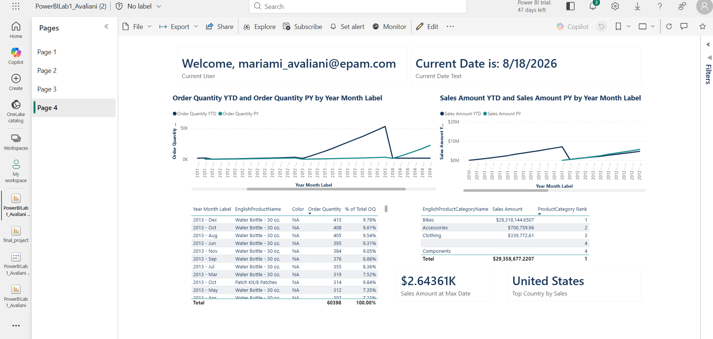
The final report page, now showing the corrected Current User (real UPN), Current Date Text, Sales Amount at Max Date, and Top Country by Sales measures after all four fixes (this is the Power BI Service view; see section 4 for the full before/after and verification).

4. Mentor Feedback & Fixes
After submitting this lab, my mentor reviewed the file and left four comments. I went back into the same report and fixed each one, testing the result directly in the visuals before moving to the next.

4.1 Greeting Card – USERNAME() vs USERPRINCIPALNAME()
Mentor's comment: USERNAME()'s return format isn't guaranteed to stay consistent between Desktop and the Service, since it depends on how the user is authenticated. USERPRINCIPALNAME() always returns a consistent UPN (email-format) identity in both, which is why Microsoft recommends it for anything user-identity related.
Before:
Current User = "Welcome, " & USERNAME()
After:
Current User = "Welcome, " & USERPRINCIPALNAME()
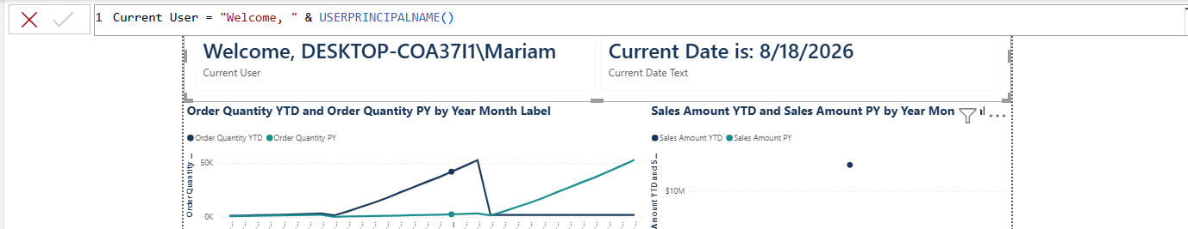
Current User measure updated to USERPRINCIPALNAME(). On Desktop it still shows the local Windows identity (DESKTOP-COA37I1\Mariam), because I am not signed into Desktop with a work/school account — this is expected. Once published to the Service, USERPRINCIPALNAME() correctly resolves to my real UPN, unlike USERNAME().
One subtlety I ran into while verifying this: on Desktop, the Current User card still showed DESKTOP-COA37I1\Mariam even after I signed into the Power BI Desktop application itself with my EPAM account. That sign-in is only for licensing and connecting to the Service — USERPRINCIPALNAME() actually reads the UPN reported by the Windows OS session, not the Power BI Desktop app's sign-in state. Since my Windows device itself is not Azure AD / domain-joined, Windows has no UPN to hand back, so DAX falls back to the same value USERNAME() would give. This is documented, expected behavior, not a bug in the measure.
The real test is the Service, where the report runs under my actual authenticated Azure AD session. After publishing, opening the report there shows the correct result:

The published report in Power BI Service. Current User correctly shows the UPN (mariami_avaliani@epam.com) instead of the Desktop-only Windows fallback, and Current Date Text shows the live current date (8/18/2026) in m/d/yyyy format — confirming both fixes work end-to-end.

4.2 Today Date – Format and Reuse in the Greeting
Mentor's comment: apply the short date format (m/d/yyyy) to the Today Date measure, and reuse the Today Date measure inside the Current Date Text measure instead of calling TODAY() a second time.
I set Today Date's format (Measure tools → Formatting → Format → Date → m/d/yyyy) and changed Current Date Text as follows.
Before:
Current Date Text = "Current Date is: " & FORMAT(TODAY(), "m/d/yyyy")
After:
Current Date Text = "Current Date is: " & FORMAT([Today Date], "m/d/yyyy")
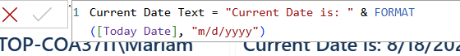
Current Date Text now references the Today Date measure instead of calling TODAY() independently, and displays in m/d/yyyy format.
I initially had Today Date's format set to yyyy-mm-dd by mistake. In the Measure tools ribbon's Format dropdown, I switched it to the correct option:
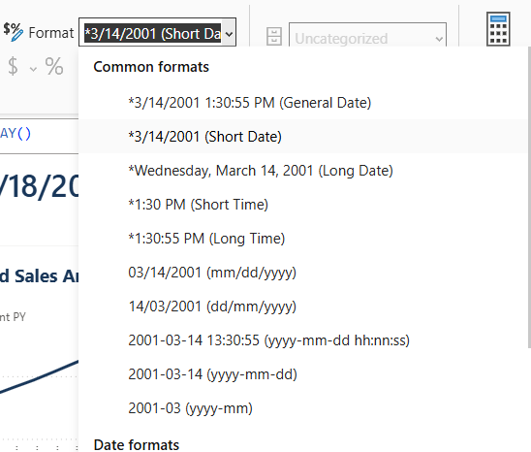
Today Date's Format set to *3/14/2001 (Short Date) in the Measure tools ribbon, giving the m/d/yyyy display the mentor requested.

4.3 Sales Amount at Max Date – Respecting the Category Filter
Mentor's comment: clicking Bikes in the table visual should show $45,779 – the sales amount on 28.12.2013, the latest available order date for EnglishProductCategoryName = Bikes. Instead the card showed “--”.
I originally wrapped MAX() in CALCULATE(..., ALL(FactInternetSales)) on purpose, thinking this would make the measure always look at the true latest date in the whole table regardless of any filter. That reasoning was backwards for this task: ALL(FactInternetSales) also erased the Category filter coming from the table visual, so MaxOrderDate always resolved to the table's global last date (28.01.2014) even when Bikes was selected – and Bikes has no sales on that exact day, so the CALCULATE that follows returned BLANK.
Before:
Sales Amount at Max Date =
VAR MaxOrderDate = CALCULATE(MAX(FactInternetSales[OrderDate]), ALL(FactInternetSales))
RETURN
CALCULATE([Sales Amount], FactInternetSales[OrderDate] = MaxOrderDate)
After (ALL(FactInternetSales) removed, so MAX() respects the current filter context):
Sales Amount at Max Date =
VAR MaxOrderDate = MAX(FactInternetSales[OrderDate])
RETURN
CALCULATE([Sales Amount], FactInternetSales[OrderDate] = MaxOrderDate)
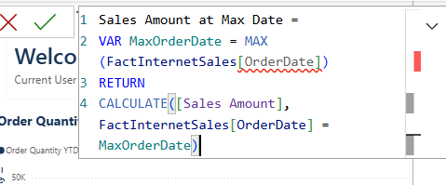
Corrected Sales Amount at Max Date formula. After this change, selecting Bikes in the table visual correctly shows $45,779.

4.4 Top Country by Sales – Ignoring Every Other Filter
Mentor's comment: the country with the highest sales across all years should not change when Bikes is clicked in the table visual or when other fields are selected on other visuals. It was changing.
This bug was the mirror image of 4.3. My original ADDCOLUMNS only removed filters from DimSalesTerritory[SalesTerritoryCountry] – it never removed the Category filter (or any other filter) from the CountrySales calculation, so each country's sales, and therefore the ranking, kept changing whenever another visual cross-filtered the page.
Before:
Top Country by Sales =
VAR CountryTable =
ADDCOLUMNS(
ALL(DimSalesTerritory[SalesTerritoryCountry]),
"CountrySales", CALCULATE([Sales Amount])
)
VAR TopCountry =
TOPN(1, CountryTable, [CountrySales], DESC)
RETURN
MAXX(TopCountry, DimSalesTerritory[SalesTerritoryCountry])
After (REMOVEFILTERS() added inside CountrySales, clearing every filter in the model before the per-country context transition is applied):
Top Country by Sales =
VAR CountryTable =
ADDCOLUMNS(
ALL(DimSalesTerritory[SalesTerritoryCountry]),
"CountrySales", CALCULATE([Sales Amount], REMOVEFILTERS())
)
VAR TopCountry =
TOPN(1, CountryTable, [CountrySales], DESC)
RETURN
MAXX(TopCountry, DimSalesTerritory[SalesTerritoryCountry])
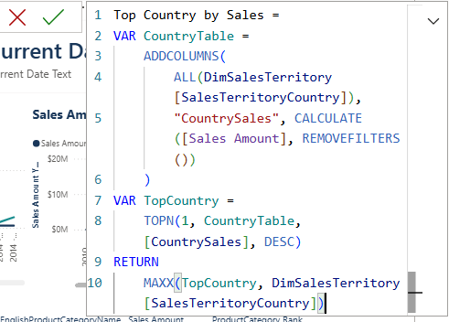
Corrected Top Country by Sales formula. After this change, the result (United States) stays the same whether or not Bikes is selected, while Sales Amount at Max Date now correctly reacts to it – confirming the two measures behave as intended in opposite ways.
Takeaway: 4.3 and 4.4 are a good illustration of why “always add ALL() to be safe” is the wrong instinct. Each measure needs the exact set of filters removed for its own purpose – 4.3 needed to keep the Category filter and only fix the date logic, while 4.4 needed to remove every filter except the one it iterates over.

4.5 Verification – Clicking Through Categories
To confirm both 4.3 and 4.4 behave correctly, and not just for Bikes, I clicked through several rows in the ProductCategory Rank table and recorded both cards each time. Sales Amount at Max Date should change to match each category's own latest order date, while Top Country by Sales should stay fixed on United States no matter what is selected.
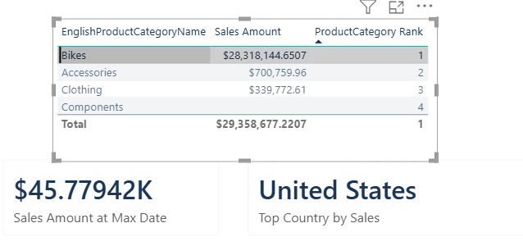
Bikes selected: Sales Amount at Max Date = $45.77942K (matches the $45,779 the mentor expected for 28.12.2013), Top Country by Sales = United States.
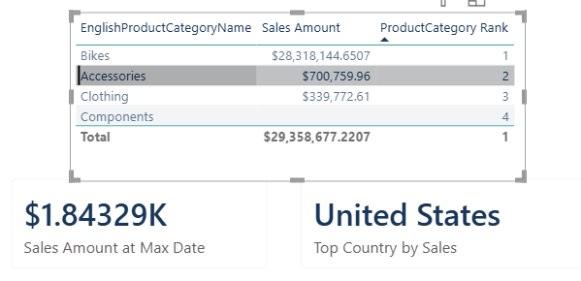
Accessories selected: Sales Amount at Max Date updates to $1.84329K – its own latest order date, different from Bikes' – while Top Country by Sales is still United States.
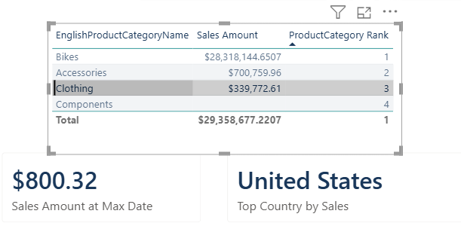
Clothing selected: Sales Amount at Max Date updates again, to $800.32, and Top Country by Sales is still United States.
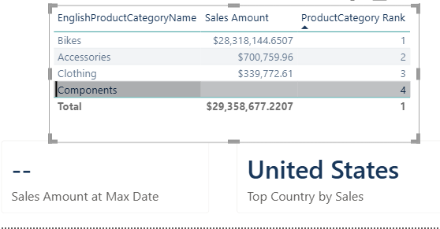
Components selected (the toughest edge case – zero sales rows for this category): Sales Amount at Max Date correctly shows "--" instead of a wrong number, since MAX(FactInternetSales[OrderDate]) finds no matching date at all when there are no sales rows for Components. Top Country by Sales is still United States, confirming REMOVEFILTERS() holds up even for a category with no data.
While testing this, I also noticed the table originally showed an extra blank row below Components, tied with it at rank 4. This is a standard Power BI Import-mode artifact, not a bug: FactInternetSales has a small number of rows that don't cleanly map through DimProduct -> DimProductSubcategory -> DimProductCategory, so Power BI auto-creates a blank member on the category dimension to hold them, and RANKX picks it up because it iterates ALL(DimProductCategory[EnglishProductCategoryName]). I removed it from the visual with a filter (Filters pane -> EnglishProductCategoryName -> Advanced filtering -> is not blank), which only affects this table's display and leaves the underlying measures untouched.
Across all four categories - including the zero-sales edge case - Sales Amount at Max Date always reflected that category's own latest order date (or blank when there was none), while Top Country by Sales never changed. This confirms both fixes behave exactly as the mentor's comments required.

Conclusion
In this lab I learned the difference between a calculated column and a measure, and practiced writing DAX from very simple expressions up to more advanced ones. I created a calculated column with FORMAT, fixed a text-based column's sort order with a helper column and Sort by Column, and learned that Power BI can link two columns together for filtering once one is sorted by the other, which caused a real bug in my % of Total measure until I cleared both columns with ALL(). I also learned that DimDate has to be marked as a proper Date Table for DATESYTD and SAMEPERIODLASTYEAR to calculate correctly. Along the way I made a couple of real mistakes too, like leaving an old field in a table by accident, but diagnosing and fixing them helped me understand how CALCULATE, ALL, DATESYTD, SAMEPERIODLASTYEAR, DIVIDE, TOPN and RANKX actually behave, not just how to type them.

