PostgreSQL DB for DWH and ETL Building
PostgreSQL Relational Structures — Task 1: Answer
Author: Mariam Avaliani
This document is the Task 1 assignment for the “PostgreSQL Relational Structures” module, completed against my own local PostgreSQL 16 instance (Windows, data directory C:/Program Files/PostgreSQL/16/data) using pgAdmin. Each step below lists the exact SQL run and what the resulting screenshot should show — the orange dashed boxes mark exactly where to paste each pgAdmin screenshot before submitting.

1. Prerequisite Task

1.1 Roles and privileges
PostgreSQL has no separate concept of “users” and “groups” — both are unified under ROLE. A role can log in (LOGIN attribute, historically called a “user”) or just group other roles together for permission management (a “group role”, without LOGIN). Roles are cluster-wide objects (stored in pg_authid / visible via pg_roles), not tied to a single database, which is why the default superuser (postgres) can connect to any database in the cluster. Key privilege-related attributes: SUPERUSER, CREATEDB, CREATEROLE, LOGIN, and REPLICATION. Object-level privileges (SELECT, INSERT, UPDATE, DELETE, USAGE, EXECUTE, etc.) are granted separately with GRANT/REVOKE on top of role membership. By default, a newly created database or schema is not accessible to other roles until privileges are explicitly granted — this is exactly what is observed in Task 3 below, where the labs schema is only usable once search_path is set correctly.

1.2 Tablespace and Database creation
CREATE DATABASE always works by cloning an existing template database (template1 by default), which is why every newly created database instantly has the standard system catalog objects. CREATE TABLESPACE requires an already-existing, empty directory on disk; PostgreSQL will not create the directory itself. Two PostgreSQL restrictions to keep in mind for Task 2: CREATE TABLESPACE and ALTER DATABASE ... SET TABLESPACE cannot run inside an explicit transaction block, and ALTER DATABASE cannot target the database the current session is connected to (it must be run from a different database, e.g. postgres).

1.3 Database Cluster Data Directory Layout (PGDATA)
Data directory used for this task:
SHOW data_directory;
-> C:/Program Files/PostgreSQL/16/data
The most relevant subdirectories/files inside PGDATA:
- base/ — main directory holding one subdirectory per database (named by its OID), containing that database's table/index files.
- global/ — cluster-wide objects shared by all databases (e.g. pg_database, role definitions).
- pg_tblspc/ — symbolic links pointing to the physical location of every non-default tablespace (see Task 2).
- pg_wal/ — Write-Ahead Log segments (binary files) used for crash recovery and replication.
- log/ — server startup and runtime logs.
- postgresql.conf — the main configuration file (memory, WAL, connection parameters, etc.); pg_hba.conf controls client authentication.

2. Understanding Database and Tablespaces

2.1 Task 1 — Create new database
Connected to the default postgres database and created test_db:
CREATE DATABASE test_db;
Then ran the join query linking pg_database to pg_tablespace:
select d.oid, d.datname, d.datistemplate, d.datallowconn, t.spcname
from pg_database d
join pg_tablespace t on t.oid = d.dattablespace;
What to look for: the full list of databases in the cluster, with test_db's row showing datistemplate = false, datallowconn = true, and spcname = pg_default (the default, before Task 2 moves it).

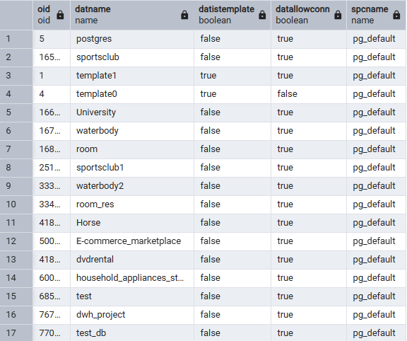

2.2 Task 2 — Create new Tablespace
Created an empty tblspc_test folder inside the data directory, then created the tablespace:
CREATE TABLESPACE mytablespace LOCATION 'C:/Program Files/PostgreSQL/16/data/tblspc_test/';
What to look for: a WARNING (not an error) that the tablespace location shouldn't be inside the data directory — expected here, the task itself asks for this location for lab purposes — followed by CREATE TABLESPACE confirming success.
Verified it exists in pg_tablespace:
SELECT * FROM pg_tablespace;
What to look for: mytablespace listed alongside the two defaults, pg_default and pg_global.
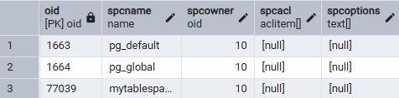
Moved test_db into the new tablespace (run from a Query Tool connected to postgres, not test_db):
ALTER DATABASE test_db SET TABLESPACE mytablespace;
What to look for: ALTER DATABASE confirming success.
Re-ran the Task 1 join query to confirm the change, and checked the tblspc_test folder in File Explorer:
select d.oid, d.datname, d.datistemplate, d.datallowconn, t.spcname
from pg_database d
join pg_tablespace t on t.oid = d.dattablespace;
What to look for: test_db's spcname now reads mytablespace instead of pg_default.
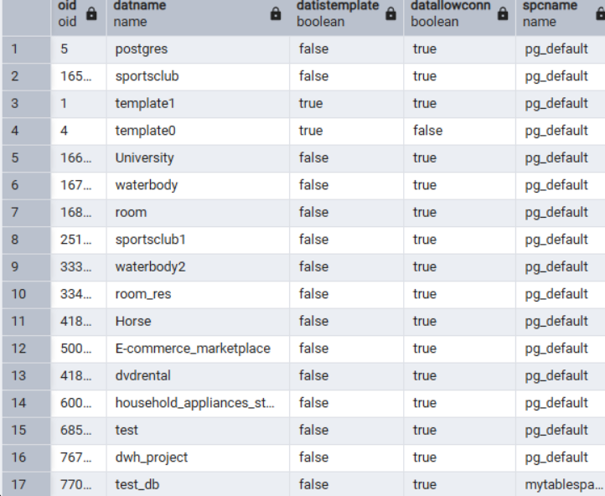

2.3 Task 3 — Create new schema
Connected to test_db and created schema labs with table person inside it:
CREATE SCHEMA labs;
CREATE TABLE labs.person (
id integer NOT NULL,
name varchar(15)
);
SELECT schemaname, tablename FROM pg_tables
WHERE tablename = 'person';
What to look for: labs.person listed in the pg_tables result, confirming both the schema and table exist.
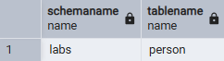
Tried the required INSERTs without qualifying the schema (this is expected to fail before search_path is set):
INSERT INTO person VALUES(1, 'Bob');
What to look for: ERROR: relation "person" does not exist — this happens because labs is not on the current session's search_path (default: "$user", public), so PostgreSQL can't resolve the unqualified table name.
Fixed it the way the task requires — by changing search_path instead of qualifying every statement with labs.person:
SHOW search_path;
SET search_path TO labs, public;
SHOW search_path;
INSERT INTO person VALUES(1, 'Bob');
INSERT INTO person VALUES(2, 'Alice');
INSERT INTO person VALUES(3, 'Robert');
SELECT * FROM person;
What to look for: search_path changing to "labs, public", followed by the same unqualified INSERT statements succeeding with no correction, and SELECT * FROM person returning all three rows (Bob, Alice, Robert).
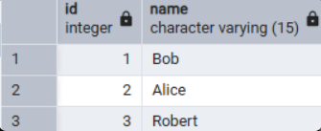

3. Transaction and Vacuuming

3.1 Task 4 — Investigate MVCC
Installed pageinspect, then captured the baseline ctid/xmin/xmax for the three rows from Task 3:
CREATE EXTENSION pageinspect;
select p.id, p.name, p.ctid, p.xmin, p.xmax from person p;
SELECT t_xmin, t_xmax, t_ctid,
tuple_data_split('labs.person'::regclass, t_data, t_infomask, t_infomask2, t_bits)
FROM heap_page_items(get_raw_page('labs.person', 0));
What to look for: all three rows with xmax = 0 (nothing has touched them yet) and distinct xmin values (the transaction ids that inserted them) — this is the “before” snapshot to compare against after each step below.
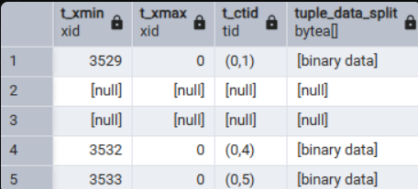
xmin is the id of the transaction that inserted the row version; xmax is the id of the transaction that deleted/replaced it (0 = still current); ctid is the physical (page, item) address on disk. Each statement below was run in its own explicit transaction, re-checking the heap_page_items query immediately after each COMMIT:

Step 1 — INSERT
BEGIN;
INSERT INTO person VALUES(4, 'John');
COMMIT;
What to look for: a brand-new row for John with a fresh xmin (the inserting transaction) and xmax = 0. All other rows unchanged.

Step 2 — UPDATE
BEGIN;
UPDATE person SET name = 'Alex' WHERE id = 2;
COMMIT;
What to look for: Alice's original row is NOT modified in place — it keeps its old xmin but now has xmax set to the updating transaction (“closed”), while a brand-new row (Alex) appears with a fresh xmin and xmax = 0. This is the direct proof that UPDATE = DELETE(old version) + INSERT(new version) under MVCC.

Step 3 — DELETE
BEGIN;
DELETE FROM person WHERE id = 3;
COMMIT;
What to look for: Robert's row stays exactly where it was (same ctid) — DELETE only stamps xmax on the existing tuple, it does not remove it or create a new version.

Step 4 — INSERT then DELETE of id = 999
BEGIN; INSERT INTO person VALUES(999, 'Test'); COMMIT;
BEGIN; DELETE FROM person WHERE id = 999; COMMIT;
What to look for: even though the row lived for only a few seconds, its tuple keeps both xmin (the INSERT) and xmax (the DELETE) set — nothing is erased until VACUUM runs, which is exactly what Task 5 covers next.

3.2 Task 5 — Investigate VACUUM
Starting from the state left at the end of Task 4 (live rows: Bob, Alex, John; dead rows: old Alice, Robert, id 999), ran:
VACUUM labs.person;
What to look for: the dead rows' line pointers freed (shown as empty/null placeholder rows, or removed outright if they were the very last item on the page) — the table is not shrunk or renumbered, the freed space is only tracked for reuse.
Inserted a new row to check whether the freed space is reused:
INSERT INTO person VALUES(5, 'Sarah');
What to look for: Sarah's new row lands directly in one of the slots VACUUM just freed, rather than being appended at the very end — direct proof the Free Space Map is reused by later inserts.
Finally ran VACUUM FULL:
VACUUM FULL labs.person;
What to look for: the whole table rewritten into a fresh, compact copy — ctids renumbered sequentially with no gaps left at all. This is the practical difference from plain VACUUM: VACUUM FULL reclaims and compacts disk space, but needs an ACCESS EXCLUSIVE lock on the table for the rewrite, while plain VACUUM does not lock the table.

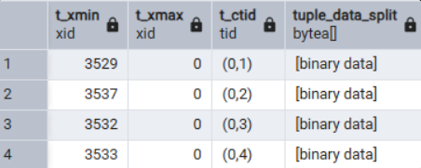

3.3 Summary — MVCC and VACUUM together
MVCC lets PostgreSQL avoid locking readers against writers by keeping multiple physical versions of a row and letting each transaction's snapshot decide which version is visible to it (based on xmin/xmax versus its own transaction id). The direct cost of this design is that INSERT/UPDATE/DELETE never truly free space immediately — dead tuples accumulate on disk. VACUUM is the mechanism that reclaims that dead space for reuse without blocking the table, while VACUUM FULL (or, in production, a well-tuned autovacuum running proactively) is the heavier operation used when the table needs to be physically compacted, at the cost of an exclusive lock.

