Business Template
sales

Contents
- Business Description
  - Business background
  - Problems because of poor data management
  - Benefits from implementing a Data Warehouse
  - DATASETS DESCRIPTION
  - GRAIN / DIM / FACT
- Business Layer 3N
- Business Layer Dimensional Model
- Logical Scheme
- Data Flow
- Fact Table Partitioning Strategy

1. Business Description
- Business background
The business represents a retail company that operates through two main sales channels: in-store (physical retail stores) and online e-commerce platforms. Customers can purchase products either by visiting physical stores or by placing orders through an online website.
The retail system manages a wide range of products including clothing, books, and electronics, and serves customers across multiple cities in the United States. Each transaction records essential business information such as product details, customer information, payment method, and transaction value.
The business aims to analyze sales performance, customer behavior, product demand, and profitability across both retail channels in order to optimize decision-making and improve operational efficiency.

  - Problems because of poor data management
Without a centralized data management system, the business faces several challenges. Data from in-store and online systems is stored separately, making it difficult to combine and analyze performance across channels.
This leads to issues such as:
- Inability to compare online and offline sales performance
- Difficulty in identifying profitable products and customers
- Lack of consistent reporting across systems
- Data duplication and inconsistency in transaction records
- Limited ability to perform historical trend analysis
As a result, business decisions are often based on incomplete or fragmented information, reducing operational efficiency and profitability.

  - Benefits from implementing a Data Warehouse
Implementing a Data Warehouse provides a unified and structured view of all business data by integrating multiple operational systems into a single analytical platform.
The key benefits include:
- Centralized and consistent data storage from both retail and online channels
- Improved reporting and analytics capabilities
- Ability to analyze customer behavior across multiple channels
- Enhanced product performance tracking and profitability analysis
- Support for time-based trend analysis and forecasting
- Better decision-making through OLAP operations such as drill-down and roll-up
Additionally, a data warehouse enables advanced segmentation of customers, products, and regions, allowing the business to improve marketing strategies and operational planning.

  - DATASETS DESCRIPTION
I used Retail Analysis on Large Dataset: https://www.kaggle.com/datasets/fahadrehman07/retail-transaction-dataset I got data from here, duplicated it added more data because it was not enough in the beginning, changed dates and I changed adresses and put in-store and online options.

The project uses two different but related datasets representing two separate source systems: Retail Store Sales Data and Online E-commerce Sales Data.
Both datasets are derived from a retail domain but differ in structure, attributes, and business processes.

First Dataset — Retail (In-Store Sales System)
The first dataset represents in-store transactions collected from physical retail stores located across different cities in the United States. It contains transaction-level data captured at the point of sale (POS) system.
This dataset includes:
- Customer information (CustomerID, segment, type, city, loyalty score)
- Product information (ProductID, category, brand, price)
- Transaction details (TransactionID, date, quantity, sales value, cost, profit)
- Payment information (payment method, status, risk score)
- Store information (store location, region, store type)
This dataset reflects traditional physical shopping behavior where customers purchase items directly from stores.

Second Dataset — Online (E-commerce Sales System)
The second dataset represents online retail transactions generated through an e-commerce platform. Customers place orders via web or mobile devices, and products are delivered through shipping or pickup methods.
This dataset includes:
- Customer information (CustomerID, demographics, city, segment)
- Product information (ProductID, category, brand, price)
- Order information (TransactionID, date, quantity, sales value, discount, profit)
- Payment information (payment method, status, channel, risk score)
- Delivery information (shipping cost, delivery type, delivery status, fulfillment time)

Dataset Separation Logic (IMPORTANT REQUIREMENT)
The second dataset is generated from the first dataset using a business-based transformation approach. While both datasets share similar product and customer structures, they differ in:
- Transaction channel (Retail vs Online)
- Payment methods (Cash/Card vs Card/PayPal/ApplePay)
- Presence of delivery attributes (only Online system)
- Transaction ID structure (separate ID ranges)
- Additional cost components (shipping cost in Online system)
- Operational behavior (store-based vs digital ordering)
This separation ensures that the datasets represent two realistic and independent source systems while maintaining analytical consistency for Data Warehouse integration.
- Hierarchy Requirement
The datasets include a well-structured hierarchy system that supports OLAP analysis:
- Time Hierarchy: Year → Month → Day (TransactionDate)
- Geography Hierarchy: Country → Region → City → Store
- Product Hierarchy: Category → Subcategory → Product
- Customer Hierarchy: Segment → Type → Individual Customer
These hierarchies allow the system to perform drill-down and roll-up analysis for business intelligence reporting.

  - GRAIN / DIM / FACT

Grain Definition
The grain of the data warehouse is defined as:
One row in the fact table represents a single product transaction (purchase event) made by a customer in either the retail or online system.
Each record contains transaction-level details including quantity, price, cost, discount, and profit.

Dimensions
The data warehouse includes the following dimension tables:

Customer Dimension
Describes customer attributes such as segment, type, age group, and city.

Product Dimension
Contains product details including category, subcategory, brand, and price.

Date Dimension
Provides time-based attributes such as year, month, and day.

Payment Dimension
Includes payment method, status, and risk score.

Store Dimension
Describes physical store or online channel information.

Delivery Dimension (Online only)
Includes shipping method, delivery status, and fulfillment time.

Fact Table
The central Fact_Sales table contains measurable business events.

Measures include:
- Quantity
- SalesValue
- Discount
- CostPrice
- TotalCost
- Profit
- ShippingCost (Online only)

Keys:
- TransactionID
- CustomerID
- ProductID
- StoreID
- TransactionDate
- PaymentMethod

Final Summary
The proposed data warehouse follows a star schema design that integrates retail and online transactional systems into a unified analytical model. It supports multi-dimensional analysis across customer behavior, product performance, and sales trends. The inclusion of hierarchies enables efficient OLAP operations, while the separation of source systems ensures data variety and business realism.

BUSINESS TEMPLATE – GRAIN

GRAIN JUSTIFICATION (4 STEPS)

Step 1: Identify the business process
The business process being analyzed is retail sales transactions, where customers purchase products through different channels such as online or in-store. Each transaction generates measurable business outcomes such as revenue, cost, and profit.

Step 2: Identify the lowest level of detail available
The most detailed level of data available in the system is a single product sold within a transaction event. Each transaction may include one or multiple products, but the dataset allows tracking each product line individually.

Step 3: Define the grain
The chosen grain for the fact table is:
One row per product per transaction per customer per store per date.
This means every record represents a single product purchased in a specific transaction, linked to a specific customer, store, payment method, delivery method, and date.

Step 4: Justify why this grain is appropriate
This grain is selected because it:
- Ensures maximum analytical detail, allowing analysis at product level
- Supports calculation of key KPIs such as sales, profit, discount, and cost
- Enables slicing data by customer, store, product, and time dimensions
- Prevents data loss by capturing each transaction line individually
- Provides flexibility for both high-level and detailed reporting

FACT_TRANSACTIONS
Column name | Description | Data Type
TransactionID | Unique identifier for each transaction | BIGINT
DateKey | Reference to transaction date | BIGINT
CustomerKey | Reference to customer dimension | BIGINT
ProductKey | Reference to product dimension | BIGINT
StoreKey | Reference to store dimension | BIGINT
PaymentKey | Reference to payment dimension | BIGINT
DeliveryKey | Reference to delivery dimension | BIGINT
Quantity | Number of units sold | INT
UnitPrice | Selling price per unit | DECIMAL(12,2)
SalesValue | Total sales amount before deductions | DECIMAL(12,2)
Discount | Discount applied to the transaction | DECIMAL(12,2)
CostPrice | Cost of goods sold | DECIMAL(12,2)
ShippingCost | Cost of shipping the product | DECIMAL(12,2)
TotalCost | Total transaction cost | DECIMAL(12,2)
Profit | Profit generated from the transaction | DECIMAL(12,2)
TransactionChannel | Channel through which transaction occurred (Online/Retail) | VARCHAR(50)

DIM_CUSTOMER
Column name | Description | Data Type
CustomerKey | Surrogate key for customer dimension | BIGINT
CustomerID | Original customer identifier | BIGINT
CustomerSegment | Customer segmentation category | VARCHAR(50)
CustomerType | Type of customer | VARCHAR(50)
CustomerCity | Customer's city | VARCHAR(100)
LoyaltyScore | Customer loyalty score | INT
AgeGroup | Customer age category | VARCHAR(30)

Example with filled data
CustomerKey | CustomerID | CustomerSegment | CustomerType | CustomerCity | LoyaltyScore | AgeGroup
1 | 5001 | Premium | Individual | Chicago | 90 | 50+

Column name | Description | Data Type
DIM_PRODUCT
ProductKey | Surrogate key for product dimension | BIGINT
ProductID | Original product identifier | BIGINT
ProductName | Name of the product | VARCHAR(255)
ProductCategory | Product category | VARCHAR(100)
ProductSubCategory | Product subcategory | VARCHAR(100)
ProductBrand | Product brand name | VARCHAR(100)
ProductPrice | Standard product price | DECIMAL(12,2)

Example with filled data

ProductKey | ProductID | ProductName | ProductCategory | ProductSubCategory | ProductBrand | ProductPrice
101 | 1001 | iPhone 15 | Clothing | skirt | Oysho | 163

DIM_STORE

Column name | Description | Data Type

StoreKey | Surrogate key for store dimension | BIGINT
StoreID | Original store identifier | BIGINT
StoreLocation | Physical location of the store | VARCHAR(255)
StoreType | Type of store | VARCHAR(50)
StoreSize | Size classification of store | VARCHAR(50)
Region | Region where store operates | VARCHAR(100)
Country | Country where store operates | VARCHAR(100)

Example with filled data
StoreKey | StoreID | StoreLocation | StoreType | StoreSize | Region | Country
10 | 2001 | Miami | Physical | Small | East | USA

DIM_PAYMENT

Column name | Description | Data Type
PaymentKey | Surrogate key for payment dimension | BIGINT
PaymentID | Original payment identifier | BIGINT
PaymentMethod | Method used for payment | VARCHAR(50)
PaymentType | Payment type category | VARCHAR(50)
PaymentStatus | Status of payment | VARCHAR(50)
Currency | Transaction currency | VARCHAR(10)
PaymentRiskScore | Risk score assigned to payment | INT

Example with filled data

PaymentKey | PaymentID | PaymentMethod | PaymentType | PaymentStatus | Currency | PaymentRiskScore
201 | 3001 | Credit Card | Card | Success | USD | 3.76674720517155

DIM_DELIVERY
Column name | Description | Data Type

DeliveryKey | Surrogate key for delivery dimension | BIGINT
DeliveryID | Original delivery identifier | BIGINT
DeliveryType | Type of delivery service | VARCHAR(50)
DeliveryStatus | Status of delivery | VARCHAR(50)
DeliveryTime | Delivery duration or lead time | INT

Example with filled data

DeliveryKey | DeliveryID | DeliveryType | DeliveryStatus | DeliveryTime
301 | 4001 | Pickup | Delivered | 2

DIM_DATE

Column name | Description | Data Type

DateKey | Surrogate key for date dimension | BIGINT
TransactionDate | Date when transaction occurred | DATE

Example with filled data

DateKey | TransactionDate
20250615 | 2025-06-15

- Business Layer 3N

Design Process

Step 1: Analyze Source Systems
Two source systems were selected for the project: Retail Sales and Online Sales. Both datasets contain similar business information related to customers, products, transactions, payments, stores, deliveries, and dates.
The first step was to analyze both datasets and identify common business entities. Since the Business Layer integrates data from multiple source systems, entities that appear in both datasets are represented only once in the 3NF model.

Step 2: Identify Business Entities
Based on the analysis of the source systems, the following business entities were identified:
- Customer
- Product
- Store
- Payment
- Delivery
- Date
- Transaction
These entities represent the core business objects required to support analytical reporting and future dimensional modeling.

Step 3: Integrate Common Entities
To avoid data duplication and support enterprise-wide reporting, common entities from the Retail and Online datasets were consolidated into single business entities.
For example, customer information from both source systems is stored in one CE_CUSTOMER table, while product information from both sources is stored in one CE_PRODUCT table.
This approach ensures data consistency and supports the integration requirements of the Business Layer.

Step 4: Define Surrogate Keys and Natural Keys
Each entity includes a surrogate key (SK) that serves as the primary key of the table. Surrogate keys are generated by the data warehouse and provide unique identification of records across multiple source systems.
Each entity also contains one or more natural key (NK) attributes originating from the source systems. Natural keys are used during ETL processing to identify business entities and manage data integration.

Step 5: Implement Source Triplet
To provide full data lineage and source traceability, the Source Triplet was added to all business entities:
- SOURCE_SYSTEM
- SOURCE_ENTITY
- SOURCE_ID
These attributes allow identification of the original source system, source entity, and source record from which the business layer data was loaded.

Step 6: Implement Slowly Changing Dimension Type 2
The Customer entity was selected for Slowly Changing Dimension Type 2 (SCD2) implementation because customer attributes may change over time.
Examples of changing customer attributes include:
- Customer Segment
- Customer Type
- Customer City
- Loyalty Score
- Age Group
To preserve historical changes, the CE_CUSTOMER entity includes the following SCD2 attributes:
- START_DT
- END_DT
- IS_ACTIVE
Whenever a customer attribute changes, a new record is created with a new surrogate key while preserving previous versions of the customer record. This approach enables historical analysis of customer behavior and segmentation.

Step 7: Add Audit Columns
Following the naming conventions, audit columns were added to all entities:
- INSERT_DT
- UPDATE_DT
These attributes support ETL monitoring and data maintenance activities.

Step 8: Define Relationships
The CE_TRANSACTION entity represents the transaction grain and acts as the central business entity in the model.
Foreign keys were created to connect transactions with the related business entities:
- CUSTOMER_SK
- PRODUCT_SK
- STORE_SK
- PAYMENT_SK
- DELIVERY_SK
- DATE_SK
This structure ensures referential integrity and provides a unified view of business transactions across both source systems.

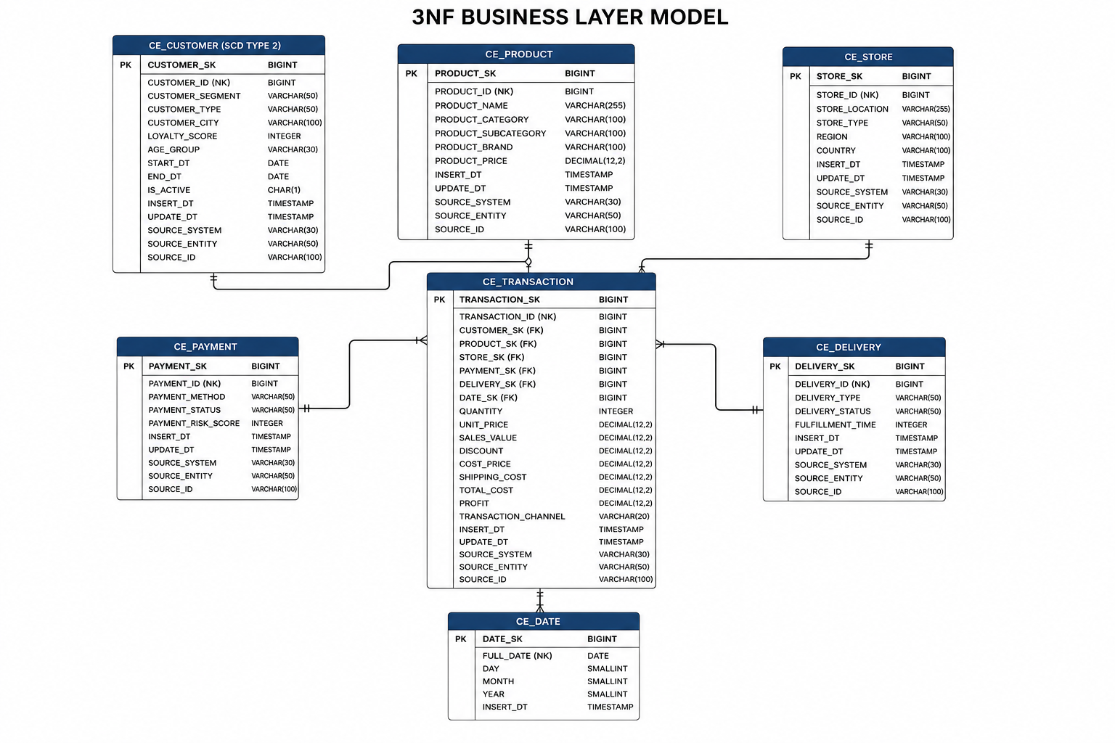
Figure 2.1. Business Layer 3NF Model
The Business Layer 3NF model integrates data from the Retail and Online source systems into a unified enterprise data model. Common business entities such as Customer, Product, Store, Payment, Delivery, and Date are represented by a single table regardless of their source system. Each entity contains a surrogate key for warehouse integration, a natural key for business identification, and a source triplet (SOURCE_SYSTEM, SOURCE_ENTITY, SOURCE_ID) to ensure data lineage and traceability. The CE_TRANSACTION entity acts as the central transactional table and maintains relationships with all business entities through foreign keys. The CE_CUSTOMER entity is implemented as a Slowly Changing Dimension Type 2 (SCD2) to preserve historical customer attribute changes over time.

- Business Layer Dimensional Model
- Logical Scheme
- Data Flow
- Fact Table Partitioning Strategy

