ANALYSIS OF dvd_rental FUNCTIONS (TASK 6)
1) What operations do the functions perform
The function film_in_stock selects inventory_id values from the inventory table where film_id and store_id match the input parameters and where the function inventory_in_stock(inventory_id) returns TRUE. This means it returns all inventory items of a specific film in a store that are currently available.
The function film_not_in_stock performs the same query but uses NOT inventory_in_stock(inventory_id). It returns inventory items that are currently rented out, meaning there is at least one rental record with return_date IS NULL. This function is essentially the inverse of film_in_stock.
The function inventory_in_stock determines whether a specific inventory item is available. It first counts all rentals for the item. If there are no rentals, it returns TRUE. Otherwise, it checks if any rental has return_date IS NULL. If such a rental exists, it returns FALSE; otherwise, it returns TRUE. This function checks availability based on active rentals.
The function get_customer_balance calculates a customer’s balance by summing rental fees for all rentals before a given date, adding late fees based on how long rentals exceed the rental duration, and subtracting all payments made before that date. However, the implementation does not fully match the described business rules.
The function inventory_held_by_customer retrieves the customer_id from the rental table where the given inventory item is currently rented (return_date IS NULL). It returns the customer currently holding that inventory item.
The function rewards_report identifies customers who meet certain monthly purchase conditions. It calculates a specific month based on CURRENT_DATE, creates a temporary table, inserts customer IDs that meet purchase thresholds using dynamic SQL, and then returns full customer records.
The function last_day calculates the last day of the month for a given date by constructing the first day of the next month and subtracting one day.

2) Why does ‘rewards_report’ return 0 rows and how to fix it
The function returns 0 rows because it calculates the reporting period using CURRENT_DATE minus three months. The dvd_rental dataset contains data only from 2005 to 2007, while CURRENT_DATE refers to the present year. As a result, the date filter does not match any records, and the query returns no rows.
A correct approach is to parameterize the date instead of using CURRENT_DATE and remove unnecessary dynamic SQL.
Corrected version:
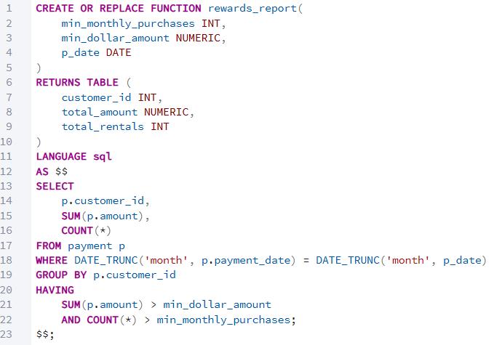
3) Function that can be removed
The function film_not_in_stock can be removed because it duplicates the logic of film_in_stock by simply negating the condition inventory_in_stock(). The same result can be achieved without creating a separate function, making it redundant.

4) Functions that violate best practices
The function rewards_report violates best practices by using dynamic SQL, temporary tables, and loops unnecessarily. It also relies on CURRENT_DATE, making it non-reusable for historical data.
The function inventory_in_stock is inefficient because it uses multiple queries and COUNT instead of EXISTS.
The function get_customer_balance violates best practices due to invalid syntax (IF instead of CASE), incomplete implementation of business rules, and incorrect calculations.
The function inventory_held_by_customer is unsafe because it assumes only one row will be returned and may fail if multiple rows exist.
The function last_day is overly complex because it uses string manipulation instead of built-in date functions.

5) Corrected get_customer_balance function
The original function does not correctly implement overdue fees, replacement costs, or handling of ongoing rentals. A corrected version is:
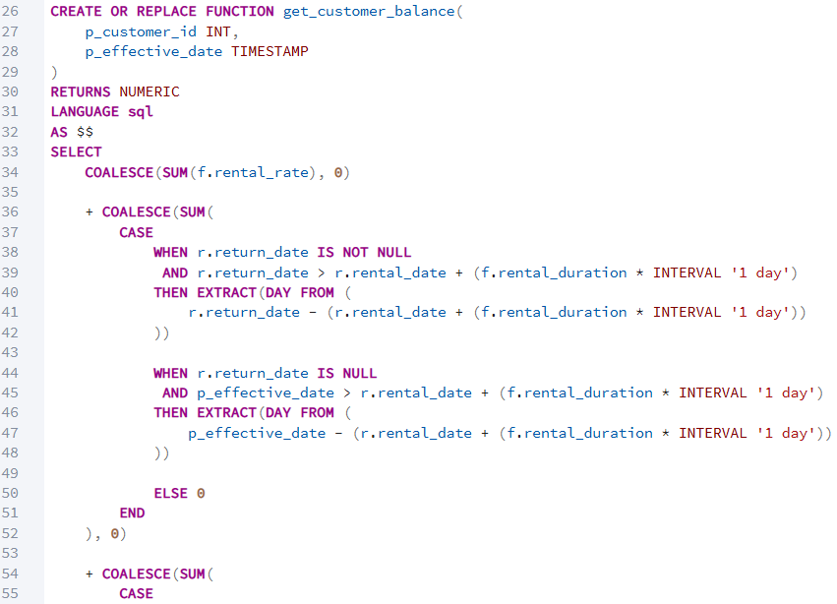
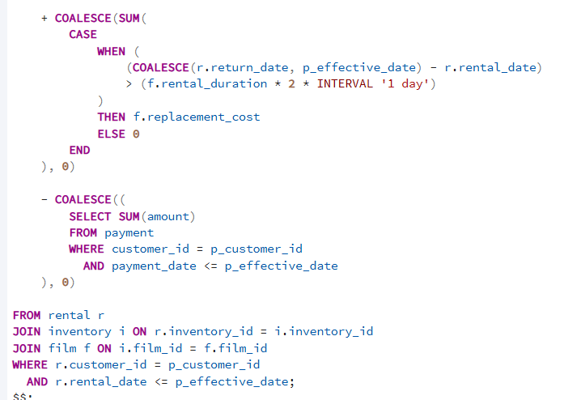
6) group_concat and _group_concat
These functions are used to concatenate multiple row values into a single string. The function _group_concat acts as the internal aggregate function, while group_concat is a wrapper that calls it. They behave similarly to PostgreSQL’s string_agg function and are typically used in reporting queries to combine values from multiple rows.

7) last_updated function
The last_updated function sets the value of the last_update column to the current timestamp using NOW() and returns the updated row. It is used in triggers on tables such as film, actor, and customer to automatically update the timestamp whenever a record is modified.

8) tmpSQL variable in rewards_report
The tmpSQL variable stores dynamically constructed SQL queries that are executed using the EXECUTE statement. It is used to build INSERT and DROP TABLE statements dynamically. However, this function can be recreated without dynamic SQL because the query structure is fixed and does not depend on dynamic table or column names. Therefore, EXECUTE is unnecessary.

9) Functions that can produce incorrect results
The function get_customer_balance can produce incorrect results because it does not correctly calculate overdue fees, does not implement the replacement cost rule, and uses invalid syntax.
The function inventory_held_by_customer can fail or return incorrect results if multiple active rentals exist for the same inventory item.
The function inventory_in_stock may produce unreliable results if the data is inconsistent and is also inefficient.
The function rewards_report produces incorrect results (empty set) because it uses CURRENT_DATE, which does not match the dataset.

