AWS Cloud for Data Engineering
Redshift — Task 3 Report
Mariam Avaliani — student30

Introduction
For this task I reused the resources I already had from the previous tasks, instead of creating everything again. My S3 bucket from Task 1 already had 7 tables of data (dim_customers_scd, dim_dates, dim_deliveries, dim_payments, dim_products, dim_stores, fct_transactions_dd), and I also had my Glue Data Catalog database dwh_project_bl_dm_db from that task, which already knows the structure of these tables. For the EC2 machine that I need for the SSH tunnel, I used the same instance from Task 2 (mariam-avaliani-db-ec2).
My report shows monthly sales performance by product and store — total revenue, total quantity and number of transactions, grouped by year, month, product and store. I loaded three tables for this: fct_transactions_dd (the fact table), dim_products and dim_stores. I explain later why I did not use dim_dates.
My Redshift login is student30, so my schema is dilab_student30.

Part 1 — Connecting to Redshift
First I connected to the company VPN (GlobalProtect) and checked that my EC2 instance from Task 2 was still running, with the same public IP as before.

VPN connected to vpn-eu.epam.com
EC2 instance mariam-avaliani-db-ec2, Running, 2/2 checks passed, IP 63.179.243.72
I tried to connect using the "Connect" button in the AWS console (EC2 Instance Connect), but it failed with "SendSSHPublicKey failed".
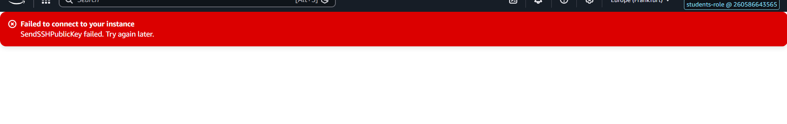
EC2 Instance Connect fails in the console
This happens because my students-role does not have permission for this action in our shared training account (I saw the same kind of restriction in Task 2 for security groups). So instead I connected with a normal SSH client from PowerShell, using my key pair from Task 2:
ssh -i "C:\Users\Mariam\Downloads\mariam-avaliani-key.pem" ec2-user@63.179.243.72
PostgreSQL 15 client was already installed on this EC2 from Task 2, so I only checked that the service is active, I did not install it again:
sudo systemctl status postgresql
Active: active (running)
Then I connected to Redshift from the EC2 shell with psql:
psql -h data-bi-lab-redshift-cluster-3.cettexdsxw3v.eu-central-1.redshift.amazonaws.com \
-p 5439 -U dilab_student30 -d dev
The connection worked and I got the dev=> prompt. But when I checked my schemas with \dn, I could not find user_dilab_student30 anywhere — I only saw schemas that belong to other students, with completely different names (my_schema, andrei_schema, bazo_dq_lab7, and so on). I tried to create it myself:
CREATE SCHEMA IF NOT EXISTS user_dilab_student30 AUTHORIZATION dilab_student30;
ERROR: permission denied for database dev
I checked our group chat and found that other students had exactly the same problem (Katsiaryna Karanevich and Ani Zviadauri posted about it). Our mentor Iuliia Potapova answered that everyone should connect to database dev_dilab instead of dev. After I reconnected with -d dev_dilab, my schema was there — but its real name is dilab_student30, without the "user_" prefix that the task document uses as an example. I used dilab_student30 for the rest of the task.
I confirmed I had write access to my schema with a quick test:
CREATE TABLE dilab_student30.test_permissions (id INT);
CREATE TABLE
DROP TABLE dilab_student30.test_permissions;
DROP TABLE

Part 2 — Loading Data into Redshift

2.a Choosing tables and getting real column definitions
I decided to reuse the data lake from Task 1 instead of making a new dataset. First I wanted to also load dim_dates for a proper date dimension, but I checked it in Athena and found it only has 1 row:
SELECT COUNT(*) FROM dwh_project_bl_dm_db.dim_dates;
-- result: 1
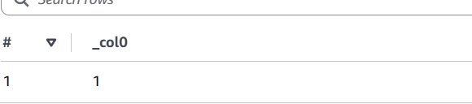
dim_dates has only 1 row — not usable
This table is useless for grouping by month, so I did not load it. Instead I decided to get the year and month directly from the event_dt column that already exists in fct_transactions_dd. First I checked a small sample of this column:
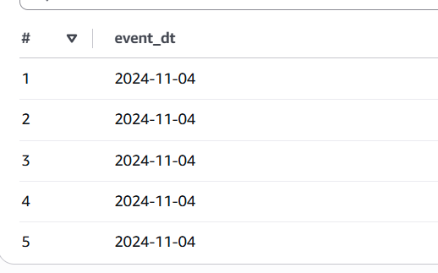
sample of event_dt values
All 5 sample rows had the same date, which worried me at first, but this was just a coincidence from LIMIT 5 without an ORDER BY. I checked the real range:
SELECT MIN(event_dt), MAX(event_dt), COUNT(DISTINCT event_dt)
FROM dwh_project_bl_dm_db.fct_transactions_dd;
-- 2024-01-01 | 2025-12-30 | 730
event_dt range: 2024-01-01 to 2025-12-30, 730 distinct dates
This is good — almost two years of data, so grouping by month makes sense. My final table list is: fct_transactions_dd, dim_products, dim_stores.
To write correct CREATE TABLE statements, I did not want to guess the column names, so I used the Glue Data Catalog from Task 1 (database dwh_project_bl_dm_db) and ran SHOW CREATE TABLE in Athena for each table:
SHOW CREATE TABLE dwh_project_bl_dm_db.fct_transactions_dd;
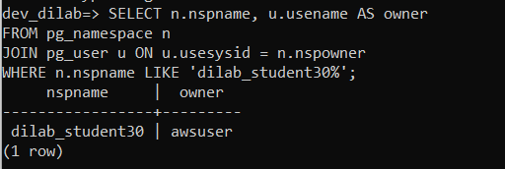
fct_transactions_dd columns, part 1
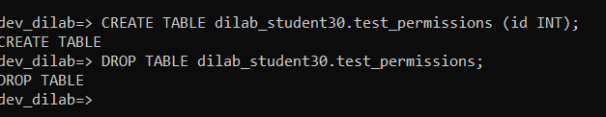
fct_transactions_dd columns, part 2
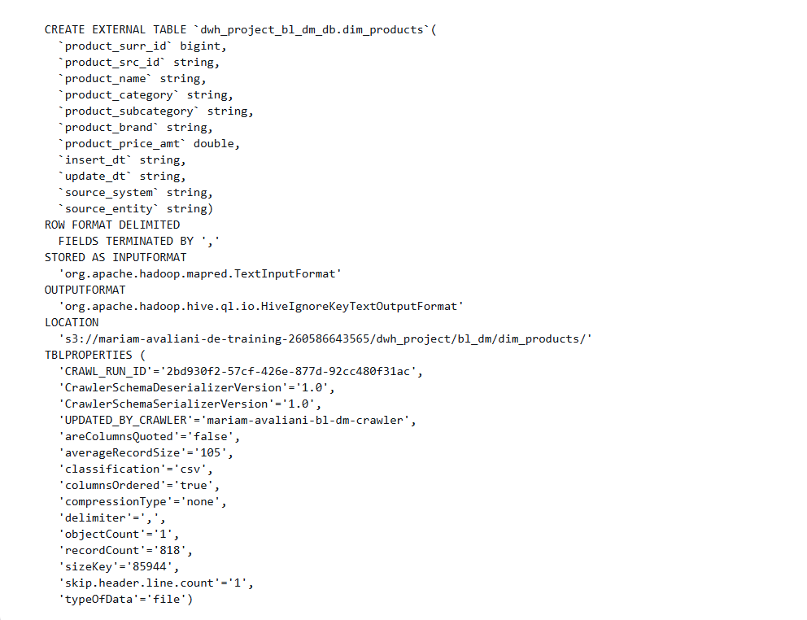
dim_products columns
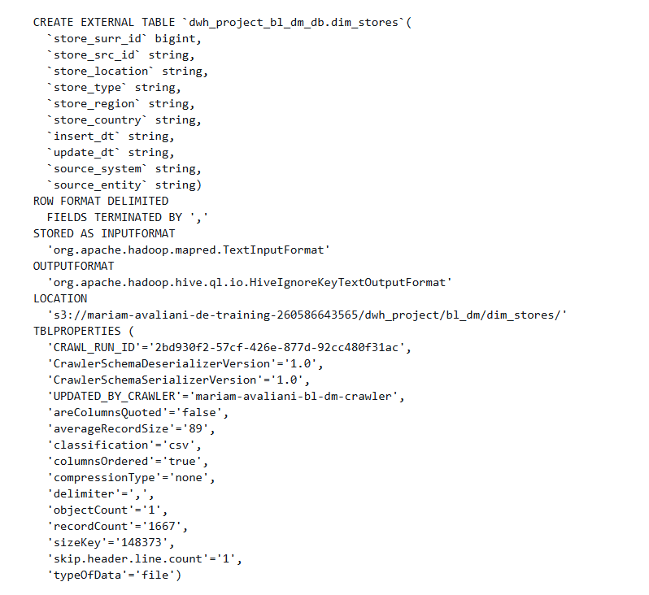
dim_stores columns
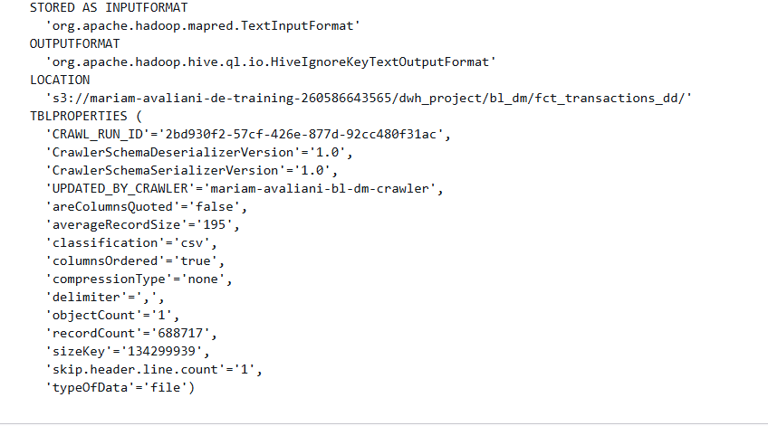
dim_dates columns (checked for reference, not loaded)

2.b Creating and loading the tables
With the real column names and types from Glue, I created the three tables in my schema:
CREATE TABLE dilab_student30.dim_products (
product_surr_id BIGINT, product_src_id VARCHAR(50), product_name VARCHAR(200),
product_category VARCHAR(100), product_subcategory VARCHAR(100), product_brand VARCHAR(100),
product_price_amt DOUBLE PRECISION, insert_dt VARCHAR(30), update_dt VARCHAR(30),
source_system VARCHAR(50), source_entity VARCHAR(50)
);
CREATE TABLE dilab_student30.dim_stores (
store_surr_id BIGINT, store_src_id VARCHAR(50), store_location VARCHAR(200),
store_type VARCHAR(100), store_region VARCHAR(100), store_country VARCHAR(100),
insert_dt VARCHAR(30), update_dt VARCHAR(30), source_system VARCHAR(50), source_entity VARCHAR(50)
);
CREATE TABLE dilab_student30.fct_transactions_dd (
transaction_src_id BIGINT, event_dt VARCHAR(20), customer_surr_id BIGINT,
product_surr_id BIGINT, store_surr_id BIGINT, payment_surr_id BIGINT, delivery_surr_id BIGINT,
date_surr_id BIGINT, transaction_channel_cd VARCHAR(50), fct_quantity_num BIGINT,
fct_unit_price_amt DOUBLE PRECISION, fct_sales_value_amt DOUBLE PRECISION,
fct_discount_amt DOUBLE PRECISION, fct_cost_price_amt DOUBLE PRECISION,
fct_shipping_cost_amt DOUBLE PRECISION, fct_total_cost_amt DOUBLE PRECISION,
fct_profit_amt DOUBLE PRECISION, fct_avg_unit_cost_amt DOUBLE PRECISION,
insert_dt VARCHAR(30), update_dt VARCHAR(30)
);
One small mistake here: I first pasted all three CREATE TABLE statements together into the SSH terminal, and the paste got broken by the terminal (it happened a few more times later too). dim_products was silently not created. I found this by checking \dt dilab_student30.* and just ran the dim_products statement again by itself.
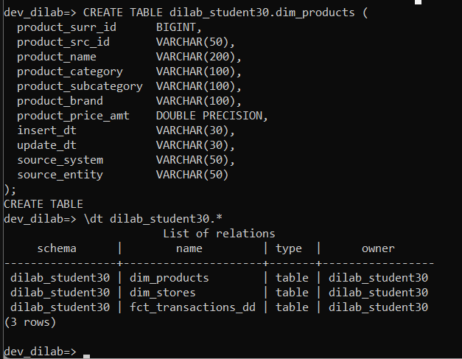
dim_products re-created, \dt confirms all 3 tables now exist
To load the data, I needed to find the IAM role attached to the Redshift cluster. I opened the Redshift console — the main dashboard gave me an AccessDenied error for one unrelated widget (DescribeReservedNodes), which I just ignored, since the cluster page itself worked fine.
AccessDenied for one dashboard widget — not a real blocker
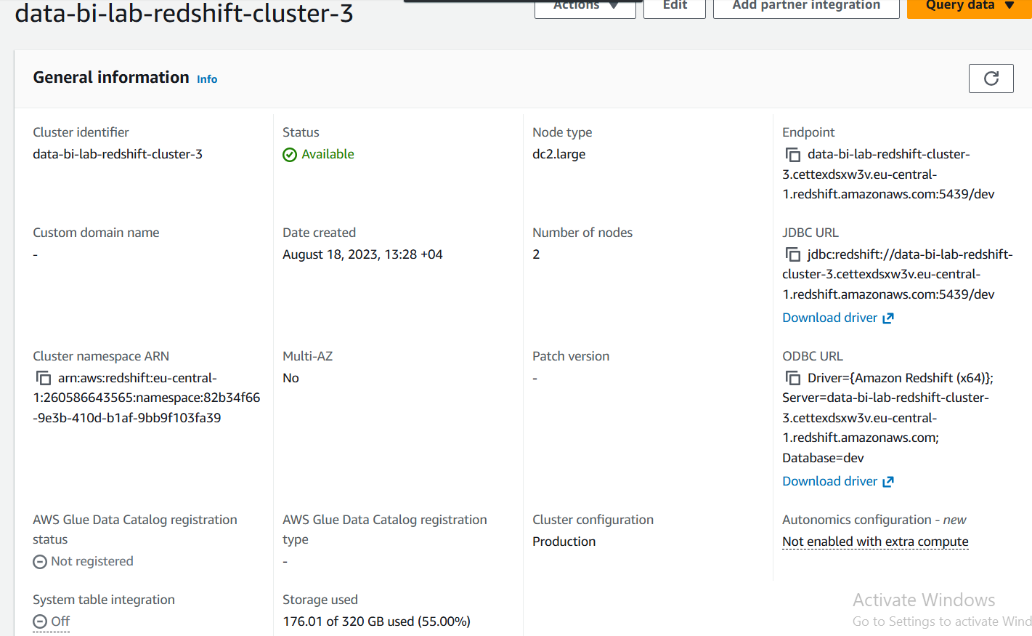
cluster data-bi-lab-redshift-cluster-3 general information
Under Properties, I found the Associated IAM roles section:
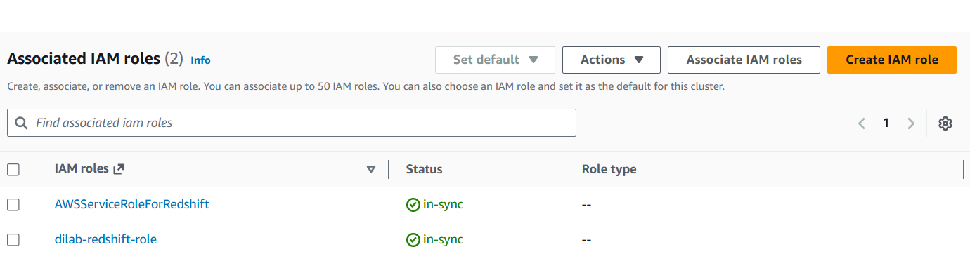
Associated IAM roles: AWSServiceRoleForRedshift and dilab-redshift-role
I opened dilab-redshift-role and got its ARN and permissions. It has AmazonS3FullAccess and Glue access policies, so I knew it could read my personal bucket too, not just the shared training buckets:
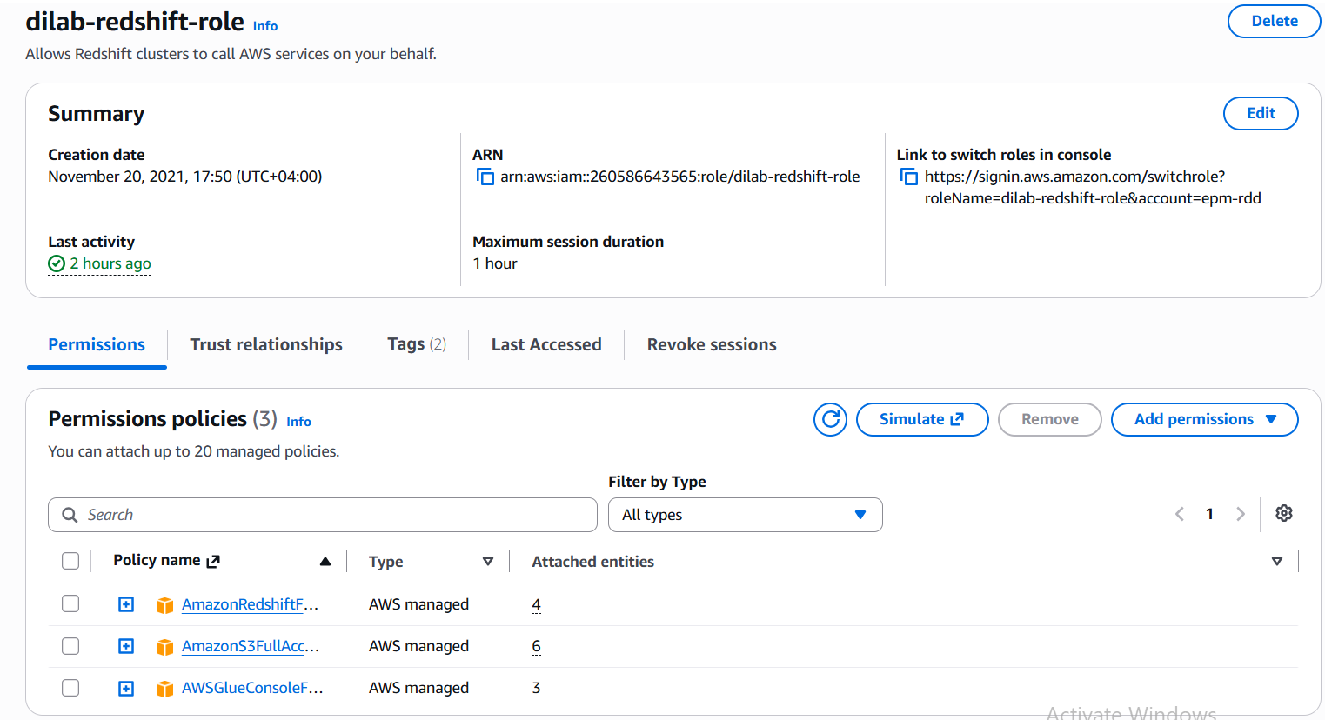
dilab-redshift-role — ARN and attached policies
Role ARN: arn:aws:iam::260586643565:role/dilab-redshift-role
Then I loaded all three tables with COPY:
COPY dilab_student30.dim_products
FROM 's3://mariam-avaliani-de-training-260586643565/dwh_project/bl_dm/dim_products/'
CREDENTIALS 'aws_iam_role=arn:aws:iam::260586643565:role/dilab-redshift-role'
REGION 'eu-central-1' CSV IGNOREHEADER 1;
-- INFO: Load into table 'dim_products' completed, 1006 record(s) loaded successfully.
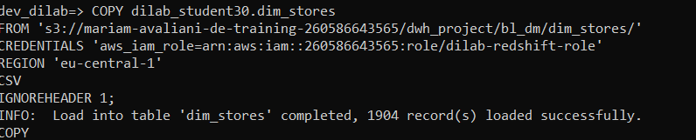
dim_stores COPY — 1,904 records loaded
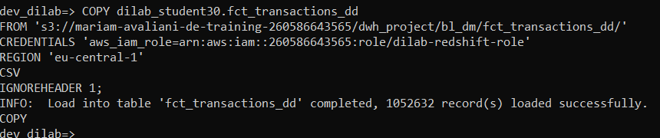
fct_transactions_dd COPY — 1,052,632 records loaded
Row counts loaded: dim_products = 1,006, dim_stores = 1,904, fct_transactions_dd = 1,052,632 (more than in Task 1, so the source data grew since then).

2.c Checking compression, distribution and sort keys after loading
SELECT * FROM pg_table_def
WHERE schemaname = 'dilab_student30' AND tablename = 'fct_transactions_dd';
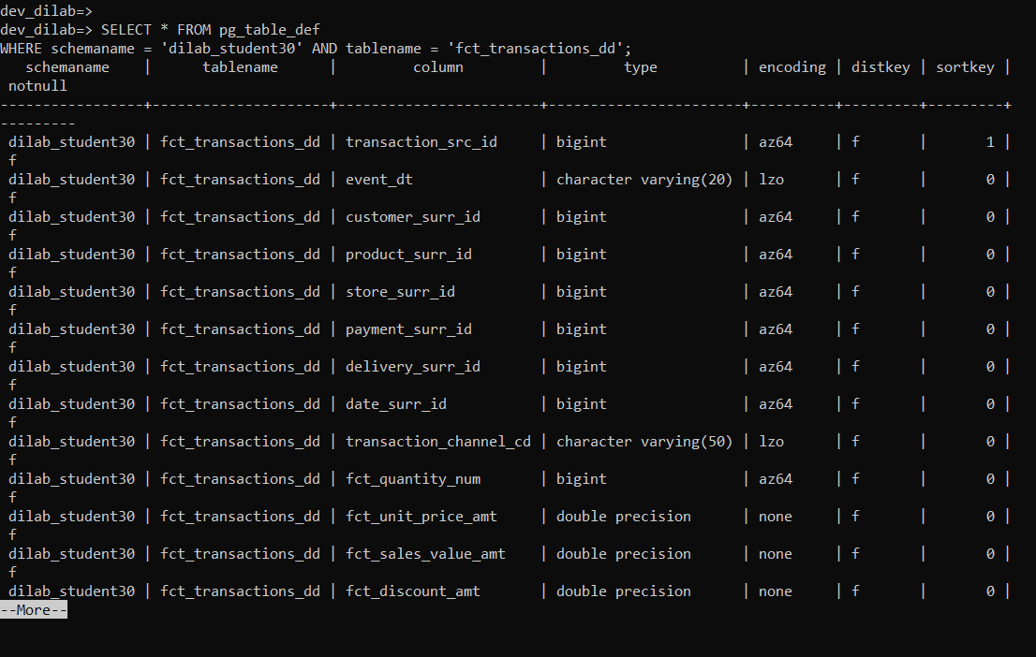
pg_table_def — per-column type, encoding, distkey, sortkey
SELECT "table", diststyle, sortkey1, size, tbl_rows FROM svv_table_info
WHERE schema = 'dilab_student30';
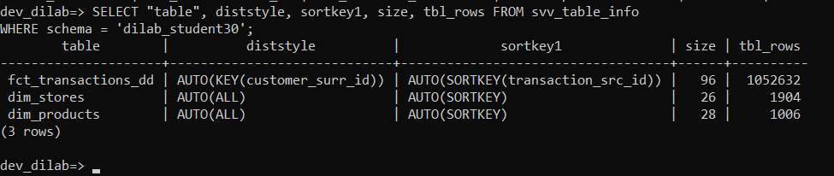
svv_table_info — diststyle and size per table
Results: fct_transactions_dd got DISTSTYLE AUTO(KEY(customer_surr_id)) and SORTKEY AUTO(SORTKEY(transaction_src_id)) automatically, size 96 MB. Both dim_products and dim_stores got AUTO(ALL), 28 MB and 26 MB. I noticed something interesting here: Redshift's automatic distribution key (customer_surr_id) is not even one of the columns I actually join on (product_surr_id, store_surr_id) — this looked like a good thing to fix later in Part 5.

Part 3 — Compression Analysis
I picked fct_transactions_dd for this part because it is my biggest table.

3.a Default compression
I already had this from Part 2's pg_table_def output — mostly az64 on the BIGINT columns and lzo on the two VARCHAR columns. I use my already-loaded fct_transactions_dd table as the "defaultcomp" reference, no need to make a copy of it.

3.b Table without compression
CREATE TABLE dilab_student30.fct_transactions_dd_withoutcomp (
transaction_src_id BIGINT ENCODE RAW, event_dt VARCHAR(20) ENCODE RAW,
customer_surr_id BIGINT ENCODE RAW, product_surr_id BIGINT ENCODE RAW,
store_surr_id BIGINT ENCODE RAW, payment_surr_id BIGINT ENCODE RAW,
delivery_surr_id BIGINT ENCODE RAW, date_surr_id BIGINT ENCODE RAW,
transaction_channel_cd VARCHAR(50) ENCODE RAW, fct_quantity_num BIGINT ENCODE RAW,
fct_unit_price_amt DOUBLE PRECISION ENCODE RAW, fct_sales_value_amt DOUBLE PRECISION ENCODE RAW,
fct_discount_amt DOUBLE PRECISION ENCODE RAW, fct_cost_price_amt DOUBLE PRECISION ENCODE RAW,
fct_shipping_cost_amt DOUBLE PRECISION ENCODE RAW, fct_total_cost_amt DOUBLE PRECISION ENCODE RAW,
fct_profit_amt DOUBLE PRECISION ENCODE RAW, fct_avg_unit_cost_amt DOUBLE PRECISION ENCODE RAW,
insert_dt VARCHAR(30) ENCODE RAW, update_dt VARCHAR(30) ENCODE RAW
);
INSERT INTO dilab_student30.fct_transactions_dd_withoutcomp
SELECT * FROM dilab_student30.fct_transactions_dd;
-- INSERT 0 1052632

3.c ANALYZE COMPRESSION recommendation
ANALYZE COMPRESSION dilab_student30.fct_transactions_dd_withoutcomp;
Column Encoding Est_reduction_pct
transaction_src_id raw 0.00
event_dt zstd 93.93
customer_surr_id az64 99.99
product_surr_id az64 81.54
store_surr_id az64 80.02
payment_surr_id az64 66.30
delivery_surr_id az64 67.81
date_surr_id az64 99.99
transaction_channel_cd zstd 94.80
fct_quantity_num az64 93.85
fct_unit_price_amt zstd 76.42
fct_sales_value_amt zstd 74.29
fct_discount_amt bytedict 86.14
fct_cost_price_amt zstd 58.81
fct_shipping_cost_amt zstd 89.97
fct_total_cost_amt zstd 58.32
fct_profit_amt zstd 57.99
fct_avg_unit_cost_amt zstd 58.82
insert_dt zstd 99.95
update_dt zstd 99.95
One interesting detail: for transaction_src_id, Redshift recommended raw (0% reduction) here, but the original automatic COPY compression had picked az64 for the same column. This makes sense because transaction_src_id looks like a unique, sequential ID — hard to compress well with any encoding.

3.d Table with recommended compression, and size comparison
CREATE TABLE dilab_student30.fct_transactions_dd_analyzedcomp (
transaction_src_id BIGINT ENCODE RAW, event_dt VARCHAR(20) ENCODE ZSTD,
customer_surr_id BIGINT ENCODE AZ64, product_surr_id BIGINT ENCODE AZ64,
store_surr_id BIGINT ENCODE AZ64, payment_surr_id BIGINT ENCODE AZ64,
delivery_surr_id BIGINT ENCODE AZ64, date_surr_id BIGINT ENCODE AZ64,
transaction_channel_cd VARCHAR(50) ENCODE ZSTD, fct_quantity_num BIGINT ENCODE AZ64,
fct_unit_price_amt DOUBLE PRECISION ENCODE ZSTD, fct_sales_value_amt DOUBLE PRECISION ENCODE ZSTD,
fct_discount_amt DOUBLE PRECISION ENCODE BYTEDICT, fct_cost_price_amt DOUBLE PRECISION ENCODE ZSTD,
fct_shipping_cost_amt DOUBLE PRECISION ENCODE ZSTD, fct_total_cost_amt DOUBLE PRECISION ENCODE ZSTD,
fct_profit_amt DOUBLE PRECISION ENCODE ZSTD, fct_avg_unit_cost_amt DOUBLE PRECISION ENCODE ZSTD,
insert_dt VARCHAR(30) ENCODE ZSTD, update_dt VARCHAR(30) ENCODE ZSTD
);
INSERT INTO dilab_student30.fct_transactions_dd_analyzedcomp
SELECT * FROM dilab_student30.fct_transactions_dd;
-- INSERT 0 1052632
SELECT "table", size AS size_mb, tbl_rows FROM svv_table_info
WHERE "table" IN ('fct_transactions_dd', 'fct_transactions_dd_withoutcomp', 'fct_transactions_dd_analyzedcomp');
table size_mb tbl_rows
fct_transactions_dd_withoutcomp 208 1052632
fct_transactions_dd (defaultcomp) 96 1052632
fct_transactions_dd_analyzedcomp 100 1052632
My conclusion: compression really makes a big difference — both compressed versions are about half the size of the uncompressed one, roughly 52-54% smaller. But I found something a bit surprising: the manual ANALYZE COMPRESSION result (100 MB) is actually a little bigger than what Redshift picked automatically during COPY (96 MB). I think this happened because ANALYZE COMPRESSION recommended zstd for several numeric columns where az64 turned out to be slightly better for this specific data. So the automatic compression that Redshift chooses while loading data with COPY already did a very good job here, and running ANALYZE COMPRESSION by hand did not clearly beat it.

Part 4 — Stored Procedure and Execution Plan Before Optimization

4.a Stored procedure
CREATE OR REPLACE PROCEDURE dilab_student30.load_sales_report()
LANGUAGE plpgsql
AS $$
BEGIN
TRUNCATE TABLE dilab_student30.rpt_sales_by_product_store_month;
INSERT INTO dilab_student30.rpt_sales_by_product_store_month
SELECT
EXTRACT(YEAR FROM TO_DATE(f.event_dt, 'YYYY-MM-DD'))::INT AS sales_year,
EXTRACT(MONTH FROM TO_DATE(f.event_dt, 'YYYY-MM-DD'))::INT AS sales_month,
p.product_name, s.store_location,
SUM(f.fct_sales_value_amt) AS total_revenue,
SUM(f.fct_quantity_num) AS total_quantity,
COUNT(*) AS transaction_count
FROM dilab_student30.fct_transactions_dd f
JOIN dilab_student30.dim_products p ON f.product_surr_id = p.product_surr_id
JOIN dilab_student30.dim_stores s ON f.store_surr_id = s.store_surr_id
GROUP BY 1, 2, p.product_name, s.store_location;
END;
$$;
-- CREATE PROCEDURE

4.b Execution plan and timing before optimization
SET enable_result_cache_for_session TO OFF;
\timing on
EXPLAIN
SELECT ... FROM dilab_student30.fct_transactions_dd f
JOIN dilab_student30.dim_products p ON f.product_surr_id = p.product_surr_id
JOIN dilab_student30.dim_stores s ON f.store_surr_id = s.store_surr_id
GROUP BY 1, 2, p.product_name, s.store_location;
XN HashAggregate (cost=96952.06..98282.41 rows=76020 width=49)
-> XN Hash Join DS_DIST_ALL_NONE (cost=36.38..78576.34 rows=1050041 width=49)
Hash Cond: (product_surr_id = product_surr_id)
-> XN Hash Join DS_DIST_ALL_NONE (cost=23.80..34124.92 rows=1041690 width=48)
Hash Cond: (store_surr_id = store_surr_id)
-> XN Seq Scan on fct_transactions_dd f (cost=0.00..10526.32 rows=1052632)
-> XN Hash -> XN Seq Scan on dim_stores s (rows=1904)
-> XN Hash -> XN Seq Scan on dim_products p (rows=1006)
Both joins already show DS_DIST_ALL_NONE, which means Redshift did not need to move any data between the two compute nodes for these joins — even before I changed anything. This is because dim_products and dim_stores already got DISTSTYLE ALL automatically when I loaded them.
I ran the actual query twice and logged the time:
Run 1 (not counted): 8624.603 ms
Run 2 (real time): 664.205 ms

4.c Why the first run does not count
The first run is always slower because it pays for two things that only happen once: Redshift has to compile the query plan, and it has to read the data blocks from disk for the first time. From the second run on, the compiled plan is already cached and the blocks that were just read are already in memory, so the timing shows the real, steady-state performance instead of a one-time cost. This is also exactly why I had to turn off result caching first — otherwise Redshift could just give back the same cached answer without actually running the query again.

4.d Current distribution and sort keys
fct_transactions_dd: DISTSTYLE AUTO(KEY(customer_surr_id)), SORTKEY AUTO(SORTKEY(transaction_src_id)). dim_products and dim_stores: both AUTO(ALL).

Part 5 — Optimizing Distribution Style and Sort Keys
Since dim_products and dim_stores already got DISTSTYLE ALL automatically, there was not much left to improve there for these joins. But I still wanted to set everything explicitly instead of leaving it on AUTO, and add a proper sort key on the fact table for date-based queries:
ALTER TABLE dilab_student30.dim_products ALTER DISTSTYLE ALL;
ALTER TABLE dilab_student30.dim_stores ALTER DISTSTYLE ALL;
ALTER TABLE dilab_student30.fct_transactions_dd ALTER DISTSTYLE KEY DISTKEY store_surr_id;
ALTER TABLE dilab_student30.fct_transactions_dd ALTER SORTKEY (event_dt);
The two ALTER statements on the dimension tables finished almost instantly (85-88 ms) because they were just a metadata change — the tables were already ALL. But the two ALTER statements on fct_transactions_dd took 20.8 and 24.7 seconds, because Redshift had to physically rewrite more than 1 million rows on disk with the new layout.

An unrelated connectivity problem I had while doing this
Right after running these ALTER statements, my SSH session dropped, and when I tried to reconnect I got "Connection timed out". My EC2 instance was still running with the same IP, so at first this did not make sense. After checking, I found the real reason: my EC2 security group only allows SSH from two specific EPAM VPN IP addresses, and I was connected to a different VPN gateway (vpn-eu-gcp.epam.com), which gave me a different IP address that is not on that list.
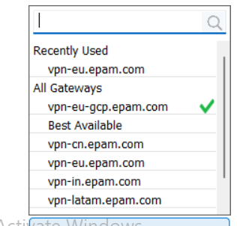
GlobalProtect gateway list — I was connected to vpn-eu-gcp.epam.com by mistake
I tried to add my new IP to the security group myself, but got an explicit permission denied error — my students-role is not allowed to change security groups (same kind of restriction I saw in Task 2):
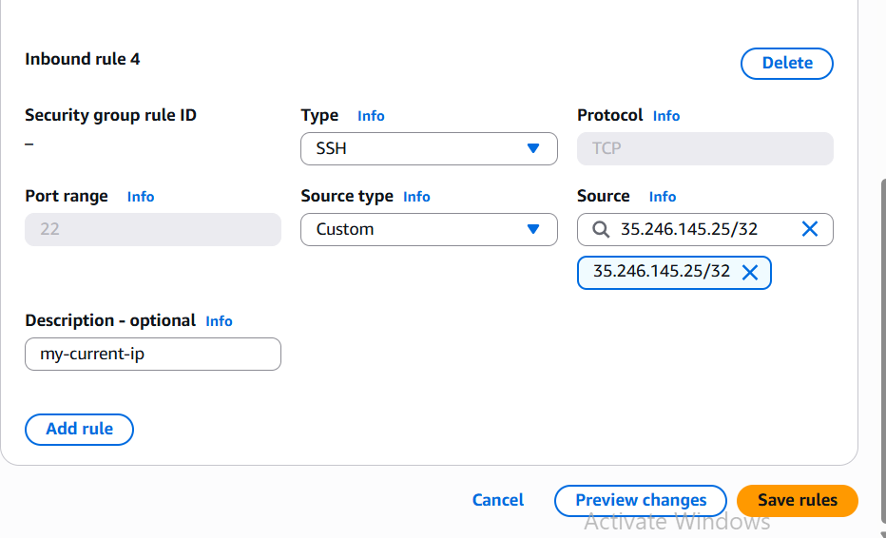
Trying to add my IP to the security group
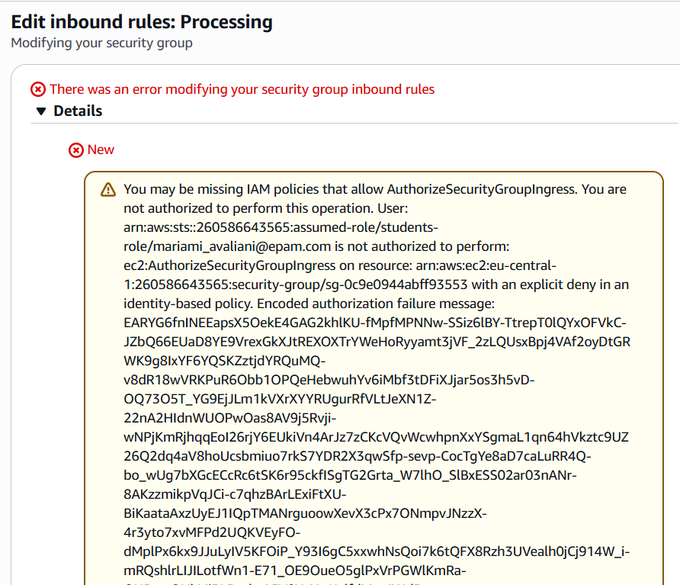
AuthorizeSecurityGroupIngress explicitly denied for students-role
I switched the VPN gateway back to the normal vpn-eu.epam.com, which gave me back one of the whitelisted IP addresses, and SSH worked again immediately.

5.b Plan and timing after optimization
After reconnecting, I ran EXPLAIN again on the same query. The plan text was exactly the same as before (still DS_DIST_ALL_NONE, same costs), which makes sense — distribution was already close to optimal because of the ALL dimension tables.
But the real execution time still improved:
Run 1 (not counted): 4960.026 ms
Run 2 (real time): 421.916 ms
That is about a 36.5% improvement compared to before (664.2 ms → 421.9 ms), even though the EXPLAIN text did not change at all. My explanation: ALTER TABLE physically rewrote the data — a better balance of rows across the two compute nodes with the new DISTKEY, and better block organization by date with the new SORTKEY. This kind of improvement is real, but it does not always show up as a visible change in the EXPLAIN plan text — the plan only shows the query strategy, not the physical layout quality underneath it.

Part 6 — Running the Optimized Report
CALL dilab_student30.load_sales_report();
SELECT COUNT(*) FROM dilab_student30.rpt_sales_by_product_store_month;
SELECT * FROM dilab_student30.rpt_sales_by_product_store_month LIMIT 20;
The procedure ran without any error and filled my report table correctly, with sensible year/month/product/store combinations and reasonable revenue and quantity totals for each group (for example, the Online store consistently has much higher volume than physical locations, which matches the kind of data I would expect).

Part 7* — Power BI (optional)
I did not have time to complete this optional bonus part for this submission.

Part 8 — COPY Question
This part is meant to be done by one student chosen from the group, who runs both COPY commands and shares the execution times with everyone else. I have not received these numbers from my group yet, so I will add my explanation of the results here once they are shared.
My expectation, based on how Redshift COPY works: loading from an S3 path with many smaller files should be noticeably faster than loading the exact same data from a path with only one (or very few) files, because COPY can read multiple files in parallel across the cluster's compute slices. With a single file, only one slice can read data at a time, so most of the cluster sits idle during the load.

Part 9 — Redshift Spectrum: External Tables

9.1 External schema over my existing Glue Catalog
Instead of building a new Data Catalog, I pointed an external schema directly at the Glue database I already had from Task 1:
CREATE EXTERNAL SCHEMA dilab_student30_ext FROM DATA CATALOG
DATABASE 'dwh_project_bl_dm_db'
IAM_ROLE 'arn:aws:iam::260586643565:role/dilab-redshift-role';
-- CREATE SCHEMA
I tested it by querying dim_products through Spectrum, and got real rows back, which confirmed the connection to the Glue Catalog was working correctly:
SELECT * FROM dilab_student30_ext.dim_products LIMIT 10;
-- returned 10 real product rows

9.2 Partitioned external table
First, I exported fct_transactions_dd into S3, split into monthly partitions using UNLOAD's PARTITION BY option, with the partition value taken from event_dt:
UNLOAD ('SELECT *, SUBSTRING(event_dt,1,7) AS year_month FROM dilab_student30.fct_transactions_dd')
TO 's3://mariam-avaliani-de-training-260586643565/spectrum/fct_transactions_partitioned/'
IAM_ROLE 'arn:aws:iam::260586643565:role/dilab-redshift-role'
PARTITION BY (year_month) FORMAT AS PARQUET ALLOWOVERWRITE;
-- INFO: UNLOAD completed, 1052632 record(s) unloaded successfully.
Then I created the partitioned external table pointing at this new location:
CREATE EXTERNAL TABLE dilab_student30_ext.fct_transactions_partitioned (
transaction_src_id BIGINT, event_dt VARCHAR(20), customer_surr_id BIGINT,
product_surr_id BIGINT, store_surr_id BIGINT, payment_surr_id BIGINT, delivery_surr_id BIGINT,
date_surr_id BIGINT, transaction_channel_cd VARCHAR(50), fct_quantity_num BIGINT,
fct_unit_price_amt DOUBLE PRECISION, fct_sales_value_amt DOUBLE PRECISION,
fct_discount_amt DOUBLE PRECISION, fct_cost_price_amt DOUBLE PRECISION,
fct_shipping_cost_amt DOUBLE PRECISION, fct_total_cost_amt DOUBLE PRECISION,
fct_profit_amt DOUBLE PRECISION, fct_avg_unit_cost_amt DOUBLE PRECISION,
insert_dt VARCHAR(30), update_dt VARCHAR(30)
)
PARTITIONED BY (year_month VARCHAR(7))
STORED AS PARQUET
LOCATION 's3://mariam-avaliani-de-training-260586643565/spectrum/fct_transactions_partitioned/';
-- CREATE EXTERNAL TABLE
To register the partitions, I first tried MSCK REPAIR TABLE directly in the Redshift terminal, but that is not valid Redshift syntax — it is an Athena/Hive command. I ran it in Athena instead, against the same Glue database:
MSCK REPAIR TABLE dwh_project_bl_dm_db.fct_transactions_partitioned;
This found and added all 24 monthly partitions automatically, from 2024-01 to 2025-12.
I checked that the row counts match exactly between my new partitioned table and the original one:
SELECT COUNT(*) FROM dilab_student30_ext.fct_transactions_partitioned; -- 1052632
SELECT COUNT(*) FROM dilab_student30.fct_transactions_dd; -- 1052632
Both return exactly 1,052,632 rows — no data was lost or duplicated in the export.
Finally, I checked partition pruning by running EXPLAIN with a filter on one month:
EXPLAIN
SELECT COUNT(*) FROM dilab_student30_ext.fct_transactions_partitioned
WHERE year_month = '2025-06';
XN Aggregate (cost=111.33..111.33 rows=1 width=8)
-> XN Partition Loop (cost=26.32..98.82 rows=5000 width=8)
-> XN Seq Scan PartitionInfo of fct_transactions_partitioned (cost=0.00..12.50 rows=5)
Filter: ((year_month)::text = '2025-06'::text)
-> XN S3 Query Scan fct_transactions_partitioned (cost=13.16..23.16 rows=1000)
-> S3 Aggregate
-> S3 Seq Scan ... location: s3://.../fct_transactions_partitioned format:PARQUET
The plan has a separate "PartitionInfo" step that applies my year_month filter before touching any actual data. This shows that Redshift checks which partitions match the filter first, and only scans the files of the matching partition — it does not read all 24 months' worth of data just to answer a query about one month.

Conclusion
In this task I learned how to connect to Redshift securely through an SSH tunnel, load data with COPY, compare compression encodings, write and optimize a stored procedure with distribution and sort keys, and use Redshift Spectrum to query and partition data directly in S3.
The most interesting result for me was in Part 5: changing the distribution and sort key improved the real execution time by about 36%, even though the EXPLAIN plan text stayed exactly the same. This showed me that EXPLAIN only tells part of the story — the physical layout of the data on disk also matters a lot, and it is not something the plan text always shows directly.
I also learned that this training environment has a few quirks that are not in the task document itself (the dev_dilab database name, the dilab_student<N> schema naming, and the VPN-IP-based security group restriction) — checking the group chat and testing things directly was the fastest way to work around these.

