Business Template

Household_stores

Contents
Business Description 3
1.1 the Benefits of implementing a database. Project Vision 3
2 Model description 3
2.1 Definitions & Acronyms 3
2.2 Logical Scheme 3
2.3 Objects 3

Business Description

the Benefits of implementing a database. Project Vision
The purpose of this database is to support the operations of a household appliances store by organizing and managing data related to products, customers, employees, suppliers, orders, and procurement processes.
The database solves business problems such as data redundancy, inconsistent records, and difficulty in tracking transactions. Instead of storing information in separate files or spreadsheets, all data is centralized, structured, and connected through relationships.
Data integrity, consistency, and traceability are ensured through:
- Primary and foreign key constraints that maintain valid relationships between tables
- Unique constraints (e.g., phone, email) to prevent duplicate records
- Check constraints (e.g., price > 0, quantity > 0) to ensure valid data input
The model stores the history of operations through transactional tables such as orders and procurement, which record each business event with timestamps (dates). This allows tracking of past activities and auditing.
The structure supports scalability because:
- It follows normalization principles (3NF), reducing redundancy
- New attributes or entities can be added without redesigning existing tables
- Relationships are flexible and extendable
Constraints and checks added include:
- Price, salary, and cost must be positive
- Quantities cannot be negative
- Order statuses are limited to predefined values
- Order dates are restricted to valid ranges
These rules ensure data accuracy as the system grows.

Model description

Definitions & Acronyms
- PK (Primary Key): A unique identifier for each record in a table
- FK (Foreign Key): A field that references a primary key in another table
- 3NF (Third Normal Form): A database design rule where all attributes depend only on the primary key
- Order: A transaction representing a customer purchase
- Procurement: A transaction representing purchasing products from suppliers
Key entities in the model:
- Customer – person purchasing products
- Employee – staff managing sales and procurement
- Product – item available for sale
- Supplier – provider of products
- Order / Procurement – business processes
These definitions ensure consistent interpretation of the database structure.

Logical Scheme
The most difficult modeling decision was separating transactional data into orders, order_item, and procurement tables. This was necessary to properly represent many-to-many relationships (e.g., one order containing multiple products).
The design prevents several data anomalies:
- Insertion anomaly: Products can exist without orders because they are stored separately
- Update anomaly: Product price changes do not affect historical order data because unit_price is stored in order_item
- Deletion anomaly: Deleting an order does not remove product or customer data
These are prevented through:
- Table separation (normalization)
- Foreign key constraints
- Composite keys in order_item
The model remains scalable because:
- New entities (e.g., payments, delivery) can be added easily
- Attributes can be extended without breaking relationships
- The structure is modular
The part most likely to change is the orders system, especially if new features like discounts, invoices, or delivery tracking are introduced.

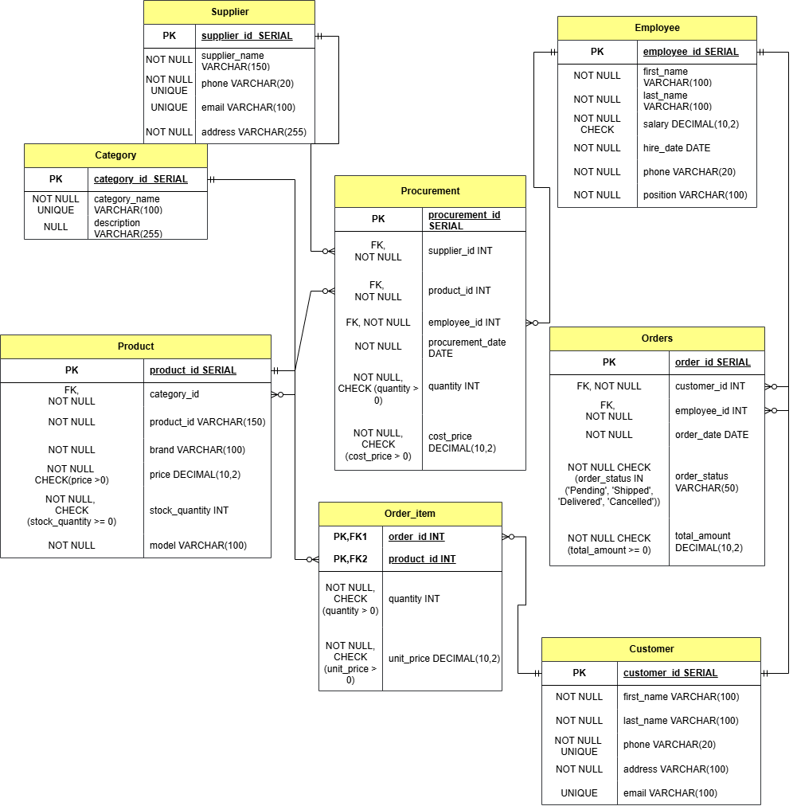

Objects
Table Description:
- What real-world concept or event does this table represent?
- Why must this information be stored separately instead of inside another table?
- What is the normalization level of the table (1NF, 2NF, 3NF)? Explain your reasoning.
- Are there partial or transitive dependencies? How did you eliminate them? Which attributes depend only on the key, and which depend on other fields?
- Why did you choose this primary key (PK) for the table? Could a composite key work instead? Which foreign keys (FK) did you add and why?

Table Name | Field name | Field Description | Data Type
Table 1 | Field Name 1 | <description>, PK/FK | Int
 | Filed Name N | <description> | Text

Table Name: CATEGORY

This table represents product categories (e.g., electronics, kitchen appliances).
It is stored separately to avoid repeating category information in every product.
The table is in 3NF because:
- All attributes depend only on category_id
- No transitive dependencies exist
The primary key is category_id because it uniquely identifies each category.
It is referenced by the product table via a foreign key.
 | Field name | Field Description | Data Type

Field Name | Field Description | Data Type
category_id | Primary Key | INT
category_name | Unique category name | VARCHAR(100)
description | Category description | VARCHAR(255)

Table Name: PRODUCT

This table represents items available for sale.
It must be separate because product data is reused across orders and procurement.
The table is in 3NF:
- All attributes depend only on product_id
- No partial or transitive dependencies
The primary key is product_id.
A foreign key (category_id) links it to the category table.

 | Field name | Field Description | Data Type

Field Name | Field Description | Data Type
product_id | Primary Key | INT
product_name | Product name | VARCHAR(150)
brand | Brand name | VARCHAR(100)
model | Model name | VARCHAR(100)
category_id | Foreign Key → CATEGORY | INT
price | Positive product price | NUMERIC(10,2)
stock_quantity | Stock >= 0 | INT
warranty_months | Warranty >= 0 | INT

Table Name: CUSTOMER
Represents store customers.
Stored separately to manage customer information independently from orders.
In 3NF:
- All attributes depend on customer_id
- No redundant data
Primary key: customer_id
Used in the orders table as a foreign key.

 | Field name | Field Description | Data Type

Field Name | Field Description | Data Type
customer_id | Primary Key | INT
first_name | Customer first name | VARCHAR(100)
last_name | Customer last name | VARCHAR(100)
phone | Unique phone | VARCHAR(20)
email | Email | VARCHAR(100)
address | Address | VARCHAR(255)

Table Name: EMPLOYEE
Represents staff members.
Stored separately to track employee roles and responsibilities.
In 3NF:
- Attributes depend only on employee_id
Primary key: employee_id
Referenced in orders and procurement.

 | Field name | Field Description | Data Type

Field Name | Field Description | Data Type
employee_id | Primary Key | INT
first_name | First name | VARCHAR(100)
last_name | Last name | VARCHAR(100)
position | Job position | VARCHAR(100)
salary | Positive salary | NUMERIC(10,2)
hire_date | Hire date | DATE
phone | Phone | VARCHAR(20)

Table Name: ORDERS
Represents customer purchases.
Separated to store transactional data.
In 3NF:
- All attributes depend on order_id
- No transitive dependencies
Primary key: order_id
Foreign keys:
- customer_id
- employee_id

 | Field name | Field Description | Data Type

Field Name | Field Description | Data Type
order_id | Primary Key | INT
customer_id | FK → CUSTOMER | INT
employee_id | FK → EMPLOYEE | INT
order_date | After 2026-01-01 | DATE
order_status | Allowed values | VARCHAR(50)
total_amount | Total amount | NUMERIC(10,2)

Table Name: ORDER_ITEM
Represents products within each order (many-to-many relationship).
This table is necessary because one order can contain multiple products.
In 3NF:
- Composite key (order_id, product_id) ensures uniqueness
- Attributes depend on the full key
Primary key: (order_id, product_id)
Foreign keys:
- order_id → orders
- product_id → product

 | Field name | Field Description | Data Type

Field Name | Field Description | Data Type
order_id | PK/FK → ORDERS | INT
product_id | PK/FK → PRODUCT | INT
quantity | Positive quantity | INT
unit_price | Positive price | NUMERIC(10,2)

Table Name: SUPPLIER
Represents product suppliers.
Stored separately to avoid duplication in procurement records.
In 3NF:
- All attributes depend on supplier_id
Primary key: supplier_id
Referenced in procurement.

 | Field name | Field Description | Data Type

Field Name | Field Description | Data Type
supplier_id | Primary Key | INT
supplier_name | Supplier name | VARCHAR(150)
phone | Unique phone | VARCHAR(20)
email | Email | VARCHAR(100)
address | Address | VARCHAR(255)

Table Name: PROCUREMENT
Represents purchasing products from suppliers.
Separated to track supply operations independently from sales.
In 3NF:
- Attributes depend on procurement_id
Primary key: procurement_id
Foreign keys:
- supplier_id
- product_id
- employee_id

 | Field name | Field Description | Data Type

Field Name | Field Description | Data Type
procurement_id | Primary Key | INT
supplier_id | FK → SUPPLIER | INT
product_id | FK → PRODUCT | INT
employee_id | FK → EMPLOYEE | INT
procurement_date | Date | DATE
quantity | Positive quantity | INT
cost_price | Positive cost | NUMERIC(10,2)

