Task 2 – DWBI Systems Testing in TestRail
Mariam Avaliani – Process and Delivery
This document describes how I completed Task 2. The goal of the task was to work with the TestRail test management tool and create test cases for a DWH/BI system, based on the schema and the materials we got (source systems S1 and S2, the DWH tables and the DM_MAIN_DASHBOARD data mart). I added screenshots from my own TestRail project so it is easy to follow what I did.

1. Getting access and creating the project
First, I logged in to TestRail QA on a temporary trial instance. On the dashboard I could see all the projects that other people from my group already created, so I used the same logic and created my own.

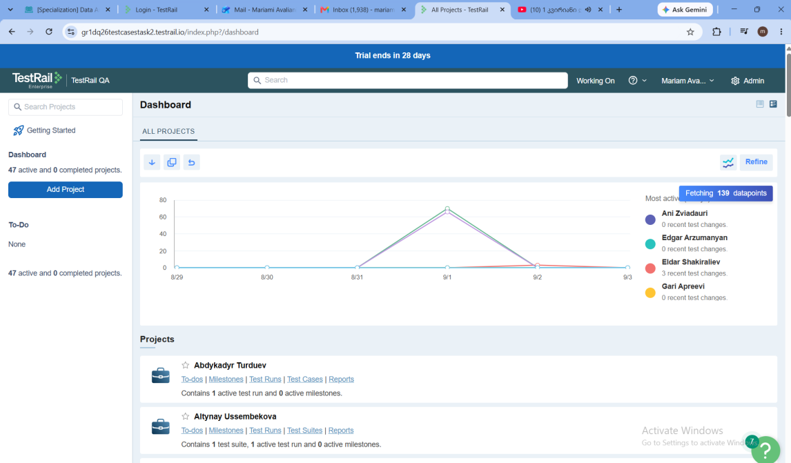
The TestRail dashboard after I logged in, before I added my own project.
I clicked "Add Project" and named it "Mariam Avaliani", using a single repository for all cases, since this was the recommended option and it fits a small project like this one. After I saved it, the project appeared under "Assigned to me".
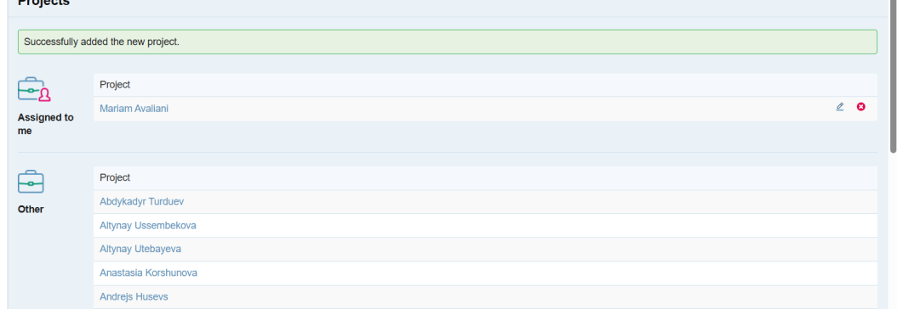
The project "Mariam Avaliani" was created successfully and assigned to me.

2. Creating the three sections
Inside the project, under Test Cases, there were no sections or cases yet, so I had to create the structure myself first.
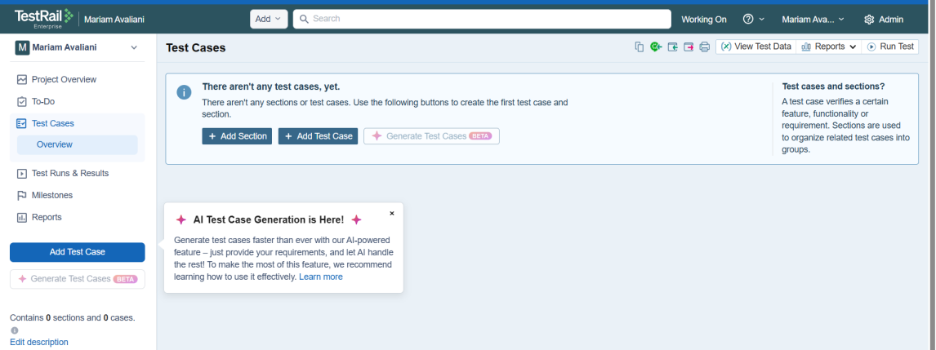
The empty Test Cases page, before I added any section.
Based on the schema and the task description, I decided to split the work into three sections: Smoke path, Critical path and Extended path. For each section I wrote a short description explaining what kind of checks belong there, so it is clear for anyone opening the project later. For example, for Smoke path I wrote that it is the minimum set of checks confirming the DWH/DM platform is operational after an ETL run, and that if any smoke test fails, the platform is not stable enough for further testing.
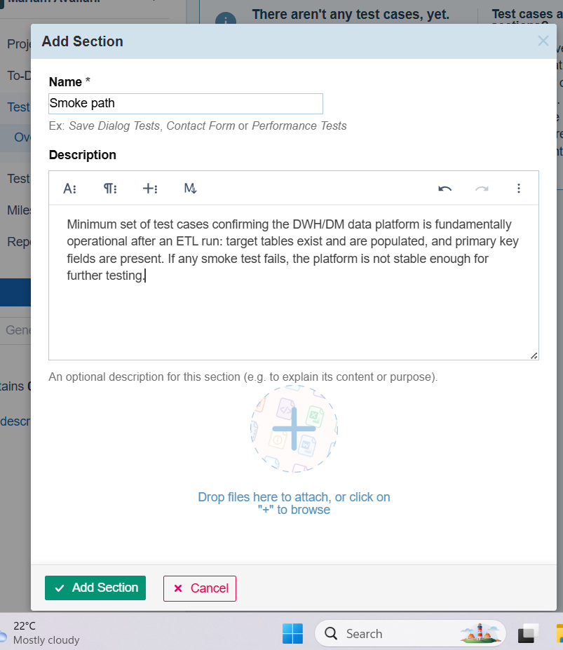
Adding the Smoke path section together with its description.
I did the same for Critical path (the core, everyday data flows: field mappings from S1/S2 into the DWH, referential integrity between DWH_SALES and the dimension tables, and the TOTAL_COST calculation in DM_MAIN_DASHBOARD) and for Extended path (lower-priority boundary and edge-case checks, like missing fields, duplicate clients across sources, date sequencing and special characters). After that, all three sections were ready and I could start adding the actual test cases.
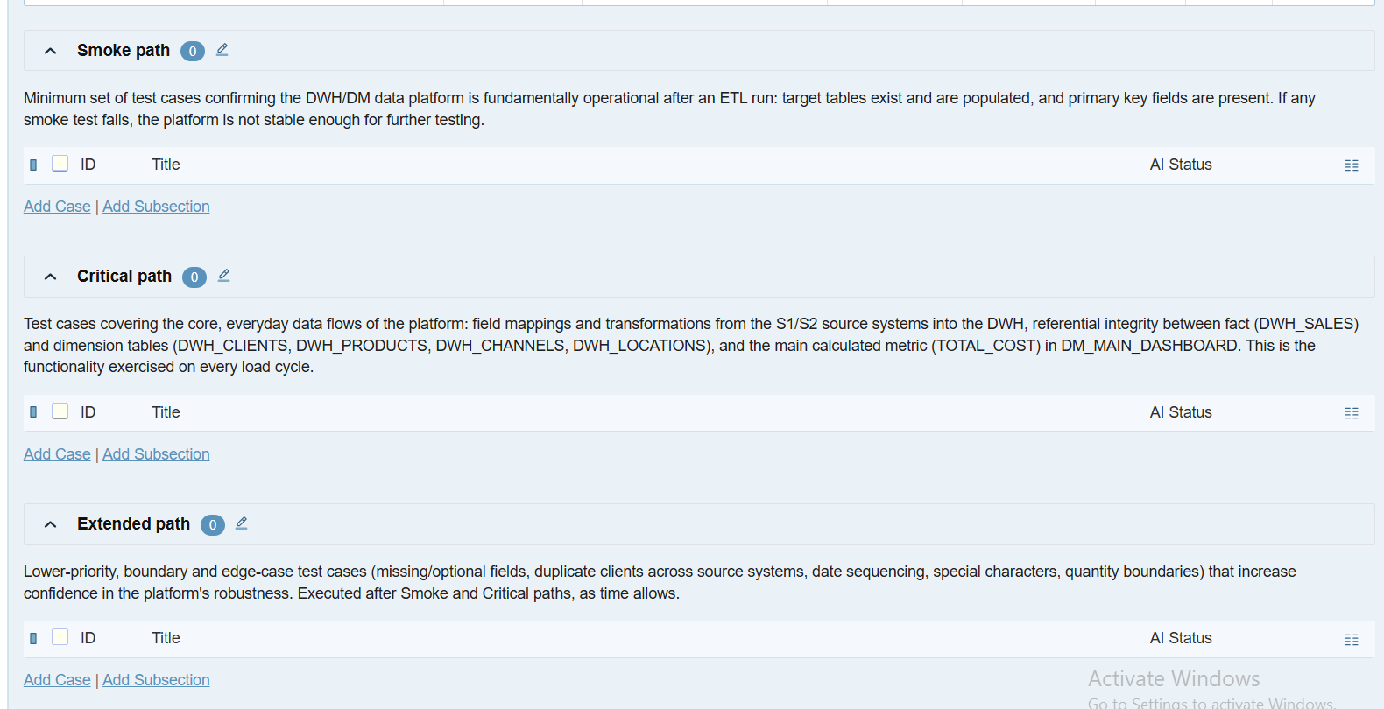
All three sections created with their descriptions, before adding test cases.

3. Writing the test cases
For every test case I filled in the Section, kept the Type as "Other" since none of the default types matched a DWH check exactly, and set the Priority (Critical, High or Medium, depending on how important the check is). I wrote the Preconditions, the Steps and the Expected Result for each case, trying to keep them clear enough that someone else could execute them without asking me anything.
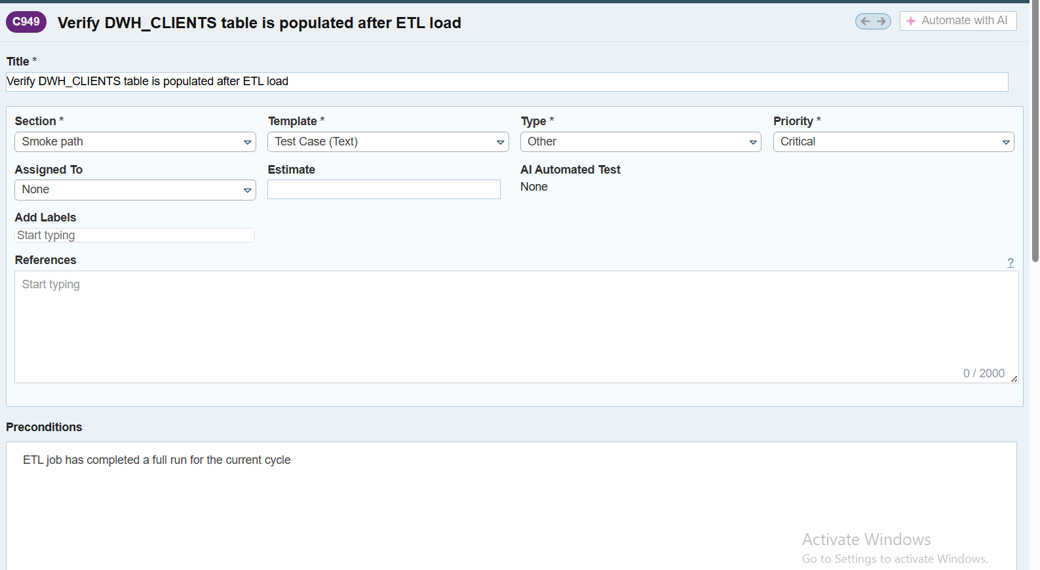
Filling in the Section, Template, Type and Priority for a new test case (C949, Smoke path).
For the Steps and Expected Result I tried to be specific, for example writing the actual query I would run and what result I expect from it. I also had a custom field called "DQ Dimension", where I picked the Data Quality dimension that the test case is mostly checking: Completeness, Accuracy, Uniqueness, Consistency, Validity or Timeliness. I tried to keep one dimension per case where possible, and only used two when a check really covered both.
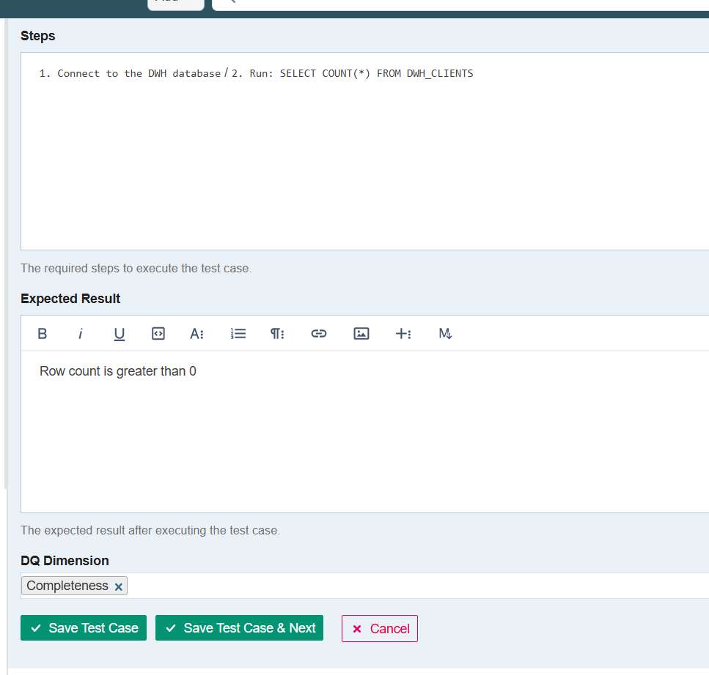
Steps, Expected Result and the DQ Dimension field (Completeness) for the same test case.
I repeated this for every case until the Smoke path section had 6 cases covering the basic checks that the target tables exist and are populated after an ETL run, and that primary key fields are not empty.
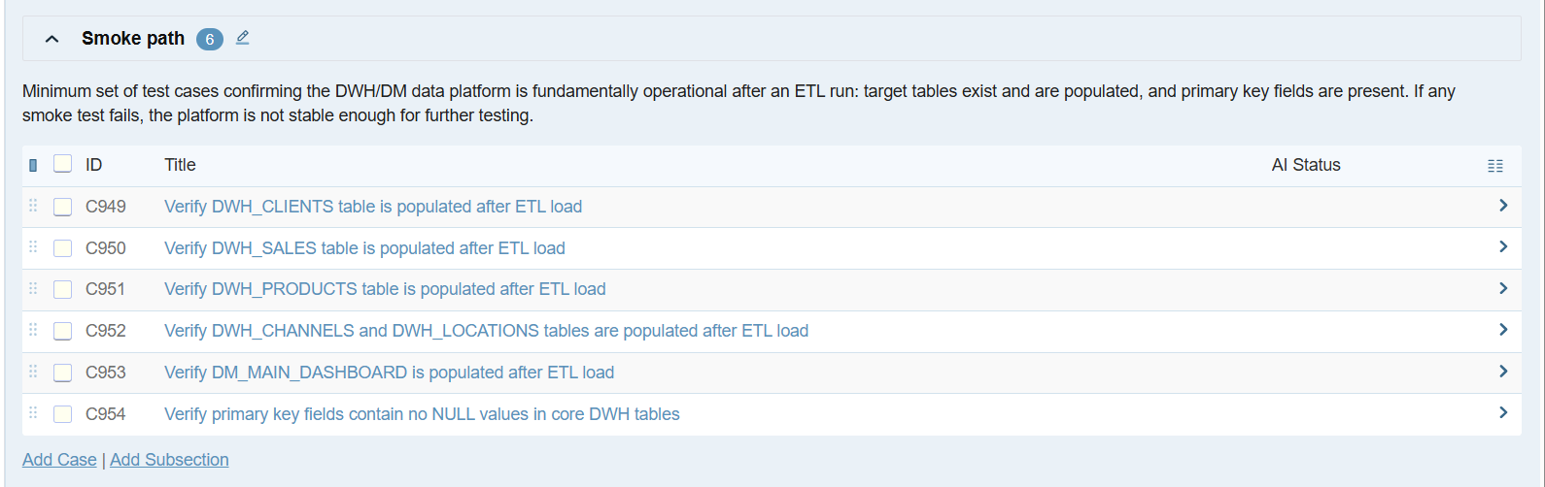
Smoke path finished with 6 test cases (C949–C954).
In Critical path I added 8 cases, covering things like client mapping from S1/S2 into DWH_CLIENTS, referential integrity of DWH_SALES, the PRODUCT_COST value, duplicate active clients, SCD fields, the TOTAL_COST calculation in the dashboard, and the link between DWH_CHANNELS and DWH_LOCATIONS.
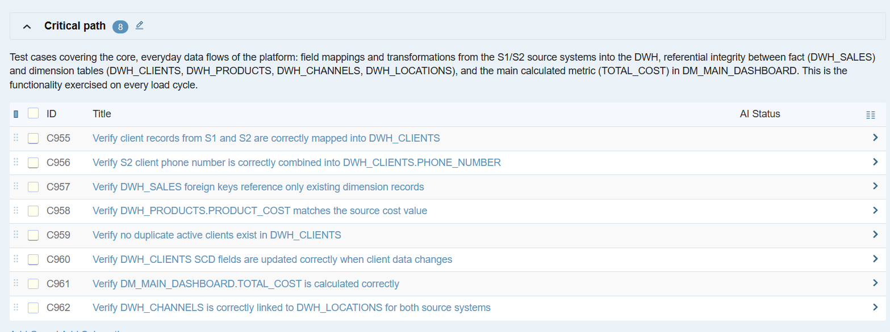
Critical path finished with 8 test cases (C955–C962).
In Extended path I added 6 cases for the edge situations: a missing middle name, the same real client appearing in both S1 and S2, order dates that should never be out of order, invalid quantity values, special characters in names, and the dashboard reflecting the latest client update.
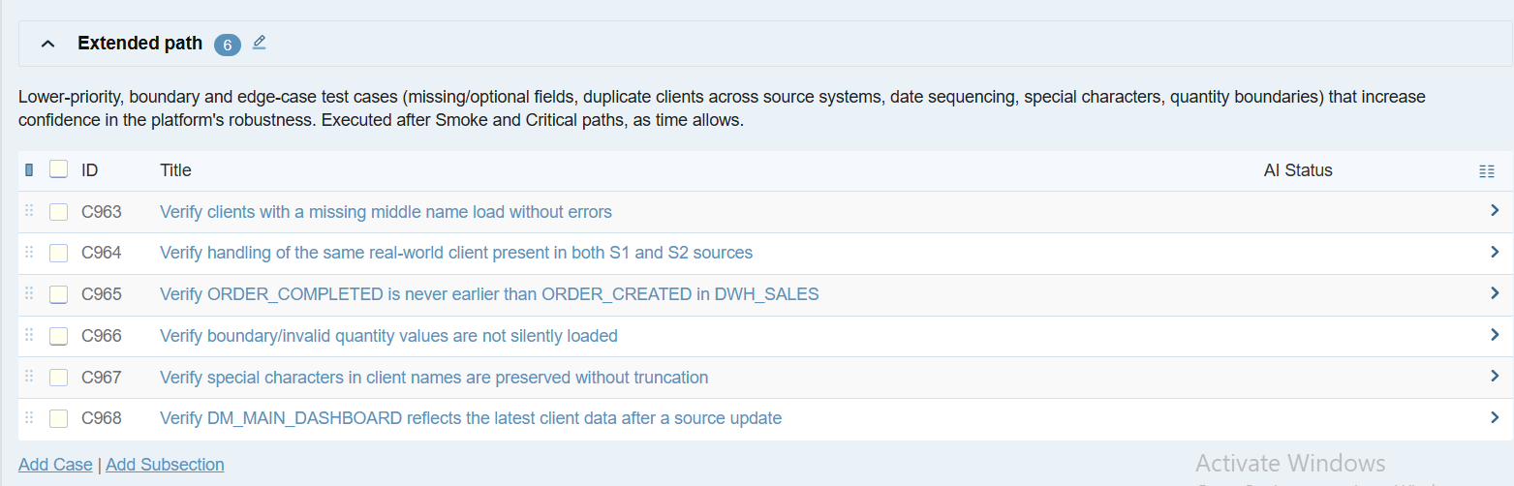
Extended path finished with 6 test cases (C963–C968). In total, all three sections together have 20 test cases.

4. Creating the Unit Tests run
The last part of the task was to create a Test Run for Unit Tests and assign it to myself, but include only the cases that really make sense on a unit/component level, meaning a check of one table or one field at a time. I did not include cases that need comparing data across systems, full end-to-end checks, or a manual look at the dashboard, because those belong to Integration or System testing rather than Unit testing.
So from the 20 cases, I selected all 6 from Smoke path, 7 out of 8 from Critical path (all except the SCD case, which compares data over time), and only 1 out of 6 from Extended path (the order date sequence check, which is the only one that is a pure single-table logic check). That gave me 14 cases in total for the Unit Tests run, and I assigned the run to myself.
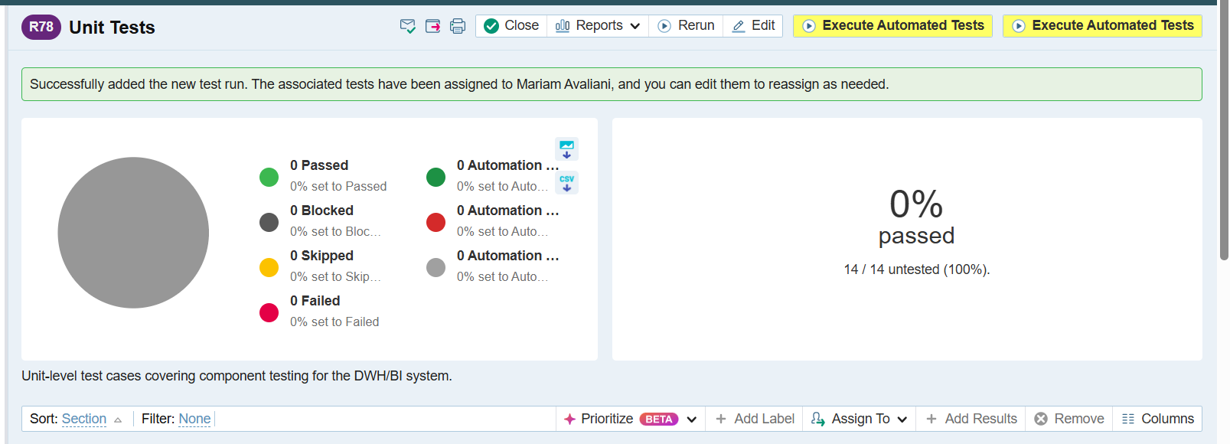
The "Unit Tests" run created successfully with 14 test cases, all assigned to me and untested at the start.

5. Result
At the end I have a TestRail project called "Mariam Avaliani" with 3 sections (Smoke path, Critical path, Extended path), 20 test cases in total, each with a Data Quality Dimension set, and a "Unit Tests" run with the 14 relevant cases assigned to me.
TestRail project link: https://gr1dq26testcasestask2.testrail.io/index.php?/projects/overview/49

