Power BI Lab Report
Task 2 – Project Design Essentials
Mariami Avaliani

1. Working with the Power BI Model
I opened the report I made in Lab 1, PowerBILab1_Avaliani.pbix, and went back to Modelling view again. This task also needed some work with the model, so before I started building the visuals, I wanted to check that the relationships were still set up the way I left them.

1.1 Checking the relationships
When I looked at the relationships between FactInternetSales and DimDate, I remembered that originally there was more than one relationship here, because the fact table has a few different date columns, like order date, due date and ship date. I already went through this in Lab 1 and removed the extra relationships at that time, so when I checked now, there was only one relationship left between these two tables, and it was drawn as a solid line, not a dashed one, which means it was active. I clicked on it to open the Edit relationship window again, just to double check that everything was still correct. The cardinality was Many to one, from FactInternetSales to DimDate, and the cross filter direction was Single.

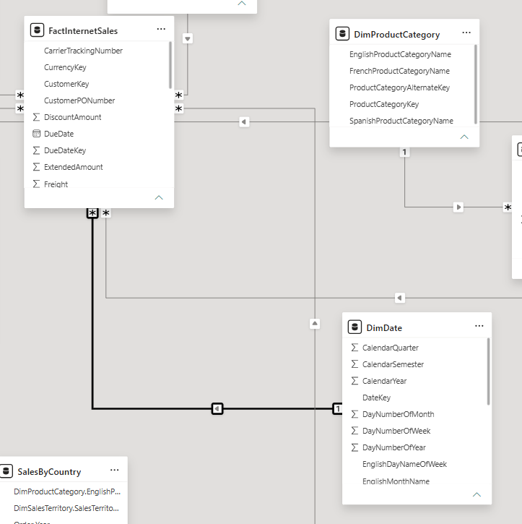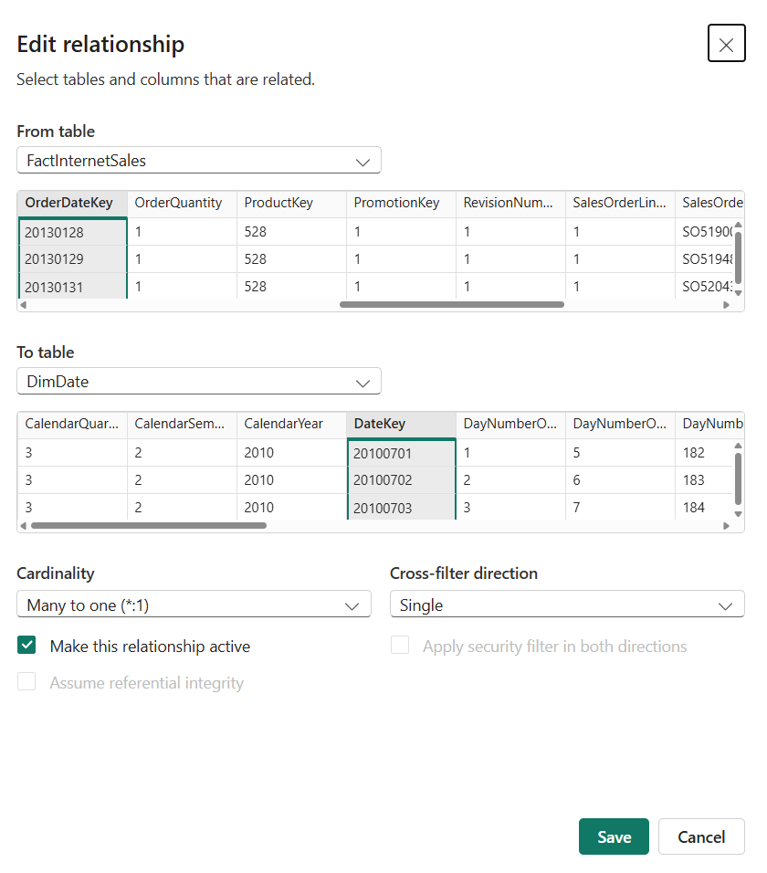

1.2 Making OrderDate the active relationship
Since OrderDate is the date column I use for the analysis in this whole report, this was exactly the relationship I wanted to stay active, the one that goes from OrderDateKey in FactInternetSales to DateKey in DimDate. I did not have to remove anything again this time, because I already deleted the other relationships to DueDate and ShipDate back in Lab 1, when I was working on the first report. So for this task I just opened Modelling view, confirmed that the model was still set up correctly, with only the OrderDate relationship active, and took a new screenshot of it for this report.

2. Building the Report
I switched to Report view and started adding visuals from the Visualizations pane.

2.1 Slicers
The task asked for 3 different types of slicers, a drop-down, a list box and a date filter, so I added all three.

Full Name slicer, list
I added a Slicer visual with Full Name from DimCustomer and set the type to List. There are a lot of customers, so I also turned on Search, to make it easier to find one name.

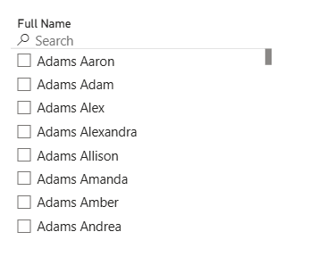

Full Name slicer, dropdown
I added a second slicer with the same Full Name field, but this time set as Dropdown, also with Search turned on.

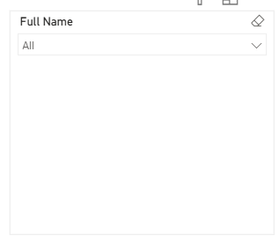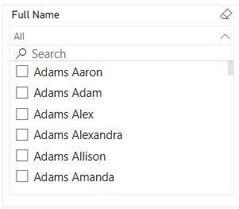

Date slicer
For the third slicer I used the FullDateAlternateKey field from the DimDate table as a date filter, instead of the OrderDate column on FactInternetSales, since filtering through the date dimension table is the better practice for performance and is consistent with how the relationship is set up in the model.
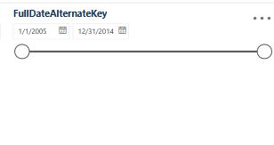

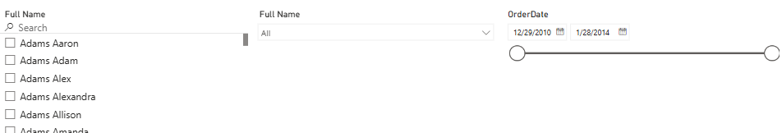

Slicers and page interaction
By default, a slicer in Power BI only filters the visuals on the same page as the slicer, so I chose to keep the synchronization for Page 1 only, and did not sync the slicers to Page 2. On Page 1, I also disabled the interaction between the date slicer (FullDateAlternateKey) and the Card visual, so the Card always shows the fixed grand total sales for the whole report, no matter what date range is selected in the slicer. Page 2 does not have its own slicers, so it always shows the complete, unfiltered picture of the data across the Table, Pie chart, Word Cloud, Bullet Chart and Map.

2.2 Standard visuals
I added five different standard visuals to the report: a clustered column chart, a line chart, a card, a table and a pie chart. I used a clustered column chart to show Sum of SalesAmount by product category (EnglishProductCategoryName), because it is the easiest way to compare a few categories side by side, and it showed clearly that Bikes bring in much more revenue than Accessories and Clothing. I used a line chart to show the sales trend by CalendarYear from the DimDate table, so I can see how sales went up and down over the years; I used the year field from DimDate here instead of the Order Year custom column on FactInternetSales, since slicing by the date dimension table is the recommended, better performing approach. I used a card to show the total sales amount for the whole report, formatted as $29.4M, so there is always one clear number for the total. I used a table with Full Name, Order Year, product category and SalesAmount, to show the detailed, row level data behind the charts, with a Total row at the bottom. And I used a pie chart to show how sales are split between countries (United States, Australia, United Kingdom, Germany, France and Canada), because a pie chart is a good way to show percentages of a whole.

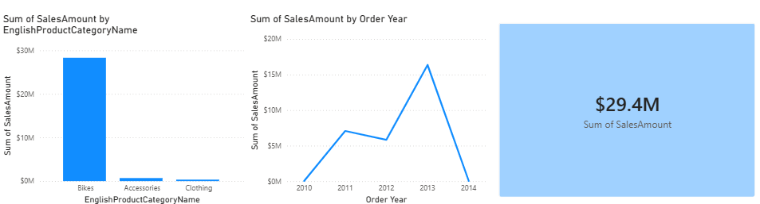

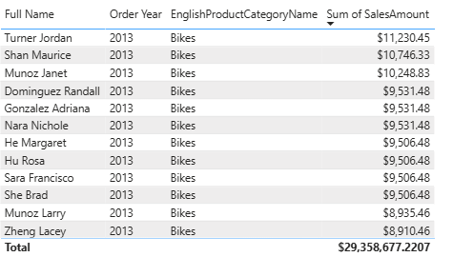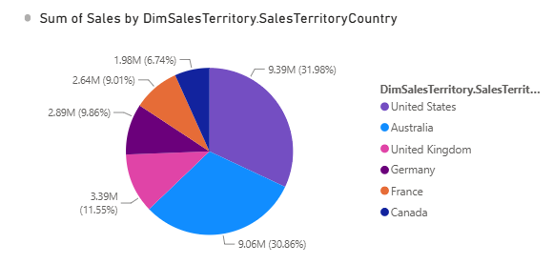

2.3 Custom visuals
I also added two custom visuals from AppSource.

Custom visual 1 – Word Cloud
I chose a Word Cloud because it gives a different, more visual way to look at the product data. I built it from the product name and product category fields, sized by SalesAmount, so the words for the best selling product models (like Mountain, Road, Touring) and colors (like Black, Silver, Blue) appear bigger than the others. It is a nice way to quickly see which product names and colors are the most popular, without reading a table of numbers.

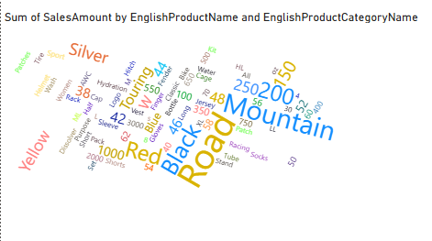

Custom visual 2 – Bullet Chart (OKViz)
I chose a Bullet Chart because I wanted to show actual sales against a target, and this is not something the standard visuals can do well. Since there was no ready made target value in the data, I created a simple DAX measure called Target Sales, calculated as the total SalesAmount multiplied by 1.1, so the target is 10% higher than the actual sales for each year. In the Bullet Chart, the grey bar shows the actual SalesAmount and the black marker shows the Target Sales for each Order Year, so it is easy to see how close the actual sales were to the target.

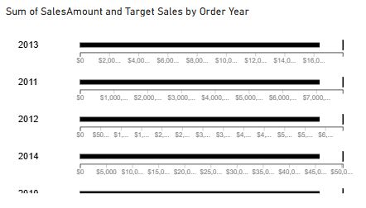

3. Header and Logo
I added a header at the top of the report with the report name and the company logo, using a text box for the title and an image for the logo.

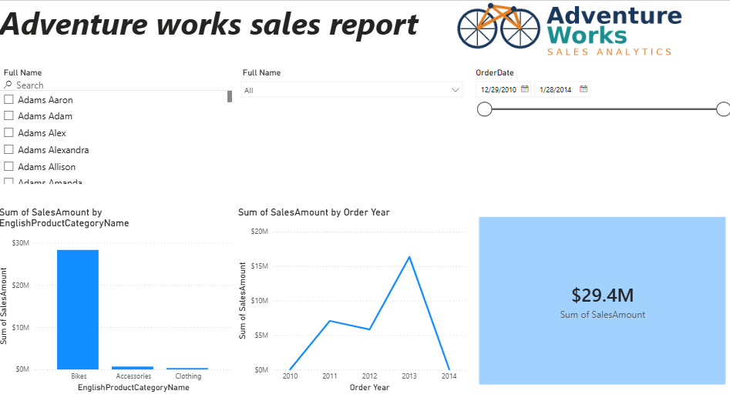

4. Color Palette
I picked a color palette that matches the logo colors and used it for the bars, lines and other visuals in the report, so the whole report looks consistent. Since AdventureWorks does not have an official logo, I made a simple one myself with a bike icon, and picked three colors from it: a dark navy blue (#19375A) for titles and the main bars and lines, a teal green (#1A8D8F) as a second color, and an orange (#E67E22) as an accent color. I saved these as a Power BI theme file and applied it from View -> Themes -> Browse for themes, so all the standard visuals picked up the same colors automatically. The two custom visuals (Word Cloud and Bullet Chart) did not follow the theme automatically, so I would need to set their colors manually if I wanted a perfect match everywhere.
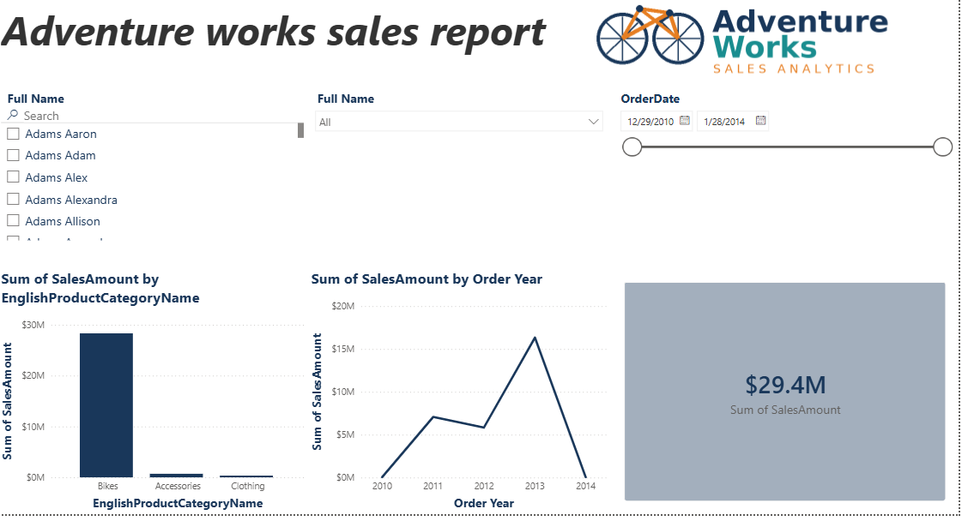
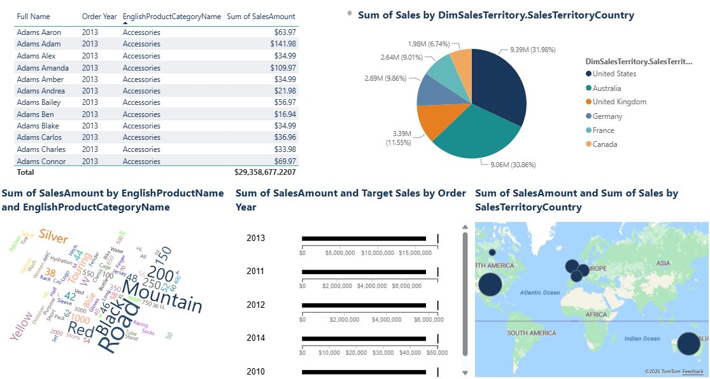

5. Disabling Interactions
I disabled the interaction between the date slicer (FullDateAlternateKey) and the Card visual (Total Sales), because I want the Card to always show the grand total sales amount for the whole report, as a fixed reference number, no matter what date range is selected in the slicer. I did this from Format -> Edit interactions, selected the date slicer, and clicked the None icon on the Card visual.

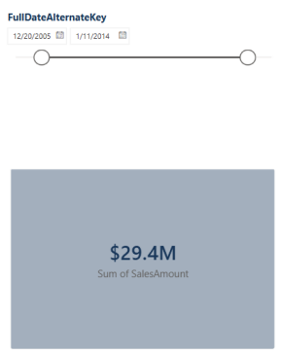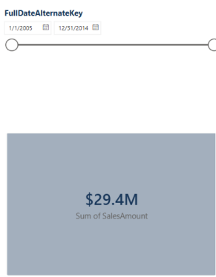

6. Map Visual
I added a Map visual using SalesTerritoryCountry from the DimSalesTerritory table as the location, and SalesAmount from FactInternetSales as the bubble size, so each country is shown as a circle on the world map, with the circle size based on how much was sold in that country. DimSalesTerritory is a dimension table with an active relationship to FactInternetSales, so I did not need to build or add any extra table for the Map, I just used the fields directly from these two tables. I originally used a different table, SalesByCountry (built in Lab 1 by merging FactInternetSales with DimSalesTerritory), for the Pie chart in section 2.2, but after my mentor review, I updated the Pie chart to use SalesTerritoryCountry from DimSalesTerritory directly, the same way as the Map, since this is the recommended practice for a dimension table with an active relationship, and it also makes the Pie chart react correctly to filters, like the URL filter link in section 11.

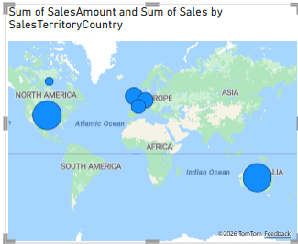

7. Mobile Layout
I configured the mobile layout from View -> Mobile Layout and arranged the visuals so the most important ones are on top for a phone screen.

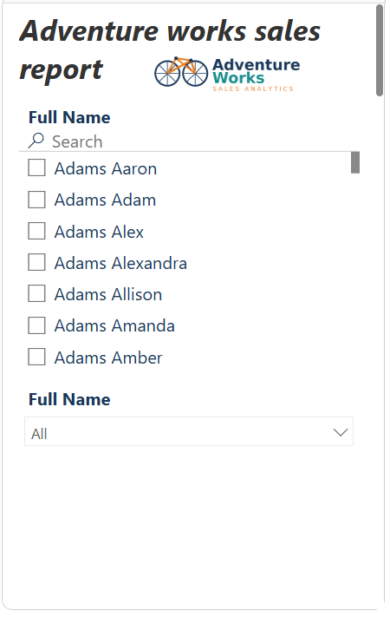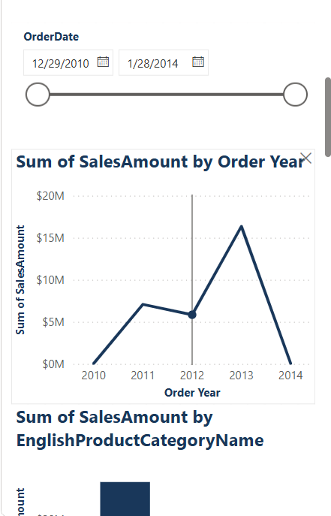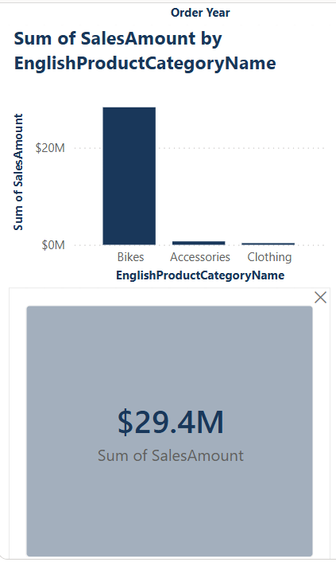
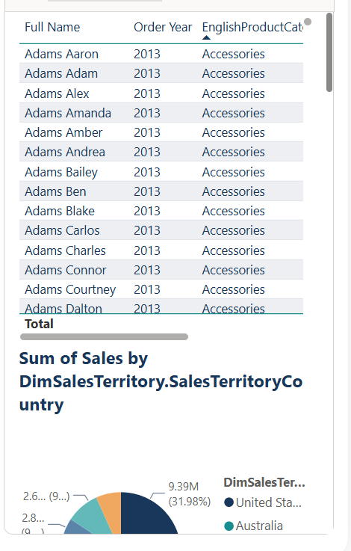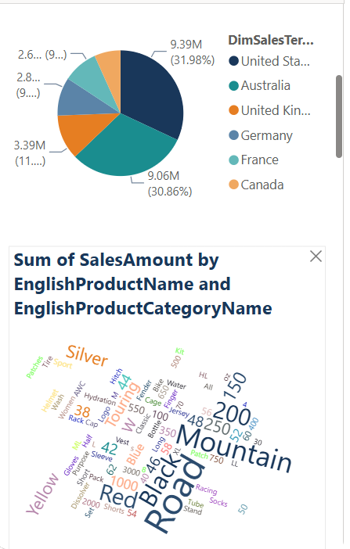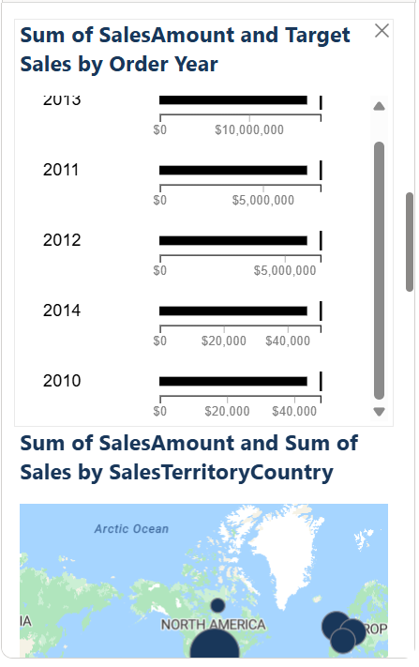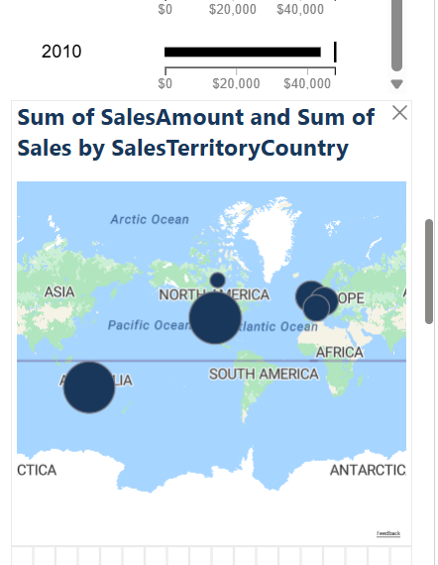

8. Publishing to Power BI Service
I published the report to the Power BI Service using the Publish button in Power BI Desktop, into My workspace.

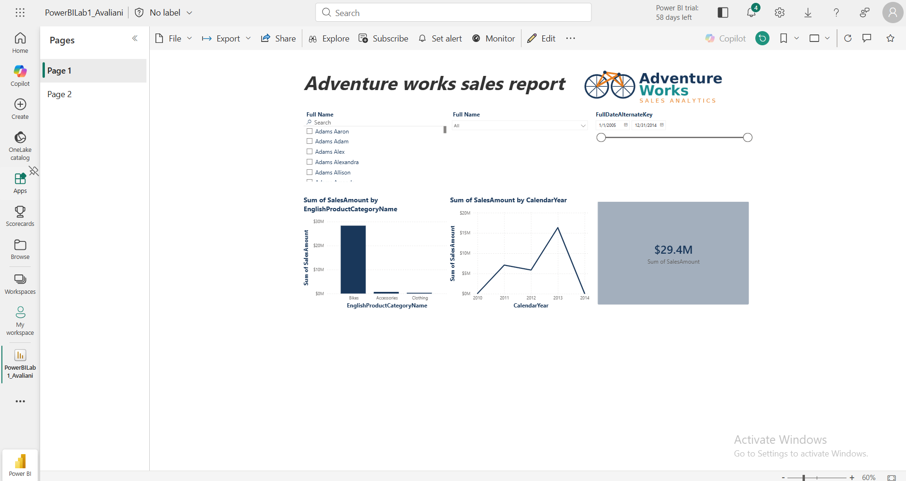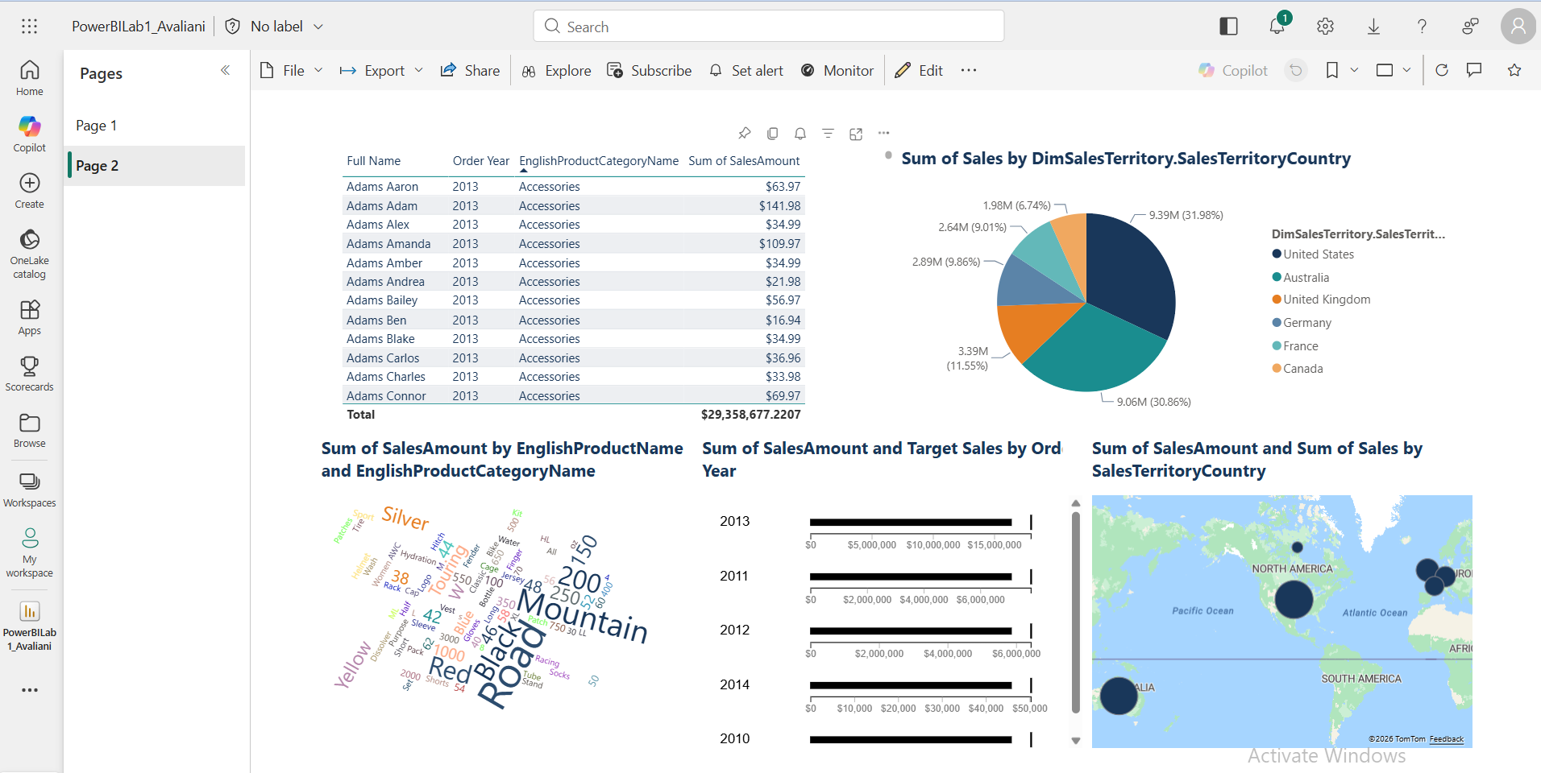

9. Personal Gateway and Scheduled Refresh
I installed the Personal Gateway on my computer and connected it to my dataset. After that I set up a scheduled refresh once a day in the dataset settings.
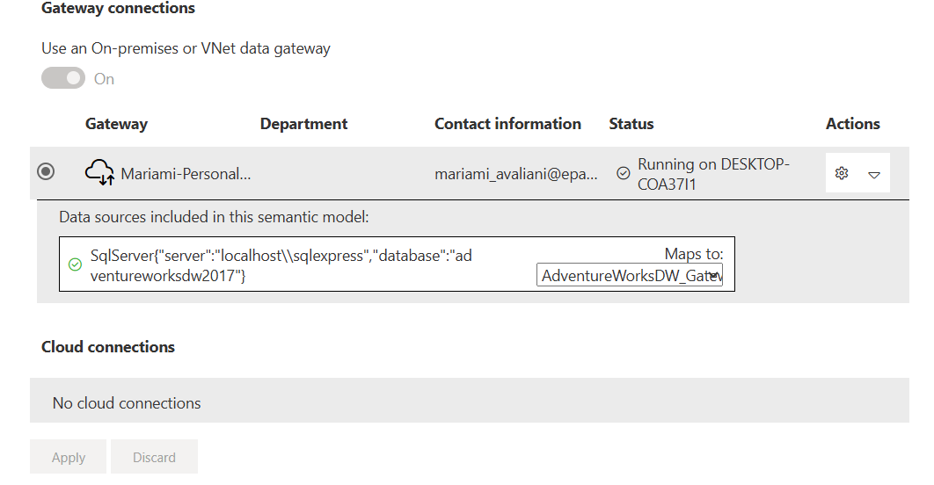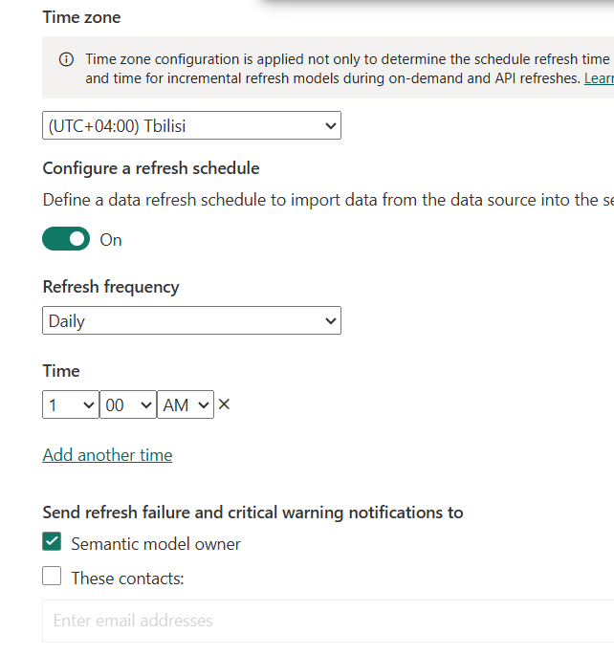
To make sure the daily refresh is actually working, I checked the workspace list after a scheduled refresh ran. I could see that the Semantic model row for PowerBILab1_Avaliani had an updated Refreshed timestamp (8/7/2026, 1:15 PM), and a Next refresh time already scheduled for the following day (8/8/2026, 1:00 AM), which confirms the refresh completed successfully and the daily schedule is active.
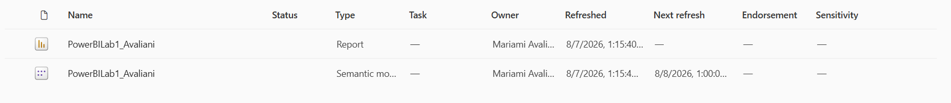
On top of sharing the report, my mentor also asked to be able to check the refresh history directly, so I went to the semantic model in my workspace, opened Manage permissions, and gave my mentor Build access on the semantic model (in addition to Read and Reshare), so he can open the dataset himself and see the refresh history without needing me to send screenshots every time.
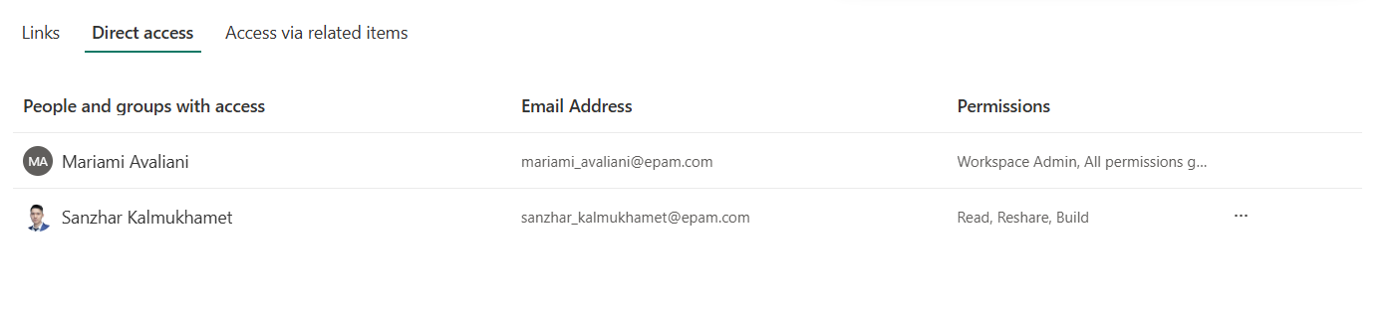

10. Sharing the Report
I shared the report with my mentor using the Share button and added his/her email, which also sent an email notification automatically.

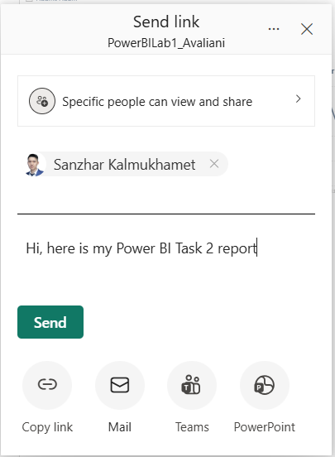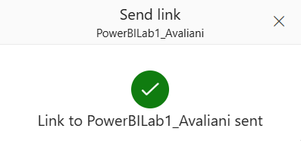

11. URL Filter Link
I also created a link that opens the report already filtered, for example by one country:
https://app.powerbi.com/groups/me/reports/1c7b9af8-9e4e-4ccc-af39-3d4f8a6b57cc/450c93807ad97262346e?experience=power-bi&filter=DimSalesTerritory/SalesTerritoryCountry eq 'Canada'

Conclusion
In this lab I reviewed and cleaned up the relationships in the Power BI model, and then built a report with three different slicers, five standard visuals and two custom visuals, a header with the company logo, and a color palette that matches the logo. I also added a map, set up a mobile layout, published the report to Power BI Service, installed a personal gateway with a daily refresh, and shared the report with my mentor.

