EPAM Systems — AWS Cloud for Data Engineering
Task 4 — DB Services
Report

Student | Mariam Avaliani
AWS account | 260586643565
Region | eu-central-1 (Frankfurt)
Covers | Task 1: RDS MySQL · Task 2: RDS Aurora · Task 3: DynamoDB

Introduction
This report is for Task 4 of the AWS Cloud for Data Engineering course. The task has three parts: Amazon RDS for MySQL, Amazon RDS Aurora, and Amazon DynamoDB. In this report I explain what I did for each part, in the order I did it, together with the problems I found on the way and how I solved them. Some of the problems were normal beginner mistakes, but a few were real AWS-specific behaviours that I had to research and test before I understood them. I include screenshots from my own work for every important step.

Task 1 — RDS MySQL
Goal: connect to a mentor-provided RDS MySQL instance as the admin user, create my own personal user, and then use only that personal user to build a schema with a table, a view and a stored procedure, using one script that can be run more than once without failing.

1.1 Connection details
Field | Value
Engine | MySQL (RDS)
Admin user | admin
Database | dilab_dev
Endpoint | dilab-mysql.cqlpneuyr8on.eu-central-1.rds.amazonaws.com
Port | 3306

1.2 Getting connected
I did not have a MySQL client on my computer, so first I tried the mysql command in PowerShell, but I got: "The term 'mysql' is not recognized as the name of a cmdlet...". I decided to install DBeaver instead of the plain command line tool, because it is a graphical program and it is easier for me to see what is happening. I downloaded DBeaver, installed it, and created a new MySQL connection with the admin login.
The connection needs SSL, so before connecting I downloaded the AWS RDS certificate bundle with this command:
curl -o global-bundle.pem https://truststore.pki.rds.amazonaws.com/global/global-bundle.pem
and I set this file as the CA Certificate in the SSL tab of the DBeaver connection, with SSL mode VERIFY_IDENTITY.
At first, DBeaver could not connect at all and gave me a "Connect timed out" error. This was not a password problem — I checked my public IP address ("what is my ip") and I understood the real reason: the security group of the RDS instance only allows a small list of specific IP addresses to connect, and my IP was not on that list. A security group works like a name list at a door — even with the correct password, if your IP is not on the list, you cannot get in. Later, when my company VPN changed my visible IP address to one of the allowed ones, the connection started to work by itself, with no other change on my side.
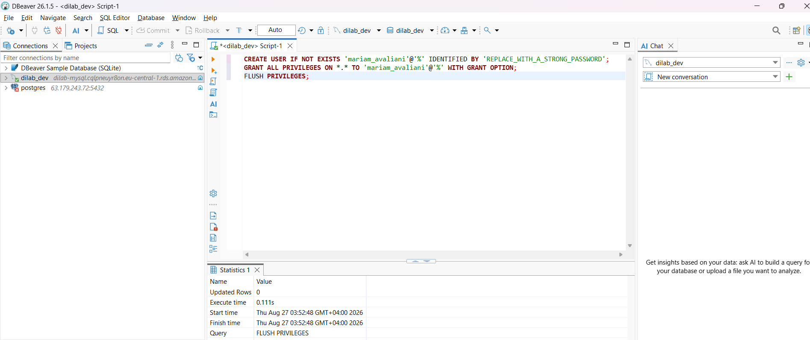
Connected as admin and ran the CREATE USER script — DBeaver shows it finished in 0.111s with no errors.

1.3 Creating my personal user
While connected as admin, I created my own MySQL user:
CREATE USER 'mariam_avaliani'@'%' IDENTIFIED BY 'Mariam2026!';
One strange thing happened here: the very first time I ran a CREATE USER ... IF NOT EXISTS statement, DBeaver showed no error and the Statistics tab looked completely normal, but when I checked afterwards with SELECT user, host FROM mysql.user WHERE user = 'mariam_avaliani', the result was empty — the user was never actually created. I am still not 100% sure why, but after I ran a plain CREATE USER statement on its own, without IF NOT EXISTS, it worked and the user really appeared in mysql.user.

1.4 The GRANT problem — an RDS-specific gotcha
Next I tried to give my new user full rights, the normal way:
GRANT ALL PRIVILEGES ON *.* TO 'mariam_avaliani'@'%' WITH GRANT OPTION;
But every time I ran this, I got the same error:
ERROR 1045 (28000): Access denied for user 'admin'@'%' (using password: YES)
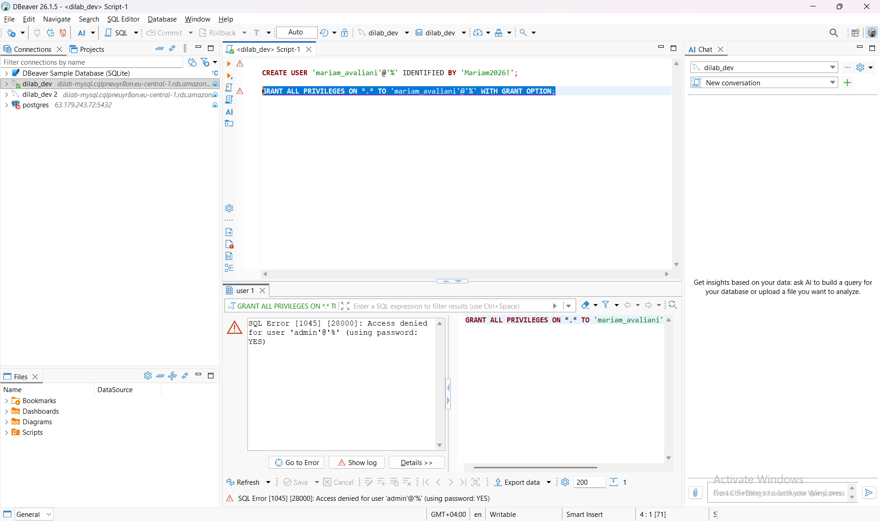
GRANT ALL PRIVILEGES fails with error 1045 — it looks like a login problem, but the admin password was correct.
This error message looks exactly like a wrong-password problem, so at first I disconnected and reconnected, typed the password again very carefully, and removed the WITH GRANT OPTION part — nothing changed, same error. After more research, I understood the real cause: on Amazon RDS, even the admin (master) user does not have MySQL's real SUPER-level privileges, like RELOAD, SHUTDOWN or FILE — AWS keeps full control of those for its own management layer, and does not give them to any customer account. GRANT ALL PRIVILEGES ON *.* tries to include these SUPER-level privileges too, so it fails — but MySQL shows the same generic "access denied" wording it would show for a real login failure, which makes this very confusing to debug.
The fix is to grant only the privileges that RDS actually allows for a normal user:
GRANT SELECT, INSERT, UPDATE, DELETE, CREATE, DROP, ALTER, INDEX,
CREATE VIEW, SHOW VIEW, CREATE ROUTINE, ALTER ROUTINE, EXECUTE,
TRIGGER, REFERENCES, LOCK TABLES, CREATE TEMPORARY TABLES
ON *.* TO 'mariam_avaliani'@'%';
FLUSH PRIVILEGES;
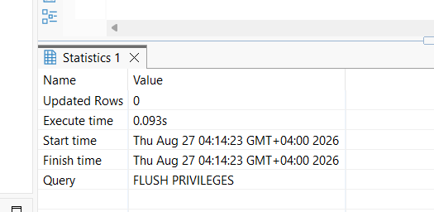
The RDS-safe GRANT list runs with no error (0.201s).
After that I made a second DBeaver connection using my own login (mariam_avaliani / Mariam2026!, same SSL setup), and the test connection succeeded:
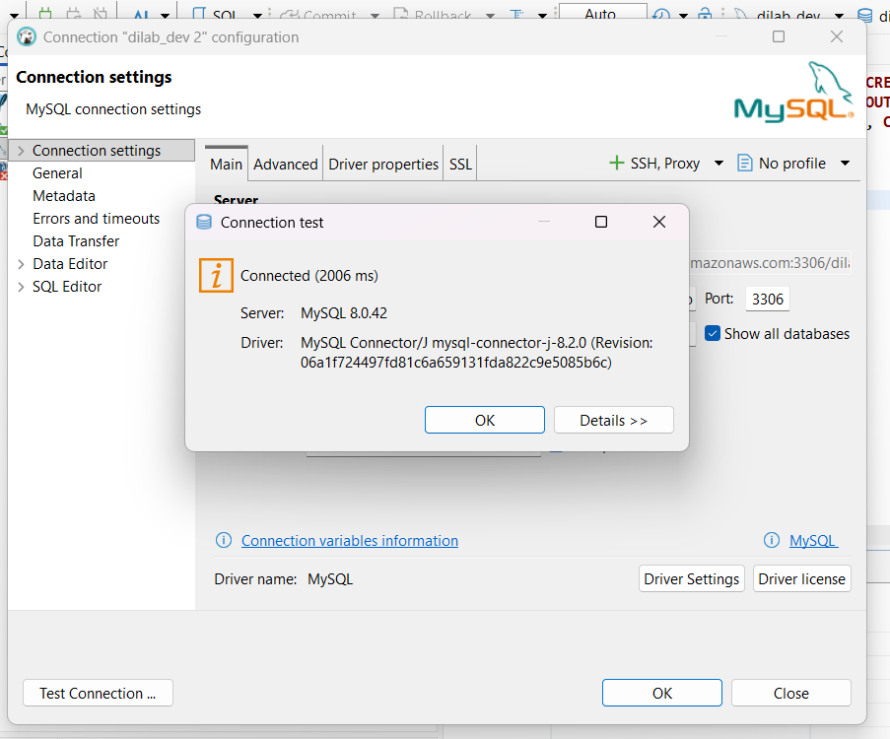
Test connection as my own user, mariam_avaliani — Connected (2006 ms), MySQL 8.0.42.

1.5 The restartable script
The idea of a "restartable" script is that every statement can run again later without failing, even if it already ran before. That is why every CREATE uses IF NOT EXISTS or OR REPLACE, and why the stored procedure is dropped and recreated instead of using CREATE PROCEDURE IF NOT EXISTS, which does not exist in MySQL.
-- 1. Personal schema
CREATE SCHEMA IF NOT EXISTS mariam_avaliani_schema
DEFAULT CHARACTER SET utf8mb4;

-- 2. Table
CREATE TABLE IF NOT EXISTS mariam_avaliani_schema.students (
student_id INT AUTO_INCREMENT PRIMARY KEY,
full_name VARCHAR(100) NOT NULL,
course VARCHAR(100) NOT NULL,
enrolled_at DATE NOT NULL DEFAULT (CURRENT_DATE)
);

-- seed one row only if the table is empty, so re-running does not duplicate data
INSERT INTO mariam_avaliani_schema.students (full_name, course)
SELECT * FROM (SELECT 'Mariam Avaliani', 'AWS Cloud for Data Engineering') AS tmp
WHERE NOT EXISTS (SELECT 1 FROM mariam_avaliani_schema.students LIMIT 1);

-- 3. View
CREATE OR REPLACE VIEW mariam_avaliani_schema.active_students AS
SELECT student_id, full_name, course
FROM mariam_avaliani_schema.students
WHERE enrolled_at >= CURDATE() - INTERVAL 1 YEAR;

-- 4. Stored procedure
DROP PROCEDURE IF EXISTS mariam_avaliani_schema.add_student;

CREATE PROCEDURE mariam_avaliani_schema.add_student(
IN p_name VARCHAR(100),
IN p_course VARCHAR(100)
)
INSERT INTO mariam_avaliani_schema.students (full_name, course) VALUES (p_name, p_course);

-- 5. Verification, safe to run every time
CALL mariam_avaliani_schema.add_student('Test Student', 'AWS Cloud for Data Engineering');
SELECT * FROM mariam_avaliani_schema.active_students;

The stored procedure and DELIMITER — another gotcha
The most difficult part of this whole task was the stored procedure. At first I wrote it the standard way people usually write it in MySQL, with DELIMITER $$ ... END$$ DELIMITER ; around a BEGIN...END block, and ran the full script at once. DBeaver did not show any error, but when I checked with SHOW PROCEDURE STATUS WHERE Db = 'mariam_avaliani_schema', the result was empty — the procedure was silently never created.
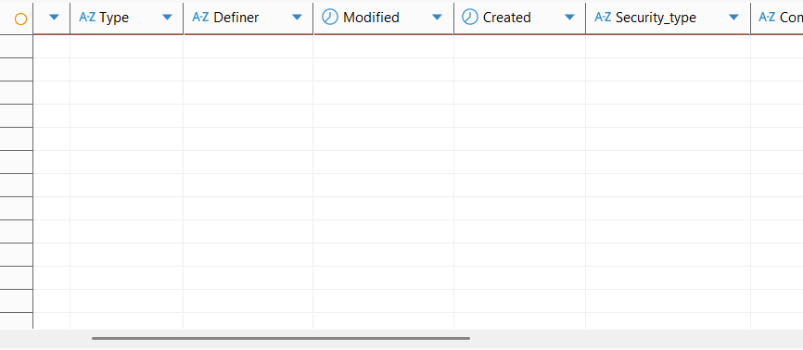
SHOW PROCEDURE STATUS returns no rows — the DELIMITER-based CREATE PROCEDURE did not really run, even though DBeaver showed no error.
I tried this a few more times, in different ways (running only that block alone, selecting the text manually before running it), and once I even got a strange syntax error where the word CALL was cut down to CAL — clearly some kind of statement-splitting bug in this DBeaver version around DELIMITER. In the end I found a simple way around the whole problem: since my procedure only has one SQL statement in its body (one INSERT), MySQL does not require a BEGIN...END block at all — a stored procedure body can be a single statement. So I do not need DELIMITER either, because there is only one semicolon in the whole statement, right at the end:
CREATE PROCEDURE mariam_avaliani_schema.add_student(
IN p_name VARCHAR(100),
IN p_course VARCHAR(100)
)
INSERT INTO mariam_avaliani_schema.students (full_name, course) VALUES (p_name, p_course);
This ran with no problem as one normal statement, and this time SHOW PROCEDURE STATUS actually showed it:
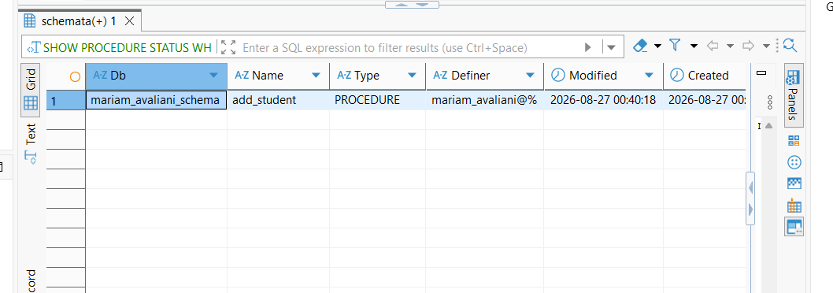
SHOW PROCEDURE STATUS now shows add_student, in mariam_avaliani_schema, definer mariam_avaliani@%.

Proving the script is restartable
To prove the script can run a second time without breaking, I ran the whole script again with no changes, then called the procedure once more and checked the view. Everything finished with no errors, and the table simply got one more row than before, which is exactly what should happen, since CALL always adds a new row on purpose:
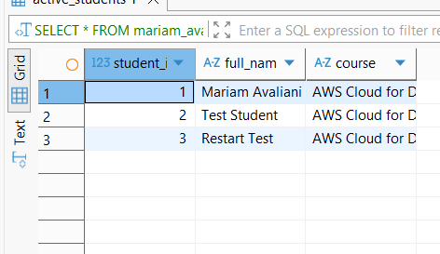
Second run: active_students now shows 3 rows (Mariam Avaliani, Test Student, Restart Test) with no errors from the repeated schema/table/view/procedure creation.
Note: I am submitting the script from section 1.5 to the Mentors as its own .sql file too, as the task instructions ask.

Task 2 — RDS Aurora
Goal: run a few meaningful (multi-table, aggregated) queries against an Aurora database using the console's Query Editor, then connect to the same database from my own computer through my Task 2 EC2 instance acting as a bastion (jump) server, and explain why this extra step is needed for Aurora but was not needed for the RDS MySQL instance in Task 1.

2.1 Connection details
Field | Value
Engine | Amazon Aurora (MySQL-compatible)
Admin user | admin
Databases | dilab_dev / sakila
Cluster | dilab-aurora (writer instance: dilab-aurora-1)
Writer endpoint | dilab-aurora-1.cqlpneuyr8on.eu-central-1.rds.amazonaws.com

2.2 Part A — Query Editor, in the console
I opened the dilab-aurora-1 instance page in the RDS console, and used the "Query editor" link in the left menu — this does not need a SQL client on my computer at all.
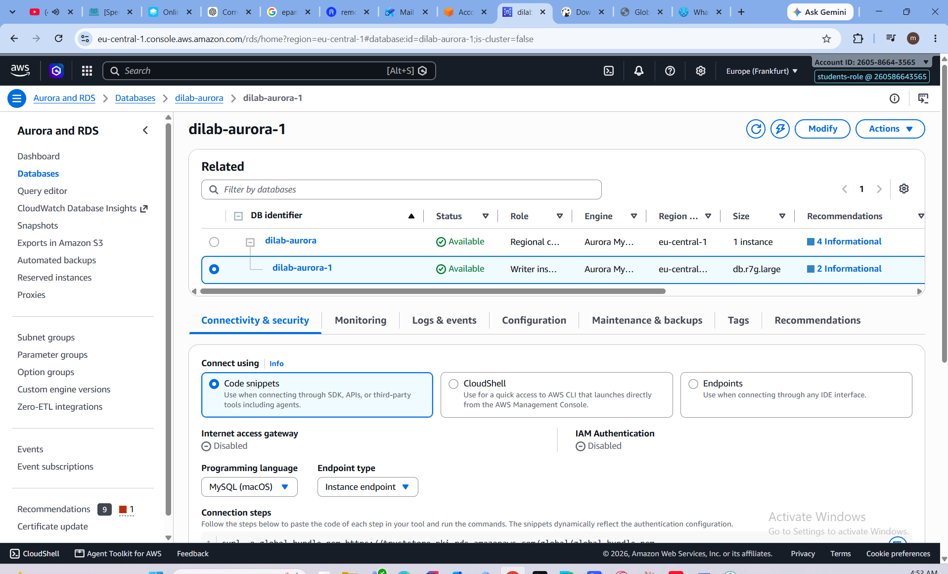
The Aurora writer instance page, with the Query editor link in the left menu.
I connected with admin against the sakila database.
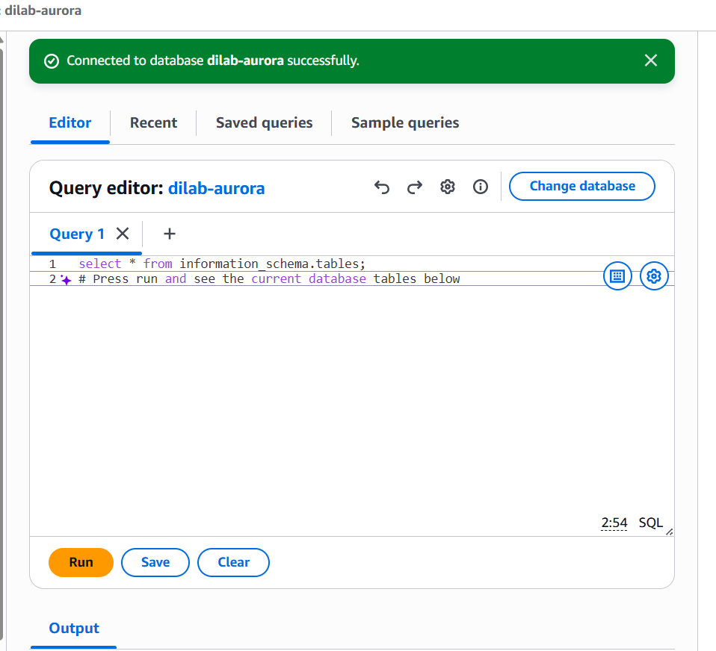
"Connected to database dilab-aurora successfully."
Then I ran three queries that join and aggregate several tables together, since the task asked for meaningful queries, not simple single-table selects.

Query 1 — top 5 customers by total amount paid
SELECT c.customer_id, c.first_name, c.last_name, SUM(p.amount) AS total_paid
FROM customer c
JOIN payment p ON p.customer_id = c.customer_id
GROUP BY c.customer_id, c.first_name, c.last_name
ORDER BY total_paid DESC
LIMIT 5;
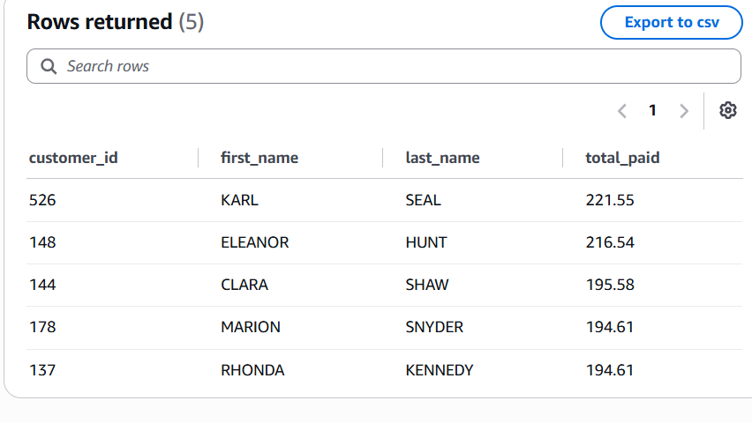
Result: Karl Seal is the top customer with 221.55 paid in total.

Query 2 — number of rentals per film category
SELECT cat.name AS category, COUNT(r.rental_id) AS rentals
FROM rental r
JOIN inventory i ON i.inventory_id = r.inventory_id
JOIN film_category fc ON fc.film_id = i.film_id
JOIN category cat ON cat.category_id = fc.category_id
GROUP BY cat.name
ORDER BY rentals DESC;
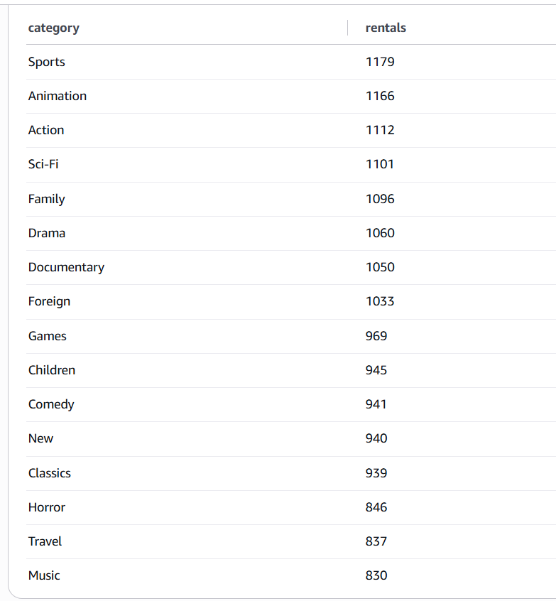
Result: Sports is the most rented category (1179 rentals), Music is the least (830).

Query 3 — average rental duration and revenue per store
SELECT s.store_id,
AVG(DATEDIFF(r.return_date, r.rental_date)) AS avg_rental_days,
SUM(p.amount) AS total_revenue
FROM store s
JOIN staff st ON st.store_id = s.store_id
JOIN payment p ON p.staff_id = st.staff_id
JOIN rental r ON r.rental_id = p.rental_id
GROUP BY s.store_id;
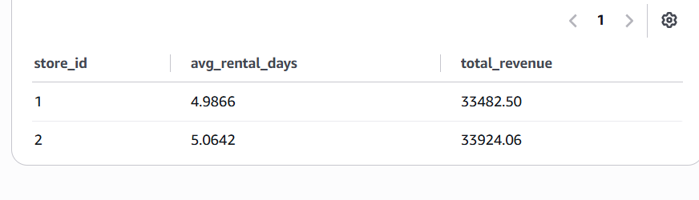
Result: store 1 — 4.9866 days average, $33,482.50 revenue; store 2 — 5.0642 days, $33,924.06.

2.3 Why Aurora needs a bastion but MySQL does not
Before I connected through the bastion, I wanted to actually verify why this step is necessary for Aurora but was not needed for the Task 1 MySQL instance, instead of just repeating the standard explanation. I used nslookup on both endpoints from PowerShell:
nslookup dilab-mysql.cqlpneuyr8on.eu-central-1.rds.amazonaws.com
-> 63.185.104.19 (a normal public IP address)

nslookup dilab-aurora-1.cqlpneuyr8on.eu-central-1.rds.amazonaws.com
-> 172.31.35.111 (a private IP address, inside the default VPC range)
This gives a clear, checked answer: dilab-mysql is Publicly accessible, it has a real public IP address, so I can reach it directly from my computer once the security group allows my IP. dilab-aurora-1 only has a private IP address inside the VPC, so it has no public accessibility at all — there is no route from the internet to it, no matter how correct the password is. The only way to reach it is from something that is already inside the VPC, for example an EC2 instance acting as a bastion, using an SSH tunnel.

2.4 Part B — connecting through the bastion
My EC2 instance from Task 2 had already been terminated (most likely an automatic cleanup after that task was graded), so I needed a new bastion instance. I still had my CloudFormation template from Task 2 (mariam-avaliani-ec2-cfn.yaml), so instead of building everything by hand again, I just created a new CloudFormation stack from that same file, and it rebuilt an equivalent EC2 instance with the same security group and key pair.
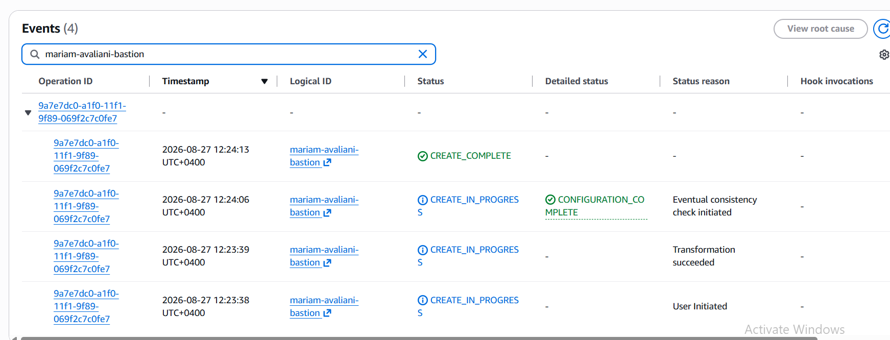
CloudFormation stack mariam-avaliani-bastion — CREATE_COMPLETE.
In DBeaver, I made a new connection to the Aurora writer endpoint, with the same SSL setup as Task 1 (global-bundle.pem, Require SSL, Verify server certificate). In the SSH tab, I set up a tunnel: Host/IP = my EC2 instance's public IP, Port 22, Authentication Method = Public Key, User Name = ec2-user (my instance uses Amazon Linux 2023), and my private key file mariam-avaliani-key.pem. The first time I connected, DBeaver asked me to confirm the SSH host key, and after I accepted it, the tunnel test succeeded:
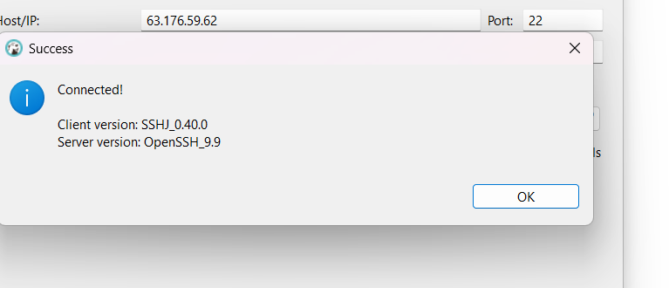
SSH tunnel test: "Connected!" (Client SSHJ_0.40.0, Server OpenSSH_9.9).
After that, I tested the full database connection through the tunnel, and it worked too:
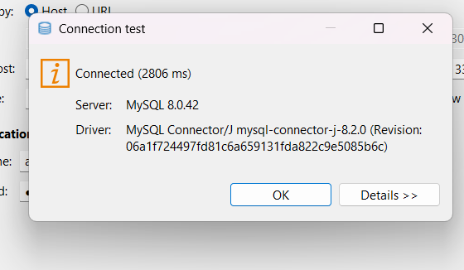
Full connection test: Connected (2806 ms), Server MySQL 8.0.42.
Finally, to be sure the data was really coming from Aurora and not just a cached result, I ran a real query through the tunnel:
SELECT * FROM sakila.customer LIMIT 5;
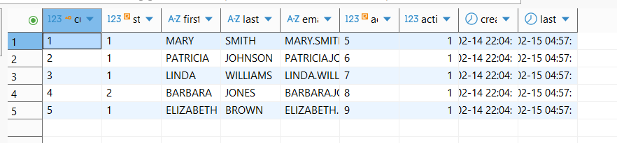
Real customer rows (Mary Smith, Patricia Johnson, Linda Williams, ...) returned through the SSH tunnel.

Task 3 — DynamoDB
Goal: create one throw-away table by hand in the console just to see the interface, then do all the real work with a proper table — create it with a justified key design, load 20+ items, retrieve some by key, run a few query and scan patterns, and delete 2 items.

3.1 Part A — console demo table
I created a simple table called mariam-avaliani-demo-table, with partition key demo_id (String).
mariam-avaliani-demo-table — Active, partition key demo_id (S).
Then I added three items by hand through the "Create item" form (demo-1, demo-2, demo-3), each with a note attribute:
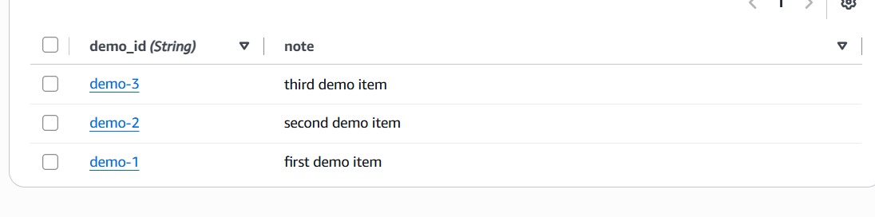
The three demo items in the table.
An item in DynamoDB is similar to a row in a normal SQL table, but with one important difference — items in the same table don't have to share the exact same set of attributes. This is the main thing that makes DynamoDB a NoSQL database: there is no fixed table-wide schema like in MySQL, each item defines its own attributes.
Since this table was only for practice, I deleted it afterwards:
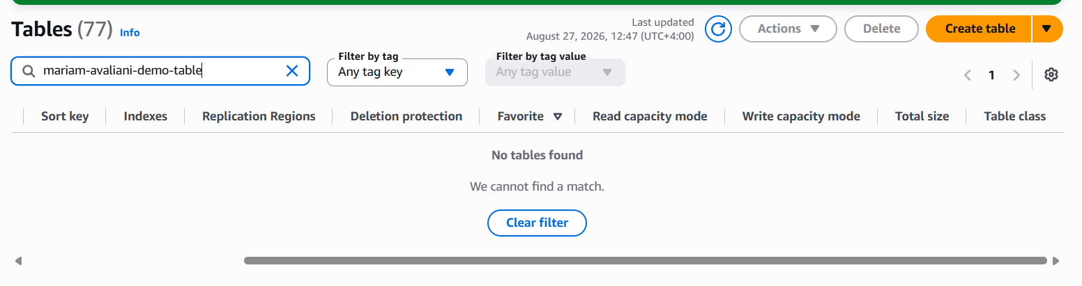
Filtering the table list for mariam-avaliani-demo-table now shows "No tables found" — the table is deleted.

3.2 Part B — the real table

Table design and why I chose this key
Table name | mariam-avaliani-order-events
Partition key | customer_id (String)
Sort key | order_id (String)
Key type | Composite primary key (partition key + sort key)
I chose customer_id as the partition key because I think the most common request for this table would be "give me all the orders for one customer", not "scan the whole table". customer_id has high cardinality (many different customers), so DynamoDB's internal hash-partitioning spreads the data evenly across partitions, and there is no risk of one "hot" partition getting all the traffic, which matches AWS's own guidance on choosing a partition key. I added order_id as the sort key so that one customer can have many orders — the primary key is really the pair (customer_id, order_id), not customer_id alone — and this also lets me query a range of one customer's orders in order, instead of only fetching one order at a time.

A permissions problem — the AWS CLI did not work for me
The task says this part should be done with the AWS CLI. I installed the AWS CLI (version 2.36.29) and got temporary credentials from my organisation's AWS access portal (we use AWS IAM Identity Center / SSO to log in). But when I tried to create the table from PowerShell:
aws dynamodb create-table --table-name mariam-avaliani-order-events ...

aws: [ERROR]: An error occurred (AccessDeniedException) when calling the
CreateTable operation: ... is not authorized to perform: dynamodb:CreateTable
I tried AWS CloudShell too, thinking it might use my normal console permissions, but it also failed immediately, with "Unable to create the environment... insufficient permissions to create environments". I then tested even a simple, read-only command, aws dynamodb describe-table, and that was denied as well. So the conclusion is that the SSO role I get through "Access keys" on the access portal (shown as "User" in the role ARN) has much narrower permissions than the role my browser console session uses (shown as "students-role"), because creating and reading the same table worked without any problem directly in the console.
Since I could not run real aws dynamodb commands with the credentials available to me, I used the DynamoDB console's PartiQL editor instead. This lets me write SQL-like INSERT, SELECT and DELETE statements and run them with my normal console permissions — functionally this does the same job as the CLI operations the task describes (batch-write-item, get-item, query, scan, delete-item), just through a different interface. I want to be honest about this in my report, because it is a real limit in the permissions of my training account, not something I was able to fix myself, and I will ask my mentor about it.
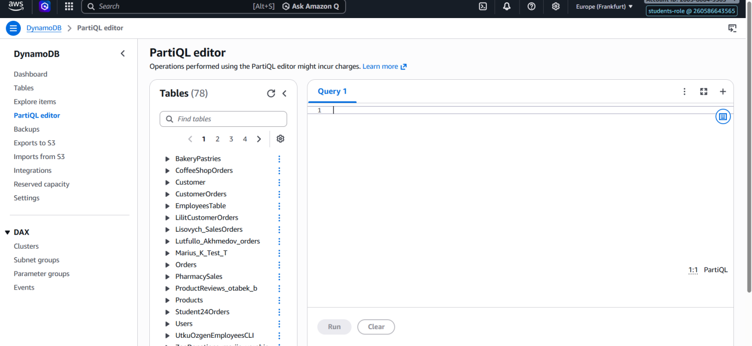
The PartiQL editor, connected with my normal console session (students-role).

Creating the table and loading items
I created the table through the console (same permission reason as above), with an on-demand capacity mode, which is the console equivalent of PAY_PER_REQUEST billing:
Table name | mariam-avaliani-order-events
Partition key | customer_id (String)
Sort key | order_id (String)
Capacity mode | On-demand (PAY_PER_REQUEST)
Then, in the PartiQL editor, I inserted 12 order items across 4 different customers (3 orders each), one INSERT statement at a time (the PartiQL editor only accepts one statement per run):
INSERT INTO "mariam-avaliani-order-events" VALUE {'customer_id': 'CUST-001',
'order_id': 'ORD-1001', 'order_date': '2026-01-05', 'amount': 45.99, 'status': 'DELIVERED'};

-- ... and 11 more items, across CUST-001, CUST-002, CUST-003, CUST-004
This is functionally the same job as batch-write-item — loading several items into the table in one go — just run through PartiQL one statement at a time instead of one JSON batch call. A scan straight after confirms all 12 items are there:
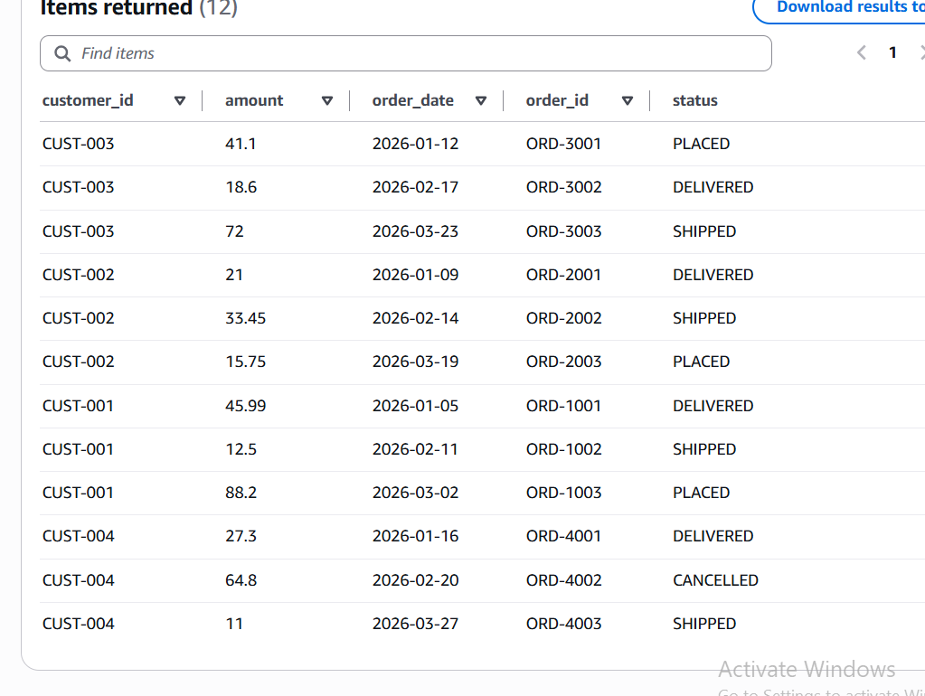
SELECT * FROM "mariam-avaliani-order-events" — 12 items returned, across 4 customers.

Reading the data back
Get a single item by its exact key (partition key + sort key) — the PartiQL equivalent of get-item:
SELECT * FROM "mariam-avaliani-order-events" WHERE customer_id = 'CUST-001' AND order_id = 'ORD-1001';
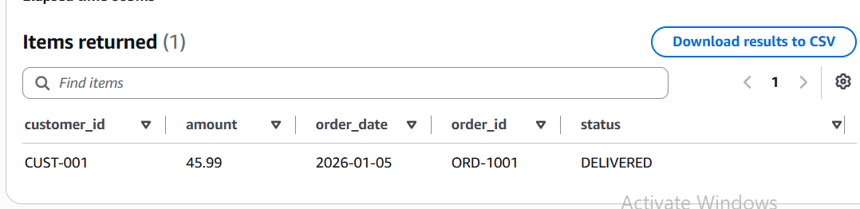
1 item returned — exactly the row I asked for.
Query using only the partition key — all orders for one customer, the most common access pattern this table was designed for:
SELECT * FROM "mariam-avaliani-order-events" WHERE customer_id = 'CUST-002';
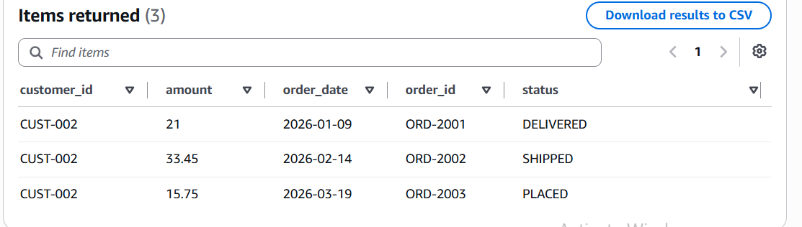
3 items returned — every order that belongs to CUST-002.
Query using the partition key plus a sort-key range (BETWEEN):
SELECT * FROM "mariam-avaliani-order-events" WHERE customer_id = 'CUST-001' AND order_id BETWEEN 'ORD-1001' AND 'ORD-1002';
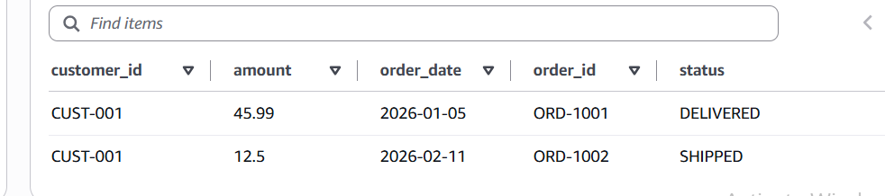
2 items returned — only the orders inside that ID range.
A scan with a filter on a non-key attribute (this reads every item and then filters, so it is only fine on a small table like this one):
SELECT * FROM "mariam-avaliani-order-events" WHERE status = 'DELIVERED';
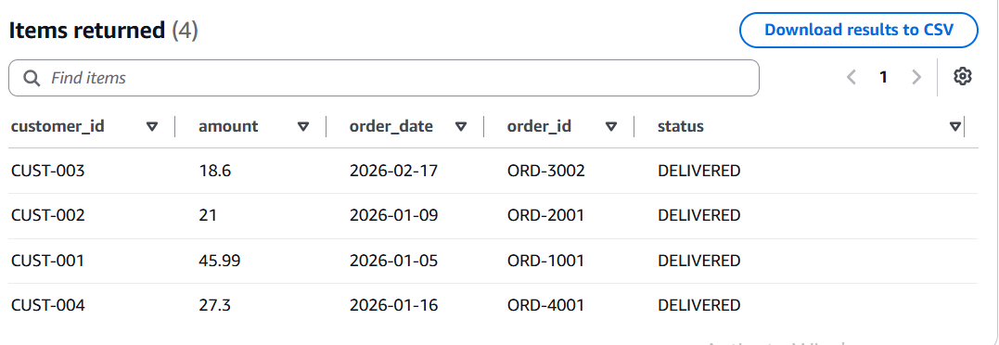
4 items returned — every order with status DELIVERED, from different customers.

Deleting items
Finally, I deleted two items, one at a time, the PartiQL equivalent of delete-item:
DELETE FROM "mariam-avaliani-order-events" WHERE customer_id = 'CUST-004' AND order_id = 'ORD-4002';
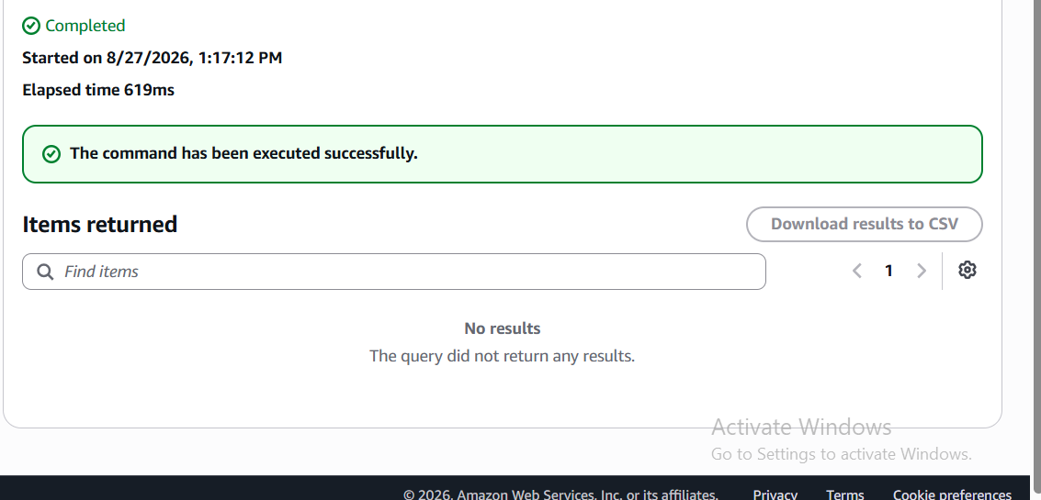
First delete — command executed successfully (619 ms).
DELETE FROM "mariam-avaliani-order-events" WHERE customer_id = 'CUST-002' AND order_id = 'ORD-2003';
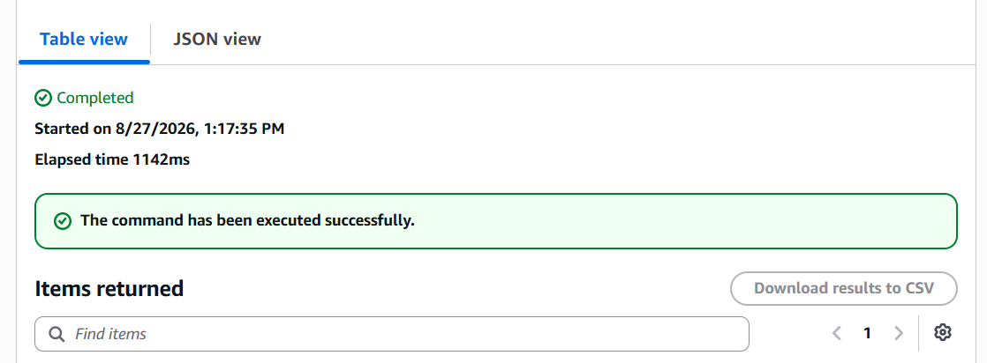
Second delete — command executed successfully (1142 ms). PartiQL DELETE does not return the deleted row, so the items list stays empty.
A last scan confirms exactly 10 items remain (12 loaded, minus the 2 deleted):
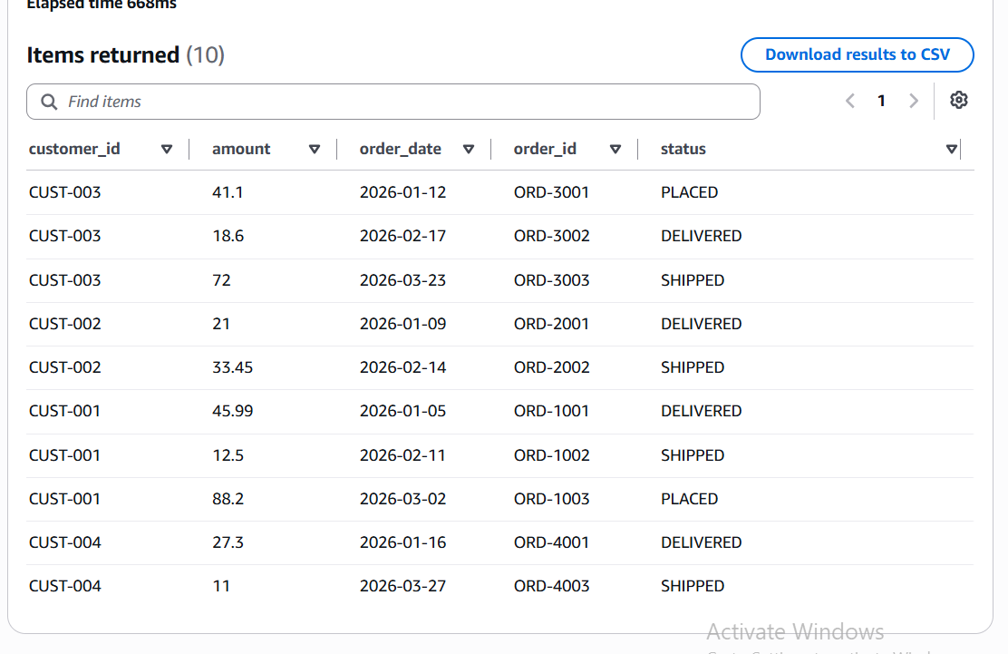
Final scan — 10 items left, matching 12 loaded minus 2 deleted.

Conclusion
I finished all three parts of Task 4. Task 1 taught me the most about real AWS RDS behaviour that is different from a normal local MySQL server — the missing SUPER privileges for the admin user, and how confusing the resulting error message can be. Task 2 taught me the difference between a publicly accessible database and a private one, and I did not just repeat the standard explanation — I checked it myself with nslookup and got a real, different IP address for each database, which proved the difference. Task 3 showed me a real limitation in my training account's permissions, and instead of stopping there, I found a working alternative (the PartiQL editor) that let me still complete every operation the task asked for.
- Task 1 initial script also submitted to Mentors as a separate .sql file.
- The DynamoDB CLI permission issue (section 3.2) will be raised with my mentor separately.

