Task 11 — Screenshots
All screenshots below are from my own machine, running the code in the delivery folder against my local PostgreSQL database.

Task 1 — fixture_task.py
pytest fixture_task.py -v -s (3 passed)
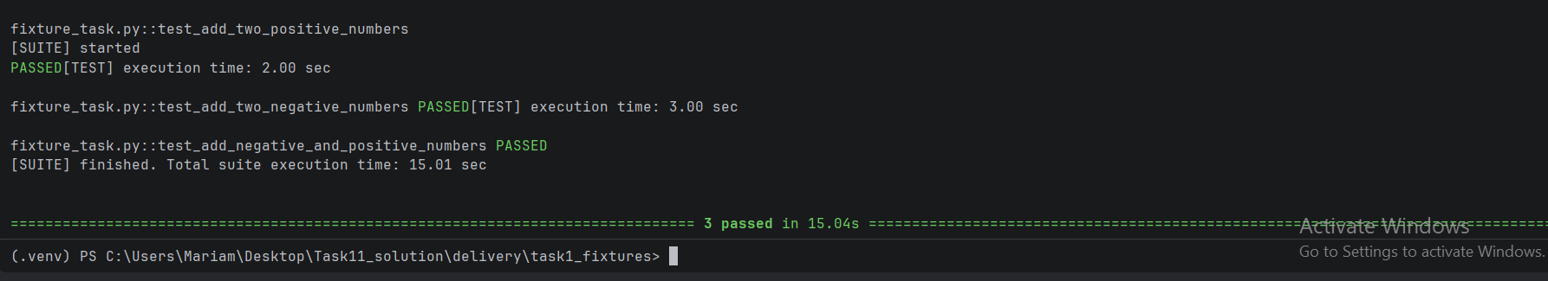

Task 2 — parametrize_task.py
pytest -m smoke -v → 3 passed, 1 deselected
pytest -m critical -v → 1 passed, 3 deselected
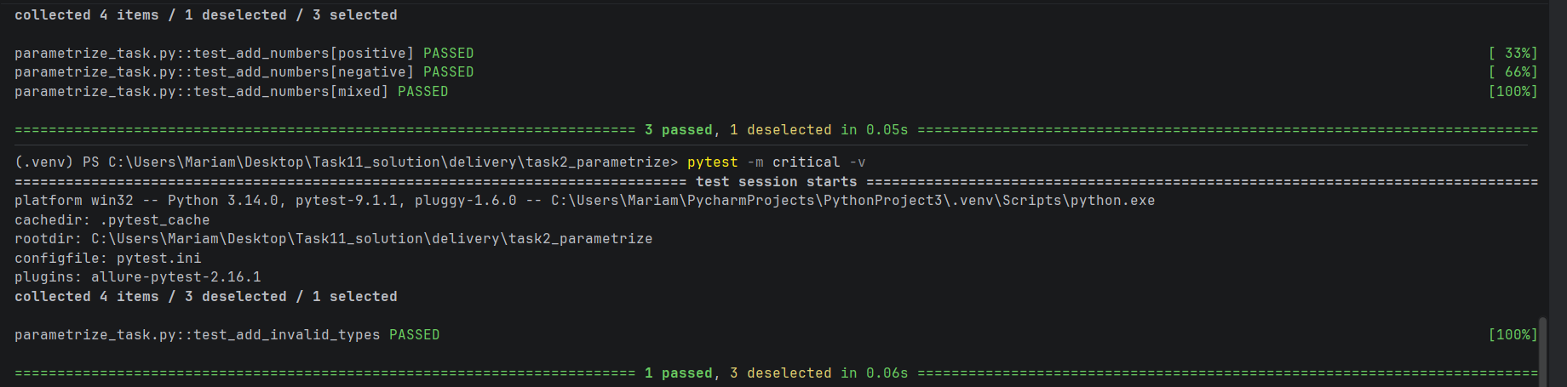
pytest -v (whole suite) → 4 passed
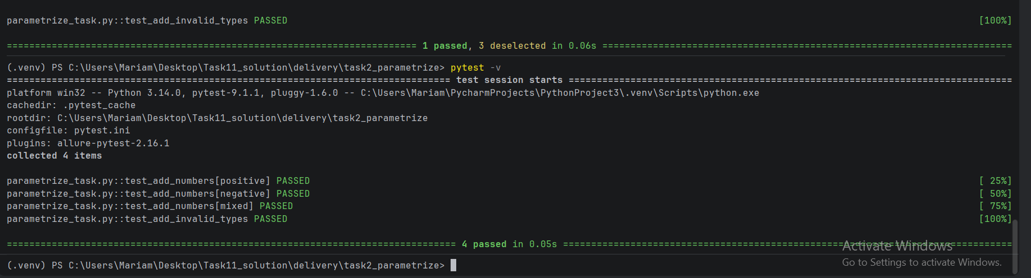

Task 3 — DB framework (Allure reports)
Smoke run — 3 test cases, 100% passed
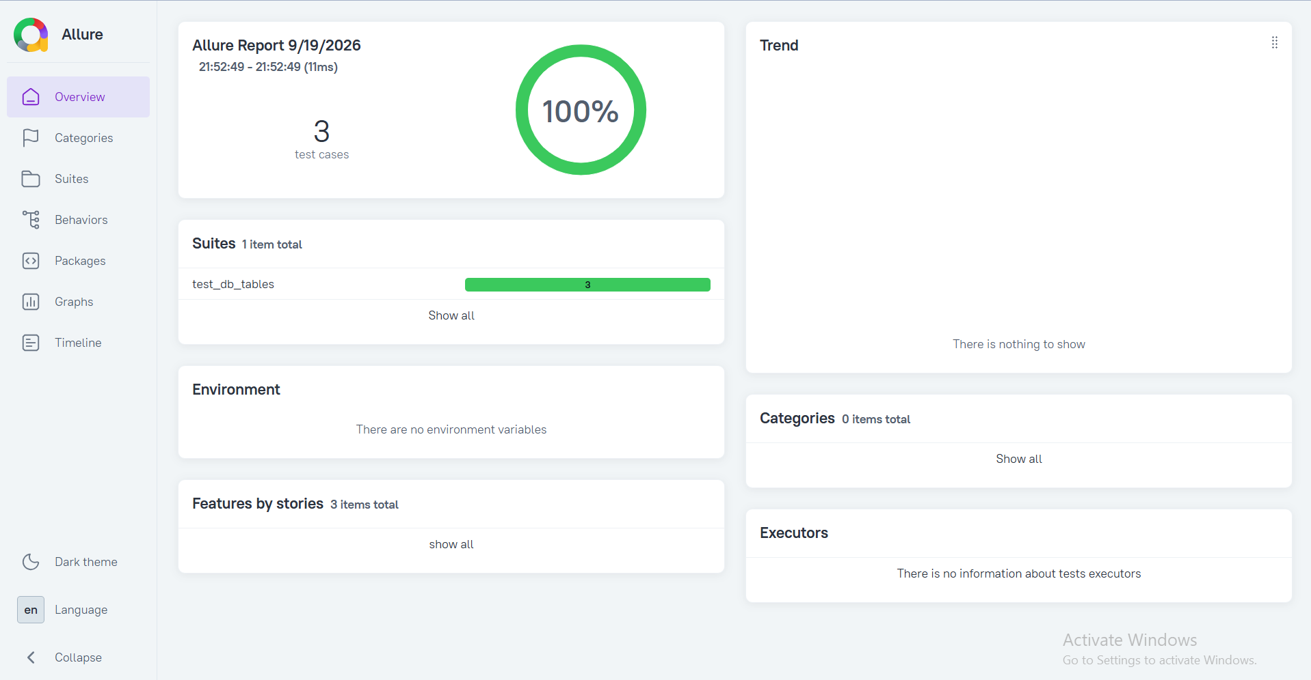
Critical run — 3 test cases, 100% passed
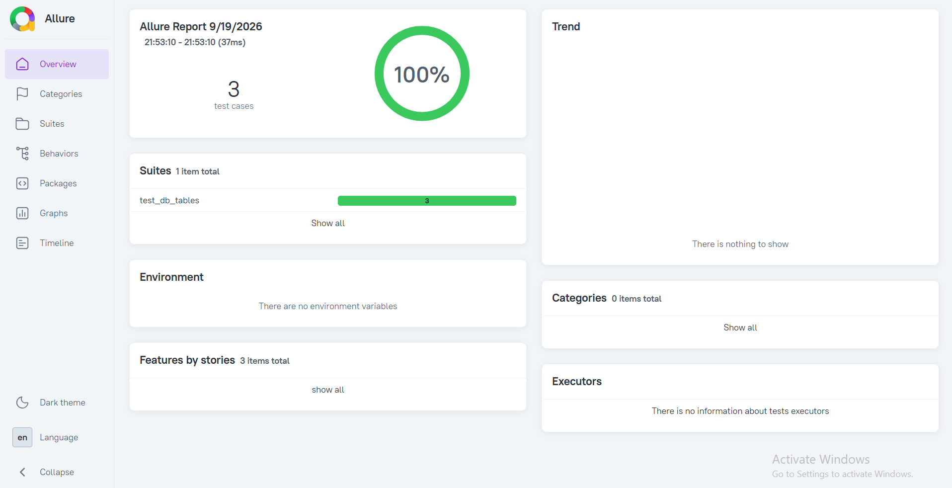
Whole suite run — 6 test cases, 100% passed
