AWS Cloud for Data Engineering
Task 1 – IAM and S3

Prepared by: Mariam Avaliani
Date: 24–25 August 2026
AWS Account: 260586643565 Region: eu-central-1 (Frankfurt)

Introduction
In this task, I connected to the AWS training account and worked with S3, AWS Glue and Amazon Athena. Before I started any work in the console or the CLI, I connected to the EPAM VPN and used the EU gateway (vpn-eu.epam.com), because this is required for the task and for the eu-central-1 (Frankfurt) region.
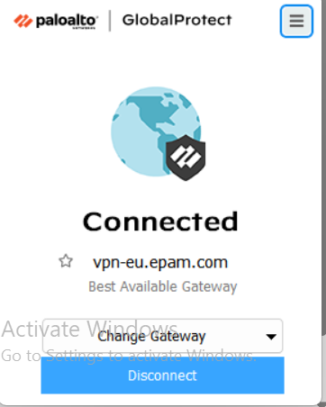
Screenshot 1. GlobalProtect, connected to vpn-eu.epam.com.

1. Connecting to the AWS account
First, I logged in to the AWS Console with the SSO link from the Auto EPM-CSUP Notification email and chose the User role. Then, in the top right corner, I clicked Switch role and switched to students-role for account 260586643565, because this role has the permissions I need for the task.
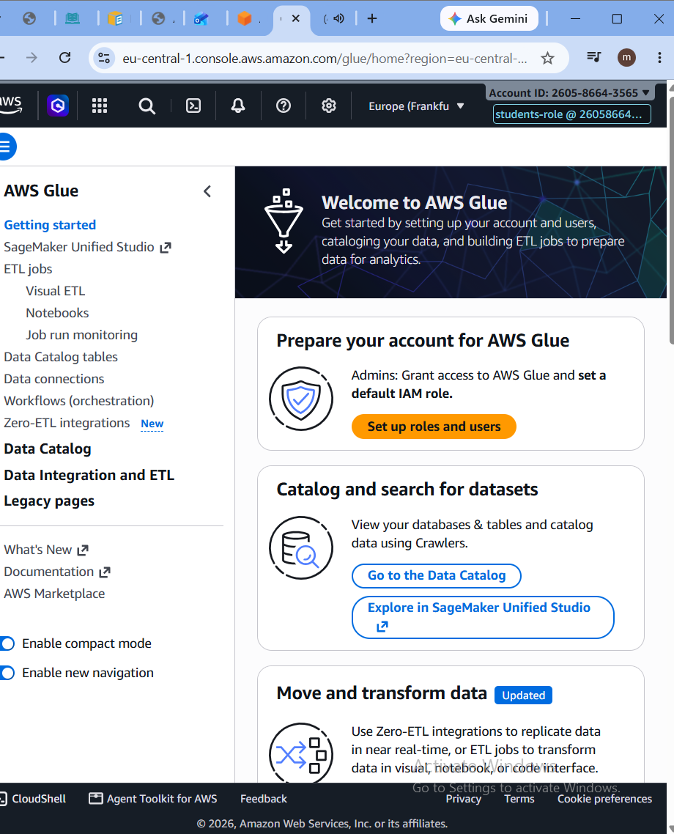
Screenshot 2. AWS Console header, showing the students-role for account 260586643565 and the Europe (Frankfurt) region.
Next, I installed AWS CLI version 2 on my computer and checked the version:
PS> aws --version
aws-cli/2.36.29 Python/3.14.6 Windows/11 script-exe/AMD64
After that, I configured an SSO profile with the aws configure sso command. I used the SSO start URL https://epam.awsapps.com/start#, the region us-east-1 for SSO, and eu-central-1 as the CLI region. I called this profile user-role-260586643565. I checked that it works:
PS> aws sts get-caller-identity --profile user-role-260586643565
{
"UserId": "AROATZLBMUBWYHKOMEQXJ:mariami_avaliani@epam.com",
"Account": "260586643565",
"Arn": "arn:aws:sts::260586643565:assumed-role/AWSReservedSSO_User_1bd09a39fab144fa/mariami_avaliani@epam.com"
}
Then I added a second profile in the AWS config file, called students-role. This profile uses the first profile to assume the students-role IAM role:
[profile user-role-260586643565]
sso_session = user-role
sso_account_id = 260586643565
sso_role_name = User
region = eu-central-1

[sso-session user-role]
sso_start_url = https://epam.awsapps.com/start#
sso_region = us-east-1
sso_registration_scopes = sso:account:access

[profile students-role]
role_arn = arn:aws:iam::260586643565:role/students-role
source_profile = user-role-260586643565
region = eu-central-1
I checked that this profile works too:
PS> aws sts get-caller-identity --profile students-role
{
"UserId": "AROATZLBMUBW65XATEWMA:botocore-session-1787591810",
"Account": "260586643565",
"Arn": "arn:aws:sts::260586643565:assumed-role/students-role/botocore-session-1787591810"
}

2. Creating an S3 bucket
I created my own S3 bucket with a name that shows who the owner is: mariam-avaliani-de-training-260586643565. I also added the tag owner=student, as required for every resource in this task:
PS> aws s3 mb s3://mariam-avaliani-de-training-260586643565 --region eu-central-1 --profile students-role
make_bucket: mariam-avaliani-de-training-260586643565

PS> aws s3api put-bucket-tagging --bucket mariam-avaliani-de-training-260586643565 --tagging "TagSet=[{Key=owner,Value=student}]" --profile students-role

PS> aws s3api get-bucket-tagging --bucket mariam-avaliani-de-training-260586643565 --profile students-role
{
"TagSet": [ { "Key": "owner", "Value": "student" } ]
}

3. Uploading the data to S3
The data for this task comes from my PostgreSQL database called dwh_project, in the bl_dm schema. This schema has 7 tables: dim_customers_scd, dim_dates, dim_deliveries, dim_payments, dim_products, dim_stores and fct_transactions_dd.
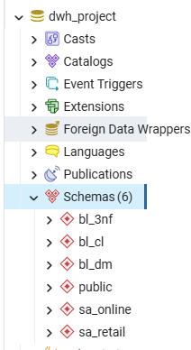
Screenshot 3. pgAdmin, showing the dwh_project database and the bl_dm schema.
I exported every table to a CSV file with pgAdmin. The fct_transactions_dd table is partitioned, so I could not export it in the normal way. Instead, I used a psql command with a SELECT statement to export it. After that, I uploaded all 7 CSV files to S3, using the folder structure <bucket>/dwh_project/bl_dm/<table_name>/:
foreach ($t in $tables) {
aws s3 cp "$localFolder\$t.csv" "s3://$bucket/dwh_project/bl_dm/$t/$t.csv" --profile students-role
}

upload: dim_customers_scd.csv -> .../dwh_project/bl_dm/dim_customers_scd/dim_customers_scd.csv
upload: dim_dates.csv -> .../dwh_project/bl_dm/dim_dates/dim_dates.csv
upload: dim_deliveries.csv -> .../dwh_project/bl_dm/dim_deliveries/dim_deliveries.csv
upload: dim_payments.csv -> .../dwh_project/bl_dm/dim_payments/dim_payments.csv
upload: dim_products.csv -> .../dwh_project/bl_dm/dim_products/dim_products.csv
upload: dim_stores.csv -> .../dwh_project/bl_dm/dim_stores/dim_stores.csv
upload: fct_transactions_dd.csv -> .../dwh_project/bl_dm/fct_transactions_dd/fct_transactions_dd.csv

4. Glue Crawler and Data Catalog
To register my tables in the AWS Glue Data Catalog, I created a crawler called mariam-avaliani-bl-dm-crawler. The data source is my S3 folder, and I used the dilab-glue-role IAM role, which is already set up in this training account. For the crawler output, I created a new database called dwh_project_bl_dm_db. I used underscores in the name instead of dashes, because this works better with Athena.
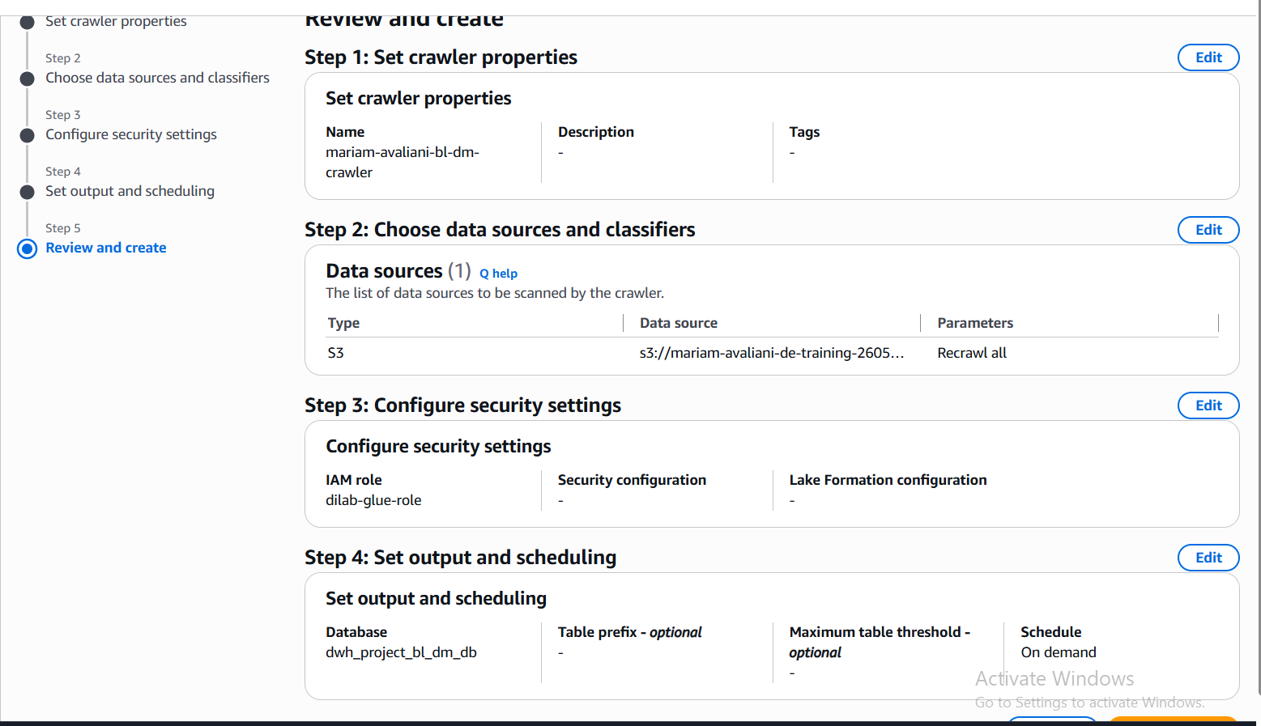
Screenshot 4. Crawler settings before creation: data source, IAM role, target database and schedule.
I ran the crawler, and it finished successfully. It created 7 tables, one for each table in the bl_dm schema:
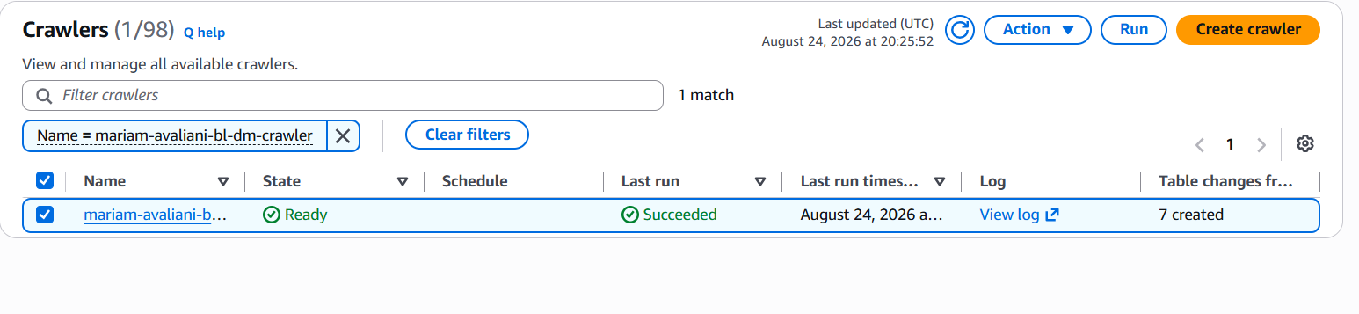
Screenshot 5. The crawler run result: Succeeded, 7 tables created.
I checked the Data Catalog, and all 7 tables are there, with the correct CSV format:
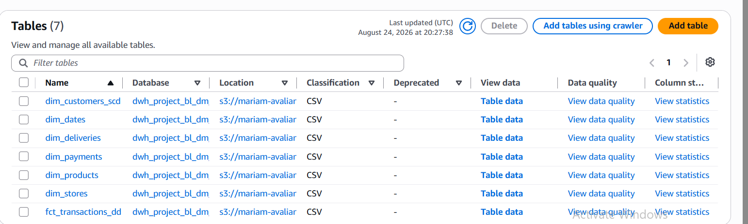
Screenshot 6. All 7 tables in the dwh_project_bl_dm_db database.

5. Querying the data with Athena
Finally, I used Amazon Athena to run a query on one of the tables. I ran this query on dim_customers_scd:
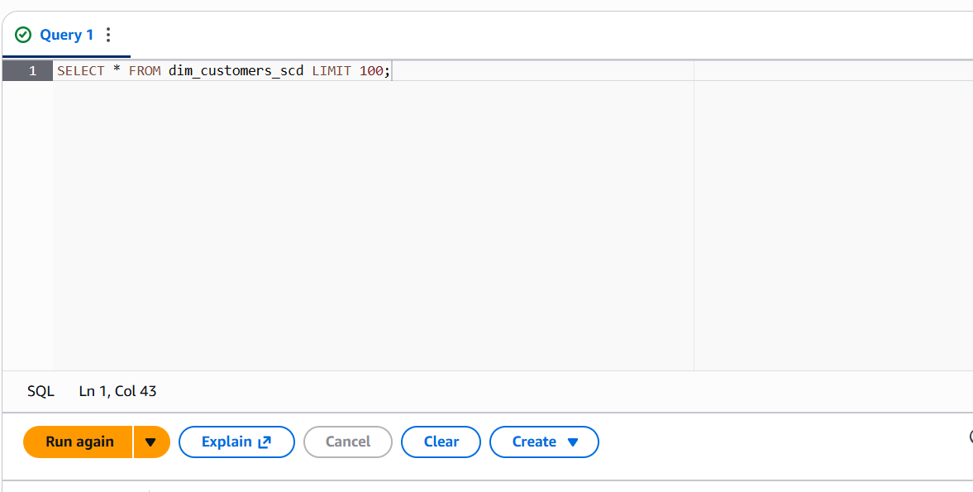
Screenshot 7. The Athena query: SELECT * FROM dim_customers_scd LIMIT 100;
The query returned 100 rows, as I expected:
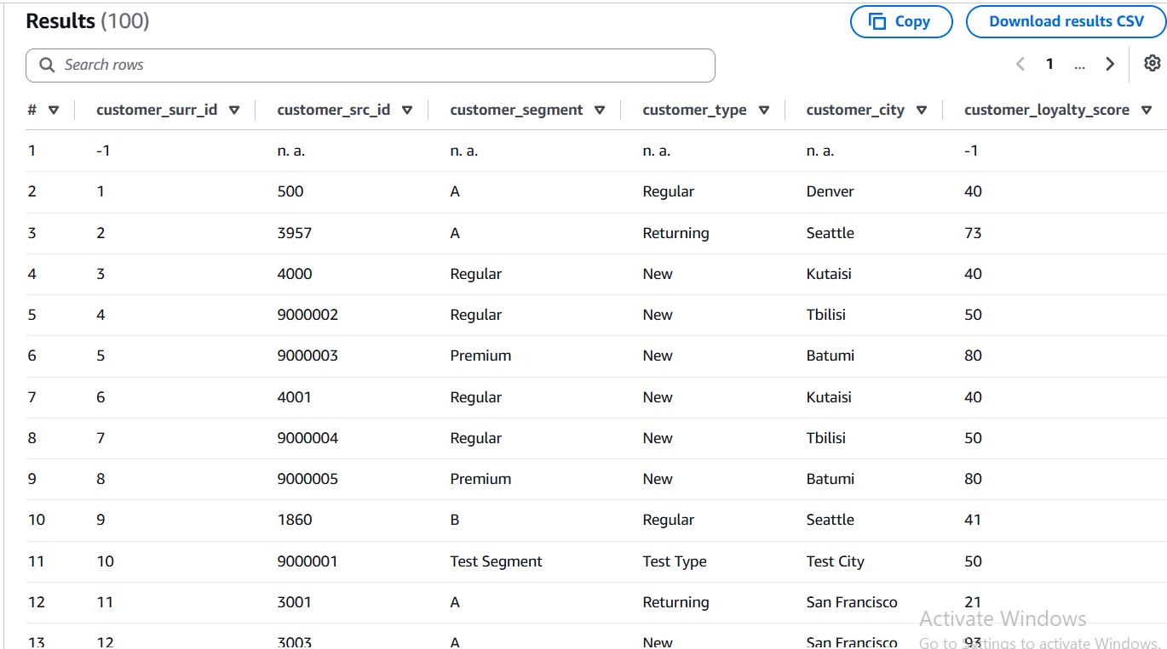
Screenshot 8. The query result, with 100 rows.
I also checked the table properties, to see the location and the format of the table:
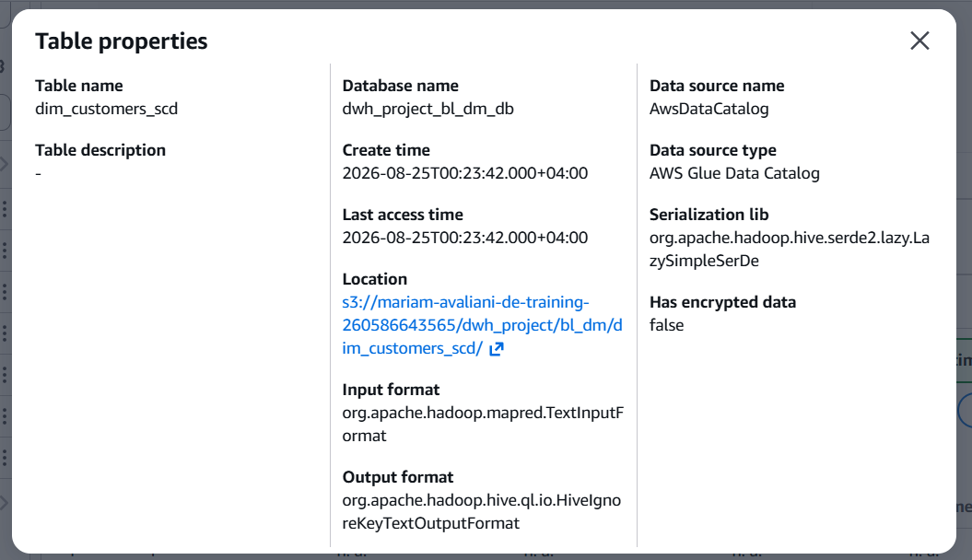
Screenshot 9. Table properties for dim_customers_scd.

Conclusion
In this task, I connected to the AWS account with SSO and the students-role, created and tagged an S3 bucket, uploaded my bl_dm tables from PostgreSQL, used a Glue Crawler to add them to the Data Catalog, and queried the data with Athena. All the steps above are completed, and the results are shown in the screenshots and command outputs in this report.

References
- AWS Identity and Access Management – user guide
- Amazon Simple Storage Service – user guide
- AWS Glue
- Glue Crawler and Athena best practices
- Use an IAM role in the AWS CLI
- aws configure sso

