PostgreSQL DB for DWH and ETL building
PL/pgSQL. Loading DM dimensions — Task 8 answer
This task was about writing the logic that loads the dimensions of my BL_DM (star schema) from BL_3NF, adding logging for it, and testing that it actually works and can run again safely. Below I explain what I built and show real output from running it on my local PostgreSQL, plus the SCD2 test that the task specifically asks for.

1. Create LOGIC to load dimensions from BL_3NF to BL_DM (star layer)

1.1 What I built
My BL_DM layer has 5 dimensions that get their data from BL_3NF: DIM_PRODUCTS, DIM_STORES, DIM_PAYMENTS, DIM_DELIVERIES and DIM_CUSTOMERS_SCD (this last one is SCD Type 2, the others are Type 0/1). DIM_DATES is not part of this task because it does not come from BL_3NF at all — I built and populated it on its own back in Task 4.
I created a new schema, BL_CL, for everything ETL-related, the way Knowledge_Base.docx describes it. Inside BL_CL I have:
• one role (BL_CL_ROLE) with the grants it actually needs, and nothing more
• two composite types, used in two different procedures for two different reasons
• a logging table plus one procedure that is the only thing allowed to write to it
• 5 loading procedures, one per dimension, per the task requirement "one procedure = one dimension"
• one small wrapper procedure that just calls all 5, so I don't run them one by one every time
Every procedure follows the same basic idea: read from BL_3NF, check if that row already exists on BL_DM, and only insert or update it if something actually changed. That is what makes them repeatable — running a procedure twice on the same source data does nothing the second time, and I show this in section 3.

1.2 BL_CL schema, role and grants
Before writing any procedure I set up who is allowed to touch what. BL_CL_ROLE represents the Cleansing Layer at runtime: it only gets SELECT on BL_3NF (the ETL layer should never write back into the 3NF layer), and SELECT / INSERT / UPDATE on BL_DM and on BL_CL's own tables, plus EXECUTE on the procedures themselves.
CREATE SCHEMA IF NOT EXISTS bl_cl;

DO $$
BEGIN
IF NOT EXISTS (SELECT 1 FROM pg_roles WHERE rolname = 'bl_cl_role') THEN
CREATE ROLE bl_cl_role NOLOGIN;
END IF;
END $$;

GRANT USAGE ON SCHEMA bl_3nf TO bl_cl_role;
GRANT SELECT ON ALL TABLES IN SCHEMA bl_3nf TO bl_cl_role;

GRANT USAGE ON SCHEMA bl_dm TO bl_cl_role;
GRANT SELECT, INSERT, UPDATE ON ALL TABLES IN SCHEMA bl_dm TO bl_cl_role;
GRANT USAGE ON ALL SEQUENCES IN SCHEMA bl_dm TO bl_cl_role;

GRANT USAGE ON SCHEMA bl_cl TO bl_cl_role;
GRANT SELECT, INSERT, UPDATE ON ALL TABLES IN SCHEMA bl_cl TO bl_cl_role;
GRANT USAGE ON ALL SEQUENCES IN SCHEMA bl_cl TO bl_cl_role;

-- (repeated again lower down, after MTA_ETL_LOG actually exists)
GRANT SELECT, INSERT, UPDATE ON ALL TABLES IN SCHEMA bl_cl TO bl_cl_role;
GRANT EXECUTE ON ALL PROCEDURES IN SCHEMA bl_cl TO bl_cl_role;
ALTER DEFAULT PRIVILEGES IN SCHEMA bl_cl GRANT EXECUTE ON ROUTINES TO bl_cl_role;
ALTER DEFAULT PRIVILEGES IN SCHEMA bl_cl GRANT SELECT, INSERT, UPDATE ON TABLES TO bl_cl_role;
Role and grants for the Cleansing Layer. The GRANT on BL_CL's own tables is repeated further down the script, after MTA_ETL_LOG actually exists — the first GRANT ... ALL TABLES runs before that table is created, so it would silently grant on nothing.

1.3 Composite types
The task asks to use composite types in one or more procedures. I ended up using two, for two different reasons.
T_DIM_PRODUCT_ROW just holds one row of the already-joined product data (source id, name, category, subcategory, brand, price, source system/entity) while I loop through the cursor in PRC_LOAD_DIM_PRODUCTS. It's mostly there to keep the loop variable readable.
T_CUSTOMER_ATTRS is more useful. It groups the 5 attributes I track for SCD2 (segment, type, city, loyalty score, age group) into a single value, so instead of writing 5 separate IS DISTINCT FROM checks to see if a customer changed, I compare the whole composite once. It's used in PRC_LOAD_DIM_CUSTOMERS_SCD, in section 1.4.5 below.
CREATE TYPE bl_cl.t_dim_product_row AS (
product_src_id VARCHAR(50),
product_name VARCHAR(255),
product_category VARCHAR(100),
product_subcategory VARCHAR(100),
product_brand VARCHAR(100),
product_price_amt DECIMAL(12,2),
source_system VARCHAR(30),
source_entity VARCHAR(50)
);

CREATE TYPE bl_cl.t_customer_attrs AS (
customer_segment VARCHAR(50),
customer_type VARCHAR(50),
customer_city VARCHAR(100),
customer_loyalty_score INTEGER,
customer_age_group VARCHAR(30)
);

1.4 The five loading procedures

1.4.1 PRC_LOAD_DIM_PRODUCTS
Loads DIM_PRODUCTS from CE_PRODUCT joined with CE_SUBCATEGORY and CE_CATEGORY — the product hierarchy gets flattened here, on the way into the DM layer, exactly the way Naming_Conventions.docx describes it for the "Hierarchy on DM Layer" case.
I used a cursor FOR loop directly over the join query (an unbound cursor — I never declare it separately, PL/pgSQL opens and closes it for me), and I hold each row in the T_DIM_PRODUCT_ROW composite variable. Instead of writing the INSERT statement directly, I build it as text with format() and run it with EXECUTE ... USING — this is the dynamic SQL part. I used $1, $2 ... placeholders with USING instead of putting the values straight into the string, because that is safer against SQL injection and it's the same pattern shown in the Advanced PL/pgSQL material (section 3.1, Executing Dynamic Commands).
The upsert is the ON CONFLICT (product_src_id) DO UPDATE part. I added a WHERE clause on that update so it only really updates a row when something changed. If nothing changed, PostgreSQL just skips that row on conflict, ROW_COUNT stays 0 for it, and my running total v_rows only grows when something real happened — that's what makes the repeatability test in section 3 work.
CREATE OR REPLACE PROCEDURE bl_cl.prc_load_dim_products()
LANGUAGE plpgsql
AS $$
DECLARE
v_start_ts TIMESTAMP := clock_timestamp();
v_row bl_cl.t_dim_product_row;
v_sql TEXT;
v_this INTEGER;
v_rows INTEGER := 0;
BEGIN
FOR v_row IN
SELECT
p.product_id::VARCHAR(50) AS product_src_id,
p.product_name,
c.category_name AS product_category,
s.subcategory_name AS product_subcategory,
p.product_brand,
p.product_price AS product_price_amt,
'BL_3NF'::VARCHAR(30) AS source_system,
'CE_PRODUCT'::VARCHAR(50) AS source_entity
FROM bl_3nf.ce_product p
JOIN bl_3nf.ce_subcategory s ON s.subcategory_sk = p.subcategory_sk
JOIN bl_3nf.ce_category c ON c.category_sk = s.category_sk
WHERE p.product_sk <> -1
LOOP
v_sql := format(
'INSERT INTO bl_dm.dim_products
(product_surr_id, product_src_id, product_name, product_category, product_subcategory,
product_brand, product_price_amt, insert_dt, update_dt, source_system, source_entity)
VALUES (nextval(%L), $1, $2, $3, $4, $5, $6, CURRENT_DATE, CURRENT_DATE, $7, $8)
ON CONFLICT (product_src_id) DO UPDATE SET
product_name = EXCLUDED.product_name,
product_category = EXCLUDED.product_category,
product_subcategory = EXCLUDED.product_subcategory,
product_brand = EXCLUDED.product_brand,
product_price_amt = EXCLUDED.product_price_amt,
update_dt = CURRENT_DATE,
source_system = EXCLUDED.source_system,
source_entity = EXCLUDED.source_entity
WHERE dim_products.product_name IS DISTINCT FROM EXCLUDED.product_name
OR dim_products.product_category IS DISTINCT FROM EXCLUDED.product_category
OR dim_products.product_subcategory IS DISTINCT FROM EXCLUDED.product_subcategory
OR dim_products.product_brand IS DISTINCT FROM EXCLUDED.product_brand
OR dim_products.product_price_amt IS DISTINCT FROM EXCLUDED.product_price_amt',
'bl_dm.seq_dim_products'
);

EXECUTE v_sql USING v_row.product_src_id, v_row.product_name, v_row.product_category,
v_row.product_subcategory, v_row.product_brand, v_row.product_price_amt,
v_row.source_system, v_row.source_entity;

GET DIAGNOSTICS v_this = ROW_COUNT;
v_rows := v_rows + v_this;
END LOOP;

CALL bl_cl.prc_log_etl_event('PRC_LOAD_DIM_PRODUCTS', v_start_ts, v_rows, 'SUCCESS', NULL);
EXCEPTION
WHEN OTHERS THEN
CALL bl_cl.prc_log_etl_event('PRC_LOAD_DIM_PRODUCTS', v_start_ts, v_rows, 'FAILED', SQLERRM);
RAISE;
END;
$$;

1.4.2 PRC_LOAD_DIM_STORES
This one is simpler on purpose. Same cursor FOR loop idea, joining CE_STORE with CE_REGION and CE_COUNTRY to flatten the location hierarchy, but this time I write the INSERT ... ON CONFLICT directly, no EXECUTE — just to show dynamic SQL is not needed everywhere, only where it actually helps (like when the query text itself has to change, as in 1.4.4).
CREATE OR REPLACE PROCEDURE bl_cl.prc_load_dim_stores()
LANGUAGE plpgsql
AS $$
DECLARE
v_start_ts TIMESTAMP := clock_timestamp();
v_rec RECORD;
v_this INTEGER;
v_rows INTEGER := 0;
BEGIN
FOR v_rec IN
SELECT st.store_id, st.store_location, st.store_type, r.region_name, c.country_name
FROM bl_3nf.ce_store st
JOIN bl_3nf.ce_region r ON r.region_sk = st.region_sk
JOIN bl_3nf.ce_country c ON c.country_sk = r.country_sk
WHERE st.store_sk <> -1
LOOP
INSERT INTO bl_dm.dim_stores (
store_surr_id, store_src_id, store_location, store_type, store_region, store_country,
insert_dt, update_dt, source_system, source_entity
) VALUES (
nextval('bl_dm.seq_dim_stores'), v_rec.store_id::VARCHAR(50), v_rec.store_location, v_rec.store_type,
v_rec.region_name, v_rec.country_name, CURRENT_DATE, CURRENT_DATE, 'BL_3NF', 'CE_STORE'
)
ON CONFLICT (store_src_id) DO UPDATE SET
store_location = EXCLUDED.store_location,
store_type = EXCLUDED.store_type,
store_region = EXCLUDED.store_region,
store_country = EXCLUDED.store_country,
update_dt = CURRENT_DATE
WHERE dim_stores.store_location IS DISTINCT FROM EXCLUDED.store_location
OR dim_stores.store_type IS DISTINCT FROM EXCLUDED.store_type
OR dim_stores.store_region IS DISTINCT FROM EXCLUDED.store_region
OR dim_stores.store_country IS DISTINCT FROM EXCLUDED.store_country;

GET DIAGNOSTICS v_this = ROW_COUNT;
v_rows := v_rows + v_this;
END LOOP;

CALL bl_cl.prc_log_etl_event('PRC_LOAD_DIM_STORES', v_start_ts, v_rows, 'SUCCESS', NULL);
EXCEPTION
WHEN OTHERS THEN
CALL bl_cl.prc_log_etl_event('PRC_LOAD_DIM_STORES', v_start_ts, v_rows, 'FAILED', SQLERRM);
RAISE;
END;
$$;

1.4.3 PRC_LOAD_DIM_PAYMENTS
Here I used an actual cursor variable instead of a FOR loop, since the task asks for cursor variables specifically. I declare c_payments as refcursor, open it with OPEN ... FOR SELECT, then fetch rows one at a time inside a LOOP with FETCH ... INTO and EXIT WHEN NOT FOUND, and CLOSE it at the end. This is the manual, lower-level version of what a FOR loop does for me automatically.
CREATE OR REPLACE PROCEDURE bl_cl.prc_load_dim_payments()
LANGUAGE plpgsql
AS $$
DECLARE
v_start_ts TIMESTAMP := clock_timestamp();
c_payments refcursor;
v_rec RECORD;
v_this INTEGER;
v_rows INTEGER := 0;
BEGIN
OPEN c_payments FOR
SELECT payment_id, payment_method, payment_status, payment_risk_score
FROM bl_3nf.ce_payment
WHERE payment_sk <> -1;

LOOP
FETCH c_payments INTO v_rec;
EXIT WHEN NOT FOUND;

INSERT INTO bl_dm.dim_payments (
payment_surr_id, payment_src_id, payment_method, payment_status, payment_risk_score,
insert_dt, update_dt, source_system, source_entity
) VALUES (
nextval('bl_dm.seq_dim_payments'), v_rec.payment_id::VARCHAR(50), v_rec.payment_method,
v_rec.payment_status, v_rec.payment_risk_score, CURRENT_DATE, CURRENT_DATE, 'BL_3NF', 'CE_PAYMENT'
)
ON CONFLICT (payment_src_id) DO UPDATE SET
payment_method = EXCLUDED.payment_method,
payment_status = EXCLUDED.payment_status,
payment_risk_score = EXCLUDED.payment_risk_score,
update_dt = CURRENT_DATE
WHERE dim_payments.payment_method IS DISTINCT FROM EXCLUDED.payment_method
OR dim_payments.payment_status IS DISTINCT FROM EXCLUDED.payment_status
OR dim_payments.payment_risk_score IS DISTINCT FROM EXCLUDED.payment_risk_score;

GET DIAGNOSTICS v_this = ROW_COUNT;
v_rows := v_rows + v_this;
END LOOP;

CLOSE c_payments;

CALL bl_cl.prc_log_etl_event('PRC_LOAD_DIM_PAYMENTS', v_start_ts, v_rows, 'SUCCESS', NULL);
EXCEPTION
WHEN OTHERS THEN
CALL bl_cl.prc_log_etl_event('PRC_LOAD_DIM_PAYMENTS', v_start_ts, v_rows, 'FAILED', SQLERRM);
RAISE;
END;
$$;

1.4.4 PRC_LOAD_DIM_DELIVERIES
This one also uses a cursor variable, but I open it with OPEN ... FOR EXECUTE, and the query text is built with format() from a variable holding the source table name. So this single statement covers both the cursor variable requirement and dynamic SQL again, just in a different combination than PRC_LOAD_DIM_PRODUCTS.
CREATE OR REPLACE PROCEDURE bl_cl.prc_load_dim_deliveries()
LANGUAGE plpgsql
AS $$
DECLARE
v_start_ts TIMESTAMP := clock_timestamp();
c_deliveries refcursor;
v_rec RECORD;
v_this INTEGER;
v_rows INTEGER := 0;
v_src_table TEXT := 'bl_3nf.ce_delivery';
BEGIN
OPEN c_deliveries FOR EXECUTE
format('SELECT delivery_id, delivery_type, delivery_status, fulfillment_time FROM %s WHERE delivery_sk <> -1',
v_src_table);

LOOP
FETCH c_deliveries INTO v_rec;
EXIT WHEN NOT FOUND;

INSERT INTO bl_dm.dim_deliveries (
delivery_surr_id, delivery_src_id, delivery_type, delivery_status,
delivery_fulfillment_time_num, insert_dt, update_dt, source_system, source_entity
) VALUES (
nextval('bl_dm.seq_dim_deliveries'), v_rec.delivery_id, v_rec.delivery_type, v_rec.delivery_status,
v_rec.fulfillment_time, CURRENT_DATE, CURRENT_DATE, 'BL_3NF', 'CE_DELIVERY'
)
ON CONFLICT (delivery_src_id) DO UPDATE SET
delivery_type = EXCLUDED.delivery_type,
delivery_status = EXCLUDED.delivery_status,
delivery_fulfillment_time_num = EXCLUDED.delivery_fulfillment_time_num,
update_dt = CURRENT_DATE
WHERE dim_deliveries.delivery_type IS DISTINCT FROM EXCLUDED.delivery_type
OR dim_deliveries.delivery_status IS DISTINCT FROM EXCLUDED.delivery_status
OR dim_deliveries.delivery_fulfillment_time_num IS DISTINCT FROM EXCLUDED.delivery_fulfillment_time_num;

GET DIAGNOSTICS v_this = ROW_COUNT;
v_rows := v_rows + v_this;
END LOOP;

CLOSE c_deliveries;

CALL bl_cl.prc_log_etl_event('PRC_LOAD_DIM_DELIVERIES', v_start_ts, v_rows, 'SUCCESS', NULL);
EXCEPTION
WHEN OTHERS THEN
CALL bl_cl.prc_log_etl_event('PRC_LOAD_DIM_DELIVERIES', v_start_ts, v_rows, 'FAILED', SQLERRM);
RAISE;
END;
$$;

1.4.5 PRC_LOAD_DIM_CUSTOMERS_SCD
This is the SCD2 procedure and it works differently from the other four on purpose. I did not use ON CONFLICT here, because an SCD2 table is not supposed to overwrite old rows — it has to keep every version. Naming_Conventions.docx also says an SCD2 dimension should not get its FK enforced by the fact table, which matches how DIM_CUSTOMERS_SCD was defined back in Task 7. So instead of an upsert I do it by hand:
1. loop through every currently active customer in CE_CUSTOMER on BL_3NF (cursor FOR loop)
2. build the current attribute values into the T_CUSTOMER_ATTRS composite
3. look up that customer's currently active row on DIM_CUSTOMERS_SCD, if any
4. if there isn't one yet, it's a brand-new customer — insert the first version
5. if there is one, compare old vs new with IS DISTINCT FROM on the whole composite; if they differ, close the old row (END_DT = yesterday, IS_ACTIVE = 'N') and insert a new active row with a new surrogate key
6. if nothing changed, do nothing — this is what keeps it repeatable
CREATE OR REPLACE PROCEDURE bl_cl.prc_load_dim_customers_scd()
LANGUAGE plpgsql
AS $$
DECLARE
v_start_ts TIMESTAMP := clock_timestamp();
v_cur RECORD;
v_new_attrs bl_cl.t_customer_attrs;
v_old_attrs bl_cl.t_customer_attrs;
v_dm_active_id BIGINT;
v_rows INTEGER := 0;
BEGIN
FOR v_cur IN
SELECT customer_id, customer_segment, customer_type, customer_city, loyalty_score, age_group,
source_system, source_entity
FROM bl_3nf.ce_customer
WHERE is_active = 'Y' AND customer_sk <> -1
LOOP
v_new_attrs := ROW(v_cur.customer_segment, v_cur.customer_type, v_cur.customer_city,
v_cur.loyalty_score, v_cur.age_group)::bl_cl.t_customer_attrs;

v_dm_active_id := NULL;
SELECT customer_surr_id INTO v_dm_active_id
FROM bl_dm.dim_customers_scd
WHERE customer_src_id = v_cur.customer_id::VARCHAR(50) AND is_active = 'Y';

IF v_dm_active_id IS NULL THEN
-- brand-new customer on BL_DM: first version
INSERT INTO bl_dm.dim_customers_scd (
customer_surr_id, customer_src_id, customer_segment, customer_type, customer_city,
customer_loyalty_score, customer_age_group, start_dt, end_dt, is_active,
insert_dt, update_dt, source_system, source_entity
) VALUES (
nextval('bl_dm.seq_dim_customers'), v_cur.customer_id::VARCHAR(50),
(v_new_attrs).customer_segment, (v_new_attrs).customer_type, (v_new_attrs).customer_city,
(v_new_attrs).customer_loyalty_score, (v_new_attrs).customer_age_group,
CURRENT_DATE, DATE '9999-12-31', 'Y',
CURRENT_DATE, CURRENT_DATE, v_cur.source_system, v_cur.source_entity
);
v_rows := v_rows + 1;
ELSE
v_old_attrs := (
SELECT ROW(customer_segment, customer_type, customer_city,
customer_loyalty_score, customer_age_group)::bl_cl.t_customer_attrs
FROM bl_dm.dim_customers_scd
WHERE customer_surr_id = v_dm_active_id
);

IF v_old_attrs IS DISTINCT FROM v_new_attrs THEN
UPDATE bl_dm.dim_customers_scd
SET end_dt = (CURRENT_DATE - INTERVAL '1 day')::DATE,
is_active = 'N',
update_dt = CURRENT_DATE
WHERE customer_surr_id = v_dm_active_id;

INSERT INTO bl_dm.dim_customers_scd (
customer_surr_id, customer_src_id, customer_segment, customer_type, customer_city,
customer_loyalty_score, customer_age_group, start_dt, end_dt, is_active,
insert_dt, update_dt, source_system, source_entity
) VALUES (
nextval('bl_dm.seq_dim_customers'), v_cur.customer_id::VARCHAR(50),
(v_new_attrs).customer_segment, (v_new_attrs).customer_type, (v_new_attrs).customer_city,
(v_new_attrs).customer_loyalty_score, (v_new_attrs).customer_age_group,
CURRENT_DATE, DATE '9999-12-31', 'Y',
CURRENT_DATE, CURRENT_DATE, v_cur.source_system, v_cur.source_entity
);
v_rows := v_rows + 2; -- 1 row closed + 1 row opened
END IF;
-- ELSE: nothing changed, do nothing -- this is what keeps the
-- procedure repeatable on unchanged data.
END IF;
END LOOP;

CALL bl_cl.prc_log_etl_event('PRC_LOAD_DIM_CUSTOMERS_SCD', v_start_ts, v_rows, 'SUCCESS', NULL);
EXCEPTION
WHEN OTHERS THEN
CALL bl_cl.prc_log_etl_event('PRC_LOAD_DIM_CUSTOMERS_SCD', v_start_ts, v_rows, 'FAILED', SQLERRM);
RAISE;
END;
$$;

1.4.6 Wrapper procedure
Just so I don't have to CALL all 5 procedures by hand every time, I added one small wrapper. The order doesn't actually matter here, because BL_DM dimensions are all flattened and don't reference each other.
CREATE OR REPLACE PROCEDURE bl_cl.prc_run_all_dim_loads()
LANGUAGE plpgsql
AS $$
BEGIN
CALL bl_cl.prc_load_dim_products();
CALL bl_cl.prc_load_dim_stores();
CALL bl_cl.prc_load_dim_payments();
CALL bl_cl.prc_load_dim_deliveries();
CALL bl_cl.prc_load_dim_customers_scd();
END;
$$;

2. Add Logging functionality
For logging I made one table, BL_CL.MTA_ETL_LOG (MTA_ prefix because Naming_Conventions.docx calls this kind of table a metadata table), and one procedure, PRC_LOG_ETL_EVENT, which is the only thing that is allowed to write into it. Every load procedure calls it once at the end with a SUCCESS status, and I also added an EXCEPTION WHEN OTHERS block to every procedure so that if something breaks halfway through, it still logs a FAILED row with the real error text (SQLERRM) before re-raising the error — so I always know what happened, not just that something happened.
CREATE SEQUENCE IF NOT EXISTS bl_cl.seq_mta_etl_log;

CREATE TABLE IF NOT EXISTS bl_cl.mta_etl_log (
log_id BIGINT NOT NULL,
procedure_name VARCHAR(100) NOT NULL,
start_ts TIMESTAMP NOT NULL,
end_ts TIMESTAMP NOT NULL,
rows_affected INTEGER NOT NULL,
status VARCHAR(20) NOT NULL,
message VARCHAR(1000),
CONSTRAINT pk_mta_etl_log PRIMARY KEY (log_id),
CONSTRAINT ck_mta_etl_log_status CHECK (status IN ('SUCCESS', 'FAILED'))
);

CREATE OR REPLACE PROCEDURE bl_cl.prc_log_etl_event(
p_procedure_name VARCHAR,
p_start_ts TIMESTAMP,
p_rows_affected INTEGER,
p_status VARCHAR,
p_message VARCHAR DEFAULT NULL
)
LANGUAGE plpgsql
AS $$
BEGIN
INSERT INTO bl_cl.mta_etl_log (log_id, procedure_name, start_ts, end_ts, rows_affected, status, message)
VALUES (nextval('bl_cl.seq_mta_etl_log'), p_procedure_name, p_start_ts, clock_timestamp(),
p_rows_affected, p_status, p_message);
END;
$$;

3. Test Your Data

3.1 What I tested this on
Everything in this section ran against my real database — the one I built in Task 5 (staging load from retail_500k.csv / online_500k.csv), Task 6 (BL_3NF) and Task 7 (BL_DM). So the row counts and results below are the real ones from my own project data, not a made-up sample.
For the SCD2 test in section 3.4 I needed one customer I could safely insert and change without touching any real row, so I used customer_id = 500 — an id that does not exist anywhere in my real source data. I inserted it into staging myself, the same way a brand-new customer would show up in a new CSV extract, then changed it a second time to actually trigger the SCD2 close-old / open-new behaviour.

3.2 First run — loading every dimension
I called the wrapper procedure and then checked the log:
CALL bl_cl.prc_run_all_dim_loads();
SELECT log_id, procedure_name, rows_affected, status
FROM bl_cl.mta_etl_log
ORDER BY log_id;

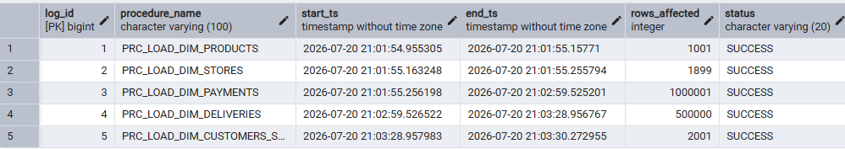

3.3 Second run — checking the procedures are repeatable
The task requires that a procedure produces the same result when it's run again on the same source data. So right after the first run, with nothing changed in BL_3NF, I called the wrapper a second time and checked the log again.
CALL bl_cl.prc_run_all_dim_loads();
SELECT log_id, procedure_name, rows_affected, status
FROM bl_cl.mta_etl_log
ORDER BY log_id DESC
LIMIT 5;

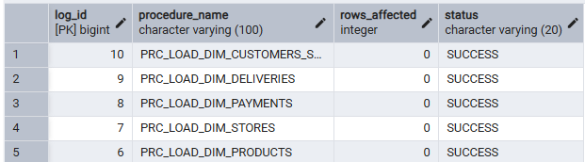
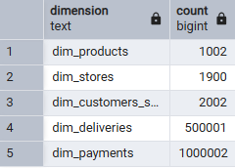
This is not a full reload — nothing gets deleted and re-inserted every time. Each procedure checks first whether the row is already there and whether its values are the same, and only touches it if something is actually different (the WHERE clause on the ON CONFLICT for the first 4 procedures, and the composite IS DISTINCT FROM check for the SCD2 procedure). So a second run with unchanged data correctly finds nothing new to load.

3.4 SCD2 test — customer_id 500
For DIM_CUSTOMERS_SCD I had to prove that changing a customer's attributes gets picked up correctly on both BL_3NF and BL_DM, without losing the old version. I used customer_id = 500 for this, specifically because it does not exist anywhere in my real data — I could insert and change it freely with no risk of touching a real customer.

Step 1— insert customer 500 as a brand-new row in staging
I inserted one row into SA_RETAIL.SRC_RETAIL_SALES for customer_id 500 — this plays the role of a brand-new customer showing up in a new CSV extract. I reused a real store I already had (store_id 100) and product data from customer 1001's own real purchase history, and gave the row a new, unique transaction_id so it doesn't collide with anything.
INSERT INTO sa_retail.src_retail_sales (
customer_id, customer_segment, customer_type, customer_city, loyalty_score, age_group,
product_id, product_name, product_category, product_subcategory, product_brand, product_price,
transaction_id, transaction_date, quantity, unit_price, sales_value, discount, cost_price,
total_cost, profit, payment_method, payment_type, payment_status, currency,
transaction_channel, payment_risk_score, store_id, store_location, store_type,
region, store_size, country
) VALUES (
500, 'A', '<TYPE>', 'Denver', 40, '18-25',
<PRODUCT_ID>, '<PRODUCT_NAME>', '<CATEGORY>', '<SUBCATEGORY>', '<BRAND>', <PRICE>,
<NEW_UNIQUE_TRANSACTION_ID>, '2025-06-01', <QTY>, <UNIT_PRICE>, <SALES_VALUE>, <DISCOUNT>, <COST_PRICE>,
<TOTAL_COST>, <PROFIT>, '<PAYMENT_METHOD>', '<PAYMENT_TYPE>', '<PAYMENT_STATUS>', 'USD',
'Retail', <RISK_SCORE>, 100, 'Atlanta', 'Physical',
'Central', 'Large', 'USA'
);
After re-running my Task 6 load for BL_3NF, this staging row was picked up as a brand-new customer — one row, is_active = Y. This is the "new customer" case, not a change yet:
SELECT * FROM bl_3nf.ce_customer WHERE customer_id = 500;

Then I ran the DM load for customers:
CALL bl_cl.prc_load_dim_customers_scd();
The log showed rows_affected = 1 — a brand-new customer, so exactly one row is inserted, nothing closed:

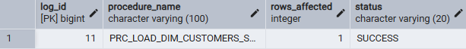

Step 2 — change customer 500 (the actual SCD2 case)
To trigger the real SCD2 behaviour I inserted a second staging row for the same customer_id 500, with a changed segment (B instead of A) and a changed city (Chicago instead of Denver), and a later transaction_date than the first row — this plays the role of an "additional CSV file with some changes":
INSERT INTO sa_retail.src_retail_sales (
customer_id, customer_segment, customer_type, customer_city, loyalty_score, age_group,
product_id, product_name, product_category, product_subcategory, product_brand, product_price,
transaction_id, transaction_date, quantity, unit_price, sales_value, discount, cost_price,
total_cost, profit, payment_method, payment_type, payment_status, currency,
transaction_channel, payment_risk_score, store_id, store_location, store_type,
region, store_size, country
) VALUES (
500, 'B', '<TYPE>', 'Chicago', <NEW_LOYALTY_SCORE>, '<NEW_AGE_GROUP>',
<PRODUCT_ID>, '<PRODUCT_NAME>', '<CATEGORY>', '<SUBCATEGORY>', '<BRAND>', <PRICE>,
<NEW_UNIQUE_TRANSACTION_ID>, '2025-09-15', <QTY>, <UNIT_PRICE>, <SALES_VALUE>, <DISCOUNT>, <COST_PRICE>,
<TOTAL_COST>, <PROFIT>, '<PAYMENT_METHOD>', '<PAYMENT_TYPE>', '<PAYMENT_STATUS>', 'USD',
'Retail', <RISK_SCORE>, 100, 'Atlanta', 'Physical',
'Central', 'Large', 'USA'
);
After re-running the BL_3NF load again, customer 500 now has two versions on BL_3NF — the first one closed (is_active = N, end_dt set to the day before), the new one active:
SELECT * FROM bl_3nf.ce_customer WHERE customer_id = 500 ORDER BY customer_sk;
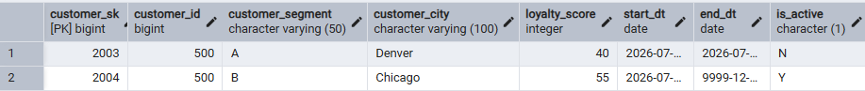
Then I ran the DM load again:
CALL bl_cl.prc_load_dim_customers_scd();
This time the log showed rows_affected = 2 — one row closed, one row opened, exactly the SCD2 behaviour the task asks for:
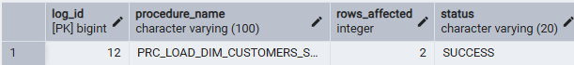
And DIM_CUSTOMERS_SCD now has both versions too, matching BL_3NF:
SELECT customer_surr_id, customer_src_id, customer_segment, customer_type, customer_city,
customer_loyalty_score, customer_age_group, start_dt, end_dt, is_active
FROM bl_dm.dim_customers_scd
WHERE customer_src_id = '500'
ORDER BY customer_surr_id;

Step 3 — repeatability check on the SCD2 procedure
Same idea as section 3.3: I ran it once more with nothing new for this customer, and it correctly logged 0 rows affected.
CALL bl_cl.prc_load_dim_customers_scd();



4. Task Results

4.1 Objects created in BL_CL
Object | Type | Purpose
bl_cl.t_dim_product_row | composite type | one product row, used inside PRC_LOAD_DIM_PRODUCTS
bl_cl.t_customer_attrs | composite type | the 5 SCD2-tracked customer attributes, compared as one value
bl_cl.mta_etl_log | table | one row per procedure run: name, start/end time, rows affected, status
bl_cl.prc_log_etl_event | procedure | the only way to write into mta_etl_log
bl_cl.prc_load_dim_products | procedure | loads DIM_PRODUCTS
bl_cl.prc_load_dim_stores | procedure | loads DIM_STORES
bl_cl.prc_load_dim_payments | procedure | loads DIM_PAYMENTS
bl_cl.prc_load_dim_deliveries | procedure | loads DIM_DELIVERIES
bl_cl.prc_load_dim_customers_scd | procedure | loads DIM_CUSTOMERS_SCD (SCD Type 2)
bl_cl.prc_run_all_dim_loads | procedure | wrapper, calls the 5 procedures above
(BL_CL already had a few objects in it from my earlier tasks before I started this one — LOAD_BL_3NF_ALL and the per-entity LOAD_CE_* procedures from Task 6, plus SP_WRITE_LOG and a couple of lookup tables. Those are not listed here since they are not part of Task 8, only the objects I built for this task are.)
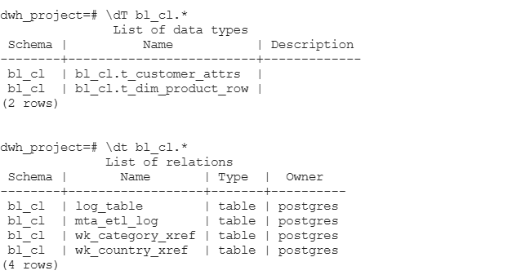
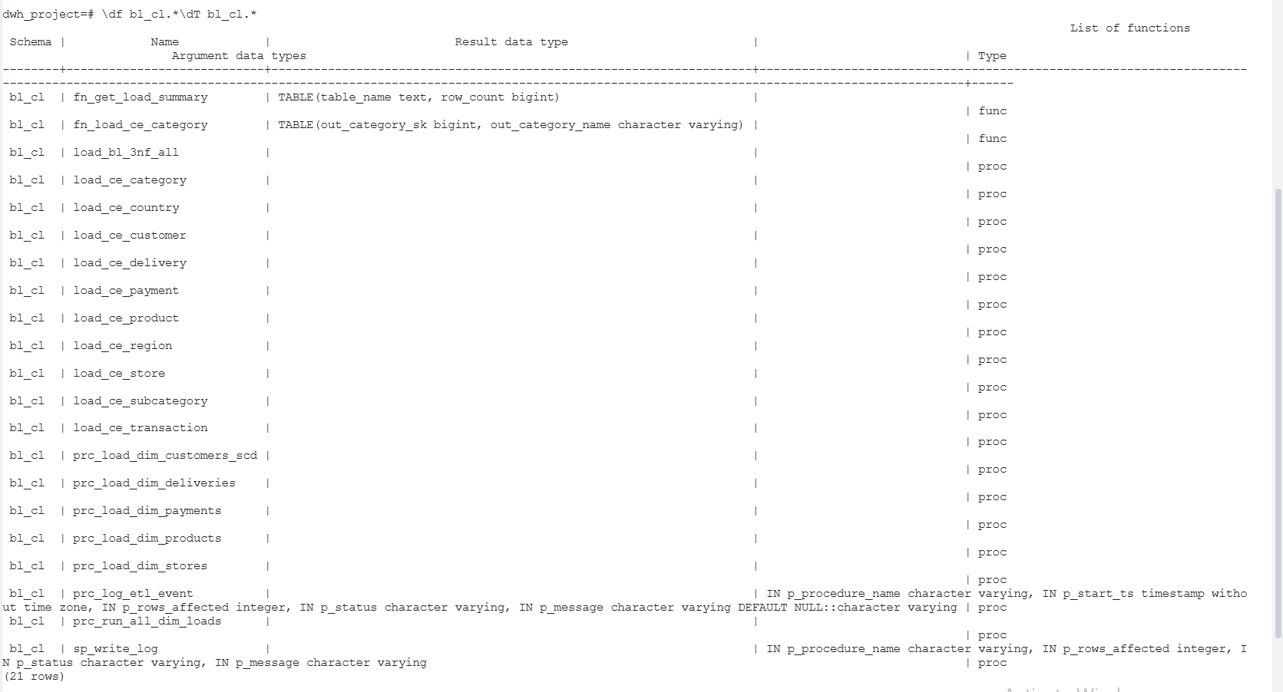
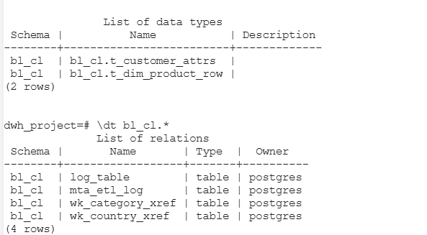

4.2 Grants — confirmed after running everything
Schema | Privileges granted to bl_cl_role
bl_3nf | SELECT (read-only, ETL layer must not write back into 3NF)
bl_dm | INSERT, SELECT, UPDATE
bl_cl | INSERT, SELECT, UPDATE on tables, EXECUTE on procedures
SELECT table_schema, string_agg(DISTINCT privilege_type, ', ' ORDER BY privilege_type) AS privileges
FROM information_schema.role_table_grants
WHERE grantee = 'bl_cl_role' AND table_schema IN ('bl_3nf', 'bl_dm', 'bl_cl')
GROUP BY table_schema
ORDER BY table_schema;

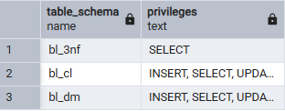

4.3 Final row counts on BL_DM
Dimension | Rows (incl. the -1 default row)
dim_products | 1,002
dim_stores | 1,900
dim_payments | 1,000,002
dim_deliveries | 500,001
dim_customers_scd | 2,004 (includes the 2 versions from the customer 500 SCD2 test in section 3.4)
SELECT 'dim_products' AS dimension, COUNT(*) FROM bl_dm.dim_products
UNION ALL SELECT 'dim_stores', COUNT(*) FROM bl_dm.dim_stores
UNION ALL SELECT 'dim_payments', COUNT(*) FROM bl_dm.dim_payments
UNION ALL SELECT 'dim_deliveries', COUNT(*) FROM bl_dm.dim_deliveries
UNION ALL SELECT 'dim_customers_scd', COUNT(*) FROM bl_dm.dim_customers_scd;
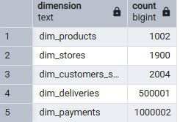

4.4 Sample of the data actually loaded
dim_customers_scd — real customers loaded from BL_3NF, alongside my test customer 500 from section 3.4. For example, customer 1001 loaded as segment A, Premium, Boston, loyalty score 17, age group 26-35:
SELECT customer_surr_id, customer_src_id, customer_segment, customer_type, customer_city,
customer_loyalty_score, customer_age_group, start_dt, end_dt, is_active
FROM bl_dm.dim_customers_scd
ORDER BY customer_surr_id
LIMIT 10;
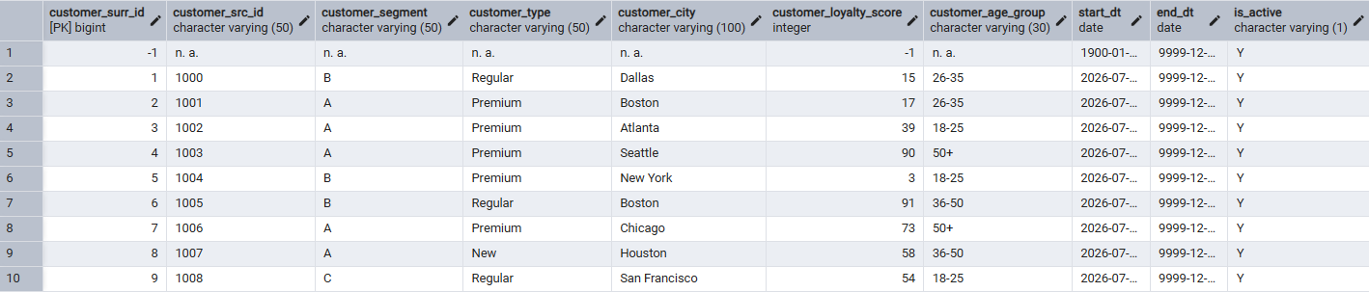
dim_products — category and subcategory are already flattened here, no more joins needed to read them:
SELECT product_surr_id, product_src_id, product_name, product_category, product_subcategory,
product_brand, product_price_amt
FROM bl_dm.dim_products
ORDER BY product_surr_id
LIMIT 6;

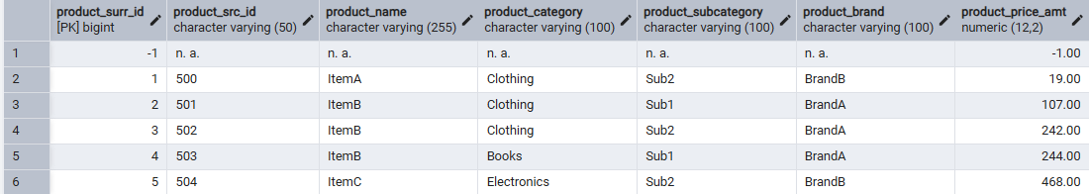
dim_stores — region and country flattened the same way:
SELECT store_surr_id, store_src_id, store_location, store_type, store_region, store_country
FROM bl_dm.dim_stores
ORDER BY store_surr_id
LIMIT 6;

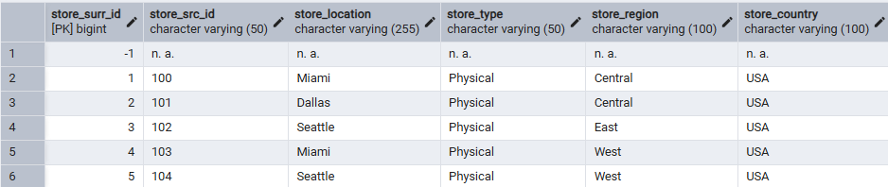
dim_payments and dim_deliveries:
SELECT payment_surr_id, payment_src_id, payment_method, payment_status, payment_risk_score
FROM bl_dm.dim_payments
ORDER BY payment_surr_id
LIMIT 5;

SELECT delivery_surr_id, delivery_src_id, delivery_type, delivery_status, delivery_fulfillment_time_num
FROM bl_dm.dim_deliveries
ORDER BY delivery_surr_id
LIMIT 5;

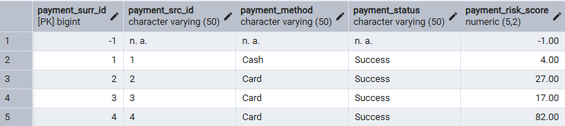

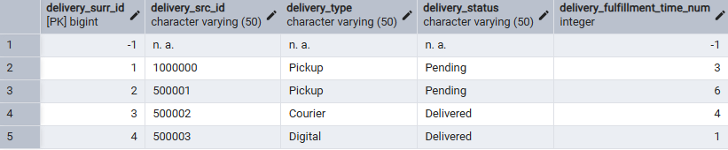
Everything above was run against my own PostgreSQL database, on top of the real BL_3NF and BL_DM schemas I built in Task 6 and Task 7, loaded from my real retail_500k.csv and online_500k.csv files. The only data I added myself for this task was customer_id 500, used purely to demonstrate the SCD2 behaviour in section 3.4.

