PostgreSQL DB for DWH and ETL Building
PostgreSQL Data Access and Query Optimizer — Task 4: Answer
Author: Mariam Avaliani
This document covers Task 4 of the module (Reading the Plan, Adding Data with INSERT and COPY, UPSERT), completed against my own local PostgreSQL instance (Windows) using pgAdmin, in the same test_db / labs schema used in the previous modules. Each step below lists the exact SQL to run and what the resulting screenshot should show — the orange dashed boxes mark exactly where to paste each pgAdmin screenshot before submitting.

1. Theory recap

1.1 The path of a query
A query passes through four stages before a result comes back:
- Parser — checks the SQL string's syntax and semantics, produces a query tree.
- Rewriter — applies stored rules to the query tree; most importantly, a query against a VIEW is rewritten to hit the view's underlying base tables instead.
- Planner/Optimizer — the cost-based heart of the process: for each table involved, it generates every feasible access path (sequential scan is always one option; index scans are added if a usable index exists), estimates the cost of each, and picks the cheapest. For multi-table queries, it also searches over possible join orders and join algorithms (nested loop, merge join, hash join), again picking the cheapest combination.
- Executor — walks the finished plan tree bottom-up and actually retrieves/combines the rows.

1.2 Statistics
The planner's cost estimates depend on statistics: the total row count and page count per table/index (kept in pg_class.reltuples / relpages), plus per-column statistics (most common values, histograms, null fraction) gathered by ANALYZE and exposed through the pg_stats view. autovacuum normally keeps these fresh automatically; after a bulk load or major change to a table's contents, running ANALYZE manually (cheap — it's a read-only sample, not a full table scan) ensures the very next query plan is based on accurate numbers rather than stale ones. A key concept here is selectivity — the fraction of a table's rows a WHERE condition is expected to match; the more selective a filter, the more attractive an index scan becomes relative to a sequential scan.

1.3 Caching
PostgreSQL caches table/index data (via shared_buffers, plus whatever the OS itself caches), and query plans (for prepared statements). Running the same query twice, with no changes to the underlying data, is expected to be noticeably faster the second time purely from “hot cache” effects — the needed pages are already in memory instead of requiring a disk read. This means a single EXPLAIN ANALYZE run right after a cold start can be misleading; running it (at least) twice and comparing is the only way to separate a genuinely better plan from simple cache warm-up, which is exactly what Task 1/2 below ask for.

1.4 EXPLAIN, EXPLAIN ANALYZE, EXPLAIN (ANALYZE, BUFFERS)
- EXPLAIN alone only plans the statement — it shows the planner's chosen plan and its cost estimates, without running anything, so it's always safe to use even for INSERT/UPDATE/DELETE.
- EXPLAIN ANALYZE actually executes the statement, then adds real numbers next to the estimates: actual time and actual rows returned per plan node — this is what reveals whether the planner's estimates were close to reality. Because it really executes the query, wrapping a write statement in BEGIN; EXPLAIN ANALYZE ...; ROLLBACK; is the safe way to profile it without changing data.
- EXPLAIN (ANALYZE, BUFFERS) additionally reports buffer usage per node — shared hit (found already in cache) vs. shared read (had to be pulled from disk/OS cache) — which is the most direct way to see the hot-vs-cold-cache effect described above.

1.5 Access paths
- Sequential Scan (Seq Scan) — reads the entire table as stored on disk, page by page. Chosen when there's no useful index, when a large fraction of the table will be returned anyway (so index overhead isn't worth it), or when the table is small enough that the overhead of using an index exceeds the cost of just reading it. Must still read through dead (vacuumable) rows even though they're not returned.
- Index Scan — looks up matching entries in the index structure to get each row's TID (its physical location), then visits the heap page for each TID to fetch the actual row and check MVCC visibility. That heap visit is required both because the index usually doesn't store every needed column and because indexes don't track row visibility themselves.
- Index Only Scan — skips the heap visit entirely, answering the query from the index alone. Requires two things: the query only needs columns that are actually part of the index, and the relevant heap pages are marked all-visible in the Visibility Map (so the planner can trust every row on that page is visible without checking). A table that was just bulk-loaded typically has its VM bits unset until VACUUM runs, which is why Index Only Scan often needs a VACUUM first to kick in.
- Bitmap Scan (Bitmap Index Scan + Bitmap Heap Scan) — a middle ground: first builds an in-memory bitmap of which heap pages contain matching rows (one Index Scan pass, no repeated back-and-forth to the heap per row), then does a single pass over just those heap pages. This avoids the random-I/O cost an Index Scan would pay when many scattered rows match, while still avoiding a full Seq Scan when only a modest fraction of the table matches.

1.6 INSERT vs. COPY, and UPSERT
Every INSERT statement pays fixed per-statement overhead — permission checks, lock acquisition, existence/type checks — on top of the actual write, so many small single-row INSERT statements are considerably slower in aggregate than one multi-row INSERT (a single VALUES list with many tuples) or an INSERT ... SELECT pulling rows from another table. COPY goes a step further: it loads data as a single transaction directly into the target table with minimal per-row overhead, making it the fastest bulk-loading method — at the cost of a strict input format where a single malformed line fails the whole COPY.
UPSERT is PostgreSQL's INSERT ... ON CONFLICT (...) DO UPDATE/DO NOTHING syntax: for each row proposed for insertion, if it violates a unique/primary-key constraint or unique index named as the conflict_target, the alternative action runs instead of raising an error — DO NOTHING silently skips the row, DO UPDATE lets the row be updated instead (commonly referencing the proposed values via the special EXCLUDED pseudo-table). This guarantees one atomic INSERT-or-UPDATE outcome even under concurrent access, without a separate SELECT-then-decide round trip from the application.

2. Task 1 — Table without Index
Created a fresh table for this module's plan-reading exercises and filled it with the same ~5 years / 10-second-interval synthetic data used in the previous module:
CREATE TABLE labs.test_index_plan (
num float NOT NULL,
load_date timestamptz NOT NULL
);
INSERT INTO labs.test_index_plan(num, load_date)
SELECT random(), x
FROM generate_series('2017-01-01 0:00'::timestamptz,
'2021-12-31 23:59:59'::timestamptz, '10 seconds'::interval) x;
Note: the task sheet's INSERT targets labs.test_index (the table name from the previous module's BRIN vs B-Tree exercise), not labs.test_index_plan (the table this task actually just created) — almost certainly another copy-paste carry-over in the task sheet. Targeted test_index_plan instead, as shown above, since that's the table every later step in this task (index creation, COPY export, etc.) actually references.
What to look for: ~15.8 million rows inserted, the same volume and timing ballpark as the equivalent load in the previous module's Task 3.
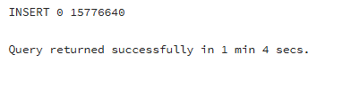
Checked the plan with plain EXPLAIN first (no execution, estimates only), disabling parallel workers so the plan is simpler to read and compare:
SET max_parallel_workers_per_gather = 0;
EXPLAIN
SELECT *
FROM labs.test_index_plan
WHERE load_date BETWEEN '2021-09-01 0:00' AND '2021-10-31 11:59:59'
ORDER BY 1;
What to look for: a Seq Scan node (no index exists yet) feeding a Sort node for the ORDER BY, each annotated only with estimated cost/rows/width — no actual time or actual rows, since plain EXPLAIN never executes anything.
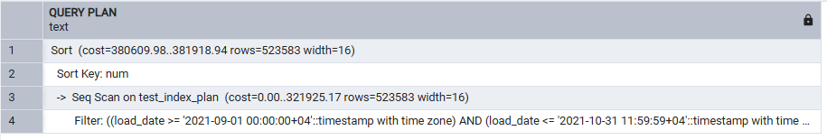
Then ran EXPLAIN ANALYZE twice in a row, to separate the true execution numbers from cache warm-up effects:
EXPLAIN ANALYZE
SELECT *
FROM labs.test_index_plan
WHERE load_date BETWEEN '2021-09-01 0:00' AND '2021-10-31 11:59:59'
ORDER BY 1;
-- run the exact same statement a second time
What to look for: both runs show the same Seq Scan + Sort shape as plain EXPLAIN, but now each node also reports actual time and actual rows; the total Execution Time on the second run should be noticeably lower than the first — that gap is the “cold cache” vs. “hot cache” effect from the theory recap, not a plan change (the plan itself is identical both times, since there's still no index to choose).
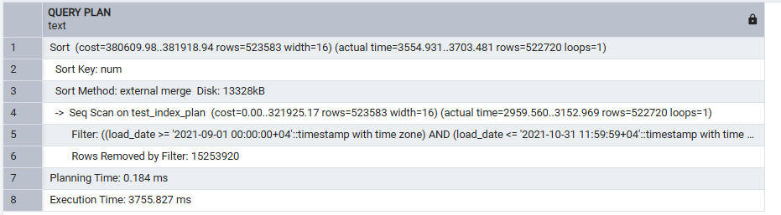
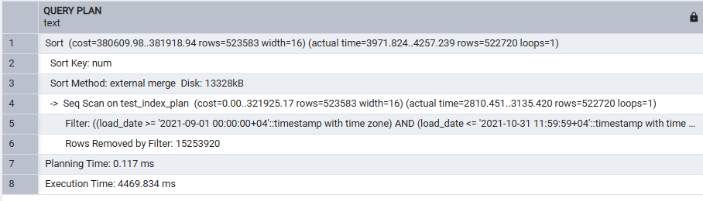
Finally, added BUFFERS to see the cache effect directly in hit/read counts rather than inferring it from timing alone:
EXPLAIN (ANALYZE, BUFFERS)
SELECT *
FROM labs.test_index_plan
WHERE load_date BETWEEN '2021-09-01 0:00' AND '2021-10-31 11:59:59'
ORDER BY 1;
What to look for: a Buffers: line under the Seq Scan node reporting shared hit (pages already in cache) and shared read (pages pulled from disk/OS cache) counts — run right after the two EXPLAIN ANALYZE calls above, this should show mostly shared hit, confirming the table is now fully warmed into cache.
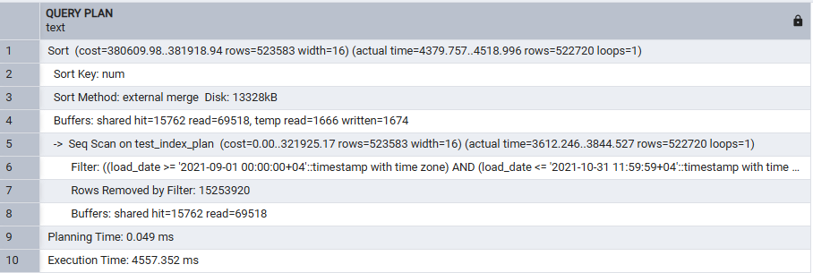
Personal takeaway: with no index, every variant of EXPLAIN produces the same Seq Scan plan shape — only the amount of information attached to each node changes (estimates only → real timings → real buffer I/O), and it's EXPLAIN ANALYZE / BUFFERS that reveal caching is doing real work here, not a smarter plan.

3. Task 2 — Adding Index
Created a B-Tree index on load_date:
CREATE INDEX idx_test_index_plan_btree ON labs.test_index_plan(load_date);
What to look for: CREATE INDEX succeeding (this will take a comparable amount of time to the equivalent B-Tree build in the previous module, since it's the same row count).
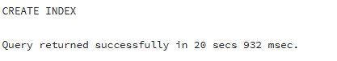
Repeated the same query twice with the index in place:
SET max_parallel_workers_per_gather = 0;
EXPLAIN ANALYZE
SELECT *
FROM labs.test_index_plan
WHERE load_date BETWEEN '2021-09-01 0:00' AND '2021-10-31 11:59:59'
ORDER BY 1;
-- run twice
What to look for: the plan switching to an Index Scan using idx_test_index_plan_btree — notice it can satisfy the ORDER BY 1 directly from the index's sorted order, so the separate Sort node from Task 1 disappears entirely. Both runs should now be fast and close to each other in Execution Time, since a targeted index scan touches far fewer pages than the earlier Seq Scan, leaving less room for a cold-vs-hot cache gap.

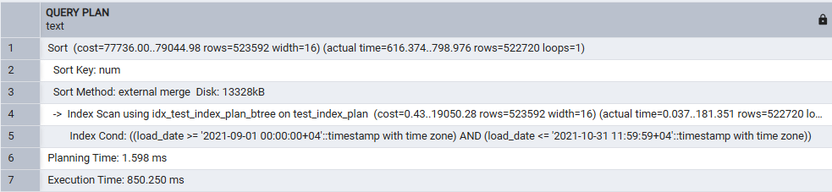
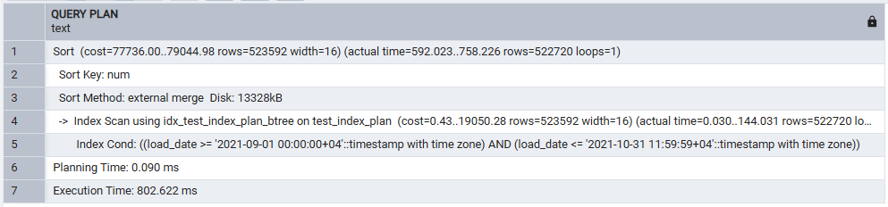

Getting an Index Only Scan
SELECT * still needs num, which is not part of the load_date index, so the planner is forced to visit the heap for every matching row (a regular Index Scan). To make an Index Only Scan possible, the query must ask only for columns the index actually contains — here, that means selecting just load_date instead of *. It also helps to VACUUM the table first, so the Visibility Map is up to date and the planner can trust the heap doesn't need rechecking for visibility:
VACUUM labs.test_index_plan;
EXPLAIN ANALYZE
SELECT load_date
FROM labs.test_index_plan
WHERE load_date BETWEEN '2021-09-01 0:00' AND '2021-10-31 11:59:59'
ORDER BY 1;
What to look for: the plan now shows Index Only Scan using idx_test_index_plan_btree, with a Heap Fetches: line at or near 0 — proof the query is being answered straight out of the index, with little or no need to visit the heap at all.

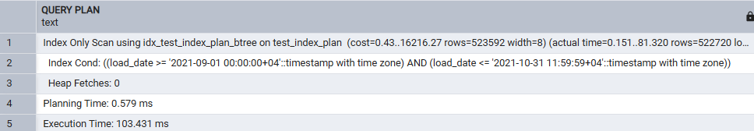

BRIN instead of B-Tree
DROP INDEX idx_test_index_plan_btree;
CREATE INDEX idx_test_index_plan_brin ON labs.test_index_plan USING brin(load_date);
SET max_parallel_workers_per_gather = 0;
EXPLAIN ANALYZE
SELECT *
FROM labs.test_index_plan
WHERE load_date BETWEEN '2021-09-01 0:00' AND '2021-10-31 11:59:59'
ORDER BY 1;
-- run twice

What to look for: the plan now shows a Bitmap Heap Scan driven by a Bitmap Index Scan on idx_test_index_plan_brin, rather than a plain Index Scan — BRIN only narrows things down to candidate page ranges, so PostgreSQL still needs the bitmap step to gather and visibility-check the actual matching rows, and (unlike the B-Tree index scan above) it can't avoid the separate Sort node for ORDER BY 1, since a bitmap scan doesn't return rows in index order. This matches the previous module's finding: BRIN is cheap to build and small, but does noticeably less work for the planner to lean on than a B-Tree here.

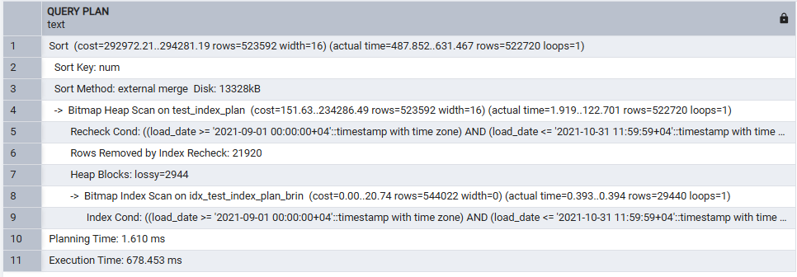
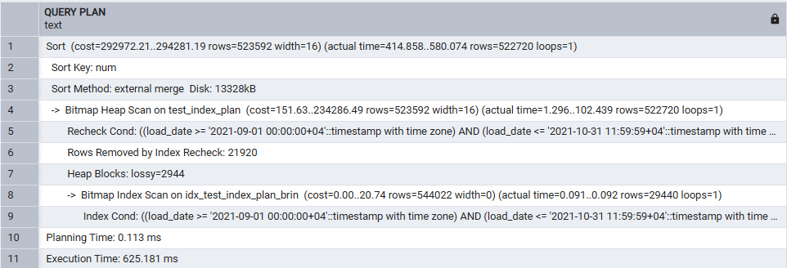

4. Task 3 — Bulk Insert
Created a destination table with an index already in place before loading it:
CREATE TABLE labs.test_inserts (
num float NOT NULL,
load_date timestamptz NOT NULL
);
CREATE INDEX idx_test_inserts_btree ON labs.test_inserts(load_date);
What to look for: both statements succeed; the index is empty at this point since test_inserts has no rows yet.
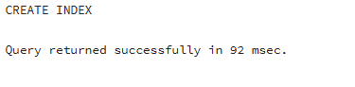
Bulk-loaded it from the existing test_index_plan table using INSERT ... SELECT, and timed it:
INSERT INTO labs.test_inserts (num, load_date)
SELECT num, load_date
FROM labs.test_index_plan;
What to look for: all ~15.8M rows copied over in one statement; this should be noticeably slower than an equivalent COPY of the same volume (see Task 4) despite being a single statement, because PostgreSQL also has to maintain the load_date index incrementally as each row is inserted — an index that already exists before a bulk load adds real overhead, which is why bulk-loading tools often build indexes after loading data rather than before.

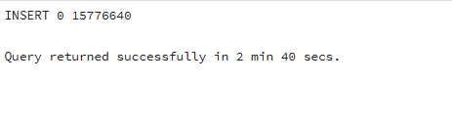

emp table and efficient multi-row INSERT
Created the classic emp table:
CREATE TABLE emp (
empno NUMERIC(4) NOT NULL CONSTRAINT emp_pk PRIMARY KEY,
ename VARCHAR(10) UNIQUE,
job VARCHAR(9),
mgr NUMERIC(4),
hiredate DATE
);
What to look for: table created successfully with a primary key on empno and a uniqueness constraint on ename — both matter for Task 5's UPSERT below.
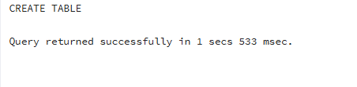
The task sheet's 14 separate INSERT INTO emp VALUES (...); statements each pay their own per-statement overhead (permission/lock/type checks) for a single row. Rewrote them as one multi-row INSERT — a single VALUES list with all 14 tuples — which is the “more efficient way” the task is asking for:
INSERT INTO emp (empno, ename, job, mgr, hiredate) VALUES
(1, 'SMITH', 'CLERK', 13, '17-DEC-80'),
(2, 'ALLEN', 'SALESMAN', 6, '20-FEB-81'),
(3, 'WARD', 'SALESMAN', 6, '22-FEB-81'),
(4, 'JONES', 'MANAGER', 9, '02-APR-81'),
(5, 'MARTIN', 'SALESMAN', 6, '28-SEP-81'),
(6, 'BLAKE', 'MANAGER', 9, '01-MAY-81'),
(7, 'CLARK', 'MANAGER', 9, '09-JUN-81'),
(8, 'SCOTT', 'ANALYST', 4, '19-APR-87'),
(9, 'KING', 'PRESIDENT', NULL, '17-NOV-81'),
(10, 'TURNER', 'SALESMAN', 6, '08-SEP-81'),
(11, 'ADAMS', 'CLERK', 8, '23-MAY-87'),
(12, 'JAMES', 'CLERK', 6, '03-DEC-81'),
(13, 'FORD', 'ANALYST', 4, '03-DEC-81'),
(14, 'MILLER', 'CLERK', 7, '23-JAN-82');

What to look for: one INSERT 0 14 result instead of fourteen separate INSERT 0 1 results — same final data, a single statement's worth of overhead instead of fourteen.

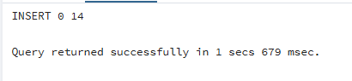
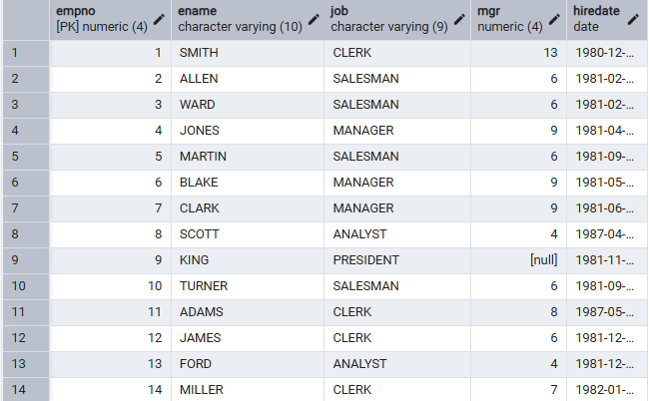

5. Task 4 — COPY Command
Exported test_index_plan to CSV, with load_date forced into quotes and num left unquoted (CSV's default behavior already leaves a plain numeric column unquoted, so only load_date needs FORCE QUOTE):
COPY labs.test_index_plan
TO 'C:/temp/test_index_plan.csv'
WITH (FORMAT csv, HEADER, DELIMITER ',', FORCE_QUOTE (load_date));
Note: used C:/temp/ again for the export path, same reasoning as the CSV foreign table in the previous module — the file is written by the PostgreSQL server process itself, so it needs a location that process can actually write to.
What to look for: the file appears in C:/temp/, and opening it in a text editor shows load_date values wrapped in double quotes (e.g. "2017-01-01 00:00:00+04") while num values are plain, unquoted numbers on the same line.
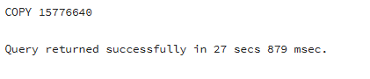
Exported a smaller, date-filtered slice — COPY TO can't take a WHERE clause directly, so the source is wrapped in a query instead:
COPY (
SELECT * FROM labs.test_index_plan
WHERE load_date BETWEEN '2021-09-01 0:00' AND '2021-09-01 11:59:59'
)
TO 'C:/temp/test_index_plan_short.csv' DELIMITER ',' CSV HEADER;
What to look for: a much smaller CSV file (just under half a day's worth of 10-second-interval rows, a few thousand lines) written to C:/temp/test_index_plan_short.csv.
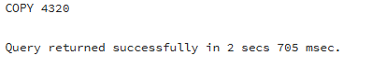
Created the destination table for the round-trip import, with its index already in place:
CREATE TABLE labs.test_copy (
num float NOT NULL,
load_date timestamptz NOT NULL
);
CREATE INDEX idx_test_copy_btree ON labs.test_copy(load_date);
Note: the task sheet's step 4 says to add the B-Tree index “on the table test_inserts” again — but test_inserts already got its index back in Task 3, and it's test_copy (the table this step just created, about to receive the COPY import below) that actually needs one. Indexed test_copy instead, as shown above.
What to look for: both statements succeed.
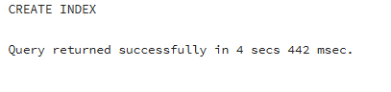
Loaded test_copy from the full CSV file exported earlier, and timed it for comparison against Task 3's INSERT ... SELECT:
COPY labs.test_copy(num, load_date)
FROM 'C:/temp/test_index_plan.csv'
WITH (FORMAT csv, HEADER, DELIMITER ',');
What to look for: all ~15.8M rows loaded via COPY should complete noticeably faster than the equivalent INSERT ... SELECT in Task 3, even though test_copy also already has an index — this is the practical demonstration of the theory recap's claim that COPY carries far less per-row overhead than INSERT.

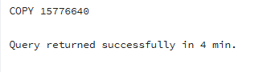

6. Task 5 — UPSERT
Before running the UPSERT, current emp contents relevant to these empno values: 1 = SMITH/CLERK, 4 = JONES/MANAGER, 11 = ADAMS/CLERK, 14 = MILLER/CLERK — 15 does not exist yet. So this single statement needs to update four existing rows and insert one brand-new row (15), atomically, using empno (the primary key) as the conflict target:
INSERT INTO emp (empno, ename, job, mgr, hiredate) VALUES
(1, 'SMITH', 'MANAGER', 13, '01-DEC-21'),
(14, 'KELLY', 'CLERK', 1, '01-DEC-21'),
(15, 'HANNAH', 'CLERK', 1, '01-DEC-21'),
(11, 'ADAMS', 'SALESMAN', 8, '01-DEC-21'),
(4, 'JONES', 'ANALIST', 9, '01-DEC-21')
ON CONFLICT (empno) DO UPDATE SET
ename = EXCLUDED.ename,
job = EXCLUDED.job,
mgr = EXCLUDED.mgr,
hiredate = EXCLUDED.hiredate;
What to look for: one statement, no error, affecting all 5 rows. Querying SELECT * FROM emp WHERE empno IN (1,4,11,14,15) ORDER BY empno afterward should show: empno 1 now MANAGER (name unchanged, SMITH); empno 4 now ANALIST; empno 11 now SALESMAN; empno 14 renamed from MILLER to KELLY; and a brand-new empno 15, HANNAH — all five with hiredate 2021-12-01. None of the ename changes collide with the UNIQUE(ename) constraint (each new name is either unchanged or genuinely new), which is why ON CONFLICT (empno) alone is enough here without also having to handle an ename conflict.
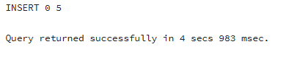
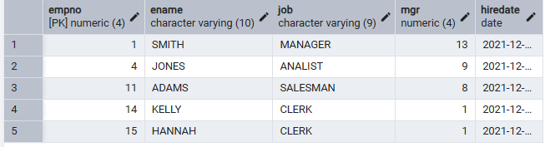
Personal takeaway: without ON CONFLICT, this exact statement would have failed outright on the very first conflicting row (empno = 1 already exists), rolling back the whole multi-row INSERT — the only alternative without UPSERT would be a slower, non-atomic SELECT-to-check-existence followed by a separate INSERT or UPDATE per row, with a race condition between the check and the write under concurrent access.

7. Summary
A query moves through parsing, rewriting, cost-based planning, and execution; the planner's choices — sequential vs. index vs. index-only vs. bitmap scan — are driven entirely by table/column statistics and the estimated cost of each candidate path, which is why EXPLAIN (showing that reasoning) and EXPLAIN ANALYZE (showing whether the reasoning matched reality) are the primary tools for understanding performance. Caching means a single timing run is never enough evidence on its own — comparing a cold run to a warm run, or using EXPLAIN (ANALYZE, BUFFERS) to see hit/read counts directly, is what actually separates a plan improvement from a cache effect. For loading data, per-statement overhead makes many small INSERTs the slowest option, a single multi-row INSERT meaningfully better, and COPY the fastest of all for genuine bulk loads — at the cost of COPY's strict, all-or-nothing input format. Finally, ON CONFLICT (UPSERT) turns what would otherwise be a fragile check-then-write sequence into one atomic, safe-under-concurrency statement.

