PostgreSQL DB for DWH and ETL Building
Transaction — Task 2: Answer
Author: Mariam Avaliani
This document works through Task 2 of the Transaction module: ACID, isolation levels, database anomalies, and MVCC row versioning, demonstrated hands-on with a two-session (Session A / Session B) setup in pgAdmin. Open two separate Query Tool tabs connected to the same database — one for Session A, one for Session B — and run each block in the order shown; the order matters, since the whole point is to see how one session's uncommitted or just-committed changes are (or aren't) visible to the other. Orange dashed boxes mark exactly where each screenshot goes.

1. Theory recap
ACID: Atomicity (a transaction's statements succeed or fail as one unit), Consistency (a transaction moves the database from one valid state to another), Isolation (concurrent transactions don't interfere with each other — how strictly is the isolation level), Durability (committed changes survive a crash, via WAL).
Isolation levels and the anomalies each one still allows in PostgreSQL:
- Read Committed (default) — no dirty reads, no lost updates for single-statement compound UPDATEs, but allows non-repeatable reads, phantom reads, and serialization anomalies.
- Repeatable Read — additionally prevents non-repeatable and phantom reads (the whole transaction sees one fixed snapshot from BEGIN), but can still allow a serialization anomaly.
- Serializable — prevents all of the above; PostgreSQL enforces this by aborting one of the conflicting transactions with a serialization_failure error rather than silently allowing an inconsistent result.
MVCC row-version system columns used throughout this task: xmin (inserting transaction id), xmax (deleting transaction id, 0 if not deleted), cmin/cmax (the command number, starting at 0, within the inserting/deleting transaction — relevant once a transaction issues more than one statement), ctid (physical row location).

2. Step 1 — Create the employee table
CREATE TABLE public.employee (
id serial PRIMARY KEY,
name varchar,
status varchar
);
What to look for: employee created with an empty result set — check it with a quick SELECT * FROM public.employee; (0 rows).
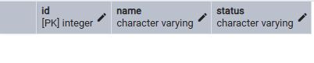

3. Step 2 — Replicate the parallel-session example (Read Committed, the default)
Three rounds, each showing a different statement type (INSERT, DELETE, UPDATE) and how it becomes visible to a concurrently open transaction in the other session. Keep both Query Tool tabs open the whole time — do not close them between rounds.

Round 1 — INSERT
Run Session A's block first, start to finish (this is the transaction that inserts the first row, Alice):
Session A (Query Tool tab 1)
-- first transaction
begin;
select txid_current();
insert into public.employee ("name", status)
values ('Alice', 'Not fired');
select *, xmin, xmax
from public.employee e;
commit;
What to look for: txid_current() returning a transaction id, then the SELECT showing the new row with xmin = that same id and xmax = 0.
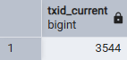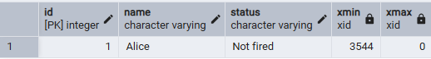
Then, in Session B — open a NEW transaction here only after Session A's commit above has finished:
Session B (Query Tool tab 2)
-- first transaction
begin;
select *, xmin, xmax from public.employee e;
commit;
What to look for: Session B sees Alice's row too, with the same xmin Session A's txid_current() reported — proof that once a transaction commits, its changes are immediately visible to any new statement in any other session (this is what "Read Committed" means: you always see the latest committed data).

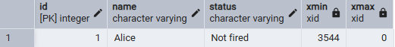

Round 2 — DELETE (demonstrates non-repeatable read)
This time the two sessions interleave. Follow this exact order:
- 1. Session A: BEGIN + the FIRST select only (leave the transaction open — don't commit yet).
- 2. Session B: run its entire block (delete id = 1, commit).
- 3. Session A: now run the SECOND select and commit.
Session A (Query Tool tab 1) — run in two parts, as instructed above
-- second transaction
begin;
-- (1) run only this first select, then switch to Session B
select *, xmin, xmax
from public.employee e;
-- (3) after Session B has committed its delete, run this second select
select *, xmin, xmax
from public.employee e;
commit;
What to look for: the FIRST select still shows Alice (id 1). The SECOND select — run later, in the very same still-open transaction — shows Alice already gone. Same query, same transaction, two different results: this is exactly what "non-repeatable read" means, and it's only possible under Read Committed.
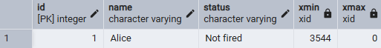
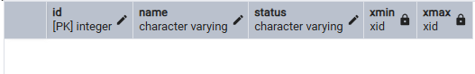

Session B (Query Tool tab 2) — run after Session A's first select
-- second transaction
begin;
select txid_current();
delete from public.employee
where id = 1;
select *, xmin, xmax
from public.employee e;
commit;
What to look for: the DELETE removing Alice, and the SELECT right after showing 0 rows — the row is gone from Session B's own perspective immediately, before Session A ever re-reads.
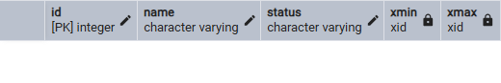
Re-seed a row for Round 3. Because id is a SERIAL column, PostgreSQL never reuses id 1 (just deleted) — this new row becomes id 2, which is exactly what Round 3 targets:
insert into public.employee ("name", status)
values ('Alice', 'Not fired');

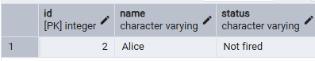

Round 3 — UPDATE (same non-repeatable read pattern)
- 1. Session A: BEGIN + the FIRST select only.
- 2. Session B: run its entire block (update id = 2, commit).
- 3. Session A: run the SECOND select and commit.
Session A (Query Tool tab 1)
-- third transaction
begin;
-- (1) run only this first select, then switch to Session B
select *, xmin, xmax
from public.employee e;
-- (3) after Session B has committed its update, run this second select
select *, xmin, xmax
from public.employee e;
commit;
What to look for: the first select shows id 2 with status = 'Not fired'; the second, later select (same open transaction) shows status = 'Fired' — another non-repeatable read, this time caused by an UPDATE instead of a DELETE.
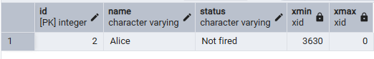
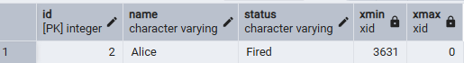
Session B (Query Tool tab 2)
-- third transaction
begin;
select txid_current();
update public.employee
set status = 'Fired'
where id = 2;
select *, xmin, xmax
from public.employee e;
commit;
What to look for: the UPDATE, and the SELECT confirming status = 'Fired' with a fresh xmin equal to this transaction's id — recall from Task 1 that UPDATE creates a brand-new row version rather than modifying in place, so xmin changes here too.

4. Steps 3–4 — Change and check the isolation level
Run in Session A (a SET TRANSACTION ISOLATION LEVEL applies only to the current transaction, so it must be issued right after BEGIN, before any query; use SET SESSION CHARACTERISTICS instead if you want it to apply to every transaction in that session from now on):
begin;
set transaction isolation level repeatable read;
-- or, to make it the default for the whole session:
set session characteristics as transaction isolation level repeatable read;
Check the current isolation level in both sessions:
show transaction isolation level;
What to look for: Session A reporting repeatable read, and Session B (untouched) still reporting the default read committed.
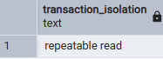
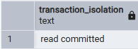

5. Step 5 — Redo the DELETE/UPDATE test with cmin/cmax, under Repeatable Read
Recreate the table and re-seed two rows:
DROP TABLE IF EXISTS public.employee;
CREATE TABLE public.employee (
id serial PRIMARY KEY,
name varchar,
status varchar
);
INSERT INTO public.employee ("name", status) VALUES ('Alice', 'Not fired'); -- id 1
INSERT INTO public.employee ("name", status) VALUES ('Bob', 'Not fired'); -- id 2
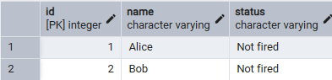
Redo Round 2 (DELETE id = 1), this time under REPEATABLE READ and with cmin/cmax added to the SELECTs:
Session A
begin;
set transaction isolation level repeatable read;
-- (1) run only this first select, then switch to Session B
select *, xmin, xmax, cmin, cmax
from public.employee e;
-- (3) after Session B has committed its delete, run this second select
select *, xmin, xmax, cmin, cmax
from public.employee e;
commit;
Session B (unchanged — still Read Committed)
begin;
select txid_current();
delete from public.employee where id = 1;
select *, xmin, xmax, cmin, cmax from public.employee e;
commit;
What to look for: this is the key comparison against Round 2 in Step 2: under Repeatable Read, Session A's SECOND select still shows Alice (id 1) as present — the whole transaction is pinned to the snapshot taken at BEGIN, so Session B's committed delete stays invisible until Session A's own transaction ends. That is exactly "What changed": Read Committed re-reads the latest committed state on every statement; Repeatable Read freezes one snapshot for the whole transaction. cmin stays 0 on each select (each is its own first command in that transaction); cmax stays 0 throughout, since Session A never deletes anything itself.
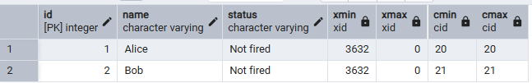
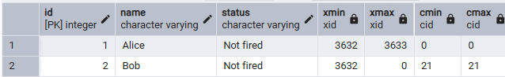

Redo Round 3 (UPDATE id = 2) the same way, under Repeatable Read with cmin/cmax:
Session A
begin;
set transaction isolation level repeatable read;
select *, xmin, xmax, cmin, cmax from public.employee e; -- (1) first select
-- switch to Session B, then come back and run:
select *, xmin, xmax, cmin, cmax from public.employee e; -- (3) second select
commit;
Session B
begin;
select txid_current();
update public.employee set status = 'Fired' where id = 2;
select *, xmin, xmax, cmin, cmax from public.employee e;
commit;
What to look for: same result as the delete case — Session A's second select still shows status = 'Not fired' for id 2, unaffected by Session B's committed update, confirming Repeatable Read's fixed-snapshot behavior a second time.
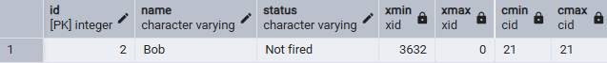
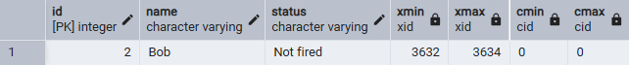

6. Step 6* — Serialization anomaly
Adapted from the lecture's order-table example to the employee table: each session counts how many employees currently have the OPPOSITE status from the one it's about to insert, and only inserts if that count is low — a classic "check, then act" pattern that is safe if run one at a time, but not necessarily if run concurrently. First seed a couple of rows of each status:
INSERT INTO public.employee ("name", status) VALUES ('Carol', 'Fired');
INSERT INTO public.employee ("name", status) VALUES ('Dave', 'Not fired');

Attempt 1 — default Read Committed (or Repeatable Read), no protection expected
Run both sessions' BEGIN + SELECT COUNT first, in either order, before either INSERT:
Session A
begin;
select count(*) from public.employee where status = 'Fired'; -- e.g. returns 2
-- based on that count, decide it's safe to add one more 'Not fired'
insert into public.employee ("name", status) values ('Eve', 'Not fired');
commit;
Session B
begin;
select count(*) from public.employee where status = 'Not fired'; -- e.g. returns 2
-- based on that count, decide it's safe to add one more 'Fired'
insert into public.employee ("name", status) values ('Frank', 'Fired');
commit;
What to look for: both transactions commit successfully with no error — but the combined result (both inserts applied) is not something either transaction would have produced if it had run strictly before or after the other with up-to-date counts. That mismatch between "ran concurrently, both succeeded" and "no valid one-at-a-time ordering explains the result" is the serialization anomaly, and Read Committed / Repeatable Read do not protect against it.
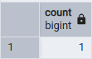

Result: Both transactions commit successfully, with no errors and no blocking, because they insert two different new rows rather than touching the same one — there is no row-level lock conflict for Postgres to detect. If, say, each session's SELECT COUNT read 2/2 before either inserted, the table ends up at 3/3 after both commits: each session's insert was individually “safe” relative to the count it saw, but that count was already stale by the time the other side committed. select status, count(*) from public.employee group by status; after both commits shows this combined effect — a result that no strictly one-at-a-time execution of the two transactions would have produced. That mismatch is the serialization anomaly, and Read Committed / Repeatable Read do nothing to prevent it.

Attempt 2 — SERIALIZABLE
Set both sessions to SERIALIZABLE and repeat the same pattern (re-seed a couple of rows first if needed):
begin;
set transaction isolation level serializable;
-- ... same select count / insert as above ...
What to look for: one of the two transactions now fails at COMMIT time with an error similar to: ERROR: could not serialize access due to read/write dependencies among transactions. This is PostgreSQL's Serializable Snapshot Isolation (SSI) actively detecting the same anomaly from Attempt 1 and refusing to let both commit — the failed transaction has to be retried by the application.
Result: One session commits normally; the other fails at COMMIT with an error of the form: ERROR: could not serialize access due to read/write dependencies among transactions (SQLSTATE 40001). This is PostgreSQL's Serializable Snapshot Isolation (SSI) engine detecting the same read/write dependency cycle as in Attempt 1 — each transaction's SELECT COUNT read data that the other transaction's INSERT later changed in a conflicting way — and refusing to let both sides commit, rather than silently allowing the anomaly through. The failed transaction is rolled back automatically; the application is expected to catch SQLSTATE 40001 and retry the whole transaction from BEGIN.

7. Step 7* — Lost update
Add a numeric column to make the anomaly concrete, and set an initial value:
ALTER TABLE public.employee ADD COLUMN salary integer;
UPDATE public.employee SET salary = 1000 WHERE id = 2; -- Bob

Attempt 1 — the lecture's version: two concurrent compound UPDATEs
Session A
begin;
update public.employee set salary = salary + 50 where id = 2;
commit;
Session B — start this BEFORE Session A commits, then commit it after
begin;
update public.employee set salary = salary - 50 where id = 2;
commit;
What to look for: Session B's UPDATE blocks (waits) the moment it's issued, because it targets a row Session A already has locked. Once Session A commits, PostgreSQL re-checks Session B's WHERE clause against the now-current row and re-evaluates "salary - 50" using the fresh, post-A value — not the stale value Session B originally saw. Check the final value: SELECT salary FROM employee WHERE id = 2; — it should correctly land back on 1000, not 950 or 1050. This single-statement form is NOT actually vulnerable to lost update in PostgreSQL, even at plain Read Committed.
Result: Session B's UPDATE blocks the instant it is issued, because it targets the same row (id = 2) that Session A is already holding a lock on. Once Session A commits (salary 1000 → 1050), Session B's UPDATE unblocks and PostgreSQL re-evaluates its SET salary = salary - 50 expression against the row as it now stands — 1050 — not the stale value Session B originally saw. So Session B computes 1050 - 50 = 1000. SELECT salary FROM public.employee WHERE id = 2; after both commits shows 1000, i.e. unchanged from the starting value — no update was lost, even though both sessions ran at plain Read Committed.

Attempt 2 — the pattern that actually loses an update: read, then write separately
This mirrors how application code usually works (read a value, compute in the app layer, write the computed value back) — run Session A up through its SELECT, then Session B all the way through, then come back to Session A:
Session A
begin;
select salary from public.employee where id = 2; -- reads 1000
-- (app layer computes 1000 + 50 = 1050; now switch to Session B)
update public.employee set salary = 1050 where id = 2;
commit;
Session B — run entirely while Session A is paused after its SELECT
begin;
select salary from public.employee where id = 2; -- also reads 1000, since A hasn't written yet
-- (app layer computes 1000 - 50 = 950)
update public.employee set salary = 950 where id = 2;
commit;
What to look for: both sessions read 1000 before either writes, so both compute off the same stale value. Whichever commits last simply overwrites the other — final salary is 950 or 1050, never the logically correct 1000. This time the update genuinely is lost, even at Read Committed.
Result: Because both sessions' SELECT statements run before either UPDATE, both read salary = 1000 and each independently computes its new value “in the application layer” (1050 for Session A, 950 for Session B) off that same stale read. Whichever UPDATE ... commit; happens to run last simply overwrites the row with its literal value, with no awareness that the other session already wrote to it. SELECT salary FROM public.employee WHERE id = 2; ends up showing either 950 or 1050 depending on commit order — never the logically correct 1000. One of the two ±50 adjustments is silently lost, even though neither transaction received any error and both believed they had succeeded.

Reflection — downsides of Postgres's approach
PostgreSQL's Read Committed protection against lost updates is syntactic, not semantic: it only re-evaluates a blocked UPDATE's SET expression against the fresh row when the read and the write happen inside the same SQL statement (salary = salary + 50). The moment an application splits that into two steps — SELECT the value, compute the new value in code, then UPDATE with a literal — Postgres has no way to know the write depends on a value that's now stale, and the update is silently lost. This is a real risk in practice because that split read-then-write pattern is extremely common (most ORMs and typical application code work exactly this way). The two real fixes are: use SELECT ... FOR UPDATE to lock the row for the duration of the read (so the second session blocks until the first finishes, then reads the up-to-date value), or raise the isolation level to Repeatable Read / Serializable, which won't silently lose the update — instead one of the transactions will fail with a serialization error and has to be retried by the application. Both fixes trade some concurrency/throughput for correctness.

