PostgreSQL DB for DWH and ETL Building
Task 5: PostgreSQL Join Methods — Answer
All queries below were run against a local PostgreSQL 16 instance. Table structures, sample data volumes, and setup statements follow the task instructions exactly; every EXPLAIN / EXPLAIN ANALYZE output shown is the real plan produced by the local optimizer, not a hypothetical one. Session-level parameters (enable_hashjoin, enable_mergejoin, enable_nestloop, join_collapse_limit) were reset to their defaults after each experiment. Dashed yellow boxes mark where a screenshot (e.g. from pgAdmin/DBeaver) should be inserted.

1. Join Methods

1.1 Task 1: Nested Loop Join
Setup
CREATE TABLE test_joins_a (id1 int, id2 int);
CREATE TABLE test_joins_b (id1 int, id2 int);

INSERT INTO test_joins_a VALUES(generate_series(1,10000),3);
INSERT INTO test_joins_b VALUES(generate_series(1,10000),3);

ANALYZE;
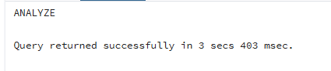

Query 1 — inequality join
EXPLAIN ANALYZE
SELECT * FROM test_joins_a a, test_joins_b b
WHERE a.id1 > b.id1;
Nested Loop (cost=0.00..1500315.00 rows=33333333 width=16) (actual time=375.452..9021.596 rows=49995000 loops=1)
Join Filter: (a.id1 > b.id1)
Rows Removed by Join Filter: 50005000
-> Seq Scan on test_joins_a a (cost=0.00..145.00 rows=10000 width=8) (actual rows=10000 loops=1)
-> Materialize (cost=0.00..195.00 rows=10000 width=8) (actual rows=10000 loops=10000)
-> Seq Scan on test_joins_b b (cost=0.00..145.00 rows=10000 width=8) (actual rows=10000 loops=1)
Planning Time: 0.971 ms
Execution Time: 14082.185 ms
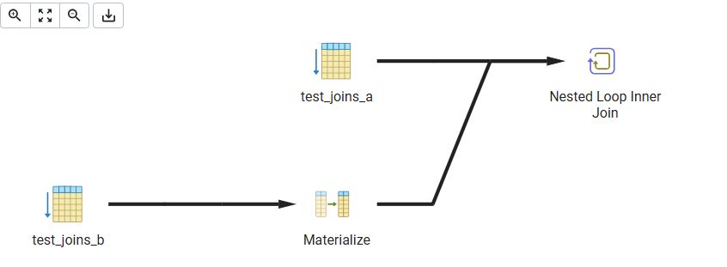
Query 2 — CROSS JOIN
EXPLAIN ANALYZE
SELECT * FROM test_joins_a a CROSS JOIN test_joins_b b;
Nested Loop (cost=0.00..1250315.00 rows=100000000 width=16) (actual rows=100000000 loops=1)
-> Seq Scan on test_joins_a a (cost=0.00..145.00 rows=10000 width=8) (actual rows=10000 loops=1)
-> Materialize (cost=0.00..195.00 rows=10000 width=8) (actual rows=10000 loops=10000)
-> Seq Scan on test_joins_b b (cost=0.00..145.00 rows=10000 width=8) (actual rows=10000 loops=1)
Planning Time: 0.107 ms
Execution Time: 12684.940 ms
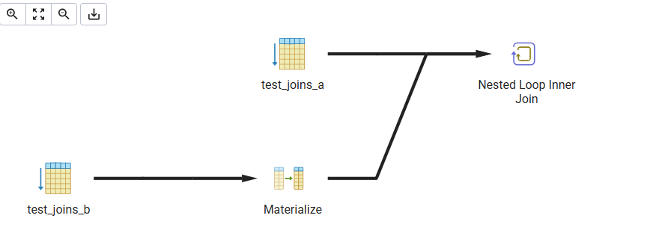
Why Nested Loop is used
Both queries return the full cartesian product (10,000 × 10,000 = 100,000,000 candidate pairs; the first query then filters ~50% of those with the inequality). Neither the inequality operator (>) nor the absence of any join predicate in the CROSS JOIN can be evaluated by a hash table (hash join requires an equality condition) or by a sorted merge (merge join needs an equality condition too — an inequality range doesn't guarantee the sorted-merge invariant holds). Nested Loop is therefore the only physical join operator capable of executing these plans: for every row of the outer table (test_joins_a) it scans the entire inner table (test_joins_b, held in a Materialize node so the second and later scans don't have to re-read from disk). This is exactly the scenario called out in the courseware — a NESTED LOOP is the only way to execute a CROSS JOIN, and it is also the fallback whenever the join condition can't be mapped to a useful MERGE or HASH JOIN.

1.2 Task 2: Hash Join
2.1 Rewriting the SELECT to force a HASH JOIN
The original predicate a.id1 > b.id1 is an inequality, so it cannot drive a hash join on its own (a hash join needs at least one equality (=) condition). Both tables carry a constant column id2 = 3, so adding an equi-join on id2 gives the planner an equality condition it can hash on, while the original inequality is kept as a residual join filter applied to each probe match:
EXPLAIN ANALYZE
SELECT * FROM test_joins_a a, test_joins_b b
WHERE a.id1 > b.id1 AND a.id2 = b.id2;
Hash Join (cost=270.00..1375440.00 rows=33333333 width=16) (actual time=133.777..4188.210 rows=49995000 loops=1)
Hash Cond: (a.id2 = b.id2)
Join Filter: (a.id1 > b.id1)
Rows Removed by Join Filter: 50005000
-> Seq Scan on test_joins_a a (cost=0.00..145.00 rows=10000 width=8)
-> Hash (cost=145.00..145.00 rows=10000 width=8) (actual rows=10000 loops=1)
Buckets: 16384 Batches: 1 Memory Usage: 519kB
-> Seq Scan on test_joins_b b (cost=0.00..145.00 rows=10000 width=8)
Planning Time: 0.521 ms
Execution Time: 5451.342 ms
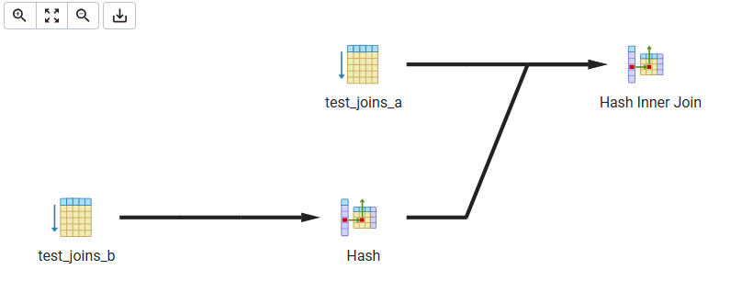
The planner now builds an in-memory hash table on b.id2 (all rows fall into a single bucket value = 3), probes it with a.id2, and applies the inequality as a Join Filter on the matches. Execution time drops from ~14.1s (Nested Loop) to ~5.5s because the hash probe is O(1) per row instead of a full inner scan per outer row.

2.2 SEMI JOIN → HASH SEMI JOIN
An EXISTS sub-query on the equality of id1 produces a semi join — for each row of test_joins_a it only needs to know whether at least one match exists in test_joins_b, never how many:
EXPLAIN ANALYZE
SELECT * FROM test_joins_a a
WHERE EXISTS (SELECT 1 FROM test_joins_b b WHERE b.id1 = a.id1);
Hash Semi Join (cost=270.00..552.50 rows=10000 width=8) (actual time=1.535..3.411 rows=10000 loops=1)
Hash Cond: (a.id1 = b.id1)
-> Seq Scan on test_joins_a a (cost=0.00..145.00 rows=10000 width=8)
-> Hash (cost=145.00..145.00 rows=10000 width=4) (actual rows=10000 loops=1)
Buckets: 16384 Batches: 1 Memory Usage: 480kB
-> Seq Scan on test_joins_b b (cost=0.00..145.00 rows=10000 width=4)
Planning Time: 0.368 ms
Execution Time: 3.674 ms
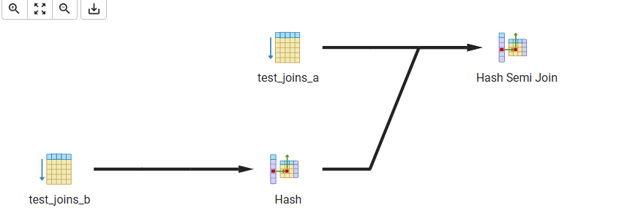
This confirms the courseware definition: a semi join returns each matching row of the first table only once, regardless of how many matches exist on the right-hand side, so PostgreSQL labels the node "Hash Semi Join" rather than a plain "Hash Join".

2.3 Disabling and re-enabling enable_hashjoin
SET enable_hashjoin = off;
EXPLAIN ANALYZE
SELECT * FROM test_joins_a a
WHERE EXISTS (SELECT 1 FROM test_joins_b b WHERE b.id1 = a.id1);
Merge Semi Join (cost=1618.77..1818.77 rows=10000 width=8) (actual time=2.549..5.616 rows=10000 loops=1)
Merge Cond: (a.id1 = b.id1)
-> Sort (cost=809.39..834.39 rows=10000 width=8) (actual rows=10000 loops=1)
Sort Key: a.id1 | Sort Method: quicksort Memory: 697kB
-> Seq Scan on test_joins_a a (cost=0.00..145.00 rows=10000 width=8)
-> Sort (cost=809.39..834.39 rows=10000 width=4) (actual rows=10000 loops=1)
Sort Key: b.id1 | Sort Method: quicksort Memory: 385kB
-> Seq Scan on test_joins_b b (cost=0.00..145.00 rows=10000 width=4)
Planning Time: 0.057 ms
Execution Time: 5.942 ms
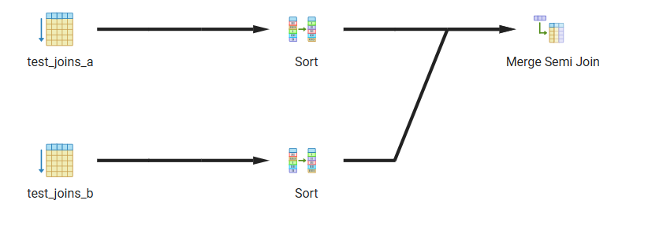
With enable_hashjoin off, the planner falls back to the next-cheapest strategy for an equality condition — a Merge Semi Join (both inputs sorted on id1, then merged). Nested Loop was not chosen because a sort+merge over 10,000 rows is still far cheaper than 10,000 individual inner scans.
SET enable_hashjoin = on;
EXPLAIN ANALYZE
SELECT * FROM test_joins_a a
WHERE EXISTS (SELECT 1 FROM test_joins_b b WHERE b.id1 = a.id1);
Hash Semi Join (cost=270.00..552.50 rows=10000 width=8) (actual time=1.455..3.329 rows=10000 loops=1)
Hash Cond: (a.id1 = b.id1)
-> Seq Scan on test_joins_a a (cost=0.00..145.00 rows=10000 width=8) (actual rows=10000 loops=1)
-> Hash (cost=145.00..145.00 rows=10000 width=4) (actual rows=10000 loops=1)
Buckets: 16384 Batches: 1 Memory Usage: 480kB
-> Seq Scan on test_joins_b b (cost=0.00..145.00 rows=10000 width=4)
Planning Time: 0.045 ms
Execution Time: 3.578 ms
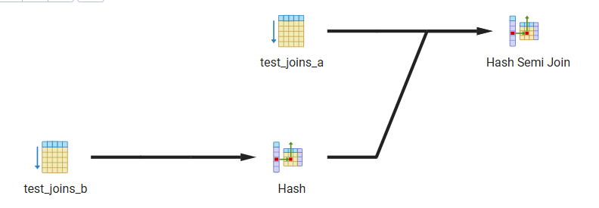
Re-running the same query with enable_hashjoin back on reproduces the original Hash Semi Join plan (cost 270.00..552.50, identical to the first run in 2.2), confirming the planner reverts to the cheaper hash-based strategy once it is available again.

1.3 Task 3: Merge Join
test_joins_a and test_joins_b are joined on the equality a.id1 = b.id1. By default PostgreSQL prefers Hash Join here (cost 270.00..552.50) because neither table is indexed or pre-sorted on id1 and the tables are small enough that building a hash table is cheaper than sorting both sides. To force a MERGE JOIN, enable_hashjoin and enable_nestloop were temporarily disabled, which leaves the planner only the merge strategy for the equality condition:
SET enable_hashjoin = off;
SET enable_nestloop = off;
EXPLAIN ANALYZE
SELECT * FROM test_joins_a a, test_joins_b b
WHERE a.id1 = b.id1;
Merge Join (cost=1618.77..1818.77 rows=10000 width=16) (actual time=2.540..5.406 rows=10000 loops=1)
Merge Cond: (a.id1 = b.id1)
-> Sort (cost=809.39..834.39 rows=10000 width=8) (actual rows=10000 loops=1)
Sort Key: a.id1 | Sort Method: quicksort Memory: 697kB
-> Seq Scan on test_joins_a a (cost=0.00..145.00 rows=10000 width=8)
-> Sort (cost=809.39..834.39 rows=10000 width=8) (actual rows=10000 loops=1)
Sort Key: b.id1 | Sort Method: quicksort Memory: 697kB
-> Seq Scan on test_joins_b b (cost=0.00..145.00 rows=10000 width=8)
Planning Time: 0.431 ms
Execution Time: 5.792 ms
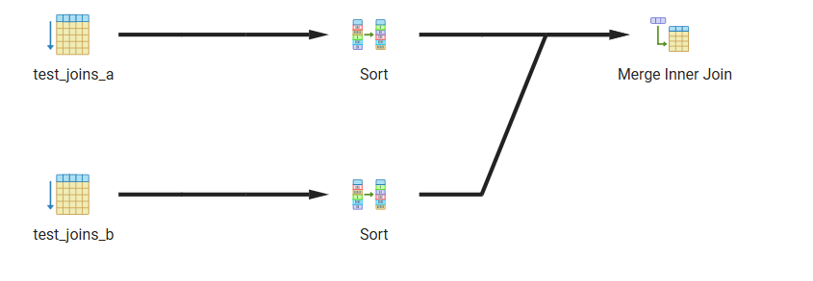
Both inputs are sorted on id1 (Sort nodes, since no index exists to provide pre-sorted access) and then merged in a single pass. Enable_hashjoin and enable_nestloop were reset immediately after.

Disabling enable_mergejoin
For the plain equality query (all flags at default), PostgreSQL already prefers Hash Join over Merge Join (estimated cost 552.50 vs. 1818.77 — sorting 10,000 unindexed rows on both sides is more expensive than one hash build):
SET enable_mergejoin = off;
EXPLAIN ANALYZE
SELECT * FROM test_joins_a a, test_joins_b b
WHERE a.id1 = b.id1;
Hash Join (cost=270.00..552.50 rows=10000 width=16) (actual time=1.250..3.297 rows=10000 loops=1)
Hash Cond: (a.id1 = b.id1)
-> Seq Scan on test_joins_a a (cost=0.00..145.00 rows=10000 width=8)
-> Hash (cost=145.00..145.00 rows=10000 width=8) (actual rows=10000 loops=1)
Buckets: 16384 Batches: 1 Memory Usage: 519kB
-> Seq Scan on test_joins_b b (cost=0.00..145.00 rows=10000 width=8)
Planning Time: 0.028 ms
Execution Time: 3.542 ms
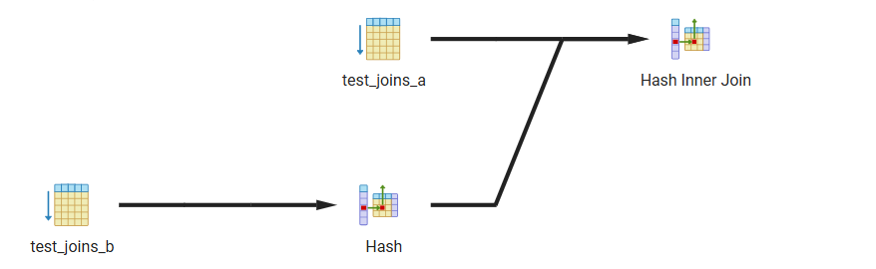
The plan is unchanged by turning enable_mergejoin off, because Merge Join was never the chosen strategy in this case — Hash Join was already the cheaper default. This is expected: enable_mergejoin only removes Merge Join from the set of candidate plans the optimizer compares; it has no effect when a different join method already wins on cost.
SET enable_mergejoin = on;
EXPLAIN ANALYZE
SELECT * FROM test_joins_a a, test_joins_b b
WHERE a.id1 = b.id1;
Hash Join (cost=270.00..552.50 rows=10000 width=16) (actual time=1.233..3.266 rows=10000 loops=1)
Hash Cond: (a.id1 = b.id1)
-> Seq Scan on test_joins_a a (cost=0.00..145.00 rows=10000 width=8) (actual rows=10000 loops=1)
-> Hash (cost=145.00..145.00 rows=10000 width=8) (actual rows=10000 loops=1)
Buckets: 16384 Batches: 1 Memory Usage: 519kB
-> Seq Scan on test_joins_b b (cost=0.00..145.00 rows=10000 width=8)
Planning Time: 0.038 ms
Execution Time: 3.510 ms
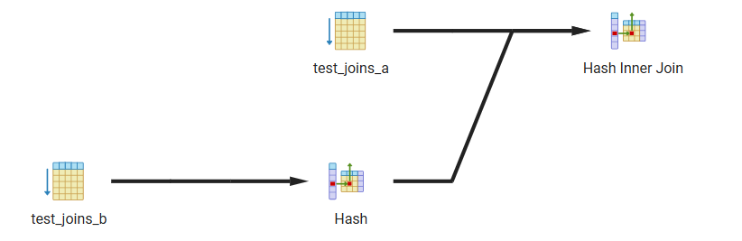
Re-enabling enable_mergejoin reproduces the identical Hash Join plan, confirming nothing else changed.

2. Join Order and Lateral Join

2.1 Task 4: Changing Join Order
Setup
CREATE TABLE test_joins_c (id1 int, id2 int);
INSERT INTO test_joins_c
VALUES(generate_series(1,1000000),(random()*10)::int);

Default plan (join_collapse_limit = 8, the default)
EXPLAIN
SELECT c.id2
FROM test_joins_b b
JOIN test_joins_a a on (b.id1 = a.id1)
LEFT JOIN test_joins_c c on (c.id1 = b.id1);
Hash Join (cost=540.00..18952.50 rows=10000 width=4)
Hash Cond: (b.id1 = a.id1)
-> Hash Right Join (cost=270.00..18545.00 rows=10000 width=8)
Hash Cond: (c.id1 = b.id1)
-> Seq Scan on test_joins_c c (cost=0.00..14425.00 rows=1000000 width=8)
-> Hash (cost=145.00..145.00 rows=10000 width=4)
-> Seq Scan on test_joins_b b (cost=0.00..145.00 rows=10000 width=4)
-> Hash (cost=145.00..145.00 rows=10000 width=4)
-> Seq Scan on test_joins_a a (cost=0.00..145.00 rows=10000 width=4)
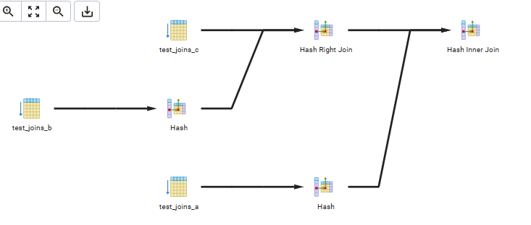
With the default join_collapse_limit = 8, the query has only 3 tables, well under the limit, so the optimizer is free to reorder the joins and evaluates every candidate order. It chose to join test_joins_b with test_joins_c first (inside a Hash Right Join, which preserves the LEFT JOIN semantics of c relative to b) and only then joins the 10,000-row result with test_joins_a. The 1,000,000-row test_joins_c is scanned once and probed via hash rather than driving the outer loop, and the LEFT JOIN’s outer-preserving property is enforced by keeping the join order b→c (then →a) even though the FROM clause lists a before c.

join_collapse_limit = 1
SET join_collapse_limit = 1;
EXPLAIN
SELECT c.id2
FROM test_joins_b b
JOIN test_joins_a a on (b.id1 = a.id1)
LEFT JOIN test_joins_c c on (c.id1 = b.id1);
Hash Right Join (cost=677.50..18952.50 rows=10000 width=4)
Hash Cond: (c.id1 = b.id1)
-> Seq Scan on test_joins_c c (cost=0.00..14425.00 rows=1000000 width=8)
-> Hash (cost=552.50..552.50 rows=10000 width=4)
-> Hash Join (cost=270.00..552.50 rows=10000 width=4)
Hash Cond: (b.id1 = a.id1)
-> Seq Scan on test_joins_b b (cost=0.00..145.00 rows=10000 width=4)
-> Hash (cost=145.00..145.00 rows=10000 width=4)
-> Seq Scan on test_joins_a a (cost=0.00..145.00 rows=10000 width=4)
SET join_collapse_limit = 8;
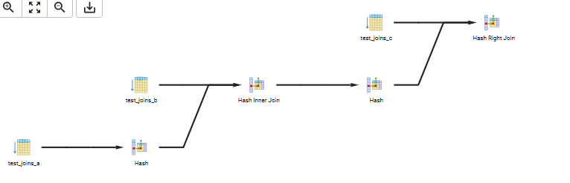
join_collapse_limit = 1 prevents the optimizer from reordering explicit JOINs: the join order is forced to follow exactly the order written in the FROM clause (b JOIN a, then LEFT JOIN c), instead of the cost-based order chosen above. The result is structurally the same two-step plan, but the roles are swapped — b is joined to a first (inner Hash Join), and the result is then treated as the build side of the outer Hash Right Join against c. Both plans have virtually the same total cost here (18952.50 either way) because these tables are small and simple, but on more complex, longer queries locking the join order this way can force a materially worse plan; that is exactly why join_collapse_limit defaults to 8 rather than 1. Join_collapse_limit was reset back to 8 immediately afterward.

2.2 Task 5: Lateral Join
Setup
CREATE TABLE orders AS
SELECT id AS order_id,
(id * 10 * random()*10)::int AS order_cost,
‘order number ‘ || id AS order_num
FROM generate_series(1, 1000) AS id;

CREATE TABLE stores (
store_id int,
store_name text,
max_order_cost int
);

INSERT INTO stores VALUES
(1, ‘grossery shop’, ‘800’),
(2, ‘bakery’, ‘100’),
(3, ‘manufactured goods’, ‘3000’);

Query — TOP 10 orders per store using LATERAL
SELECT s.store_id, s.store_name, o.order_id, o.order_cost, o.order_num
FROM stores s
LEFT JOIN LATERAL (
SELECT o.order_id, o.order_cost, o.order_num
FROM orders o
WHERE o.order_cost < s.max_order_cost
ORDER BY o.order_cost DESC
LIMIT 10
) o ON true
ORDER BY s.store_id, o.order_cost DESC;
LATERAL is required here because the sub-query’s WHERE clause (o.order_cost < s.max_order_cost) reads s.max_order_cost from the left-hand table stores — without LATERAL, a sub-query in the FROM clause cannot see columns of a sibling FROM item. LEFT JOIN LATERAL (rather than plain JOIN LATERAL) is used so that a store with fewer than 10 qualifying orders — or none at all — still appears in the output instead of being dropped.
Result (row counts per store; costs are random, so exact rows vary run to run)
store_id | store_name | orders_returned
----------+--------------------+-----------------
1 | grossery shop | 10
2 | bakery | 4
3 | manufactured goods | 10
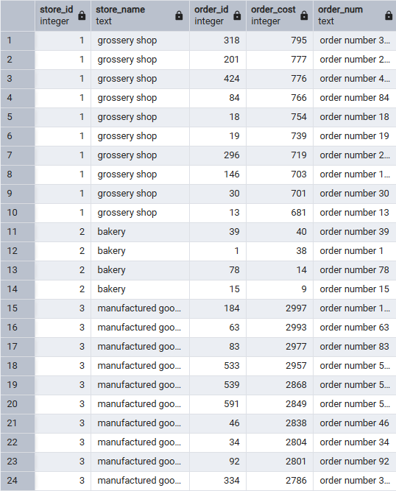
grossery shop and manufactured goods both returned the full 10 rows; bakery (max_order_cost = 100) only had 4 orders in the entire 1,000-row sample priced under 100, so it correctly returns fewer than 10 — exactly the “or less, depending on sample random data” behavior called out in the task.
Plan
Sort (cost=41357.67..41387.67 rows=12000 width=76)
Sort Key: s.store_id, o.order_cost DESC
-> Nested Loop Left Join (cost=33.64..40544.63 rows=12000 width=76)
-> Seq Scan on stores s (cost=0.00..22.00 rows=1200 width=40)
-> Limit (cost=33.64..33.67 rows=10 width=40)
-> Sort (cost=33.64..34.64 rows=400 width=40)
Sort Key: o.order_cost DESC
-> Seq Scan on orders o (cost=0.00..25.00 rows=400 width=40)
Filter: (order_cost < s.max_order_cost)
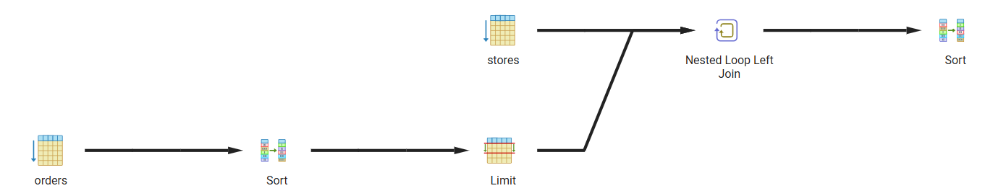
A LATERAL sub-query can only be executed as the inner side of a Nested Loop — the planner has no way to hash or sort-merge a computation that must be re-evaluated per outer row. For every row of stores, PostgreSQL re-scans orders, filters by that store’s max_order_cost, sorts the qualifying rows by cost, and keeps the top 10 (the Limit pushed inside the lateral sub-plan). With only 3 stores this is cheap; the pattern is what the courseware describes as LATERAL acting like a per-row “for each” loop, and it is the standard, faster way to write per-group Top-N without a window function.

3. CTEs

3.1 Task 6: Recursive CTE
The emp table referenced by the task (created in an earlier session) was recreated here using the classic 14-row EMP sample data set, with KING (PRESIDENT) as the only row with mgr IS NULL — i.e., the president of the company.
Setup
CREATE TABLE emp (
empno integer PRIMARY KEY,
ename varchar(10),
job varchar(9),
mgr integer,
hiredate date,
sal numeric(7,2),
comm numeric(7,2),
deptno integer
);
-- 14 rows inserted (KING/PRESIDENT with mgr = NULL down to CLERK level)

Recursive CTE — employee, manager name, and level from the president down
WITH RECURSIVE emp_hier AS (
SELECT empno, mgr, ename, ename AS mngname, 1 AS lvl
FROM emp
WHERE mgr IS NULL
UNION ALL
SELECT e.empno, e.mgr, e.ename, h.ename AS mngname, h.lvl + 1 AS lvl
FROM emp e
JOIN emp_hier h ON e.mgr = h.empno
)
SELECT empno, mgr, ename, mngname, lvl
FROM emp_hier
ORDER BY lvl, empno;
Result
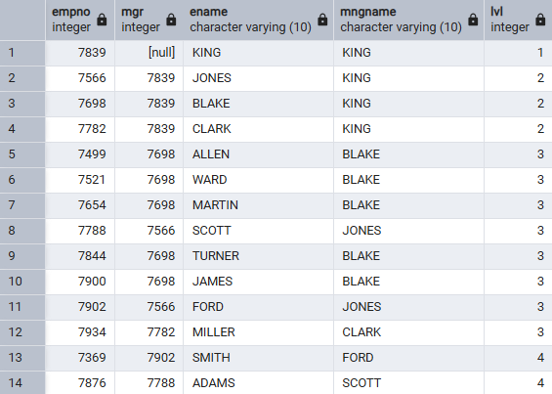
The non-recursive term selects the single row with no manager (KING, lvl = 1) and seeds the working table. Each iteration of the recursive term joins emp back to the current working-table contents (emp_hier) on e.mgr = h.empno, producing every employee whose manager was found in the previous iteration, carrying the manager's name (h.ename) forward as mngname and incrementing lvl. Recursion stops naturally once an iteration produces zero new rows (level 5 would need an employee whose manager is at level 4, and none exists). The output structure matches the example given in the task exactly: empno, mgr, ename, mngname, lvl, ordered from the president downward.

3.2 Task 7: Changing Data CTE
Setup
CREATE TABLE order_log
(
log_id integer primary key generated always as identity,
order_id integer,
order_cost integer,
order_num text,
action_type varchar(1) CHECK (action_type IN ('U','D')),
log_date TIMESTAMPTZ DEFAULT Now()
);

Single data-modifying CTE — update, delete, and log in one statement
WITH updated AS (
UPDATE orders
SET order_cost = order_cost / 2
WHERE order_cost BETWEEN 100 AND 1000
RETURNING order_id, order_cost, order_num
),
deleted AS (
DELETE FROM orders
WHERE order_cost < 50
RETURNING order_id, order_cost, order_num
)
INSERT INTO order_log (order_id, order_cost, order_num, action_type)
SELECT order_id, order_cost, order_num, 'U' FROM updated
UNION ALL
SELECT order_id, order_cost, order_num, 'D' FROM deleted;
All WITH sub-statements in a data-modifying CTE run against the same snapshot of orders, so the DELETE's WHERE order_cost < 50 is evaluated against the original (pre-update) values, not the halved ones — exactly as the courseware warns: PostgreSQL does not support reliably updating and then deleting the same row within one statement, so the update range (100–1000) and the delete threshold (< 50) were kept non-overlapping by design, avoiding any row being touched by both sub-statements.

Verification

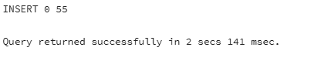

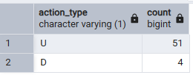
The order_log table now holds one row per changed order: 51 rows with action_type = 'U' carrying the new (post-update) order_cost, and 4 rows with action_type = 'D' carrying the last known order_cost of the deleted rows, each timestamped by log_date. Because the exact order_cost values are seeded from random(), the specific counts (51 / 4, 55 total) will differ on a fresh run of the setup script, but the logic and the resulting log_id / order_id / order_cost / order_num / action_type / log_date structure will always hold.

