POWER BI — LAB REPORT
Task 4: Advanced Reporting Concepts
Author: Mariam Avaliani | Data model: AdventureWorks (FactInternetSales)
In this report, I document how I implemented six advanced reporting features on the AdventureWorks data model that I used in my previous home tasks: Row-Level Security, Bookmarks & Buttons, a dynamic MTD/QTD/YTD view switch, a Decomposition Tree, a report-page tooltip, and an optional custom visual. For each part, I explain what I did and why, and I include screenshots from my own Power BI Desktop file.

1. Row-Level Security (RLS)
✔ COMPLETED — Configured and validated in Power BI Desktop, and published with a member assigned to the role in Power BI Service.

Security pattern
For this task, I chose a static, geography-based security pattern. I noticed that my fact table (FactInternetSales) does not have a Country column directly - it only has a SalesTerritoryKey that connects to the dimension table. So instead of trying to filter the fact table, I applied my RLS rule on DimSalesTerritory, using its SalesTerritoryCountry column. Because DimSalesTerritory is on the "one" side of a one-to-many relationship with FactInternetSales, the filter I set on the dimension table flows down to the fact table automatically, without needing RELATED() or a bidirectional cross-filter.

Role created
Role "Europe"
Table: DimSalesTerritory
Filter: DimSalesTerritoryCountry IN { "France", "Germany", "United Kingdom" }
Manage Roles — visual rule editor: column SalesTerritoryCountry, condition "In", values France / Germany / (United Kingdom).

Screenshot — Validation (View as Roles)
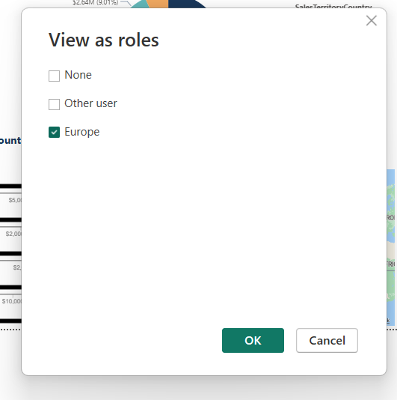
"View as roles" dialog with the Europe role selected.
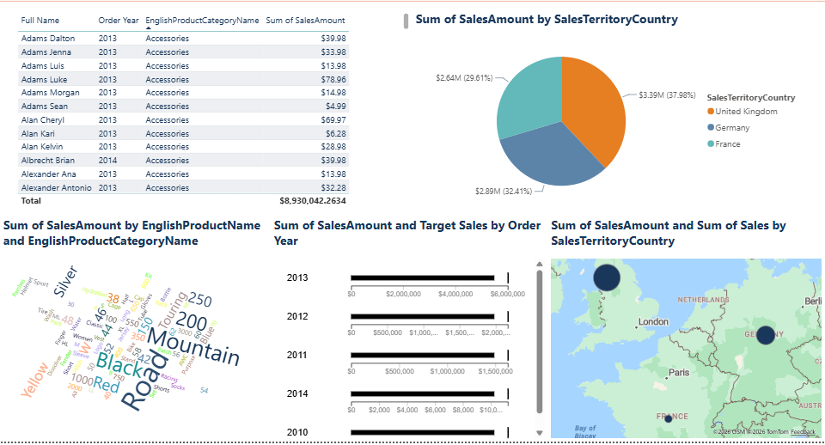
Resulting report page while viewing as the Europe role: the SalesTerritoryCountry pie chart and map now show only France, Germany and United Kingdom — confirming the filter correctly propagated from DimSalesTerritory to FactInternetSales.

Screenshot — Power BI Service (Security)
After publishing the report to Power BI Service, I opened the dataset's Security settings, selected the Europe role, and added my mentor as a member so he can open the report and verify that the row-level filter works correctly for him.
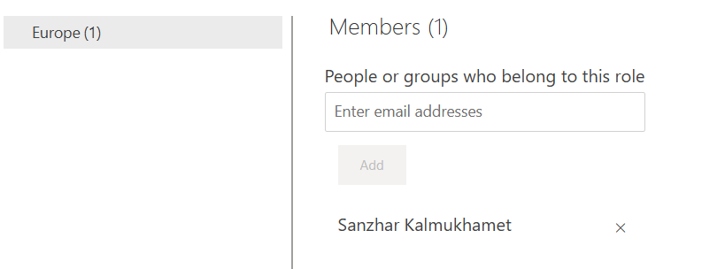
Power BI Service — Security page for the semantic model: the Europe role now has one member, my mentor, added by email.

2. Bookmarks & Buttons — Switching Between Bar Chart and Map
✔ COMPLETED — Configured and validated in Power BI Desktop.
For this task, I decided to add a Map visual next to my existing bar chart on the sales report page, so I could show the same sales data in two different ways in the same area of the page. First, I created two bookmarks: "Bar Chart View", where only the bar chart is visible, and "Map View", where only the map is visible. To control this, I used the Selection pane and turned the visibility (the eye icon) on and off for each visual before saving each bookmark, so every bookmark remembers which visual should be shown.
After that, I added two buttons on the page, named "Bar Chart" and "Map". In the Format pane of each button, under the Action settings, I set the Action type to Bookmark and linked each button to its matching bookmark. Now, when I click the "Bar Chart" button, the report switches to show the bar chart of sales by category, and when I click "Map", it switches to the map of sales by country instead. Both visuals share exactly the same space on the page, and the buttons let the user choose which one they want to look at.

Screenshots
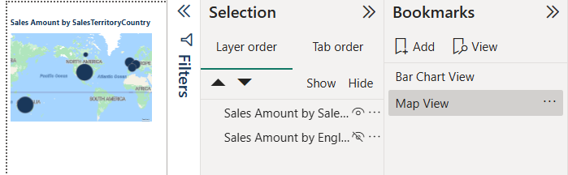
Bookmarks pane with my two bookmarks, "Bar Chart View" and "Map View", together with the Selection pane controlling visual visibility.
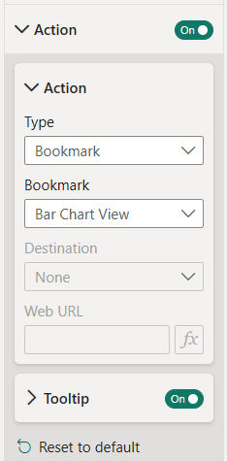
Button Action settings: Type = Bookmark, linked to the "Bar Chart View" bookmark, with Tooltip turned on.
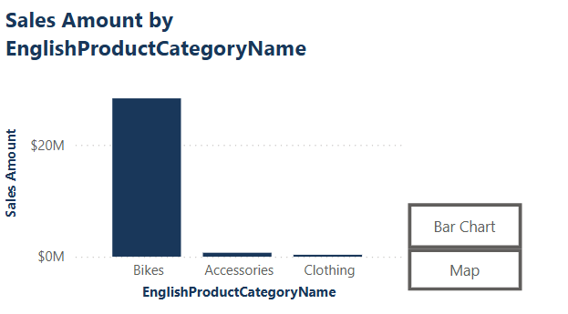
Report page in "Bar Chart View" — the bar chart of sales by category is visible, with the "Bar Chart" and "Map" buttons on the right.
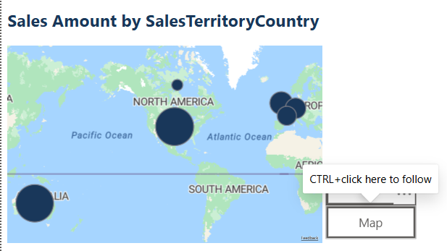
Report page in "Map View" after clicking the "Map" button — the map of sales by country is now visible in the same area.

3. MTD / QTD / YTD View Switch
✔ COMPLETED — Configured and validated in Power BI Desktop.
My report already had a page with a YTD (Year-To-Date) view, using the measure "Sales Amount YTD" and the DimDate[FullDateAlternateKey] column. For this task, I wanted to turn that single YTD page into a page that can show MTD (Month-To-Date), QTD (Quarter-To-Date) or YTD, depending on what the user picks, instead of building three separate pages.
First, I created two new measures using time intelligence functions: "Sales Amount MTD" with TOTALMTD, and "Sales Amount QTD" with TOTALQTD. Then I made a small standalone table called PeriodSelector with one column, Period, and three rows: MTD, QTD, YTD. This table is not connected to anything else in the model - its only job is to let the user pick an option from a slicer. After that, I wrote one more measure, "Sales Amount (Period Selected)", using SWITCH together with SELECTEDVALUE, so it checks which value is currently selected in the Period slicer and returns the matching measure. Finally, I added a Slicer visual using PeriodSelector[Period] on the same page, and I used my new "Sales Amount (Period Selected)" measure in the chart instead of a fixed one.
Now, when I click MTD, QTD or YTD in the slicer, the chart and the numbers on the page update automatically to show the correct period, without me needing to move to a different page or change anything else.

Measures
Sales Amount MTD = TOTALMTD ( [Sales Amount], 'DimDate'[FullDateAlternateKey] )
Sales Amount QTD = TOTALQTD ( [Sales Amount], 'DimDate'[FullDateAlternateKey] )
Sales Amount (Period Selected) =
SWITCH (
SELECTEDVALUE ( PeriodSelector[Period] ),
"MTD", [Sales Amount MTD],
"QTD", [Sales Amount QTD],
"YTD", [Sales Amount YTD],
[Sales Amount YTD]
)

Screenshots
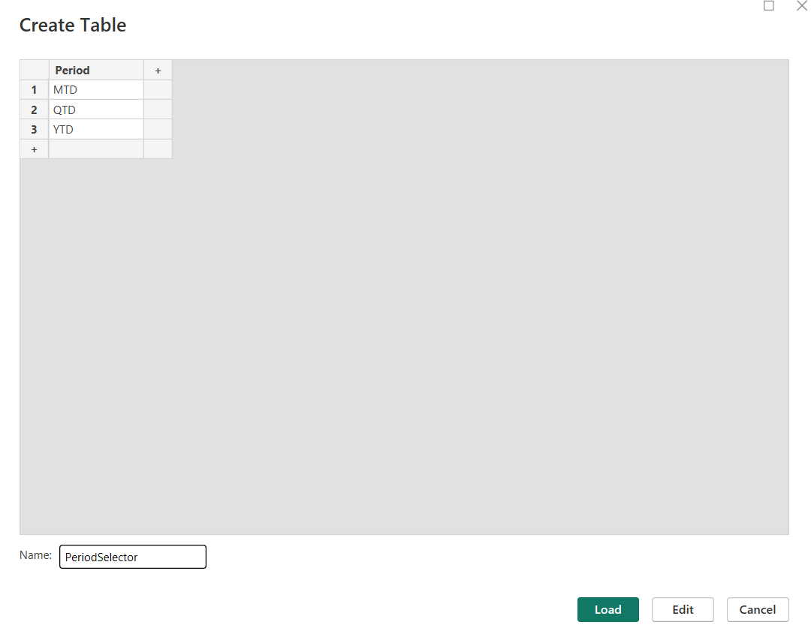
Create Table dialog where I built the standalone PeriodSelector table with the Period column: MTD, QTD, YTD.
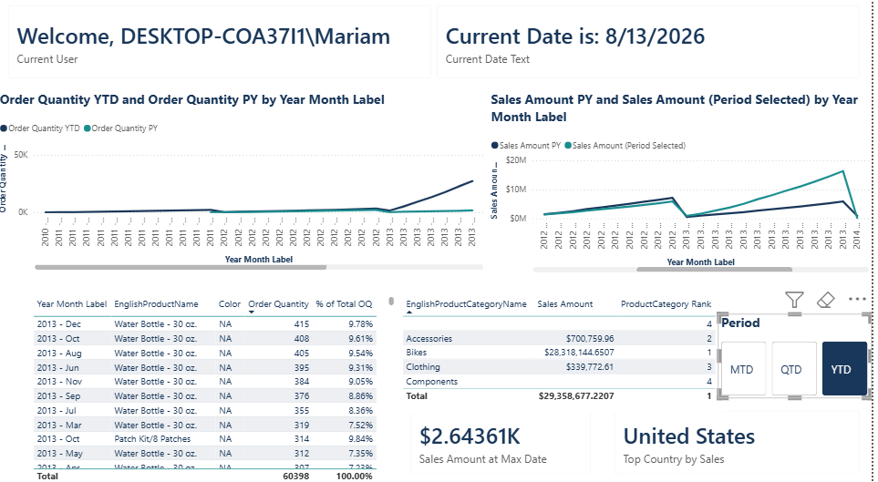
Dashboard with the Period slicer set to YTD - all cards, tables and charts reflect year-to-date values.
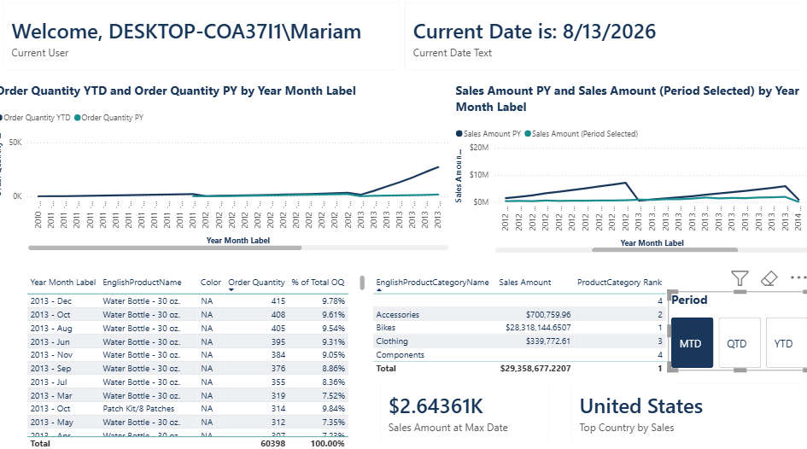
Same page with the Period slicer set to MTD - the visuals update to show month-to-date values instead.
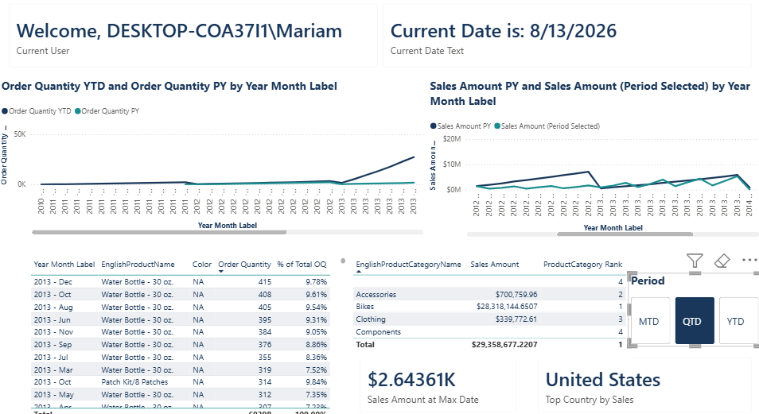
Same page with the Period slicer set to QTD - the visuals now show quarter-to-date values.

4. Decomposition Tree
✔ COMPLETED — Configured and validated in Power BI Desktop.
For the Decomposition Tree, I used "Sales Amount" as the dependent variable (the Analyze field), because it is the main number I want to break down. As independent variables (the Explain by fields), I picked three fields from different dimension tables: Category (from DimProductCategory), Product Name (from DimProduct) and Country (from DimSalesTerritory). I added the visual from the Insert ribbon, because the first time I tried to find it in the Visualizations pane, I accidentally picked a different, similar-looking custom visual, so I made sure to use the real, built-in Decomposition Tree instead.
Once the fields were set, I expanded the tree step by step. First, I expanded by Category, which split the total sales into groups like Bikes, Accessories and Clothing. Then I expanded the Bikes branch by Product Name, and I could see which individual bike models sell the most inside that category. Finally, I expanded one more level by Country, and this showed me that sales are not equal across countries even for the same product - for example, the United States had the highest sales among the branches I checked. This showed me that the Decomposition Tree is a good tool for exploring data from different angles, because I can choose in real time which field to drill into next, without writing any extra DAX.

Screenshots
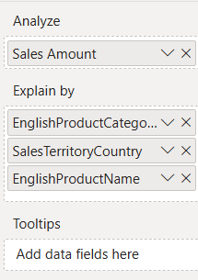
Explain by field list: Analyze = Sales Amount, Explain by = Category, Country, Product Name.
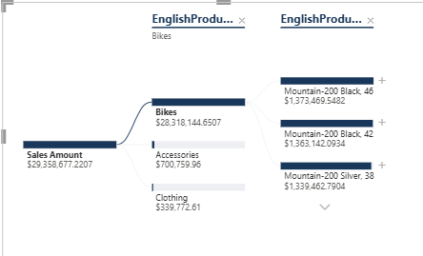
Tree expanded two levels: Sales Amount split by Category (Bikes selected), then by Product Name.
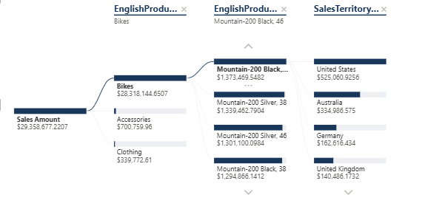
Tree expanded a third level by Country - within the selected product, the United States shows the highest sales.

5. Report-Page Tooltip
✔ COMPLETED — Configured and validated in Power BI Desktop.
For the report-page tooltip, I created a new page and, in the Format pane under Page information, I turned on "Allow use as tooltip". I also changed the Canvas settings Type to "Tooltip", which automatically resized the page to the small default tooltip size of 320 x 240 pixels. On this page, I added two Card visuals: one showing "Sales Amount" and one showing "Sales Amount YTD", so that whenever someone hovers over a data point, they can see both the normal total and the year-to-date total for that same context at the same time.
After the tooltip page was ready, I went to my bar chart visual on the main report page, opened its Tooltips settings in the Format pane, and changed the Type from "Auto" to "Report page", then selected my new tooltip page from the list. At first, the tooltip did not appear when I hovered over the chart, so I checked a few things: I made sure no visual was selected on the page, I hovered directly over a bar instead of the axis or the title, and I checked again that the Page field was not still set to "Auto". After fixing this, the tooltip started working correctly - now, when I hover over a bar in the chart, a small popup appears showing the Sales Amount and Sales Amount YTD values filtered to that specific category, which makes it much faster to compare the two numbers without clicking anywhere.

Screenshots
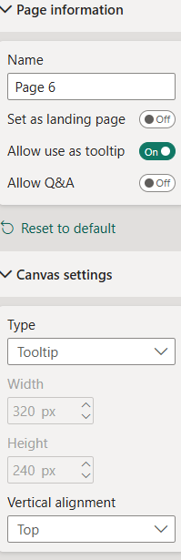
Page information settings for my tooltip page: "Allow use as tooltip" turned On, Canvas Type set to Tooltip (320 x 240).
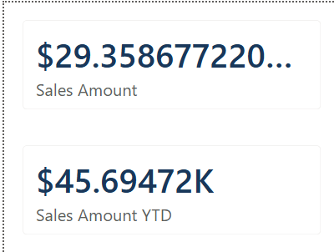
My tooltip page content: two Card visuals showing Sales Amount and Sales Amount YTD.
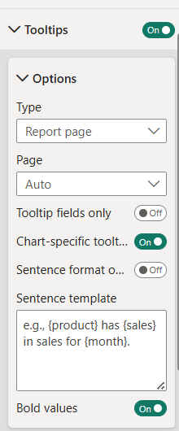
Tooltip settings on the bar chart visual: Type = Report page, with my tooltip page selected instead of Auto.
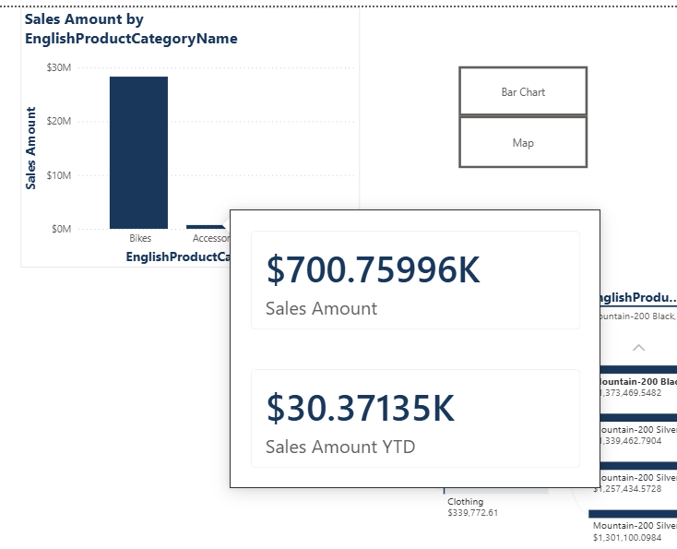
The tooltip working on hover: pointing at a bar shows Sales Amount ($700.76K) and Sales Amount YTD ($30.37K) for that category.

6. Custom Visual (optional)
✔ COMPLETED — Configured and validated in Power BI Desktop.
As an optional extra, I decided to try a custom visual instead of only using the default Power BI visuals. I went to "Get more visuals" and added the Chiclet Slicer from AppSource. I used it on the Period field, from the same PeriodSelector table I built for the MTD/QTD/YTD task, so now instead of a normal slicer, I have a row of clickable tiles labelled MTD, QTD and YTD. I placed it above a line chart that shows Sales Amount by Year Month, connected to the same "Sales Amount (Period Selected)" measure from Section 3.
This means the Chiclet Slicer filters the report in exactly the same way as a normal slicer, but it looks more visual, and it makes it very clear which period is currently selected, because the selected tile is highlighted in a different color. Trying this custom visual helped me understand that Power BI can be extended with community or marketplace visuals when the built-in ones do not give the exact look I want, while they still connect to the data model in the same way as native visuals do.

Screenshots
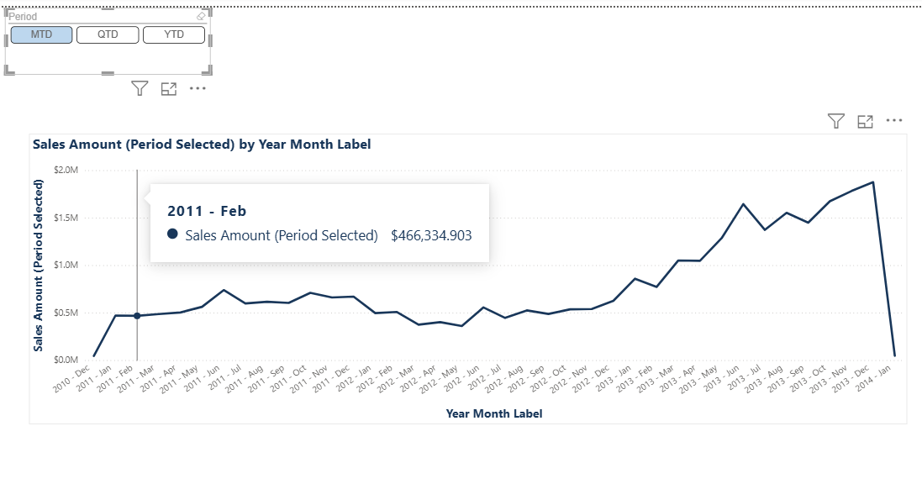
Chiclet Slicer on the Period field (MTD selected) driving the line chart of Sales Amount by Year Month.

Artefacts & Submission
I am submitting the following artefacts together with this report, committed to GitLab:
1. This Word document, with a description and screenshots for each of the six items above.
2. The PBIX file containing the finished report.

