Task 8 – Databricks Overview Homework
Mariam Avaliani | Notebook: databricks_HW_Mariam_Avaliani

For this task, I signed up for Databricks Free Edition, imported the databricks_HW notebook, created a table from the Sales_December_2019.csv file, and completed the 6 PySpark/SQL exercises inside the notebook. Below I explain each step and what I did.

Step 1: Setting up Databricks
I signed up for Databricks Free Edition using my personal email address, as the task asked. After confirming my email, I got access to my own workspace:
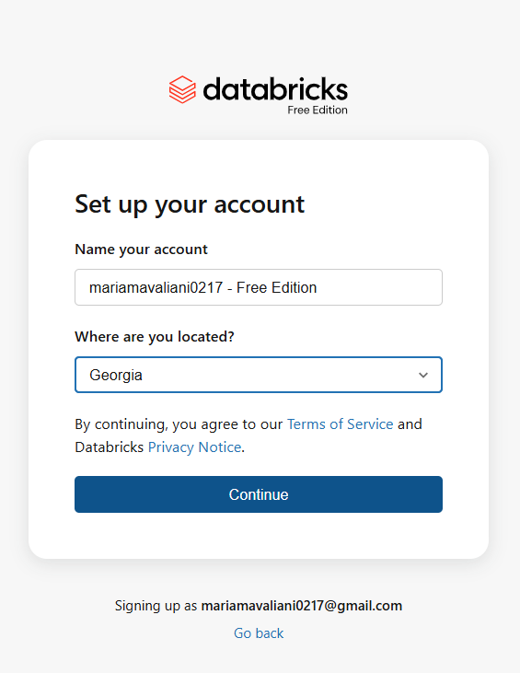
Setting up my Databricks Free Edition account.
Then I imported the databricks_HW.dbc file into my workspace (Workspace → Home → Create → the ⋮ menu → Import), which gave me the notebook with all the task instructions and empty code cells already in place:
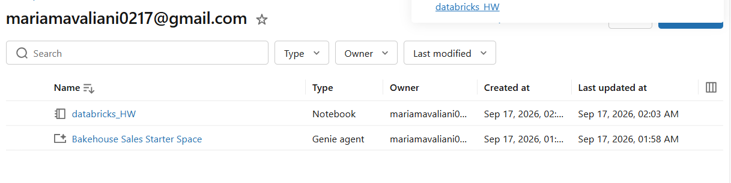
The databricks_HW notebook after importing it into my workspace.

Step 2: Creating the table from the CSV file
I used Catalog → Add data → Create or modify table, and uploaded Sales_December_2019.csv. Databricks read the header row automatically and created a table called sales_december_2019 in the default schema, with the columns Order ID, Product, Quantity Ordered, Price Each, Order Date and Purchase Address. When I checked the table, I noticed that every column was created as a string, including the ones that are actually numbers (Quantity Ordered and Price Each):
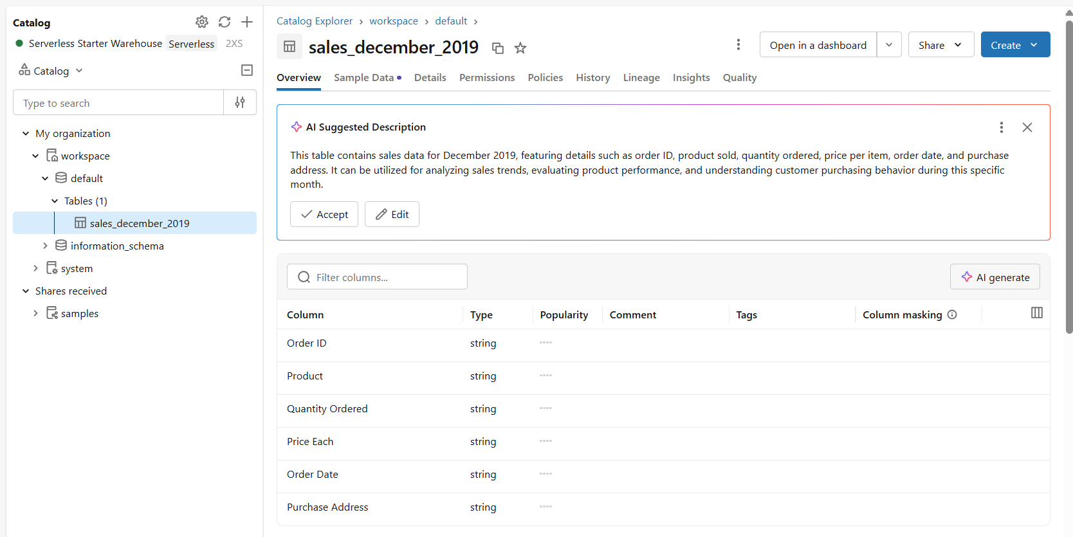
The sales_december_2019 table: all columns loaded as string type.
This is important for later tasks, because I can only calculate sales correctly if these two columns are converted to numeric types first.

Task 1: Reading the table into a DataFrame
The first task was to read the table into a DataFrame with a PySpark SQL query and show the data:
df = spark.sql("SELECT * FROM workspace.default.sales_december_2019")
df.show()

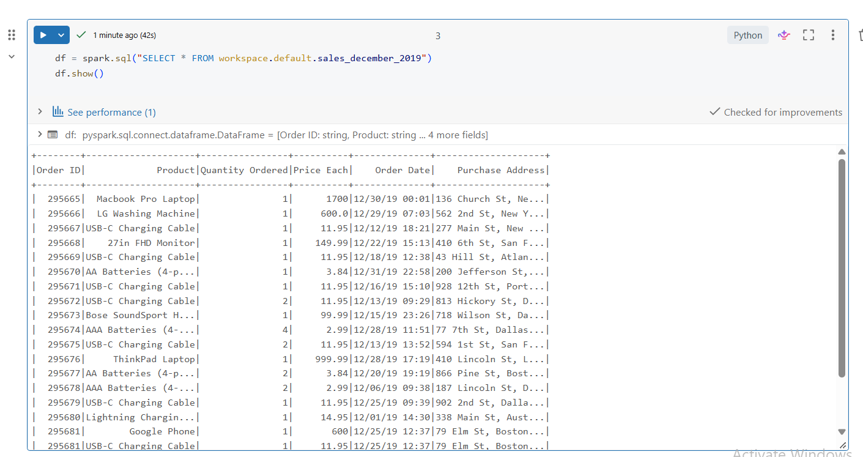
Task 1: the table loaded into a DataFrame and displayed with df.show().

Task 2: Filtering with a widget parameter
For this task I added a widget called Product_name, so the notebook can be parameterized, and used its value to filter the DataFrame:
dbutils.widgets.text("Product_name", "iPhone")
product_name = dbutils.widgets.get("Product_name")

filtered_df = df.filter(df.Product == product_name)
filtered_df.show()

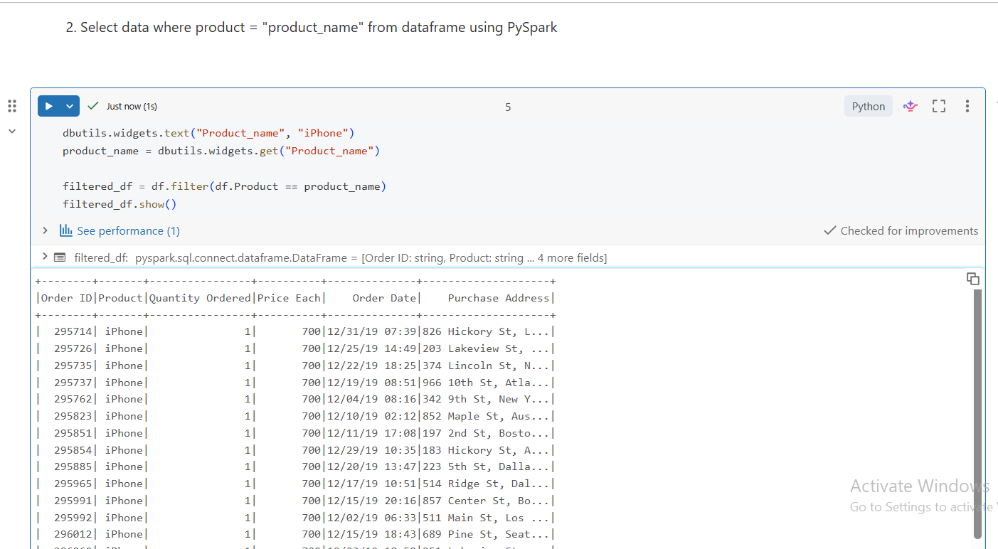
Task 2: rows filtered by the Product_name widget (set to “iPhone”).

Task 3: Calculating sales per product
For this task, I first had to cast Quantity Ordered and Price Each to numeric types, then group the data by product to calculate total sales and total quantity sold. My first attempt used a normal cast() and failed:
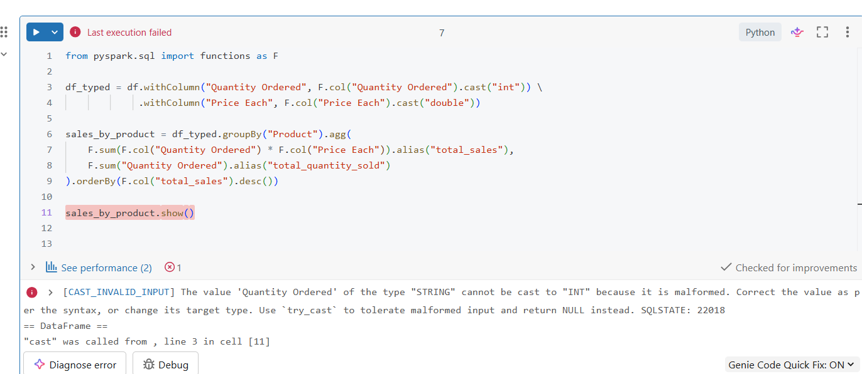
First attempt: cast() fails because some rows contain the literal text “Quantity Ordered” instead of a number.
The error message explained the reason: this CSV has a few rows where the header line is repeated as if it were data, so a plain cast to int or double fails on those rows. I fixed this by using try_cast instead of cast, which turns any value it cannot convert into NULL instead of raising an error (and NULL values are simply ignored by sum()):
from pyspark.sql import functions as F

df_typed = df.withColumn("Quantity Ordered", F.expr("try_cast(`Quantity Ordered` as int)")) \
.withColumn("Price Each", F.expr("try_cast(`Price Each` as double)"))

sales_by_product = df_typed.groupBy("Product").agg(
F.sum(F.col("Quantity Ordered") * F.col("Price Each")).alias("total_sales"),
F.sum("Quantity Ordered").alias("total_quantity_sold")
).orderBy(F.col("total_sales").desc())

sales_by_product.show()

After this fix, the aggregation ran correctly and showed the total sales and quantity sold for every product, sorted from the highest to the lowest total sales (Macbook Pro Laptop was the top seller by revenue).

Task 4: Data profiling
The task asked for row count, minimum and maximum values for each column. I first tried the special Databricks command dbutils.data.summarize(), but it is not supported on serverless compute:
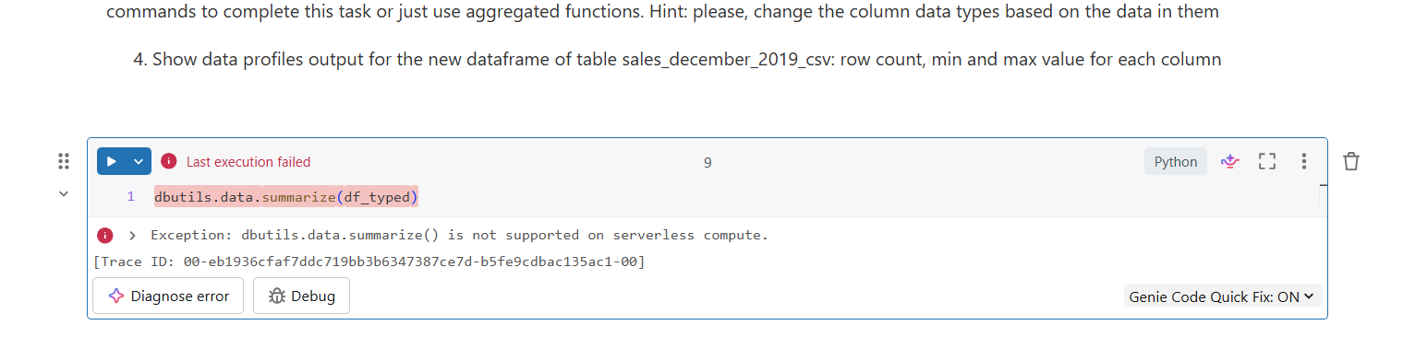
dbutils.data.summarize() is not available on serverless compute.
So I used the built-in DataFrame function summary() instead, which is a normal aggregated-functions approach and gives exactly what was asked — count, min and max for every column:
df_typed.summary("count", "min", "max").show()

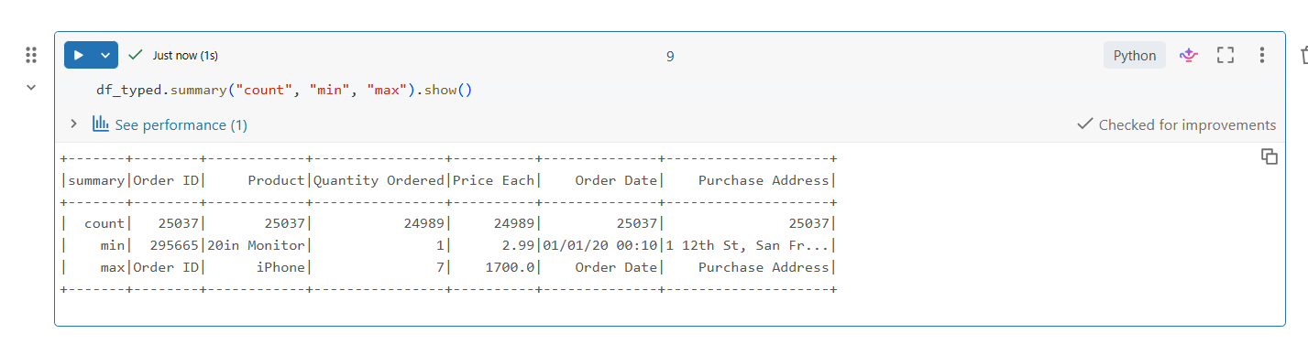
Task 4: row count, min and max for every column.
I noticed that Quantity Ordered and Price Each have a slightly lower count than the other columns (24989 instead of 25037) — this matches the malformed rows I found in Task 3, which try_cast turned into NULL and count() does not count NULLs.

Task 5: Adding a new column
I added a new column called data_source with a fixed default value, to mark where this data came from:
df_with_flag = df_typed.withColumn("data_source", F.lit("Sales_December_2019"))
df_with_flag.show()

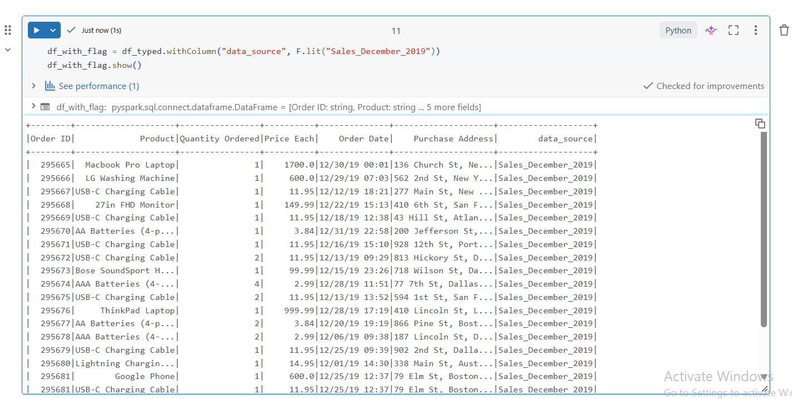
Task 5: the new data_source column added with the same value on every row.

Task 6: Temporary view and SQL query
For the last task, I created a temporary view from the DataFrame built in the previous task, so it can be queried with plain SQL:
df_with_flag.createOrReplaceTempView("sales_december_view")

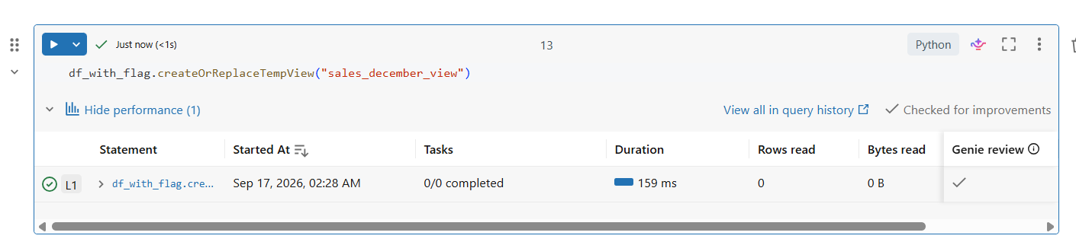
The temporary view sales_december_view created successfully.
Then, in a separate %sql cell, I ran a SELECT against this view. Because the column names Quantity Ordered and Price Each contain spaces, I had to wrap them in backticks in the SQL text:
%sql
SELECT Product, `Quantity Ordered`, `Price Each`, data_source
FROM sales_december_view
ORDER BY `Price Each` DESC
LIMIT 10

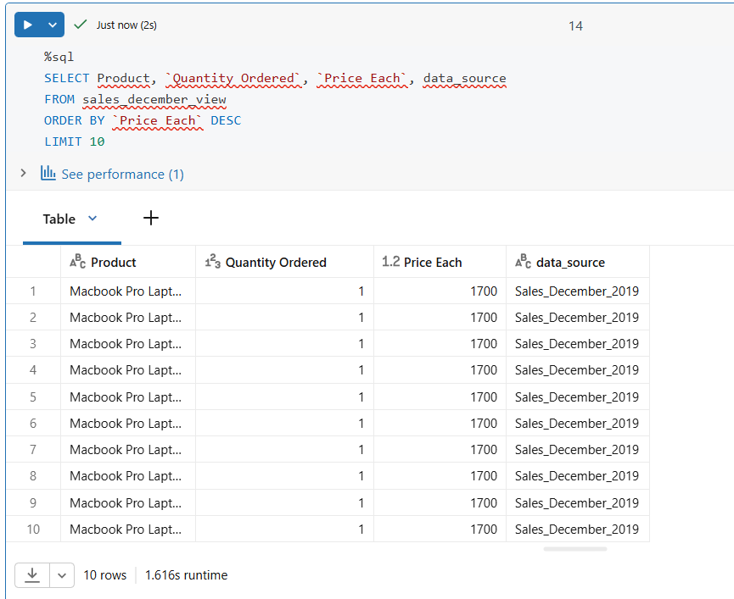
Task 6: top 10 rows by price, read from the temporary view with SQL.

Key points
Column types: the CSV loaded every column as a string by default, so before I could do any math (Task 3) or meaningful min/max profiling (Task 4) on Quantity Ordered and Price Each, I had to cast them to numeric types.
Malformed data: this dataset has a few rows where the header text is repeated as a data row. A plain cast() fails on these rows, so I used try_cast(), which converts anything it cannot parse into NULL instead of stopping the whole query. sum() and count() then simply ignore those NULLs.
Serverless limitations: not every Databricks command works the same way on serverless compute — dbutils.data.summarize() is not supported there, so I used the plain DataFrame function summary() instead, which gave the same information (count, min, max) in a supported way.
Notebook cells and shared state: every code cell in the notebook shares the same session, so a DataFrame created in one cell (like df, df_typed or df_with_flag) stays available and can be reused directly in the next cells, without recreating it.

