Task 7 – Optional Task: SQL Queries from S3
Mariam Avaliani | IAM role used: dilab-lambda-sf-role

For the optional part of Task 7, I moved the two hardcoded SQL queries (the SELECT used by mariam_avaliani_sf_test and the UPDATE used by mariam_avaliani_sf_update) into a small JSON file on S3, and changed both Lambdas to read their query from that file instead of having it written directly in the code.

Step 1: Creating and uploading the queries file
I created a file called queries.json with both queries as key-value pairs, and uploaded it to my existing S3 bucket, under a new lambda-queries/ folder:
{
"test_query": "SELECT status FROM lambda_iceberg WHERE id = 1",
"update_query": "UPDATE lambda_iceberg SET status = 'processed' WHERE id = 1"
}

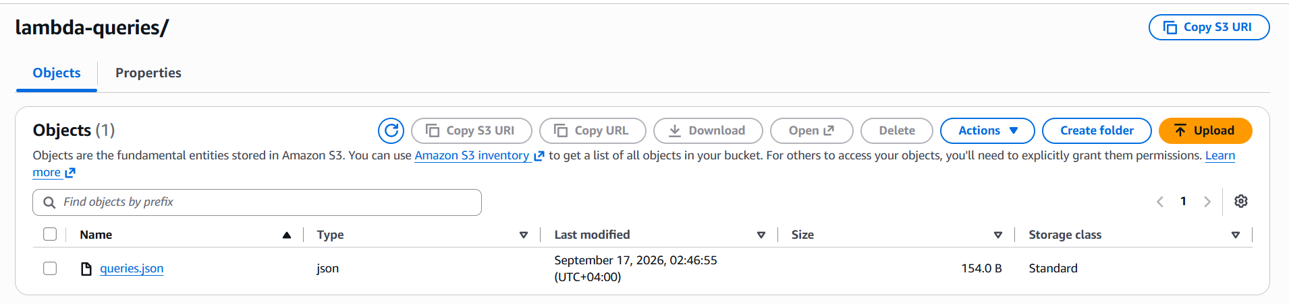
queries.json uploaded to s3://.../lambda-queries/.

Step 2: Reading the query from S3 in both Lambdas
I added a small load_query() helper to both Lambdas, which reads this file from S3 with boto3, parses it as JSON, and returns the query text for the key I ask for ("test_query" or "update_query"):
def load_query(query_name):
s3 = boto3.client("s3")
obj = s3.get_object(Bucket=QUERIES_BUCKET, Key=QUERIES_KEY)
queries = json.loads(obj["Body"].read())
return queries[query_name]

In mariam_avaliani_sf_test, the hardcoded query string was replaced with query = load_query("test_query"), and in mariam_avaliani_sf_update with query = load_query("update_query"). No other logic changed — the rest of both functions (starting the Athena query, polling until it finishes, reading the result) stayed the same. I tested both functions separately, and the CloudWatch logs confirm the query text now comes from S3, not from the code:
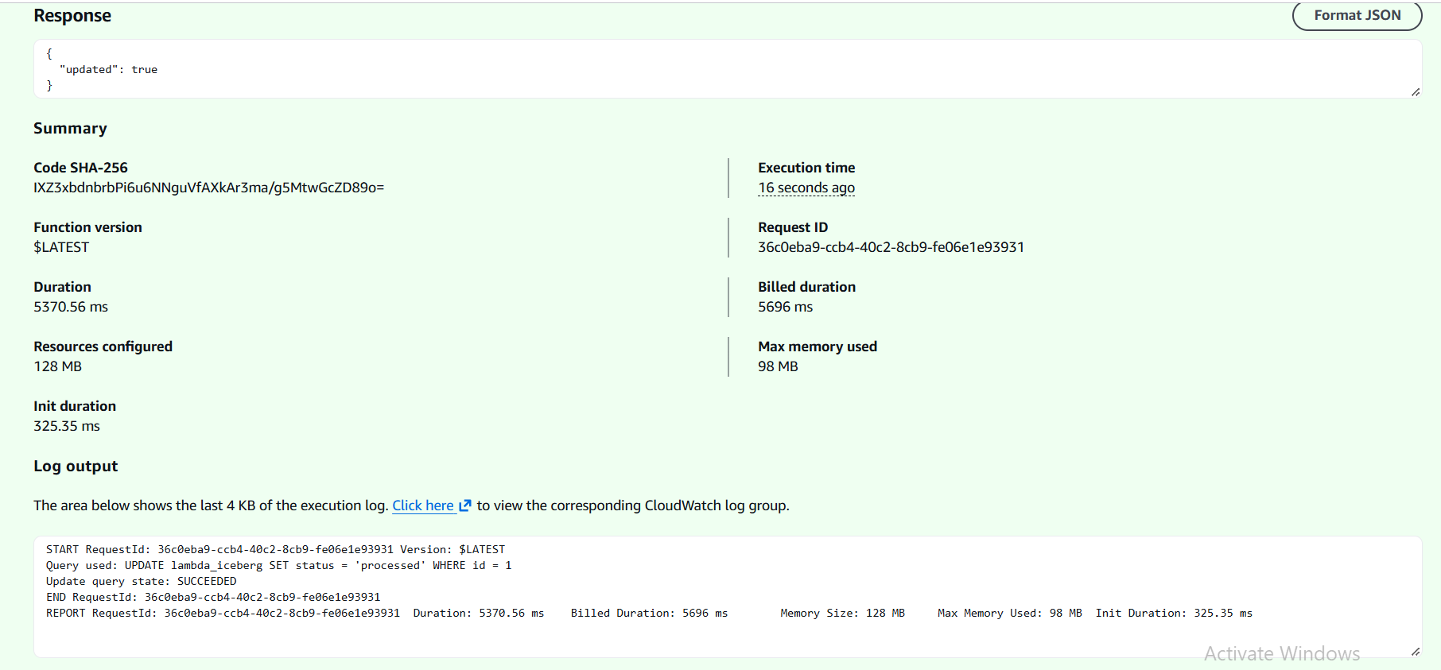
mariam_avaliani_sf_update: the UPDATE query loaded from S3 and executed successfully (visible in the log output).

Step 3: Running the full Step Function again
Finally, I reset the row back to status = 'pending' in Athena and ran the whole Step Function again from the start, to make sure the S3-based Lambdas still work correctly end to end:
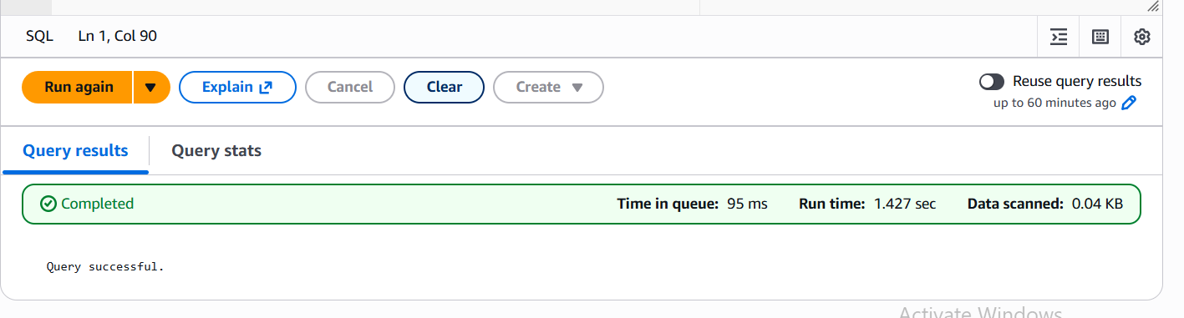
Resetting the row to 'pending' before the final run.
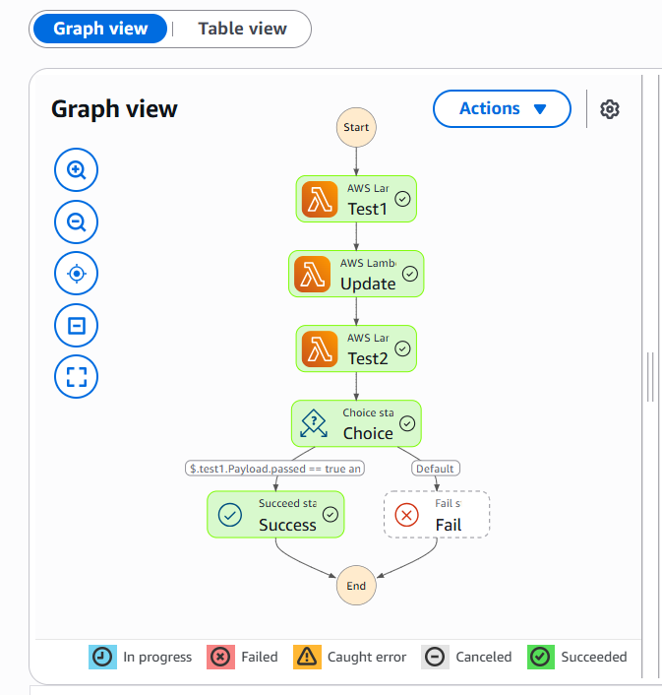
Full execution with the updated Lambdas: Test1 -> Update -> Test2 -> Choice -> Success.
The workflow completed successfully, which confirms that reading the query from S3 instead of hardcoding it did not change the behavior of the pipeline — only where the query text comes from.

Key point
Externalizing SQL queries: moving the SQL text out of the code and into a JSON file on S3 means the query can be changed later without redeploying the Lambda — the function only needs permission to read one object from S3 and knows which key to ask for.

