Power BI Lab Report
Task 1 – Introduction to Power BI
Mariami Avaliani

1. Installing the necessary tools
Before I started the report I installed all the tools that were needed. First I downloaded and installed Power BI Desktop and logged in with my EPAM account. After that I installed SQL Server Management Studio (SSMS). I used the newest version of SSMS, version 22, because the link from the instructions was already redirecting to it, and I checked that this newer version works the same way for this task, so it was not a problem.
Because I did not have any local SQL Server on my computer, I also had to install SQL Server Express first, because SSMS by itself is only a tool to manage a database, it is not a database engine. After the installation finished, my local server instance was called localhost\SQLEXPRESS.
Then I downloaded the AdventureWorksDW2017.bak file and restored it as a database in SSMS, using the Restore Database option and choosing the .bak file as a device. During the restore I also had a small issue with the SSL certificate (the server was not trusted), so I had to enable the "Trust Server Certificate" option, and after that the connection worked and the database restored successfully.

2. Building the report and loading data
I opened Power BI Desktop and used Get Data -> SQL Server database. I entered the server name localhost\SQLEXPRESS and left the database field empty. For the Data Connectivity mode I chose Import. When I connected, I also got a message about encryption, so I clicked OK to continue without an encrypted connection, which is normal for a local development server.
In the Navigator window I selected the FactInternetSales table and then clicked "Select Related Tables" so all the connected dimension tables were added automatically. After that I clicked Transform Data to open the Power Query Editor.

3. Basic data transformations

3.1 Creating a Full Name column
In the DimCustomer table I duplicated the First Name and Last Name columns, selected both new columns and used Merge Columns with a space as the separator. I named the new column "Full Name".

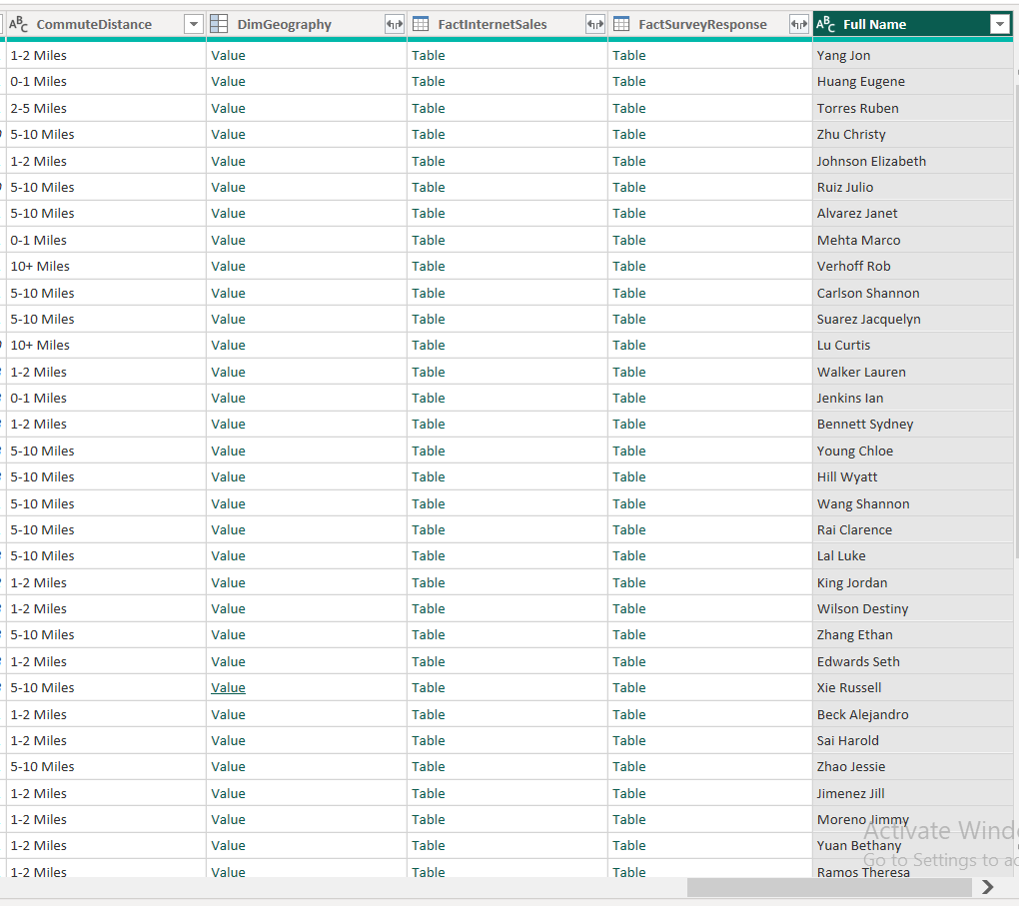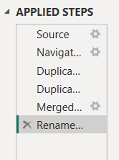

3.2 Changing the DiscountPct column type
In the DimPromotion table I changed the data type of the DiscountPct column to Percentage.

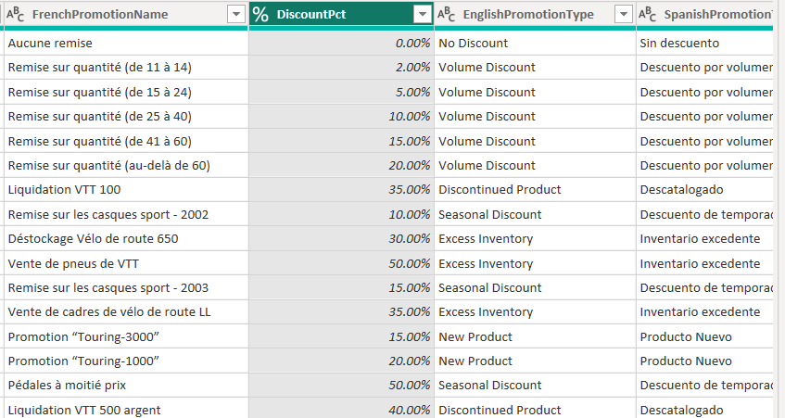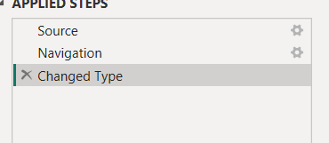

3.3 Calculating the length of the promo campaign
I used a Custom Column in the DimPromotion table with the formula [EndDate] - [StartDate], and named the column "Promotion, days". The result was in Duration format, so after that I also changed the column type to Whole Number, to get a clean number of days instead of a duration.

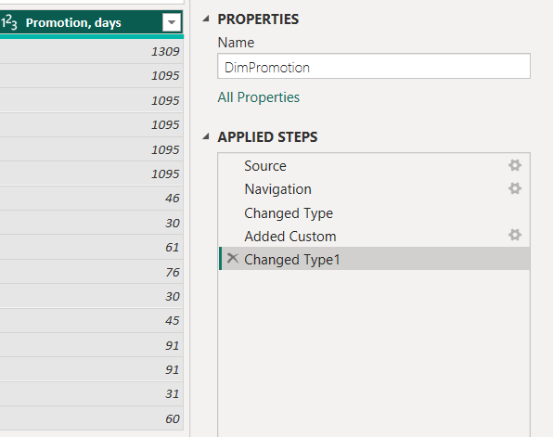

4. Adding new tables
I loaded two more tables from the AdventureWorks database, DimProductSubcategory and DimProductCategory, the same way I loaded the first tables, with Get Data -> SQL Server database.

5. Data profiling
On the View tab I turned on Column Quality, Column Distribution and Column Profile. This shows small statistics under every column header, like how many values are valid, how many are empty, how many distinct values there are and so on.

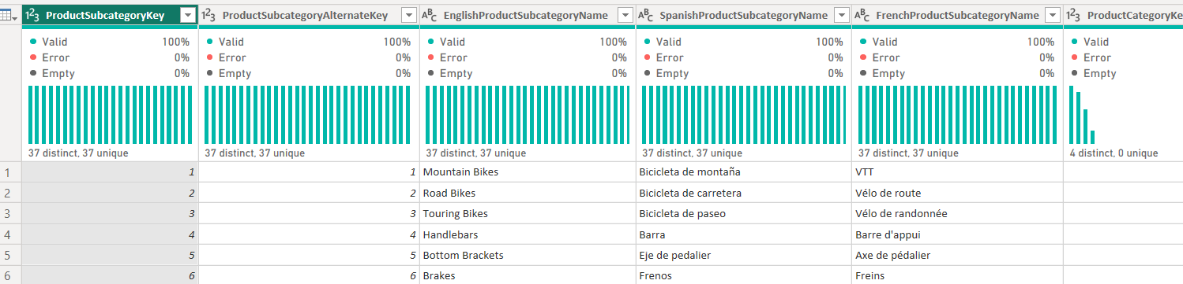
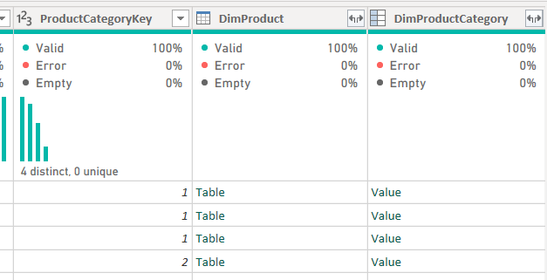
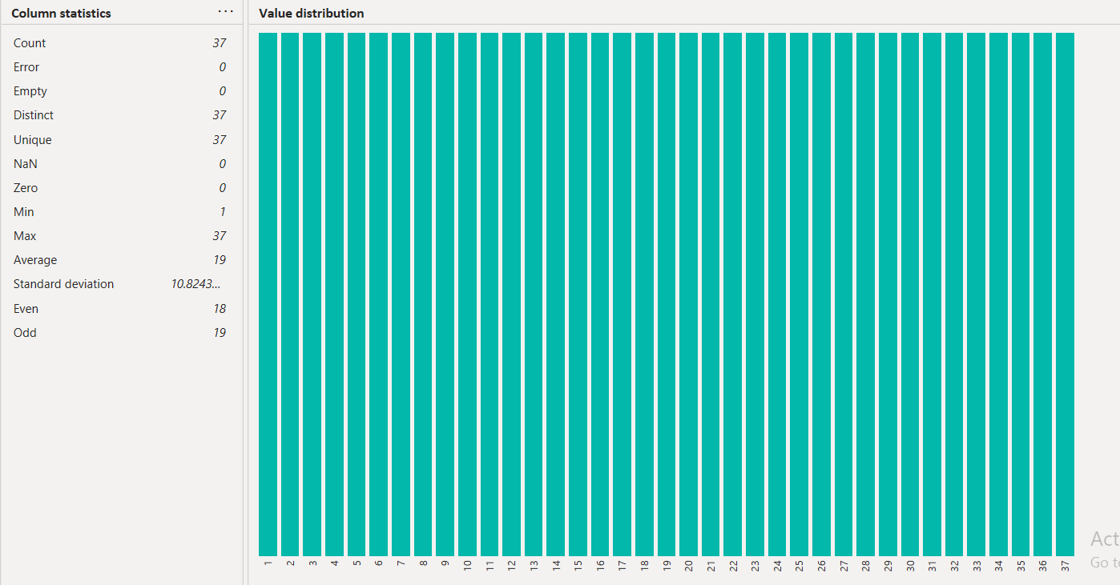

6. Pivot column

6.1 Order Year column
In the FactInternetSales table I added a custom column called "Order Year" with the formula Date.Year([OrderDate]), to get the year from the order date.

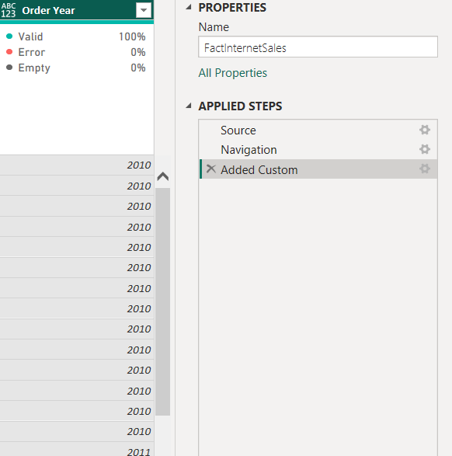

6.2 SalesByYearsNPrice table
I right-clicked FactInternetSales and chose Reference to create a new table, and renamed it to SalesByYearsNPrice. In this table I kept only four columns: Order Year, OrderQuantity, DiscountAmount and SalesAmount, and removed all the other columns.

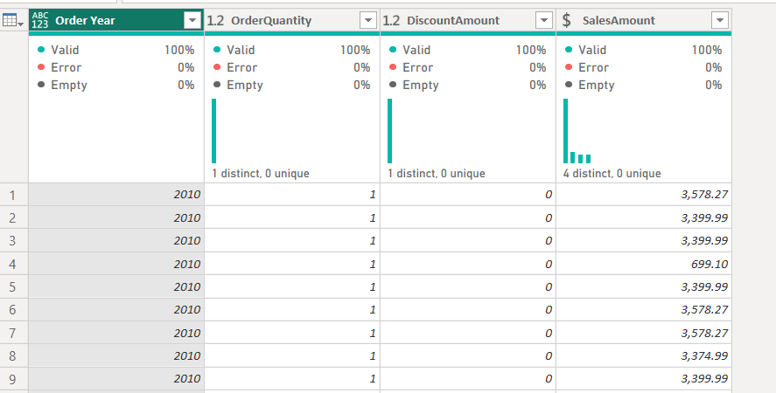

6.3 Pivoting Order Year
I selected the Order Year column and used Transform -> Pivot Column, with Values Column set to SalesAmount. After this, every year became a separate column, and the values are the sum of sales for that year.

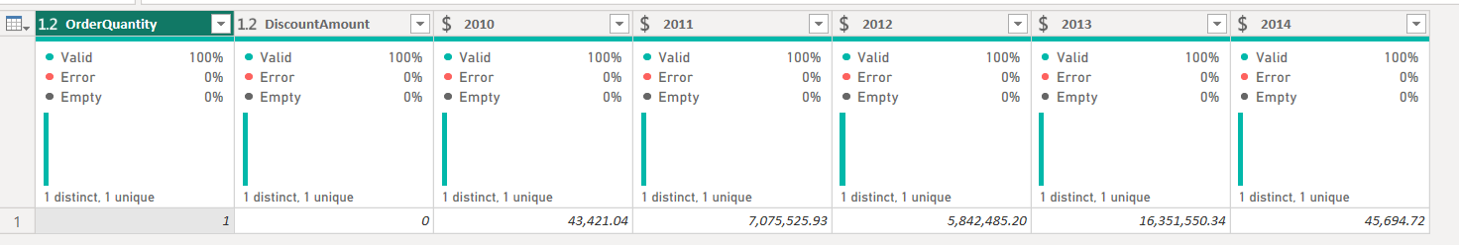

7. Table joining
I created another table from FactInternetSales the same way as before (using Reference) and named it SalesByCountry. This time I kept the columns ProductKey, Order Year, SalesAmount and SalesTerritoryKey.
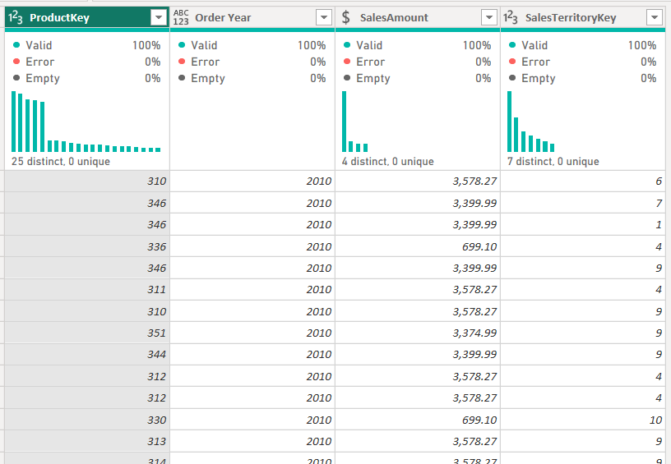
To get the country, I merged SalesByCountry with DimSalesTerritory, using SalesTerritoryKey as the connecting column and a Left Outer join, and then expanded only the SalesTerritoryCountry column.
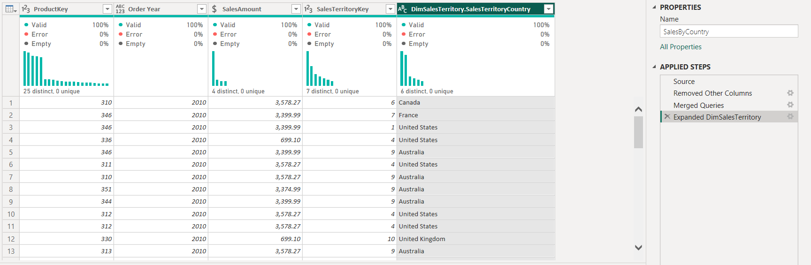
Getting the product category was more difficult, because ProductKey does not connect to DimProductCategory directly. I had to join three tables one after another: first DimProduct (to get ProductSubcategoryKey), then DimProductSubcategory (to get ProductCategoryKey), and finally DimProductCategory (to get EnglishProductCategoryName). Every time I used a Left Outer join and expanded only the one column I needed, so the table did not become too wide.

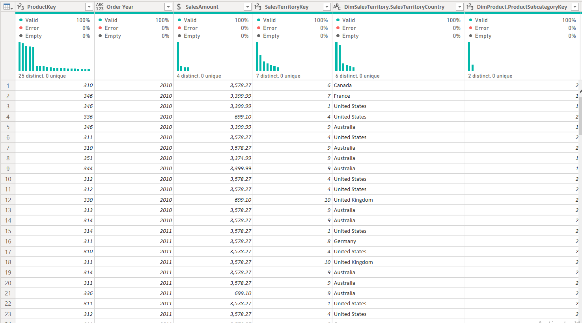
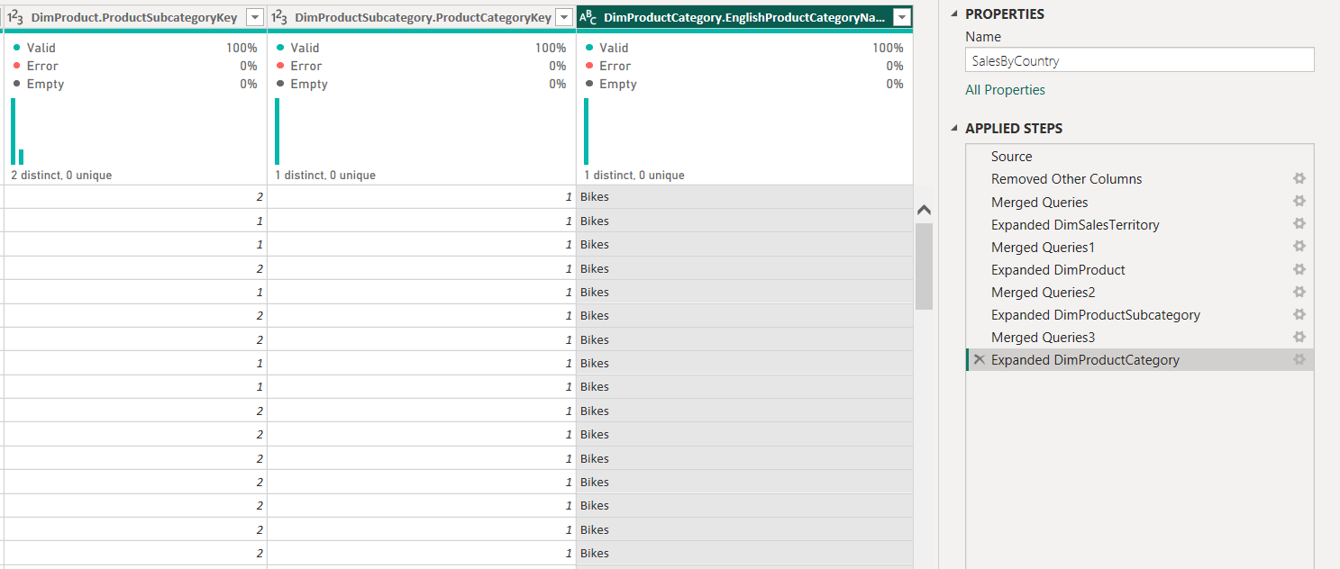

8. Grouping data
I used Transform -> Group By with the Advanced option, and grouped the data by three columns: Order Year, SalesTerritoryCountry and EnglishProductCategoryName. I called the new column "Sales", the operation was Sum and the column was SalesAmount. After that I sorted the table by Order Year.

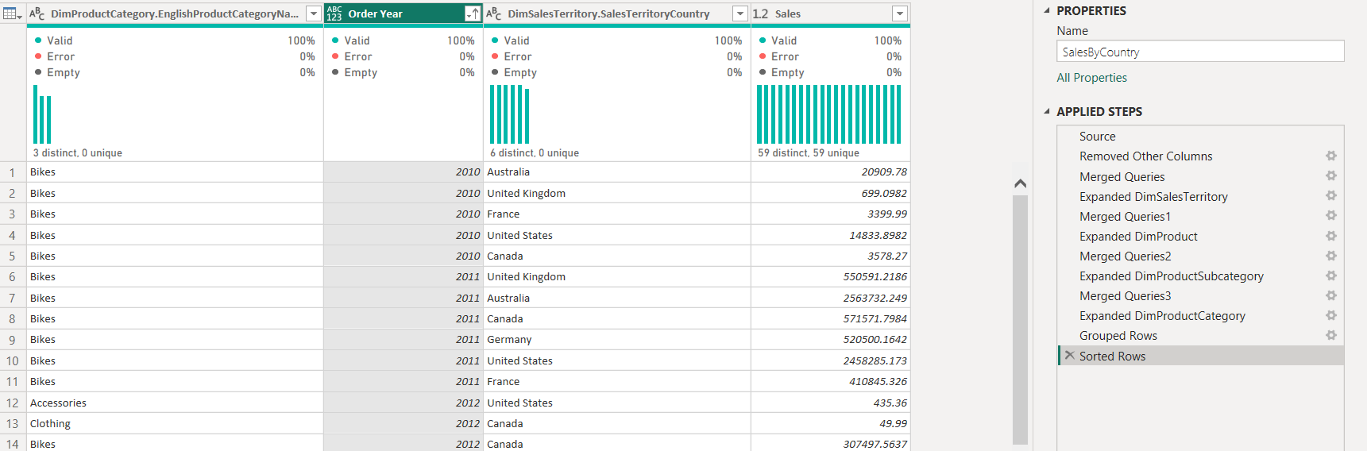

9. Loading the data into the report
When all the transformations were ready, I clicked Close & Apply on the Home tab, and Power BI loaded all the tables into the report. Then I saved the file with File -> Save As, using the name PowerBILab1_Avaliani.

10. Import vs DirectQuery
I also created a second, separate .pbix file and connected to the same database, but this time I chose DirectQuery instead of Import as the connectivity mode.
The difference between the two modes is quite clear. With Import, Power BI copies all the data into its own memory, so the report is very fast, but the data is only as fresh as the last refresh, and I could use all the Power Query transformation tools without any limits. With DirectQuery, Power BI does not store any data locally, every visual sends a query directly to the SQL Server database, so the data is always up to date, but it can be slower, and a lot of the transformation options in Power Query are not available or are greyed out. At the bottom of the Power BI Desktop window there is also a "Storage Mode" indicator that shows DirectQuery, which confirms which mode the file is using.

11. Working with the Power BI model
I opened the Modelling view and checked the relationships that Power BI created automatically when the data was loaded. Between FactInternetSales and DimDate there was more than one possible relationship, because the fact table has several date fields (order date, due date, ship date). Since OrderDate is the date I use for the analysis in this report, I removed the other relationships between FactInternetSales and DimDate and made sure that only the OrderDateKey relationship stays, and that this relationship is active.

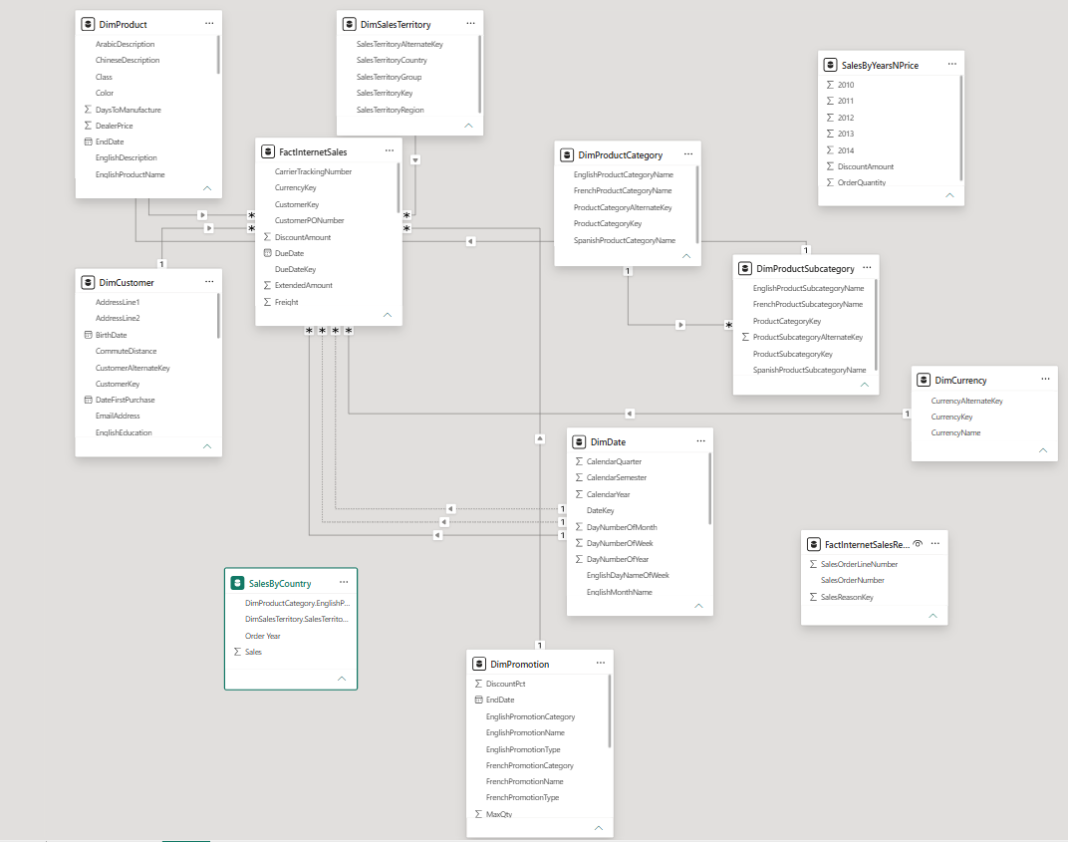
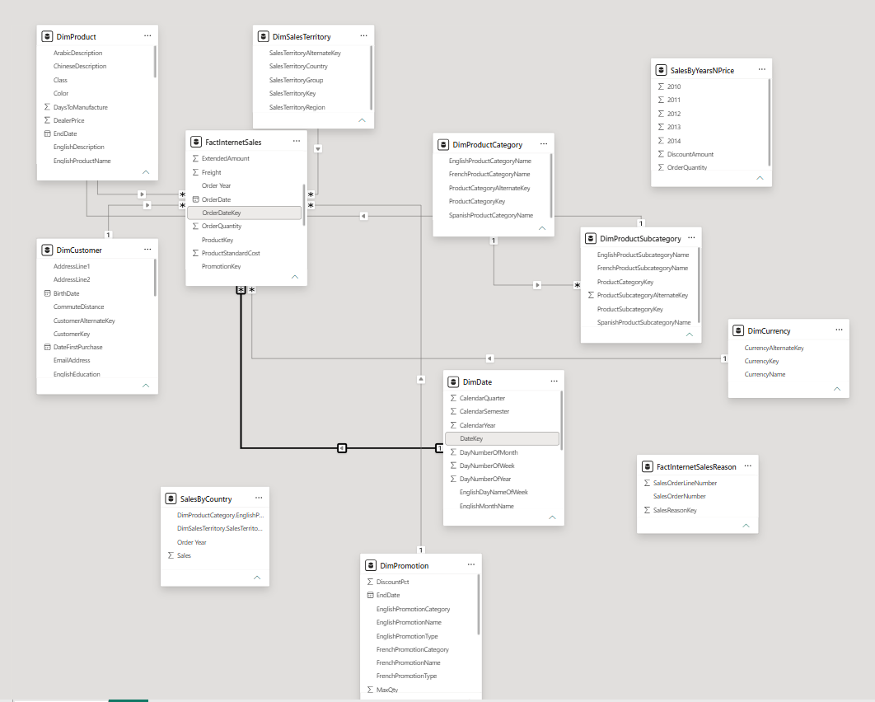

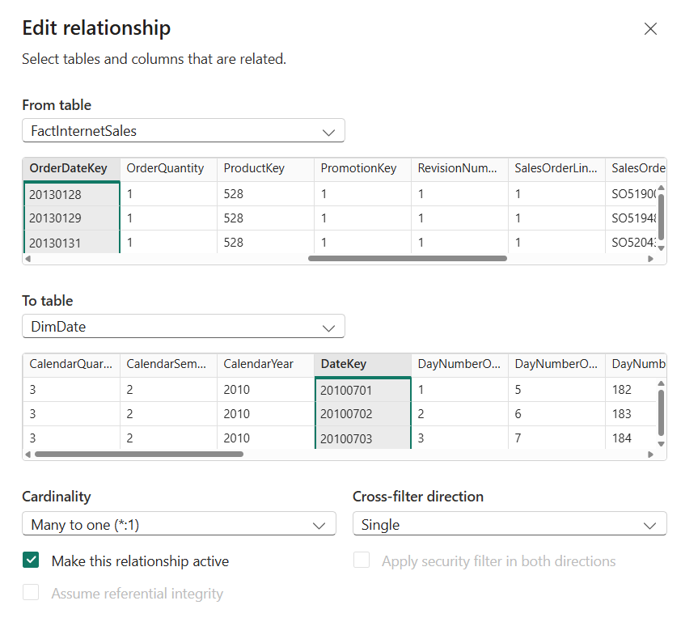

Conclusion
In this lab I installed and connected Power BI Desktop with a local SQL Server database, made several transformations in Power Query (creating columns, changing types, joining tables, grouping data), compared Import and DirectQuery connectivity modes, and checked the relationships in the data model. All the steps from the task were completed and the final report was saved as PowerBILab1_Avaliani.pbix.

