Task 7 – AWS for Data Quality Engineers
Mariam Avaliani | IAM role used for all Lambdas and the Step Function: dilab-lambda-sf-role

Task 1a – AWS Lambda: parsing a test JSON event
For the first part of the task, I created my first Lambda function and used it to read a test JSON event and print each value to the logs.

Step 1: Creating the function
I created the function with the name mariam_avaliani_test1. This name follows the mask required by the task: <name>_<surname>_<anything>. I chose Python as the runtime and, in the Permissions section, I selected "Use an existing role" and chose dilab-lambda-sf-role, because this role is required for both this Lambda and the Step Function later.
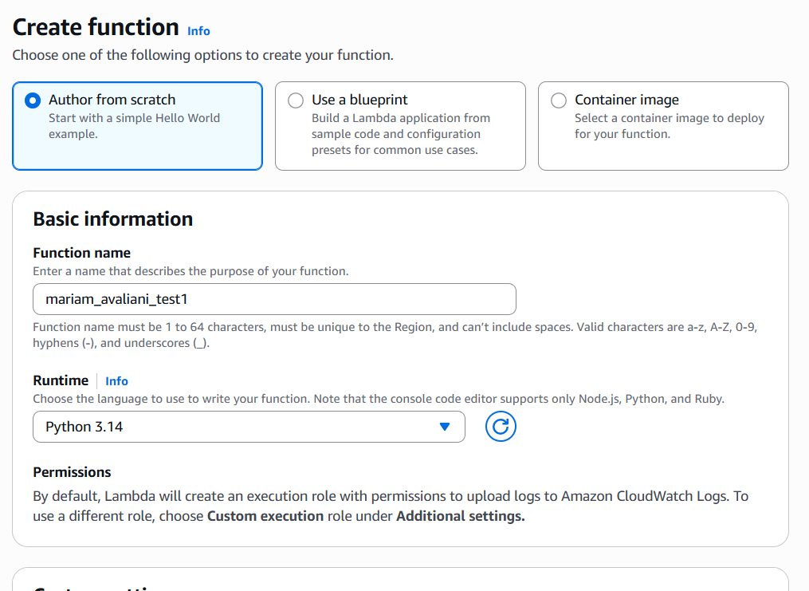
Creating the function: name and runtime configuration.

Step 2: Writing the code
In the code editor, I replaced the default code with the following:
import json

def lambda_handler(event, context):
for key, value in event.items():
print(f"Value for the key {key} is - {value}")
return event

This function reads the incoming event as a dictionary, loops over each key and value, prints them, and returns the same event back as the response.
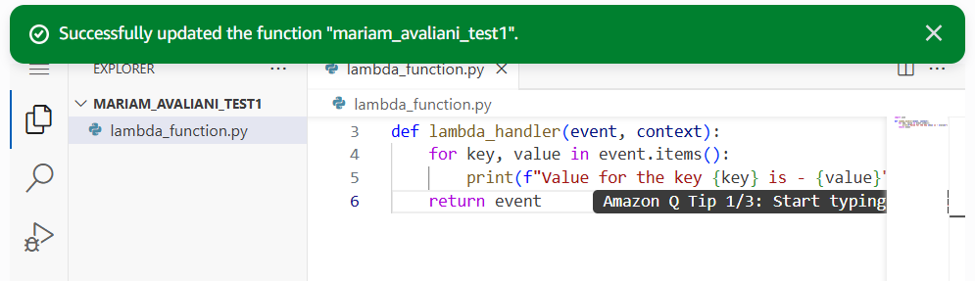
The function deployed successfully with the code above.

Step 3: Testing
I created a test event using the default "hello-world" template, which already contains the exact structure the task asked for:
{"key1": "value1", "key2": "value2", "key3": "value3"}

I ran the test. The Response shows the same JSON returned by the function:
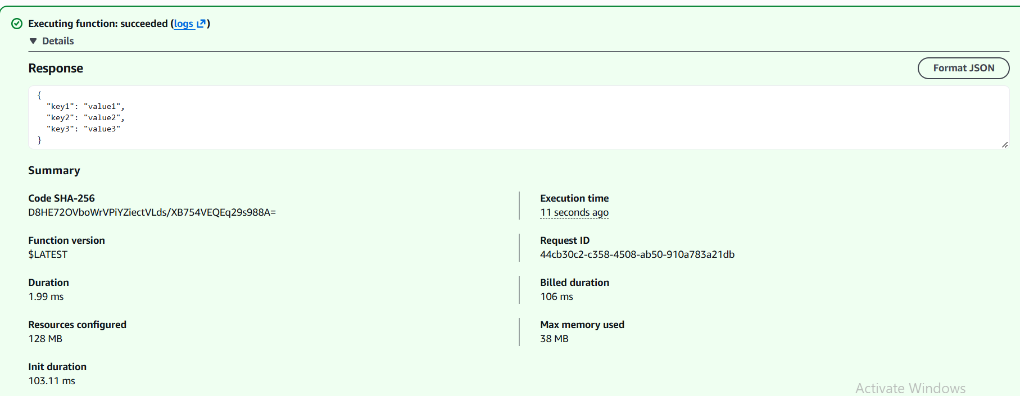
Response after running the test.
And the Function Logs show each key printed in the expected format:
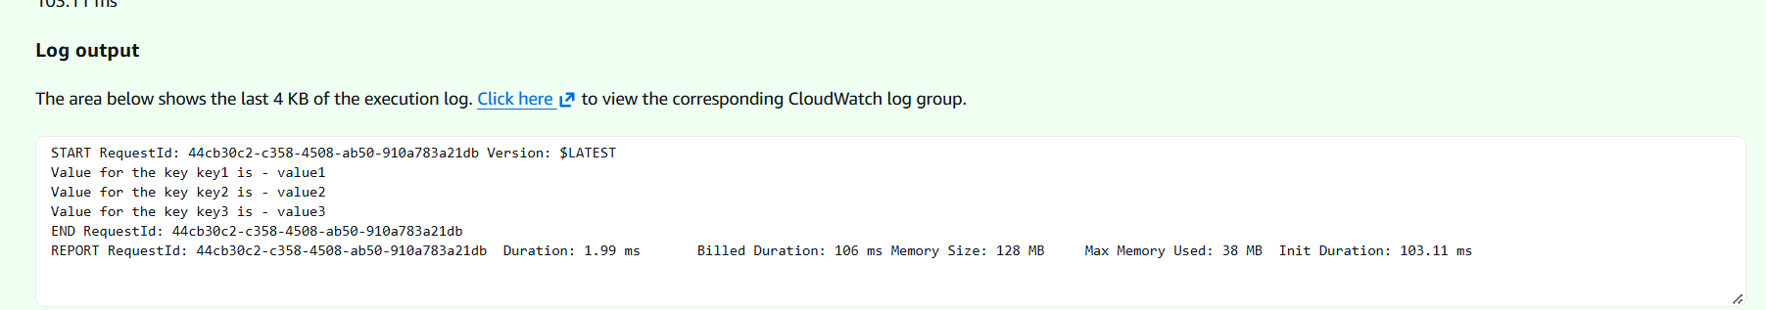
Function Logs: every key from the test event is printed.

Task 2 – Step Function: testing a table before and after an update
For this task, I built a Step Function with three Lambda steps: a first test, an update, and a second test. If both tests pass, the Step Function finishes successfully; otherwise, it fails. I used the same execution role (dilab-lambda-sf-role) for the Lambdas and for the state machine.

Step 1: Checking the reference Lambda's network settings
The task note said that the Step Function's Lambdas need a Layer, VPC, subnets, and a security group, and that these can be found on the existing function dq_lambda_example. I opened that function's Configuration tab and checked its VPC settings and its Layers.
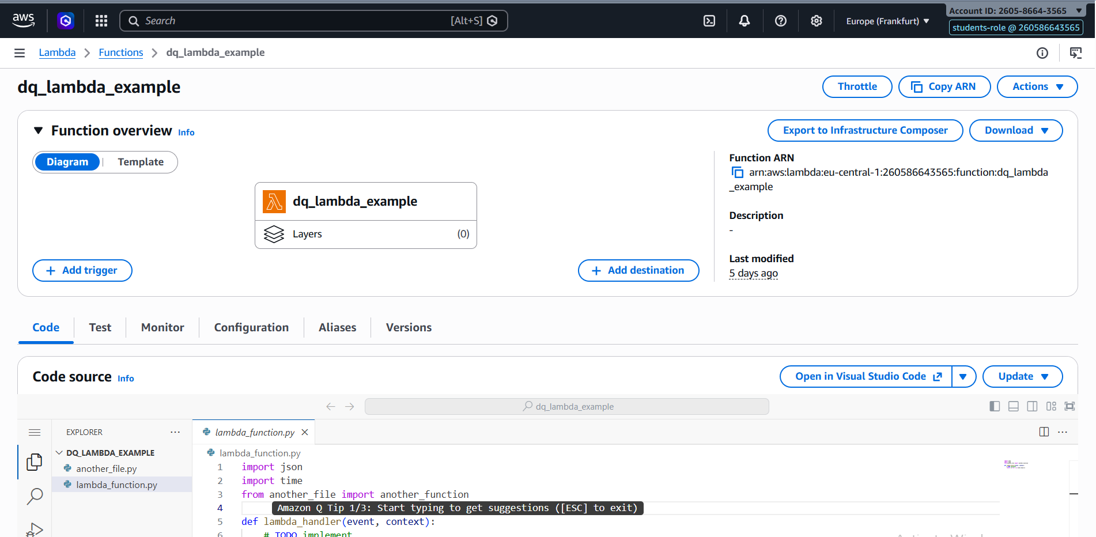
dq_lambda_example: overview showing Layers (0 attached).
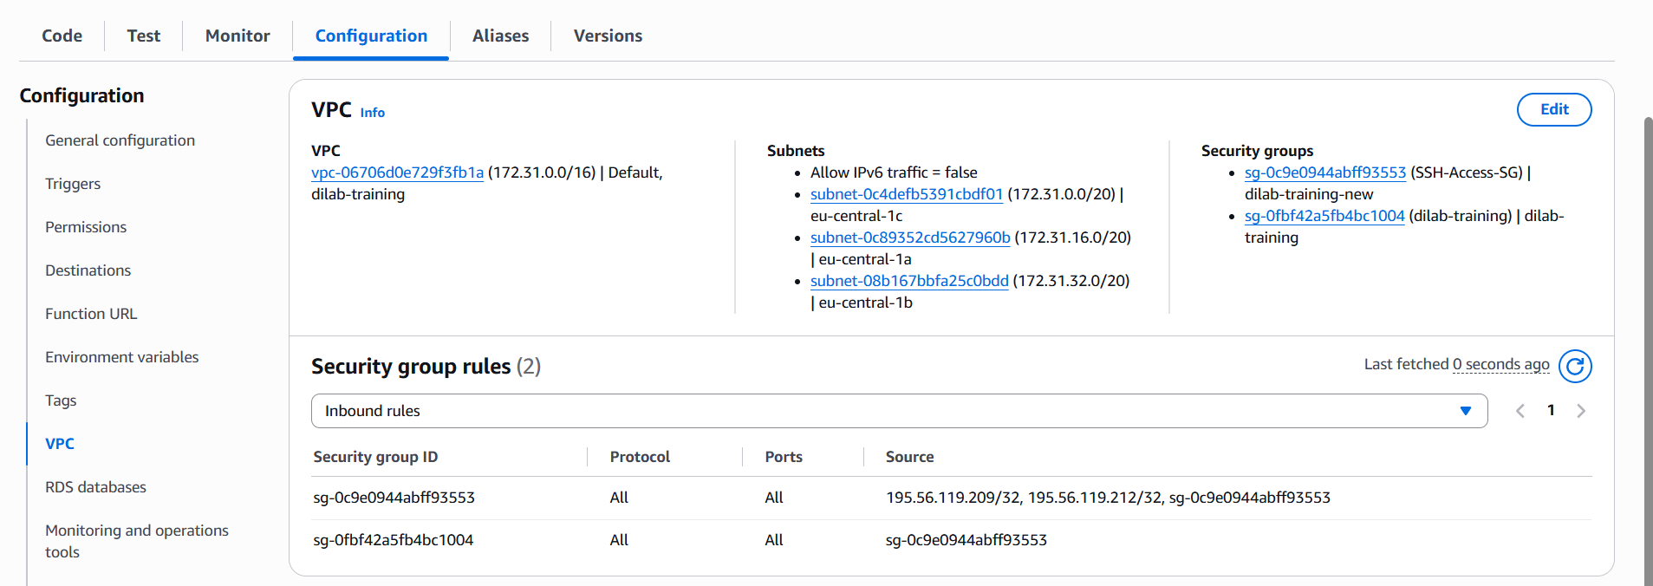
dq_lambda_example: VPC, subnets and security groups.
The function had no Layers, and its VPC used three private subnets and two security groups. I noted these values to use on my own Lambdas.

Step 2: Preparing the data — an Iceberg table in Athena
A regular Athena table does not support the UPDATE statement, so I created an Apache Iceberg table using the Athena Query Editor, as suggested by the task:
CREATE TABLE mariam_avaliani_lambda_database.lambda_iceberg (
id int,
status string
)
LOCATION 's3://mariam-avaliani-de-training-260586643565/lambda_iceberg/'
TBLPROPERTIES ('table_type'='ICEBERG')

I then inserted one starting row (id = 1, status = 'pending') and confirmed it with a SELECT query:
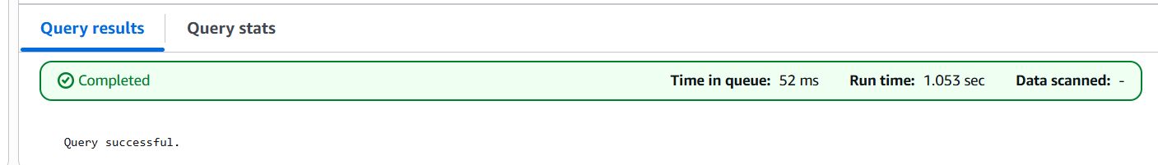
The CREATE TABLE and INSERT queries completed successfully.
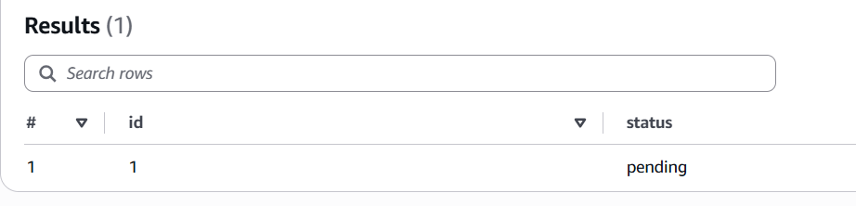
SELECT result: one row with status = 'pending'.

Step 3: Building and testing the Lambda functions
I built two Lambda functions. The first one, mariam_avaliani_sf_test, is reused for both the first and the third step of the Step Function — it takes an expected_status value as input, reads the current status from the Iceberg table through Athena, and returns whether the two match:
import boto3
import time

ATHENA_DATABASE = "mariam_avaliani_lambda_database"
ATHENA_OUTPUT = "s3://mariam-avaliani-de-training-260586643565/athena-results/"

def run_query(query):
client = boto3.client("athena")
exec_id = client.start_query_execution(
QueryString=query,
QueryExecutionContext={"Database": ATHENA_DATABASE},
ResultConfiguration={"OutputLocation": ATHENA_OUTPUT},
)["QueryExecutionId"]

while True:
state = client.get_query_execution(QueryExecutionId=exec_id)["QueryExecution"]["Status"]["State"]
if state in ("SUCCEEDED", "FAILED", "CANCELLED"):
break
time.sleep(1)

if state != "SUCCEEDED":
raise Exception(f"Athena query failed: {state}")

return client.get_query_results(QueryExecutionId=exec_id)

def lambda_handler(event, context):
expected_status = event.get("expected_status")

result = run_query("SELECT status FROM lambda_iceberg WHERE id = 1")
rows = result["ResultSet"]["Rows"]
actual_status = rows[1]["Data"][0]["VarCharValue"] # rows[0] is the header row

print(f"Expected status: {expected_status}, Actual status: {actual_status}")
passed = (actual_status == expected_status)
print(f"Test passed: {passed}")

return {"passed": passed, "status": actual_status}

When I first ran this function with the VPC from dq_lambda_example attached, it timed out after 3 and then after 30 seconds, without printing anything at all. I checked the VPC's route tables and found only one route, to the VPC itself, with no NAT Gateway. I also checked the VPC's endpoints and found only an S3 gateway endpoint, attached to a different route table than my subnets. This told me the subnets had no way to reach Athena over the network — they are private subnets, most likely built for reaching a database privately, not for calling AWS's public APIs. Since Athena is a public AWS service and the task itself says Athena Lambdas do not need a VPC, I removed the VPC from the function. After that change, it worked correctly on the first try.
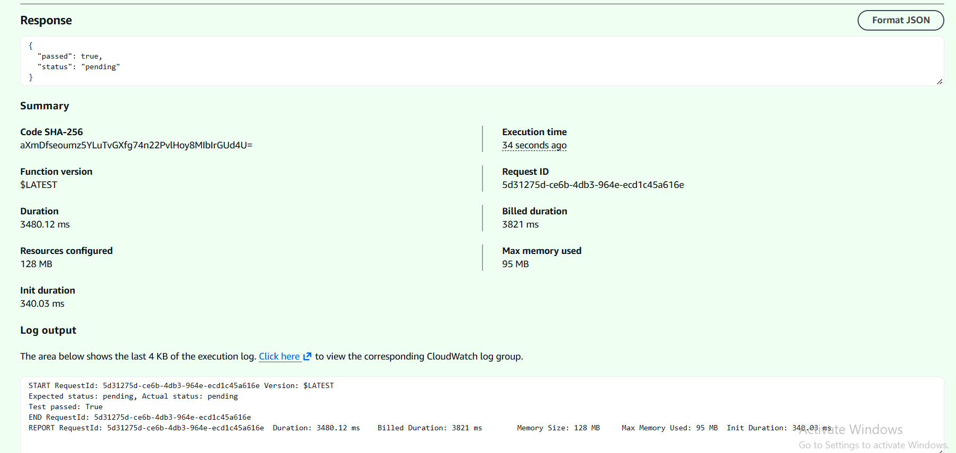
mariam_avaliani_sf_test, run with expected_status = pending: passed = true, and the logs show the comparison.
The second Lambda, mariam_avaliani_sf_update, runs the UPDATE statement between the two tests:
import boto3
import time

ATHENA_DATABASE = "mariam_avaliani_lambda_database"
ATHENA_OUTPUT = "s3://mariam-avaliani-de-training-260586643565/athena-results/"

def lambda_handler(event, context):
client = boto3.client("athena")
query = "UPDATE lambda_iceberg SET status = 'processed' WHERE id = 1"

exec_id = client.start_query_execution(
QueryString=query,
QueryExecutionContext={"Database": ATHENA_DATABASE},
ResultConfiguration={"OutputLocation": ATHENA_OUTPUT},
)["QueryExecutionId"]

while True:
state = client.get_query_execution(QueryExecutionId=exec_id)["QueryExecution"]["Status"]["State"]
if state in ("SUCCEEDED", "FAILED", "CANCELLED"):
break
time.sleep(1)

print(f"Update query state: {state}")
if state != "SUCCEEDED":
raise Exception(f"Update failed: {state}")

return {"updated": True}

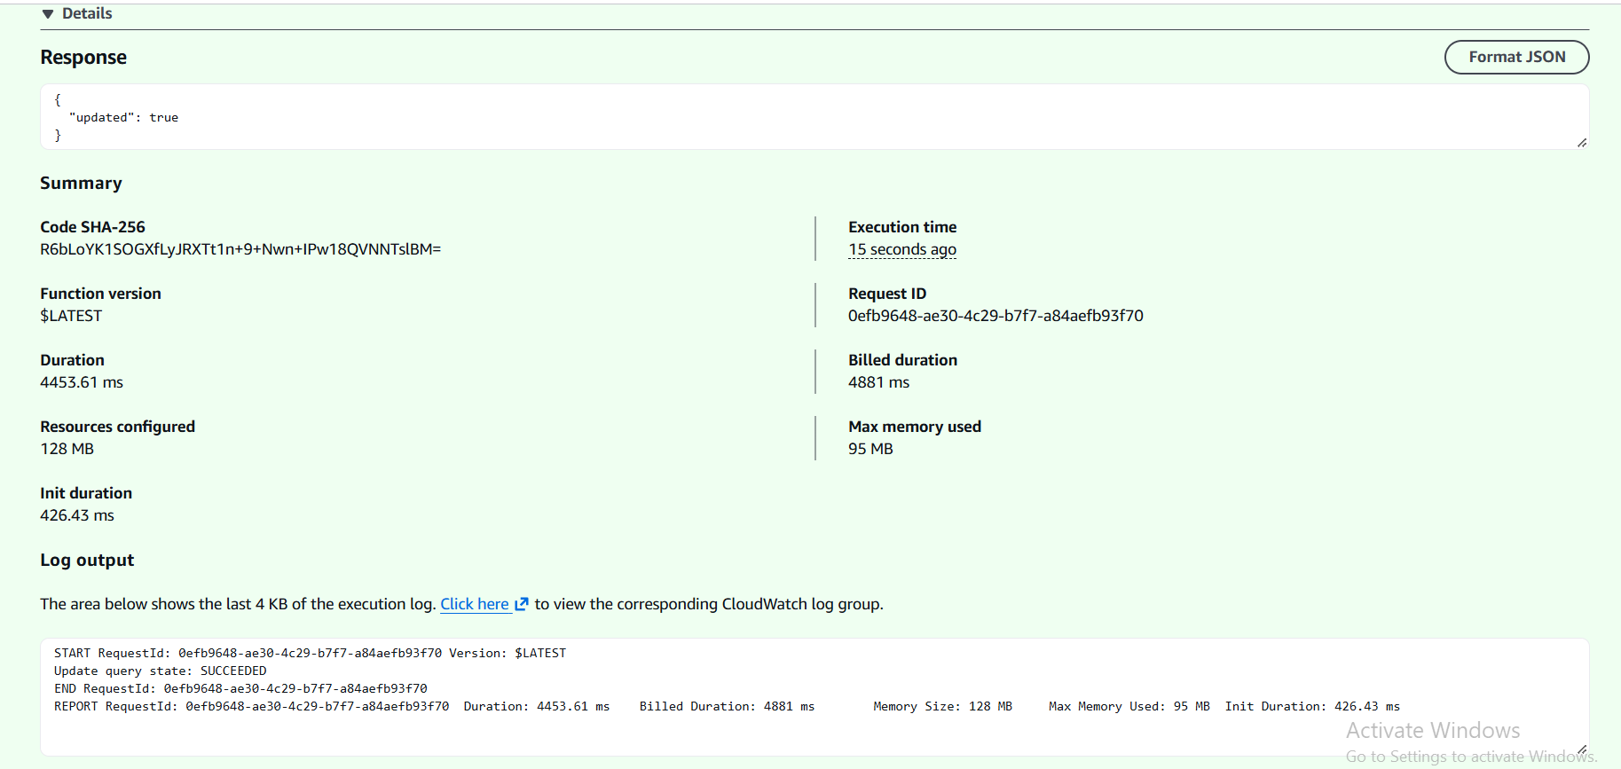
mariam_avaliani_sf_update: the update query succeeded.
To confirm the update really changed the value, I ran mariam_avaliani_sf_test again, this time with expected_status = processed:
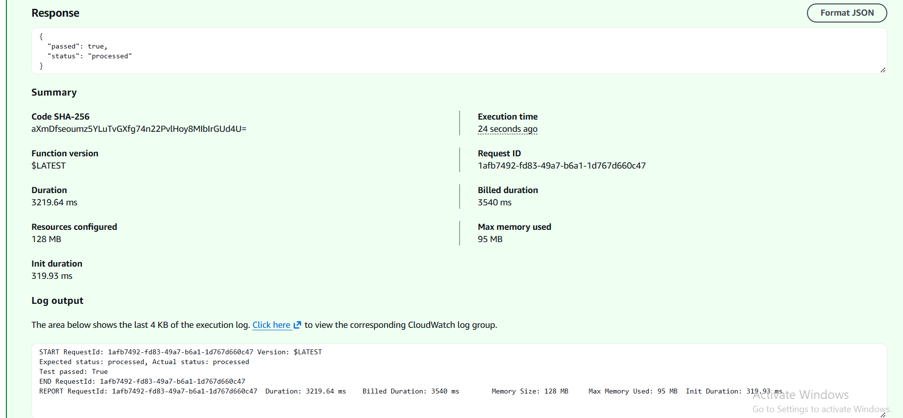
Second test, after the update: passed = true, status = processed.
Once both Lambdas were confirmed working, I reset the row back to status = 'pending' in Athena, so the full Step Function run would start from a clean state:
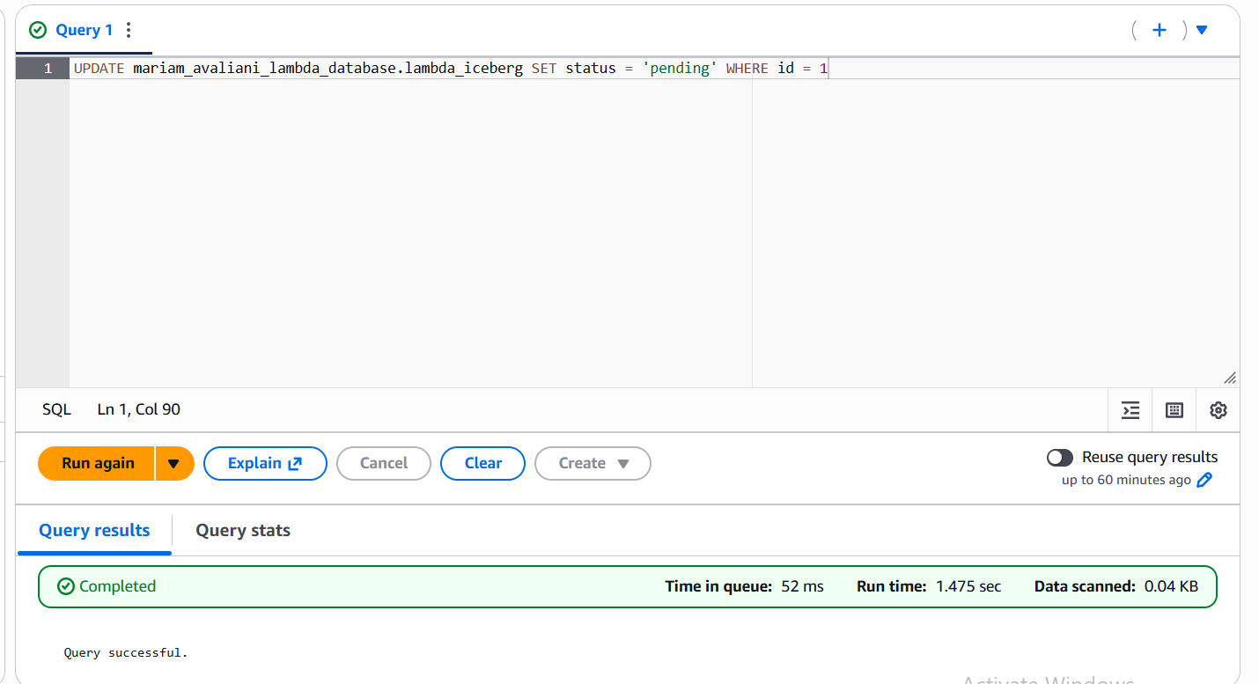
Resetting the row back to 'pending' before running the full workflow.

Step 4: Building the Step Function
I created a new state machine called mariam_avaliani_sf_workflow (Standard type, JSONPath query language) using Workflow Studio. I added three Lambda Invoke steps in order — Test1, Update, Test2 — followed by a Choice state. On each Lambda Invoke step I set a ResultPath ($.test1, $.updateResult, $.test2) so every step's result is kept under its own key instead of overwriting the whole input. The Choice state checks $.test1.Payload.passed and $.test2.Payload.passed together: if both are true, it goes to a Succeed state; otherwise, it goes to a Fail state.
{
"Comment": "A description of my state machine",
"StartAt": "Test1",
"States": {
"Test1": {
"Type": "Task",
"Resource": "arn:aws:states:::lambda:invoke",
"Parameters": {
"FunctionName": "arn:aws:lambda:eu-central-1:260586643565:function:mariam_avaliani_sf_test:$LATEST",
"Payload": {
"expected_status": "pending"
}
},
"Retry": [
{
"ErrorEquals": [
"Lambda.ServiceException",
"Lambda.AWSLambdaException",
"Lambda.SdkClientException",
"Lambda.TooManyRequestsException"
],
"IntervalSeconds": 1,
"MaxAttempts": 3,
"BackoffRate": 2,
"JitterStrategy": "FULL"
}
],
"ResultPath": "$.test1",
"Next": "Update"
},
"Update": {
"Type": "Task",
"Resource": "arn:aws:states:::lambda:invoke",
"Parameters": {
"FunctionName": "arn:aws:lambda:eu-central-1:260586643565:function:mariam_avaliani_sf_update:$LATEST",
"Payload": {}
},
"Retry": [
{
"ErrorEquals": [
"Lambda.ServiceException",
"Lambda.AWSLambdaException",
"Lambda.SdkClientException",
"Lambda.TooManyRequestsException"
],
"IntervalSeconds": 1,
"MaxAttempts": 3,
"BackoffRate": 2,
"JitterStrategy": "FULL"
}
],
"ResultPath": "$.updateResult",
"Next": "Test2"
},
"Test2": {
"Type": "Task",
"Resource": "arn:aws:states:::lambda:invoke",
"Parameters": {
"FunctionName": "arn:aws:lambda:eu-central-1:260586643565:function:mariam_avaliani_sf_test:$LATEST",
"Payload": {
"expected_status": "processed"
}
},
"Retry": [
{
"ErrorEquals": [
"Lambda.ServiceException",
"Lambda.AWSLambdaException",
"Lambda.SdkClientException",
"Lambda.TooManyRequestsException"
],
"IntervalSeconds": 1,
"MaxAttempts": 3,
"BackoffRate": 2,
"JitterStrategy": "FULL"
}
],
"ResultPath": "$.test2",
"Next": "Choice"
},
"Choice": {
"Type": "Choice",
"Choices": [
{
"Next": "Success",
"And": [
{
"Variable": "$.test1.Payload.passed",
"BooleanEquals": true
},
{
"Variable": "$.test2.Payload.passed",
"BooleanEquals": true
}
]
}
],
"Default": "Fail"
},
"Success": {
"Type": "Succeed"
},
"Fail": {
"Type": "Fail"
}
},
"QueryLanguage": "JSONPath"
}

This is the exact definition copied from the Code tab of mariam_avaliani_sf_workflow. It matches what I built in Workflow Studio: three Lambda Invoke steps with ResultPath, a Choice state combining both test results with And, and Succeed/Fail terminal states. AWS also added a default Retry block to each Lambda Invoke step, which retries the call automatically if Lambda itself has a transient error.

Step 5: Execution role and result
Before running the state machine, I checked the Config tab and confirmed that dilab-lambda-sf-role was set as the execution role, as required by the task:
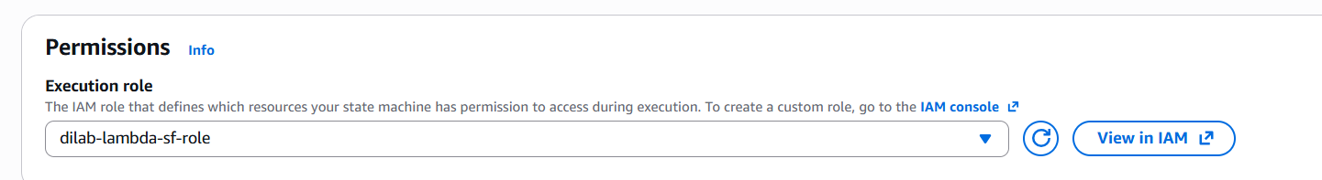
Execution role of the state machine: dilab-lambda-sf-role.
I then ran the state machine. Every step completed successfully, and the workflow reached the Success state, meaning both tests passed and the update in between was confirmed:
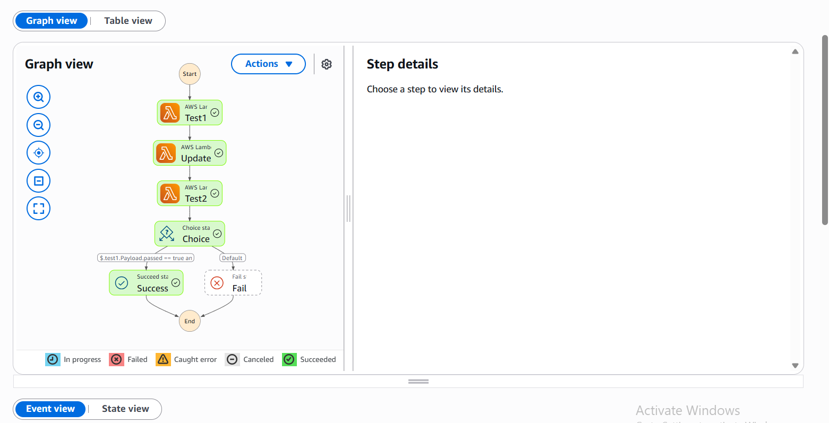
Full execution graph: Test1 -> Update -> Test2 -> Choice -> Success. The Fail branch was not entered.

Key points
Connecting to other services: both Lambdas call Athena through boto3. Since an Athena query runs asynchronously, each Lambda starts the query with start_query_execution and then checks get_query_execution in a loop until the query reaches a final state (SUCCEEDED, FAILED, or CANCELLED) before continuing.
Response parsing: get_query_results returns a header row followed by the data rows, so the actual value is read from rows[1] (row 0 is only the header), then compared to the expected value to build the true/false result the Step Function reads.
Passing results between steps: ResultPath keeps each Lambda's output under its own key ($.test1, $.updateResult, $.test2), so the Choice state at the end can read both test results together instead of only seeing the last step's output.
VPC decision: the VPC used by the reference function turned out to be a private, NAT-less network built for reaching something like a private database, not for reaching AWS APIs like Athena. Since Athena is a public service, and the task itself notes that Athena Lambdas do not need a VPC, I ran all three Lambdas without one, after confirming this by inspecting the route tables and VPC endpoints.

