DWH Testing – Test Result Report
Mariam Avaliani | Data Quality Engineer (Trainee) | Project: DWH Set-Up, Reconciliation & Testing

1. Summary
I tested the DWH and DM layers of the data warehouse (dwh.* and dm.* schemas) against the business rules described in the DWH schema documentation. I checked the data itself, not only the table structure, and validated it using ad-hoc SQL queries, since no existing test case in TestRail covered these specific field-level rules. During this testing cycle, I found and logged 10 new defects in Jira. Three of them are Major severity and High priority: two affect a validity flag across a large part of the CLIENTS dimension, and one is a product record that cannot be traced back to either source system but is still referenced by 230 real sales. The remaining seven are Minor severity, affecting a smaller number of rows or a cosmetic value. The first five defects were found during the initial pass of testing; the other five (DWH-6 to DWH-10) were found on a deeper follow-up re-check of every mapping rule, done after a mentor review pointed out that more defects were likely present in the data than the first pass had caught. Before this testing round, I also completed a separate data reconciliation check between the two source systems and the landing layer, which is reported separately and is not counted in the defect numbers below.

2. Test Team
Name | Role | Responsibility
Mariam Avaliani | Data Quality Engineer (Trainee) | Test case design, SQL-based data validation, defect reporting and documentation

3. Testing Process Description
I set up the dwh_src_hw_db and dwh_hw_db databases and loaded all source, landing, DWH and DM layer scripts in order. Testing was done directly against the DWH and DM schemas using SQL queries written from the business rules in the schema documentation, rather than from pre-existing TestRail test cases, since none of the existing cases covered these specific field-level checks. For each rule (for example, how VALID_TO and IS_VALID should be set, or how TOTAL_COST should be calculated), I wrote a query to find rows that violated the rule, then manually reviewed a sample of the results to confirm the discrepancy was real before logging a defect. In the first pass I checked the rules most likely to be broken (the CLIENTS validity fields, LOCATION_SRC_ID, and the DM_MAIN_DASHBOARD row count and TOTAL_COST calculation) and found 5 defects. On a follow-up review, I went back and checked every remaining mapping rule in the schema documentation one by one — every column of DWH_CLIENTS, DWH_PRODUCTS, DWH_LOCATIONS, DWH_CHANNELS and DWH_SALES against both source systems, using dblink to cross-check source values directly, plus row-count and aggregate parity checks (total rows, SUM of quantities) to catch anything a row-by-row comparison might miss. That pass found 5 more defects, including one case where a mismatch I initially suspected (order dates in the S1 sales data) turned out to be a false positive caused by duplicate client/channel/product combinations in the source data, not an actual DWH bug — row-count and SUM(quantity) checks confirmed the S1 and S2 sales data load correctly. Each confirmed defect was documented with a clear test case, precondition, steps to reproduce, actual result, expected result, environment, severity, priority and reproducibility, and created in Jira (project DQ26) with a DWH_ prefix.

4. New Defects Statistics
Status | Quantity | Major | Minor
Submitted | 10 | 3 | 7
In Progress | 10 | 3 | 7
Fixed | 0 | 0 | 0
Verified | 0 | 0 | 0

All 10 defects are new (submitted during this testing cycle) and are currently being worked on; none have been fixed or verified yet at the time of this report.

5. New Defects List
ID | Severity | Priority | Summary
DWH-1 | Major | High | VALID_TO is wrong for all 700 S1-origin rows in DWH_CLIENTS (set to 2000-01-01 instead of 2100-01-01).
DWH-2 | Major | High | IS_VALID is hardcoded to 'Y' for all 780 rows in DWH_CLIENTS, ignoring the VALID_TO rule (727 rows are wrong).
DWH-3 | Minor | Medium | LOCATION_SRC_ID shows 'NA' instead of 'N/A' for 15 rows.
DWH-4 | Minor | Low | DM_MAIN_DASHBOARD has 2 duplicate/orphan rows (id 25000, 25001) that do not exist in DWH_SALES.
DWH-5 | Minor | Low | TOTAL_COST does not equal QUANTITY × PRODUCT_COST for 7 rows in DM_MAIN_DASHBOARD.
DWH-6 | Major | High | DWH_PRODUCTS has a product (id 50, 'helmet', cost 9.06) not present in either source system, referenced by 230 sales.
DWH-7 | Minor | Medium | DM_MAIN_DASHBOARD.EMAIL is missing the '@' character for 2 clients (67 rows).
DWH-8 | Minor | Medium | DM_MAIN_DASHBOARD.PHONE_NUMBER is NULL instead of the real value for 1 client (43 rows).
DWH-9 | Minor | Low | DWH_CHANNELS is missing 3 channels that exist in S1_CHANNELS (156, 157, 158).
DWH-10 | Minor | Low | DWH_CLIENTS.PHONE_NUMBER has extra inserted spaces for 1 S1 client, breaking the 1:1 load rule.

6. Recommendations
- Fix DWH-1, DWH-2 and DWH-6 first. All three are High priority and Major severity: DWH-1/DWH-2 affect the CLIENTS dimension, which many other reports likely depend on, and DWH-6 means 230 dashboard rows currently show product information that cannot be traced back to any source system record.
- For DWH-6, involve the data engineering team that owns the S1 source system as well, not only the DWH build — S1_SALES itself references a product_id that has no row in S1_PRODUCTS, so part of the root cause may sit upstream of the DWH.
- Add an automated regression check for the VALID_TO / IS_VALID logic once fixed, so a similar mistake is caught immediately in future loads instead of through manual testing.
- Schedule the seven Minor defects (DWH-3, DWH-4, DWH-5, DWH-7, DWH-8, DWH-9, DWH-10) after the three Major ones are resolved, since each affects a much smaller number of rows.
- Add TestRail test cases for all ten field-level rules, since none currently exist — this will make it easier to catch the same issues automatically in the next testing cycle, and reduce the chance that a first testing pass misses defects the way it did here.

7. Attachments
The following charts summarize the defects found during this testing cycle.
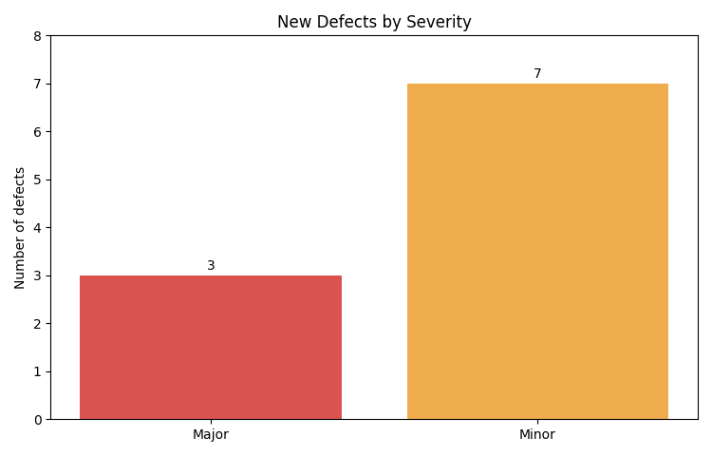
Chart 1: New defects grouped by severity.
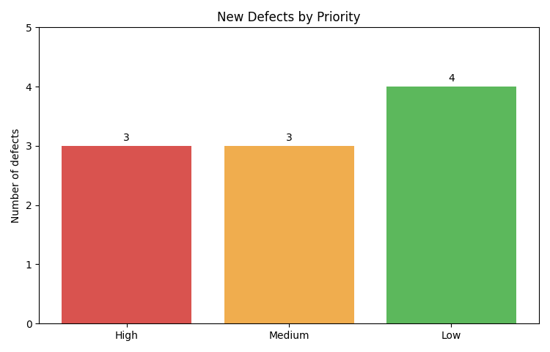
Chart 2: New defects grouped by priority.
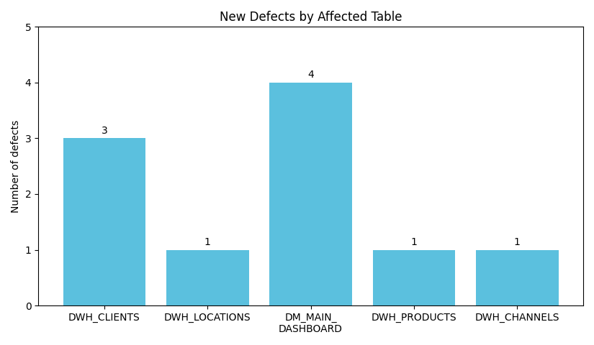
Chart 3: New defects grouped by the DWH/DM table they affect.

