
POWER BI FINAL PROJECT
Business Background

Company
ORBIX Retail Group is an omnichannel, multi-category retailer selling Books, Clothing, and Electronics through a network of physical stores (flagship, standard, and warehouse formats) and a direct-to-consumer e-commerce platform.

Logo Concept
A minimalist orbit symbol formed by three connected nodes, representing the company’s three product categories and its two sales channels operating as one connected ecosystem. Navy (trust, stability) is paired with a teal accent (modern, digital) to reflect a technology-driven retail brand.

Field of Activity
ORBIX operates in Georgia (headquarters and flagship store in Tbilisi) and the United States (regional physical stores across the Central, East, and West regions), giving it a cross-border, dual-market retail footprint across in-store and online channels.

Business Process
The report exposes and analyzes the end-to-end sales transaction process — from customer purchase (in-store or online), through product pricing and discounting, payment processing, to order fulfillment and delivery (courier, digital, or pickup) — covering the 2024–2025 period, with roughly one million transactions split evenly between in-store and online channels.

Purpose of the Report
To give business stakeholders a single, interactive view of sales performance, profitability, and operational efficiency across product categories, sales channels, customer segments, and geographies — enabling faster, evidence-based decisions instead of manual spreadsheet reporting.

End User
Regional and category sales managers, the executive/management team, and the marketing team — anyone who needs a quick, self-service view of business performance without querying the database directly.

Business Questions & Problems Addressed
- Which product category or brand generates the most revenue and profit?
- How does performance compare between the InStore and Online channels — which is more profitable?
- Which customer segment (A/B/C, Premium/Regular/New/Returning) delivers the most value?
- Is there a significant share of failed payments, and in which payment method?
- Are there delivery delays (Pending share), and in which delivery type (Courier/Digital/Pickup)?
- What is the sales trend by month/quarter — is there seasonality?
- Which store, region, or country (USA vs. Georgia) is leading, and which needs attention?

Project Process

Connecting to the Data
For this project, I used the data warehouse (DWH_PROJECT) that I built in the previous module. It is a PostgreSQL database with several schemas: staging layers, a 3NF layer, a control layer, and a data mart (bl_dm) with a star schema. I connected Power BI Desktop to this database using the PostgreSQL connector, with the server address and database name from pgAdmin.
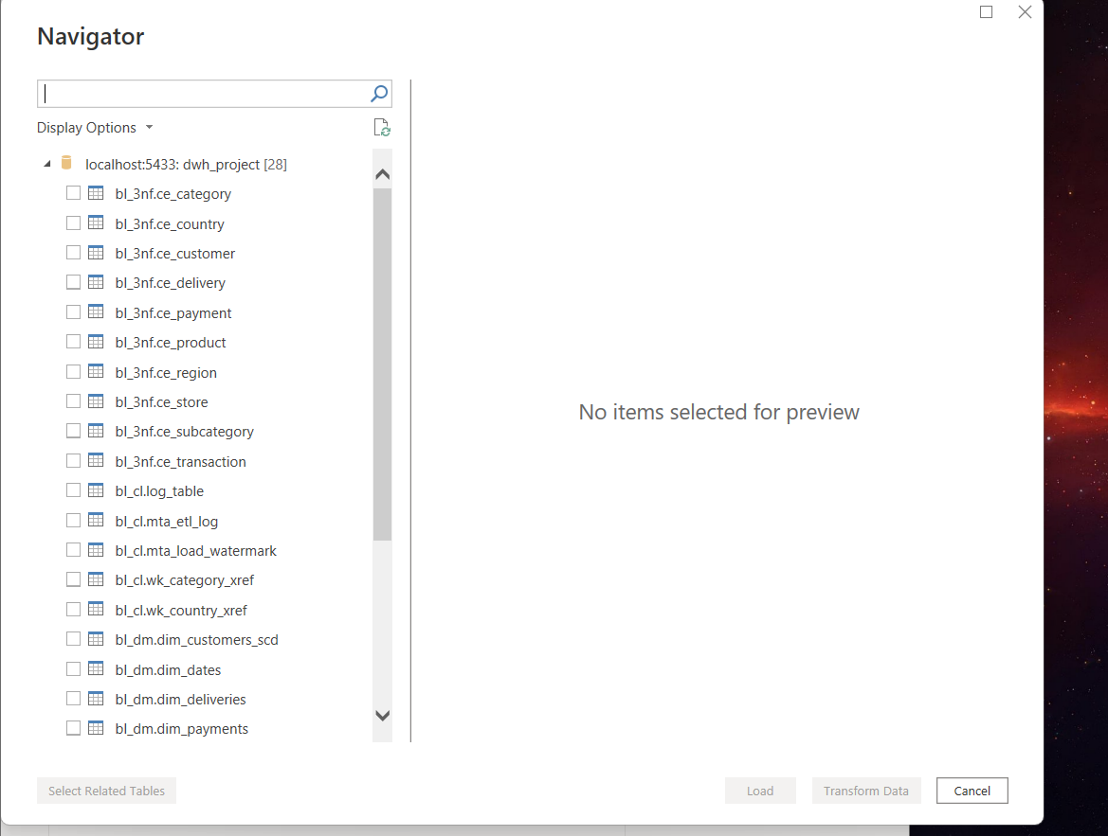

Loading and Cleaning the Data
In the Navigator window, I selected only the tables from the bl_dm schema, because this is the layer that is ready for reporting. I did not select the partition tables of the fact table, because the main table already includes all the data from its partitions. In Power Query, I cleaned the dimension tables by keeping only the valid values in each column and removing placeholder values like "Type1" or unclear test data. To decide which values were valid, I first checked the real data in the database with a few SQL queries.
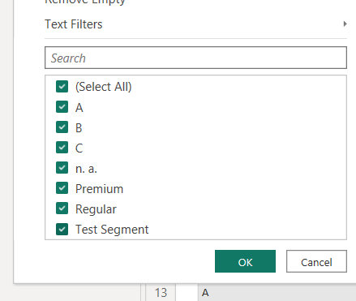

Building the Data Model
After loading the tables, I built the star schema model. Most of the relationships were created automatically, but I added one manually between the customer table and the fact table. While building the model, I found a few data quality issues in the source data warehouse itself, which I explain in detail in the Data Quality Notes section at the end of this document.
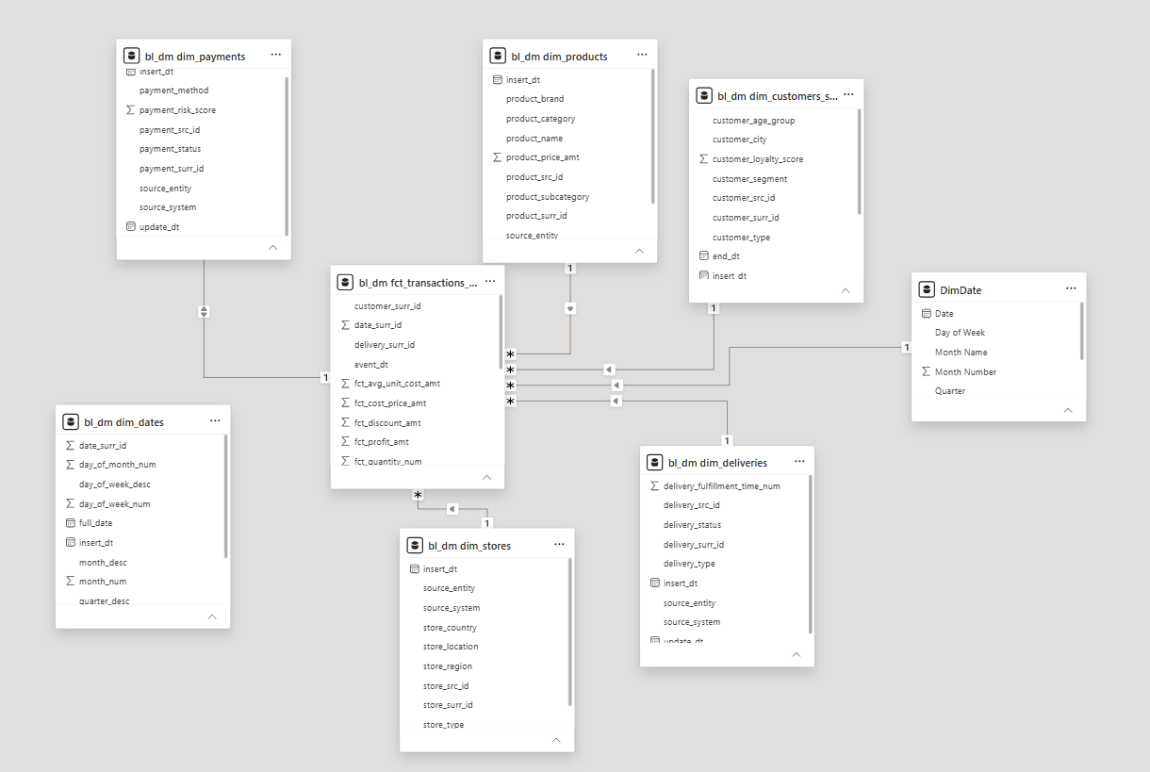

DAX Calculations
I created two calculated columns, Order Value Tier and Price Tier, to group transactions and products by value. I also wrote several measures, for example Total Sales, Total Profit, Profit Margin %, Total Transactions, Average Order Value, and Failed Payment Rate. One of the measures builds the title of a chart automatically, depending on which product category is selected.

Designing the Report
I designed the report for a company idea called ORBIX Retail Group, with a custom logo, colors and theme. The report has three pages: Overview, Products & Categories, and Channels & Operations. Every page has KPI cards, charts, and a table with conditional formatting on the profit margin column. The chart title on this page changes automatically depending on the selected category. I also added a hidden drillthrough page that shows transaction-level details for a selected category, and a hidden tooltip page that appears when hovering over the sales chart.
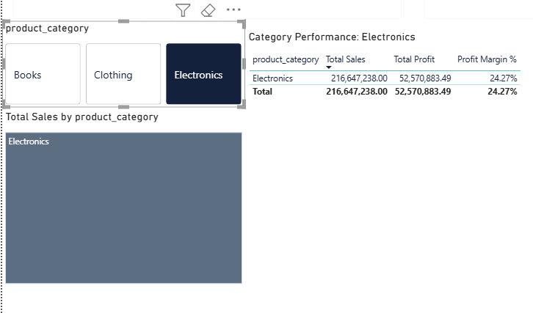

Navigation
To make the report easier to use, I added a page navigator with buttons at the top of every page, so the user can move between the three main pages without using the page tabs at the bottom.
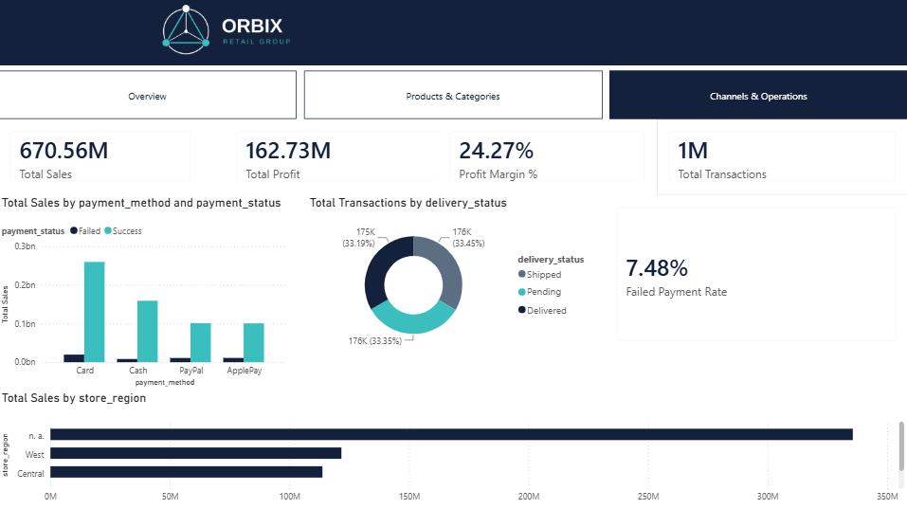

Publishing to Power BI Service
When the report was ready, I published it to Power BI Service from Power BI Desktop. I checked that the pages, navigation and visuals worked correctly online, and I took a screenshot of the published report below. I also shared the report with my mentor so it can be reviewed online.

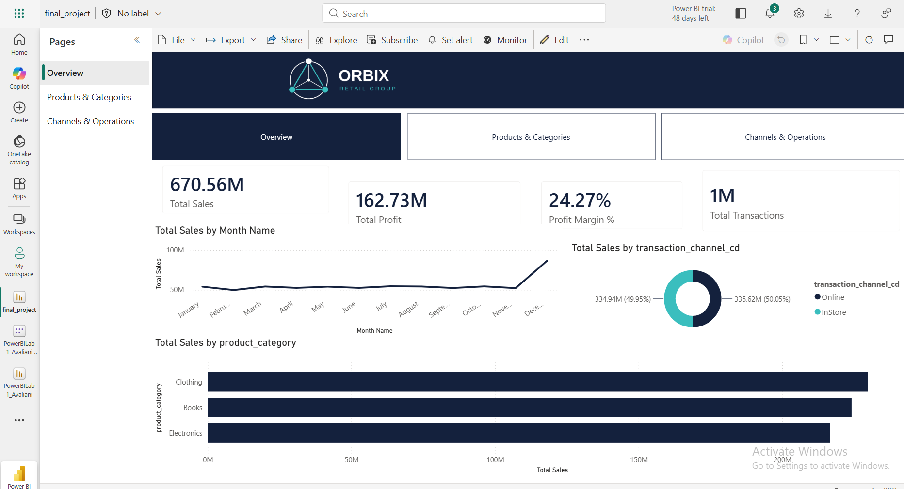
Figure 1. ORBIX Retail Group — "Overview" page, published in Power BI Service.

Data Quality Notes
While building the model, I found several real problems in the data warehouse itself, and I want to explain them clearly instead of hiding them.
First, the date dimension table (dim_dates) in the database had only one row, a default placeholder row. Because of this, I could not use it for a real date hierarchy, so I built a new date table directly in Power BI with DAX (CALENDAR and ADDCOLUMNS functions) and connected it to the fact table on the transaction date instead.
Second, the customer_surr_id column in the fact table was equal to -1, the default "unknown" value, for 100% of the transactions, close to one million rows. This means the data warehouse never linked transactions to a real customer record. Because of this, I could not build a customer segmentation analysis, so I removed this idea from the report instead of showing a chart full of blank or incorrect values.
Third, the store_region column was empty for the E-commerce and Warehouse store types, because these store types do not have a physical region by design. At first, my Power Query filter removed these rows completely, which made all Online and Warehouse transactions disappear from the store-based charts. I fixed this by keeping these rows in Power Query and labeling them clearly instead of hiding them.
Fourth, the delivery_surr_id column was empty for InStore transactions. This is not a data problem, it is expected, because in-store purchases do not need a delivery record.
I decided to explain all of these findings in the report and in this document, instead of hiding them or showing wrong numbers.

