Task 13, Home Task 2 – Frameworks & Advanced Selenium
Building a decomposed PyTest + Selenium framework
Mariam Avaliani | Data Quality / Data Engineering course

Putting the framework together
For this task I had to take everything I already wrote in the previous home tasks (API and bucket tests, browser driver tests, locator tests, wait tests, the DB tests from the Data Warehousing course, the parametrize and fixtures tasks) and turn it into one framework, split into packages, plus add two new UI checks against a Power BI report.
I used the structure from the DQE_LAB_2024 GitHub repo as a pattern: Configs, Pages and Tests folders. Configs holds the yaml files (SQL checks, the numbers used in the parametrize task, and the Selenium settings for the Power BI test). Pages holds a Page Object class for the Power BI report, the same idea as the repo's own report page class. Tests holds all the test files, plus one shared conftest.py with all the fixtures merged into it, instead of having a separate conftest.py per topic like before.
One thing I kept as it was: the two timing fixtures in the fixtures-demo test file stayed in that file only, not in the shared conftest.py. If I moved them into the shared conftest.py they would run before and after every single test in the whole framework, which was not the point of that exercise – they were meant to time just that one test file.
For the Power BI target, the homework file itself pointed to playground.powerbi.com's "Capture report views" showcase, but the pptx slides and the DQE_LAB_2024 repo's own code pointed to a different page (Microsoft's investor relations report). I checked both live: the investor relations page does not have a Power BI tab anymore, the site changed since the slides were made. So I used the target from the homework file, since that one still works.

First run: fixing my own setup mistakes
Before running anything I had to install two more packages through PyCharm's interpreter search, the same way I installed the packages in the previous homework: psycopg2-binary (to connect to my Postgres database) and pyyaml (to read the config files).
My first full run failed to even collect the tests, with a FileNotFoundError on Configs/numbers_config.yaml. The reason was that I ran the Tests folder directly, so PyCharm's working directory was set to Tests instead of the project root, and the yaml path in that file is written relative to the root. I fixed it in Run → Edit Configurations, changing the working directory back to the project root folder. I also added one line to pytest.ini, addopts = --alluredir=allure-results, so that every run automatically writes the Allure results, without me having to remember to type that flag every time.
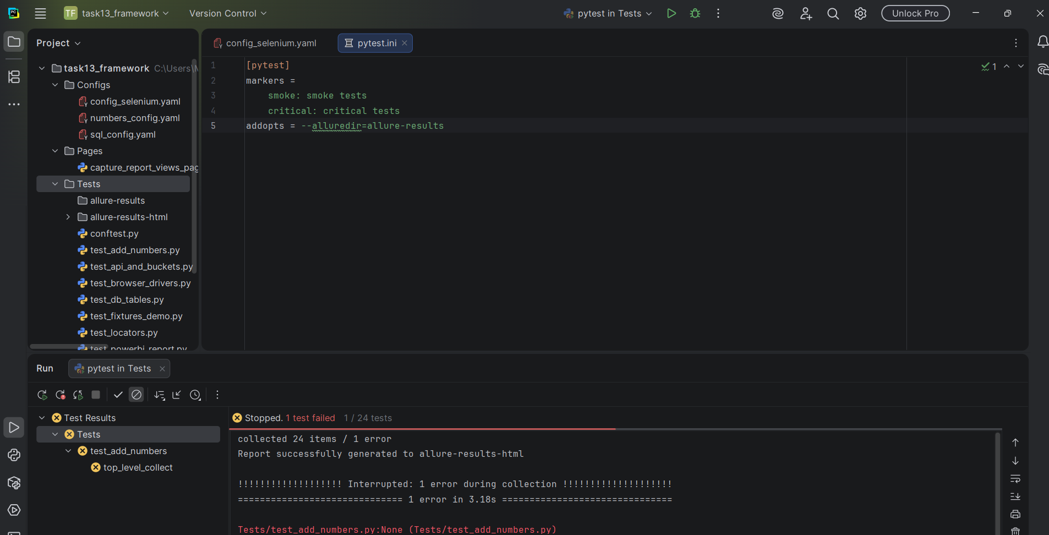
The working-directory fix in pytest.ini, and the FileNotFoundError before I found the cause

The one test that would not pass
After that fix, 26 out of 28 tests passed on the first real run. The Firefox test skipped itself on purpose, since I don't have geckodriver installed. The one real failure was one of my two new checks, test_capture_view_button_present – it kept timing out trying to find the "Capture view" button, no matter what I changed.
I went through this step by step. First I thought it was just slow loading, so I raised the wait time from 20 seconds up to 60, then 120 seconds – still failed every time, always on the exact same test. That already told me it probably was not really about time, since 120 seconds is a lot for a page to load.
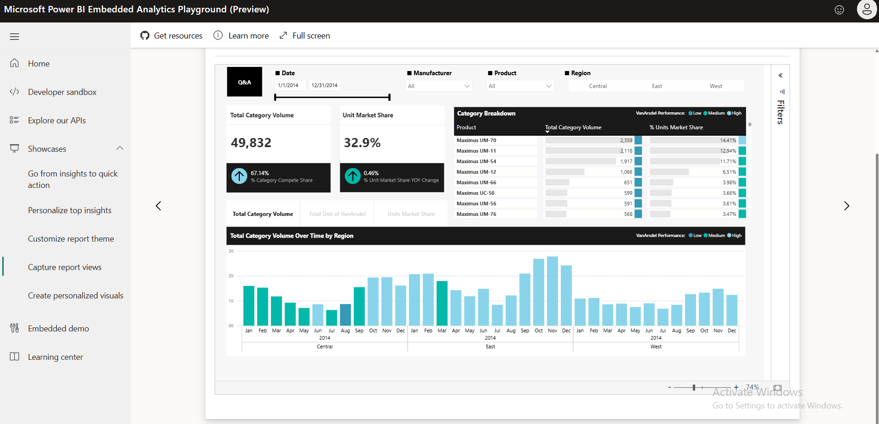
The same showcase page at a wider window size – Microsoft's own "Showcases" browsing layout, a different view than the compact one with the toolbar
I also added a debug line to save a screenshot of exactly what the browser saw at the moment it started looking for the button, to see it with my own eyes instead of guessing.
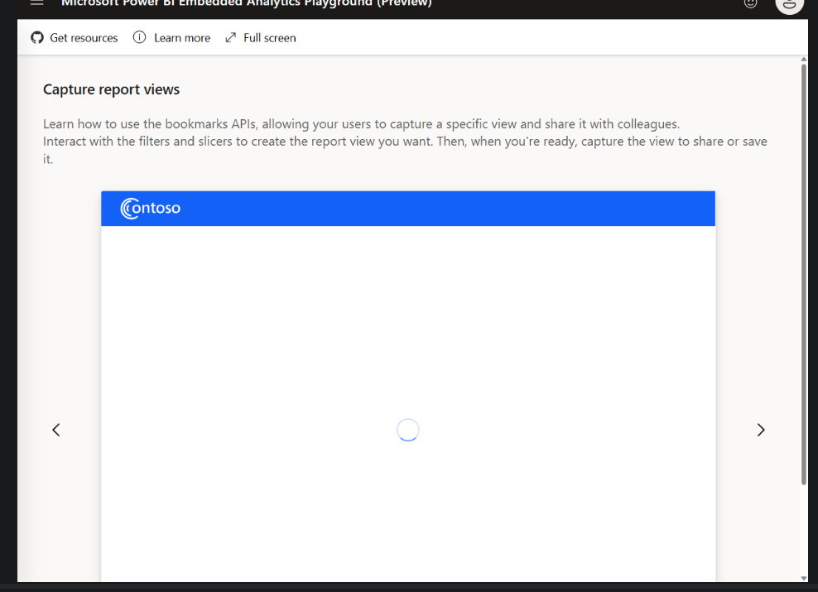
debug_view.png – the report was still showing its loading spinner at that exact moment
That screenshot ruled out a wrong locator (the text really is there once the report loads) but did not explain why it still failed after two whole minutes of waiting. I tried two more things that are common causes for this kind of problem: Selenium sometimes gets treated differently by a site because of a flag on automated browsers (navigator.webdriver), so I added Chrome options to hide that flag – no change. I also thought the very first Chrome window in the whole test run might be a "cold start" and just slower – also no change, even with 120 seconds.
The real cause turned out to be a mistake in my own code, not the website. The showcase page has one iframe, and inside that iframe there are two things sitting side by side: the toolbar with the "Capture view" button, and a second, more deeply nested iframe that holds only the actual Power BI report (its chart, its title). My switch_to_report_frame() method always stepped into both iframes before checking anything, so when it looked for the button, it was searching inside the report iframe – where that button has never existed. My chart-title check passed because the chart title really is inside that deeper iframe, which is exactly why one check kept failing and the other kept passing, every single time, instead of it being random.
I fixed the Page Object so each check switches to the frame depth it actually needs: the button check stops after the first switch, the chart-title and bar-count checks go one level deeper. Once that was fixed, both Power BI checks passed in under 30 seconds – proof that it was never a timing problem.
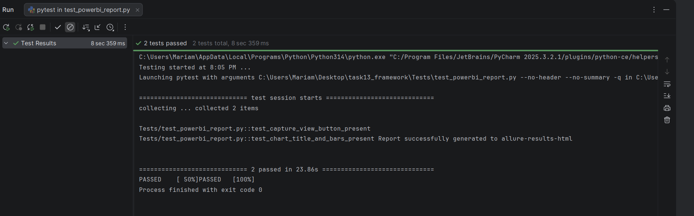
Both Power BI checks passing, in 23.86 seconds, after fixing the frame depth

Final run
With that fixed, I ran the whole Tests folder again: 27 passed, 1 skipped (Firefox), 0 failed.
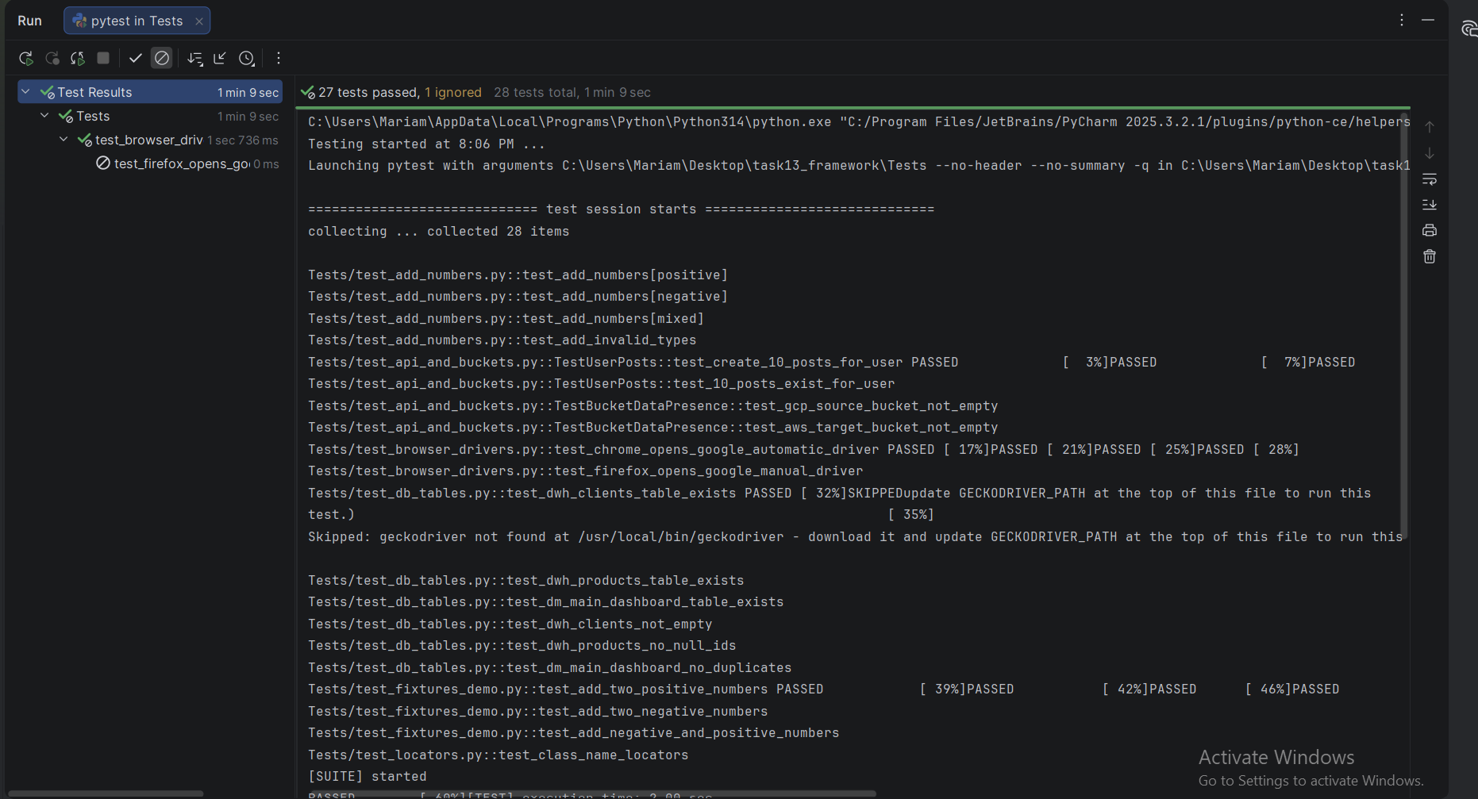
The full framework – 27 passed, 1 skipped, 28 tests total

Allure report
Since pytest.ini now writes the Allure results automatically, I generated the report with allure generate allure-results --clean -o allure-report and opened it. It shows all 28 test cases with a 100% pass rate (27 passed, 1 skipped, counted separately from failures).
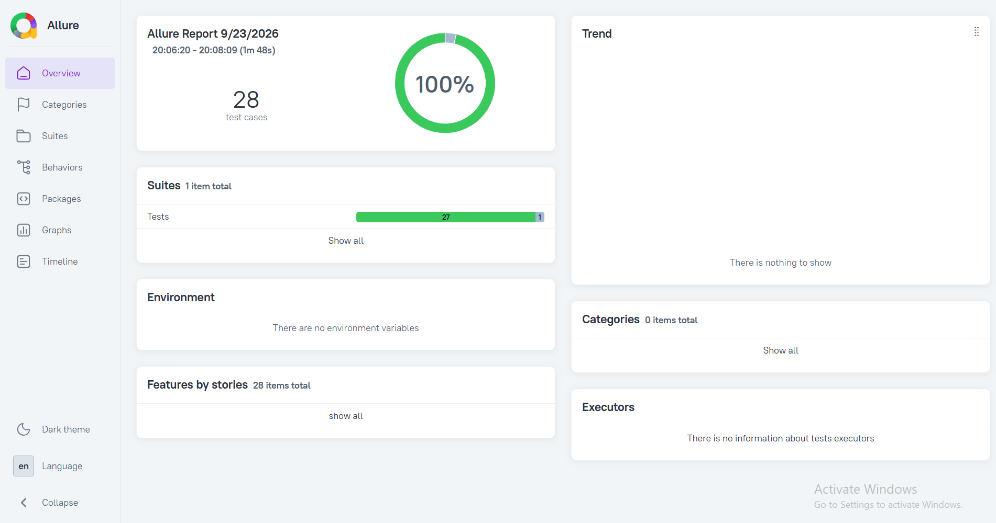
Allure report – 28 test cases, 100%
I uploaded the whole allure-report folder to GitHub alongside the framework, so the report itself is available, not just this screenshot.

Uploading to GitHub
I don't use git from the command line, so I uploaded everything through GitHub's website directly – dragging the Configs, Pages and Tests folders (and later the allure-report folder) into "Add file → Upload files", which keeps the folder structure and still creates a real commit for each upload.
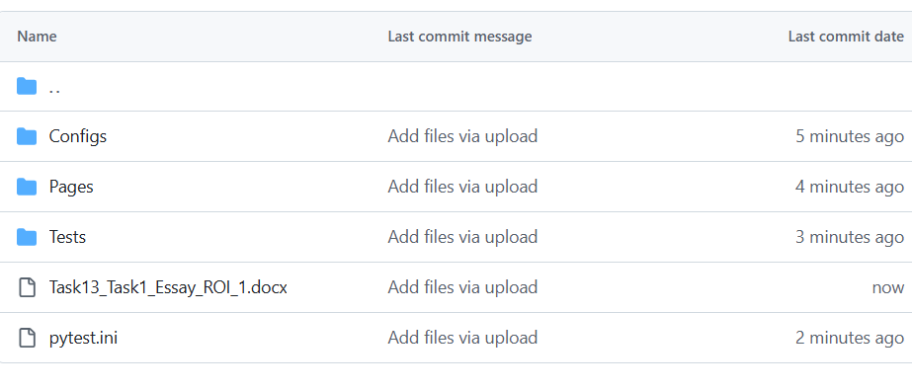
Configs, Pages, Tests and pytest.ini uploaded to my repository

