**Linker-Loader Project**

We used python to implement our code. The program simulates an absolute Loader for SIC HTE record, and a Linker-Loader HDRTME record with external symbol table.

How to open the code from the terminal?



How to use the code?

First after execution it asks you if you want a sic or a sicxe file

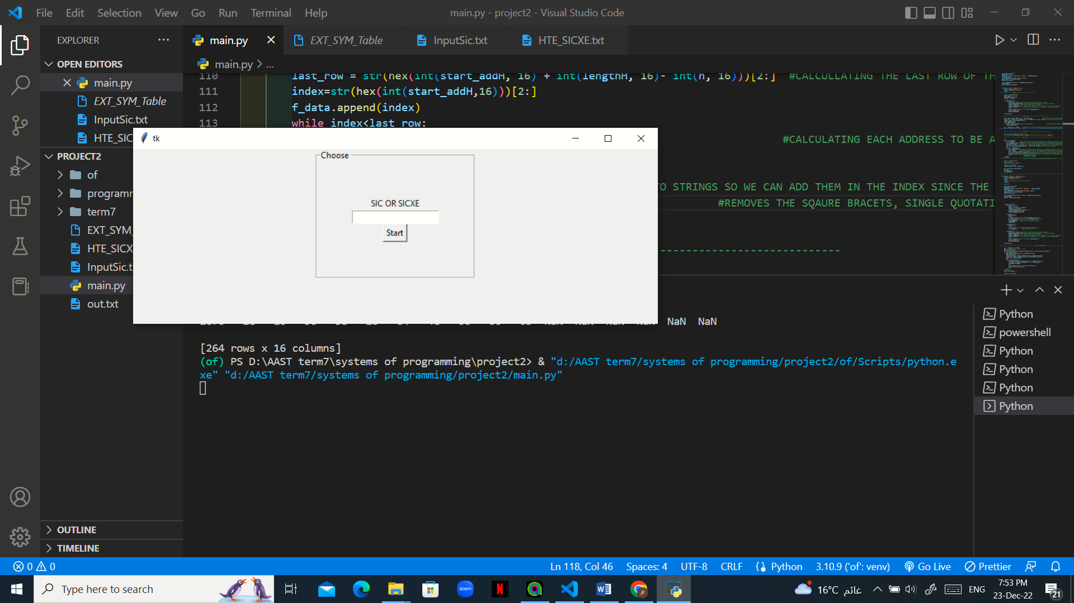

In case of sic:

The program reads the input file of the record of the given sic program you want and give a simulation of the memory in a table as shown:

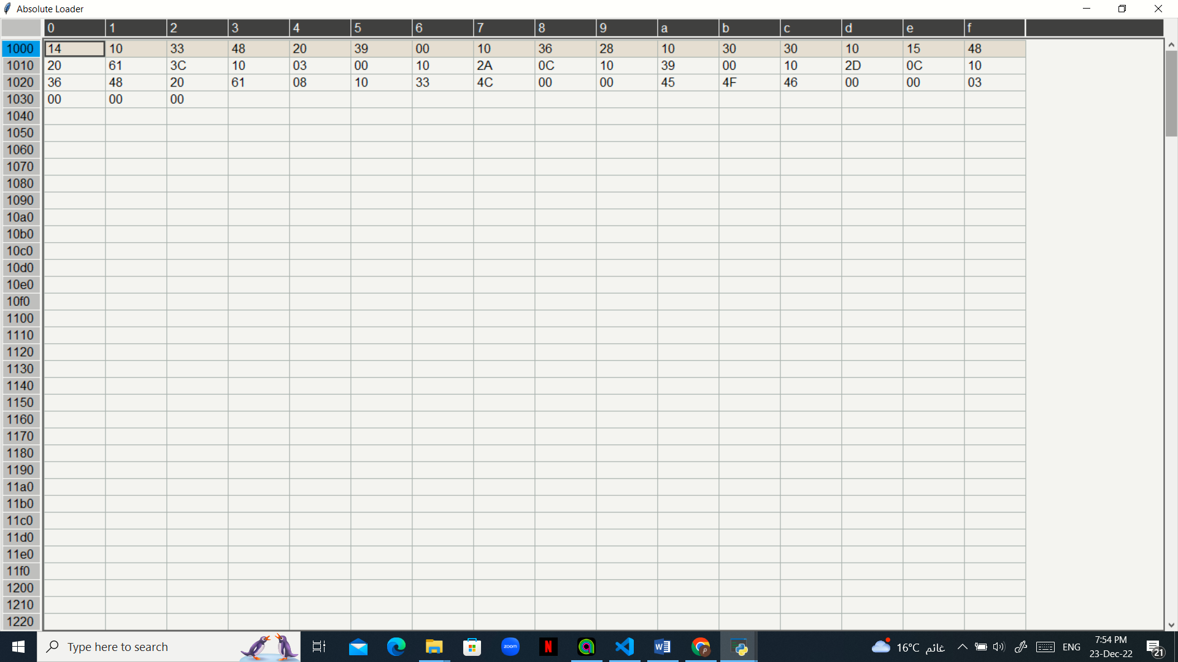

**.**

**.**

**.**

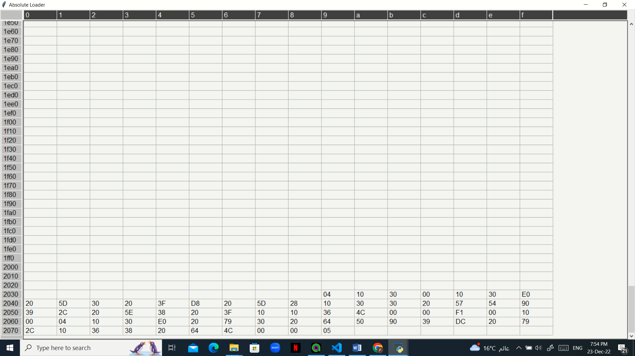

In case of sicxe:

The program asks the user about the address of the program to be loaded in

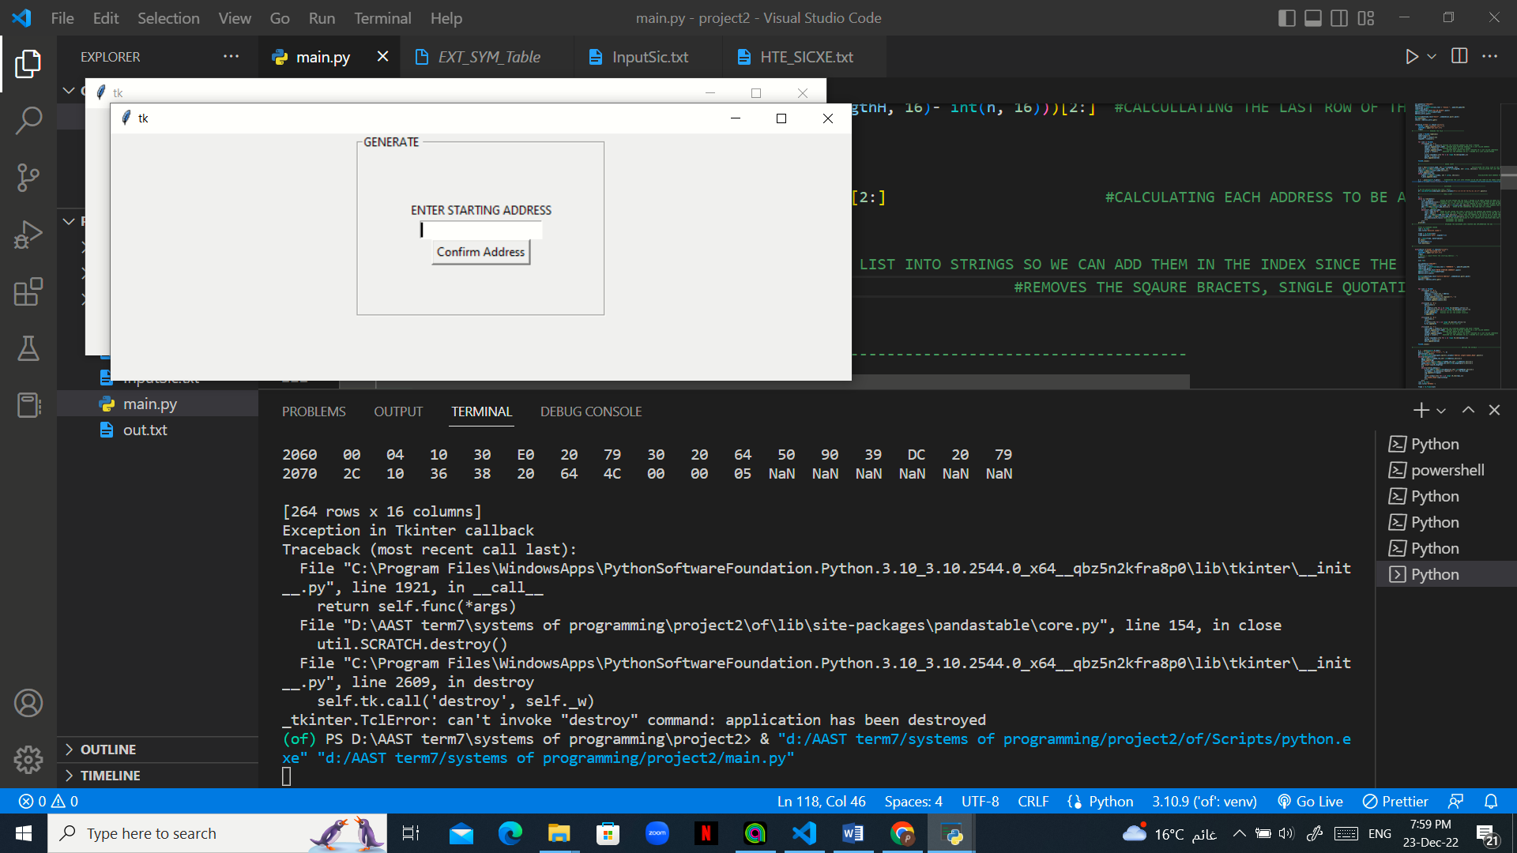

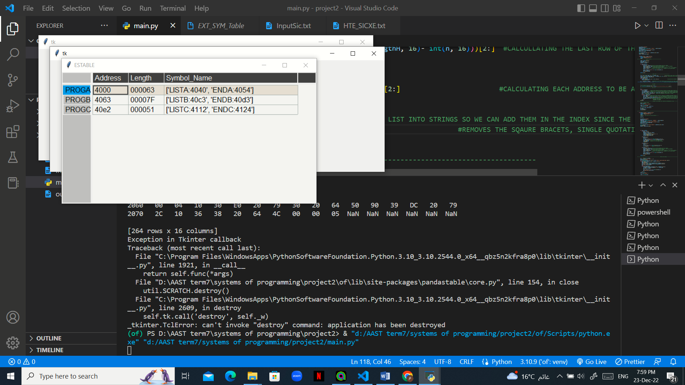For example, the given address was 4000 so the program will start making the external symbol table of the programs given with their HDRTE record

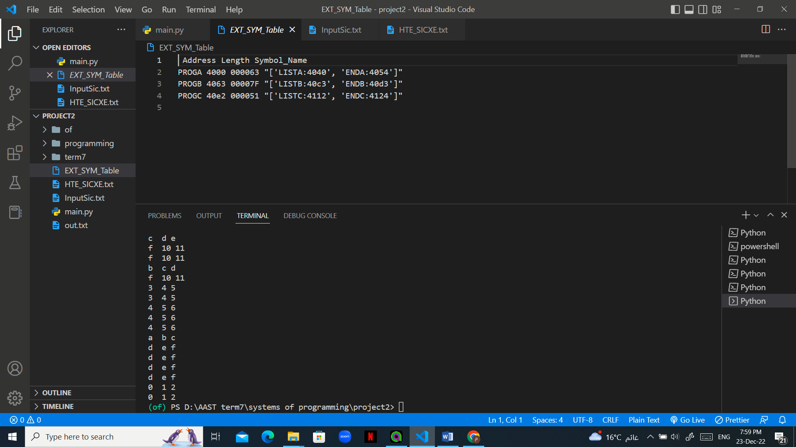

After forming the external symbol table, the program will give 2 tables

The first table showing the memory before the modifications of the M records

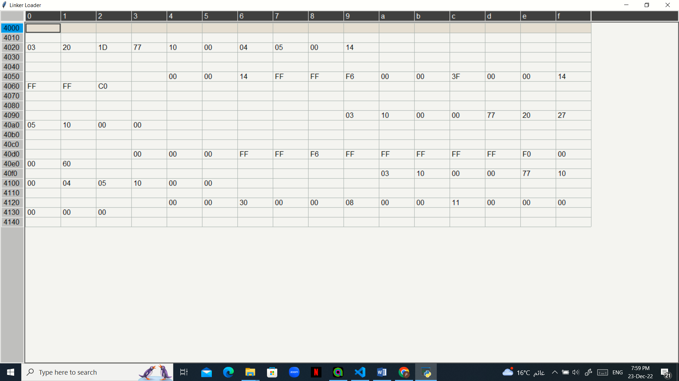

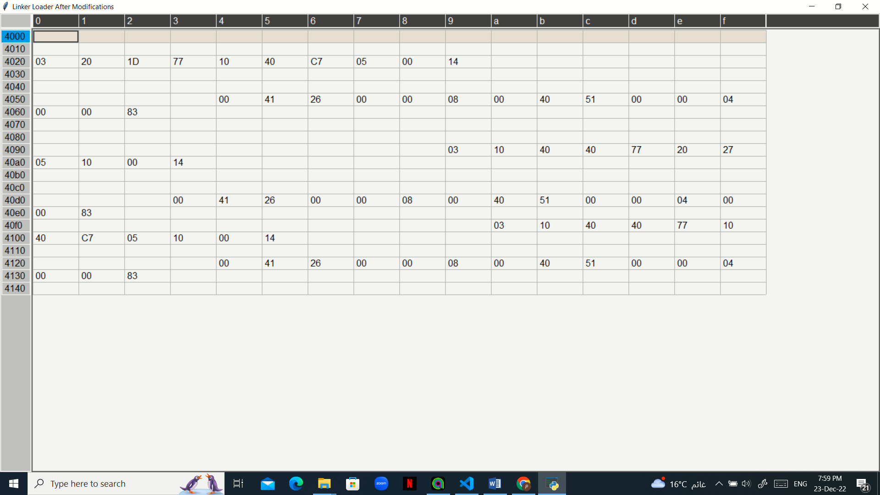The second table showing the memory after the modifications of the M records

Design issues and sample run

1. If the user entered values other than sic and sicxe

* The program handles this issue by asking the user for the type of the program again

1. The data was shown in the table in a wrong format

* The program handles this issue by :

m =' '.join(map(str,f_data))     #CONVERTING THE LIST INTO STRINGS SO WE CAN ADD THEM IN THE INDEX SINCE THE INDEX ACCEPTS ONLY STRING

        patn = re.sub(r"[\([{''})\]]", "", m)                             #REMOVES THE SQAURE BRACETS, SINGLE QUOTATIONS , THE X CHAR

1. Some of the modification records modify for 5 bits others for 6 bits and this gave a conflict when modifying the data so it was handled as shown:

if(line2[7:9] =='05'):

                    firstChar = value [0]

                    value = value[1:]

1. The GUI wasn’t reading the data correctly (the input was read as an empty string)

win.geometry("750x250")

    Address_entry=None

    labelFrame = LabelFrame(win,text = "Choose " , padx=50,pady=50)

    labelFrame.pack()

    Label(labelFrame,text="SIC OR SICXE").pack()

    Address_entry = Entry(labelFrame)

    Address_entry.pack()

    Button(labelFrame,text="Start" ,command=win.quit).pack()

    win.mainloop()

    choice = Address_entry.get()