
Project Part 3
Tourism Management Database System in Oman

Done by:
| Shahad Al Ghassani 133140
| Khulood Al Hosni 136968
| Mariam Al Rashdi 141535

SULTAN QABOOS UNIVERSITY
COLLEGE OF SCIENCE
DEPARTMENT OF COMPUTER SCIENCE
COMP3205: INTRODUCTION TO DATABASE SYSTEMS

Table of Contents
Mapping: 3
EER Diagram: 3
Mapping Option Chosen: Option 8A 3
Why not another option? 4
Assumptions Made: 4
Relational Model Constraints: 5
Relation Database Schema: 8
DB Construction: 9
Data Loading: 18
- TOURIST 18
- LOCALTOURIST 19
- FOREIGNTOURIST 19
- DESTINATION 20
- HOTEL 20
- TOURGUIDE 20
- TOURISTOFFICE 21
- TOURPACKAGE 21
- REVIEW 21
- BOOKING 22
- APPROVED 23
- CANCELLED 23
- WAITING 24
- Has 24
- Visit 25
- Included_in 25

Mapping:

EER Diagram:

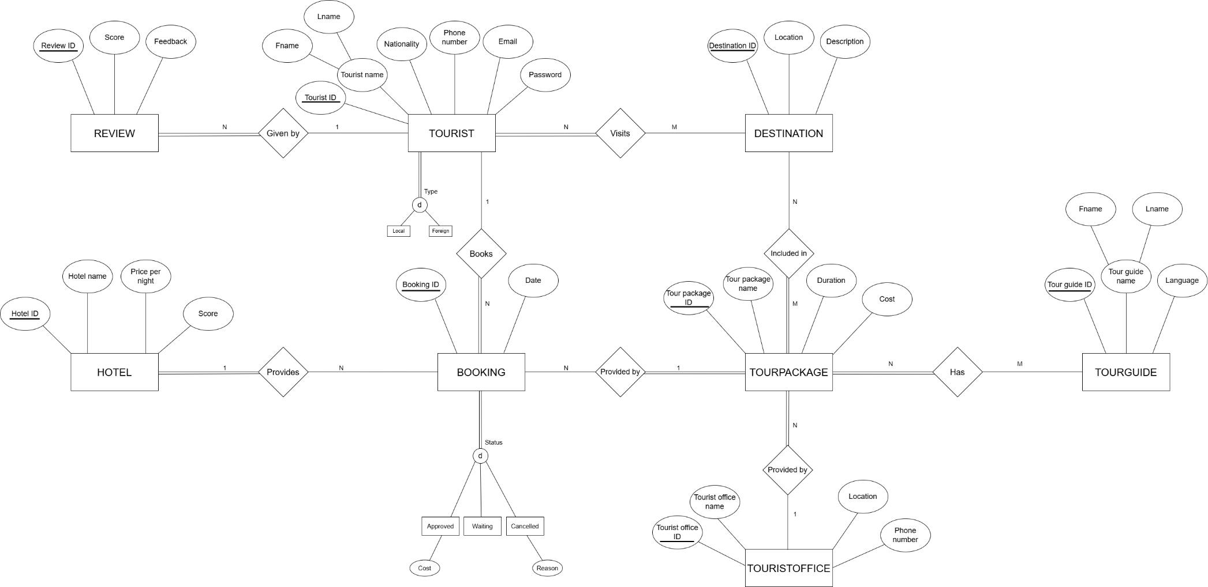
Mapping Option Chosen: Option 8A
We applied Option 8A (Multiple relations - superclass and subclasses) ,because it considered the best choice for handling the specialization of entities like Tourist and Booking because it effectively supports disjoint and total specializations, keeping subclass-specific attributes (such as Cost for Approved bookings and Reason for Cancelled ones) in their respective subclass tables. This avoids the use of NULLs for irrelevant attributes and maintains database normalization by ensuring each subclass has its own relation, thereby reducing redundancy.

Why not another option?
Other options (8B, 8C, 8D) were not suitable for several reasons. Option 8B removes the main table (Tourist/Booking), which we need to keep relationships like Booking. TouristID. Option 8C puts everything into one table with a label to tell types apart, but this causes a lot of empty (NULL) values for attributes like Reason and Cost. Option 8D is made for overlapping types using flags like IsApproved, but since our model is disjoint (no overlaps), it just makes things more complicated.

Assumptions Made:
- Tourist specialization is total and disjoint: every tourist is either local or foreign, not both.
- Booking specialization is total and disjoint: a booking must have exactly one status (approved, waiting, or cancelled).
- Subclass-specific attributes only exist in their respective subclass tables.

Relational Model Constraints:
- TOURIST:
- Check Entity Integrity Constraint → tourist_id is the primary key in the relation, must be unique & cannot be null.
- Check Not Null Constraint → fname, lname, nationality, email, and phone number, password cannot be null.
- Check Unique Constraint → email and phone number must be unique.
- Check Domain Constraint (varchar) → fname, lname, nationality, email, phone number, password.

- LOCALTOURIST:
- Check Entity Integrity Constraint → tourist_id is the primary key in the relation, must be unique & cannot be null.

- FOREIGNTOURIST:
- Check Entity Integrity Constraint → tourist_id is the primary key in the relation, must be unique & cannot be null.

- DESTINATION:
- Check Entity Integrity Constraint → destination_id is the primary key in the relation, must be unique & cannot be null.
- Check Not Null Constraint → location, description cannot be null.
- Check Domain Constraint → location (varchar), description (text).

- HOTEL:
- Check Entity Integrity Constraint → hotel_id is the primary key in the relation, must be unique & cannot be null.
- Check Not Null Constraint → hotel name, price per night, score cannot be null.
- Check Unique Constraint → hotel_name must be unique.
- Check Domain Constraint (integer) → score between 1 to 5.
- Check Domain Constraint (decimal) → price_per_night > 0.
- Check Domain Constraint (varchar) → hotel name.

- TOURGUIDE:
- Check Entity Integrity Constraint → tour_guide_id is the primary key in the relation, must be unique & cannot be null.
- Check Not Null Constraint → name, language cannot be null.
- Check Domain Constraint (varchar) → name, language.

- TOURPACKAGE:
- Check Entity Integrity Constraint → tour_package_id is the primary key in the relation, must be unique & cannot be null.
- Check Referential Integrity Constraint → touristoffice_id is foreign key referencing tourist office.
- Check Not Null Constraint → package name, cost cannot be null.
- Check Domain Constraint (varchar) → package name.
- Check Domain Constraint (decimal) → cost > 0.

- BOOKING:
- Check Entity Integrity Constraint → booking_id is the primary key in the relation, must be unique & cannot be null.
- Check Referential Integrity Constraint → tourist_id, hotel_id, tour_package_id are foreign keys referencing tourist, hotel, and tour package respectively.
- Check Not Null Constraint → date cannot be null.
- Check Domain Constraint (date) → date.

- APPROVED:
- Check Entity Integrity Constraint → booking_id is the primary key in the relation, must be unique & cannot be null.
- Check Not Null Constraint → cost cannot be null.
- Check Domain Constraint (decimal) → cost > 0.

- Cancelled:
- Check Entity Integrity Constraint → booking_id is the primary key in the relation, must be unique & cannot be null.
- Check Not Null Constraint → reason cannot be null.
- Check Domain Constraint (varchar) → reason.

- WAITING:
- Check Entity Integrity Constraint → booking_id is the primary key in the relation, must be unique & cannot be null.

- REVIEW:
- Check Entity Integrity Constraint → review_id is the primary key in the relation, must be unique & cannot be null.
- Check Referential Integrity Constraint → tourist_id is foreign key referencing tourist.
- Check Not Null Constraint → score, feedback cannot be null.
- Check Domain Constraint (integer) → score between 1 to 5.
- Check Domain Constraint (varchar) → feedback.

- TOURISTOFFICE:
- Check Entity Integrity Constraint → touristoffice_id is the primary key in the relation, must be unique & cannot be null.
- Check Not Null Constraint → touristoffice_name, location, phone_number cannot be null.
- Check Domain Constraint (varchar) → touristoffice_name, location.
- Check Domain Constraint (integer) → Phone_number (8-digit).

Relation Database Schema:
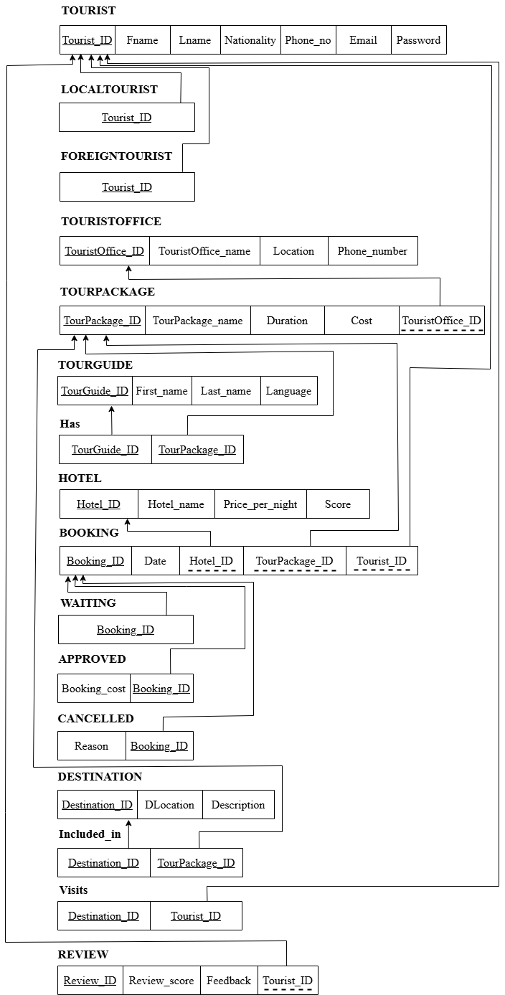

DB Construction:

Tourist

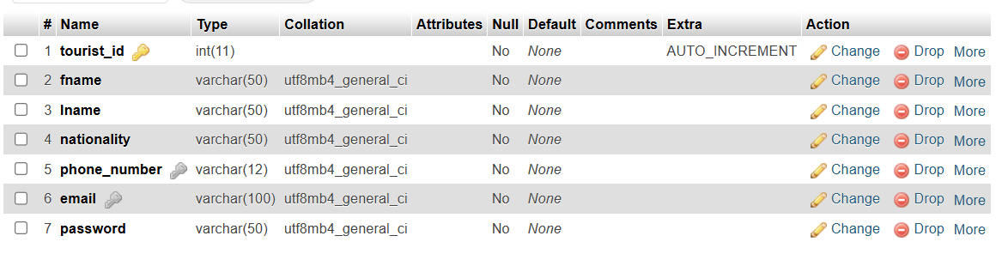
- Constraints:
PRIMARY KEY (tourist_id): Verifies that each visitor's tourist_id is their unique identification.
ensures non-nullability and uniqueness automatically.
For every new record, AUTO_INCREMENT creates a distinct integer that starts at 1 and increases by 1.
NOT NULL (fname, lname, nationality, phone number, email, and password): Makes sure that each record has a value in these columns and that they cannot be null.
ensures that all pertinent tourist data is complete.
UNIQUE (email): Guarantees that every email value is distinct throughout all records.
avoids using duplicate email addresses, which is essential for communication and user identification.
UNIQUE (phone_no): Guarantees that every phone_no value is distinct.
ensures every visitor has a unique phone number by preventing duplicates.
The goal of these restrictions is to guarantee that every visitor has a distinct identity, contact information, and all necessary information, preserving data integrity and preventing duplicates.

- Hotel
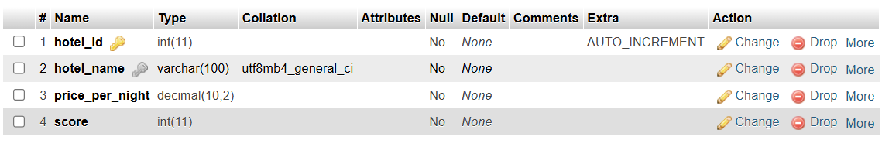
- Constraints:
PRIMARY KEY (hotel_id): A special number assigned to every hotel.
Unique IDs are generated using AUTO_INCREMENT.(hotel_name, price_per_night, score) NOT NULL: Guarantees that these columns are always filled in.
(score <= 5 AND score >= 1) CHECK:
ensures accurate hotel ratings by limiting the score to values between 1 and 5 (inclusive).
Making sure that no two hotels have the same name is possible with UNIQUE (hotel_name).
The goal is to guarantee that hotels have accurate information, distinct names, genuine scores, and are easily identified.

- TOURISTOFFICE
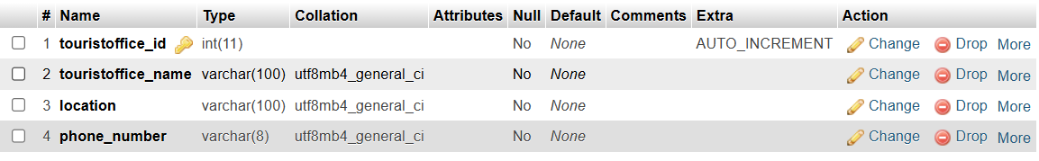
- Constraints:
PRIMARY KEY (touristoffice_id): This serves as each tourist office's unique identification.
AUTO_INCREMENT guarantees a distinct ID for every new office.
NOT NULL (touristoffice_name, location, phone_number): This ensures that each tourist office has complete data by requiring these fields to have values.
UNIQUE (touristoffice_name): Prevents confusion by guaranteeing that no two tourist offices share the same name.
The UNIQUE (phone_number) feature guarantees that every tourist office has a distinct phone number for different contact details.
Goal: These restrictions guarantee that every tourist office has complete information, is easily identified, and does not have duplicate names or phone numbers.

- TOURPACKAGE
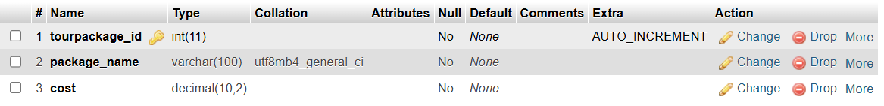
- Constraints:
Tourpackage_id, the primary key, serves as each tour package's unique identification.
AUTO_INCREMENT automatically creates unique IDs.
NOT NULL (package_name, cost): Ensures that each tour package has a name and price, which are essential for pricing and identification.
References Tourist Office (touristoffice_id) FOREIGN KEY (touristoffice_id) ON DELETE SET NULL:
connects touristoffice_id to the touristoffice_id associated with the TOURISTOFFICE table.
Verifies that the touristoffice_id in TOURPACKAGE corresponds to the one that already exists in TOURISTOFFICE.
ON DELETE SET NULL: The tour package record is preserved if the tourist office_id in TOURPACKAGE is set to NULL in the event that the linked tourist office is destroyed.
UNIQUE (package_name): Prevents duplicates by guaranteeing that every tour package has a distinct name.
The goal of these restrictions is to guarantee that travel packages are easily recognized, connected to legitimate travel agencies, and contain all necessary information. The ON DELETE SET NULL function permits flexibility if a tourist office is removed.

- Cancelled
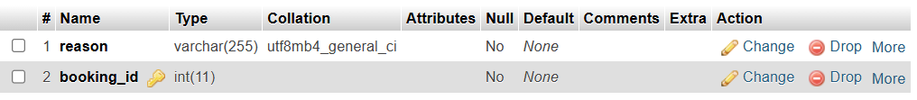
- Constraints:
Booking_id, the primary key, serves as each cancellation record's unique identification.
NOT NULL (justification):
requires documentation and a justification for each cancelation.
Booking_id is the FOREIGN KEY. BOOKING REFERENCES (booking_id) ON DELETE CASCADE:
connects booking_id to the booking_id in the BOOKING table.
makes certain that every cancellation relates to a reservation that already exists.
ON DELETE CASCADE: Referential integrity is maintained if the cancelation record is erased along with the referenced booking.
Goal: These restrictions guarantee that cancellations are linked to legitimate reservations, have a recorded justification, and are eliminated automatically in the event that the related reservation is terminated.

- Waiting
- Constraints:
Booking_id is designated as the unique identifier by the PRIMARY KEY.
Unique IDs are generated using AUTO_INCREMENT.
Booking_id is the FOREIGN KEY. BOOKING REFERENCES (booking_id) ON DELETE CASCADE: Verifies that booking_id corresponds to one that already exists in BOOKING.
ON DELETE CASCADE: The waiting record is erased if the booked reservation in question is removed.
The goal of this table is to keep track of reservations on a waiting list, making sure that each entry relates to a legitimate reservation and is eliminated in the event that the reservation is deleted.

- LocalTourist

- Constraints:
PRIMARY KEY (tourist_id): Gives local tourists their unique identification.
REFERENCES TOURIST (tourist_id) ON DELETE CASCADE FOREIGN KEY (tourist_id):
connects the TOURIST table to tourist_id.
Verifies that every local visitor is a legitimate traveler.
ON DELETE CASCADE: The local tourist record is erased if the mentioned tourist is removed.
The goal is to identify visitors as locals, make sure they are listed in the TOURIST table, and remove their local status if they are removed.

- ForeignTourist
- Constraints:
For international travelers, it is the same as LocalTourist.
PRIMARY KEY: A special identification number (tourist_id).
REFERENCES TOURIST (tourist_id) ON DELETE CASCADE FOREIGN KEY (tourist_id: Verifies that the visitor is legitimate and removes the record if the visitor is removed.
The goal is to identify international visitors while maintaining the same integrity and deletion policies as LocalTourist.

- DESTINATION
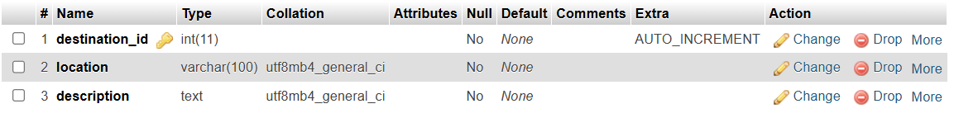
- Constraints:
PRIMARY KEY (destination_id): A special number assigned to every location.
Unique IDs are guaranteed by AUTO_INCREMENT.
NOT NULL (location, description): Every destination must have a location and a description.
The goal is to guarantee that destinations have complete data and can be uniquely identified.

- TOURGUIDE
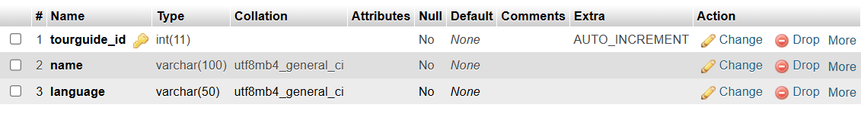
- Constraints:
Tourguide_id, the primary key, is a special identification number for every tour guide.
Unique IDs are generated using AUTO_INCREMENT.
NOT NULL (language, name):
need each tour guide's name and language.
The goal is to guarantee that tour guides have complete information and can be individually identified.

- BOOKING
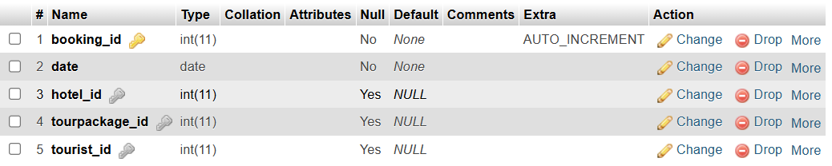
- Constraints:
PRIMARY KEY (booking_id): A special number assigned to every reservation.
Unique IDs are generated using AUTO_INCREMENT.
NOT NULL (date): Assures that a date is included in each reservation.
A reference to the HOTEL table is provided by the FOREIGN KEY (hotel_id) REFERENCES HOTEL(hotel_id) ON DELETE SET NULL, which guarantees a genuine hotel.
If the hotel is erased, ON DELETE SET NULL sets hotel_id to NULL.
A legitimate tour package is ensured by the FOREIGN KEY (tourpackage_id) REFERENCES TOURPACKAGE(tourpackage_id) ON DELETE SET NULL, which links to the TOURPACKAGE table.
If the tour package is deleted, ON DELETE SET NULL sets tourpackage_id to NULL.
REFERENCES TOURIST (tourist_id) ON DELETE CASCADE FOREIGN KEY (tourist_id):
Guarantees valid tourists by linking to the TOURIST table.
ON DELETE CASCADE: If the visitor is removed, the reservation is also removed.
With flexible deletion criteria for hotels and packages and tight deletion requirements for tourists, the goal is to guarantee that reservations are individually recognizable and associated with legitimate hotels, tour packages, and travelers.

- Approved
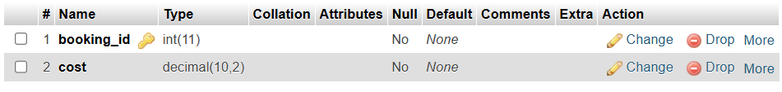
- Constraints:
Booking_id, the primary key, is a special identification number for authorized reservations.
NOT NULL (booking_cost): Demands a fee for each authorized reservation.
Verifies that the booking cost is positive by using the CHECK (booking_cost > 0) function.
Booking_id is the FOREIGN KEY. BOOKING REFERENCES (booking_id) ON DELETE CASCADE: Verifies that the reservation is present in BOOKING.
ON DELETE CASCADE: If the reservation is removed, the authorized record is also removed.
The goal is to keep track of authorized reservations with legitimate fees and make sure they are linked to other reservations, eliminating them in the event that a booking is removed.

- REVIEW
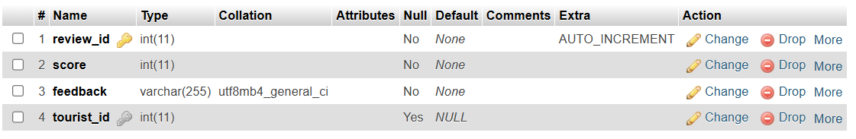
- Constraints:
PRIMARY KEY (review_id): A special number assigned to every review.
Unique IDs are generated using AUTO_INCREMENT.
NOT NULL (feedback, review_score):
requires each review to include a score and feedback.
Make sure that review_score is greater than or equal to one.
Review_score is limited to 1–5.
REFERENCES TOURIST (tourist_id) ON DELETE CASCADE FOREIGN KEY (tourist_id:
makes sure a legitimate traveler is associated with the review.
ON DELETE CASCADE: If the tourist is removed, the review is also removed.
The goal is to make sure that reviews are linked to current visitors, contain legitimate ratings and comments, are easily recognizable, and are automatically erased if the visitor is removed.

- Visit

- Constraints:
PRIMARY KEY (destination_id, tourist_id): A composite primary key guarantees the uniqueness of every tourist-destination pair.
A valid tourist is ensured by the FOREIGN KEY (tourist_id) REFERENCES TOURIST (tourist_id) ON DELETE CASCADE.
ON DELETE CASCADE: If the visitor is removed, the visit record is also removed.
A valid destination is ensured by the FOREIGN KEY (destination_id) REFERENCES DESTINATION (destination_id) ON DELETE CASCADE.
ON DELETE CASCADE: If the destination is removed, the visit record is also removed.
The goal is to keep track of distinct tourist visits to locations, verify that both travelers and destinations are legitimate, and erase records if either is removed.

- Has
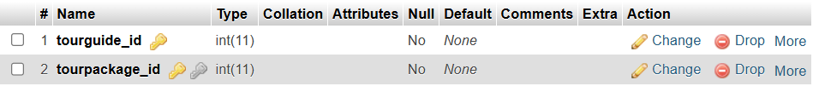
- Constraints:
The composite primary key (tourguide_id, tourpackage_id) guarantees that every tour guide-tour package pair is distinct.
References TourGuide (tourguide_id) FOREIGN KEY (tourguide_id) ON DELETE CASCADE: Verifies if the tour guide is legitimate.
ON DELETE CASCADE: In the event that the tour guide is removed, this deletes the association.
A legitimate tour package is ensured by the FOREIGN KEY (tourpackage_id) REFERENCES TOURPACKAGE (tourpackage_id) ON DELETE CASCADE.
ON DELETE CASCADE: In the event that the tour package is removed, this deletes the association.
Linking tour guides to tour packages serves the purpose of guaranteeing distinct pairings and reliable references, with automatic deletion in the event that either is deleted.

- Included_in

- Constraints:
PRIMARY KEY (destination_id, tourpackage_id): A composite primary key guarantees the uniqueness of every pair of destinations and tour packages.
A valid destination is ensured by the FOREIGN KEY (destination_id) REFERENCES DESTINATION (destination_id) ON DELETE CASCADE.
ON DELETE CASCADE: If the destination is removed, the association is also removed.
A legitimate tour package is ensured by the FOREIGN KEY (tourpackage_id) REFERENCES TOURPACKAGE (tourpackage_id) ON DELETE CASCADE.
ON DELETE CASCADE: In the event that the tour package is removed, this deletes the association.
Linking destinations to tour packages serves the purpose of guaranteeing distinct pairings and legitimate references, with automatic deletion in the event that either is deleted.

- Constraints
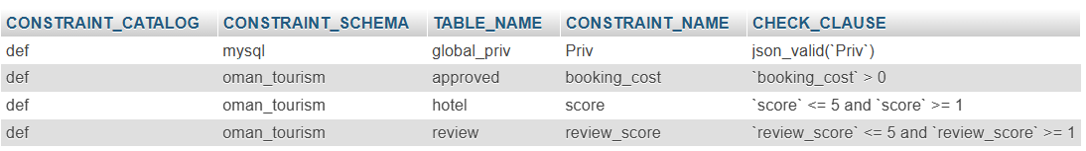
- The following guidelines are enforced by the CHECK constraints in the oman_tourism schema (rows 2–4):
approved.booking_cost: Prevents zero or negative expenses for authorized bookings, ensuring that the booking_cost in the approved table is larger than 0. This preserves the integrity of financial data.
hotel.score: Guarantees that hotel ratings are legitimate and in line with a 5-star rating system by limiting the score in the hotel table to a range of 1 to 5.
In order to guarantee that review ratings are legitimate and in line with a 5-star rating system, review.review_score limits the review_score in the review table to a range of 1 to 5.
- Note: the first raw don’t belong to our database.

Data Loading:

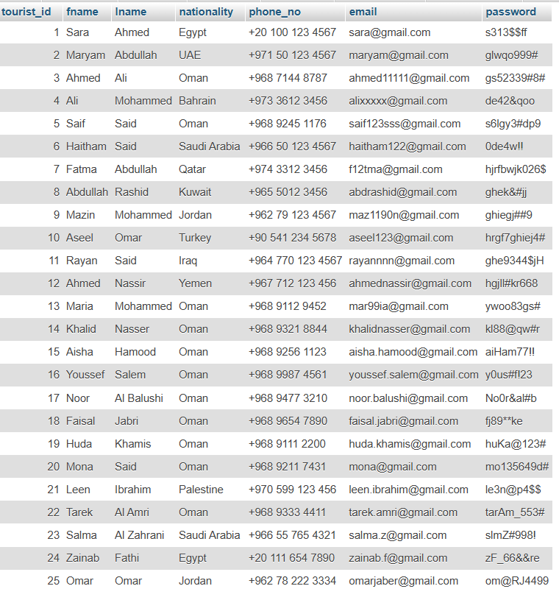
- TOURIST

- LOCALTOURIST
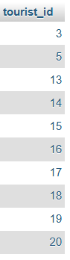

- FOREIGNTOURIST
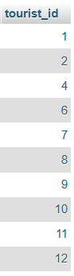

- DESTINATION
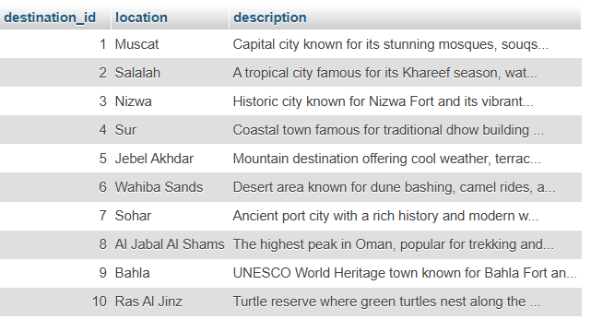

- HOTEL
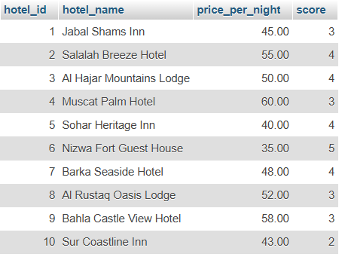

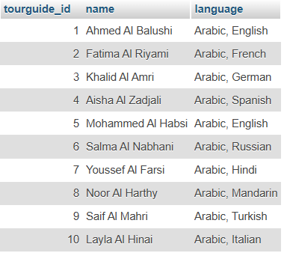
- TOURGUIDE

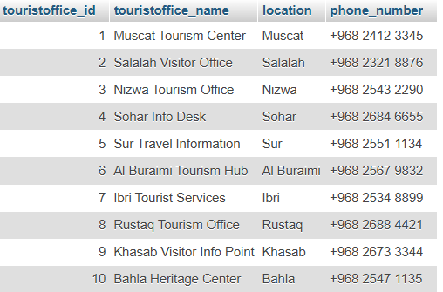
- TOURISTOFFICE

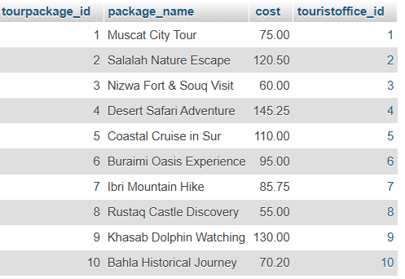
- TOURPACKAGE

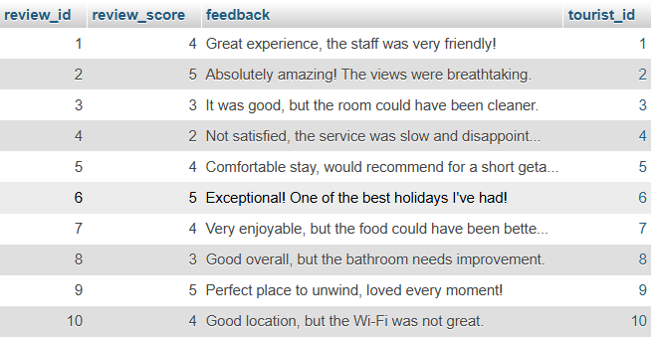
- REVIEW

- BOOKING
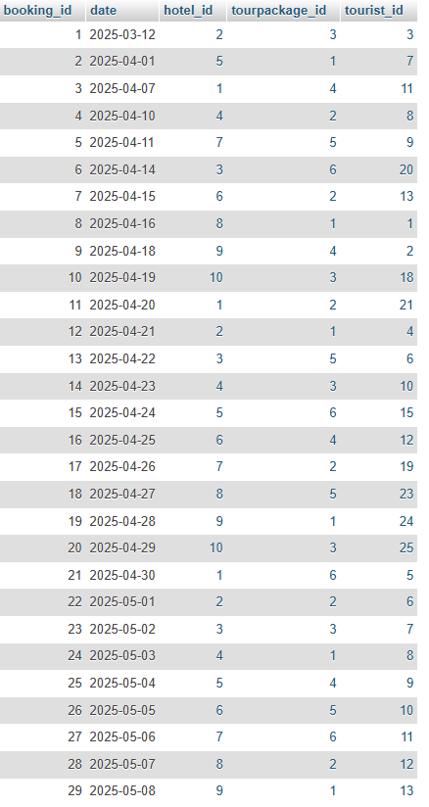

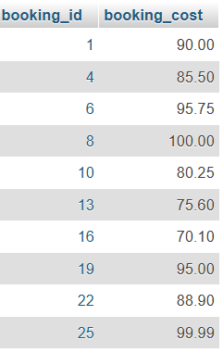
- APPROVED

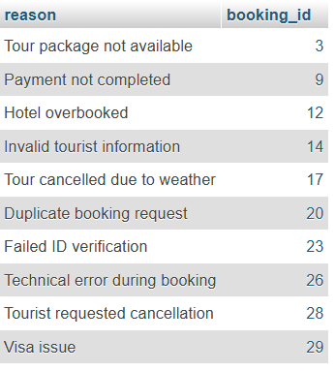
- CANCELLED

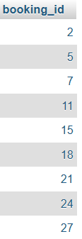
- WAITING

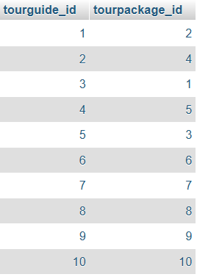
- Has

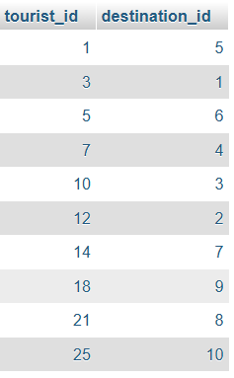
- Visit

- Included_in
